32.3.2 LC Common Mode

32.3.2.1 Introduction
The LC common mode PHY is based on the OFDM PHY in 17. In the following, the differences to the OFDM PHY in clause 17 are described.
All LC STAs shall support the mandatory features defined in Clause 17, except:
17.3.8.4 – Operating channel frequencies
17.3.8.5 – Transmit and receive in-band and out-of-band spurious emissions
17.3.9.3 – Transmit spectrum mask
17.3.9.7.2 – Transmitter center frequency leakage
17.3.10.3 – Adjacent channel rejection
17.3.10.4 – Nonadjacent channel rejection

32.3.2.2 OFDM Mode-specific service parameter list
TXVECTOR is the same as in section 17.2.2.

RXVECTOR is the same as in section 17.2.3, except that the parameters RX_ANTENNA, CH_BANDWIDTH _IN_NON_HT and DYN_BANDWIDTH _IN_NON_HT are not used.

TXSTATUS is the same as in section 17.2.4.

32.3.2.3 OFDM PHY

32.3.2.3.1 Introduction
The OFDM PHY shall be the same as in section 17.3 except for the data scrambling which is described in section 32.3.2.3.2, the OFDM modulation, which is described in 32.3.2.3.3, operation specification in 32.3.2.3.4, and the virtual CCA mechanism described in 32.3.2.3.5.

32.3.2.3.2 PHY DATA scrambler and descrambler
Unlike the text in section 17.3.5.5, the scrambler seed shall be initialized with a pseudorandom nonzero value. It shall not convey any information.

32.3.2.3.3 Light Interface
Figure 1 illustrates how a light emitting diode (LED) is connected to the TX OFDM PHY and a photo diode (PD) to the RX OFDM PHY.

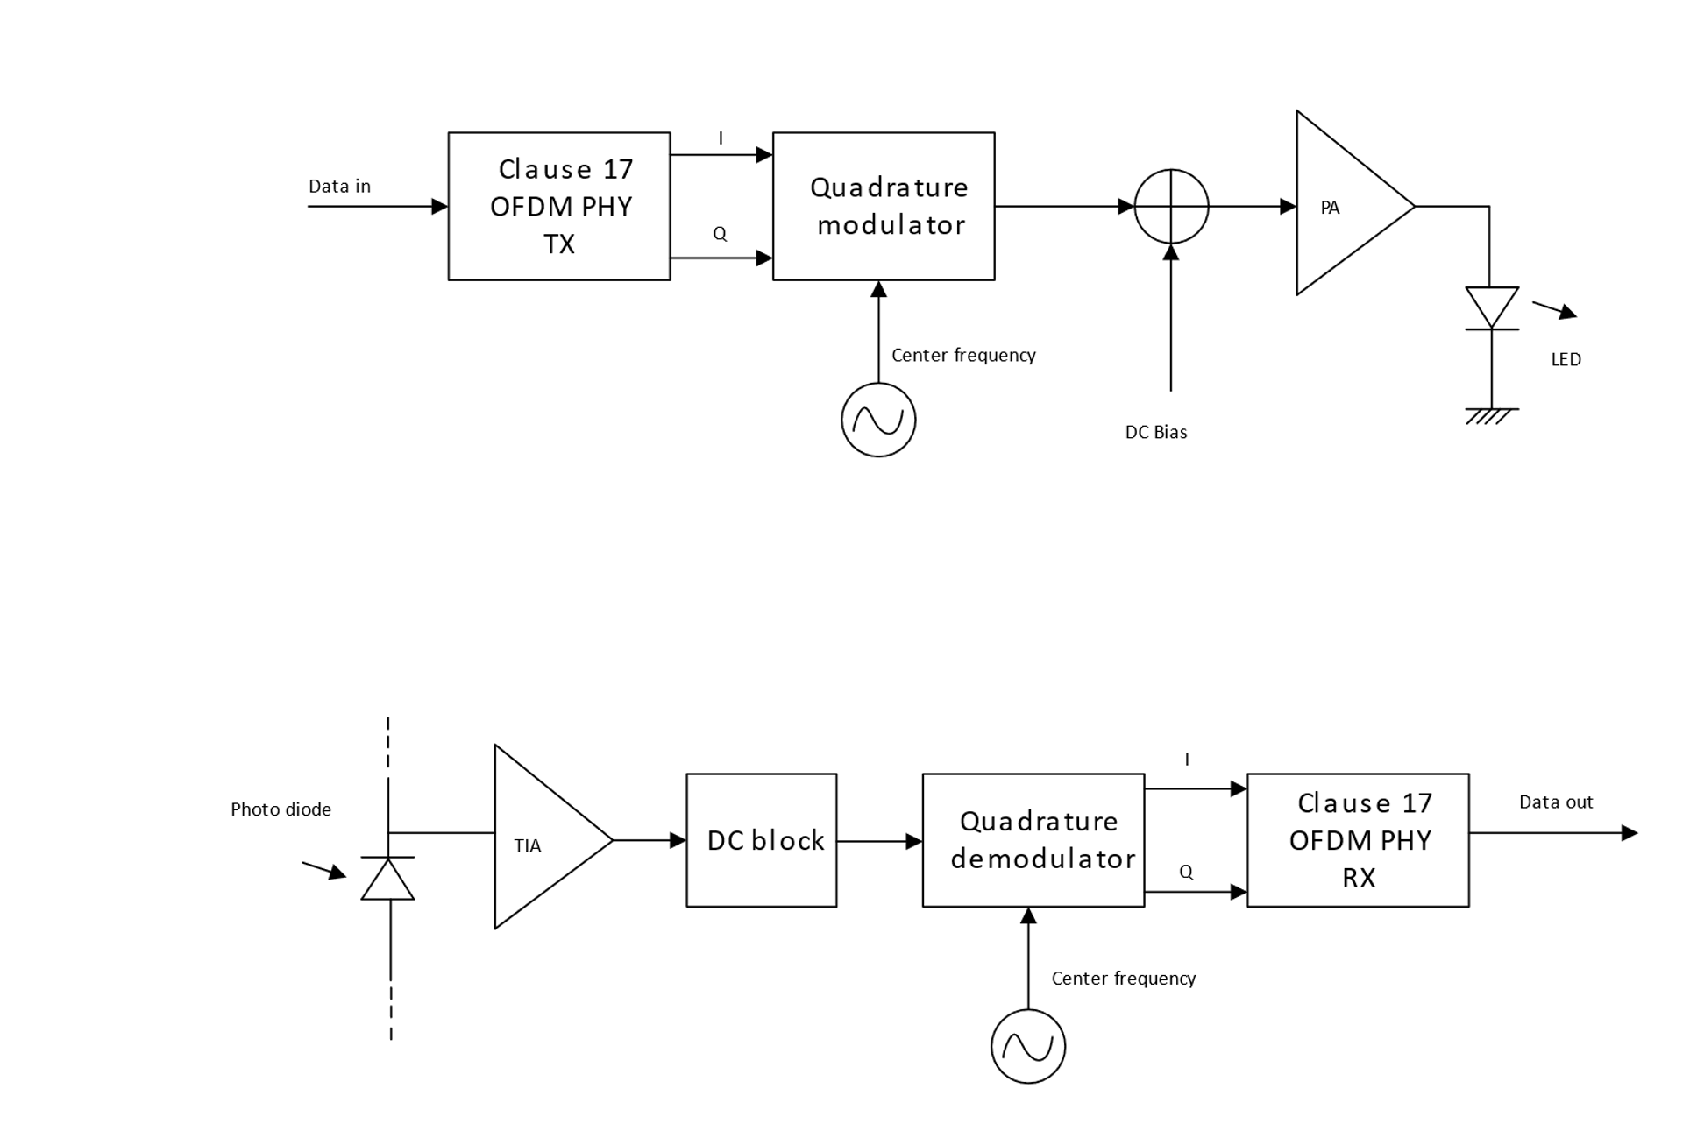
Figure 1: Interfacing OFDM PHY to light emitter and receiver
In the TX chain, the I and Q samples from the baseband shall be quadrature modulated, see 32.3.2.3.41.2.3.9.4 Operating channel frequencies for center frequencies. A DC bias is added before the signal is fed to the LED because the current through a diode can only be positive as illustrated in Figure 2.
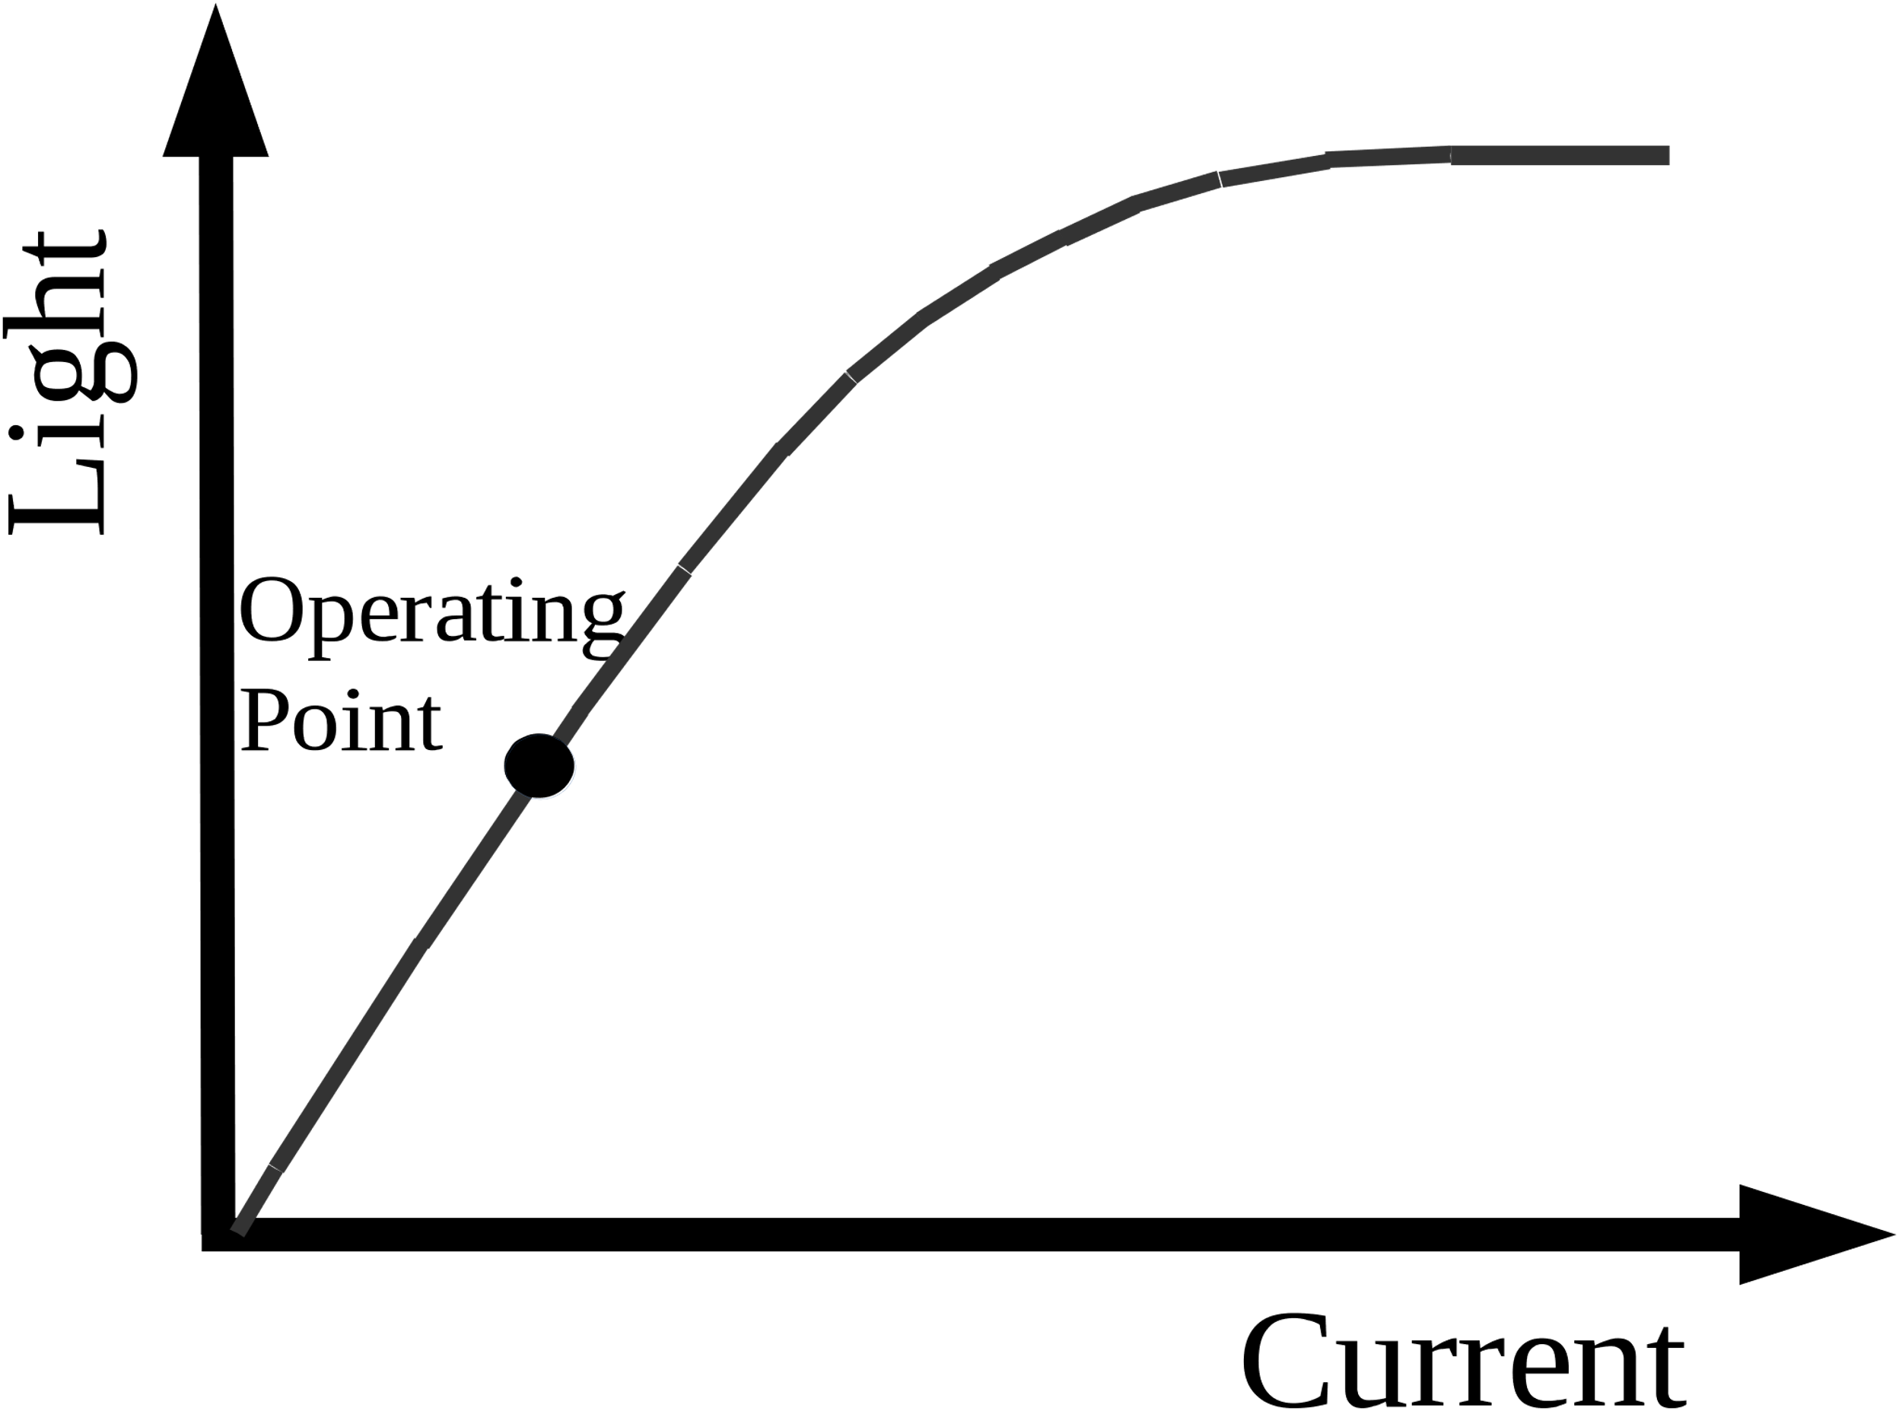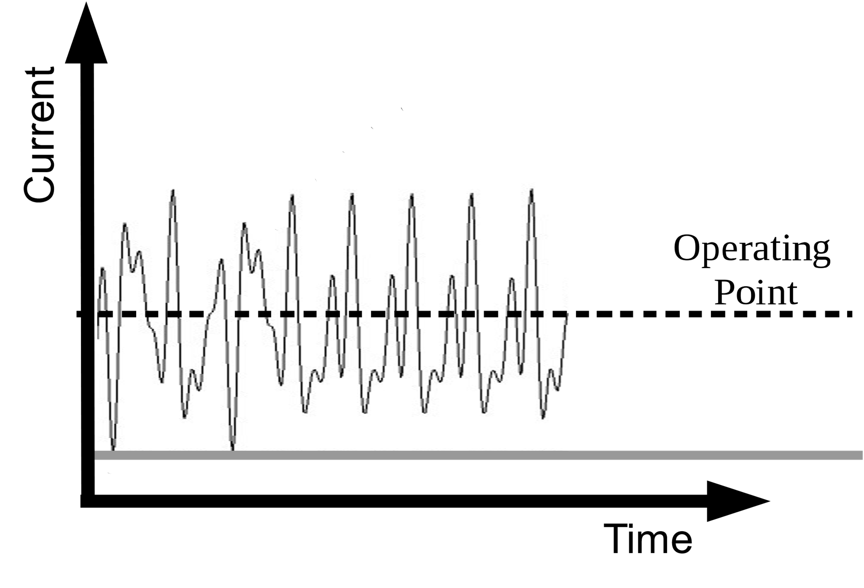
Figure 2: Operation of LED with DC bias
In the RX chain, the light variations produced by the LED are converted into a current by a photo diode (PD) and amplified by a transimpedance amplifier (TIA). The DC component is removed, the signal shall be downconverted to baseband and fed to the RX OFDM PHY.

The light communications transmitter and receiver shall operate at a wavelength between 800 nm and 1000 nm.

32.3.2.3.4 PHY operating specifications (general)

32.3.2.3.4.1 General
The operating specifications shall be the same as in section 17.3.8 except for the changes made to support LC. In addition, 17.3.8.5 is not required in the LC CM PHY.

32.3.2.3.4.2 Outline description
The outline shall be the same as in section 17.3.8.2. In Figure 17-12 the antennas have to replaced by optical frontends (OFE)s, for example as described in document IEEE 802.11-19/0087r1.

32.3.2.3.4.3 Regulatory requirements
The IEC 60825-1 laser eye safety regulations shall apply to all LC devices.

32.3.2.3.4.4 Operating channel frequencies
The LC common mode shall operate at a center frequency of 26 MHz. The common bandwidth shall be
20 MHz. This centre frequency shall correspond to LC channel 0.

32.3.2.3.5 Relayed CCA

32.3.2.3.5.1 Relayed CCA mechanism description

Due to the nature of light communications, the CCA mechanism will not work on STA side. The relayed CCA mechanism relies on the AP that detects the transmission from any STA as described in 32.3.2.3.5.2 CCA requirements, and disseminates the channel occupation among the STAs.

The access point (AP) is modified to retransmit the received packets from STAs, when the AP does not transmit anything itself. Figure 3 shows the preferred embodiment of a modified AP that retransmits at the analog level of the receiver chain. A data packet, or other input, from a STA is received by the photodetector (for example photodiodes including APDs and PIN diodes). The input from the photodetector is passed through an amplifier or amplifier chain (or other conditioning circuitry) and is directed to both a receiver physical layer (RX PHY) for decoding and a multiplexer (MUX) to route input to the lamp (comprising an LED or other light emitting optical element such as a VCSEL or laser). Prior to entering the MUX, the input from the photodetector optionally passes through an amplifier or other conditioning circuitry. By default, the multiplexer (MUX) routes the input from the photodetector to the lamp. When the AP wants to transmit a packet, the MUX is switched such that the transmitted packet goes to the lamp.

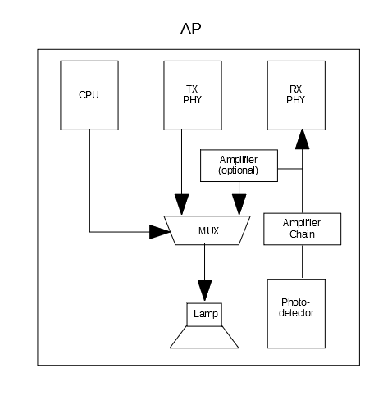
Figure 3 Modifications on AP

32.3.2.3.5.2 CCA requirements

1.2.4 OFDM PLME
This shall be the same as in section 17.4, except that the parameter “dot11RegDomainsImplementedValue” in Table 17.20 does not apply to the LC Common Mode.

32.3.3 LC High Efficiency (HE) Mode

32.3.3.1 Introduction
The LC HE Mode is based on the HE PHY in Clause 27. In the following, the differences to the HE PHY in clause 27 are described.

32.3.3.2 LC HE PHY service interface
The LC HE PHY service interface shall be the same as in 27.2 except for the following fields which shall be set to zero,
- BEAMFORMED
- BEAM_CHANGE
because beamforming is not supported.

32.3.3.3 LC HE PHY
The subclause shall be the same as section 27.3 except the following subclauses which do not apply to LC HE PHY:
27.3.16 — SU-MIMO and DL MU-MIMO beamforming
27.3.23 — Channel numbering

32.3.3.3.1 Light Interface

32.3.3.3.1.1 Introduction
The light interface shall be an extension of the light interface described in 1.2.3.38 Light Interface to multiple TX and RX streams.

32.3.3.3.1.2 Multiple transmitters and receivers
Figure 3 shows multiple LEDs connected to the TX baseband and Figure 4 shows multiple PDs connected to the RX baseband.
The LEDs may all operate at the same wavelength or at different wavelengths.
The TX baseband outputs shall be all quadrature modulated to the same common center frequency, see Error: Reference source not found for details.
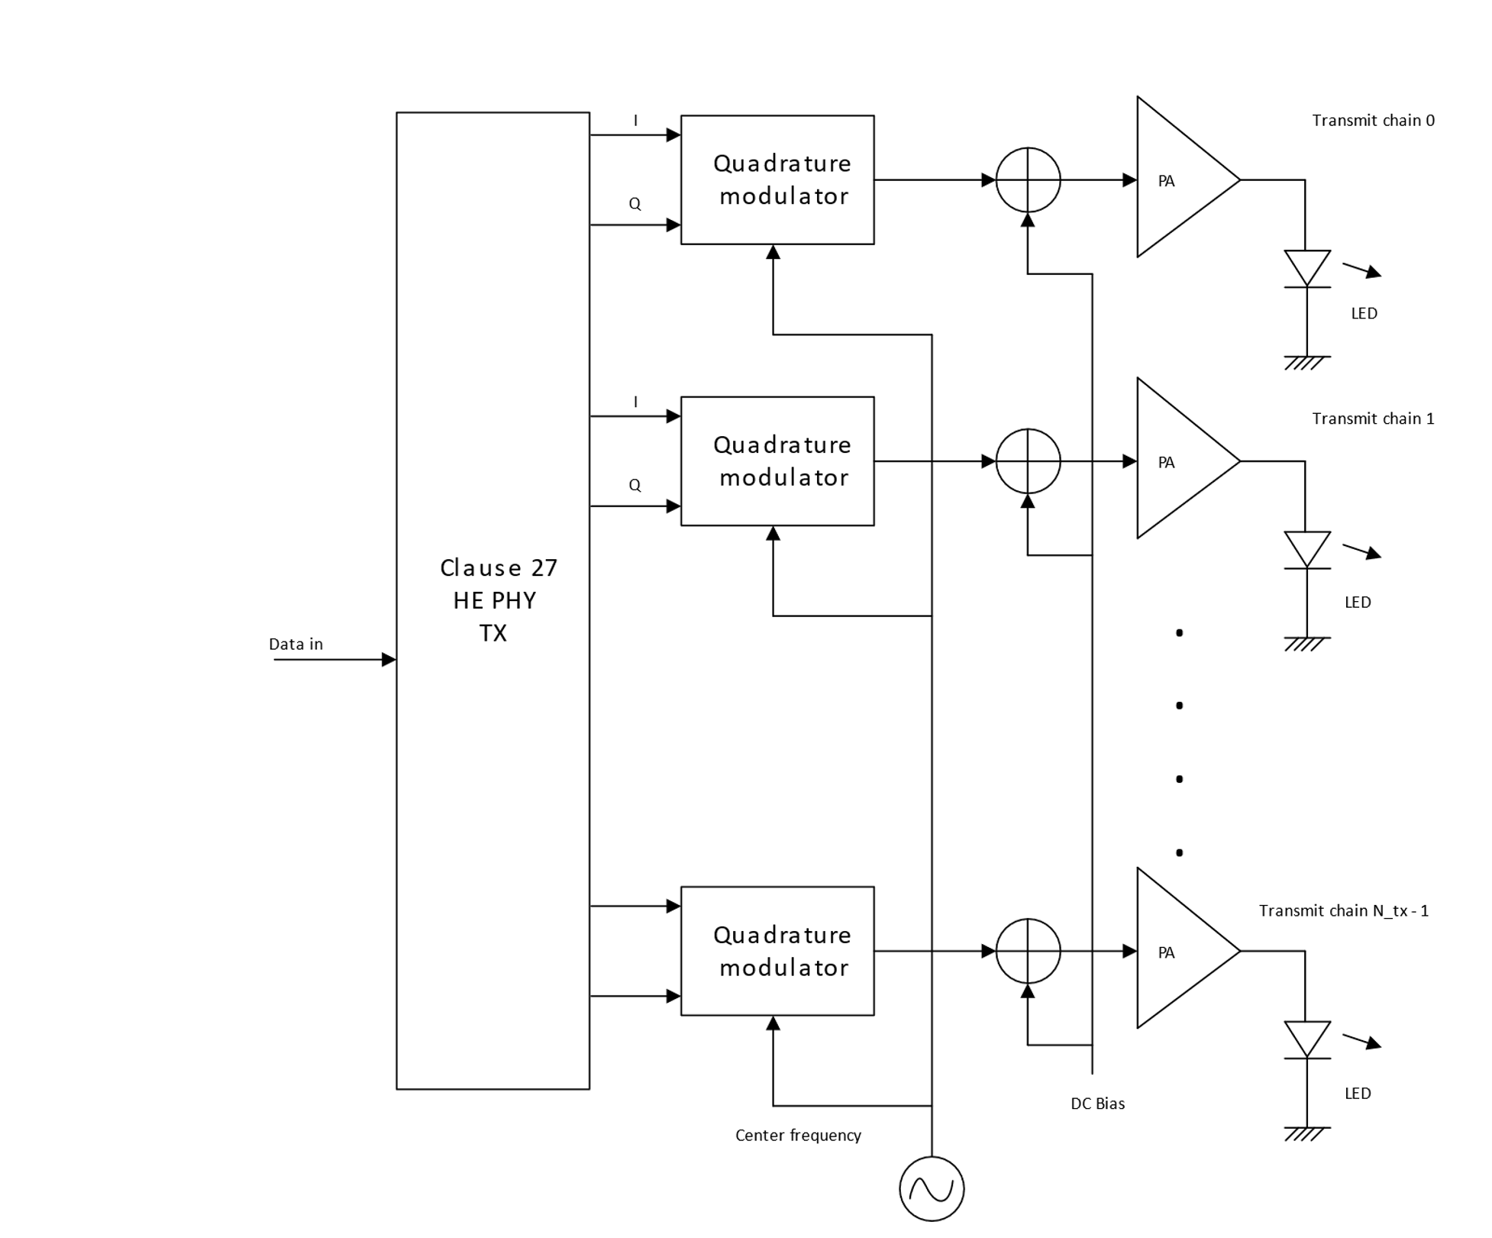
Figure 4: Connecting multiple LEDs to TX baseband
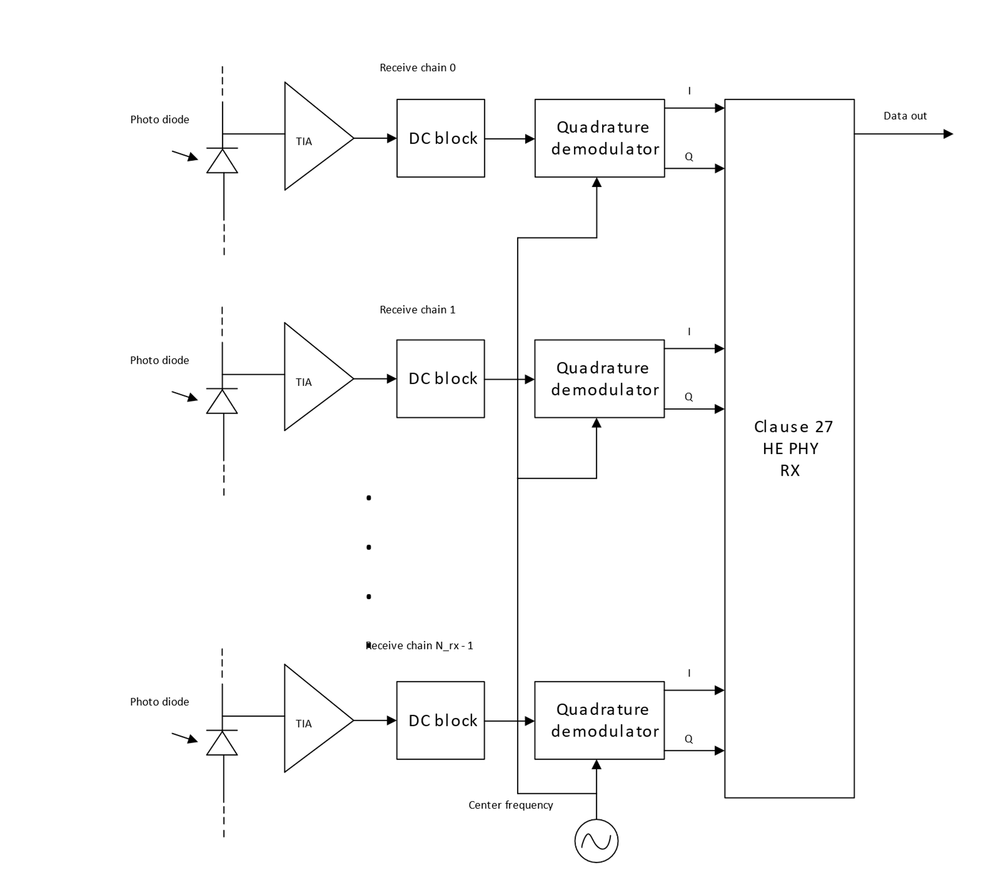
Figure 5: Connecting multiple PDs to RX baseband

32.3.3.3.2 Channel numbering
The centre frequencies and channel numbering depending on the channel bandwidth are shown in Table 1.
Table 1: Channelization
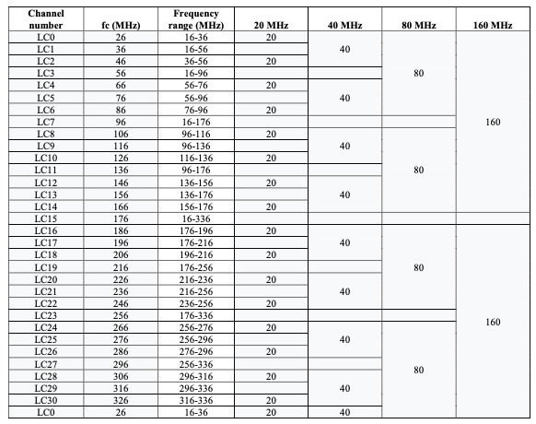

32.3.3.3.3 Regulatory Requirements
The IEC 60825-1 laser eye safety regulations shall apply to all LC devices.

32.3.3.4 LC PHY PLME
This section shall be the same as section 27.4 except the following changes.

Two new values for the PHY MIB attribute “dot11PHYType” shall be introduced, LC1 and LC2. LC1 indicates an LC PHY with the light interface described in 32.3.3.3.1.2, LC2 shall be reserved for a different light interface to be defined in the future.

32.3.3.5 Parameters for HE-MCSs
This section shall be the same as section 27.5.

32.3.3.6 Parameters for HE--SIG-B- MCSs
This section shall be the same as section 27.6.

