IEEE P802.11
Wireless LANs
TGbb:
Proposed text for 11bb mandatory and optional LC HE PHY modes
Date: 2020-04-03
Author(s):
Name | Affiliation | Address | Phone | Email
Nikola Serafimovski | pureLiFi |  |  | nikola.serafimovski@purelifi.com
Stephan Berner |  |  |  | stephan.berner@purelifi.com
Chong Han |  |  |  | chong.han@purelifi.com
Ardimas Purwita | University of Edinburgh |  |  | a.purwita@ed.ac.uk
Harald Haas | University of Edinburgh |  |  | h.haas@ed.ac.uk
Abstract
This document provides text to be incorporated in the 11bb draft for the common and LC HE PHY modes.

Table of Contents
Table of Contents 2
1 LC PHY 2
1.1 Introduction 2
1.2 LC Common Mode 2
1.2.1 Introduction 2
1.2.2 OFDM Mode specific service parameter list 2
1.2.3 OFDM Mode 2
1.2.4 OFDM PLME 5
1.3 LC High Efficiency (HE) Mode 5
1.3.1 Introduction 5
1.3.2 LC HE PHY service interface 5
1.3.3 LC HE PHY 6
1.3.4 LC PHY PLME 8

1 LC PHY

1.1 Introduction
This clause defines the light communications (LC) PHY. There are three versions of the LC PHY, the mandatory, common 802.11 based LC PHY, the optional 802.11 based LC High Efficiency (HE) PHY and the optimized PHY. The LC PHY transmits in a channel located in a frequency range of near DC up to a few hundred MHz, see the respective sections about channelization for details.

1.2 LC Common Mode

1.2.1 Introduction
The mandatory LC PHY is based on the OFDM PHY in clause 17. In the following the differences to the OFDM PHY in clause 17 are described.

1.2.2 OFDM Mode specific service parameter list
TXVECTOR the same as in section 17.2 of the 802.11 standard.
RXVECTOR is the same as in section 17.2 2 of the 802.11 standard, except that the parameters RX_ANTENNA, CH_BANDWIDTH _IN_NON_HT and DYN_BANDWIDTH _IN_NON_HT are not present.

1.2.3 OFDM Mode

1.2.3.1 Introduction
The OFDM PHY is the same as in section 17.3 except for the data scrambling and the OFDM modulation, which is described in section 1.2.3.5.5

1.2.3.2 PPDU format
This shall be the same as in section 17.3.2 of the 802.11 standard.

1.2.3.3 PHY preamble (SYNC)
This shall be the same as in section 17.3.3 of the 802.11 standard.

1.2.3.4 SIGNAL field
This shall be the same as in section 17.3.4 of the 802.11 standard.

1.2.3.5 DATA field

1.2.3.5.1 General
The data field shall be the same as in section 17.3.5 2 of the 802.11 standard except for the scrambler seed (described in section 1.2.3.5.5) and the OFDM modulation (described in section 1.2.3.8)

1.2.3.5.2 SERVICE field
This shall be the same as in section 17.3.5.2 of the 802.11 standard.

1.2.3.5.3 PPDU TAIL field
This shall be the same as in section 17.3.5.3 of the 802.11 standard

1.2.3.5.4 Pad bits (PAD)
This shall be the same as in section 17.3.5.4 of the 802.11 standard

1.2.3.5.5 PHY DATA scrambler and descrambler
Unlike the text in section 17.3.5.5 of the 802.11 standard, the scrambler seed shall be initialized with a pseudorandom nonzero value. It shall not convey any information.

1.2.3.5.6 Convolutional encoder
This shall be the same as in section 17.3.5.6 of the 802.11 standard

1.2.3.5.7 Data interleaving
This shall be the same as in section 17.3.5.7 of the 802.11 standard

1.2.3.5.8 Subcarrier modulation mapping
This shall be the same as in section 17.3.5.8 of the 802.11 standard

1.2.3.5.9 Pilot subcarriers
This shall be the same as in section 17.3.5.9 of the 802.11 standard

1.2.3.5.10 OFDM modulation
This shall be the same as in section 17.3.6.10 of the 802.11 standard

1.2.3.6 CCA
This shall be the same as in section 17.3.6 of the 802.11 standard

1.2.3.7 PHY data modulation and modulation rate change
This shall be the same as in section 17.3.7 6 of the 802.11 standard

1.2.3.8 Light Interface
Figure 1 illustrates how a light emitting diode (LED) is connected to the TX OFDM PHY and a photo diode (PD) to the RX OFDM PHY.

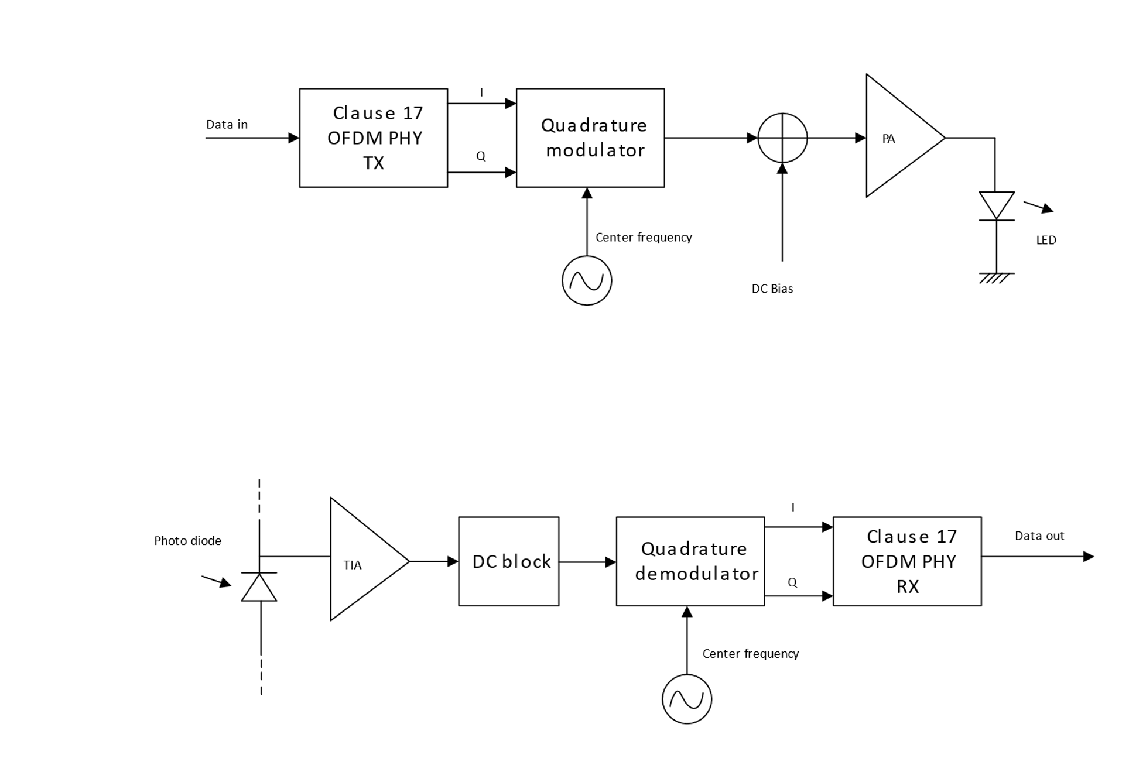
Figure 1: Interfacing OFDM PHY to light emitter and receiver
In the TX chain, the I and Q samples from the baseband shall be quadrature modulated, see 1.2.3.9.4 Operating channel frequencies for center frequencies. A DC bias is added before the signal is fed to the LED because the current through a diode can only be positive as illustrated in Figure 2.
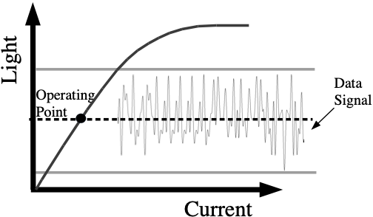
Figure 2: Operation of LED with DC bias
In the RX chain, the light variations produced by the LED are converted into a current by a photo diode (PD) and amplified by a transimpedance amplifier (TIA). The DC component is removed, the signal shall be downconverted to baseband and fed to the RX OFDM PHY.

The light communications transmitter and receiver shall operate at a wavelength between 800 nm and 1000 nm.

1.2.3.9 PHY operating specifications (general)

1.2.3.9.1 General
The operating specifications shall be the same as in section 17.3.8 of the 802.11 standard except for the regulatory requirements and operating frequencies

1.2.3.9.2 Outline description
This shall be the same as in section 17.3.8.2 of the 802.11 standard. In Figure 17-12 the antennas have to replaced by optical frontends (OFE)s, for example as described in document IEEE 802.11-19/0087r1.

1.2.3.9.3 Regulatory requirements
The IEC 60825-1 laser eye safety regulations shall apply to all LC devices.

1.2.3.9.4 Operating channel frequencies
The LC PHY with mandatory features operates at a center frequency of 26 MHz or at an alternative center frequency of 46 MHz. The common bandwidth shall be 20 MHz. These two center frequencies shall correspond to LC channel 0 and LC channel 1.

1.2.3.9.5 Transmit and receive in-band and out-of-band spurious emissions
This does not apply to any LC PHY Mode

1.2.3.9.6 Slot time
This shall be the same as in section 17.3.8.6 of the 802.11 standard

1.2.3.9.7 Transmit and receive impedance at the antenna connector
This shall be the same as in section 17.3.8.7 of the 802.11 standard

1.2.3.10 PHY transmit specifications
This shall be the shall be the same as in section 17.3.9 of the 802.11 standard

1.2.3.11 PHY receiver specifications
This shall be the same as in section 17.3.10 of the 802.11 standard

1.2.3.12 Transmit PHY
This shall be the same as in section 17.3.11 of the 802.11 standard

1.2.3.13 Receive PHY
This shall be the same as in section 17.3.12 of the 802.11 standard

1.2.4 OFDM PLME
This shall be the same as in section 17.4 of the 802.11 standard, except that the parameter “dot11RegDomainsImplementedValue” in Table 17.20 does not apply to the LC Common Mode

1.3 LC High Efficiency (HE) Mode

1.3.1 Introduction
The LC HE Mode is based on the HE PHY in Clause 27 of the 802.11 standard. In the following, the differences to the HE PHY in clause 27 are described.

1.3.2 LC HE PHY service interface
The LC HE PHY service interface shall be the same as in 27.2 of the 802.11 standard except for the following fields which shall be set to zero,
- BEAMFORMED
- BEAM_CHANGE
because beamforming is not supported.

1.3.3 LC HE PHY

1.3.3.1 Introduction
This subclause describes the differences to the subclause 27.3 of the 802.11 standard.

1.3.3.2 Subcarrier and resource allocation
This section shall be the same as section 27.3.2 of the 802.11 standard.

1.3.3.3 MU-MIMO
This section shall be the same as section 27.3.3 of the 802.11 standard.

1.3.3.4 LC PPDU formats
This section shall be the same as section 27.3.4 of the 802.11 standard.

1.3.3.5 Transmitter block diagram
This section shall be the same as section 27.3.5 of the 802.11 standard.

1.3.3.6 Overview of the PPDU encoding process
This section shall be the same as section 27.3.6 of the 802.11 standard.

1.3.3.7 LC modulation and coding schemes (HE-MCSs)
This section shall be the same as section 27.3.7 of the 802.11 standard.

1.3.3.8 LC-SIG-B modulation and coding schemes (HE-SIG-B-MCSs)
This section shall be the same as section 27.3.8 of the 802.11 standard.

1.3.3.9 Timing-related parameters
This section shall be the same as section 27.3.9 of the 802.11 standard.

1.3.3.10 Mathematical description of signals
This section shall be the same as section 27.3.10 of the 802.11 standard.

1.3.3.11 LC HE preamble
This section is the same as section 27.3.11 of the 802.11 standard.

1.3.3.12 Data field
This section shall be the same as section 27.3.12 of the 802.11 standard.

1.3.3.13 Packet extension
This section shall be the same as section 27.3.13 of the 802.11 standard.

1.3.3.14 Non-HT duplicate transmission
This section shall be the same as section 27.3.14 of the 802.11 standard.

1.3.3.15 Transmit requirements for PPDUs sent in response to a triggering frame
This section shall be the same as section 27.3.15 of the 802.11 standard.

1.3.3.16 SU-MIMO and DL MU-MIMO beamforming
Beamforming shall be not supported for LC. Therefore, this section does not apply to the LC HE Mode.

1.3.3.17 LC sounding NDP
This section shall be the same as section 27.3.17 of the 802.11 standard.

1.3.3.18 LC TB feedback NDP
This section shall be the same as section 27.3.18 of the 802.11 standard.

1.3.3.19 Transmit specification
This section shall be the same as section 27.3.19 of the 802.11 standard.

1.3.3.20 Receiver specification
This section shall be the same as section 27.3.20 of the 802.11 standard.

1.3.3.21 LC transmit procedure
This section shall be the same as section 27.3.21 of the 802.11 standard.

1.3.3.22 LC receive procedure
This section shall be the same as section 27.3.22 of the 802.11 standard.

1.3.3.23 Light Interface

1.3.3.23.1 Introduction
The light interface shall be an extension of the light interface described in 1.2.3.8 Light Interface to multiple TX and RX streams.

1.3.3.23.2 Multiple transmitters and receivers
Figure 3 shows multiple LEDs connected to the TX baseband and Figure 4 shows multiple PDs connected to the RX baseband.
The LEDs may all operate at the same wavelength or at different wavelengths.
The TX baseband outputs shall be all quadrature modulated to the same common center frequency, see 1.3.3.24.1 Case of multiple transmitters and receivers for details.
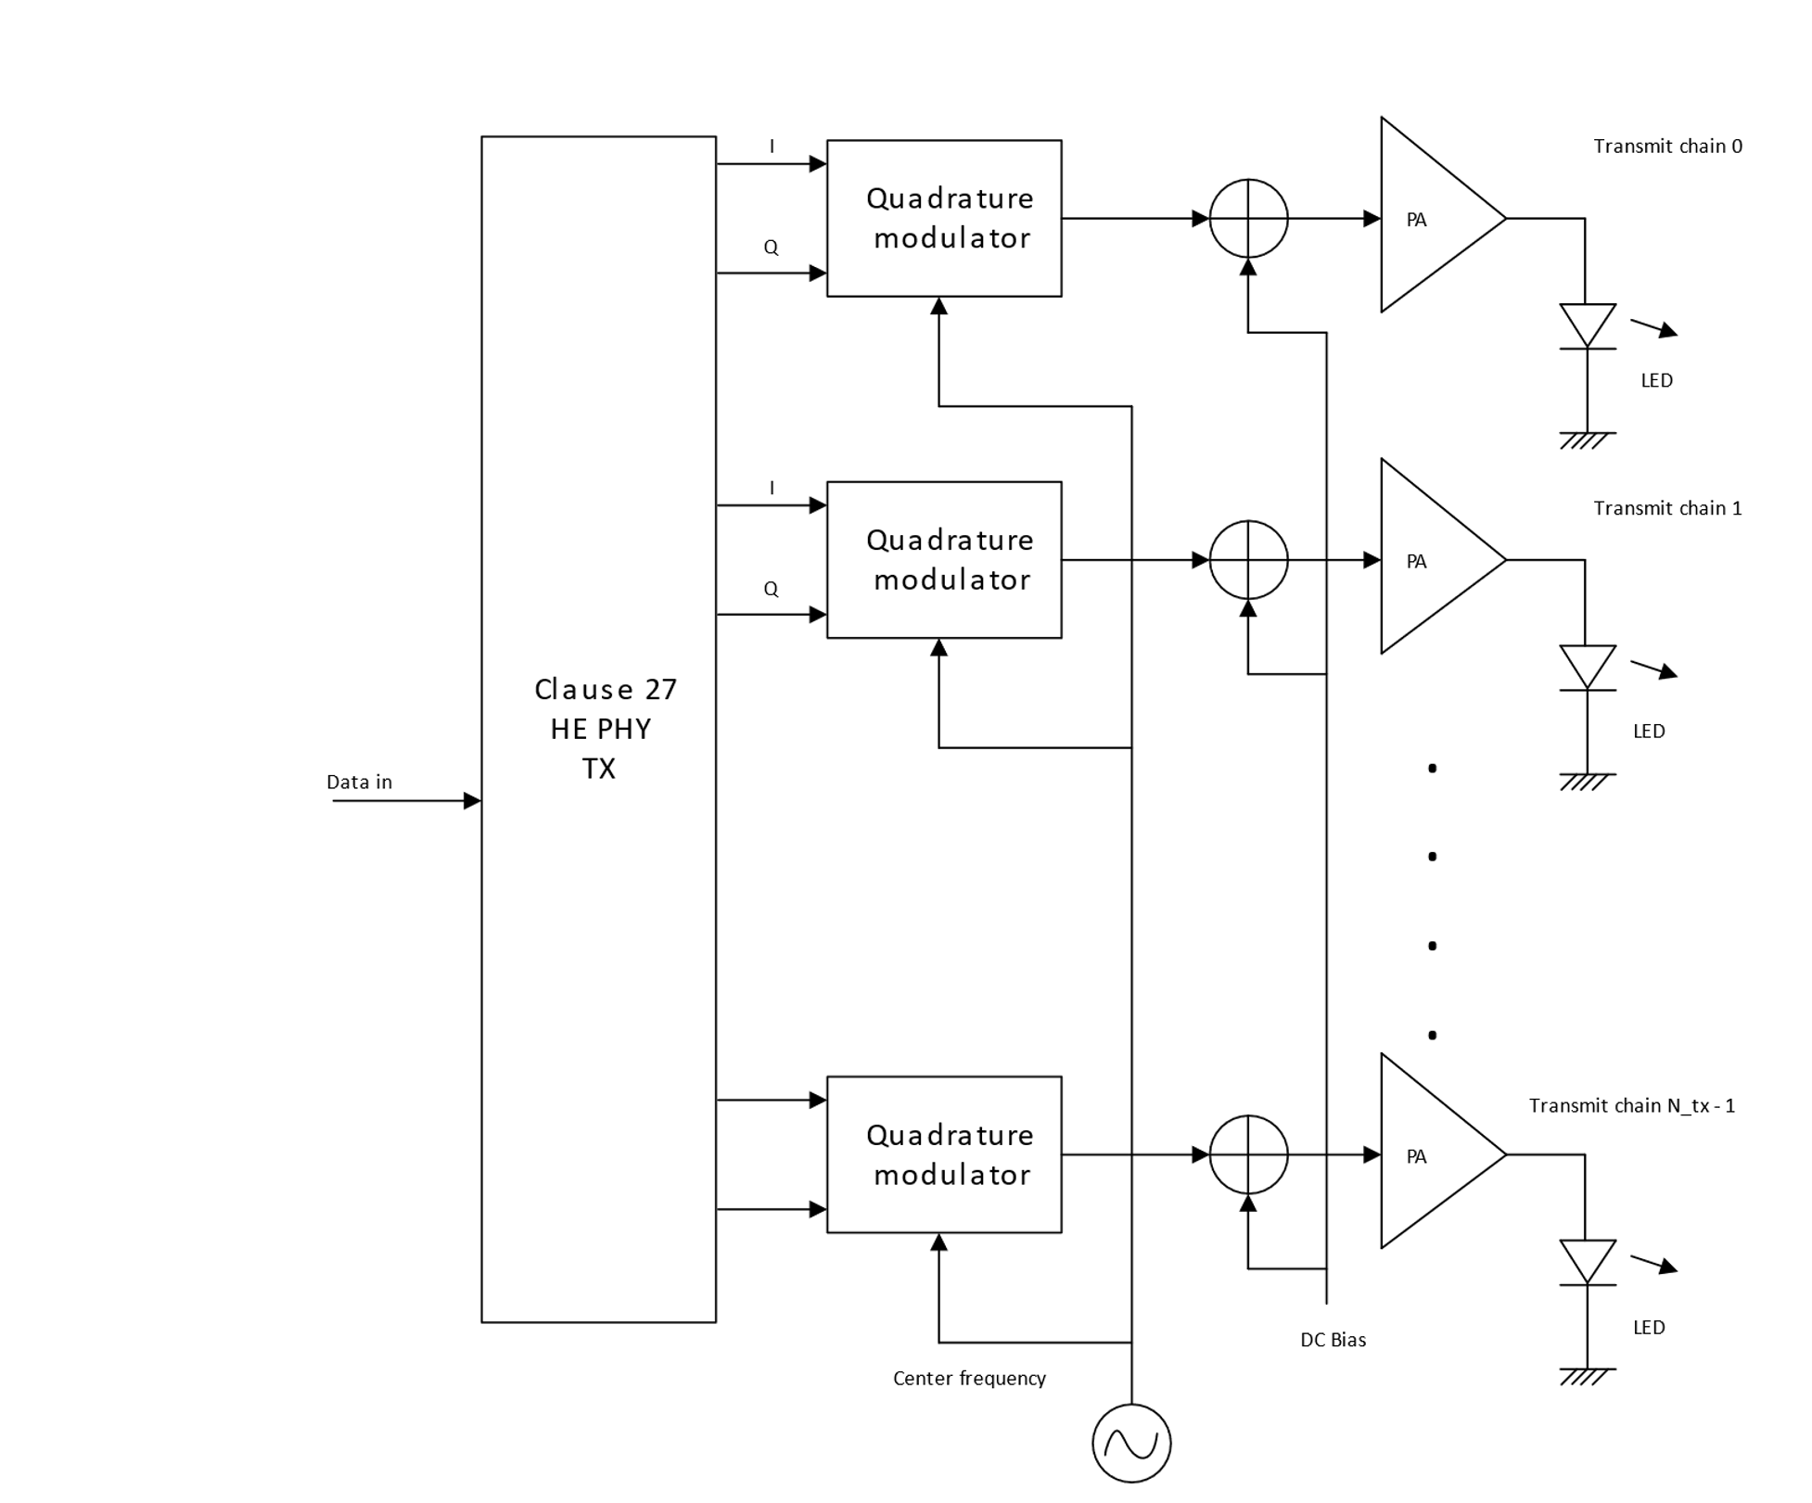
Figure 3: Connecting multiple LEDs to TX baseband
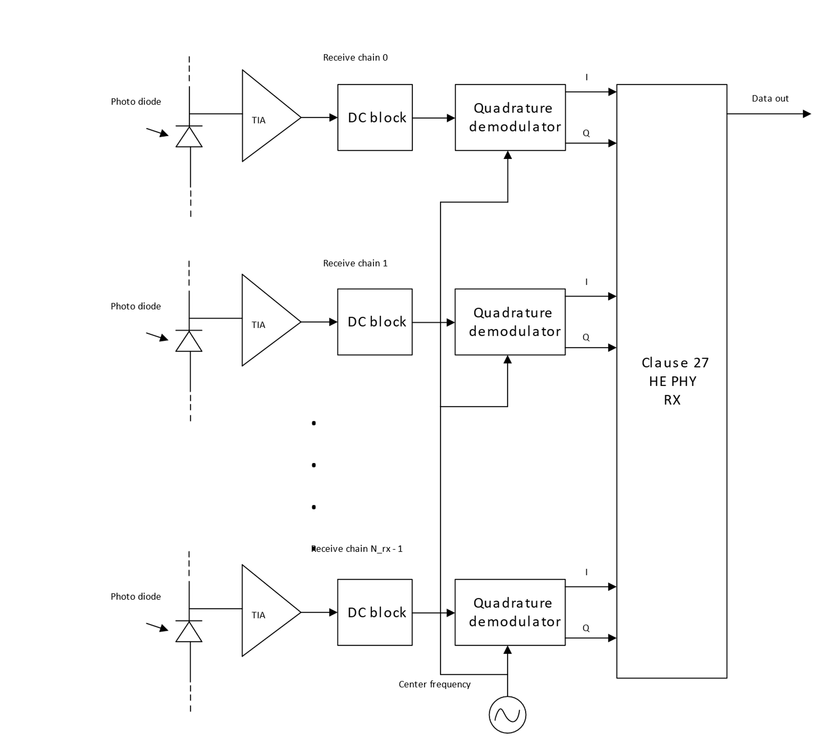
Figure 4: Connecting multiple PDs to RX baseband

1.3.3.24 Channel numbering

1.3.3.24.1 Case of multiple transmitters and receivers
In this case the setup described in 1.3.3.23.2 Multiple transmitters and receivers shall be used. The center frequencies depending on the CBW are shown in Table 1.
Table 1: Modulation frequencies
PHY channel BW | Modulator LO
20 MHz | 26 MHz
40 MHz | 36 MHz
80 MHz | 56 MHz
160 MHz | 96 MHz
320 MHz | 176 MHz

1.3.3.25 Regulatory Requirements
The IEC 60825-1 laser eye safety regulations shall apply to all LC devices.

1.3.4 LC PHY PLME
Two new values for the PHY MIB attribute “dot11PHYType” shall be introduced, LC1 and LC2. LC1 indicates an LC PHY with the light interface described in1.3.3.23.2 Multiple transmitters and receivers, LC2 shall be reserved for a different light interface to be defined in the future.

