IEEE P802.11
Wireless LANs
TGbb:
Proposed text for 11bb mandatory and optional PHY modes
Date: 2020-04-03
Author(s):
Name | Affiliation | Address | Phone | Email
Nikola Serafimovski | pureLiFi |  |  | nikola.serafimovski@purelifi.com
Stephan Berner |  |  |  | stephan.berner@purelifi.com
Chong Han |  |  |  | chong.han@purelifi.com
Ardimas Purwita | University of Edinburgh |  |  | a.purwita@ed.ac.uk
Harald Haas | University of Edinburgh |  |  | h.haas@ed.ac.uk
Abstract
This document provides text to be incorporated in the 11bb draft for the mandatory and optional PHY modes.

Table of Contents
Table of Contents 1
1 LC PHY 1
1.1 Introduction 1
1.2 Mandatory LC PHY 1
1.2.1 Introduction 1
1.2.2 OFDM PHY specific service parameter list 1
1.2.3 OFDM PHY 1
1.2.4 OFDM PLME 4
1.3 LC Optional PHY 5
1.3.1 Introduction 5
1.3.2 LC Optional PHY service interface 5
1.3.3 LC Optional PHY 5
1.3.4 LC PHY PLME 8

1 LC PHY

1.1 Introduction
This clause defines the light communications (LC) PHY. There are three versions of the LC PHY, the mandatory 802.11 based LC PHY, the optional 802.11 based LC PHY and the optimized PHY. The LC PHY transmits in a channel located in a frequency range of near DC up to a few hundred MHz, see the respective sections about channelization for details.

1.2 Mandatory LC PHY

1.2.1 Introduction
The mandatory LC PHY is based on the OFDM PHY in clause 17. In the following the differences to the OFDM PHY in clause 17 are described.

1.2.2 OFDM PHY specific service parameter list
TXVECTOR the same as in section 17.2 of the 802.11 standard.
RXVECTOR is the same as in section 17.2 2 of the 802.11 standard, except that the parameters RX_ANTENNA, CH_BANDWIDTH _IN_NON_HT and DYN_BANDWIDTH _IN_NON_HT are not present.

1.2.3 OFDM PHY

1.2.3.1 Introduction
The OFDM PHY is the same as in section 17.3 except for the data scrambling and the OFDM modulation, which is described in

1.2.3.2 PPDU format
Same as in section 17.3.2 of the 802.11 standard.

1.2.3.3 PHY preamble (SYNC)
Same as in section 17.3.3 of the 802.11 standard.

1.2.3.4 SIGNAL field
Same as in section 17.3.4 of the 802.11 standard.

1.2.3.5 DATA field

1.2.3.5.1 General
The data field is the same as in section 17.3.5 2 of the 802.11 standard except for the scrambler seed and the OFDM modulation, which is described in

1.2.3.5.2 SERVICE field
Same as in section 17.3.5.2 of the 802.11 standard.

1.2.3.5.3 PPDU TAIL field
Same as in section 17.3.5.3 of the 802.11 standard

1.2.3.5.4 Pad bits (PAD)
Same as in section 17.3.5.4 of the 802.11 standard

1.2.3.5.5 PHY DATA scrambler and descrambler
Unlike described in section 17.3.5.5 of the 802.11 standard, the scrambler seed shall be initialized with a pseudorandom nonzero value. It does not convey any information.

1.2.3.5.6 Convolutional encoder
Same as in section 17.3.5.6 of the 802.11 standard

1.2.3.5.7 Data interleaving
Same as in section 17.3.5.7 of the 802.11 standard

1.2.3.5.8 Subcarrier modulation mapping
Same as in section 17.3.5.8 of the 802.11 standard

1.2.3.5.9 Pilot subcarriers
Same as in section 17.3.5.9 of the 802.11 standard

1.2.3.5.10 OFDM modulation
Same as in section 17.3.6.10 of the 802.11 standard

1.2.3.6 CCA
Same as in section 17.3.6 of the 802.11 standard

1.2.3.7 PHY data modulation and modulation rate change
Same as in section 17.3.7 6 of the 802.11 standard

1.2.3.8 Light Interface
Figure 1 illustrates how a light emitting diode (LED) is connected to the TX OFDM PHY and a photo diode (PD) to the RX OFDM PHY.

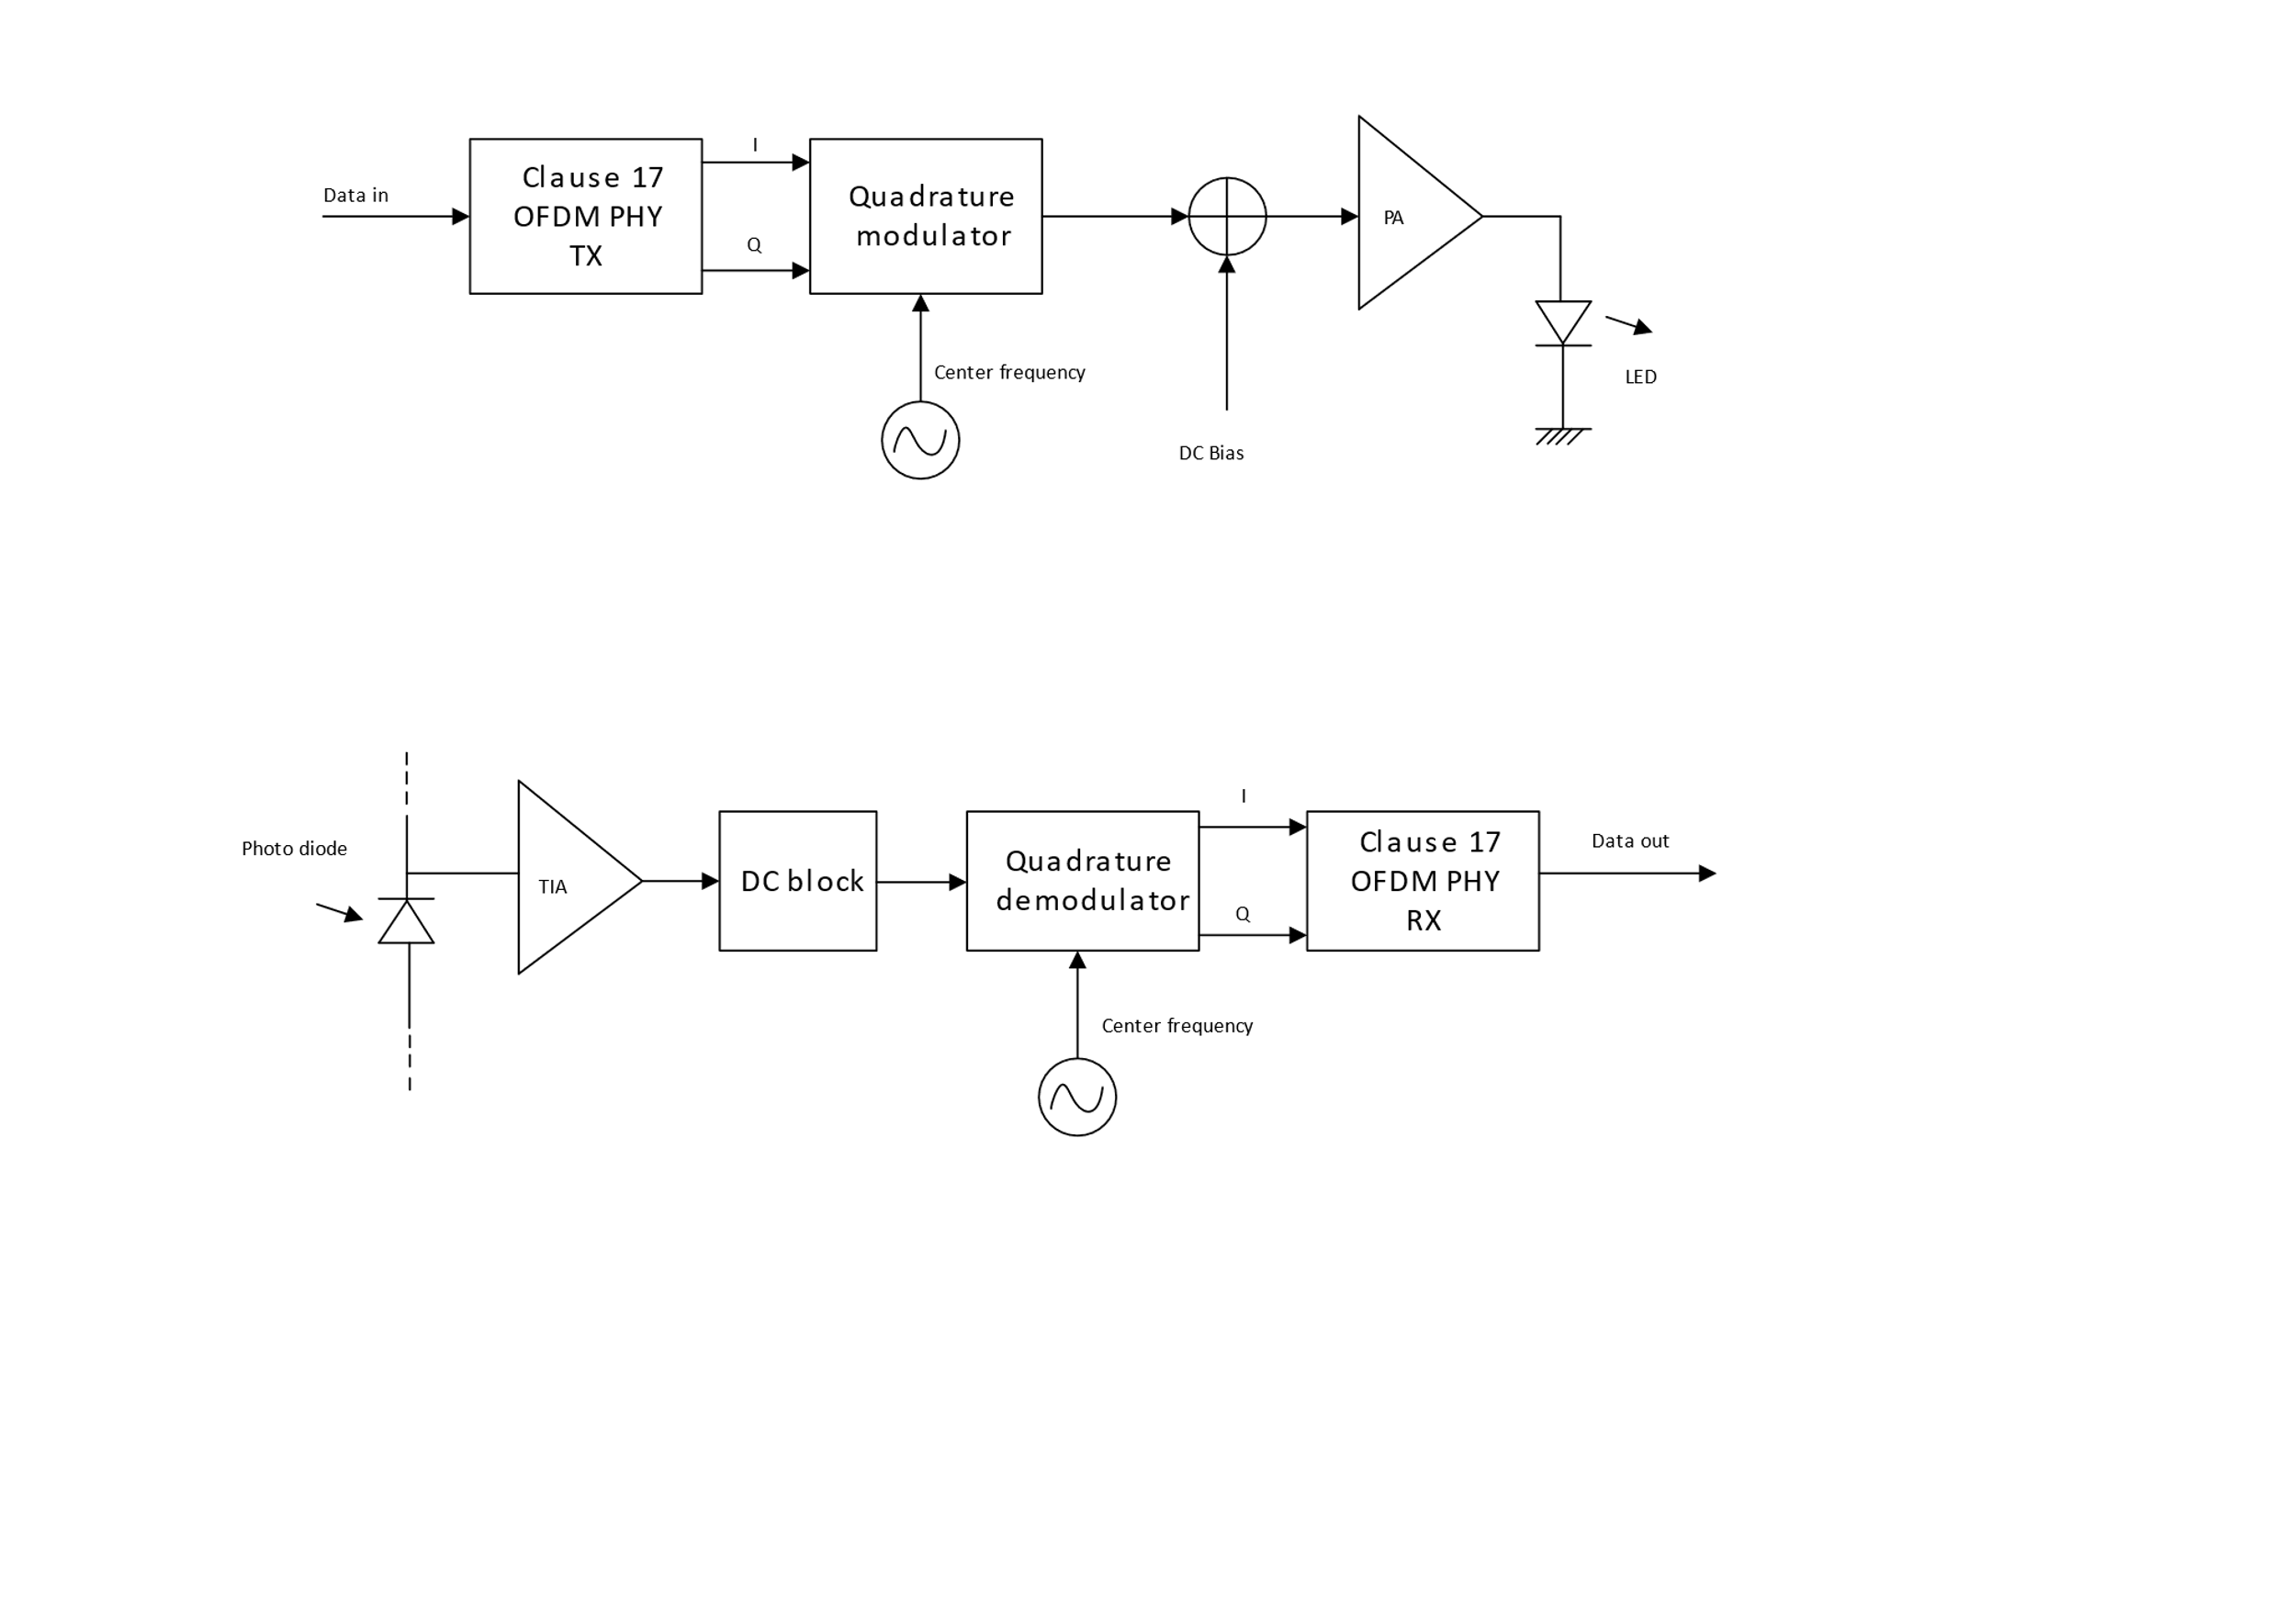
Figure 1: Interfacing OFDM PHY to light emitter and receiver
In the TX chain, the I and Q samples from the baseband are quadrature modulated, see 1.2.3.9.4 Operating channel frequencies for center frequencies. A DC bias is added before the signal is fed to the LED because the current through a diode can only be positive as illustrated in Figure 2.
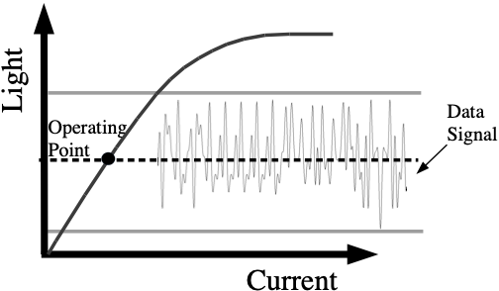
Figure 2: Operation of LED with DC bias
In the RX chain, the light variations produced by the LED are converted into a current by a photo diode (PD) and amplified by a transimpedance amplifier (TIA). The DC component is removed, the signal is downconverted to baseband and fed to the RX OFDM PHY.
The light communications transmitter and receiver shall operate at a wavelength between 800 nm and 1000 nm.

1.2.3.9 PHY operating specifications (general)

1.2.3.9.1 General
The operating specifications are the same as in section 17.3.8 of the 802.11 standard except for the regulatory requirements and operating frequencies

1.2.3.9.2 Outline description
Same as in section 17.3.8.2 of the 802.11 standard. In Figure 17-12 the antennas have to replaced by optical frontends (OFE)s, for example as described in document IEEE 802.11-19/0087r1.

1.2.3.9.3 Regulatory requirements
The IEC 60825-1 laser eye safety regulations shall apply to all LC devices.

1.2.3.9.4 Operating channel frequencies
The LC PHY with mandatory features operates at a center frequency of 26 MHz or at an alternative center frequency of 46 MHz . The bandwidth is 20 MHz. These two center frequencies correspond to LC channel 0 and LC channel 1.
For discussion – shall we have a center freq. of 34.37 MHz, where packet detect overlap is limited?

1.2.3.9.5 Transmit and receive in-band and out-of-band spurious emissions
Does not apply to the LC PHY

1.2.3.9.6 Slot time
Same as in section 17.3.8.6 of the 802.11 standard

1.2.3.9.7 Transmit and receive impedance at the antenna connector
Same as in section 17.3.8.7 of the 802.11 standard

1.2.3.10 PHY transmit specifications
Same as in section 17.3.9 of the 802.11 standard

1.2.3.11 PHY receiver specifications
Same as in section 17.3.10 of the 802.11 standard

1.2.3.12 Transmit PHY
Same as in section 17.3.11 of the 802.11 standard

1.2.3.13 Receive PHY
Same as in section 17.3.12 of the 802.11 standard

1.2.4 OFDM PLME
Same as in section 17.4 of the 802.11 standard, except that the parameter “dot11RegDomainsImplementedValue” in Table 17.20 does not apply to the LC PHY

1.3 LC Optional PHY

1.3.1 Introduction
The LC optional PHY is based on the HE PHY in clause 27. In the following the differences to the HE PHY in clause 27 are described.

1.3.2 LC Optional PHY service interface
The LC optional PHY service interface is the same as in 27.2 of the 802.11 standard except for the following fields which shall be set to zero,
- BEAMFORMED
- BEAM_CHANGE
because beamforming is not supported.

1.3.3 LC Optional PHY

1.3.3.1 Introduction
This subclause describes the differences to the subclause 27.3 of the 802.11 standard.

1.3.3.2 Subcarrier and resource allocation
This section is the same as section 27.3.2 of the 802.11 standard.

1.3.3.3 MU-MIMO
This section is the same as section 27.3.3 of the 802.11 standard.

1.3.3.4 LC PPDU formats
This section is the same as section 27.3.4 of the 802.11 standard.

1.3.3.5 Transmitter block diagram
This section is the same as section 27.3.5 of the 802.11 standard.

1.3.3.6 Overview of the PPDU encoding process
This section is the same as section 27.3.6 of the 802.11 standard.

1.3.3.7 LC modulation and coding schemes (HE-MCSs)
This section is the same as section 27.3.7 of the 802.11 standard.

1.3.3.8 LC-SIG-B modulation and coding schemes (HE-SIG-B-MCSs)
This section is the same as section 27.3.8 of the 802.11 standard.

1.3.3.9 Timing-related parameters
This section is the same as section 27.3.9 of the 802.11 standard.

1.3.3.10 Mathematical description of signals
This section is the same as section 27.3.10 of the 802.11 standard.

1.3.3.11 LC Optional preamble
This section is the same as section 27.3.11 of the 802.11 standard.

1.3.3.12 Data field
This section is the same as section 27.3.12 of the 802.11 standard.

1.3.3.13 Packet extension
This section is the same as section 27.3.13 of the 802.11 standard.

1.3.3.14 Non-HT duplicate transmission
This section is the same as section 27.3.14 of the 802.11 standard.

1.3.3.15 Transmit requirements for PPDUs sent in response to a triggering frame
This section is the same as section 27.3.15 of the 802.11 standard.

1.3.3.16 SU-MIMO and DL MU-MIMO beamforming
Beamforming is not supported for LC. Therefore, this section does not apply to the LC PHY.

1.3.3.17 LC sounding NDP
This section is the same as section 27.3.17 of the 802.11 standard.

1.3.3.18 LC TB feedback NDP
This section is the same as section 27.3.18 of the 802.11 standard.

1.3.3.19 Transmit specification
This section is the same as section 27.3.19 of the 802.11 standard.

1.3.3.20 Receiver specification
This section is the same as section 27.3.20 of the 802.11 standard.

1.3.3.21 LC transmit procedure
This section is the same as section 27.3.21 of the 802.11 standard.

1.3.3.22 LC receive procedure
This section is the same as section 27.3.22 of the 802.11 standard.

1.3.3.23 Light Interface

1.3.3.23.1 Introduction
The light interface is an extension of the light interface described in 1.2.3.8 Light Interface to multiple TX and RX streams.

1.3.3.23.2 Multiple transmitters and receivers
Figure 3 shows multiple LEDs connected to the TX baseband and Figure 4 shows multiple PDs connected to the RX baseband. The LEDs may all operate at the same wavelength or at different wavelengths between 800 nm and 1000 nm.
The TX baseband outputs are all quadrature modulated to the same common center frequency, see 1.3.3.24.1 Case of multiple transmitters and receivers for details.
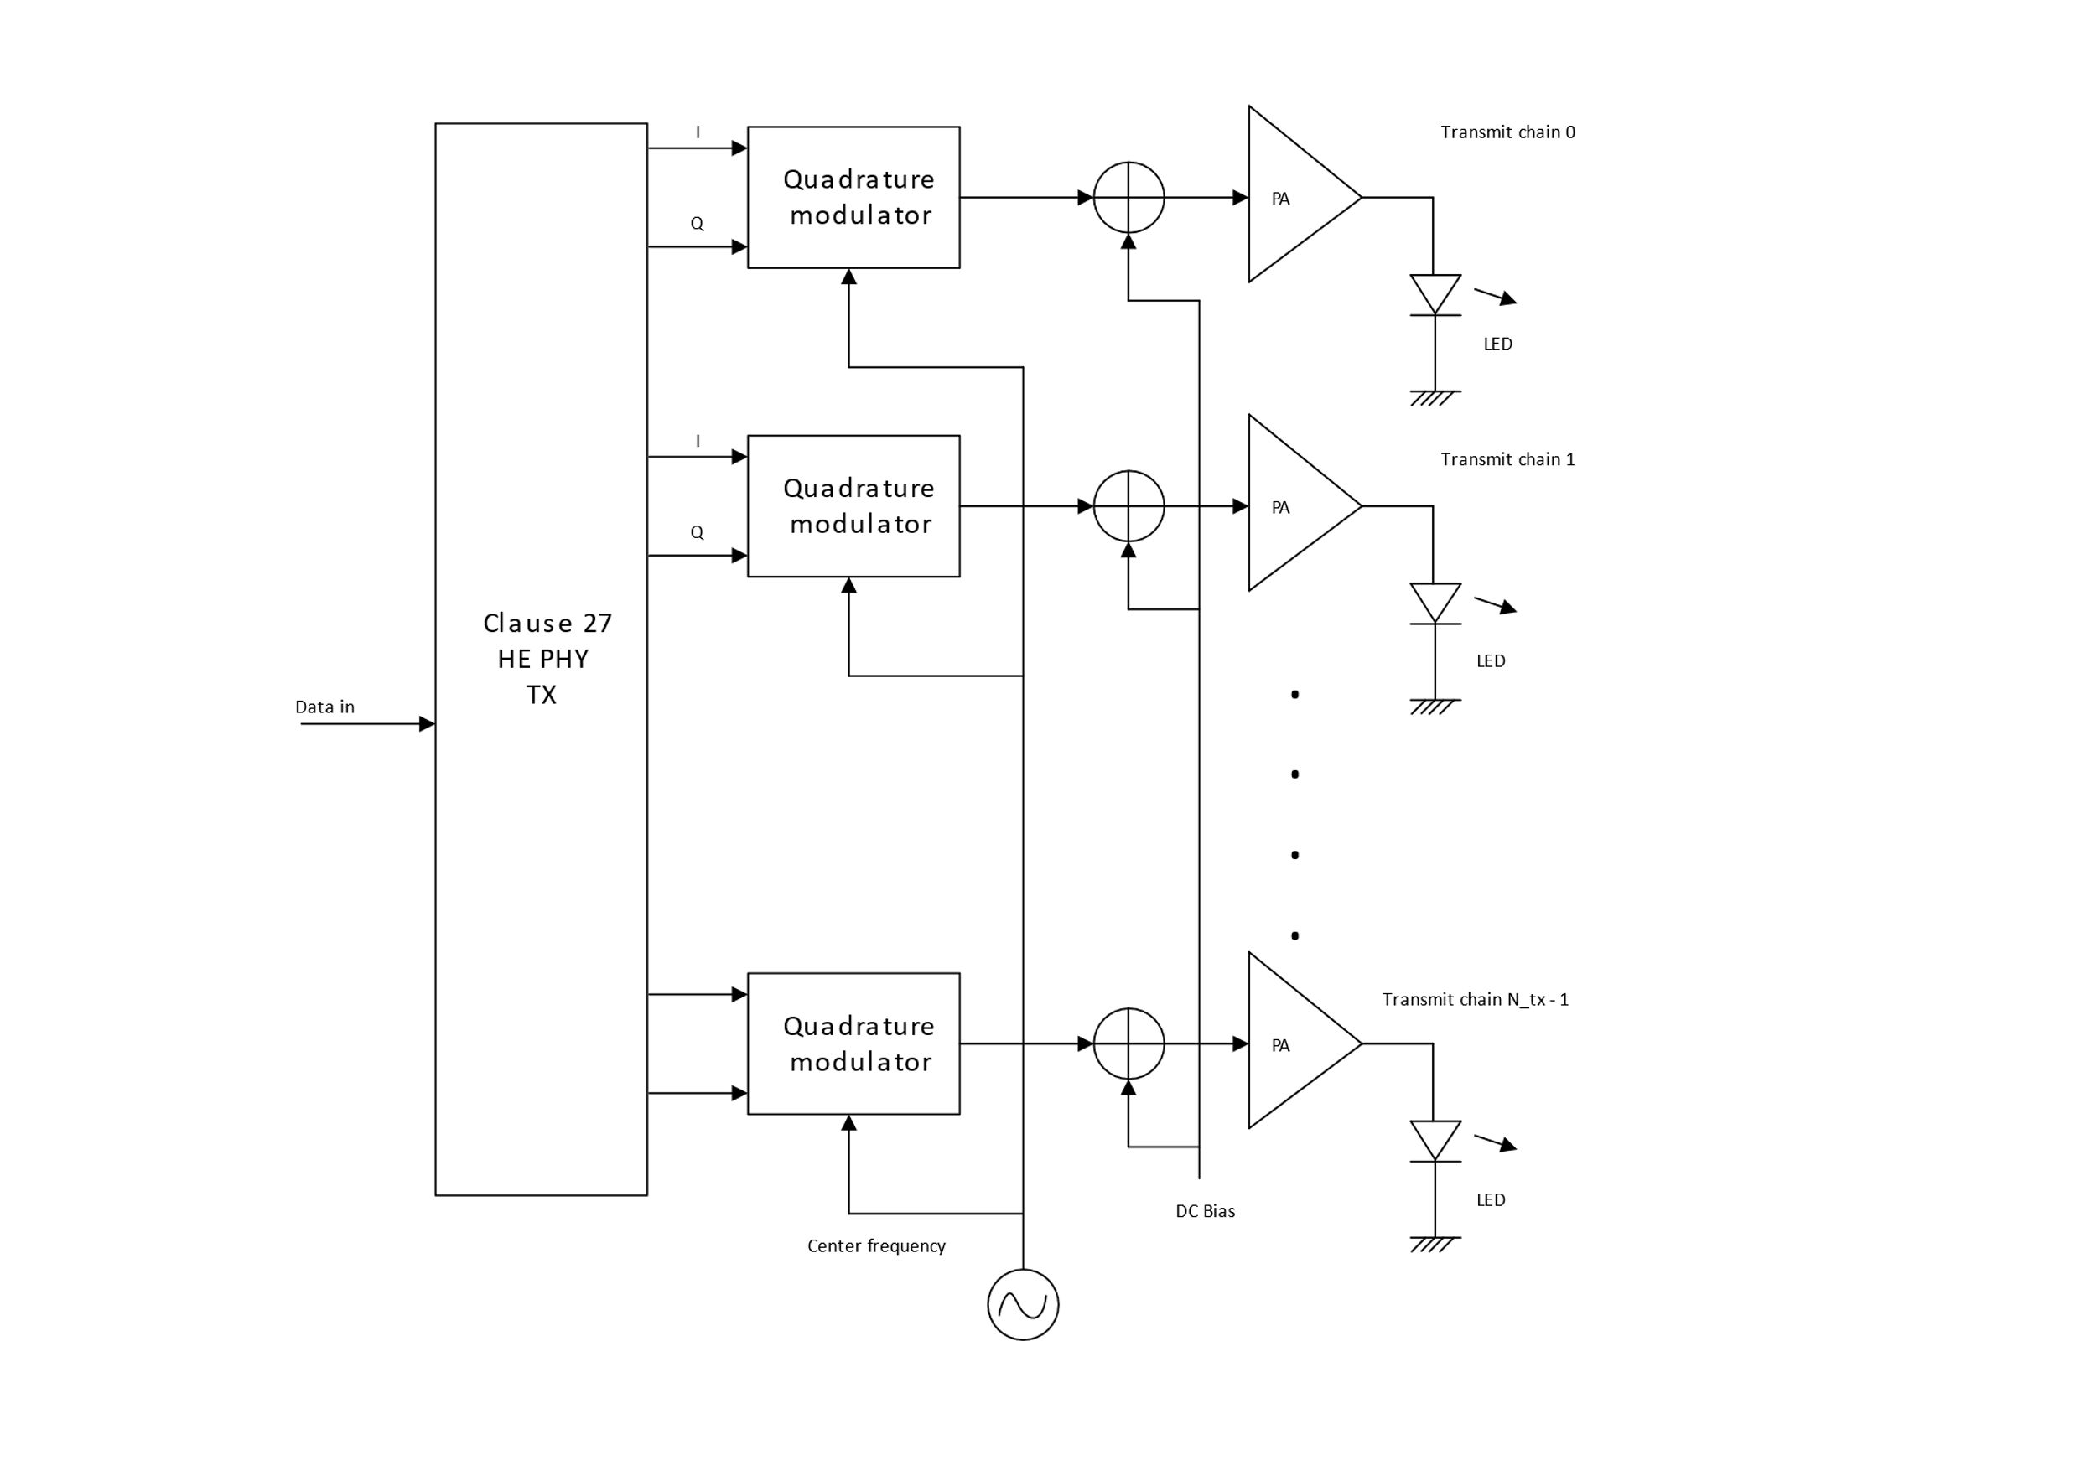
Figure 3: Connecting multiple LEDs to TX baseband
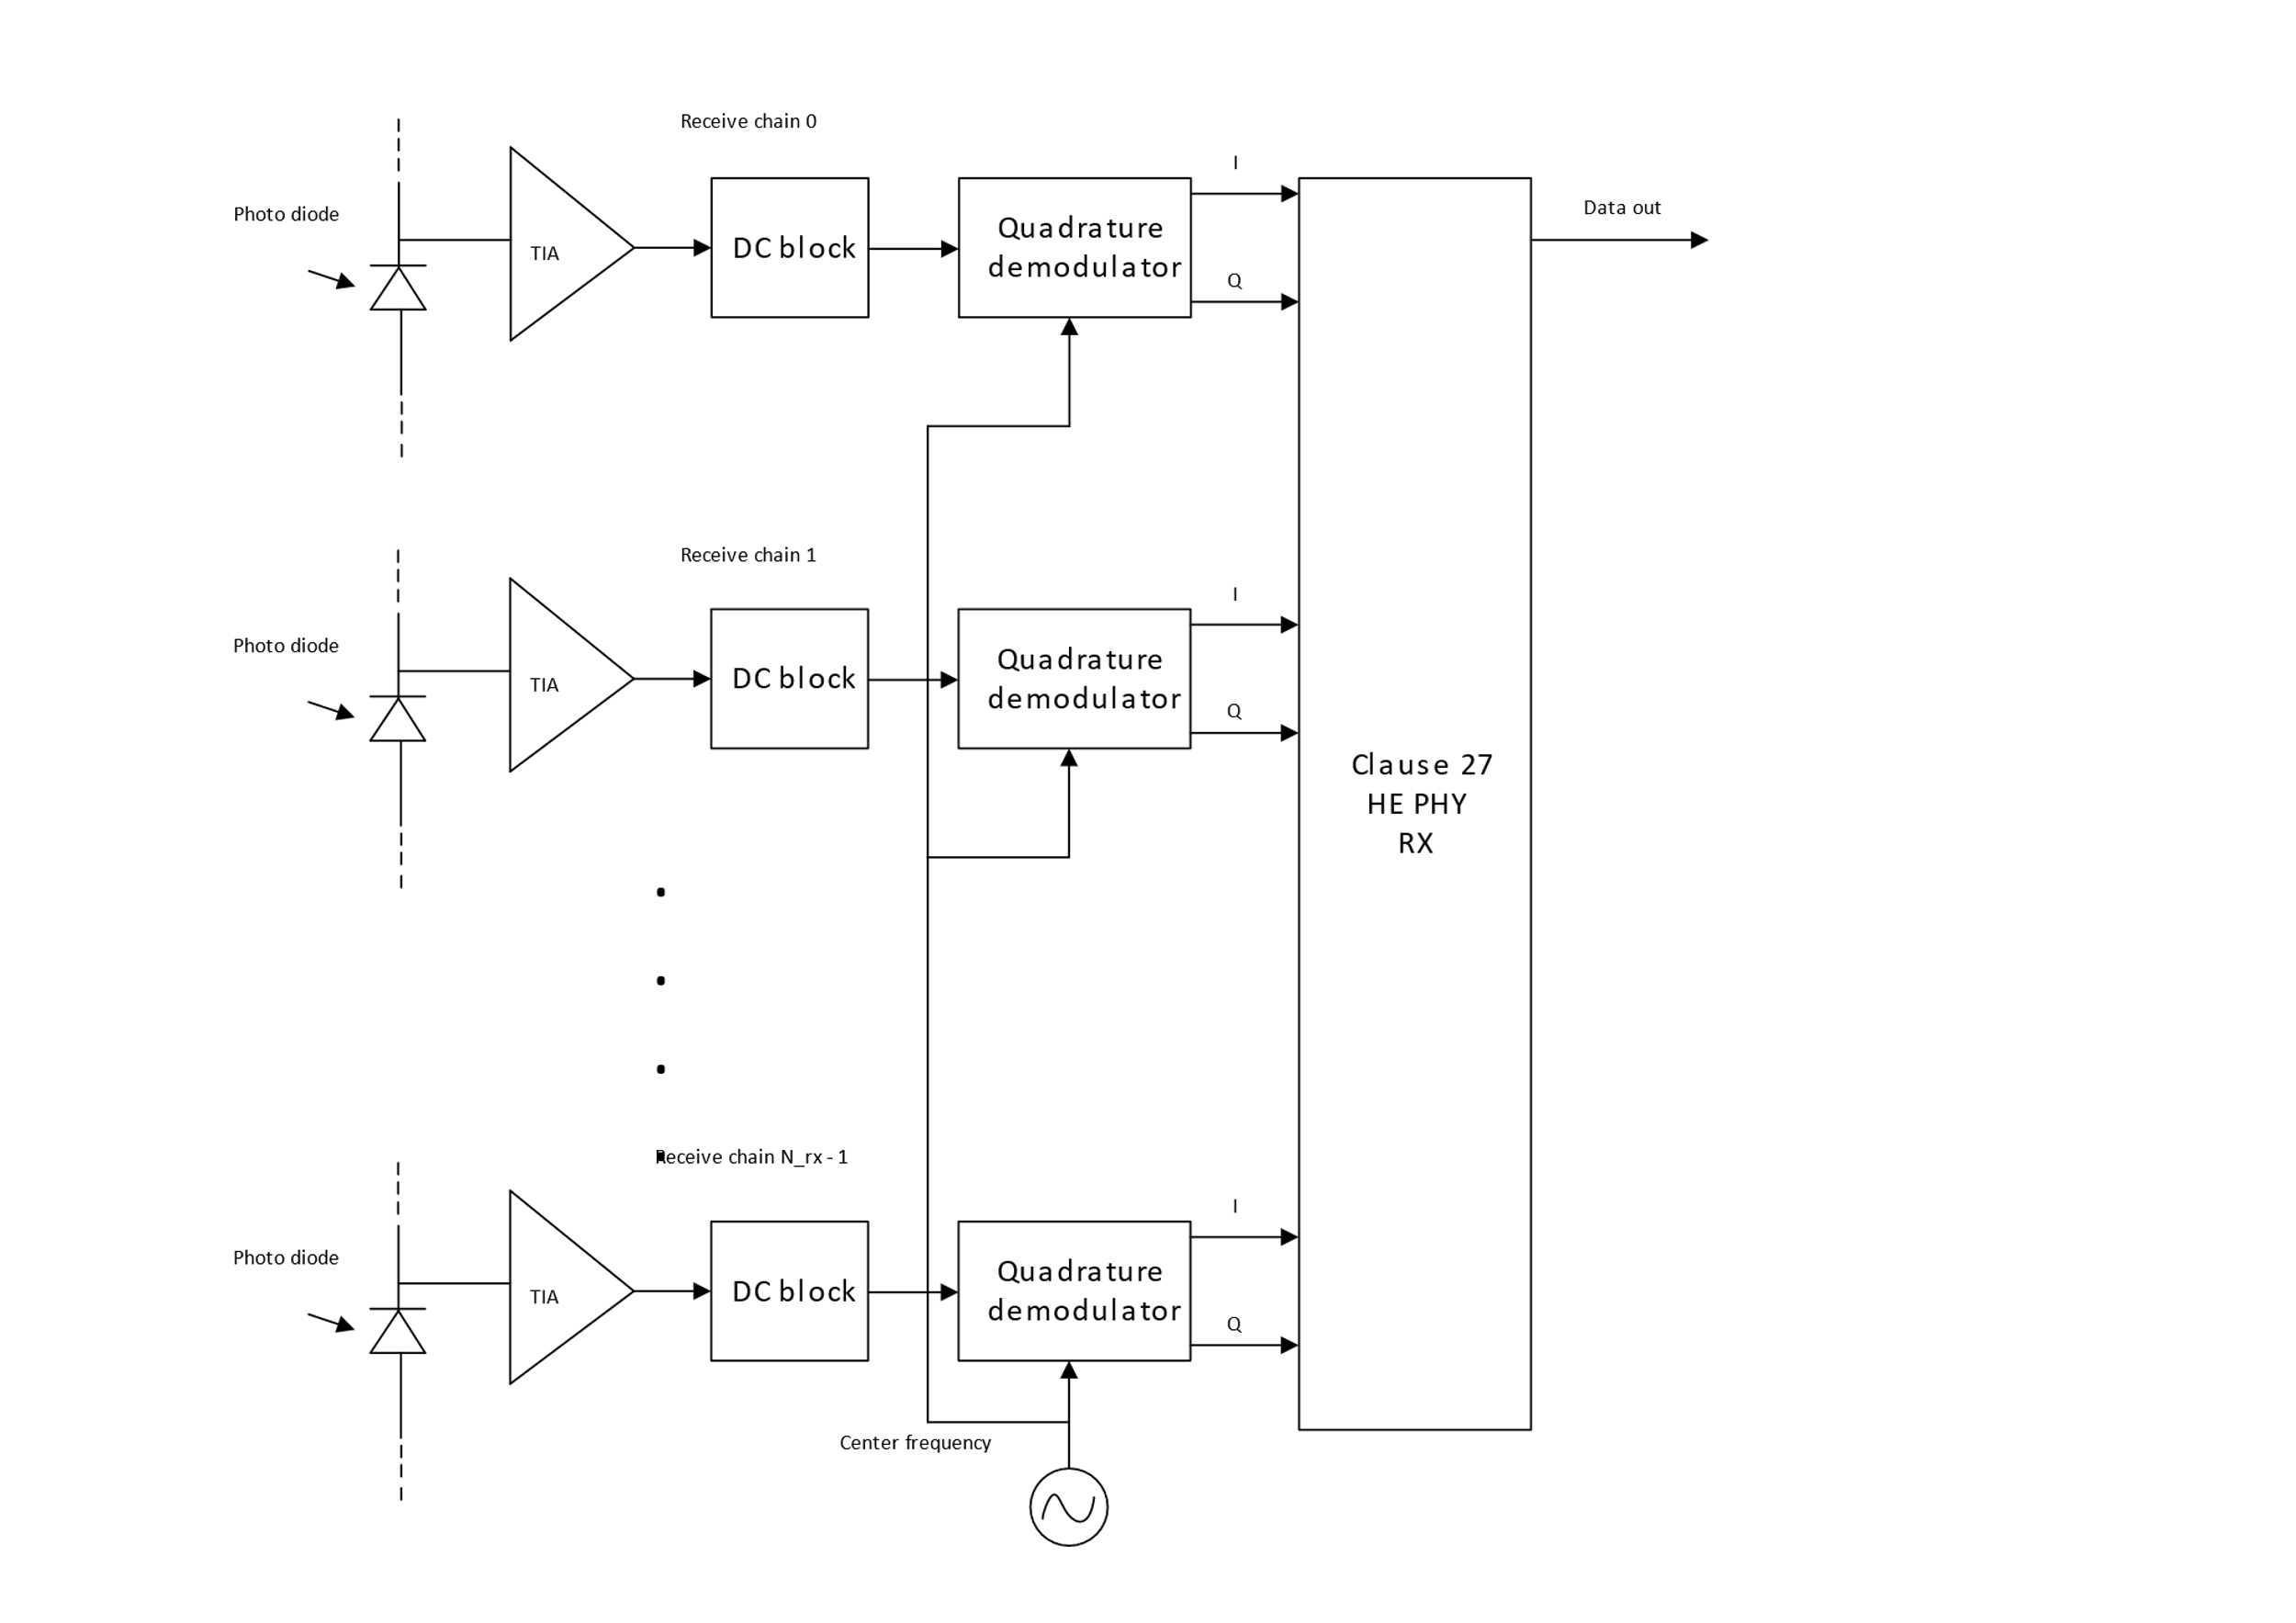
Figure 4: Connecting multiple PDs to RX baseband

1.3.3.24 Channel numbering

1.3.3.24.1 Case of multiple transmitters and receivers
In this case the setup described in 1.3.3.23.2 Multiple transmitters and receivers is used. The center frequencies depending on the CBW are shown in Table 1.
Table 1: Modulation frequencies
PHY channel BW | Modulator LO
20 MHz | 26 MHz
40 MHz | 36 MHz
80 MHz | 56 MHz
160 MHz | 96 MHz
320 MHz | 176 MHz

1.3.3.25 Regulatory Requirements
The IEC 60825-1 laser eye safety regulations shall apply to all LC devices.

1.3.4 LC PHY PLME
Two new values for the PHY MIB attribute “dot11PHYType” are introduced, LC1 and LC2. LC1 indicates an LC PHY with the light interface described in1.3.3.23.2 Multiple transmitters and receivers, LC2 is reserved for a different light interface to be defined in the future.

