IEEE P802.11
Wireless LANs
D6.0 PHY CR
Date: 2020-03-25
Author(s):
Name | Affiliation | Address | Phone | email
Youhan Kim | Qualcomm |  |  | youhank@qti.qualcomm.com

Abstract
This submission proposes resolutions for the following comments from the SA1 on P802.11ax D6.0:

24319, 24320, 24171, 24172, 24173, 24174, 24522, 24176, 24177, 24280, 24521, 24189, 24295, 24298, 24282

NOTE – Set the Track Changes Viewing Option in the MS Word to “All Markup” to clearly see the proposed text edits.

Revision History:

R0: Initial version.
R1: Updates made during conference call on 4/9/2020.
R2: Updated proposed resolution for CID 24522 per suggestion from Robert Stacey.

CID 24319

CID | Page.Line | Clause | Comment | Proposed Change
24319 | 38.19 | 3.1 | Should be clearer that multiple spatial streams used in different RUs do not constitute MU-MIMO | At the referenced location add a "NOTE---STAs simultaneously transmitting to or receiving from a STA with multiple antennas but on different radio frequencies, e.g. on different resource units (RUs), does not constitute MU-MIMO."

Discussion

D6.0 P38

This reviewer proposes the following simpler change.
multi-user multiple input, multiple output (MU-MIMO): A technique by which multiple stations (STAs), each with one or more antennas, either simultaneously transmit to a single STA or simultaneously receive from a single STA independent data streams over the same subcarriers.

Proposed Resolution: CID 24319
Revised
A simpler text update is proposed to resolve the issue raised by the commenter.

Instruction to Editor:
At D6.0 P38L17, change “same radio frequencies” to “same subcarriers”.

CID 24320

CID | Page.Line | Clause | Comment | Proposed Change
24320 | 42.26 | 3.1 | Deleting the word "downlink" in the definition of an MU PPDU is just going to confuse/mislead. UL MU is achieved through use of TB PPDUs, not MU PPDUs | Undelete the word "downlink"

Discussion

D6.0 P42
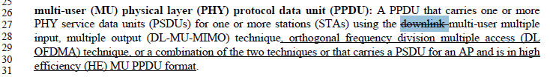

Agree with the commenter that the remaining portion of the paragraph is all referring to “downlink” (e.g. DL OFDMA, HE MU PPDU). Also, the deletion of “downlink” was made between D4.3 and D5.0, but this reviewer could not find any CID which resulted in that change, and thus could not find any history/discussion on why the deletion was made. It looks like it could have been an editorial error.

Proposed Resolution: CID 24320
Accepted

CID 24171

CID | Page.Line | Clause | Comment | Proposed Change
24171 | 473.49 | 27.1.1 | Bullet contains two requirements. Split into two bullets (as is done on e.g. page 472) | See comment

Background

D6.0 P473

Proposed Resolution: CID 24171
Revised
Proposed text update implements the request from the commenter.

Instruction to Editor:
At D6.0 P473L49, split the bullet items to two lines by re-writing it as
“- HE MU PPDUs with a 2x HE-LTF and 0.8 μs GI duration on the HE-LTF and Data field OFDM symbols (transmit).
- HE MU PPDUs with a 2x HE-LTF and 1.6 μs GI duration on the HE-LTF and Data field OFDM symbols (transmit).”

CID 24172

CID | Page.Line | Clause | Comment | Proposed Change
24172 | 474.12 | 27.1.1 | An AP may support: "40 MHz channel width in the 2.4 GHz band (transmit and receive). If it is supported then all RU sizes and locations applicable to 40 MHz channel width are supported in 2.4 GHz band (transmit and receive).".  The second sentence is a conditional mandatory requirement. This should be included under "An HE AP shall support", as is done e.g. for other CM features in the last bullet on page 473, line 60. | Move "support of all RU sizes and locations applicable to 40 MHz channel in 2.4 GHz band" to the bullet list starting at page 473, line 34 with the condition "if 40 MHz channel width in the 2.4 GHz band is supported"

Background

D6.0 P473-474
…

Proposed Resolution: CID 24172
Revised
Proposed text update implements the request from the commenter, but with some editorial updates.

Instruction to Editor:
At D6.0 P473L63, add
“- All RU sizes and locations applicable to 40 MHz channel width in the 2.4 GHz band if 40 MHz channel width is supported in the 2.4 GHz band (transmit and receive).”
At D6.0 P474L12, delete
“If it is supported then all RU sizes and locations applicable to 40 MHz channel width are supported in 2.4 GHz band (transmit and receive).”

CID 24173

CID | Page.Line | Clause | Comment | Proposed Change
24173 | 475.08 | 27.1.1 | This paragraph makes it sound like 20 MHz operating STA only needs to comply with the requirements in this (short) paragraph. I assume a 20 MHz operating STA also has to comply with the mandatroy requiremetns of a non-AP STA? | Add: a 20 MHz operating STA shall also support the mandatory features of a non-AP STA

Background

D6.0 P475

Proposed Resolution: CID 24173
Revised
A 20 MHz operating non-AP HE STA is a non-AP HE STA, so it is redundant to re-state that a 20 MHz operating non-AP HE STA shall support the mandatory features of a non-AP HE STA. Instead, the proposed resolution by this review moves this paragraph as a conditional mandatory feature for a non-AP HE STA.

Instruction to Editor:
At D6.0 P475L7, add
“- 26-, 52-, and 106-tone RU sizes on locations allowed in 27.3.2.8 in the primary 20 MHz channel within 40 MHz channel width if the non-AP HE STA is a 20 MHz operating non-AP HE STA (transmit and receive).
- 26-, 52-, and 106-tone RU sizes on locations allowed in 27.3.2.8 in the primary 20 MHz channel within 80 MHz channel width if the non-AP HE STA is a 20 MHz operating non-AP HE STA and is operating in the 5 GHz or 6 GHz bands (transmit and receive).”

Delete the paragraph at D6.0 P475L8-11.

CID 24174

CID | Page.Line | Clause | Comment | Proposed Change
24174 | 482.23 | 27.2.2 | It states that MCS is an integer in the range 0 to 11. This is not correct for HE_ER_SU | Correct: for HE ER SU, MCS is an integer in the range 0 to 2.

Background

D6.0 P482
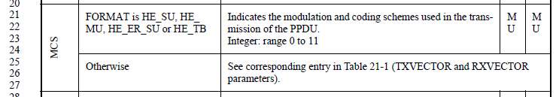

Proposed Resolution: CID 24174
Revised
Proposed text update for this CID creates a separate row for HE_ER_SU format for MCS in TXVECTOR/RXVECTOR.

Instruction to Editor: Implement the proposed text updates for CID 24174 in https://mentor.ieee.org/802.11/dcn/20/11-20-0540-02-00ax-d6-0-phy-cr.docx

Proposed Text Updates: CID 24174

Instruction to Editor: Update D6.0 P482L22 (Table 27-1) as shown below.

MCS | FORMAT is HE_SU, HE_MU or HE_TB | Indicates the modulation and coding schemes used in the transmission of the PPDU.  Integer: range 0 to 11 | MU | MU
 | FORMAT is HE_ER_SU | Indicates the modulation and coding schemes used in the transmission of the PPDU.  Integer: range 0 to 2 | Y | Y
 | Otherwise | See corresponding entry in Table 21-1 (TXVECTOR and RXVECTOR parameters).

CID 24522

CID | Page.Line | Clause | Comment | Proposed Change
24522 | 484.64 | 27.2.2 | "NOTE--The TXVECTOR parameter CH_BANDWIDTH  does not represent the channel width of the transmitted PPDU." -- this is rather counter-intuitive, so a reference to what does should be given in this NOTE | Append "This is represented in the TXVECTOR parameter RU_ALLOCATION.",

Background

D6.0 P484
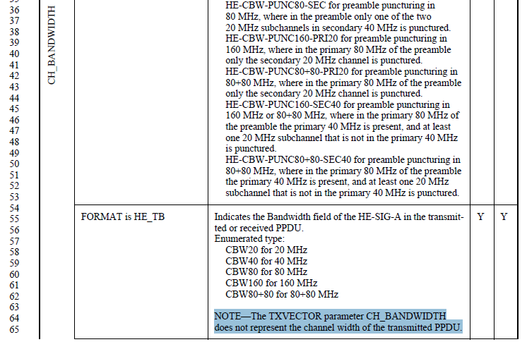

Proposed Resolution: CID 24522
Revised
TXVECTOR parameter RU_ALLOCATION is an 8 bits variable, whose definition is referred to 9.3.1.22. Even at 9.3.1.22, the RU size is simply specified in terms of number of subcarriers, not by “bandwidth”.
Hence, the proposed resolution instead is to update the text to clarify what CH_BANDWIDTH means.

Instruction to Editor:
At D6.0 P484L64, change the NOTE to “NOTE - The setting of the CH_BANDWIDTH parameter is determined by the triggering frame. See 26.5.2.3.3 and 26.5.2.3.4.”.

CID 24176

CID | Page.Line | Clause | Comment | Proposed Change
24176 | 486.30 | 27.2.2 | It states that NUM_STS is in the range 1-2 for HE_ER_SU. Note that 2 is only valid when STBC is used. | See comment

Background

D6.0 P486
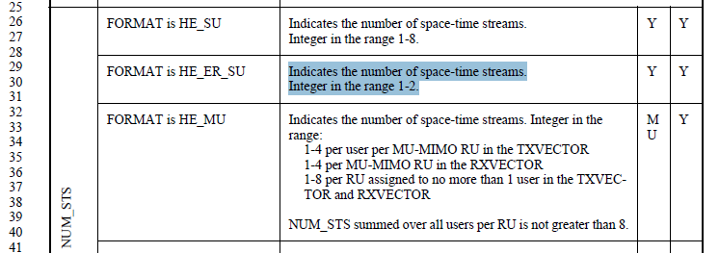

Proposed Resolution: CID 24176
Revised
Proposed resolution adds a NOTE to clarify this.

Instruction to Editor:
At D6.0 P486L31, add
“NOTE – NUM_STS equal to 2 is valid only when STBC is used.”

CID 24177

CID | Page.Line | Clause | Comment | Proposed Change
24177 | 492.10 | 27.2.2 | Another condition for BEAM_CHANGE is that NUM_STS <=2 | Add in "conditions" column

Background

D6.0 P492
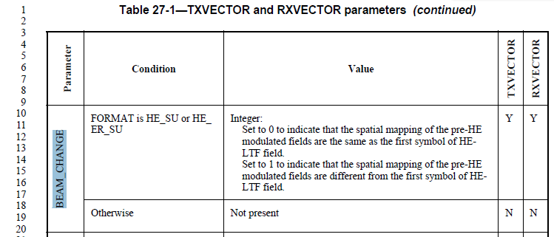

Proposed Resolution: CID 24177
Rejected
26.11.3 (BEAM_CHANGE) at D6.0 P429L35 clearly states that “HE STA … shall set the TXVECTOR parameter BEAM_CHANGE to 1 if … the number of spatial streams is greater than 2”. Hence, there is no need to repeat the condition again in the TXVECTOR table.

CID 24280

CID | Page.Line | Clause | Comment | Proposed Change
24280 | 493.19 | 27.2.2 | Move the following into the 26.11 (Setting TXVECTOR parameters for an HE PPDU) because it is provided from the MAC to the PHY and the PHY can't decide the value by itself. .  - Set to true if the non-HT or non-HT duplicate PPDU is sent in response to an MU-RTS Trigger frame.  - Set to false otherwise. | As in the comment.

Background

D6.0 P493
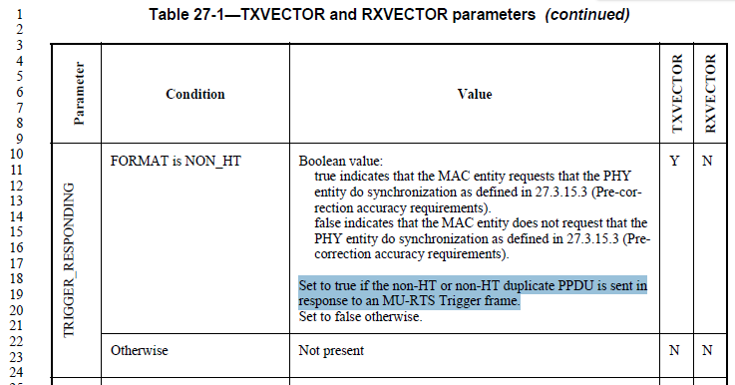

Proposed Resolution: CID 24280
Revised
Proposal by the commenter is implemented by this resolution.

Instruction to Editor: Implement the proposed text updates for CID 24280 in https://mentor.ieee.org/802.11/dcn/20/11-20-0540-02-00ax-d6-0-phy-cr.docx

Proposed Text Updates: CID 24280

Instruction to Editor: Add the following subclause after D6.0 P434L65.

26.11.X1 TRIGGER_RESPONDING
An HE non-AP STA that transmits a non-HT or non-HT duplicate PPDU shall set the TXVECTOR parameter TRIGGER_RESPONDING to true if the PPDU is sent in response to an MU-RTS Trigger frame. Otherwise, the HE non-AP STA shall set the TXVECTOR parameter TRIGGER_RESPONDING to false.

Instruction to Editor: Update D6.0 P494L19 (Table 27-1) as shown below.

TRIGGER_RESPONDING | FORMAT is NON_HT | Boolean value:  true indicates that the MAC entity requests that the PHY entity do synchronization as defined in 27.3.15.3 (Pre-correction accuracy requirements).  false indicates that the MAC entity does not request that the PHY entity do synchronization as defined in 27.3.15.3 (Pre-correction accuracy requirements). | Y | N
 | Otherwise | Not present | N | N

CID 24521

CID | Page.Line | Clause | Comment | Proposed Change
24521 | 494.40 | 27.2.2 | "For an HE TB PPDU, MU in the TXVECTOR column indicates that the parameter is pres-  ent once and MU in the RXVECTOR column indicates the parameter is not present" -- it is not clear why they are not present | Append " (the receiver knows the values since they were specified in the triggering PPDU)"

Background

D6.0 P494
…

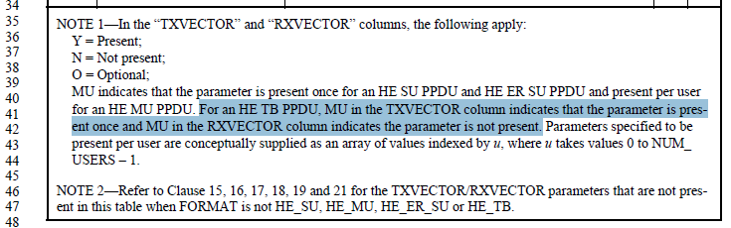

Proposed Resolution: CID 24521
Accepted

CID 24189

CID | Page.Line | Clause | Comment | Proposed Change
24189 | 558.23 | 27.3.11.7.2 | "Set to 1 if a beamforming steering matrix is applied to the portion of the waveform contributed by the RU that contains this user's allocation and the RU contains no more than one user."  Given this Table is for SU format, this wording is not appropriate. | Change to "Set to 1 if a beamforming steering matrix is applied"

Background

D6.0 P558
…

Proposed Resolution: CID 24521
Accepted

CID 24295

CID | Page.Line | Clause | Comment | Proposed Change
24295 | 609.22 | 27.3.11.10 | "HE TB NDP report response" -- no such thing | Change to "HE TB feedback NDP"

Background

D6.0 P609
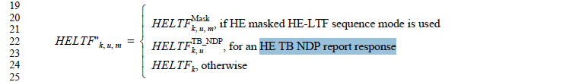

Proposed Resolution: CID 24295
Accepted

CID 24298

CID | Page.Line | Clause | Comment | Proposed Change
24298 | 634.65 | 27.3.13 | "single 26-tones RU" should be singular and shouldn't include "single" (not used elsewhere in this kind of context) | Change to "26-tone RU"

Background

D6.0 P634

Proposed Resolution: CID 24298
Revised
Agree that “tones” should be “tone”. Regarding “single”, this example is specifically for the case where there is only one 26-tone RU modulated. Hence, the term “single” is appropriate.

Instruction to Editor:
At D6.0 P634L64, change “For example, the Data field an OFDMA HE PPDU using a 26-tones RU” to “For example, the Data field of an OFDMA HE PPDU using a 26-tone RU”.

CID 24282

CID | Page.Line | Clause | Comment | Proposed Change
24282 | 634.57 | 27.3.13 | "A PE field of duration 4 us, 8 us, 12 us, or 16 us may be present in an HE PPDU."  This is conflicted with the following:  "The duration of the PE field, TPE, may take values of 0, 4, 8, 12 or 16 us."  Please change the as the following:  "A PE field of duration 0 us, 4 us, 8 us, 12 us, or 16 us may be present in an HE PPDU." | As in the comment.

Background

D6.0 P634

D6.0 P634

Proposed Resolution: CID 24282
Revised
Agree with the commenter. This proposed resolution implements the proposed change by the commenter with some editorial update.

Instruction to Editor:
At D6.0 P634L57, change “duration 4 us, 8 us, 12us, or 16 us” to “duration 0, 4, 8, 12 or 16 us”.

This CID was transferred to Xiaogang Chen during the conference call on 4/9/2020.

[End of File]

