IEEE P802.11
Wireless LANs
D3.0 PHY CR
Date: 2020-03-23
Author(s):
Name | Affiliation | Address | Phone | email
Youhan Kim | Qualcomm |  |  | youhank@qti.qualcomm.com

Abstract
This submission proposes resolutions for the following comments from the SA ballot on P802.11-REVmd D3.0:

4344, 4429, 4171, 4172, 4173, 4535, 4450, 4322, 4604, 4022, 4023, 4544, 4368

NOTE – Set the Track Changes Viewing Option in the MS Word to “All Markup” to clearly see the proposed text edits.

Revision History:

R0: Initial version.
R1: Updated resolution to CID 4022 to include update in S1G.

CID 4344

CID | Clause | Page.Line | Comment | Proposed Change
4344 | 17.3.9.3 | 2952.63 | "NOTE 2--For rules regarding TX center frequency leakage levels by VHT STAs, see 21.3.17.4.2 (Transmit center  frequency leakage)." -- what about HT STAs then? Why does the OFDM PHY need to care about rules for VHT STAs? | Delete the cited NOTE, first para of 17.3.9.7.2 Transmitter center frequency leakage, NOTE 3 in 19.3.18.1 Transmit spectrum mask, first para of 19.3.18.7.2 Transmit center frequency leakage

Background

Following are the four places the commenter is proposing to delete.

D3.0 P2952
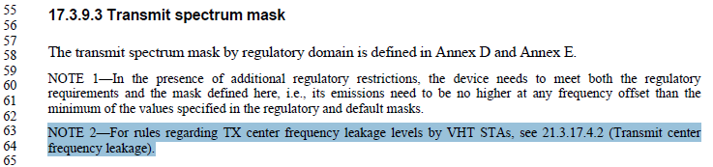

D3.0 P2955
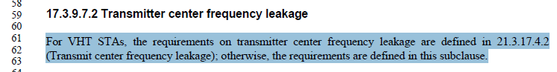

D3.0 P3056
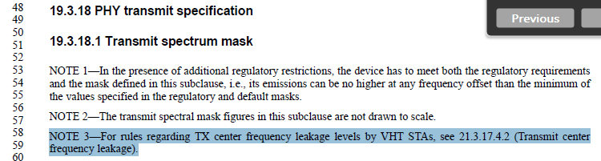

D3.0 P3060
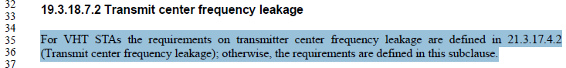

Proposed Resolution: CID 4344
Rejected
TX center frequency leakage is mostly a function of the RF circuit implementation, and is mostly agnostic to the PPDU type being transmitted such as non-HT, HT or VHT. Note that Clause 21 (VHT) have more stringent requirement for TX center frequency leakage than Clause 17 or 19. Furthermore, VHT devices could transmit a 20 MHz PPDU (including non-HT or HT) in an 80 or 160 MHz channel, where the TX center frequency leakage would be outside of the 20 MHz spectrum actively modulated by the PPDU. And Clause 17 and 19 do not clearly specify the TX center frequency requirement for those cases. Hence, if a VHT capable device is transmitting a non-HT or HT PPDU, IEEE 802.11 is requiring that the TX center frequency leakage requirement be that defined in Clause 21. Hence, the information the commenter is proposing to delete is essential to the standard and should not be deleted.

CID 4429

CID | Clause | Page.Line | Comment | Proposed Change
4429 | 19.3.2 | 2996.39 | 11md: "19.3.2 PPDU format  Two formats are defined for the PPDU: HT-mixed format and HT-greenfield format. These two formats are  called HT formats. Figure 19-1 (PPDU format) shows the non-HT format  and the HT formats. There is  also an MCS 32 format" -- but MCS 32 is an HT format | Change the sentence starting "There is also an MCS 32 format" to "The HT formats can be used for MCS 32 that  provides the lowest rate in a 40 MHz channel (see 19.3.11.11.5 (Transmission in MCS 32 format))"

Discussion

Commenter’s proposed change on top of D3.2 P2984:
19.3.2 PPDU format

Two formats are defined for the PPDU: HT-mixed format and HT-greenfield format. These two formats are called HT formats. Figure 19-1 (PPDU format) shows the non-HT format and the HT formats. The HT formats can be used for MCS 32 that provides the lowest rate in a 40 MHz channel (see 19.3.11.11.5 (Transmission in MCS 32 format)).

The “MCS 32” is applicable for HT only. So instead of “HT format can be used for MCS32”, “HT format includes MCS 32” seems more appropriate.
19.3.2 PPDU format

Two formats are defined for the PPDU: HT-mixed format and HT-greenfield format. These two formats are called HT formats. Figure 19-1 (PPDU format) shows the non-HT format and the HT formats. The HT format includes MCS 32 that provides the lowest rate in a 40 MHz channel (see 19.3.11.11.5 (Transmission in MCS 32 format)).

Proposed Resolution: CID 4429
Revised.
The “MCS 32” is applicable for HT only. So instead of “HT format can be used for MCS32”, “HT format includes MCS 32” seems more appropriate.

Instruction to Editor: At D3.2 P2984L41, change “There is also an MCS 32 format (specified in 19.3.11.11.5 (Transmission in MCS 32 format)) used for MCS 32 that provides the lowest rate in a 40 MHz channel.” to “The HT format includes MCS 32 that provides the lowest rate in a 40 MHz channel (see 19.3.11.11.5 (Transmission in MCS 32 format)).”

CID 4171, 4172, 4173

CID | Clause | Page.Line | Comment | Proposed Change
4171 | 19.3.11.11.2 | 3041.32 | "When a (Ed)beamforming steering matrix is applied, the Smoothing bit(#2370) should be set to 1. It may be set to 0 otherwise(#323)(#75)." is a bit confusing. Since the first sentence is a "should" it may be set to 0 in all cases, not just "otherwise" | Change the second cited sentence to "It shall be set to 0 otherwise."
4172 | 19.3.11.11.2 | 3041.32 | "When a (Ed)beamforming steering matrix is applied, the Smoothing bit(#2370) should be set to 1. It may be  set to 0 otherwise(#323)(#75)." is a bit confusing. Since the first sentence is a "should" it may be set to 0 in all cases, not just "otherwise" | Change the second cited sentence to "It should be set to 0 otherwise."
4173 | 19.3.11.11.2 | 3041.32 | "When a (Ed)beamforming steering matrix is applied, the Smoothing bit(#2370) should be set to 1. It may be  set to 0 otherwise(#323)(#75)." is a bit confusing. Since the first sentence is a "should" it may be set to 0 in all cases, not just "otherwise" | Change the second cited sentence to "It may be set to 0."

Discussion

These three comments are very similar to each other.

Commenter’s proposed change for CID4171 on top of D3.2 P3029L32:
When a beamforming steering matrix is applied, the Smoothing bit should be set to 1. It may be set to 0.

Commenter’s proposed change for CID4172 on top of D3.2 P3029L32:
When a beamforming steering matrix is applied, the Smoothing bit should be set to 1. It should be set to 0 otherwise.

Commenter’s proposed change for CID4173 on top of D3.2 P3029L32:
When a beamforming steering matrix is applied, the Smoothing bit should be set to 1. It shall be set to 0 otherwise.

While reviewing this comment, this reviewer found error in the first sentence. The first sentence was updated in REVmd D1.0 via CID 75 (11-17/1089r12):
Proposed Resolution:
Revised. Replace
“ If at least 95% of the sum of the energy from all impulse responses of the time domain channels between all
space-time streams and all transmit chain inputs, induced by the CSD added according to Table 19-10
(Cyclic shift values of HT portion of packet) and the frequency-dependence in the matrix , is contained
within 800 ns, the smoothing bit should be set to 1. Otherwise, it shall be set to 0.”

with
“When a Beamforming steering matrix is applied, the smoothing bit should be set to 1. It may be set to 0 otherwise.”

Note that the definition of the smoothing bit is
D3.2 P2770:
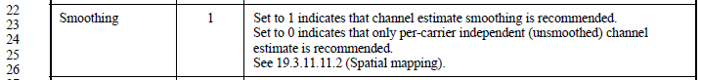

And the D3.2 P2796 states Beamforming steering matrix to be:
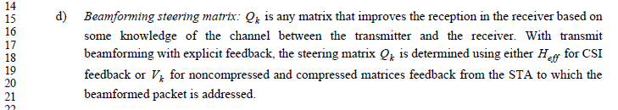

When Beamforming steering matrix is applied (e.g. based on compressed matrices feedback), there is possibility that the Beamforming steering matrix is not ‘continugous’ between adjancent tones. In this case, the transmitter should inform the receiver that smoothing should not be applied to this packet. However, the sentence “When a beamforming steering matrix is applied, the Smoothing bit should be set to 1.” says the opposite by mistake.

Now, going on to the original portion of the comment, even if the transmitter does not apply a Beamforming steering matrix, transmitter is not required to recommend smoothing to the receiver. Hence, ‘may’ is correct in the second sentence, with the polarity of the smoothing bit reversed.

I.e., the proposed resolution is
When a beamforming steering matrix is applied, the Smoothing bit should be set to 0. It may be
set to 1 otherwise.

Proposed Resolution: CID 4172, 4173
Revised.
The relevant sentences were introduced in REVmd D1.0 (CID 75) but had error. Proposed resolution fixes this error, after which the ‘may’ in the sentence referenced by the commenter is the correct wording.

Instruction to Editor:
At D3.2 P3029L32, change “Smoothing bit should be set to 1” to “Smoothing bit should be set to 0”.
At D3.2 P3029L33, change “It may be set to 0 otherwise” to “It may be set to 1 otherwise”.

Proposed Resolution: CID 4171
Rejected.
Proposed text change by the commenter reads “… Smoothing bit should be set to 1. It may be set to 0.” One sentence says it should be set to 1, and the sentence immediately after it says it may be set to 0, which is confusing.

Instruction to Editor:
At D3.2 P3029L32, change “Smoothing bit should be set to 1” to “Smoothing bit should be set to 0”.
At D3.2 P3029L33, change “It may be set to 0 otherwise” to “It may be set to 1 otherwise”.

CID 4535

CID | Clause | Page.Line | Comment | Proposed Change
4535 | 19.4.4 | 3079.16 | Table 19-25--HT PHY characteristics is not clear on slot time in 2G4 (what does short = and long = mean?) | As it says in the comment

Background

D3.2 P3067
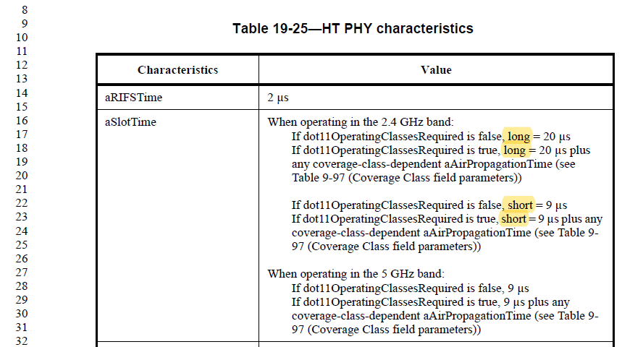

Note that clause 18 also has similar language:
D3.2 P2969
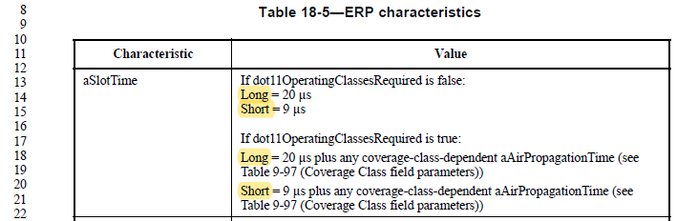

Proposed text change by the reviewer:

- ERP characteristics
Characteristic | Value
aSlotTime | If dot11OperatingClassesRequired is false:  Long slot time = 20 µs  Short slot time = 9 µs  If dot11OperatingClassesRequired is true:  Long slot time = 20 µs plus any coverage-class-dependent aAirPropagationTime (see Table 9-97 (Coverage Class field parameters))  Short slot time = 9 µs plus any coverage-class-dependent aAirPropagationTime (see Table 9-97 (Coverage Class field parameters))

- HT PHY characteristics
Characteristics | Value
aRIFSTime | 2 µs
aSlotTime | When operating in the 2.4 GHz band:  If dot11OperatingClassesRequired is false, long slot time = 20 µs  If dot11OperatingClassesRequired is true, long slot time = 20 µs plus any coverage-class-dependent aAirPropagationTime (see Table 9-97 (Coverage Class field parameters))  If dot11OperatingClassesRequired is false, short slot time = 9 µs  If dot11OperatingClassesRequired is true, short slot time = 9 µs plus any coverage-class-dependent aAirPropagationTime (see Table 9-97 (Coverage Class field parameters))  When operating in the 5 GHz band:  If dot11OperatingClassesRequired is false, 9 µs  If dot11OperatingClassesRequired is true, 9 µs plus any coverage-class-dependent aAirPropagationTime (see Table 9-97 (Coverage Class field parameters))

Proposed Resolution: CID 4535
Revised.
The “Long” and “Short” refer to long slot time and short slot time, respectively. Proposed resolution makes this clearer, in both clause 18 and 19.

Instruction to Editor: In D3.2,
Change “Long = 20 us” to “Long slot time = 20 us” at P2969L13, P2969L18, P3067L16, P3067L17.
Change “Short = 9 us” to “Short slot time = 9 us” at P2969L14, P2969L20, P3067L22, P3067L23.

CID 4450

CID | Clause | Page.Line | Comment | Proposed Change
4450 | 19.5 | 3080.45 | N_TBPS is not used anywhere | Delete the last row of Table 19-26--Symbols used in MCS parameter tables

Discussion

D3.2 P3068
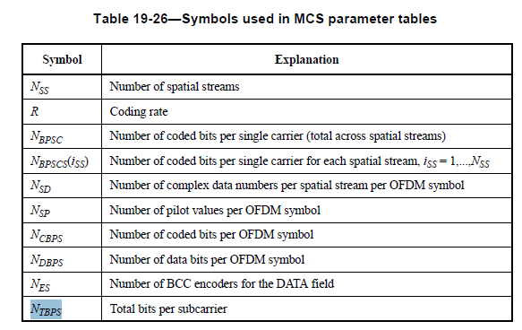

Agree that N_TBPS is not used any where in the draft.

Proposed Resolution: CID 4450
Accepted.

CID 4322

CID | Clause | Page.Line | Comment | Proposed Change
4322 | 21.2.2 | 3145.22 | numberOfOctets is not a defined operator (also in Table 22-1 and Table 23-1) | Add a definition of the operator to 1.5 or C.1

Discussion

D3.2 P3133
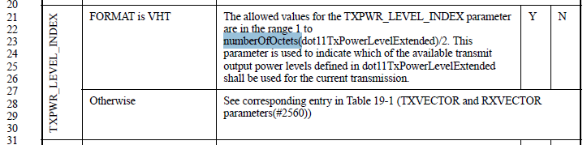

Note that there are two more places using numberOfOctets.

D3.2 P3265
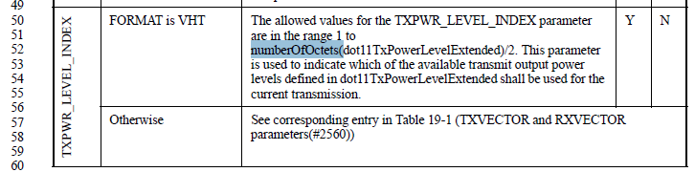

D3.2 P3319
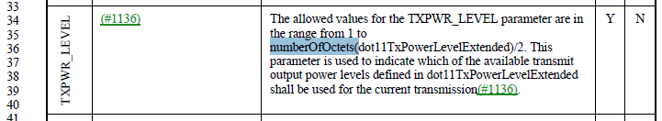

All three places have the exact same phrase, and it is simpler to just reword the phrase to not use the undefined function numberOfOctets. For example, proposal is to change P3133 as below.

TXPWR_LEVEL_INDEX | FORMAT is VHT | The allowed values for the TXPWR_LEVEL_INDEX parameter are in the range 1 to N/2, where N is the number of octets in dot11TxPowerLevelExtended. This parameter is used to indicate which of the available transmit output power levels defined in dot11TxPowerLevelExtended shall be used for the current transmission. | Y | N
 | Otherwise | See corresponding entry in Table 19-1 (TXVECTOR and RXVECTOR parameters(#2560))

Proposed Resolution: CID 4322
Revised.
Proposed resolution updates the text to avoid using the undefined function numberOfOctets().

Instruction to Editor:
At D3.2 P3133L21, P3265L51 and P3319L35, change “1 to numberOfOctets(dot11TxPowerLevelExtended)/2” to “1 to N/2, where N is the number of octets in dot11TxPowerLevelExtended”.

CID 4604

CID | Clause | Page.Line | Comment | Proposed Change
4604 | 21.3.6 | 3175.8 | "For a VHT MU PPDU, NDBPS is undefined" -- so NDBPS only applies to HE SU PPDUs, so u will always be 0, so there is no point definining NDBPS,u | Delete NDBPS,u from Table 21-6

Discussion

D3.2 P3163
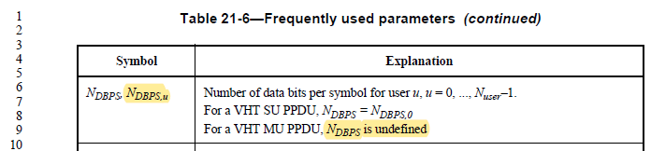

Note that N_DBPS,u is used in 21.5.
P3243:
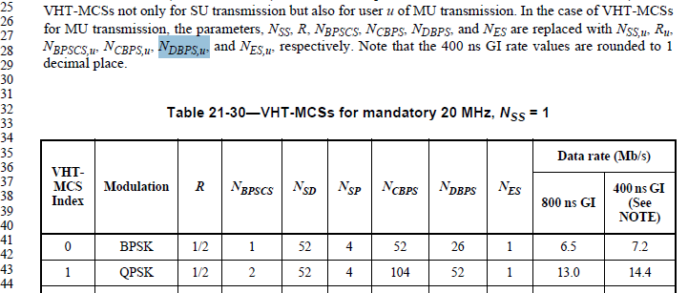

Proposed Resolution: CID 4604
Rejected.
In VHT MU, each user can have different number of data bits per symbol, thus N_DBPS,u with the subscript “u” is appropriate. And N_DBPS,u is used in D3.2 P3243L28.

CID 4022

CID | Clause | Page.Line | Comment | Proposed Change
4022 | 21.3.8.2.2 | 3185.12 | For CBW20, N_SR is 28.  And, Sk for CBW20 refers Equation 19-8.  But, Sk in 19-8 is specifying {-26,26}.  Values for -28, -27, 27, and 28 are not defined. | Please define Sk for -28, -27, 27, and 28.

Background

D3.2 P3172
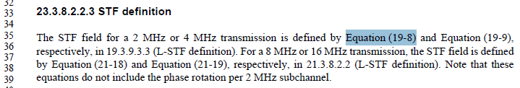

D3.2 P2999
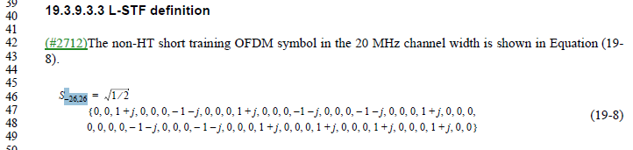

D3.2 P3173
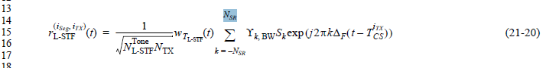

P3.2 P3161
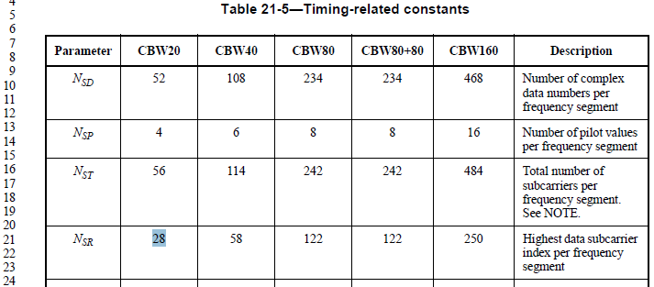

Note that L-SIG and VHT-SIG-A uses summation over +-26, not +-N_SR to avoid the same issue.

D3.2 P3174
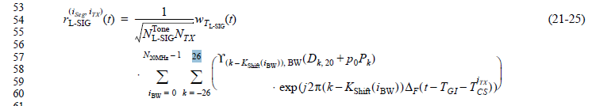

D3.2 P3177
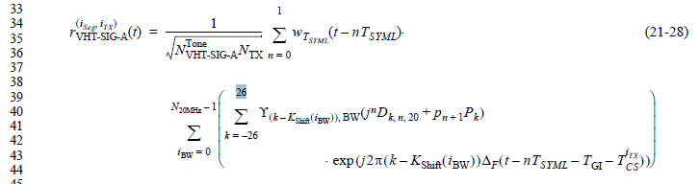

Update in R1:
David Goodall (Morse Micro) indicated that similar change should be made for Equation (23-14) in S1G. This change has been confirmed by Yujin Noh (Newracom) as well.

D3.2 P3353

P3.2 P3342
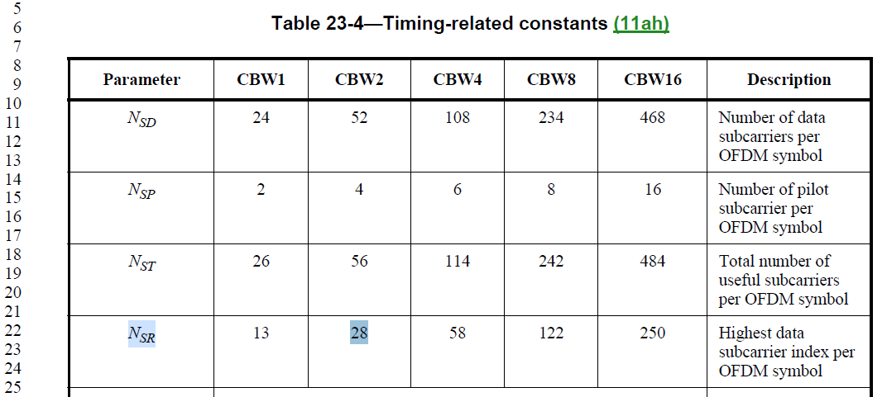

Proposed Resolution: CID 4022
Revised.
Commenter is correct about the issue. Note that L-SIG and VHT-SIG-A avoids similar issue by not use the variable N_SR, but rather using “26” in Equations (21-25) and (21-28), respectively. Hence changing N_SR to 26 in Equation (21-20) is more appropriate. Similar change should also be made for S1G in Equation (23-14).

Instruction to Editor:
At D3.2 P3173L15 Equation (21-20), change “N_SR” to “26”, and “k = -N_SR” to “k = -26”.
At D3.2 P3353L46 Equation (23-14), change “N_SR” to “26”, and “k = -N_SR” to “k = -26”.

CID 4023

CID | Clause | Page.Line | Comment | Proposed Change
4023 | 21.3.8.2.3 | 3185.60 | For CBW20, N_SR is 28.  And, Lk for CBW20 refers Equation 19-11.  But, Lk in 19-11 is specifying {-26,26}.  Values for -28, -27, 27, and 28 are not defined. | Please define Lk for -28, -27, 27, and 28.

Discussion

D3.2 P3173
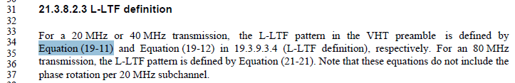

D3.2 P3000

D3.2 P3173
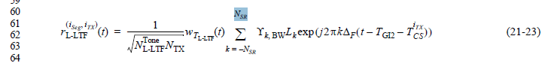

P3.2 P3161

Note that L-SIG and VHT-SIG-A uses summation over +-26, not +-N_SR to avoid the same issue.

D3.2 P3174

D3.2 P3177

Proposed Resolution: CID 4023
Revised.
Commenter is correct about the issue. Note that L-SIG and VHT-SIG-A avoids similar issue by not use the variable N_SR, but rather using “26” in Equations (21-25) and (21-28), respectively. Hence changing N_SR to 26 in Equation (21-23) is more appropriate.

Instruction to Editor:
At D3.2 P3173L62 Equation (21-23), change “N_SR” to “26”, and “k = -N_SR” to “k = -26”.

CID 4544

CID | Clause | Page.Line | Comment | Proposed Change
4544 | 21.3.8.3.5 | 3194.60 | "left" and "right" are not well-defined for frequencies; the correct terminology is "lower", "higher". LTF_left, for example, looks suspect | As it says in the comment

Background

D3.0 P3194
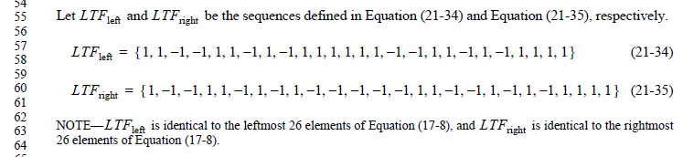
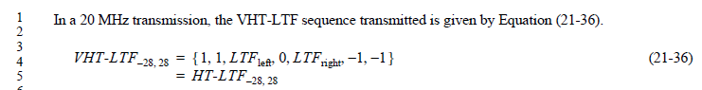

Proposed Resolution: CID 4544
Rejected.
LTF_left and LTF_right are intermediate variables used to define VHT-LTF. The usage of LTF_left and LTF_right is clear in the standard (e.g. see Equation (21-36)), and thus there is no technical issue with the terms.

CID 4368

CID | Clause | Page.Line | Comment | Proposed Change
4368 | 21.3.17.4.2 | 3235.12 | "When the RF LO is not at the center of the transmitted PPDU BW, the power measured at the  location of the RF LO using resolution BW 312.5 kHz shall not exceed the maximum of -32 dB  relative to the total transmit power and -20 dBm, or equivalently , where P is the  transmit power per antenna in dBm, and NST is defined in Table 21-5" -- but NST is not mentioned anywhere in this bullet! | Delete ", and NST is defined in Table 21-5" in the cited text and "and NST is defined in Table 22-8 (Timing-related  parameters)" at 3312.24

Discussion

D3.0 P3194
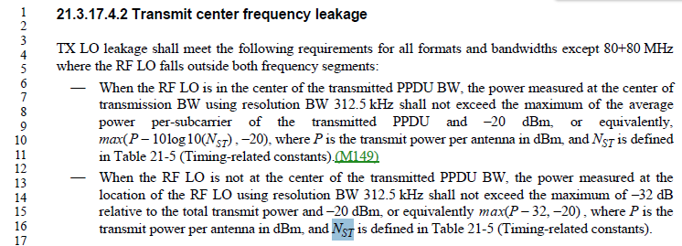

D3.0 P3312
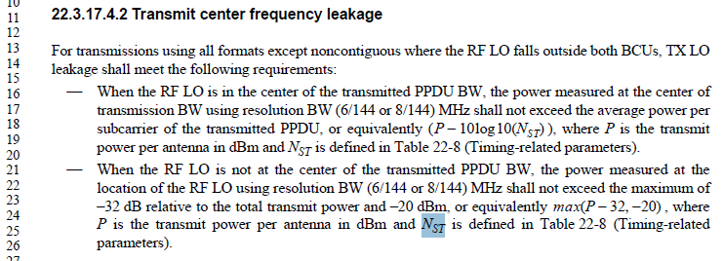

Commenter is correct that the second bullet in each case do not use N_ST.

Proposed Resolution: CID 4368
Accepted

[End of File]

