IEEE P802.11
Wireless LANs
Resolutions for some comments on 11md/D3.0 (SB1)
Date: 2020-03-11
Author(s):
Name | Affiliation | Address | Phone | email
Mark RISON | Samsung Cambridge Solution Centre | SJH, CB4 0DS, U.K. | +44 1223 434600 | at samsung (a global commercial entity) I'm the letter emme then dot rison
Abstract
This submission proposes resolutions for various CIDs on 11md/D3.0. Green indicates material agreed to in the group, yellow material to be discussed, red material rejected by the group and cyan material not to be overlooked. The “Final” view should be selected in Word.

Identifiers | Comment | Proposed change
CID 4393  Mark RISON | It doesn't make sense to sometimes plonk "(no data)" after the frame name | Delete "(no data)" throughout except in Table 9-1--Valid type and subtype combinations

Discussion:

In general, references to Data frames that contain no data are not qualified with “(no data)”. For example there are about 8 instances of “QoS Null (no data)” and over 100 instances of “QoS Null” without “(no data)”.

Proposed resolution:

REVISED

In D3.1:

At 782.10 change:

QoS (+)Null frame refers to all three QoS data subtypes with “no data”: the QoS Null (no data) frame, subtype 1100; the QoS CF-Poll (no data) frame, subtype 1110; and the QoS CF-Ack +CF-Poll frame, subtype 1111.

to:

QoS (+)Null frame refers to all three QoS data subtypes with an empty frame body: the QoS Null frame, subtype 1100; the QoS CF-Poll frame, subtype 1110; and the QoS CF-Ack +CF-Poll frame, subtype 1111.

Delete “ (no data)” at 785.60, 786.15/18/20, 790.48 (2x), 790.49, 799.43, 850.32 (3x), 850.33 (2x), 1860.24, 3605.32/35/39/47, 3613.23/27/30/41.

Identifiers | Comment | Proposed change
CID 4432  Mark RISON  11 | "The Address 1 field of the TIM frame shall be set to the broadcast address." -- equivalent statements are needed for other Management frames that are always broadcast e.g. Beacon, FILS Discovery frames | As it says in the comment

Discussion:

The following Management frames are already explicitly specified to be transmitted as broadcasts:

If the Announce frame is transmitted, it shall use MCS 0, and the TA field shall be set to the broadcast address.
The Address 1 field of the TIM frame shall be set to the broadcast address.
An AP shall transmit Measurement Pilots [sic] to the broadcast address.

However, I cannot find anything to say that FILS Discovery frames or Timing Advertisement frames are broadcast, nor indeed that Beacon frames are broadcast! [Am I missing something? And are there other Management frames that are broadcast?]

Note: DMG beacons don’t have an RA, just a BSSID, and S1G beacons don’t have an RA either, just a SA.

Proposed resolution:

REVISED

In D3.1:

At the end of the first para of 11.46.2.1 FILS Discovery frame transmission add “The Address 1 field of the FILS Discovery frame shall be set to the broadcast address.”.

At the end of the second para of 11.1.3.1 General (in 11.1.3 Maintaining synchronization) add “The Address 1 field of the Beacon or Timing Advertisement frame shall be set to the broadcast address.”.

At the end of the third para of 11.1.3.1 General (in 11.1.3 Maintaining synchronization) add “The Address 1 field of the Timing Advertisement frame shall be set to the broadcast address.”.

At the end of second para of 14.13.3.1 Beacon generation in MBSSs add “The Address 1 field of the Beacon frame shall be set to the broadcast address.”.

At 2302.47 and 2302.49 change “multiple Beacons, Measurement Pilots, or Probe Response frames” to “multiple Beacon, Measurement Pilot, or Probe Response frames”.

At 2318.56, 2320.52/53(2x)/60/61/63, 2321.1/3/5/13/19/43 change “Measurement Pilots” to “Measurement Pilot frames”. At 327.16 change “measurement pilots” to “Measurement Pilot frames”.

Identifiers | Comment | Proposed change
CID 4451  Mark RISON  10.23.2.7  1834.13 | "When an AP supports DL-MU-MIMO, frames from a higher or lower priority AC may be included  in a VHT or S1G MU PPDU with the TXVECTOR parameter(#2639) NUM_USERS > 1 when  these frames do not increase the duration of the VHT or S1G MU PPDU beyond that required for the  transmissions of the frames of the primary AC(#2426)." -- why the not increase duration constraint, given that the previous bullet does allow extension? Maybe special-case for TXOP Limit 0, i.e. only in that case do not extend (since otherwise TXOP Limit is the limit, irrespective of content)? | Change to "When an AP supports DL-MU-MIMO, frames from a higher or lower priority AC may be included  in a VHT or S1G MU PPDU with the TXVECTOR parameter(#2639) NUM_USERS > 1 when  the TXOP limit for the primary AC is nonzero."

Discussion:

The current wording is:

10.23.2.7 Sharing an EDCA TXOP

(#1195)The AC associated with the EDCAF that gains an EDCA TXOP is referred to as the primary AC. Frames from ACs other than the primary AC shall not be included in the TXOP, with the following exceptions (TXOP sharing):

— Frames from a higher priority AC may be included when at least one frame from the primary AC has been transmitted and all frames from the primary AC have been transmitted.

— When an AP supports DL-MU-MIMO, frames from a higher or lower priority AC may be included in a VHT or S1G MU PPDU with the TXVECTOR parameter(#2639) NUM_USERS > 1 when these frames do not increase the duration of the VHT or S1G MU PPDU beyond that required for the transmissions of the frames of the primary AC(#2426). Frames from the primary AC shall be transmitted first.

The first bullet allows higher-priority frames to be included in the TXOP, even if this causes the TXOP to be lengthened, as long as the primary AC frames have gone out (and implicitly as long as the TXOP limit is not violated).

However, the second bullet disallows (or can be read as disallowing) higher-priority frames from being included in the MU PPDU if that would lengthen the MU PPDU. It should be made clearer that this is not the case, i.e. just as for the first bullet, higher-priority frames can be included even if they lengthen the MU PPDU (and possibly also the TXOP), subject to the overall restrictions.

Also, the final sentence of the second bullet is not clear. There might not be frames for the primary AC for all users, and higher-priority stuff should go ahead of lower-priority stuff, since lower-priority stuff should only be allowed if it’s getting a completely free ride that would go unused otherwise.

Examples with the EDCAF that wins contention being VI, with a non-zero TXOP limit, and the TXOP not exceeding that limit:
- Sending some SU PPDUs with VI traffic (none left to tx) and then some SU PPDUs with VO traffic: OK
- Sending some SU PPDUs with VI traffic (none left to tx) and then some SU PPDUs with BE traffic: not OK
- Sending some MU PPDUs with one user having just VI traffic (no extraneous padding) and another user having just BE traffic (no VI/VO traffic to send): OK
- Sending some MU PPDUs with one user having just VI traffic but extraneous padding so that another user can have extra BE traffic: not OK
- Sending some MU PPDUs with one user having just VI traffic (none left to tx; no extraneous padding) and then that user having just VO traffic (no extraneous padding), and another using having just BE traffic throughout (no VI/VO traffic to send): OK
- Sending some MU PPDUs with one user having just VI traffic (none left to tx; no extraneous padding) and then that user having just VO traffic (none left to tx; no extraneous padding) and then that using having BE traffic, and another using having just BE traffic throughout (no VI/VO traffic to send): not OK
- Sending some MU PPDUs with one user having just VO traffic and then that user having VI traffic: not OK

There is no need to explicitly discuss the case where the TXOP limit is 0, since per 10.23.2.9 TXOP limits this means a single A-MPDU to each user, so the case is covered.

Proposed changes:

Change 10.3.2.7 as follows:

10.23.2.7 Sharing an EDCA TXOP

(#1195)The AC associated with the EDCAF that gains an EDCA TXOP is referred to as the primary AC. Frames from ACs other than the primary AC shall not be included in the TXOP, with the following exceptions (TXOP sharing):

— Frames from a higher priority AC may be included when at least one frame from the primary AC has been transmitted and all frames from the primary AC have been transmitted.

NOTE—The frames from a higher priority AC might be included in successive PPDUs in the TXOP and/or in one or more MU PPDUs.

— When an AP supports DL-MU-MIMO, frames from a higher or lower priority AC may be included in a VHT or S1G MU PPDU with the TXVECTOR parameter(#2639) NUM_USERS > 1 when these frames do not increase the duration of the VHT or S1G MU PPDU beyond that required for the transmissions of the frames of the primary AC(#2426) and any frames from a higher priority AC. For a given user, any frames from the primary AC shall be transmitted first and then any frames from a higher priority AC immediately next.

The EDCAF remains bound by the TXOP limit for its AC (i.e. the primary AC), irrespective of the AC(s) of the frames transmitted during the TXOP.

Proposed resolution:

REVISED

Make the changes shown under “Proposed changes” for CID 4451 in <this document>, which xx

Identifiers | Comment | Proposed change
CID 4433  Mark RISON  10.27.3.1  1902.28 | Table 10-22--Applicable HT protection mechanisms only goes up to 40 MHz non-HT dup. However, it also applies to VHT through 10.27.5 Protection rules for VHT STAs ("A VHT STA is subject to all of the rules for HT STAs that apply to its operating band, except that a PPDU  with the TXECTOR FORMAT parameter set to VHT may be substituted for a PPDU with the TXVECTOR  FORMAT parameter set to HT_MF."). Therefore it should also cover the use of 80/80+80/160 non-HT dup for RTS" | In Table 10-22 change "40 MHz transmissions use non-HT duplicate frames defined in Clause 19 (High-throughput (HT) PHY  specification)" to "40 MHz, 80 MHz, 160 MHz and 80+80 MHz transmissions use non-HT duplicate frames defined in Clause 19 (High-throughput (HT) PHY  specification) and Clause 21"

Discussion:

10.27.5 says:

10.27.5 Protection rules for VHT STAs

A VHT STA is subject to all of the rules for HT STAs that apply to its operating band, except that a PPDU with the (#4228)TXVECTOR FORMAT parameter set to VHT may be substituted for a PPDU with the TXVECTOR FORMAT parameter set to HT_MF.

So this means Table 10-22 in 10.27.3 Protection mechanisms for transmissions of HT PPDUs applies to VHT STAs too. This says:

Table 10-22—Applicable HT protection mechanisms(#67)

HT protection mechanism
Control frames such as RTS/CTS or CTS-to-self prior to the HT transmissions:
— 20 MHz transmissions use the rates defined in Clause 17 (Orthogonal frequency division multiplexing (OFDM) PHY specification) or Clause 18 (Extended Rate PHY (ERP) specification)
— 40 MHz transmissions use non-HT duplicate frames defined in Clause 19 (High-throughput (HT) PHY specification)
As the first PPDU in the TXOP, send one of:
— a non-HT PPDU containing a frame that requires an immediate response
— (#4434)an HT-mixed format PPDU containing a frame that requires an immediate response in a non-HT PPDU
PPDUs after the first PPDU exchange may be HT-greenfield format PPDUs and/or be separated by RIFS.

As the comment says, protection of 80+ MHz transmissions should also be covered for VHT.

TGm prefers, however, not to make changes to Table 10-22 since it sees that table as being for HT STAs.

Proposed resolution:

REVISED

At the end of the sentence in 10.27.5 Protection rules for VHT STAs add “ and that the applicable HT protection mechanisms are extended to include 80, 160 and 80+80 MHz transmissions using non-HT duplicate frames defined in Clause 21”.
Identifiers | Comment | Proposed change
CID 4582  Mark RISON | The definition of dot11EDCATableMSDULifetime (and QAP version) needs to allow for A-MSDUs and MMPDUs, since those are/can be sent under a particular AC. Also similarly change 1763.63 in 10.3.4.4 and dot11MaxTransmitMSDU Lifetime in C.3 | As it says in the comment

Discussion:

dot11EDCATableMSDULifetime’s definition says that it “specifies the maximum duration an MSDU, for a given AC, would be retained by the MAC before it is discarded.”

So which attribute specifies the lifetime for MMPDUs? It must be this one too, since there’s no other one for this.

However, we don’t need to explicitly allow for A-MSDUs, since MSDUs are a component of MSDUs (see also e.g. D3.1/1843.43).

1763.63 is:

Retries for failed transmission attempts shall continue until the SRC for the MPDU with the Type subfield
equal to Data or Management is equal to dot11ShortRetryLimit or until the LRC for the MPDU with the Type subfield equal to Data or Management is equal to dot11LongRetryLimit. When either of these limits is reached, retry attempts shall cease, and the MPDU with the Type subfield Data (and any MSDU of which it is a part) or Management shall be discarded. A DMG STA, in addition to using random access within a CBAP, may transmit retries in available scheduled SPs.

so it’s not entirely clear what the commenter is on about here (is this a similar point to CID 4168?).

The range of the EDCA MSDU lifetimes seems odd, too. It allows 0, i.e. the MSDUs are stillborn, and it only allows up to 500 TUs. It should be the same as the range for DCF MSDU lifetimes, which goes from 1 TU to 2³²-1 TUs (for the really determined).

Proposed changes:

Change D3.1 as follows:

10.4 MSDU and MMPDU fragmentation

The source STA shall maintain a transmit MSDU/MMPDU timer for each MSDU/MMPDU being transmitted. The attribute dot11MaxTransmitMSDULifetime specifies the maximum amount of time allowed to transmit an MSDU/MMPDU. The timer starts on the initial attempt to transmit the (#1452)MSDU/MMPDU, or first fragment of the MSDU/MMPDU (#1452)if the MSDU/MMPDU is fragmented. If the timer exceeds dot11MaxTransmitMSDULifetime, then (#1452)any remaining fragments are discarded by the source STA and no attempt is made to complete transmission of the MSDU/MMPDU.

10.7 MSDU transmission restrictions

(#66)A STA should select a value of dot11MaxTransmitMSDULifetime that is sufficiently large that the STA does not discard MSDUs or MMPDUsA-MSDUs due to the transmit MSDU/MMPDU timer being exceeded, excessive Transmit MSDU timeouts under normal operating conditions.

10.23.2.12 Retransmit procedures
10.23.2.12.1 General

(#2432)A QoS STA shall maintain a transmit MSDU/MMPDU timer for each MSDU passed to the MAC and for each MMPDU. dot11EDCATableMSDULifetime specifies the maximum amount of time allowed to transmit an MSDU/MMPDU for a given AC. The transmit MSDU/MMPDU timer shall be started when the MSDU/MMPDU is passed to the MAC.

(#2432)When A-MSDU aggregation is used, the HT STA maintains a single timer for the whole A-MSDU. The timer is restarted each time an MSDU is added to the A-MSDU. The result of this procedure is that no MSDU in the A-MSDU is discarded before a period of dot11EDCATableMSDULifetime has elapsed.

(#2664)(#1505)Retries for failed transmission attempts shall continue until one or more of the following conditions occur:
— (#2664)The frame retry count for the MSDU, A-MSDU, or MMPDU is equal to dot11ShortRetryLimit.
— (#2664)The drop-eligible frame retry count for the MSDU, A-MSDU, or MMPDU is equal to dot11ShortDEIRetryLimit.
— (#2664)The unsolicited frame retry count for the A-MSDU is equal to dot11UnsolicitedRetryLimit.
— (#2432)The transmit MSDU/MMPDU timer for the MSDU/MMPDU or any undelivered fragments of that MSDU/MMPDU exceeds dot11EDCATableMSDULifetime.

C.3 MIB detail

dot11MaxTransmitMSDULifetime OBJECT-TYPE
SYNTAX Unsigned32 (1..4294967295)
UNITS "TUs"
MAX-ACCESS read-write
STATUS current
DESCRIPTION
"This is a control variable.
It is written by an external management entity.
Changes take effect as soon as practical in the implementation.
The MaxTransmitMSDULifetime isThis attribute specifies the elapsed time, after the initial transmission of an MSDU/MMPDU (or the first fragment thereof), after which further attempts to transmit the MSDU/MMPDU are terminated."
DEFVAL { 512 }
::= { dot11OperationEntry 6 }

dot11EDCATableMSDULifetime OBJECT-TYPE
SYNTAX Unsigned32 (0..5001..4294967295)
UNITS "TUs"
MAX-ACCESS read-write
STATUS current
DESCRIPTION
"This is a control variable.
It is written by the MAC upon receiving an EDCA Parameter Set in a Beacon frame.
Changes take effect as soon as practical in the implementation.
This attribute specifies the maximum duration an MSDU/MMPDU, for a given AC, would be retained by the MAC at the non-AP STA before it is discarded."
DEFVAL { 500 }
::= { dot11EDCAEntry 6 }

dot11QAPEDCATableMSDULifetime OBJECT-TYPE
SYNTAX Unsigned32 (0..5001..4294967295)
UNITS "TUs"
MAX-ACCESS read-write
STATUS current
DESCRIPTION
"This is a control variable.
It is written by an external management entity.
Changes take effect as soon as practical in the implementation.
This attribute specifies the maximum duration an MSDU/MMPDU, for a given AC, would be retained by the MAC at the AP before it is discarded."
DEFVAL { 500 }
::= { dot11QAPEDCAEntry 6 }

Proposed resolution:

REVISED

Make the changes shown under “Proposed changes” for CID 4582 in <this document>, which address the issue raised by the commenter (except for the one at 1763.63 -- see CID 4168).

Identifiers | Comment | Proposed change
CID 4284  Mark RISON  9.4.2.20.18  1043.59 | Should Figure 9-219--Measurement Request field format for Directional Statistics request not allow for optional subelements, like the corresponding report, and like most requests? Ditto Directional Measurement request | As it says in the comment

Discussion:

Most requests/reports allow for optional subelements, if only to allow for vendor-specific subelements. E.g.:

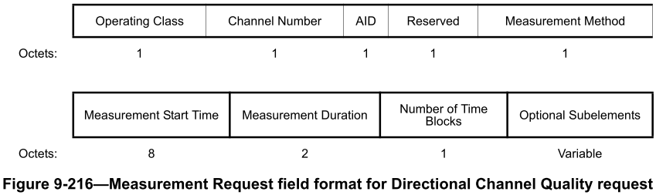

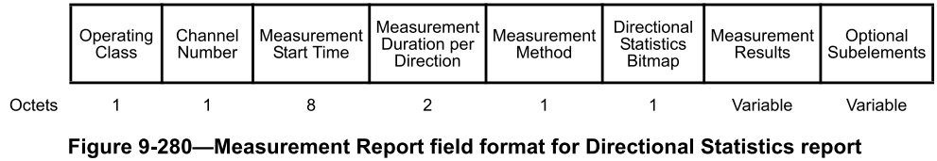

However, for some reason, Directional Statistics requests and Directional Measurement requests don’t allow for optional subelements. There is no reason for this limitation.

Proposed changes:

In Figure 9-218—Measurement Request field format for Directional Measurement request and Figure 9-219—Measurement Request field format for Directional Statistics request add a field at the end “Optional Subelements” with “Variable” as the number of octets.

At the end of 9.4.2.20.17 Directional Measurement request insert:

The Optional Subelements field contains zero or more subelements. The subelement format and ordering of subelements are defined in 9.4.3.

The Subelement ID field values for the defined subelements are shown in Table 9-xx.

Immediately after, insert a Table 9-xx with caption “Optional subelement IDs for Directional Measurement request” and contents the same as Table 9-177—Optional subelement IDs for Measurement Pilot Transmission.

Immediately after, insert:

The Vendor Specific subelements have the same format as their corresponding elements (see 9.4.2.25). Zero or more Vendor Specific subelements are included in the list of optional subelements.

At the end of 9.4.2.20.18 Directional Statistics request insert:

The Optional Subelements field contains zero or more subelements. The subelement format and ordering of subelements are defined in 9.4.3.

The Subelement ID field values for the defined subelements are shown in Table 9-yy.

Immediately after, insert a Table 9-yy with caption “Optional subelement IDs for Directional Statistics request” and contents the same as Table 9-177—Optional subelement IDs for Measurement Pilot Transmission.

Immediately after, insert:

The Vendor Specific subelements have the same format as their corresponding elements (see 9.4.2.25). Zero or more Vendor Specific subelements are included in the list of optional subelements.

Remember to hyperlinkify all the xrefs!

Proposed resolution:

REVISED

Make the changes shown under “Proposed changes” for CID 4284 in <this document>, which allow for optional subelements in the requests identified by the commenter.

Identifiers | Comment | Proposed change
CID 4204  Mark RISON  9.4.2.24.3  1101.29 | Table 9-151--AKM suite selectors has overlapping conditions. For example, 00-0F-AC:3 and 00-0F-AC:5 have the same key derivation, can both use 0 for the auth alg num, have subset key management type (since 12.7.1.6 is a subclause of 12.7) and have subset authentication (since FT authentication  negotiated over IEEE  Std 802.1X is a type of Authentication  negotiated over IEEE  Std 802.1X). Similarly :8 and :9, etc. | Add a column to the table with heading something like "Can be used with PMKSA caching" and then state that this means that the AKM can also be used for the use of a cached PMKSA for a previous AKM of that type, and cross-reference from there to 12.6.10.3 Cached PMKSAs and RSNA key management
CID 4205  Mark RISON  9.4.2.24.3  1101.29 | Table 9-151--AKM suite selectors has overlapping conditions. For example, 00-0F-AC:3 and 00-0F-AC:5 have the same key derivation, can both use 0 for the auth alg num, have subset key management type (since 12.7.1.6 is a subclause of 12.7) and have subset authentication (since FT authentication  negotiated over IEEE  Std 802.1X is a type of Authentication  negotiated over IEEE  Std 802.1X). Similarly :8 and :9, etc. | Make sure each suite selector has no overlap with other suite selectors

Discussion:

Here are the conditions for 00-0F-AC:3 and :5:

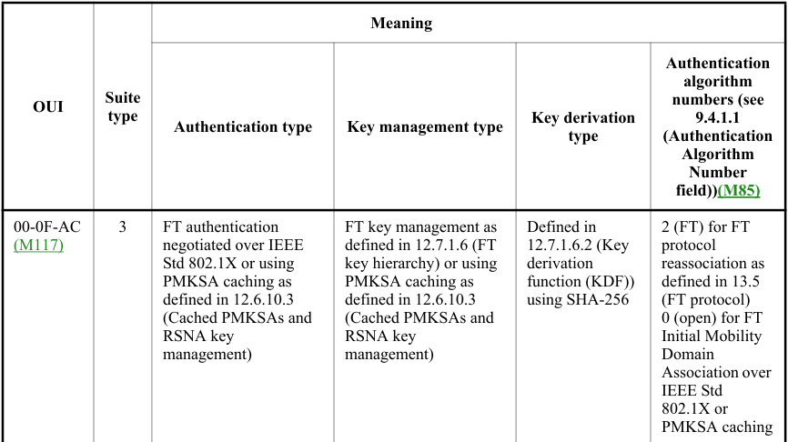
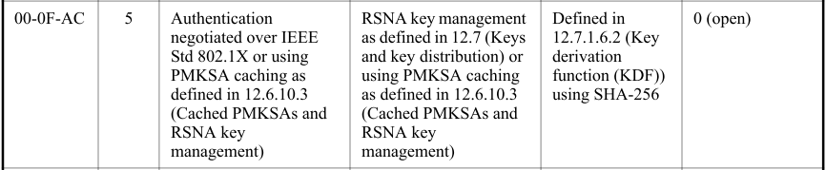

So, when the auth alg num is 0, what distinguishes :3 and :5? How does the receiver know which is intended?
- “FT authentication negotiated over IEEE Std 802.1X or using PMKSA caching as defined in 12.6.10.3”
is a subset of
“Authentication negotiated over IEEE Std 802.1X or using PMKSA caching as defined in 12.6.10.3”
- “FT key management as defined in 12.7.1.6 or using PMKSA caching as defined in 12.6.10.3”
is a subset of
“RSNA key management as defined in 12.7 or using PMKSA caching as defined in 12.6.10.3”
- The key derivation type is the same (“Defined in 12.7.1.6.2 using SHA-256”)

Similarly, the only difference between

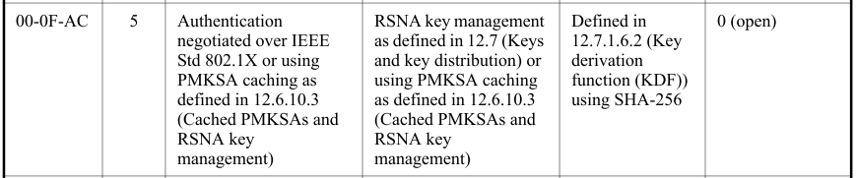

and

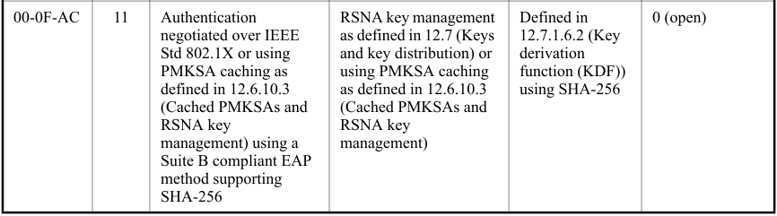

is that :11 guarantees that it's Suite B compliant (extra text at end of third cell).

Proposed changes:

Proposed resolution:

REVISED

Make the changes shown under “Proposed changes” for CID in <this document>, which

Identifiers | Comment | Proposed change
CID 4499  Mark RISON | If the term "slave" is no longer acceptable (CID 2020), is the term "master" still acceptable (other than "master key" contexts)? There are only a few such instances | As it says in the comment

Discussion:

If “slave” is objectionable, then so is “master”, in those contexts that imply the existence of a “slave”.

Proposed resolution:

REVISED

In 9.5.6 Beamformed Link Maintenance field inc. Figure 9-852—Beamformed Link Maintenance field format and Table 9-344—The Beamformed Link Maintenance negotiation, change “isMaster” to “isController” (5x). In 9.5.6 Beamformed Link Maintenance field change “master of the data transfer” to “controller of the data transfer”.

In 11.1.2.1 TSF for an infrastructure BSS or a PBSS change “timing master” to “timing source”.

In 3.3 change “master white space device” to “authoritative white space device”. In B.4.26 TVWS functions change “Master STA TVWS operation” to “Authoritative STA TVWS operation”.

Identifiers | Comment | Proposed change
CID 4715  Mark RISON  6.3.68  576.10 | MLME-FINETIMINGMSMTRQ primitives are not used anywhere | In Figure 6-17---Fine timing measurement primitives and timestamps capture add at the top a MLME-FINETIMINGMSMT.request from STA B's SME to STA B's MLME, a Fine Timing Measurement Request frame from STA B's MLME to STA A's MLME and a MLME-FINETIMINGMSMT.request from STA A's MLME to STA A's SME
CID 4716  Mark RISON  6.3.68  576.10 | MLME-FINETIMINGMSMTRQ primitives are not used anywhere | Delete 6.3.68

Discussion:

6.3.56 has information on the MLME-FINETIMINGMSMT primitives, including a figure showing how the primitives map to frames over the air. However, 6.3.68 has no similar information on the MLME-FINETIMINGMSMTRQ primitives.

Mark HAMILTON further points out:

Perhaps, if we are going to show the “RQ” primitives in the figure(s) (that is, Figure 6-17, and maybe as suggested in Figure 6-16 also), then we should merge those primitives into the subclause also. That is, merge subclause 6.3.68 into 6.3.56 (and maybe 6.3.67 into 6.3.55)?

Those later clauses have the primitive definitions for MLME-[FINE]TIMINGMSMTRQ, .request and .indication. In the current subclause with Figure 6-17, there are only the primitives for the FTM frames themselves. But, the clause states this, w.r.t. Figure 6-17:

The following set of primitives supports exchange of FTM information from one SME to another.
(M138)The diagram in Figure 6-17 (Fine timing measurement primitives and timestamps capture) shows
various points in time that are of interest to the FTM procedure.

Given the combination of both sets of actions in the Figure, I think having both sets of primitives in the subclause makes sense. Right now, the subclauses are very far apart, and there is no cross-reference hint to go look at the other one, to understand the whole picture that Figure 6-17 is trying to convey.

Proposed changes:

Change the first para of 6.3.56.1 General as follows:

The following set of primitives supports triggering an FTM(#1022) procedure or stopping an ongoing FTM procedure, and exchange of FTM information from one SME to another. (M138)The diagram in Figure 6-17 (Fine timing measurement primitives and timestamps capture) shows the use of these primitives and various points in time that are of interest to the FTM procedure.

Change Figure 6-17 as follows, adding the material in red:

Insert 6.3.68.2 MLME-FINETIMINGMSMTRQ.request and 6.3.68.3 MLME-FINETIMINGMSMTRQ.indication after 6.3.56.1, renumbering them to 6.3.56.2 and 6.3.56.3 respectively, and renumbering the current 6.3.56.2 and 6.3.56.3 to 6.3.56.4 and 6.3.56.5 respectively. Delete 6.3.68 Fine timing measurement request and 6.3.68.1 General.

Change the first para of 6.3.55.1 General as follows:

The following set of primitives supports triggering a Timing Measurement procedure or stopping an
ongoing Timing Measurement procedure, and exchange of timing measurement information from one SME to another. (M138)The diagram in Figure 6-16 (Timing measurement primitives and timestamps
capture(#1563)) shows various points in time that are of interest to the timing measurement procedure.

Change Figure 6-16 by adding the material shown in red above, but with “FINE” and “Fine ” deleted.

Insert 6.3.67.2 MLME-TIMINGMSMTRQ.request and 6.3.67.3 MLME-TIMINGMSMTRQ.indication after 6.3.55.1, renumbering them to 6.3.55.2 and 6.3.55.3 respectively, and renumbering the current 6.3.55.2 and 6.3.55.3 to 6.3.55.4 and 6.3.55.5 respectively. Delete 6.3.67 Timing measurement request and 6.3.67.1 General.

Proposed resolution:

REVISED

Make the changes shown under “Proposed changes” for CIDs 4715 and 4716 in <this document>, which clarify the use of MLME-FINETIMINGMSMTRQ primitives and also MLME-TIMINGMSMTRQ primitives.

Identifiers | Comment | Proposed change
CID 4591  Mark RISON | The way UTF-8 strings are referred to is inconsistent. We have a definition of UTF-8 string (in 9.2.2) so just use that | In 9.4.2.2 change “the SSID is interpreted using UTF-8 encoding” to “the SSID is a UTF-8 string”. In 9.4.2.21.14 change “The Public Identifier URI/FQDN field contains a URI encoded using UTF-8 and formatted in accordance  with IETF RFC 3986” to “The Public Identifier URI/FQDN field contains a URI as a UTF-8 string, formatted in accordance  with IETF RFC 3986,”. In 9.4.2.26 change “The SSID in this BSS is interpreted using UTF-8 encoding” to “The SSID in this BSS is a UTF-8 string”. At 1217.8 change “an UTF” to “a UTF”. In 9.4.5.4 and 9.4.5.5 change “UTF-8 encoded field” to “UTF-8 string”. In 9.4.5.10 change “a UTF-8 encoded character string” to “a UTF-8 string” and “in UTF-8 format” to “in UTF-8”. In 9.4.5.17 change “field encoded using UTF-8 and “ to “UTF-8 string,”. In 9.4.5.21 change “UTF-8 formatted field “ to “UTF-8 string “. In 9.4.5.22 change “a UTF-8 formatted string” to “a UTF-8 string”

Discussion:

The definition in 9.2.2 (which covers the conventions for structures defined in the MAC sublayer) defines a UTF-8 string as follows:

A[…] UTF-8 string is a sequence of […] UTF-8 encoded code points […] without a terminating null.

[For those who are not character representation geeks: a code point is a number that represents (in general) a character in a character set, and an encoding is a mechanism for representing a code point as one or more numbers (see e.g. https://unicode.org/glossary/ ). For example, the (non-Greek) micro character µ is Unicode code point U+00B5 and is encoded in UTF-8 (Unicode/UCS transformation format 8) as the octet sequence 0xC2 0xB5. For characters in ASCII, the UTF-8 encoding is the same as the ASCII encoding.]

An important point of the above definition is that it states that for the purposes of the MAC sublayer a UTF-8 string does not have a terminator. That is, the UTF-8 string “Password” is represented as “Password” (8 octets), not “Password\0” (9 octets, where \0 is the null character) -- this is obviously important where the string is being compared or hashed.

Proposed changes:

Change 9.4.2.2 as follows:

When the UTF-8 SSID subfield of the Extended Capabilities element is equal to 1 in the frame that includes the SSID element, or the Extended Capabilities of the source of the SSID information is known to include the UTF-8 SSID capability based on a previously received Extended Capabilities element, the SSID is interpreted using UTF-8 encodinga UTF-8 string. Otherwise, the character encoding of the octets in this SSID element is unspecified.

Change 9.4.2.21.14 as follows:

The Public Identifier URI/FQDN field contains a URI encoded using UTF-8 andas a UTF-8 string, formatted in accordance with IETF RFC 3986, that points to a location object or an FQDN that identifies a location server.

Change Table 9-153—Extended Capabilities field as follows:

The SSID in this BSS is interpreted using UTF-8 encodinga UTF-8 string

Change 9.4.2.68.5 Diagnostic subelement descriptions as follows:

The Certificate ID field contains an UTF-8 string indicating an identifier assigned to the STA in a manner
outside the scope of the standard. The Certificate ID typically takes the form of “WFA3991” and might be
used by a receiving STA to look up the certificate assigned to that ID.

Change 9.4.5.4 Venue Name ANQP-element as follows:

The Venue Name field is a variable length(#183) UTF-8 encoded fieldstring containing the venue’s name.

Change 9.4.5.5 Emergency Call Number ANQP-element as follows:

The Emergency Call Number field is a variable length(#183) UTF-8 encoded fieldstring containing information, used to reach emergency services, from the network (e.g., dialed digits, emergency service URN label [B40]).

Change 9.4.5.10 NAI Realm ANQP-element as follows:

The NAI Realm Encoding Type subfield(M101) is a 1-bit subfield. It is set to 0 to indicate that the NAI Realm in the NAI Realm subfield is formatted in accordance with IETF RFC 4282. It is set to 1 to indicate it is a UTF-8 encoded character string that is not formatted in accordance with IETF RFC 4282.

If there is more than one NAI Realm in this subfield, the NAI Realms are delimited by a semicolon character (i.e., “;”, which is encoded in UTF-8 format as 0x3B).

Change 9.4.5.17 Emergency NAI ANQP-element as follows:

The Emergency NAI Information field is a variable length(#183) field encoded using UTF-8 string, and formatted in accordance with IETF RFC 4282.

Change 9.4.5.21 Advice of Charge ANQP-element as follows:

The Plan Information field is a variable length UTF-8 formatted fieldstring that carries an XML description of an Advice of Charge plan.

Change 9.4.5.22 Local Content ANQP-element as follows:

(#2203)The Label field is a variable length(#183) field containing a text description of the URL. It provides the type and potential usage of the URL. This is a UTF-8 formatted string.

Proposed resolution:

ACCEPTED

Identifiers | Comment | Proposed change
CID 4679  Mark RISON  9.3.3.1  854.23 | "a) The Address 1 field of the Management frame is the RA (=DA) and is determined as the destination  of the frame.  b) The Address 2 field of the Management frame is the TA (=SA) and is determined as the address of  the STA transmitting the frame(#2013)." arguably duplicates 9.2.4.3.1" | As it says in the comment

Discussion:

The description in 9.2.4.3.1 is:

Certain address field usage is specified by the relative position of the address field (1–4) within the MAC header, independent of the type of address present in that field. For example, receiver address matching is always performed on the contents of the Address 1 field in received frames, and the receiver address of CTS and Ack frames is always obtained from the Address 2 field in the corresponding RTS frame, or from the frame being acknowledged.

However, the examples duplicate more specific information, e.g. in 9.3.3.1 for Management frames:

A STA uses the contents of the Address 1 field to perform the address matching for receive decisions.

The address fields for all Management frames except Multihop Action frames are as follows:
a) The Address 1 field of the Management frame is the RA (=DA) and is determined as the destination of the frame.
b) The Address 2 field of the Management frame is the TA (=SA) and is determined as the address of the STA transmitting the frame(#2013).

and in 9.3.2.1.2 for Data frames:

The content of the address fields of Data frames are dependent upon the values of the To DS and From DS subfields in the Frame Control field and whether the Frame Body field contains either an MSDU (or fragment thereof) or an entire A-MSDU, as determined by the A-MSDU Present subfield of the QoS Control field (see 9.2.4.5.9 (A-MSDU Present subfield)). The content of the address fields transmitted by nonmesh STAs is defined in Table 9-32 (Address field contents). The content of the address fields transmitted by mesh STAs is defined in 9.3.5 (Frame addressing in an MBSS), and the content of the fields transmitted by GLK STAs is defined in 10.65 (Addressing of GLK Data frame(M101) transmission(11ak)).(11ak) Where the content of a field is shown as not applicable (N/A), the field is omitted. Note that Address 1 always holds the receiver address of the intended receiver (or, in the case of group addressed frames, receivers), and that Address 2 always holds the address of the STA that is transmitting the frame.

and in 9.3.1.x for Control frames, e.g. in 9.3.1.2 for RTS:

(MDR2)The RA field of the RTS frame is the address of the STA, on the WM, that is the intended immediate recipient of the pending individually addressed Data, Management, or Control frame.
(MDR2)The TA field is the address of the STA transmitting the RTS frame or the bandwidth signaling TA of the STA transmitting the RTS frame.

Also, it is not the case that “the receiver address of […] Ack frames is always obtained from the Address 2 field in the corresponding […] frame being acknowledged”, because per 9.3.1.4:

The RA field of the Ack frame is the nonbandwidth signaling TA from the Address 2 field of the immediately previous individually addressed Data, Management, BlockAckReq, BlockAck, or PS-Poll frames.

so the RA of the Ack might not be the same as the A2 (TA) of the preceding frame.

It is possible to argue that 9.2.4.3.1’s ad libbing is helpful to set out general principles, however.

Proposed changes:

Proposed resolution:

REVISED

Alternative 1:

Delete “For example, receiver address matching is always performed on the contents of the Address 1 field in received frames, and the receiver address of CTS and Ack frames is always obtained from the Address 2 field in the corresponding RTS frame, or from the frame being acknowledged.” in 9.2.4.3.1.

Alternative 2:

After “For example, receiver address matching is always performed on the contents of the Address 1 field in received frames, and the receiver address of CTS and Ack frames is always obtained from the Address 2 field in the corresponding RTS frame, or from the frame being acknowledged.” in 9.2.4.3.1 add:

NOTE—The receiver address of Ack frames does not equal the Address 2 field of the frame being acknowledged, if that field was a bandwidth signalling TA.

Alternative 3:

Change “For example, receiver address matching is always performed on the contents of the Address 1 field in received frames, and the receiver address of CTS and Ack frames is always obtained from the Address 2 field in the corresponding RTS frame, or from the frame being acknowledged.” in 9.2.4.3.1 to “Specifically, the Address 1 field in received frames always identifies the receiver(s) of the frame, and the Address 2 field in received frames, where present, always identifies the transmitter of the frame.”

Make the changes shown under “Proposed changes” for CID in <this document>, which

Identifiers | Comment | Proposed change
CID 4689  Mark RISON  9.4.3 | "The optional  subelements are ordered by nondecreasing subelement ID." (2x) -- they're ordered per 9.4.3 ("Subelements within an element are ordered by nondecreasing Subelement ID.") | Change to refer to 9.4.3 as for most optional subelement lists

Discussion:

It has been pointed out that

In 9.4.3, subelements are within an element. In 9.6.7.37 and 9.6.7.38, subelements are within a field. Therefore, cannot change to refer to 9.4.3 in 9.6.7.37 and 9.6.7.38.

This is valid of itself, although pedantically in lots of places (if not most/all) subelements are within a field, though sometimes this is itself within an element.

Conversely, Figure 9-865—Measurement Pilot frame Action field format has an Optional Subelements field, is not in an element, and yet says "The Optional Subelements field contains zero or more subelements. The subelement format and ordering of subelements are defined in 9.4.3 (Subelements)." Ditto Figure 9-949—WNM Notification Request frame Action field(#2568) format:

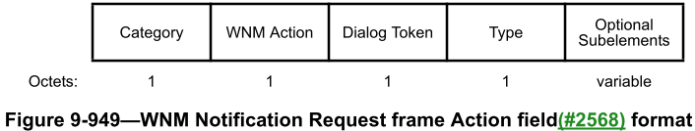

Proposed resolution:

REVISED

In 9.4.3 change “Subelements within an element are ordered by nondecreasing Subelement ID.” (1465.1 in D3.0) to “Subelements within an element and subelements in a field outside of an element are in each case ordered by nondecreasing Subelement ID.”

In 9.6.7.37 and in 9.6.7.38 change “The Optional Subelements field contains zero or more subelements, each consisting of a 1-octet Subelement ID field, a 1-octet Length field, and a variable-length Data field, as defined in 9.4.3 (Subelements). The optional subelements are ordered by nondecreasing subelement ID.” (1566.1 and 1567.36 in D3.0) to “The Optional Subelements field contains zero or more subelements, The subelement format and ordering of subelements are defined in 9.4.3 (Subelements).”

Identifiers | Comment | Proposed change
CID
Mark RISON

Discussion:

Proposed changes:

Proposed resolution:

REVISED

Make the changes shown under “Proposed changes” for CID in <this document>, which

References:

802.11md/D3.0 except where otherwise specified

