IEEE P802.11
Wireless LANs
RESOLUTION OF CID 4444
Date: 2020-03-03
Author(s):
Name | Affiliation | Address | Phone | email
Graham SMITH | SR Technology | Sunrise, FL, USA. | 916 799 9563 | gsmith@srtrl.com
telecom
Abstract
This submission proposes resolution for CID 4444.

Green indicates material agreed to in the group,
yellow material to be discussed, red material rejected by the group and
cyan material not to be overlooked.

The “Final” view should be selected in Word.
R1 – After changes suggested by Mark R. CAP discussion.
R2 – Forgot to change heading Rev. Tidied up a bit
R3 – Updates from presentation 4/30/20
R4 - Updates from 6/5/20
R5 – Updated assuming polled TXOP
R6 – Updated with HCCA TXOP that includes polled TXOP.

CID 4444
4444 RISON, Mark 1001 3 10.23.3.2.2
Comment
"When the HC needs access to the WM to start a (#65)TXOP, the HC shall sense the WM. When the WM is determined to be idle at the TxPIFS slot boundary as defined in 10.3.7 (DCF timing relations), the HC shall transmit the first frame of any permitted frame exchange sequence, with the duration value set to cover the TXOP(#65)."" –

This seems to allow any AP that claims to support HCCA to always transmit after PIFS, even if the access is not for HCCA. The permission to use PIFS should be constrained to HCCA contexts"

Proposed
As it says in the comment

Discussion JUMP TO PAGE 5

Here is the referenced text in the Standard
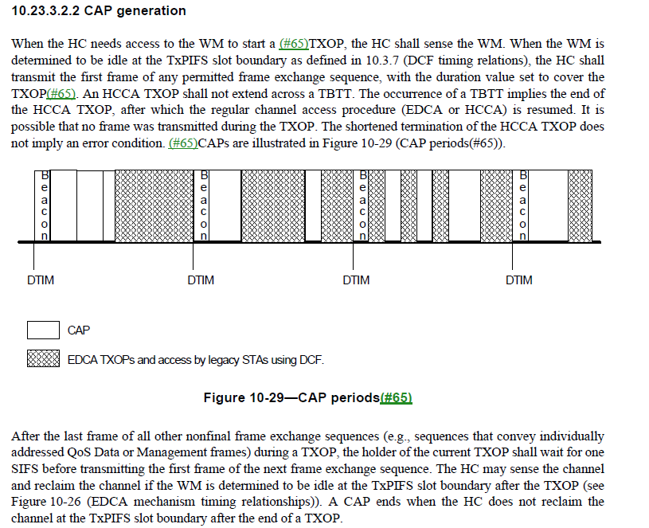

Here is original 802.11e D13.0 relevant clause.
That used CFP and CP but we go rid of that, and hence left with simply “TXOP”

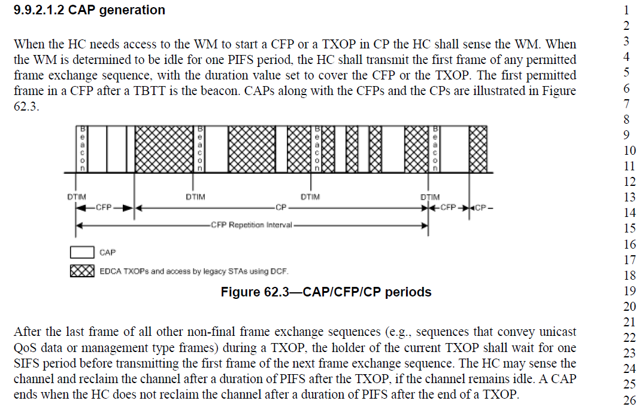
Clearly, the HC reclaims the channel at PIFS for HCCA

Note that in 10.23.3.1
“The HCCA mechanism manages access to the WM using an HC that has higher medium access priority than non-AP STAs. This allows it to transfer MSDUs to STAs and to allocate TXOPs to STAs.”

So a quick refresher on “What is an HC?”

P186.39
hybrid coordinator (HC): A type of coordinator, defined as part of the quality-of-service (QoS) facility, that implements the frame exchange sequences and medium access control (MAC) service data unit(MSDU) handling rules defined by the hybrid coordination function (HCF).

Note, however, that HCF includes EDCA and HCCA as per Clause 10.23.3.

So, when the HC is acting as an HCCA HC, the HC does use PIFS to grab the WM. The commenter is correct, we need to be clear that an HC is acting as the “HCCA” HC and not just an AP that may support HCCA (as noted by the comment).
The question is, if the AP /HC simply claims to support HCCA, can it grab the WM using PIFS, or, must the AP be acting in the “HCCA” HC role in order to do so?

Obviously the latter is the answer.
Hence, we do need to edit the sentence “When the HC needs access to the WM to start a (#65)TXOP, the HC shall sense the WM” so as to be clear that the AP is an “HCCA HC” in this case.

Question? - What distinguishes the HC when used for HCCA? Let’s go looking for clues

P1844.36 10.23.3.1. we read
“The HC is a type of centralized coordinator that grants a STA a polled TXOP with duration specified in a QoS (+)CF-Poll frame.”

Maybe the term “polled TXOP” may be the distinction plus that the HC transmits “a QoS (+)CF-Poll frame in order to start the TXOP.”

The HCCA HC starts a non-contention period using the QoS (+)CF-Poll.
Hence, as to the comment, I suggest two possible answers:
OPTION A
When the HC needs access to the WM to start a polled TXOP, the HC shall first sense the WM…
OR, to be double clear,
OPTION B
When the HC needs access to the WM to transmit a QoS (+)CF-Poll frame and start a polled TXOP,

Suggest, as does Mark, we go with Option A.

Hence I propose that the definition be modified
controlled access phase (CAP): A time period during which the hybrid coordinator (HC) maintains control of the medium using HCCA procedures. It consists of one or more consecutive polled transmission opportunities (TXOPs).It might span multiple consecutive transmission opportunities (TXOPs) and can contain polled TXOPs

4/30/20 Mark H pointed out that a CAP is when the AP maintains control. In between polled TXOPs there is a PIFS hence a new CAP each time a polled TXOP.
Changed to

controlled access phase (CAP): A time period during which the hybrid coordinator (HC) maintains control of the medium using HCCA procedures by means of a polled transmission opportunity (TXOP). It might span multiple consecutive transmission opportunities (TXOPs) and can contain polled TXOP

Checking each CAP reference, I think just one clarification is needed in a PIFS rule, so as to support the change proposed to satisfy the comment.

10.3.2.3.4
“The PIFS may be used as described in the following list and shall not be used otherwise:
P1729.46 “An HC starting (M53)a polled TXOP, as described in 10.23.3.2.2 (CAP generation)”

I think that Figure 10-29 is not correct. It appears to show 3 CAPs in the first CFP when the HC maintains control of the WM. These may well be different polled TXOPs but they are clearly the same CAP and hence are polled TXOPs. Also note that “CAP Generation” and this figure are in the “HCCA procedure” clause.

Hence, we could consider editing Figure 10-29 as follows:

4/30/20
Menzo wanted to check further.
Mark H noted that a CAP and TXOP are similar and that the CAP does not encompass several TXOPs.

6/5/20
Discussion seemed to gain the following consensus :
- HC used for EDCA and HCCA
- CAP is HCCA only
- CAP can encompass several polled TXOPs
- CAP attempts to get control of the medium using PIFS
Also, make as few changes as possible.

----------------------------------------------------------------------------------------------------------------------------
Exchanges have (eventually)settled on the following:
At 10.2.3.1
If a TXOP is obtained using the contention based channel access, it is defined as EDCA TXOP. If a TXOP is obtained using the controlled channel access, it is defined as HCCA TXOP. If an HCCA TXOP is obtained due to a QoS (+)CF-Poll frame from the HC, the TXOP is defined as a polled TXOP.

Hence, we have a set of “agreed” rules:
- A polled TXOP is an HCCA TXOP
- A CAP starts as soon as the HC grabs the medium using PIFS and includes the CF_poll (if sent)
- A CAP started by a CF_Poll solicits the first packet from the STA and sets the duration of the TXOP. This is a polled TXOP
- An AP can start a CAP by simply grabbing the medium using PIFS and transmits the first DL packet with a duration that covers the TXOP. This is an HCCA TXOP.
- HCCA TXOPs include polled TXOPs and both can exist within a CAP. The HC grants a polled TXOP to a STA. It might then grant a second TXOP to the same or another STA all within the same CAP.
  - Aside - FIG.10-20 should be edited as it seems to show 3 CAPs when a CAP can span several HCCA TXOPs

Proposed Resolution:
Revised

Make changes as shown

At P179.49
controlled access phase (CAP): A time period during which the hybrid coordinator (HC) maintains control of the medium. It might span multiple consecutive HCCA transmission opportunities (TXOPs) and can contain polled TXOPs.

At 10.23.3.2.2. P1845.13,
Change,
“When the HC needs access to the WM to start a TXOP,”
To
“When the HC needs access to the WM to start an HCCA TXOP,”

10.3.2.3.4 P1729.46, edit as follows:
“An HC starting (M53)a CAP TXOP, as described in 10.23.3.2.2 (CAP generation)”

10.23.3.2.1 P1845.6
Change
“The HC gains control of the WM as needed to send QoS traffic and to issue QoS (+)CF-Poll frames to STAs by waiting a shorter time between transmissions than the STAs using the EDCA procedures”

To

“To start an HCCA TXOP, Tthe HC gains control of the WM as needed to send QoS traffic and or to issue QoS (+)CF-Poll frames to STAs by waiting a shorter time between transmissions than the STAs using the EDCA procedures”

10.23.3.1
The HC is a type of centralized coordinator that grants a STA a polled TXOP with duration specified in a QoS (+)CF-Poll frame. A STA may transmit multiple frame exchange sequences within given polled TXOPs, subject to the limit on TXOP duration.

10.23.3.2.2 , make changes as shown.
When the HC needs access to the WM to start a (#65)TXOP CAP, the HC shall sense the WM. When the WM is determined to be idle at the TxPIFS slot boundary as defined in 10.3.7 (DCF timing relations), the HC shall transmit either a QoS (+)CF-Poll the first frame of any permitted frame exchange sequence , with the duration value set to cover the polled TXOP, or the first frame of any permitted frame exchange sequence with the duration value set to cover the HCCA TXOP. (#65). An HCCA TXOP A CAP shall not extend across a TBTT. The occurrence of a TBTT implies the end of the TXOP CAP, after which the regular channel access procedure (EDCA or HCCA) is resumed. It is possible that no Data frame was transmitted during the an HCCA TXOP. The shortened termination of the HCCA TXOP does not imply an error condition. (#65)CAPs are illustrated in Figure 10-29 (CAP periods(#65)).

After the last frame of all other nonfinal frame exchange sequences (e.g., sequences that convey individually addressed QoS Data or Management frames) during an HCCA TXOP, the holder of the current HCCA TXOP shall wait for one SIFS before transmitting the first frame of the next frame exchange sequence. The HC may sense the channel and reclaim the channel if the WM is determined to be idle at the TxPIFS slot boundary after the HCCA TXOP (see Figure 10-26 (EDCA mechanism timing relationships)). A CAP ends when the HC does not reclaim the channel at the TxPIFS slot boundary after the end of a TXOP.

At P1845.22
Edit Figure 10-29 as follows to show HCCA TXOPs inside a CAP
Note to Editor: Dotted lines within the first CAP

