IEEE P802.11
Wireless LANs
Resolution for CMMG related CIDs 4559 and 4600
Date: 2020-03-27
Author:
Name | Affiliation | Address | Phone | Email
Shiwen He | Central South University |  |  | shiwen.he.hn@csu.edu.cn
Haiming Wang | South East University |  |  | hmwang@seu.edu.cn
Dejian Li | HiSilicon |  |  | lidejian@hisilicon.com
Jiamin Chen | HiSilicon |  |  | jiamin.chen@hisilicon.com
Edward Au | Huawei Technologies |  |  | edward.ks.au@huawei.com

This submission present proposed resolution for CIDs 4559 and 4600. The proposed changes are based on REVmd/D3.0.

Revision history:

R0 – initial version
R1 – editorial fix in the proposed resolution of CID 4559

CID | Clause | Page | Line | Comments | Proposed Change
4559 | 25.7.2.3 | 3545 | 38 | “A value of N in the Training Length field indicates that the AGC has 4N subfields and that the TRN- R/T field has 5N subfields." but 20.9.2.2.3 (referred to from Table 25-7--Fields in the CMMG SIG field) says "A value of N in the Training Length field indicates 4xN AGC subfields and that the TRN-R/T field has N TRN Units." so there is duplication and possibly also contradiction | Delete the xref to 20.9.2.2.3 in Table 25-7

Discussion:
The following is the paragraph of interest as pointed out by the commenter:
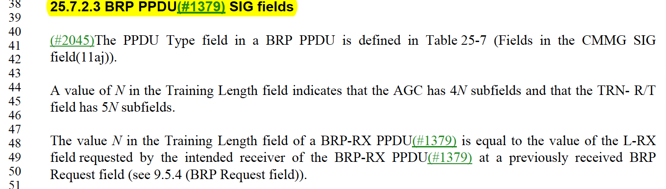
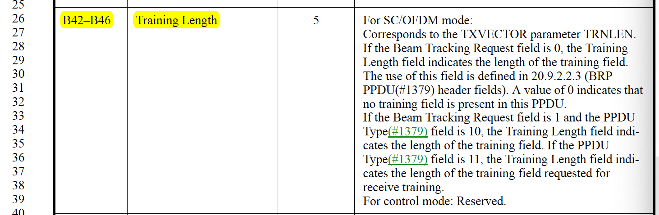

Proposed Resolution:
Revised
At page 3545, lines 44-46,
change
“A value of N in the Training Length field indicates that the AGC has 4N subfields and that the TRN- R/T field has 5N subfields.”
to
“A value of N in the Training Length field indicates that the AGC has 4N subfields and that the TRN-R/T field has N subfields.”.

At page 3505, lines 26-39,
change
B42-46 | Training Length | 5 | For SC/OFDM mode:  Corresponds to the TXVECTOR parameter TRNLEN.  If the Beam Tracking Request field is 0, the Training Length field indicates the length of the training field.  The use of this field is defined in 20.9.2.2.3 (BRP PPDU header fields). A value of 0 indicates that no training field is present in this PPDU.  If the Beam Tracking Request field is 1 and the PPDU Type field is 10, the Training Length field indicates the length of the training field. If the PPDU Type field is 11, the Training Length field indicates the length of the training field requested for receive training.  For control mode: Reserved.

to
B42-46 | Training Length | 5 | For SC/OFDM mode:  Corresponds to the TXVECTOR parameter TRNLEN.  If the Beam Tracking Request field is 0, the Training Length field indicates the length of the training field.  The use of this field is defined in 25.7.3.2 (BRP PPDU SIG fields). A value of 0 indicates that no training field is present in this PPDU.  If the Beam Tracking Request field is 1 and the PPDU Type field is 10, the Training Length field indicates the length of the training field. If the PPDU Type field is 11, the Training Length field indicates the length of the training field requested for receive training.  For control mode: Reserved.

CID | Clause | Page | Line | Comments | Proposed Change
4600 | 25.3.10 | 3507 | 21 | References to duplicate transmission for CMMG should use the term "CMMG-duplicate", by analogy with "HT-duplicate" | As it says in the comment

Discussion:
The following is the paragraph of interest as pointed out by the commenter:
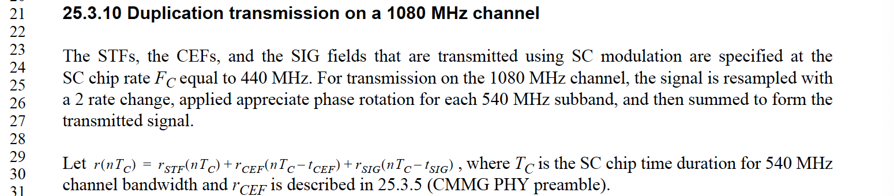
Proposed Resolution:
Revised
At page 3507, line 26,
change
“25.3.10 Duplication transmission on a 1080 MHz channel”
to
“25.3.10 CMMG duplicate transmission on a 1080 MHz channel”

At page 3497, lines 50-53,
change
“NOTE—All fields are transmitted with SC mode transmission. For 1080 MHz SC transmission, the STFs, the CEFs, and the SIG fields are transmitted (#2037)in duplicate format as defined in 25.3.10 (Duplication transmission on a 1080 MHz channel).”

to
“NOTE—All fields are transmitted with SC mode transmission. For 1080 MHz SC transmission, the STFs, the CEFs, and the SIG fields are transmitted (#2037)in duplicate format as defined in 25.3.10 (CMMG duplicate transmission on a 1080 MHz channel).”

At page 3499, lines 1-3,
change
“NOTE—All fields are transmitted with SC mode transmission. For 1080 MHz SC mode transmission, the STFs, the CEFs, and the SIG fields are transmitted (#2037)in duplicate format as defined in 25.3.10 (Duplication transmission on a 1080 MHz channel).”
to
“NOTE—All fields are transmitted with SC mode transmission. For 1080 MHz SC mode transmission, the STFs, the CEFs, and the SIG fields are transmitted (#2037)in duplicate format as defined in 25.3.10 (CMMG duplicate transmission on a 1080 MHz channel).”

At page 3450, lines 1-3,
change
“NOTE—The STFs, the CEFs, and the SIG fields are transmitted with SC mode transmission. For 1080 MHz SC mode transmission, the STFs, the CEFs, and the SIG fields are transmitted (#2037)in duplicate format as defined in 25.3.10 (Duplication transmission on a 1080 MHz channel)..”
to
“NOTE—The STFs, the CEFs, and the SIG fields are transmitted with SC mode transmission. For 1080 MHz SC mode transmission, the STFs, the CEFs, and the SIG fields are transmitted (#2037)in duplicate format as defined in 25.3.10 (CMMG duplicate transmission on a 1080 MHz channel).”

At page 3516, lines 26-30,
change
“25.5.5.4.4 Duplication
If the channel bandwidth is 1080 MHz, the modulated SIG symbols are (#2037)transmitted in duplicate format as defined in 25.3.10 (Duplication transmission on a 1080 MHz channel).”
to
“25.5.5.4.4 Duplication
If the channel bandwidth is 1080 MHz, the modulated SIG symbols are (#2037)transmitted in duplicate format as defined in 25.3.10 (CMMG duplicate transmission on a 1080 MHz channel).”

At page 3522, lines 50-53,
change
“When the TXVECTOR parameter DUPLICATE_MODULATION is present, the transmitted PPDU is a duplicate. The modulated data symbols are duplicated as described in 25.3.10 (Duplication transmission on a 1080 MHz channel).”
to
“When the TXVECTOR parameter DUPLICATE_MODULATION is present, the transmitted PPDU is a duplicate. The modulated data symbols are duplicated as described in 25.3.10 (CMMG duplicate transmission on a 1080 MHz channel).”

At page 3528, lines 1-3,
change
“If the channel bandwidth is 1080 MHz, the modulated SIG symbols are duplicated as described in 25.3.10 (Duplication transmission on a 1080 MHz channel).”
to
“If the channel bandwidth is 1080 MHz, the modulated SIG symbols are duplicated as described in 25.3.10 (CMMG duplicate transmission on a 1080 MHz channel).”

