IEEE P802.11
Wireless LANs
Initial SA ballot comments assigned to Hamilton
Date: 2020-07-30
Author(s):
Name | Affiliation | Address | Phone | email
Mark Hamilton | Ruckus/CommScope | 350 W Java Dr  Sunnyvale, CA 94089 | +1.303.818.8472 | mark.hamilton2152@gmail.com
Abstract

This submission contains comments on REVmd initial SA ballot, assigned to Mark Hamilton for preparation of proposed resolutions.

The first section contains comments with proposed resolutions ready for review or discussion by TGmd. The latter sections are comments not ready for discussion yet, or already completed.

R0 – initial version. CIDs ready for TGmd review or discussion: 4553, 4809, 4599, 4594, 4570, 4642, 4555, 4652, 4534, 4528, 4524, 4585, 4567, 4511, 4507, 4492, 4491, 4561, 4774.
R1 – Miscellaneous changes, marked in blue highlight, based on off-line review/discussion.
R2 – Agreed resolutions marked in green highlight: CIDs 4553, 4809, 4599, 4594, 4570, 4642, 4555, 4652, 4528, 4524, 4585, 4511, 4507, 4492, 4491, 4561.
R3 – Updated resolutions proposed with updates highlighted in blue for CIDs: 4534, 4567, 4774, 4392, 4653, 4325, 4445. CIDs with resolutions ready for review: 4808, 4462. Not ready yet: 4806, 4805.
R4 – Agreed resolutions marked in green highlight: CIDs: 4534, 4567, 4774, 4392, 4653, 4325, 4445, 4808, 4462.
R5 – CIDs with resolutions ready for review: 4802, 4799, 4797, 4347, 4351, 4349, 4641, 4782, 4488, 4723, 4722, 4658, 4795, 4234, 4318, 4317, 4309, 4295, 4285, 4253, 4490, 4240.
R6 – Agreed resolutions marked in green highlight: CIDs: 4802, 4799, 4797, 4347, 4351, 4349, 4641, 4782, 4488, 4722, 4658, 4795, 4234, 4318, 4317, 4309, 4295, 4285, 4253, 4490, 4240. Updated resolutions proposed with updates highlighted in blue for CIDs: 4723. CIDs with resolutions ready for review: 4221, 4193, 4068, 4067, 4243, 4377, 4056, 4485, 4454, 4447, 4442, 4418.
R7 – Minor updates to CIDs 4723, 4221, 4067, 4377, 4056, 4454, 4447, 4418, from reviewer comments.
R8 – Agreed resolutions marked in green highlight: CIDs: 4193, 4068, 4067, 4243, 4056, 4454, 4447. CIDs for revisit by the TG on a future call (in blue highlight): CIDs: 4723, 4221, 4377, 4485. CIDs ready for (first time) review: 4442, 4418.
R9 – Agreed resolutions marked in green highlight: CIDs: 4377, 4485, 4442, 4418. CID ready to be reviewed again: 4221. CIDs with resolutions ready for review: 4814, 4780, 4323, 4342, 4376, 4373 4371, 4370, 4410, 4489.
R10 – Agreed resolutions marked in green highlight: CIDs: 4221, 4814, 4780, 4323, 4342, 4376, 4373 4371, 4410, 4489.
R11 – Added proposed resolutions for CIDs: 4768, 4771, 4419, 4380.
R12 – Removed CID 4419 (it is already resolved by 11-20/0690r1).
R13 – Agreed resolutions marked in green highlight: CIDs: 4768, 4771, 4380.
R14 – CIDs ready for TG review: 4479, 4677.
R15 – Agreed resolutions marked in green highlight: CIDs 4479, 4677. Updated resolutions proposed with updates highlighted in blue for CIDs: 4652, 4653.

For review by TG:

All page/line references are per REVmd D3.0.

CID | Page | Clause | Comment | Proposed Change
4652 | 885.35 | 9.3.3.11 | "conditionally present" is not clear | Change to "present"
4653 | 885.35 | 9.3.3.11 | "conditionally present" is not clear | Change to "optionally present"

Discussion:

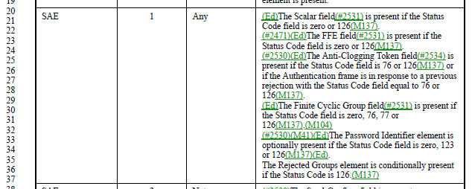

The concept/phrase “conditionally present” does not appear anywhere else in a clause 9 table – there are a couple uses within the text.

Agree with the commenter.

Proposed Resolution:

Accepted. (CID 4652)

To answer the question on optionality, we look at P2574, in subclause 12.4.5.4, Processing of a peer’s SAE Commit message:

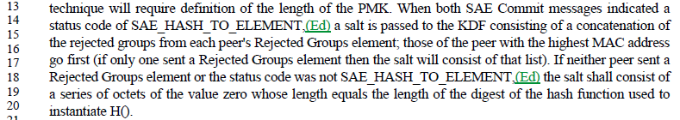

As status code 126 is SAE_HASH_TO_ELEMENT (per Table 9-52), the “conditionally present” referenced in Table 9-43 is on condition of that status code, as described in the above paragraph. The above paragraph makes it clear that either endpoint may send no Rejected Groups element, even when the status code is SAE_HASH_TO_ELEMENT.

Thus, it is correct/appropriate that “optionally present” is the correct phrase.

Proposed Resolution:

Accepted. (CID 4653)

Also,

Revisit CID 4652, and change that resolution to:
Revised. Change to "optionally present"

After off-line review/discussion with Jouni and Dan:

I agree that "optionally present" would be incorrect description here. That element shall be included under certain conditions. Not doing so would result in security properties of the design being broken (losing protection against downgrade attacks). Clause 9 is not the place to go into details for such conditions, but the "conditionally present" is still the most appropriate way of describing this case there. If we need to have a reference to somewhere in Clause 12 to make this clearer, that's fine.

Not sure what the best choice is here. I see your point about not making it appear that this is a relatively arbitrary choice by the transmitter. But, a statement that this is conditional, with no hint as to what the conditions are doesn’t seem good. Let me think about it. (Or, I’m open to suggestions. Maybe leave it as conditional, with the reference to clause 12, as Jouni mentioned…)

Proposed Resolution:

Revised.

Change the referenced sentence to, “The Rejected Groups element is conditionally present if the Status Code is 126, as described in 12.4.7.4.”

Marked as “Insufficient detail”, until/unless a submission is provided:

CID | Page | Clause | Comment | Proposed Change

Not ready for review, yet:

CID | Page | Clause | Comment | Proposed Change
4370 | 1353.29 | 9.4.2.167 | "Fine Timing Request" -- no such frame | Change to "initial Fine Timing Measurement Request frame"

Discussion:

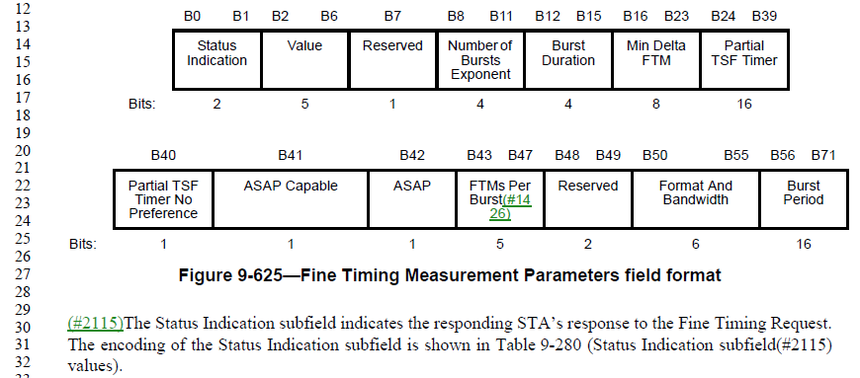

This is in reference to the Status Indication subfield of the Fine Timing Measurement Parameters element.

The occurrence of this element appears to be confused/confusing. The comment suggests changing the cited text to “initial Fine Timing Measurement Request frame".

It might be carried in the in initial Fine Timing Measurement Request frames:

P1555.14:

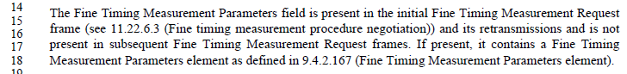

And, P2373.39:

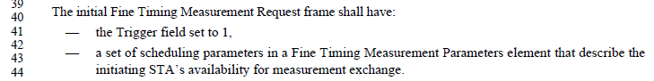

But, it might be carried in the initial Fine Timing Measurement frames (not “Request” frames):

P1557.31:

And, P2373.49

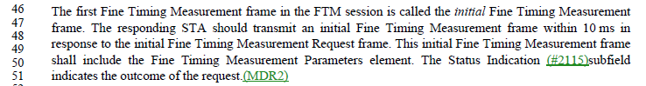

It seems this could be in either frame type.

Proposed Resolution: - consider off-line, bring back

Revised.

Change “Fine Timing Request” to “initial Fine Timing Measurement Request frame or initial Fine Timing Measurement frame” at the cited location.

Also, at 1557.29, replace “Fine Timing Measurement Frame” with “Fine Timing Measurement frame” (lowercase).

CID | Page | Clause | Comment | Proposed Change
4723 | 1165.59 | 9.4.2.47 | "The Wrapped Key field contains the encrypted GTK" is confusing -- is it wrapped or encrypted? | Change to "The Wrapped Key field contains the wrapped GTK"

Discussion:

The comment is in reference to the GTK subelement, one of the optional subelements of the Fast BSS Transition element.

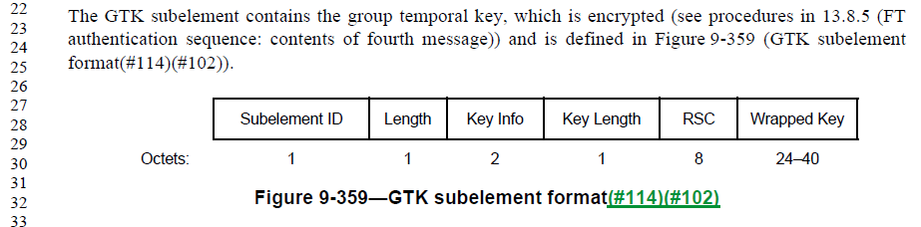

Per clause 13.8.5 referenced in the cited sentence, the GTK is “encrypted using KEK or KEK2 and the NIST AES key wrap algorithm.”

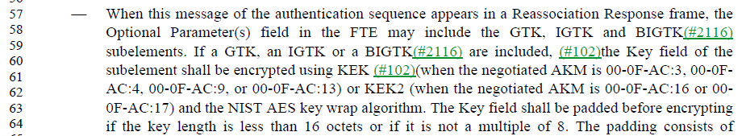

So, the 13.8.5 text does describe the process as both encryption and wrapping. .

Update after June 3 telecon:

Per off-line discussion, and investigation into the AES key wrap algorithm, the KEK or KEK2 are used as the keys for an encryption process (per RFCs 3394 and 5649), and this process is how the key is wrapped. So, encryption and wrapping are the same thing.

The baseline sentence could be clarified. Something like “"wrapped with the AES Key Wrap algorithm using KEK (...) or KEK2 (...). ..."” rather than saying it is encrypted.

There is similar usage of the “encrypted” wording in the description of the Authenticator state machine:

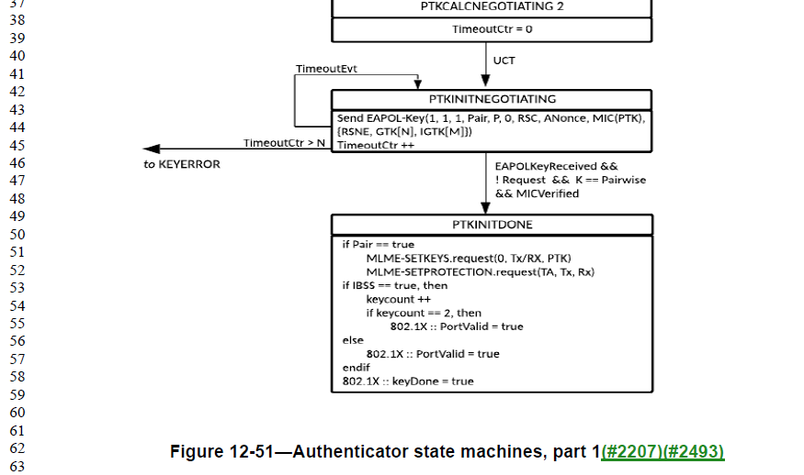

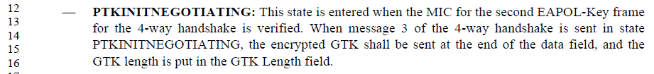

We also need to consider the usage of “Encrypted” in Figures 4-32 and 4-33:
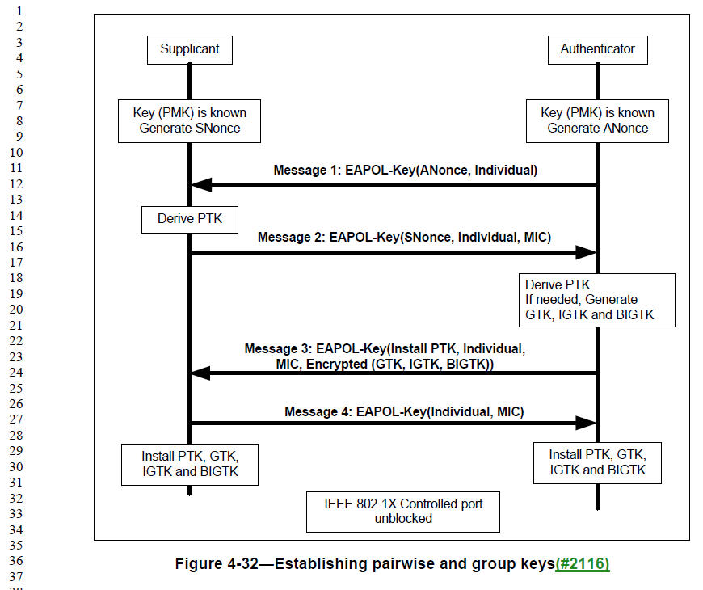

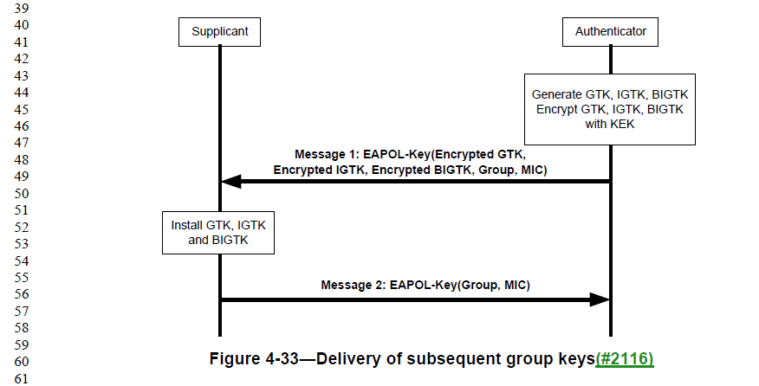

While we’re at it, why does Figure 4-32 have a box around it, but Figure 4-33 does not?

And, why does the EAPOL-Key carry an “Encrypted(GTK, IGTK, BIGTK)” in Figure 4-32, but it carries “Encrypted GTK, Encrypted IGTK, Encrypted BIGTK” in Figure 4-33?

Proposed Resolution:

Revised.

Change “encrypted GTK” to “wrapped GTK” (as requested by the commenter). Same thing at P2698.15 (in the description of the Authenticator state machine).

Similarly, replace “Encrypted” with “Wrapped” in Figures 4-32 and 4-33.

In 13.8.5 (P2748.59), change “shall be encrypted using KEK … and the NIST AES key wrap algorithm.” to “shall be wrapped with the NIST AES key wrap algorithm using KEK … or KEK2 …” (Delete the “and the NIST AES key wrap algorithm” from the end of the sentence.)

At P2668.7 and P2668.10, change “key-wrap” to “key wrap”

Since agreement on the June 10 telecon:

- If you check out table 12-10, AKMs 00-0F-AC:14-17 use AES-SIV
- There is no padding needed with AES-SIV.
- So, we now have wrapping algorithms other than “NIST AES Key Wrap”, and padding is conditional. The baseline text was wrong on this aspect. This is now a technical change/fix.

Proposed Resolution:

Revised.

Change “encrypted GTK” to “wrapped GTK” (as requested by the commenter). Same thing at P2698.15 (in the description of the Authenticator state machine).

Similarly, replace “Encrypted” with “Wrapped” in Figures 4-32 and 4-33.

In 13.8.5 (P2748.59), change
“If a GTK, an IGTK or a BIGTK(#2116) are included, (#102)the Key field of the subelement shall be encrypted using KEK (#102)(when the negotiated AKM is 00-0F-AC:3, 00-0FAC:4, 00-0F-AC:9, or 00-0F-AC:13) or KEK2 (when the negotiated AKM is 00-0F-AC:16 or 00-0F-AC:17) and the NIST AES key wrap algorithm. The Key field shall be padded before encrypting if the key length is less than 16 octets or if it is not a multiple of 8.”
to
“If a GTK, an IGTK or a BIGTK are included, the Key field of the subelement shall be wrapped using KEK and/or KEK2 and the appropriate key wrap algorithm, as specified in Table 12-10.”

At P2668.7 and P2668.10, change “key-wrap” to “key wrap”.

CID | Page | Clause | Comment | Proposed Change
4422 | 1834.17 | 10.23.2.7 | "Frames from the primary AC shall be transmitted first." is not clear: does it mean at least one (or two?) shall be transmitted, or does it mean all available shall be transmitted (cf.previous bullet) | Change to "All frames from the primary AC shall be  transmitted first"

Disucssion:

xxxxxx

CID | Page | Clause | Comment | Proposed Change
4154 | 1827.61 | 10.23.2.2 | The subbullets all refer to "that AC" but there is no reference for "that" | Add the words "corresponding to an AC" in the introductory phrase which immediately precedes item a), so that it reads, "The backoff procedure shall be invoked by an EDCAF corresopnding to an AC when"

Disucssion:

xxxxxx

CID | Page | Clause | Comment | Proposed Change
4806 | 2235.37 | 11.3.5.3 | Sub-bullet (2) requires allocation of multiple, distinct AIDs for the STAs in the MMS element. How is this allocation communicated back to those STAs? | Add facility (Association Response frame contents, and MLME-ASSOCIATE.response parameter) to communicate these AIDs back to the peer.
4805 | 2235.34 | 11.3.5.3 | This text requires an MMS element be passed to the MLME-ASSOCIATION.response (sic), under some circumstances. The MLME-ASSOCIATE.response primitive has no such parameter. Add it. | Insert a row for an MMS paramter in the parameters table for the MLME-ASSOCIATE.response. Match the contents to the MMS row in the parameters Table in the MLME-ASSOCIATE.request, except change the Description to "Specifies the parameters within the Multiple MAC Sublayers element that are supported by the MAC entity, and were received from the MM-SME coordinated STA. The parameter is present if dot11MultipleMACActivated is  true and the corresponding MLME-ASSOCIATE.indication primitive included an MMS parameter, and is absent otherwise."

Discussion:

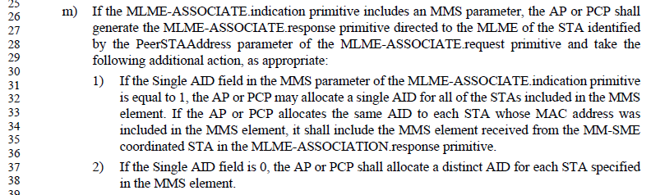

Similarly, for the MLME-REASSOCIATE:
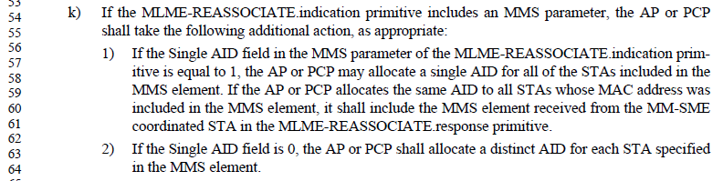

A check of the (Re)Association Request and (Re)Association Response frames (subclause 9.3.3) shows that they carry a Multiple MAC Sublayers element. However, the Multiple MAC Sublayers element does not carry AID(s) to be assigned to one or more requesting STA entities.

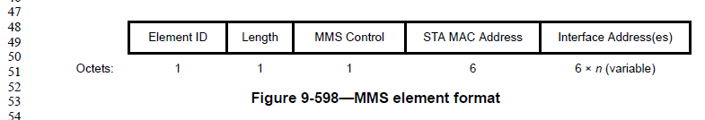

Table 9-94 says that the Multiple MAC Sublayers element is Extensible. However, there appears to be no indication of the number of Inferface Address(es) included in the element (that is, the value of ‘n’). However, the MMS element returned by the AP/PCP is the same one received from the request, in some scenarios, so in those cases the requesting MM-SME should know the value of “n”. In other cases, it is not clear how, or if, the Interface Address(es) field is formatter, or if the requesting MM-SME can parse an extension to the element.

So, despite the element claiming it is extensible, this is not obviously correct. It is probably safer to create a new element to carry the AID(s) in the response, rather than try to extend the MMS element.

Shifting consideration to the response primitives, it can be seen that the MLME-(RE)ASSOCIATE request, indication and confirm primitives have an MMS parameter. However, the MLME-(RE)ASSOCIATE.response primitive does not have such a parameter. This response primitive will need a parameter at least to pass the AID(s) (the new element mentioned above), but it seems to need the MMS element as well, to indicate whether the “Single AID” request was satisfied, or if the AP/PCP elected to allocate distinct AIDs for each STA in the request.

For purposes of carrying the AID assignments to the Interface Address(es), the AID Announcement element would appear to serve the purpose well:

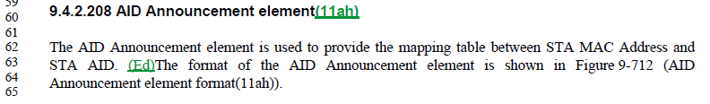
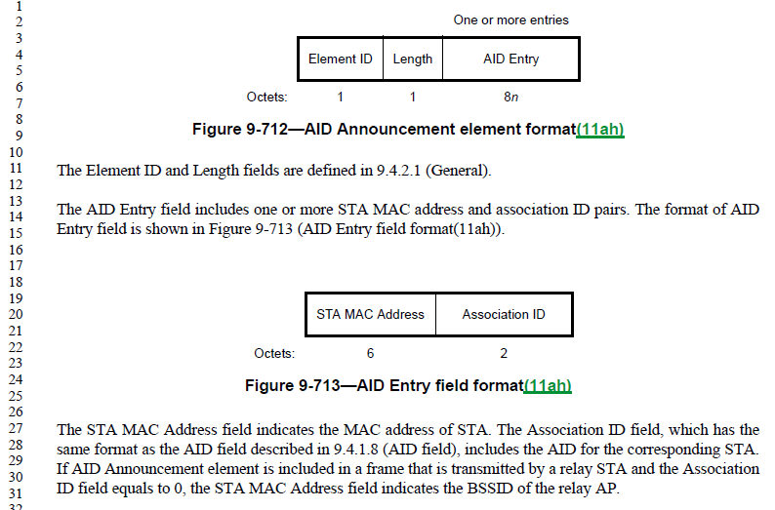

Proposed Resolution:

Revised.

In subclause 6.3.7.5.2 (Semantics of the [MLME-ASSOCIATE.response] service primitive) add a parameter in the parameter list: “MMS”, before the “FILSHLPContainer” parameter. Add a row in the parameter description table before the “FILSHLPContainer” row, with:
- Name=”MMS”,
- Type=”Multiple MAC Sublayers element”,
- Valid range=”As defined in 9.4.2.152”, and
- Description=”Specifies the parameters within the Multiple MAC Sublayers element that are supported by the MAC entity, and negotiated for the association. The parameter is present if dot11MultipleMACActivated is true and is absent otherwise.”

In subclauses:
- 6.3.7.5.2 (Semantics of the [MLME-ASSOCIATE.response] service primitive),
- 6.3.7.3.2 (Semantics of the [MLME-ASSOCIATE.confirm] service primitive),
- 6.3.8.5.2 (Semantics of the [MLME-REASSOCIATE.response] service primitive), and
- 6.3.8.3.2 (Semantics of the [MLME-REASSOCIATE.confirm] service primitive):
  - add a parameter in the parameter list: “AIDAnnouncement” immediately before the “VendorSpecificInfo” parameter.
  - add a row in the parameter description table, immediately before the VendorSpecificInfo row:
    - Name=“AIDAnnouncement”,
    - Type=”AID Announcement element”,
    - Valid range=”As defined in 9.4.2.208”,
    - Description=”Specifies the mapping from MAC Address(es) to assigned AID(s) for all of the STAs included in the MMS element. The parameter is present if dot11MultipleMACActivated is true, the corresponding MLME-[RE]ASSOCIATE.indication had an MMS parameter present, and distinct AIDs are assigned for each STA in the request per 11.3.5.3 [11.3.5.5 for REASSOCIATE]. The parameter is absent otherwise.”

In subclauses 9.3.3.6 (Association Response frame format) and 9.3.3.8 (Reassociation Response frame format), in the frame body Table, add a row before the Vendor Specific row:
- Order=<next value>
- Information=”AID Announcement”
- Notes=”The AID Announcement element is present if dot11MultipleMACActivated is true, the corresponding [Re]Association Request frame had a Multiple MAC Sublayers parameter present, and distinct AIDs are assigned for each STA in the request per 11.3.5.3 [11.3.5.5 for Reassociation]. The parameter is absent otherwise.”

In subclause 11.3.5.3, bullet (m), subbullet (2), add to the end, “, and shall include an AID Announcement element in the MLME-ASSOCIATION.response primitive indicating the AID assignments.”

In subclause 11.3.5.5, bullet (k), subbullet (2), add to the end, “, and shall include an AID Announcement element in the MLME-REASSOCIATION.response primitive indicating the AID assignments.”

In subclause 11.3.5.2, bullet (f), change “Single AID … is equal to 1” to xxxxxxxxxx

In subclause 11.3.5.2, insert a new bullet after bullet (f): “If an Association Response frame is received with a status code of SUCCESS at an MM-SME coordinated STA and the Single AID field within the MMS element is equal to 0, the MLME shall xxxxxxxxxx

In subclause 11.3.5.4, insert a new bullet after bullet (e): xxxxxxxxxx

CID | Page | Clause | Comment | Proposed Change
4709 | 0.00 | 10.6.7 | The CMMG rules being separated (in 10.6.8) causes the exclusion rules structure of 10.6.5.x to be confusing or broken. DMG started it with 10.6.7. | Delete 10.6.7 and 10.6.8
4708 | 0.00 | 10.6.7 | The CMMG rules being separated (in 10.6.8) causes the exclusion rules structure of 10.6.5.x to be confusing or broken. DMG started it with 10.6.7. | Merge 10.6.7 and 10.6.8 into 10.6.5. I think perhaps the other Mark has some ideas about this

Discussion:

xxxxxx

CID | Page | Clause | Comment | Proposed Change
4700 | 0.00 | 9.4.5 | Instead of ISO 14962 just refer to ASCII | In 9.4.5.4 and 9.4.5.21 change " is a 3-octet ISO 14962:1997 encoded string" to " is an ASCII string" and "ISO 14962:1997)" to "ASCII)"

Disucssion:

xxxxxx

Completed:

CID | Page | Clause | Comment | Proposed Change
4553 | 1748.00 | 10.3.2.12 | "the fragment BA procedure described in this subclause" -- there is no other fragment BA procedure than the one in this subclause | Delete " described in this subclause" (3x)

Discussion:

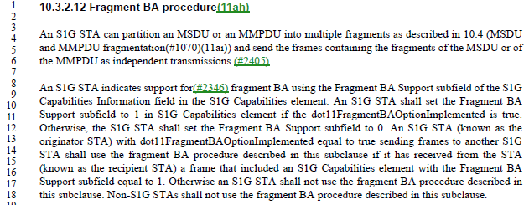

Arguably, it is helpful to be very clear that an S1G STA uses the procedure described in this subclause, and not the procedure described in 10.4, given the mention of partitioning MSDUs/MMPDUs per 10.4 in the prior paragraph.

“described in this subclause” could perhaps be parenthetical “(described in this subclause)” since saying “shall use the fragment BA procedure” is a complete specification. However, this is not the usual style in the Draft. The repetition of this information three times is excessive, however.

Proposed Resolution:

Revised.

At P1748.17, delete “described in this subclause”. Same thing at P1748.18.

At P1748.14, change “described in this subclause” to “, as described in this subclause,”. At line 13, replace “sending frames” with “sending an MSDU or MMPDU (whether fragmented or not)”

CID | Page | Clause | Comment | Proposed Change
4809 | 1589.40 | 9.6.12.3 | Change 6 occurrences of "in response to a received", to be simpler and match the majority language in the draft. | Delete "received" (and change "a" to "an" as appropriate) at P1589L40, P1590L53, P1592L56, P2180L1, P2482L30, and P2482L39.

Discussion:

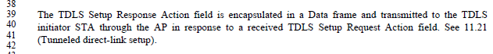

Agree with the comment, “in response to a TDLS Setup Request Action field” is simpler, and consistent with style elsewhere in the Draft.

The other locations are similar.

Proposed Resolution:

Accepted.

CID | Page | Clause | Comment | Proposed Change
4599 | 2487.52 | 11.32.5 | "A receiving TR-MLME may silently ignore the received On-channel Tunnel Request frame if  that frame is not targeting an NT-MLME in the same multi-band capable device with the TR-MLME." -- it has no choice but to ignore it. Also "with" should be "as" | Change to "A receiving TR-MLME shall silently ignore the received On-channel Tunnel Request frame if  that frame is not targeting an NT-MLME in the same multi-band capable device as the TR-MLME."

Discussion:

Agree with the commenter (on both points).

Also, “silently ignore” is duplicative; what other way can something be “ignored”?

Proposed Resolution:

Revised.

Replace
A receiving TR-MLME may silently ignore the received On-channel Tunnel Request frame if
that frame is not targeting an NT-MLME in the same multi-band capable device with the TR-MLME.
with
A receiving TR-MLME shall ignore the received On-channel Tunnel Request frame if
that frame is not targeting an NT-MLME in the same multi-band capable device as the TR-MLME.

CID | Page | Clause | Comment | Proposed Change
4594 | 1487.36 | 9.4.5.20 | "The Venue Number field identifies the position (1 = 1st, 2 = 2nd, and so on) of the corresponding Venue Name Tuple subfield in a Venue Name ANQP-element from the same STA, as defined in 9.4.5.4 (Venue Name ANQP-element). If that same STA does not advertise a Venue Name ANQP-element, or does not advertise any Venue Name Tuple subfields in the Venue Name ANQP-element, then the Venue Number field is set to 0." -- second sentence implies there can only be at most one Venue Name ANQP-element | Change "a" to "the" in the first sentence

Discussion:

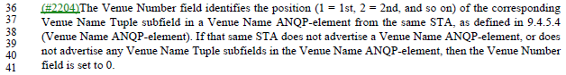

Unpacking the first sentence a bit:
- The STA might send a Venue Name ANQP-element, which contains zero or more venue names in Venue Name Tuples, as seen in 9.4.5.4:

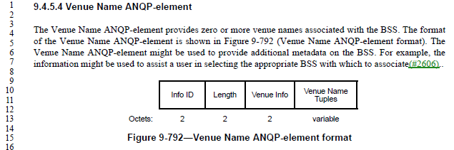

- There is only one Venue Name ANQP-element transmitted, as implied by 11.23.3.3.11 (note the use of “the” in this text):

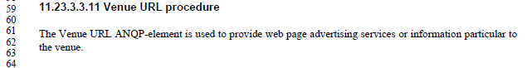
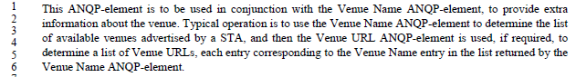

- The Venue Number field is used to carry an ‘index’ into the Venue Name Tuples, as described in the cited text. If there were more than one Venue Name ANQP-element from the same STA, this indexing would be ambiguous as to which Venue Name Tuples list was being referenced.

Thus, agree with the commenter, there is only one (at most) Venue Name ANQP-element from this STA, so the article should be “the” to reference this specific, single element.

Proposed Resolution:

Accepted.

CID | Page | Clause | Comment | Proposed Change
4570 | 1656.52 | 9.6.20.7 | "The MMPDU Frame Body subfield carries the content of the Frame Body field of an MMPDU that would  be constructed if the MMPDU for the corresponding management frame type were transmitted  (#2562)unencrypted over the air" -- well, the thing that is constructed is an MPDU, not an MMPDU, which (for an unencrypted case) goes straight into the Frame Body field | Change to "The MMPDU Frame Body subfield carries the content of the Frame Body field of an MPDU carrying the MMPDU that would  be constructed if the MMPDU for the corresponding management frame type were transmitted  (#2562)unencrypted over the air"

Discussion:

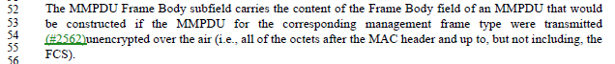

It is a management frame (which is by definition, a type of MPDU) that contains a Frame Body.

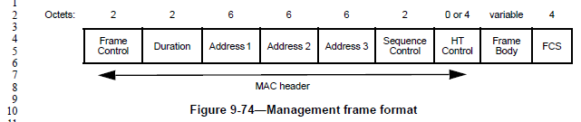
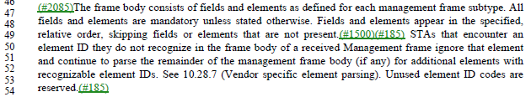

The management frame’s Frame Body is not described as carrying an MMPDU, but conceptually the “fields and elements … defined for each management frame subtype” comprise the “unit of data exchanged between two peer MAC entities … to implement the MAC management protocol”, which is the definition of MMPDU (see below). So, this is roughly equivalent.

So, agree with the commenter that the simplest way to describe this Frame Body is that it is the same Frame Body that would be in a management MPDU that conceptually is carrying the MMPDU.

Proposed Resolution:

Accepted.

CID | Page | Clause | Comment | Proposed Change
4642 | 0.00 | 10.42.7 | The MAC can't determine whether the dot11BeamTrackingTimeLimit came from the SME, the MAC or the default | Delete "from the SME" at 2061.54, "from SME" at 2062.5

Discussion:

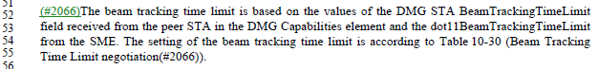

Agree with the commenter.

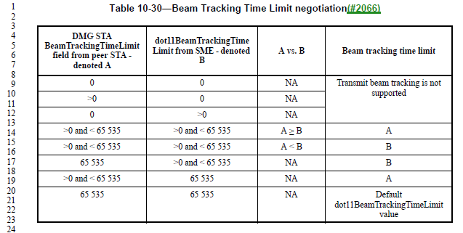

Agree with the commenter.

Proposed Resolution:

Accepted.

CID | Page | Clause | Comment | Proposed Change
4555 | 1721.54 | 10.2.6 | "increasing the probability of successful transmission (as defined in 10.2.2 (DCF))" -- 10.2.2 doesn't define successful transmission (this seems to be defined in 3.2 | Delete the parenthetical

Discussion:

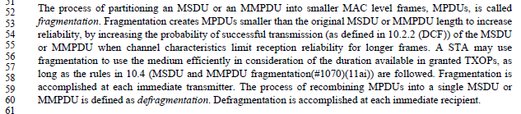

Agree with the commenter, this concept has been moved to the definitions (subclause 3.2):

Proposed Resolution:

Accepted.

CID | Page | Clause | Comment | Proposed Change
4528 | 1354.43 | 9.4.2.167 | "The Partial TSF Timer subfield value is derived as follows, so as to have units  of TUs: from the 64 TSF timer bits at the start of the first burst instance of an FTM session and remove the  most significant 38 bits and the least significant 10 bits." is garbled | Delete the first "and " in the cited text

Discussion:

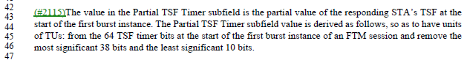

Agree with the commenter. However, inserting a comma might be helpful, as the introductory clause is somewhat long and complex.

Proposed Resolution:

Revised.

At P1354.45, replace the “and” with a comma.

CID | Page | Clause | Comment | Proposed Change
4524 | 2487.43 | 11.32.5 | The notion of a "request" or "response" tunnelled MMPDU is referred to but not defined | At the start of 11.32.5 add a para "A request tunnelled MMPDU is an MMPDU generated in the context of an MLME .request primitive. A response tunnelled MMPDU is an MMPDU generated in the context of an MLME .response primitive."

Discussion:

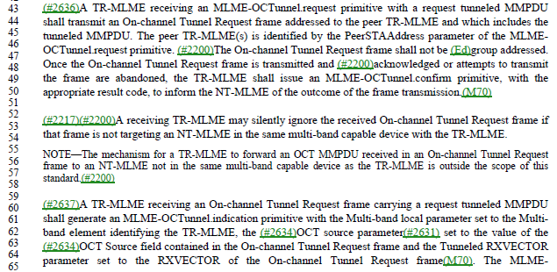

Similar text occurs at P2488.48 and P2488.57 for a “response tunnelled MMPDU”.

Figure 11-53 can help put these situations in context:

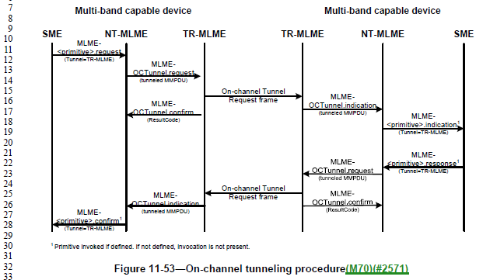

As can be seen in Figure 11-53, the text is attempting to identify the TR-MLME on the left (identified as getting a MLME-OCTunnel.request) and the TR-MLME on the right (identified as getting an On-channel Tunnel Request frame), as these are getting the “forward path” events in the Figure. The text goes on to also identify these two TR-MLMEs in the context of the “return path”, which has the same events. The difference between the forward path and the return path is only in the nature of the tunnelled MMPDU, being either a request MMPDU or a response MMPDU.

However, in agreement with the commenter, the terms "request tunnelled MMPDU " or "response tunnelled MMPDU” are never defined, as the method to convey this distinction.

The start of 11.32.5, where the commenter proposes to add text to define these terms, is the general introduction to the operation of OCT. It would not make sense to start with the introduction of these detailed terms before the introductory text is understood. So, “at the start” of 11.32.5 is probably not the right place. The procedure details start at P2487.16, and this is probably a better place for it.

A bit of introductory text for these terms would also help.

Proposed Resolution:

Revised.

At P2487.15, insert a new paragraph:
‘In the following procedure, a “request tunnelled MMPDU” is an MMPDU generated in the context of an MLME .request primitive. A “response tunnelled MMPDU” is an MMPDU generated in the context of an MLME .response primitive.’

CID | Page | Clause | Comment | Proposed Change
4585 | 1526.06 | 9.6.6.6 | Why is there a "Table 9-173--Optional subelement IDs for Neighbor report" but no table showing optional subelements for Neighbor request? | As it says in the comment

Discussion:

The Neighbor Report Request frame (note, not “Neighbor Request”) is described in 9.6.6.6:

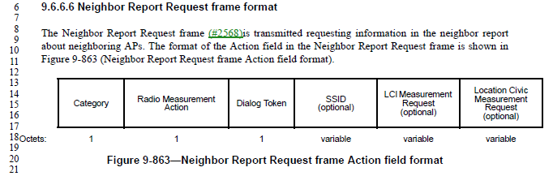

Contrast this with the Neighbor Report Response frame, described in 9.6.6.7:

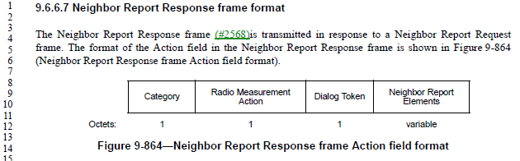

Unlike the Neighbor Report Response, the Neighbor Report Request does not carry “Neighbor Report Elements”.

Table 9-173 only applies to the concept “Neighbor Report Elements”. These elements are carried in various frames from the AP to the non-AP STA, including the Neighbor Report Response, but are not carried in a Neighbor Report Request or other frames from the non-AP STA to the AP.

So, in response to the commenter, two points:
- First, these element IDs apply to “Neighbor Reports” (per the title of Table 9-173), and in theory “Neighbor Reports” could include both the Request and Response frames. So, there is only one table of these values
- Second, in usage, however, the Neighbor Report elements in fact only appear in the information provided by the AP to the non-AP STA, and are not present in the request from the non-AP STA.

Proposed Resolution:

Revised. Change the title of Table 9-173 to have an upper-case “R”, (“Neighbor Report”).

Note to commenter: The elements listed in Table 9-173 appear wherever “Neighbor Report elements” are called out. Conceptually, this could be in both the Neighbor Report Response from the AP to the non-AP STA (and other informational frames from the AP) as well as in the Neighbor Report Request from the non-AP STA to the AP – which is what the commenter questioned. However, currently the Neighbor Report elements in fact only occur in frames from the AP to the non-AP STA, anyway.

CID | Page | Clause | Comment | Proposed Change
4511 | 0.00 | 10.3.8 | "frames with the TXVECTOR" should be "PPDUs with the TXVECTOR" | Change as indicated in 10.3.8 (2x), 19.3.2

Discussion:

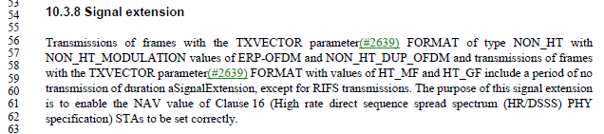

And in 19.3.2:

There are also 5 occurrences of “frame with the TXVECTOR”.

The vast majority of other uses of “with the TXVECTOR” are applied to PSDU(s) or PPDU(s).

Since the TXVECTOR is provided at the PHY SAP, along with a MPDU (== PSDU) to be transmitted, it seems that either MPDU or PSDU are most likely the best usage. There are zero occurrences of “MPDU(s) with the TXVECTOR”, however.

In the cases in 10.3.8, in the discussion of the Signal extension’s implication on clause 16 operation, it seems that PSDU is a logical object to reference. Same thing in 19.3.2.

Arguably, since these subclauses contain these details of PHY operation, they should be moved to the PHY service clause (clause 8). But, that is way beyond the scope of this comment. Also, the existing occurrences of “PPDU with the TXVECTOR” should be checked for whether these should be PSDU; but again, this is beyond the scope of this comment.

In the cases of “frame with the TXVECTOR” (singular “frame”), these occur in two places: rules for control response frame guard intervals, coding and format, and for S1G frame traveling pilots and preamble type. Since the control response frame examples are in the context of a particular frame (MPDU) type, it does not make sense to reference a PSDU – we don’t talk about a PSDU “type” of (for example) “control response”. Therefore, propose that these occurrences remain “frame with the TXVECTOR …”

The S1G frame traveling pilots and preamble type examples, however, are similar to the uses above that should be modified.

Proposed Resolution:

Revised.

At P1769.56 and P1769.57, replace "frames with the TXVECTOR" with "PSDUs with the TXVECTOR".

At P2988.14, replace "frames with the TXVECTOR" with "PSDUs with the TXVECTOR".

At P2126.39, replace “frame with the TXVECTOR” with “PSDU with the TXVECTOR”. Same thing at P2129.25.

Note to the commenter, there are also occurrences of “control response frame [singular] with the TXVECTOR”. Coincidentally, these occurrences all involve noting the MPDU frame type of the referenced frame, and so these are left using the term “frame”. Thus, there is inherent inconsistency in the Draft around this wording, depending on the context.

CID | Page | Clause | Comment | Proposed Change
4507 | 996.05 | 9.4.2.5.1 | "When the TIM is carried in an S1G PPDU, the traffic-indication virtual bitmap has the hierarchical structure shown in Figure 9-152 (Hierarchical structure of traffic-indication virtual bitmap carried in an S1G PPDU (11ah)), consists of 64NPNB bits and is organized into NP pages where each page consists of NB blocks, each block consists of eight subblocks, and each subblock consists of 8 bits (NP=4 and NB=32). Bit number N in the bitmap corresponds to bit number N[0:2] of the N[3:5]-th subblock of the N[6:5+n1]-th block of the N[6+n1:12]-th page, where n1 is log2NB and NB is power of 2. N[a:b] represents bits a to b inclusive of the bit number N." text duplicates figure | Change to "When the TIM is carried in an S1G PPDU, the traffic-indication virtual bitmap has the hierarchical structure shown in Figure 9-152 (Hierarchical structure of traffic-indication virtual bitmap carried in an S1G PPDU (11ah))."

Discussion:

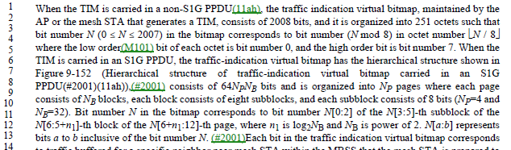

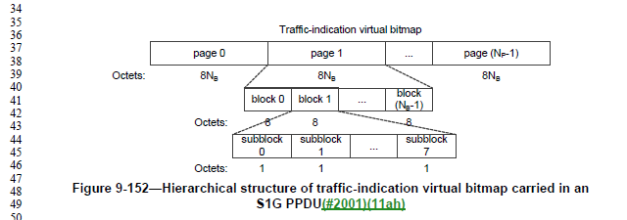

Agree with the commenter, the follow-on text seems to be representing Figure 9-152 in words.

Proposed Resolution:

Accepted.

CID | Page | Clause | Comment | Proposed Change
4492 | 994.53 | 9.4.2.5.1 | Figure 9-149--TIM element format suggests the Bitmap Control field might be absent but the Partial Virtual Bitmap field present, and there is nothing to say this is not allowed | After "If all bits in the virtual bitmap are 0 and all the bits of the Bitmap Control field  are 0, both the Partial Virtual Bitmap field and the Bitmap Control field are not present in the TIM element  and the Length field of the TIM element is set to 2." at 997.6 add "The Bitmap Control field is present if the Partial Virtual Bitmap field is present."

Discussion:

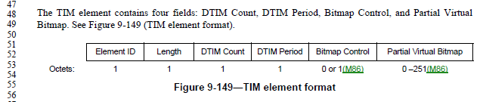

The paragraph on P997 does cover the cases where either/both of the fields are not present due to there being no non-zero bits. This does seem like the right place to note that if the Partial Virtual Bitmap is present, the Bitmap Control must be present.

However, the line reference in the Proposed Change is incorrect (P997.6 is not after the text quoted, P997.8 is).

Proposed Resolution:

Revised.

At P997.8, after “the Length field of the TIM element is set to 2." add "The Bitmap Control field is present if the Partial Virtual Bitmap field is present."

Note to the commenter, this is the requested change, with the location for the inserted text clarified.

CID | Page | Clause | Comment | Proposed Change
4491 | 1618.27 | 9.6.14.2 | Figure 9-951--TIM frame Action field(#2568) format shows the TIM Element field (which contains a TIM element) as being 6-256 octets, but Figure 9-149--TIM element format shows it might only contain 4 octets | Change "6-256" to "4-256"

Discussion:

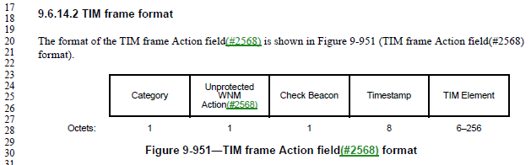

As specified in 9.4.2.5, a TIM element length could be 4-256 octets:

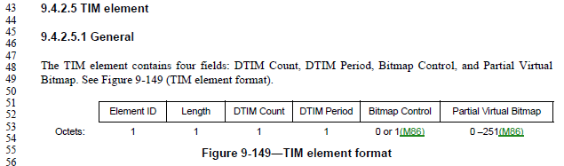

Proposed Resolution:

Accepted.

CID | Page | Clause | Comment | Proposed Change
4561 | 838.04 | 9.3.1.9 | "The Frame Control field is defined in 9.3.1 (Control frames). (MDR2)The subtype field is the value from  Table 9-1 (Valid type and subtype combinations) of 9.2.4.1.3 (Type and Subtype subfields) that corresponds  to Control Wrapper frame." -- we don't say this for any other frame | Delete the cited text

Discussion:

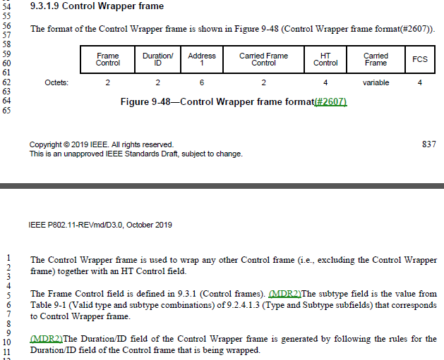

This Control Wrapper frame does appear to be the only frame definition that explicitly says this, and it is not necessary as the Frame Control field is clearly defined in the overall Control Frame format in 9.3.1.1.

Proposed Resolution:

Accepted.

CID | Page | Clause | Comment | Proposed Change
4774 | 2187.02 | 11.2.3.6 | There is no concept of StrictlyOrdered service class, anymore. | Delete "except those that have the StrictlyOrdered service class". Same thing at line 5.  Delete the paragraph at P299.29, discussing two service classes for non-QoS STAs.  At the start of subclause 5.1.1.4, insert a paragraph, "In Non-QoS STAs, the value of the service class parameter in invoked MAC Service Primitives (see 5.2) is ignored. The value of the service class parameter in generated MAC Service Primitives is set to ReorderableGroupAddressed."
4392 | 2187.02 | 11.2.3.6 | There is no strictly ordered service class anymore | In the referenced para delete ", except those that have the StrictlyOrdered service  class" (2x). In Figure 9-27 delete "/  Order"

Discussion:

There are exactly two occurrences of “StrictlyOrdered” (or “strictly ordered”) in the Draft, at the P2187 locations cited in the Proposed Changes.

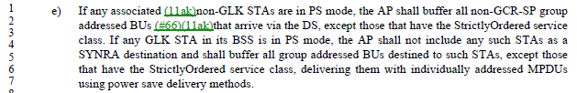

The cited locations on P299 (subclause 5.1.1.1) and in 5.1.1.4 are the only locations that discuss the concept “service class” for non-QoS STAs, without a restriction that only “ReorderableGroupAddressed” is allowed. So, these two locations are the only other places that need to be modified to complete the restriction to only “ReorderableGroupAddressed” service class for non-QoS STAs.

The paragraph at P299.29:
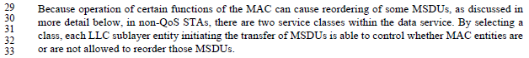
Note that this paragraph says, “as discussed in more detail below”, except it is not discussed below (that has been removed already).

Subclause 5.1.1.4 is where the service class parameter to the MAC SAP is discussed:
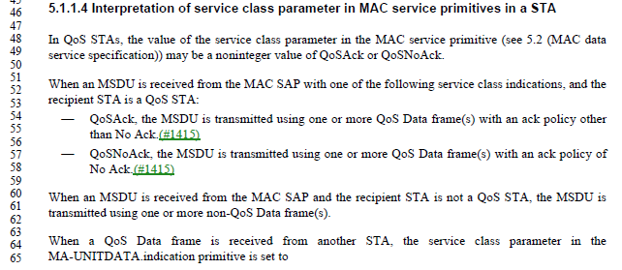
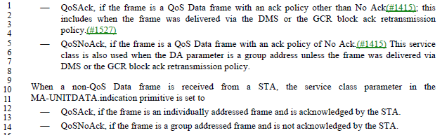

The last paragraph of this subclause deals with receiving a non-QoS Data frame. This could be in the context of a non-QoS STA receiving the frame, or a QoS STA receiving the frame. The current text seems correct for a QoS STA receiving the frame. But a non-QoS STA receiving the frame needs to yield a value of service class in the indication primitive that is understood by the non-QoS upper layers.

Thus, the Proposed Changes for CID 4774 appear correct. But, for completeness, it would be better to note in the last paragraph of 5.1.1.4 that the existing text applies if the non-QoS Data frame is received at a QoS STA. And, then, for clarity, the new text about a non-QoS STA receiving such a frame should be located here (at the end of the subclause, not the beginning).

Also, one straggling vestige of strictly ordered is the +HTC/Order bit in the Frame Control header of control frames in some cases, as shown in Figure 9-27. The use of this bit position as a “+HTC/Order” subfield, rather than just a “+HTC” subfield was removed previously, but the field in Figure 9-27 was missed.

Proposed Resolution:

Revised.

At 2187.02, delete "except those that have the StrictlyOrdered service class". Same thing at line 5.

Delete the paragraph at P299.29, discussing two service classes for non-QoS STAs.

In the (currently) last paragraph of 5.1.1.4, change “from a STA” to “at a QoS STA from any other STA”.

At the end of subclause 5.1.1.4, insert a paragraph, "In non-QoS STAs, the value of the service class parameter in invoked MAC service primitives (see 5.2) is ignored. The value of the service class parameter in generated MAC service primitives is set to ReorderableGroupAddressed."

In Figure 9-27, change the subfield “+HTC/Order” to be “+HTC”.

CID | Page | Clause | Comment | Proposed Change
4534 | 1038.22 | 9.4.2.20.13 | Figure 9-211--Measurement Request field format for a Multicast Diagnostics request is confusing in showing a Multicast Triggered Reporting (optional) field because there is a separate Optional Subelements field and Table 9-117--Optional subelement IDs for STA Multicast Diagnostics request shows Multicast Triggered Reporting | In Table 9-117 delete the first two non-header rows and change 2-220 to 0-220

Discussion:

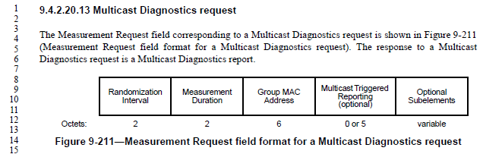

Indeed there are both the Multicast Triggered Reporting subfield and Optional Subelements in the Multicast Diagnostics request variant of the Measurement Request field.

The Multicast Triggered Reporting subfield is described, as:

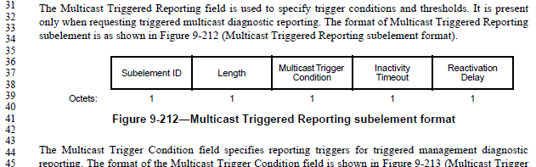

This text goes on for several paragraphs, describing these subfields.

However, nowhere in this text is the Sublement ID specified for the Multicast Triggered Reporting subelement. Thus, it seems the row in Table 9-117 is required for this specification:

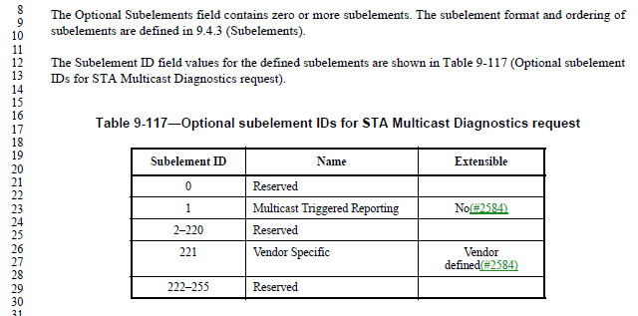

Since the Multicast Triggered Reporting subelement is optional, as is the Vendor Specific subelement, the question here perhaps should be why there is a specific call out for the Multicast Triggered Reporting sublement in the Figure 9-211 field layout, rather than having Multicast Triggered Reporting subelement just be one of the Optional Subelements, in the usual style.

Proposed Resolution:

Revised. Remove the field “Multicast Triggered Reporting (optional)” from Figure 9-211. Move the text from P1037.31 through P1038.10 to appear after the text at P1038.14 and Table 9-117 and before the text at P1038.32.

2020-02-19 Telecon:

Review P1037.31 – note that the removal of the field causes the text that is proposed to be moved no longer correct.
Optional fields need to have a subelement ID and then the subsequent optional fields can be identified. Having a strange tag for identifying the 4th field is strange.
More Work is needed to address the moving of the text.

Updated Proposed Resolution:

Revised. Remove the field “Multicast Triggered Reporting (optional)” from Figure 9-211. Move the text from P1037.31 through P1038.7 to appear after the text at P1038.14 and Table 9-117 and before the text at P1038.32, with the indicated changes:

The Multicast Triggered Reporting field subelement is used to specify trigger conditions and thresholds. It is present only when requesting triggered multicast diagnostic reporting. The format of Multicast Triggered Reporting subelement is as shown in Figure 9-212 (Multicast Triggered Reporting subelement format).

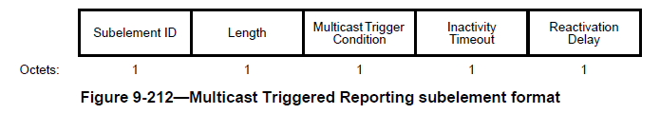

The Multicast Trigger Condition field specifies reporting triggers for triggered management diagnostic reporting. The format of the Multicast Trigger Condition field is shown in Figure 9-213 (Multicast Trigger Condition field format(#2607)).

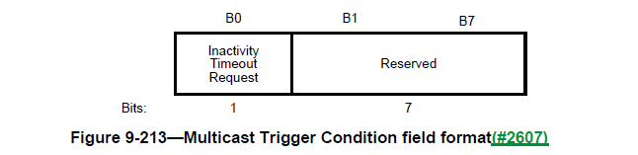

The Inactivity Timeout Request field is 1 to request that a multicast triggered report be generated when no group addressed frames with the monitored group address are received in a time equal to the value given in the Inactivity Timeout field. The Inactivity Timeout Request field is 0 when a multicast reception timeout is not requested.

The Inactivity Timeout field contains a time value in units of 100 TUs to be used as the threshold value for the inactivity timeout trigger condition.

The Reactivation Delay field contains a value in units of 100 TUs during which a measuring STA does not generate further multicast triggered reports after a trigger condition has been met.

CID | Page | Clause | Comment | Proposed Change
4567 | 2302.49 | 11.10.9.2 | "a Frame Report  Entry field where Transmitter Address (TA) matching the MAC address field value" -- is this TA in the MAC header? A field somewhere? I think it's a misnamed field from Figure 9-235--Frame Report Entry field format | Change to "a Frame Report  Entry field with a Transmit Address field matching the MAC address field value"

Discussion:

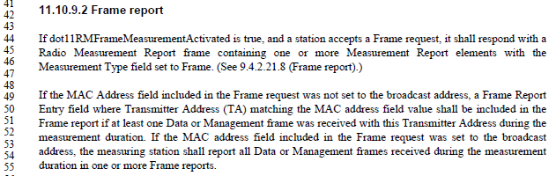

The Frame request frame has the following format and description:

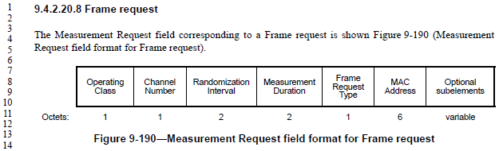

So, it is frames received with a TA that matches the Frame request’s MAC Address field, that are counted for the Frame report. So, agree with the commenter that this sentence is mixing up terms and concepts.

However, it would be better to state this clearly (with a re-write of the sentence), in a way that is similar to the subsequent sentence.

Proposed Resolution:
Revised.

Replace:
If the MAC Address field included in the Frame request was not set to the broadcast address, a Frame Report Entry field where Transmitter Address (TA) matching the MAC address field value shall be included in the Frame report if at least one Data or Management frame was received with this Transmitter Address during the measurement duration.

with:
If the MAC Address field included in the Frame request was not set to the broadcast address, the measuring station shall report, in one or more Frame reports, only those Data or Management frames received during the measurement duration with a TA field matching the MAC Address field of the Frame request, if at least one such frame was received.

Also, in 9.4.2.20.8, Replace:
If the MAC Address field is the broadcast address, then all Data or Management frames are counted toward the Frame report generated in response to this Frame request. For other MAC addresses, only frames matching this MAC address as the Transmitter Address are counted toward the Frame report generated in response to this Frame request.

with:
The MAC Address field indicates the TA field to match against Data and Management frames in order to count toward the Frame report generated in response to this Frame request.

CID | Page | Clause | Comment | Proposed Change
4808 | 1543.10 | 9.6.7.16 | RSNE, and FTE, are not "optionally present" if security is required. They _are_ present if security is required. | Delete "optionally" at P1543.10 and P1543.18.

Discussion:

From P1543:
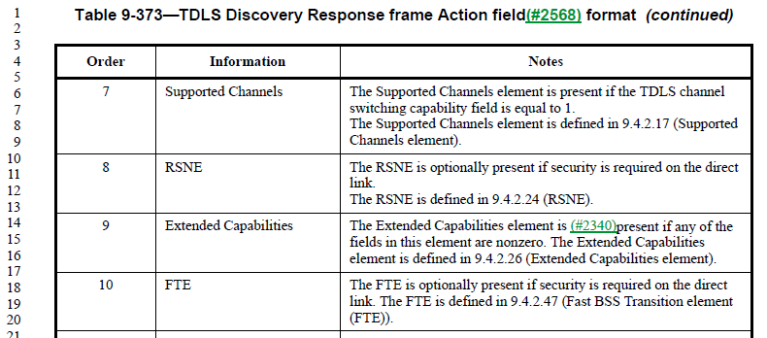

In TDLS Setup frames, the language is (for the RSNE, for example, FTE is similar): “The RSNE is present if security is required on the TDLS direct link and the Status Code is SUCCESS, and not present otherwise. The RSNE is defined in 9.4.2.24 (RSNE).”

Per 11.21.1 (General subclause of Tunneled direct-link setup): “Security is available on the TDLS direct link only when both TDLS peer STAs have an RSNA with the BSS.”

Per 12.7.8.4.2 (TPK handshake message 1): “If the TDLS initiator STA has security enabled on the link with the AP, it shall add an RSNE, FTE, and Timeout Interval element to its TDLS Setup Request frame.”

Per 12.7.8.4.3 (TPK handshake message 2): “If the TDLS responder STA validates the TPK handshake message 1 for this TDLS instance, the TDLS responder STA may respond with TPK handshake message 2. To do so, the TDLS responder STA shall add an RSNE, FTE, and Timeout Interval element to its TDLS Setup Response frame.”

Thus, it appears that the RSNE and FTE elements shall be present when security is enabled on the link to the AP (“with the BSS”) on both the initiator and responder.

In Table 9-373, we are dealing with TDLS Discovery. As the TDLS Discovery Request frame does not appear to provide security/RSN information for the potential TDLS initiator, at the time of responding to the discovery, the responder can only indicate whether it does have security enabled with the BSS, and security would be available on the TDLS link, if the initiator also has security enabled.

Thus, in the TDLS Discovery Response frame, the RSNE and FTE must be present if the transmitter has security enabled on the link with the AP.

Proposed Resolution:

Revised.

At P1543.10 and P1543.18, replace:
“is optionally present if security is required on the direct link.”

with:
“is present if the transmitting STA has security enabled on its link with the AP”.

CID | Page | Clause | Comment | Proposed Change
4325 |  |  | "AC parameters" is not a defined thing; should be "EDCA parameters" (5x) | As it says in the comment

Discussion:

In 11-20/272r6, Graham states that there are 5 instances of “AC parameters”, there are 22 instances of “EDCA parameters”.

Per 10.2.3.2 (HCF contention based channel access (EDCA)), the AP uses EDCA parameters per dot11QAPEDCATable in the MIB, while non-AP STAs use parameters as announced by the AP (or a default if no such announcement is made) and stored in dot11EDCATable.

Also per 10.2.3.2, “The QoS AP shall announce the EDCA parameters in selected Beacon frames and in all Probe Response and (Re)Association Response frames by the inclusion of the EDCA Parameter Set element using the information from the MIB entries in dot11ECDATable.”

So, the information being described in 9.4.2.28 (EDCA Parameter Set element) is the ECDA parameters announced by the AP.

Proposed Resolution:

Revised.

At the following locations, make changes as shown:

P1117L47 9.4.2.28
Change
“is incremented each time any of the AC parameters changes”
to
“is incremented each time any of the announced EDCA parameters change.”

P1717L60
Change
“When communicating within a BSS, the EDCA parameters used are from the EDCA Parameter Set element”
to
“For a non-AP STA communicating within a BSS, the EDCA parameters used are from the EDCA Parameter Set element”

P1718L58 10.2.3.2
Change
“following a change in AC parameters, which provides all STAs an opportunity to receive the updated EDCA parameters.”
To
following a change in announced EDCA parameters, which provides all STAs an opportunity to receive the updated EDCA parameters.

P1719L41 10.2.3.2
Change
“is incremented every time any of the AC parameters changes.”
To
“is incremented every time any of the announced EDCA parameters change.”

P4544L24 K.2.1.
“It is recommended that admission control not be required for the access categories AC_BE and AC_BK. The ACM subfield for these categories should be set to 0. The AC parameters chosen by the AP should account for unadmitted traffic in these ACs.”
To
“It is recommended that admission control not be required for the access categories AC_BE and AC_BK. The ACM subfield for these categories should be set to 0. The announced EDCA parameters and the EDCA parameters used by the AP should account for unadmitted traffic in these ACs.”

P4544L32 K.2.1.
Change:
“AC parameters chosen by the AP should further account for any unadmitted traffic in AC_VO and AC_VI that might be reserved for users of a particular SSPN.”
To
“The announced EDCA parameters and the EDCA parameters used by the AP should further account for any unadmitted traffic in AC_VO and AC_VI that might be reserved for users of a particular SSPN.”

CID | Page | Clause | Comment | Proposed Change
4445 | 1011.8 |  | "For nonmesh STAs, the Channel Switch Count field either is set to the number of TBTTs until the STA  sending the Channel Switch Announcement element switches to the new channel or is set to 0. (MDR2)A 1  indicates that the switch occurs immediately before the next TBTT. A 0 indicates that the switch occurs at  any time after the frame containing the element is transmitted." is self-contradictory. If it switches before the next TBTT, the number of TBTTs until the switch was 0 | Change to "For nonmesh STAs, the Channel Switch Count field is set to the number of TBTTs until the STA  sending the Channel Switch Announcement element switches to the new channel. (MDR2)1  indicates that the switch occurs immediately before the next TBTT. 0 indicates that the switch occurs at  any time after the frame containing the element is transmitted."  Proposed:  At P1011L8  Change  “For nonmesh STAs, the Channel Switch Count field either is set to the number of TBTTs until the STA sending the Channel Switch Announcement element switches to the new channel or is set to 0. A 1 indicates that the switch occurs immediately before the next TBTT. A 0 indicates that the switch occurs at any time after the frame containing the element is transmitted.”  To  "For nonmesh STAs, the Channel Switch Count field is set to the number of TBTTs until the STA sending the Channel Switch Announcement element switches to the new channel. A value of 1 indicates that the switch occurs immediately before the next TBTT and a value of 0 indicates that the switch occurs at any time after the frame containing the element is transmitted."

Discussion:

From discussion in February, and in 11-20/0272:

P1011L8
“For nonmesh STAs, the Channel Switch Count field either is set to the number of TBTTs until the STA sending the Channel Switch Announcement element switches to the new channel or is set to 0. (MDR2)A 1 indicates that the switch occurs immediately before the next TBTT. A 0 indicates that the switch occurs at any time after the frame containing the element is transmitted.”

Agree with commenter
Comment suggested change to:
"For nonmesh STAs, the Channel Switch Count field is set to the number of TBTTs until the STA sending the Channel Switch Announcement element switches to the new channel. (MDR2)1 indicates that the switch occurs immediately before the next TBTT. 0 indicates that the switch occurs at any time after the frame containing the element is transmitted."

Not sure about “1 indicates”, how about

REVISED
At P1011L8
Change
“For nonmesh STAs, the Channel Switch Count field either is set to the number of TBTTs until the STA sending the Channel Switch Announcement element switches to the new channel or is set to 0. (MDR2)A 1 indicates that the switch occurs immediately before the next TBTT. A 0 indicates that the switch occurs at any time after the frame containing the element is transmitted.”
To
"For nonmesh STAs, the Channel Switch Count field is set to the number of TBTTs until the STA sending the Channel Switch Announcement element switches to the new channel. (MDR2)A value of 1 indicates that the switch occurs immediately before the next TBTT and a value of 0 indicates that the switch occurs at any time after the frame containing the element is transmitted."

From 802.11 Editorial Style Guide (11-09/1034):
The use of “value of <field> field” is deprecated.

Note 802.11-2016 1.4 states: ‘If <x> represents a scalar field, scalar subfield, scalar parameter or scalar MIB attribute:
— if “<x> is” is used in a context that relates to the testing or setting the value of “<x>” this usage is to
be interpreted as though written “the value of <x> is”
— “<x> indicate(s)” is to be interpreted as though written “the value of <x> indicate(s)”
— “indicated by <x>” is to be interpreted as though written “indicated by the value of <x>”
— “<x> that indicate” isto be interpreted as though written “<x> whose value indicates” ’

There was also discussion on changing “immediately before” vs “at”
The argument of “at” the TBTT will start the change of channel, but you may have a race condition.
The switch has to occur before the beacon is created.

Suggest being clear that the change happens “at” the TBTT (and not before, which opens a small and unknown window when the AP is no longer on the old channel), and also clarifying that the Beacon is created assuming this new channel.

Proposed Resolution:

Revised.

At P1011L8
Change
“For nonmesh STAs, the Channel Switch Count field either is set to the number of TBTTs until the STA sending the Channel Switch Announcement element switches to the new channel or is set to 0. (MDR2)A 1 indicates that the switch occurs immediately before the next TBTT. A 0 indicates that the switch occurs at any time after the frame containing the element is transmitted.”
to
"For nonmesh STAs, the Channel Switch Count field is set to the number of TBTTs until the STA sending the Channel Switch Announcement element switches to the new channel. (MDR2)1 indicates that the switch occurs at the next TBTT (the ensuing Beacon frame is created assuming the new channel), and 0 indicates that the switch occurs at any time after the frame containing the element is transmitted."

CID | Page | Clause | Comment | Proposed Change
4462 |  |  | "of all MSDUs and A-MSDUs buffered at the STA". A STA does not buffer A-MSDUs. The things it receives via MA-UNITDATA.request are MSDUs, and those are the things it buffers prior to transmission Change the cited text to "of all MSDUs buffered at the STA" | Delete "or A-MSDUs" in 9.2.4.1.8 More Data subfield (4x), 9.2.4.5.6 Queue Size subfield, 9.2.4.5.8 AP PS Buffer State subfield

Discussion:

Examining Figure 5-1 - MAC data plane architecture(11ak)(#2273), we see that A-MSDU aggregation occurs higher in stack, thus before transmit buffering for Power Save.

This is consistent with the definition of bufferable unit:

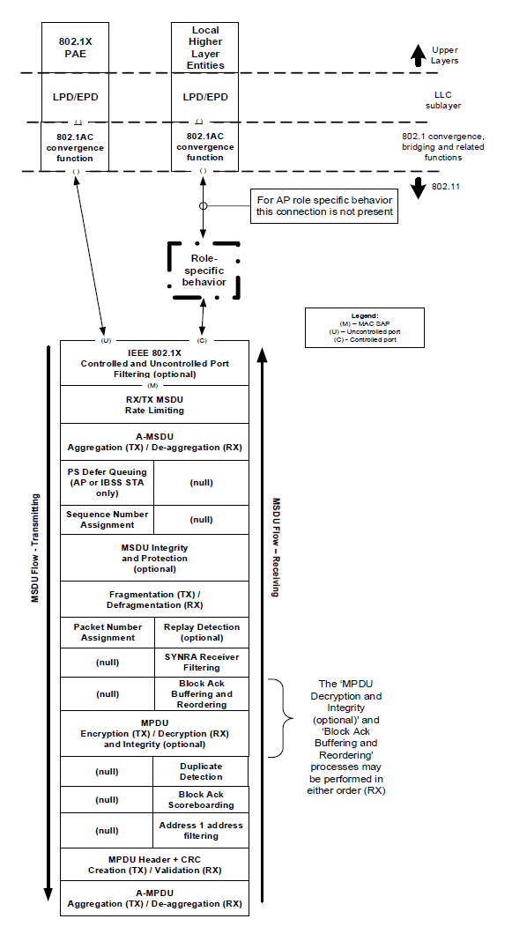

Proposed Resolution:

Rejected. As described in the definition of bufferable unit (BU), and Figure 5-1’s flow of action for transmitted frames, aggregation into A-MSDUs occurs before the power buffering stage, and thus A-MSDUs are buffered.

CID | Page | Clause | Comment | Proposed Change
4722 | 1166.25 | 9.4.2.47 | "The length of the resulting AES-Key-  wrapped IGTK in the Wrapped Key field is Key Length + 8 octets." -- this is true for the NIST key wrap algorithm (CID 2510 resolution) but might not be of other key wrap algorithms in the future, so risk of spec rot. Also, "AES-Key-wrapped" is not defined | Delete the cited sentence, and last sentence of referenced subclause (on BIGTK)

Discussion:

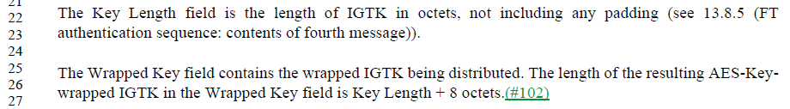

The length of the Wrapped Key is indicated in the Key Length field, and the derivation of that is referenced to be per subclause 13.8.5.

The current 13.8.5 does specify the NIST AES key wrap algorithm.

However, it is true that this could be changed in a future revision/amendment, and saying the length result of the wrap algorithm is the original length plus 8 octets seems to be duplicate specification, and in particular duplicates an external specification, which is generally risky. The cited sentence does not seem to add any new or necessary information to the Standard.

Proposed Resolution:

Accepted.

CID | Page | Clause | Comment | Proposed Change
4658 | 1464.28 | 9.4.2.246 | "concatenated list of " -- it can hardly be anything else. For other lists we don't explcitly say it's a concatenation | Delete "concatenated"

Discussion:

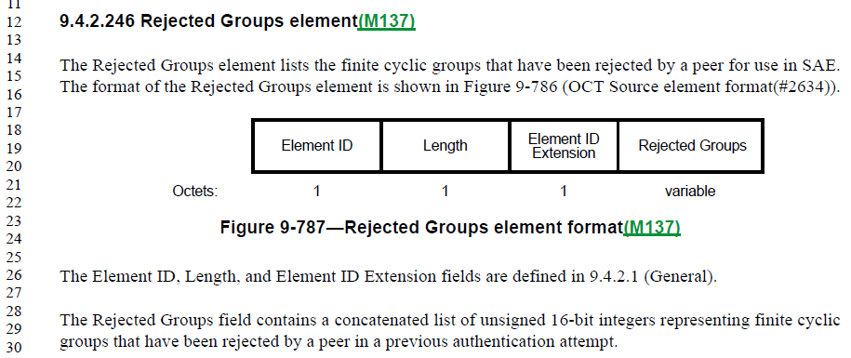

Agreed that “list of” is sufficient.

Proposed Resolution:

Accepted.

CID | Page | Clause | Comment | Proposed Change
4795 | 2060.28 | 10.42.7 | No such thing as "TRN-R-PACKET" type. | Change "TRN-R-PACKET" to "TRN-R" throughout.

Discussion:

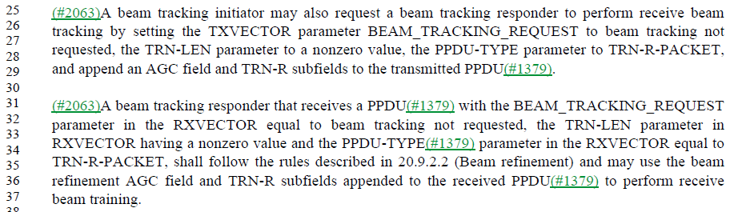

The only occurrences of TRN-R-PACKET are in these two paragraphs. Further, the RXVECTOR is specified to include a PPDU_TYPE (note underscore) parameter which takes the values TRN-R or TRN-T:

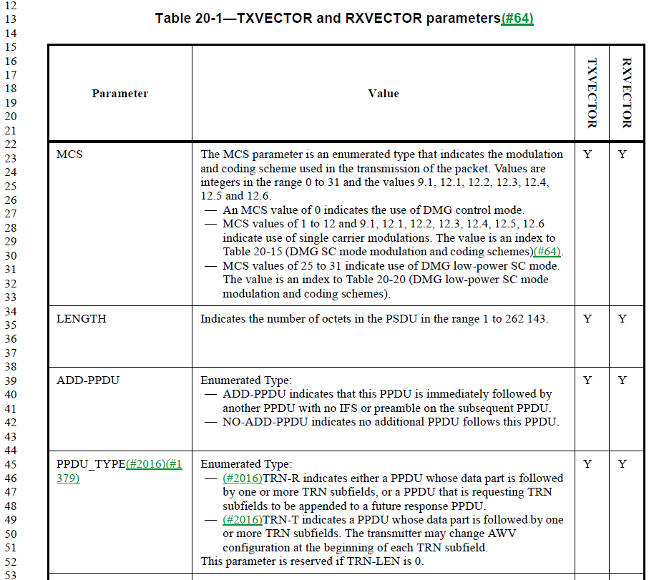

Thus, it is correct that TRN-R is the correct enumeration.

Note that “PPDU-TYPE” has been changed to “PPDU_TYPE” by CID 4794.

Proposed Resolution:

Accepted. Note to Editor, there are two locations, at 2060.28 and 2060.35.

CID | Page | Clause | Comment | Proposed Change
4234 | 793.14 | 9.2.4.2 | The Duration/ID field sent by (QoS) STAs in Extension frames is not specified | Change "In Data and Management frames sent by QoS STAs, the Duration/ID field contains a duration value  as defined for each frame type in 9.2.5 (Duration/ID field (QoS STA))." to "In Data, Management and Extension frames sent by QoS STAs, the Duration/ID field contains a duration value  as defined for each frame type in 9.2.5 (Duration/ID field (QoS STA)) and 9.3.4.3."

Discussion:

On March 25 telecon, the concern was raised that this may need to be applied to all Extension frames. Since the proposed text applies to frames sent by QoS STAs, the only concern is that Extension frames might not be recognized as QoS frames.

The only Extension frames defined in REVmd are the DMG Beacon and S1G Beacon.

Per 4.3.10, a DMG STA is a QoS STA. So, DMG Beacons are QoS frames. However, S1G STAs are not explicitly defined as QoS STAs (that I can find).

So, it is better to be clear that the Duration/ID field is specified in 9.3.4 for all Extension frames, regardless of the STA being defined as a QoS STA or not.

Proposed Resolution:

Revised.

Change
"In Data and Management frames sent by QoS STAs, the Duration/ID field contains a duration value as defined for each frame type in 9.2.5 (Duration/ID field (QoS STA))."
to
"In Data and Management frames sent by QoS STAs, the Duration/ID field contains a duration value as defined for each frame type in 9.2.5 (Duration/ID field (QoS STA)). In Extension frames the Duration/ID field contains a duration value as defined in 9.3.4."

CID | Page | Clause | Comment | Proposed Change
4318 | 2504.37 | 11.39.1 | "A STA shall not transmit an MPDU in a VHT PPDU to a STA that exceeds the maximum MPDU length  capability indicated in the VHT Capabilities element received from the recipient STA." -- it's not the STA that exceeds, it's the MPDU | Change to "An STA shall not transmit in a VHT PPDU an MPDU that exceeds the maximum MPDU length capability indicated in the VHT Capabilities element received from the recipient STA"; also for S1G instead of VHT in 10.12.5
4317 | 2504.37 | 11.39.1 | "A STA shall not transmit an MPDU in a VHT PPDU to a STA that exceeds the maximum MPDU length  capability indicated in the VHT Capabilities element received from the recipient STA." -- it's not the STA that exceeds, it's the MPDU | Delete "to a STA " in the cited text; also in 10.12.5

Discussion:

The cited text in 11.39.1:

Simple editorial change to clarify the subject of “that exceeds the maximum MPDU length”.

The example in 10.12.5:

Suggest the CID 4317 proposed change is simpler and still quite understandable.

Proposed Resolution:

CID 4317: Accepted.

CID 4318: Revised. Delete "to a STA " in the cited text; also in 10.12.5.

CID | Page | Clause | Comment | Proposed Change
4309 | 844.18 | 9.3.1.19 | "in the Compressed Beamforming Feedback Matrix  subfield" -- no such subfield | Change to "in the compressed beamforming feedback matrix"

Discussion:

The cited location is in Table 9-31:

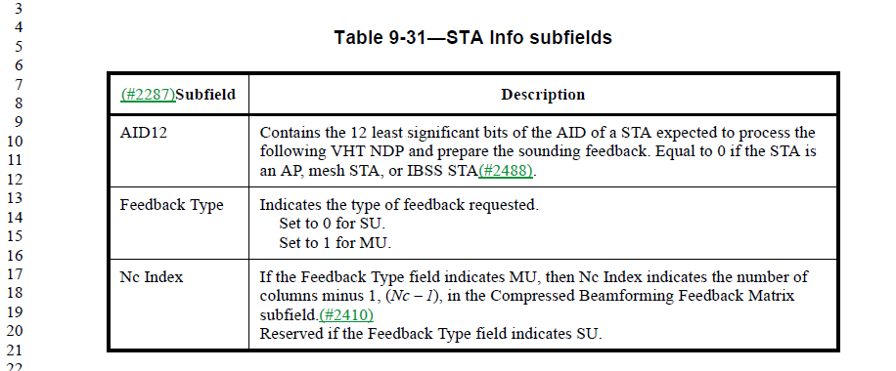

This is in the context of a VHT NDP Announcement frame, and the STA Info List field:

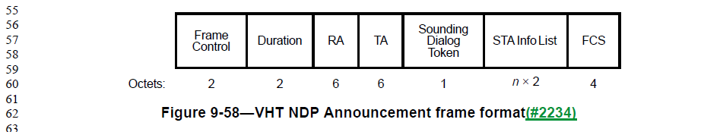

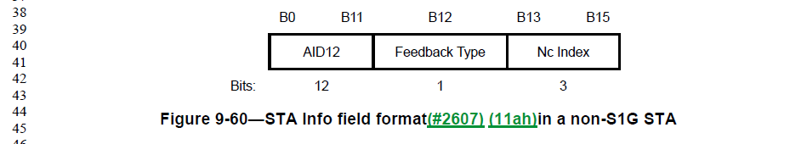

This is a short frame with high-level information to start a beamforming sequence. The details are carried in subsequent frames, such as beamforming reports. Specifically, a beamforming feedback matrix is communicated in the (Non)Compressed Beamforming Report field, carried in a (Non)Compressed Beamforming frame. For example.

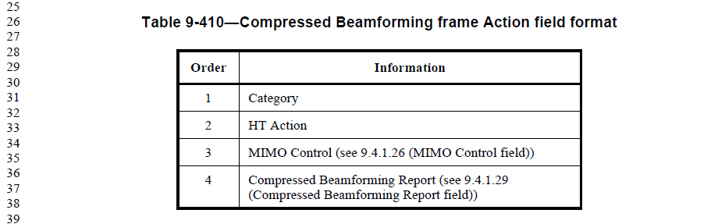

Subclause 9.4.1.29 details the format and structure of the Compressed Beamforming Report (to long to reproduce here).

In this case, the reference is to the general concept of the beamforming feedback matrix, without explicit reference to a field (which is not carried in the same frame). This is similar to the meaning in the MIMO Control field, where the lower-case reference to the conceptual object is used:

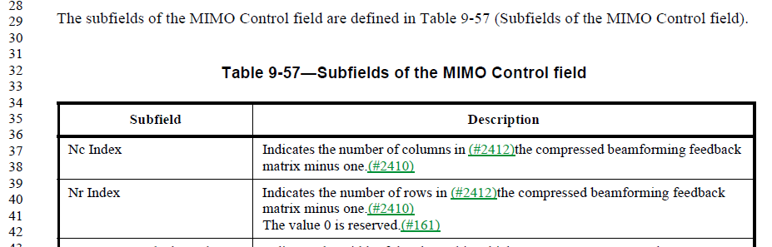

Agree, the lower-case spelling is correct in the cited location.

Proposed Resolution:

Accepted.

CID | Page | Clause | Comment | Proposed Change
4295 | 797.37 | 9.2.4.5.1 | A TPU STA is by definition not in a mesh BSS | Delete "in a  nonmesh BSS" in the fifth from last to penultimate row of Table 9-10--QoS Control field

Discussion:

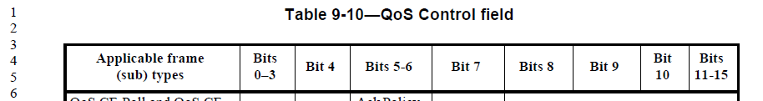
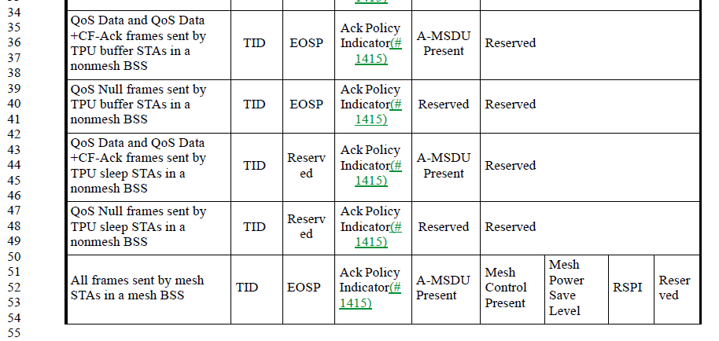

TPU is a TDLS concept:

TDLS is defined to be a mechanism involving an AP, ant thus does not apply to mesh BSS:

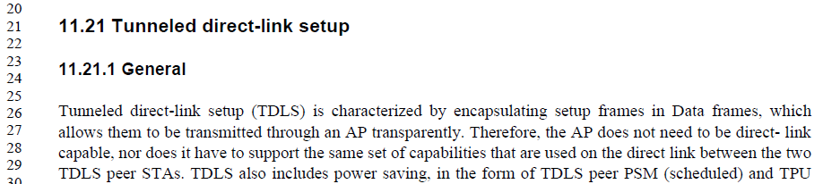

So, agree, the cited rows do not need to specify “in a nonmesh BSS”.

Proposed Resolution:

Accepted.

CID | Page | Clause | Comment | Proposed Change
4285 | 1045.28 | 9.4.2.20.19 | "The (#151)Neighbor Report subelements specify a superset of nearby APs with which the  requested STA is requested to perform the FTM procedure" -- you can't do FTM with more than the nearby APs | Change "superset" to "subset" in the cited text

Discussion:

The comment is on text in clause 9, describing the format of the Fine Timing Measurement Range request. This request includes a list of subelements that describe a number of neighbour APs with which the requested STA should/might perform an FTM range operation. The request also includes a field specifying the minimum number of such neighbour APs that are requested to be ranged.

The requested STA is expected to (try to) perform the FTM range operation with at least the Minimum AP Count number of APs from the Neighbor Report subelements, but it is not expected to perform an FTM range operation with all of them.

Thus, the Neighbor Report subelements list is a superset of the APs, and the requested STA may choose a subset of this list to actually perform the FTM ranging.

Proposed Resolution:

Revised. Change “specify a superset of nearby APs with which the requested STA is requested to perform the FTM procedure” to “specify a set of nearby APs; the requested STA is requested to perform the FTM procedure with a subset of these APs”

CID | Page | Clause | Comment | Proposed Change
4253 | 1117.10 | 9.4.2.27 | "The default value of dot11ChannelUtilizationBea-  conIntervals is defined in Annex C." -- so is the default of many other MIB attributes, but we don't say so for any other ones | Delete the cited sentence

Discussion:

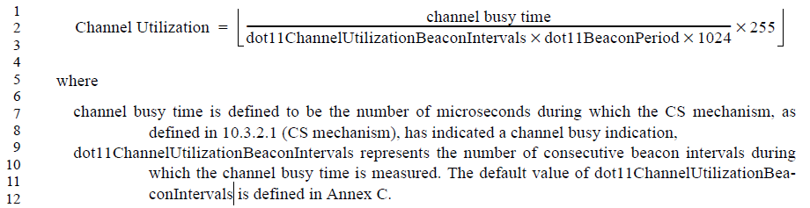

It appears to be a true statement; there is no other occurrence of “the default value of dot11”, anyway.

Proposed Resolution:

Accepted.

CID | Page | Clause | Comment | Proposed Change
4490 | 994.47 | 9.4.2.5.1 | "The TIM element contains four fields: DTIM Count, DTIM Period, Bitmap Control, and Partial Virtual  Bitmap. See Figure 9-149 (TIM element format)." -- as the figure shows, it contains 6 fields, including Element ID and Length. Duplication considered harmful! | Change to "The TIM element is used to signal the timing and availability of data for associated STAs. The format of  this element is shown in Figure 9-149."

Discussion:

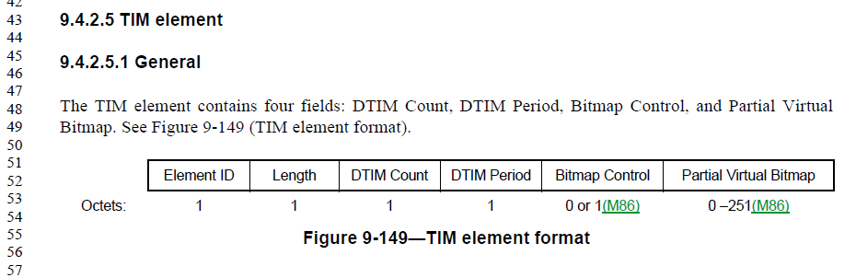

Agree, the statement is redundant, and incomplete. And, duplication leads to errors.

Proposed Resolution:

Accepted.

CID | Page | Clause | Comment | Proposed Change
4240 | 855.52 | 9.3.3.1 | "Unused element ID codes are reserved." is unclear (how "unused"?) and unnecessary (T9-94 already lists all possible EIDs and EEIDs). Delete | Delete the cited text at the referenced location and in 9.8.5.1

Discussion:

The cited sentence is the last sentence in this last paragraph of 9.3.3.1 (Format of Management frames):

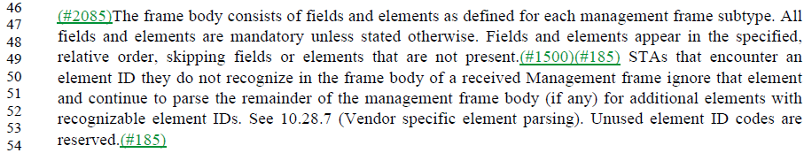

The sentence does not seem necessary to the paragraph, and is redundant with the rows in Table 9-94 which indicate all currently unallocated element IDs to be “Reserved”. Agree with the comment.

The context for the 9.8.5.1 reference, to the subclause on the format of PV1 Management frames:

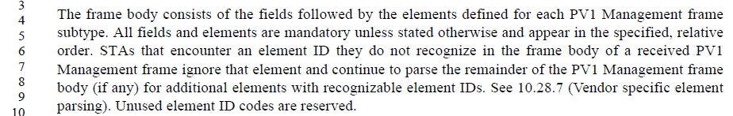

This is a very similar paragraph, with the same sentence at the end. Same analysis applies.

Proposed Resolution:

Accepted.

CID | Page | Clause | Comment | Proposed Change
4802 | 1056.02 | 9.4.2.21.7 | While considerably less likely, it is still possible for a beacon Measurement Report's Reported Frame Body to exceed the maximum element size, even for Reporting Detail type 1. Recommend moving this text about truncating elements and/or using fragmentation (when supported) to apply in all cases. | Break the paragraph into two, after the first sentence (at the full stop on line 2). Start the new paragraph with, "Some elements in the Reported Frame Body subelement, or the Reported Frame Body subelement itself, might be large."

Discussion:

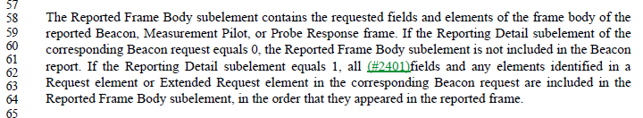
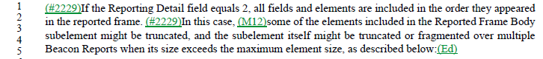

The first paragraph describes the contents of the Reported Frame Body element in the Beacon report variant of the Measurement Report facility, for two of the report types (Reporting Detail in the request equal to 0, or 1). The second paragraph describes the contents when the Reporting Detail is 2.

The second paragraph goes on to describe what happens when the Reported Frame Body is too large to fit into an element. However, that description is limited to “In this case”, implying the Reporting Detail=2 case.

However, Reporting Detail of 1 can also result in too large a reported detail to fit in the Reported Frame Body element. Agree with the comment.

The proposed change would result in the following (first paragraph is unchanged):

The Reported Frame Body subelement contains the requested fields and elements of the frame body of the
reported Beacon, Measurement Pilot, or Probe Response frame. If the Reporting Detail subelement of the
corresponding Beacon request equals 0, the Reported Frame Body subelement is not included in the Beacon
report. If the Reporting Detail subelement equals 1, all (#2401)fields and any elements identified in a
Request element or Extended Request element in the corresponding Beacon request are included in the
Reported Frame Body subelement, in the order that they appeared in the reported frame.

(#2229)If the Reporting Detail field equals 2, all fields and elements are included in the order they appeared
in the reported frame.

(#2229) Some elements in the Reported Frame Body subelement, or the Reported Frame Body subelement itself, might be large. In this case, (M12)some of the elements included in the Reported Frame Body
subelement might be truncated, and the subelement itself might be truncated or fragmented over multiple
Beacon Reports when its size exceeds the maximum element size, as described below:(Ed)

Proposed Resolution:

Revised.

Break the cited paragraph into two, after the first sentence (at the full stop on line 2). Add a new sentence to the start of the new paragraph as, "Some elements in the Reported Frame Body subelement, or the Reported Frame Body subelement itself, might be large."

Note to Editor, the change is shown in document 11-20/338r6 (https://mentor.ieee.org/802.11/dcn/20/11-20-0338-06-000m-revmd-initial-sa-comments-assigned-to-hamilton.docx).

CID | Page | Clause | Comment | Proposed Change
4799 | 2153.65 | 11.1.3.8 | It's not clear what list of elements are implied by, "The AP or PCP may include all other elements in the nontransmitted BSSID profile." This list should be restricted to those allowed per 9.4.2.45. | Insert "allowed per 9.4.2.45" after "all other elements"

Discussion:

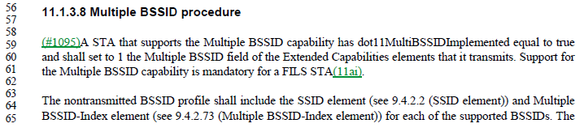

From 9.4.2.45, the Nontransmitted BSSID Profile subelement is one of the optional sublements of the Multiple BSSID element, and is defined as follows:

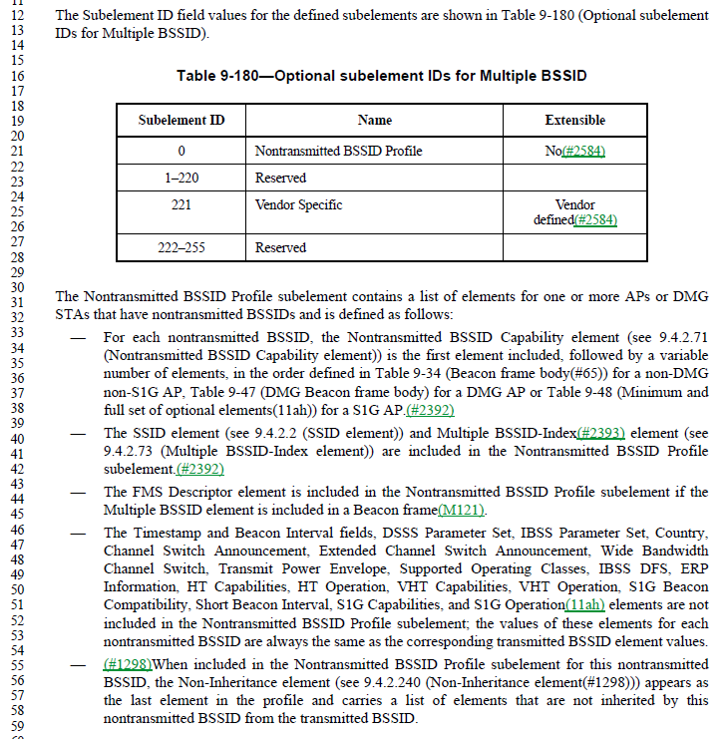

From the bullet list, the Nontransmitted BSSID Profile subelement must contain:
- Nontransmitted BSSID Capability element
- Followed by a variable number of elements
- SSID element
- Multiple BSSID-Index element
- FMS Descriptor (conditionally)
- Timestamp, Beacon Interval, etc. are not included (per list in the fourth bullet)
- Non-Inheritance element (optional)

Note that the first bullet is non-specific about what can be included in the “a variable number of elements”. But, these elements must be found in a Beacon frame, DMG Beacon frame, or Table 9-48 for an S1G AP. Further, these elements must not appear in the list in the fourth bullet. Hence the exact list of elements that must be, or can be, present is complicated.

The commenter proposes to clarify the phrase “all other elements” in the cited sentence, by saying this is “all other elements allowed per 9.4.2.45". This seems like a valid clarification.

Proposed Resolution:

Accepted.

CID | Page | Clause | Comment | Proposed Change
4797 | 2159.33 | 11.1.4.3.2 | Per the changes in 11-19/0551r17 (https://mentor.ieee.org/802.11/dcn/19/11-19-0551-17-000m-revmd-lb236-comments-assigned-to-hamilton.docx), as agreed on CID 2692 during working group ballot, bullet (e) is redundant, and should be deleted. | Delete bullet (e)
4347 | 2159.33 | 11.1.4.3.2 | e) needs to be conditional on dot11SSIDListActivated is true, like d) | Change e) to start "When dot11SSIDListActivated is true and the SSID List parameter is present"
4351 | 2159.33 | 11.1.4.3.2 | e) appears to duplicate d), though d) does not give the destination address | Delete e) and in d) after "send zero or more probe requests" add " to the broadcast destination address"
4349 | 2159.29 | 11.1.4.3.2 | d) says "These additional probe  requests (following step c)) should only carry SSIDs not indicated in the step c) probe request.". Why is this a should? There's no point sending probes for stuff that has already been probed | Delete "should" in the cited text

Discussion:

CID 2692 was resolved as:
REVISED (MAC: 2019-09-17 14:13:59Z): Incorporate the changes for CID 2692 in doc 11-19/551r17 (https://mentor.ieee.org/802.11/dcn/19/11-19-0551-17-000m-revmd-lb236-comments-assigned-to-hamilton.docx) which makes the changes in the direction suggested by the commentor.

Document 11-19/551r17 (unchanged in 11-19/551r19, the final version) shows this for CID 2692:
Modify bullets (c) and (d) as shown:
c) Perform the basic access procedure as defined in 10.3.4.2 (Basic access). Send a probe request to the broadcast destination address. The probe request is sent with the SSID and BSSID from the received MLME-SCAN.request primitive. If dot11SSIDListActivated is true and the SSID List parameter is present in the MLME-SCAN.request primitive, then one or more SSID List elements should be present in the probe request, indicating all SSIDs in the SSID List parameter if possible.

d) Send a probe request to the broadcast destination address. The probe request is sent with the SSID and BSSID from the received MLME-SCAN.request primitive. When dot11SSIDListActivated is true and the SSID List parameter is present in the MLME-SCAN.request primitive, send one zero or more pProbe rRequests frames to the broadcast address, each with an SSID indicated in the SSID List and the BSSID from the MLME-SCAN.request primitive(11ai). These additional probe requests (following step c)) should only carry SSIDs not indicated in the step c) probe request. The basic access procedure (10.3.4.2 (Basic access)) is performed prior to each probe request transmission.

Delete bullet (e).

Renumber references to “step i)” to reference “step h)” (D2.0 P2127.14) and “step l)” to “step k)” (P2127.41).

From draft D2.0 to D3.0, the modifications to bullets (c) and (d) were done, as was the renumbering of references to steps (i) and (l). However, step (e) was not deleted.

CID 4797 should be accepted.

Which makes CID 4347 moot, as (e) will be deleted, and (d) already is conditional on dot11SSIDListActivated as requested.

CID 4351 requests adding “to the broadcast destination address” to bullet (d). It appears that 11-19/551r17 also intended to add this phrase, but it was not marked as an edit and was missed.

CID 4349 requests that the second part of (d), which was added by 11-19/551r17, be a hard requirement and not a “should”. While it is true that sending more Probe Requests using an SSID already covered by (c) is redundant, it would potentially make existing implementations non-compliant to make this a hard requirement.

Proposed Resolutions:

CID 4797: Revised. Delete e) and in d) after "send zero or more probe requests" add " to the broadcast destination address"

CID 4347: Revised. Delete e) and in d) after "send zero or more probe requests" add " to the broadcast destination address"

CID 4351: Accepted.

CID 4349: Rejected. While it is true that sending more Probe Requests using an SSID already covered by (c) is redundant, it would potentially make existing implementations non-compliant to make this a hard requirement.

Add a note to the editor in CIDs 4797, 4347 and 4351 that the changes are the same for all three.

CID | Page | Clause | Comment | Proposed Change
4641 | 2061.33 | 10.42.7 | "If the initiator receives the expected feedback" should be "If the beam tracking initiator receives the expected feedback"; ditto in that sentence "responder" -> "beam tracking responder" | As it says in the comment

Discussion:

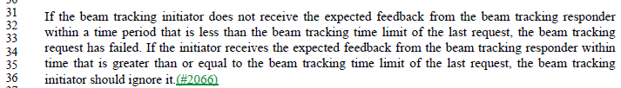

The comment is on the second sentence, which shortens “beam tracking initiator” and “bream tracking responder” from the first sentence, to just “initiator” and “responder”.

Given the immediately nearby antecedent phrases in the first sentence which spells out that these are in reference to the beam tracking roles, the references in the second sentence seem clear enough.

Proposed Resolution:

Revised.
Change
If the initiator receives the expected feedback from the beam tracking responder within time that is greater than or equal to the beam tracking time limit of the last request, the beam tracking initiator should ignore it.
to:
If the initiator receives the expected feedback from the beam tracking responder within time that is greater than or equal to the beam tracking time limit of the last request, the beam tracking initiator should ignore it.

CID | Page | Clause | Comment | Proposed Change
4782 | 2164.58 | 11.1.4.3.4 | From the draft: "If a FILS STA receives one or more Probe Request frame(s), subject to the criteria above, and the STA has dot11FILSOmitReplicateProbeResponses equal to true, the responding STA shall select the response with the next Beacon frame or one or more Probe Response frames as a response to all Probe Request frames(11ai)." Huh? | Replace the sentence with: "If a FILS STA receives one or more Probe Request frame(s) and the STA has dot11FILSOmitReplicateProbeResponses equal to true, then the responding STA shall respond, subject to the criteria above, by letting the response be the next Beacon frame, a broadcast Probe Response frame, or one or more directed Probe Response frames."

Discussion:

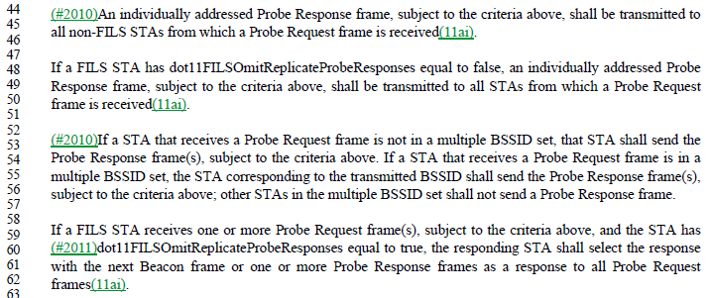

The “criteria above” is a reference to the bullet lists with the criteria for sending a probe response.

The cited paragraph is meant to cover the case of a FILS STA responding, when dot11FILSOmitReplicateProbeResponses is equal to true, so an individually addressed Probe Response can be replaced with equivalent information in a Beacon frame or broadcast Probe Response frame. Agree that it seems to have grammar and possible editing errors, and doesn’t make this behaviour clear.

Also, since the paragraph at line 48 is the case for a FILS STA with dot11FILSOmitReplicateProbeResponses equal to false, it would be more logical to keep these paragraphs together.

Proposed Resolution:

Revised. Replace the sentence with: "If a FILS STA receives one or more Probe Request frame(s) and the STA has dot11FILSOmitReplicateProbeResponses equal to true, then the responding STA shall respond, subject to the criteria above, via the next Beacon frame, a broadcast Probe Response frame, or one or more individually addressed Probe Response frames.". Also, move the paragraph at P2164.48 to appear after the paragraph at P2164.52.

CID | Page | Clause | Comment | Proposed Change
4488 | 2465.00 | 11.28.2.2 | There are two references to a "Remaining BI field" (singular BI), but there is no such field | Change each to "Remaining BIs field"

Discussion:

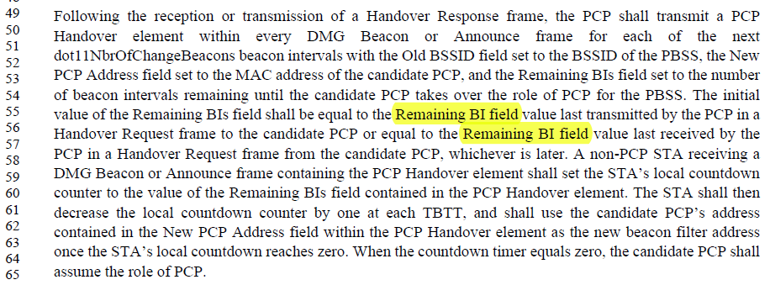

The PCP Handover element, which is transmitted in a number of DMG Beacon or Announce frames, is defined in Figure 9-582, and the field in this structure is named “Remaining BIs”:

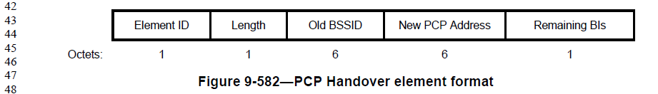

However, the Handover Request frame, from which the initial value of the Remaining BIs field is taken, is defined in 9.6.19.6:

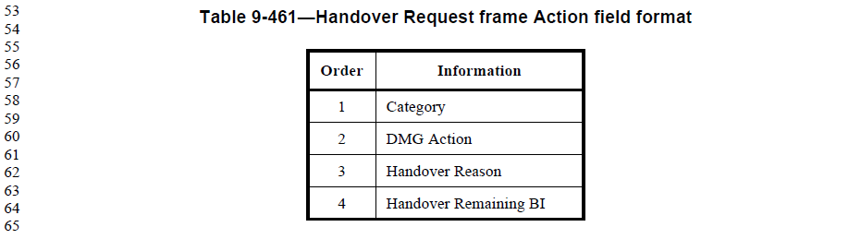

In this frame, the field name is “Handover Remaining BI”.

Proposed Resolution:

Revised. Change each “Remaining BI field” (singular) in the cited paragraph to “Handover Remaining BI field”.

CID | Page | Clause | Comment | Proposed Change
4193 | 1852.54 | 10.23.4.2.3 | "To describe the behavior at the STA, two MAC variables are defined. " duplicates the first para of the subclause | Delete the cited text

Discussion:

The first paragraph of the subclause:

And, the cited sentence:

The sentence at line 55 is a duplicate of the start of the subclause. Further, the text between these two paragraphs is discussing the default values of the variables, and how a STA can request admission control and how the variables are updated. So, introducing the concept of the variables in the latter paragraph does not fit the flow of the subclause.

Agree with the commenter, the cited sentence is out-of-place and not needed.

Proposed Resolution

Accepted.

CID | Page | Clause | Comment | Proposed Change
4068 | 1503.49 | 9.5.4 | "STA needs transmit training". This is a protocol for interoperability, so I think it is better to say "STA requests transmit training". | Change "needs" to "requests".

Discussion:

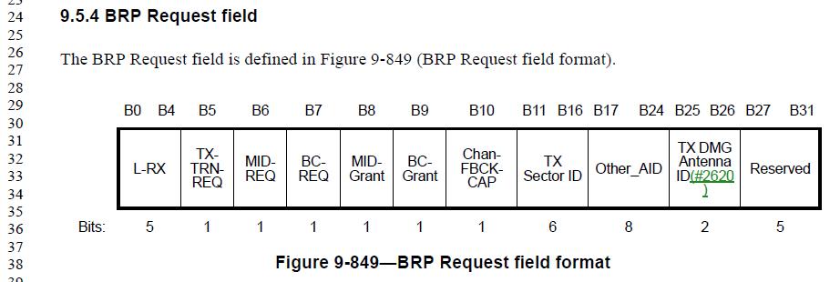

The field in question is in the BRP Request frame, as part of the bean refinement protocol. This field/bit indicates the that request includes a request for transmit training.

The previous paragraph covers a request for receive training:

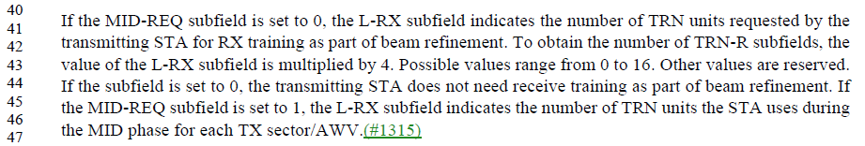

Both of these are probably better phrased as the transmitter “requests” either/both transmit or receive training.

Proposed Resolution:

Revised.

At 1503.49, replace “needs” with “requests”.

At 1503.44, replace “need” with “request”.

CID | Page | Clause | Comment | Proposed Change
4067 | 1503.42 | 9.5.4 | The ordering of these sentences is confusing to read: "To obtain the number of TRN-R subfields, the value of the L-RX subfield is multiplied by 4. Possible values range from 0 to 16." | Reword to "The L-RX field is an unsigned integer with range 0 to 16. Values outside this range are reserved. The number of requested TRN-R subfields is equal to the value of the L-RX subfield multiplied by 4."

Discussion:

Agree, the rewording is a bit more clear.

Some additional editorial rewording has been suggested.

Proposed Resolution:

Revised. Reword to "The L-RX field contains an unsigned integer in the range 0 to 16. Values outside this range are reserved. The number of requested TRN-R subfields is equal to the value of the L-RX subfield multiplied by 4."

CID | Page | Clause | Comment | Proposed Change
4243 | 2467.63 | 11.29.2 | "The Information Response frame may include vendor-specific elements. " -- true of all Action frames unless explicitly disallowed | Delete the cited text

Discussion:

The Information Response frame is part of the Peer Service Discovery facility.

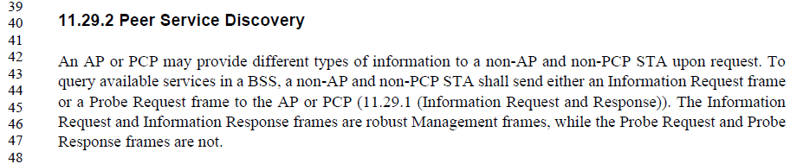

And is an Action frame:

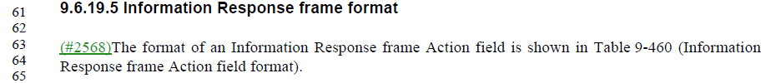

Action frames do have a Vendor-specific IE, by default:

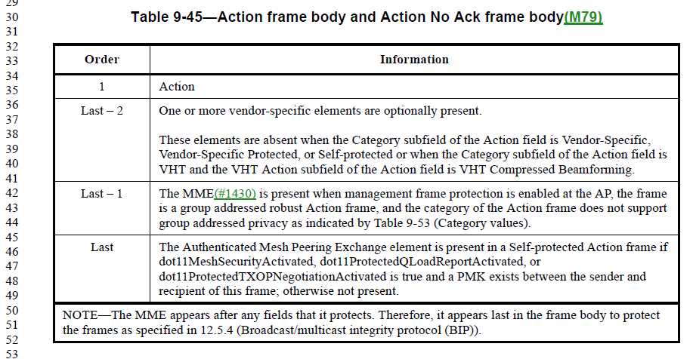

The sentence does appear to be redundant.

Proposed Resolution:

Accepted.

CID | Page | Clause | Comment | Proposed Change
4056 | 1121.31 | 9.4.2.29 | "Length (55)". The Length is 55 or 57. Also, there is no need to include "55" in the figure. | Delete "(55)" at 1121.31

Discussion:

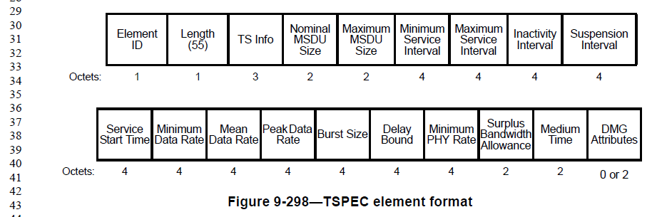

This is a field in the TSPEC element. The element format is clearly labelled with the length of each field, so the total length is already clear. Agree, the “(55)” is unnecessary and not the usual style, and can be in error.

Proposed Resolution:

Revised. Delete “(55)” as proposed. Also, similarly in Figures 9-169, 9-292, 9-293, 9-330, 9-331, 9-332, 9-334.

CID | Page | Clause | Comment | Proposed Change
4454 | 1518.53 | 9.6.3.8 | "The QoS Action field is defined in 9.6.3.1 (General). representing ADDTS Reserve Response.  The (#2110)Higher Layer Stream ID element is defined in 9.4.2.124 (Higher Layer Stream ID element).  The Status Code field is defined in 9.4.1.9 (Status Code field)." is too vague. Needs to refer to specific contents. Similarly in other locations in 9.6.3 | At 1518.53, change to "The QoS Action field is defined in 9.6.3.1." and "The Higher Layer Stream ID field contains a Higher Layer Stream ID element (see 9.4.2.124)."

Discussion:

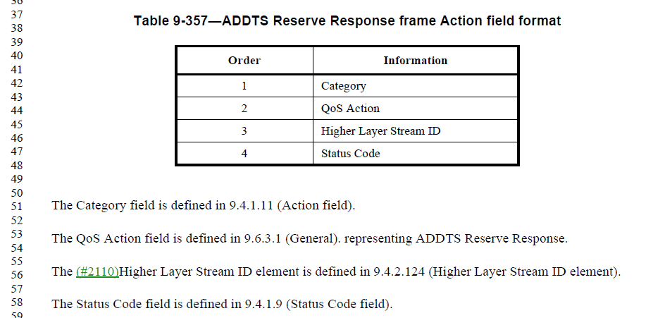

This comment is to clean up the wording of the descriptions for the fields of the ADDTS Reserve Response action frame.

The QoS Action field is used to differentiate the “QoS” type Action frames, per the Table 9-346 in 9.6.3.1. The other QoS Action frames don’t have the “representing …” verbiage. For consistency, it can be removed, as unnecessary, as requested by the commenter.

The ADDTS Reserve Request frame (previous subclause, 9.6.3.7) says this:

Similar, but slightly different from the Response version, but still unnecessary.

The Higher Layer Stream ID should be referred to as a “field”, with a reference that it contains an element as defined in 9.4.2.124. Again, agree with the commenter’s proposed change.

The comment references the Status Code field in the comment, but leaves it out of the proposed change (which implies it would deleted). This appears to be in error.

Proposed Resolution:

Revised. At the cited location, replace
“The QoS Action field is defined in 9.6.3.1 (General). representing ADDTS Reserve Response.
The Higher Layer Stream ID element is defined in 9.4.2.124 (Higher Layer Stream ID element).”
with
“The QoS Action field is defined in 9.6.3.1 (General).
The Higher Layer Stream ID field contains a Higher Layer Stream ID element (see 9.4.2.124 (Higher Layer Stream ID element))."

In subclause 9.6.3.7, replace
“The QoS Action field is defined in 9.6.3.1 (General). ADDTS Reserve Request.”
with
“The QoS Action field is defined in 9.6.3.1 (General).”

CID | Page | Clause | Comment | Proposed Change
4447 | 1718.01 | 10.1 | The "Designation  (informative)" in Table 10-1 is not used anywhere, so just delete the column | As it says in the comment

Discussion:

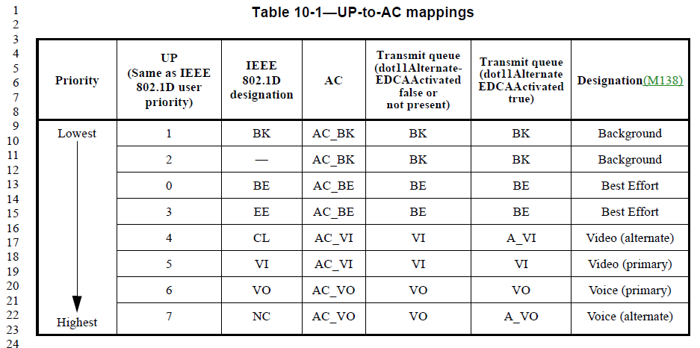

Note, the correct subclause reference is 10.2.3.2 (not 10.1).

Note, the Designation column was previously marked as “(Informative)”, but that was removed as part of the MEC changes.

Agree that this column is not required, for any of uses in the Standard. However, it is helpful to a reader who is not familiar with the abbreviations (BK, BE, VI, VO). The mapping to commonly used concepts, even if only as broadly accurate, is helpful to understanding the priority concepts in 802.11.

Proposed Resolution:

Revised. While unused elsewhere in the Standard, the Designation column is helpful to a reader trying to become familiar with the 802.11 QoS prioritization mechanism and its purposes.

REVmd Editor: Add a NOTE at the bottom of Table 10-1, “NOTE—The Designation column is an indication of general usage and guidance. Actual uses of each UP are implementation specific.”

CID | Page | Clause | Comment | Proposed Change
4377 | 805.22 | 9.2.4.6.2 | Figure 9-13--Link Adaptation Control subfield format should number the bits from 0, not from 1. Ditto Figure 9-12--HT Control Middle subfield of the HT variant HT Control field format, Figure 9-16--HT Control Middle subfield of the VHT variant HT Control field format, Figure 9-21--MFB subfield in the CMMG variant HT Control field format, Figure 9-687--Control field format, Figure 9-114--First example of Compressed Beamforming Report field encoding, Figure 9-115--Second example of Compressed Beamforming Report field encoding | Subtract 1 from each of the bit positions in the figure

Discussion:

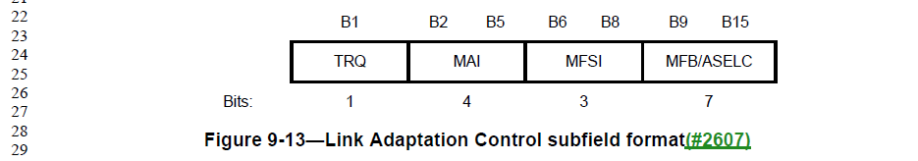

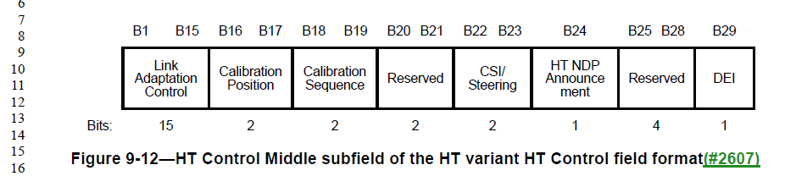

These are subfields of the Non-CMMG variant HT Control field:

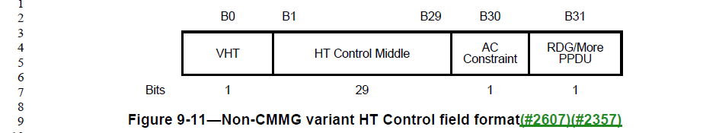

It seems that because the HT Control Middle field started at B1 in the HT Control field, that the authors thought that should be reproduced in the figures that detailed the format of the contents. While there are examples of starting bit numbers at zero on subfield Figures such as this, there are also examples of this (non-zero) style elsewhere and nearby (for example Figures 9-8 and 9-9). The Editorial Style Guide appears to be silent on the topic of how the bit numbers should be indicated/assigned.

Proposed Resolution:

On June 10 telecon, agreed to resolve in the direction of the comment.

Searched Figures in clause 9 for other examples that don’t start at bit 0, and added those to the list in the Proposed Resolution.

However, consider the following examples, in 9.4.1.29:

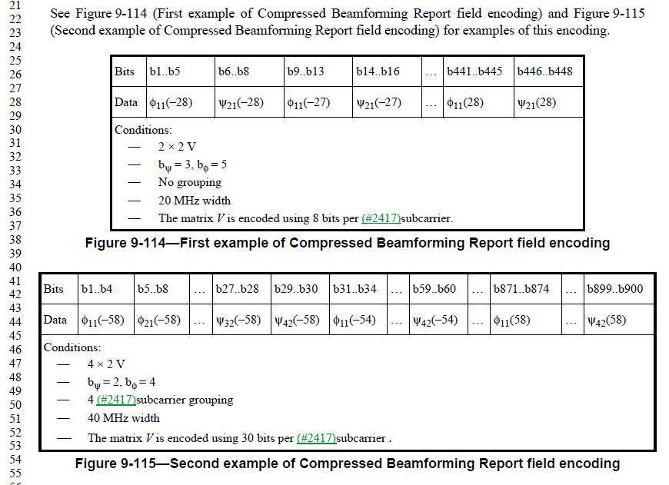

The Compressed Beamforming Report field is in the Compressed Beamforming action frame:

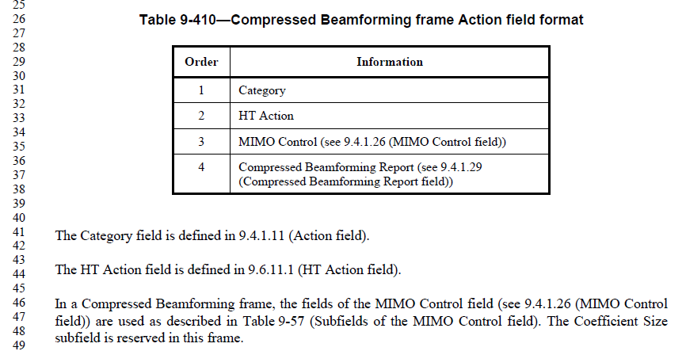

This is a different style, but the effect is the same, so also subtract 1 from all these bit numbers.

Proposed Resolution:

Revised.

Subtract 1 from each of the bit positions in the Figures 9-12, 9-13, 9-16, 9-21, 9-687.

Subtract 4 from each of the bit positions in Figures 9-8, 9-338.

Subtract 8 from each of the bit positions in Figure 9-9.

Subtract 3 from each of the bit positions in Figure 9-17.

Subtract 9 from each of the bit positions in Figures 9-18, 9-19.

Subtract 18 from each of the bit positions in Figure 9-22.

Subtract 29 from each of the bit positions in Figure 9-559.

Subtract 34 from each of the bit positions in Figure 9-560.

Subtract 1 from each of the bit numberings in Figures 9-114 and 9-115.

Correct “B4” to “B0” in Figure 9-838.

Request the Editors to add a statement in the Editors Guide that all format figures shall number bits from B0.

CID | Page | Clause | Comment | Proposed Change
4485 | 1242.42 | 9.4.2.83 | "The Low Rate TIM Rate field provides an indication of the rate that is used to transmit the low data rate TIM frame, in units of 0.5 Mb/s. A value of 0 indicates that the low rate TIM frame is not transmitted." -- 11.2.3.15 TIM Broadcast does not allow the low rate TIM frame not to be txed; only the high rate one is optional to transmit | Delete "A value of 0 indicates that the low rate TIM frame is not transmitted."

Discussion:

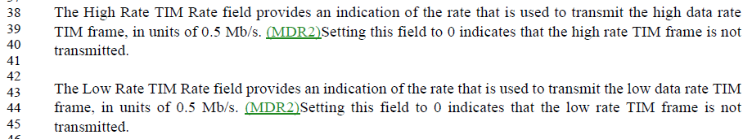

While it could be more clear, the TIM Broadcast behavior requirements in 11.2.3.15 are clear that the high data rate TIM is not transmitted in some situations, but no such exceptions exist for the low data rate TIM.

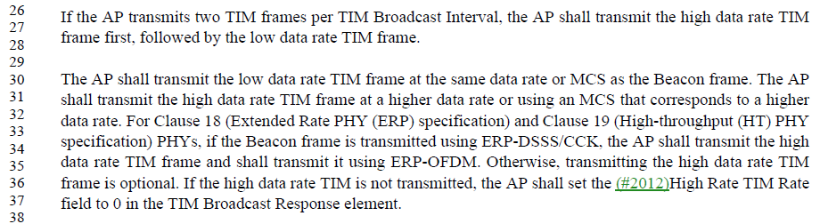

Thus, agree with the commenter, that it seems the low data rate TIM must be transmitted, and logically therefore it must have a non-zero data rate.

The TIM Broadcast Response element carries an indication of the rate for both the high date rate TIM and the low data rate TIM.

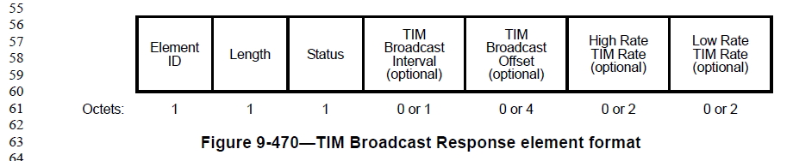

The Low Rate TIM Rate field is optional, presumably because it is not included if the request is “Denied”. However, if the request is accepted or overridden, there is nothing to indicate that the rate could be zero.

Thus, agree with the comment.

However, if the value of zero does not mean the low data rate TIM is not transmitted, then the value of zero is non-sensical, and should be disallowed.

Proposed Resolution:

Revised. Replace, at the cited location, “Setting this field to 0 indicates that the low rate TIM frame is not transmitted.” with “The value 0 is reserved.”

Add to the end of subclause 9.2.2:

“Reserved field and subfield values are not used upon transmission. Upon reception of a reserved field or subfield value, the behavior is undefined.”

CID | Page | Clause | Comment | Proposed Change
4442 | 2272.13 | 11.6.2 | " If  the MAC and the transmitter of the (#1072)(#2409)sync packet are collocated within the same STA" -- huh? How can a MAC and a transmitter be distinct things that are collocated within a STA? | Change the cited text to "If the STA is the transmitter of the sync packet"

Discussion:

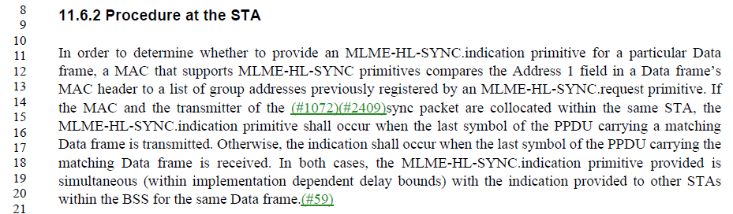

This is within the procedure for the HL-SYNC mechanism.

Since HL sync frames are, by definition, higher layer, the phrase “transmitter of the sync packet” is probably trying to refer to the higher layer entity, not the MAC transmitter. This is further borne out by the use of “packet” instead of “frame”.

Per the MLME-HL-SYNC primitives, data frames’ Address 1 field is matched against a provided group address, for either a received or transmitted frame, If the Address 1 field matches, a MLME-HL-SYNC.indication is generated.

It seems the intent is to generate the .indication primitive when: 1) the higher layer transmitter is co-located with the MAC (the MAC being asked to transmit the packet); or 2) the MAC receives a frame that is carrying a sync packet. Both situations are identified by matching the Address 1 field with a group address provided via an earlier MLME-HL-SYNC.request.

So, the intention of the text is to state in the first sentence that the matching is done on Data frames (leaving it implied, both transmitted and received). The second sentence is trying to clarify that if the high layer transmitter is collocated with the MAC, the .indication is generated at the last symbol of the PPDU being transmitted. The third sentence is trying to clarify for the receive case, that the .indication is generated at the last symbol of the PPDU being received. This is technically correct, but the wording is confusing.

Proposed Resolution:

Revised.

Replace the second and third sentences with:
“When the MAC transmits a Data frame with an Address 1 match, the MLME-HL-SYNC.indication shall occur when the last symbol of the PPDU carrying the Data frame is transmitted. When the MAC receives a Data frame with an Address 1 match, the MLME-HL-SYNC.indication shall occur when the last symbol of the PPDU carrying the matching Data frame is received.”

CID | Page | Clause | Comment | Proposed Change
4418 | 1113.25 | 9.4.2.26 | The "Reject Unadmitted Frame" extended capability is weird: "When dot11RejectUnadmittedTraffic is true, the Reject Unadmitted Frame bit is  set to 1 to indicate that the STA rejects MA-UNITDATA.request primitives for  frames belonging to an unadmitted TS.  When dot11RejectUnadmittedTraffic is false, the Reject Unadmitted Frame bit is  set to 0 to indicate that the STA is not required to reject MA-UNITDATA.request  primitives for frames belonging to an unadmitted TS.". Why does the peer need to know the local policy on rejecting unadmitted traffic? Why does the peer not need to know for sure whether the peer will reject unadmitted traffic ("is not required to reject" ... but might). Also "the STA's MA-UNITDATA primitive rejects  frames" is weird -- it's not the primitive that rejects, it's the STA, and there is no MA-UNITDATA primitive, there are only MA-UNITDATA.something primitives | In Table 9-153--Extended Capabilities field change "the STA rejects MA-UNITDATA.request primitives for  frames belonging to an unadmitted TS" to "the STA does not transmit frames belonging to an unadmitted TS" and "the STA is not required to reject MA-UNITDATA.request  primitives for frames belonging to an unadmitted TS" to "the STA might transmit frames belonging to an unadmitted TS". In C.3 change "This attribute when true indicates the STA's MA-UNITDATA primitive rejects  frames" to "This attribute when true indicates the STA rejects MA-UNITDATA.requests"

Discussion:

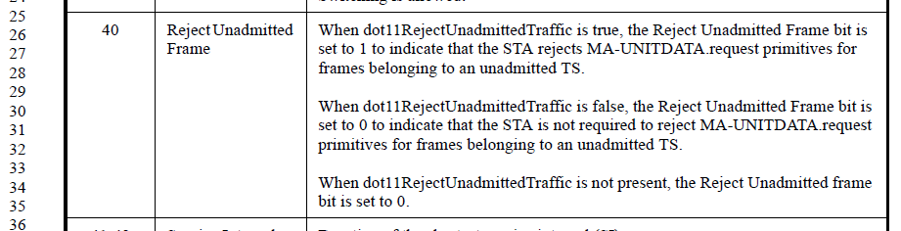

This feature was introduced in 802.11-2012 (REVmb). It is the result from (REVmb) CIDs 1685 and 1686, per 11-09/1063r1 (https://mentor.ieee.org/802.11/dcn/09/11-09-1063-01-000m-lb149-ma-unitdata-rejection-of-un-admitted-traffic.doc).

In that document, the rationale appears to be a concern that an AP (“HC”) that is attempting to manage the WM can get confused if a non-AP STA is sending traffic that appears to be exceeding the STA’s admitted time, if the TID is unchanged on downgraded traffic. However, if the TID is changed on downgraded traffic, the AP has no way to know that this is really intended to be higher-priority traffic (on the upstream flow). Thus, we have a conflict around the best way to signal such downgraded traffic.

The adopted proposed resolution was to add a capability indication (and MIB attribute, etc.) that signals whether a given non-AP STA will or will not downgrade traffic that is not admitted at its priority level as provided at the MA-UNITDATA interface.

The MIB (C.3) context is:
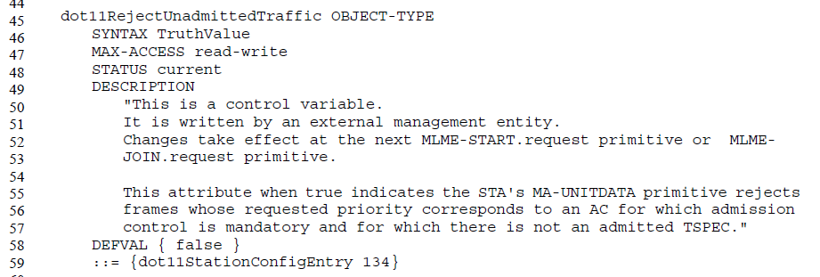

Reviewing the changes proposed in this (current) CID:
- In Table 9-153--Extended Capabilities field change [when the Capability bit set to 1] "the STA rejects MA-UNITDATA.request primitives for frames belonging to an unadmitted TS" to "the STA does not transmit frames belonging to an unadmitted TS"
  - This appears to be just a wording concern that the remote peer only needs to know that the STA won’t transmit such frames, not the inner-workings of the MA-UNITDATA.request primitive. Seems correct, and still in-line with the intent of the feature.
- and [when the Capability bit is set to 0] "the STA is not required to reject MA-UNITDATA.request primitives for frames belonging to an unadmitted TS" to "the STA might transmit frames belonging to an unadmitted TS".
  - Similar to (1). Seems okay.
- In C.3 change "This attribute when true indicates the STA's MA-UNITDATA primitive rejects frames" to "This attribute when true indicates the STA rejects MA-UNITDATA.requests"
  - This change is to remove calling the MA-UNITDATA service a primitive. It is more explicit to mention that it is upon the .request primitive that a STA rejects such requests (if the MIB attribute is true), rather than leave it confusing that perhaps the MA-UNITDATA.indication would also result in any such rejection.

Proposed Resolution:

Accepted.

CID | Page | Clause | Comment | Proposed Change
4221 | 1618.40 | 9.6.14.2 | There is no such thing as a "valid TSF" as opposed to an invalid one | Delete "valid " in the cited text

Discussion:

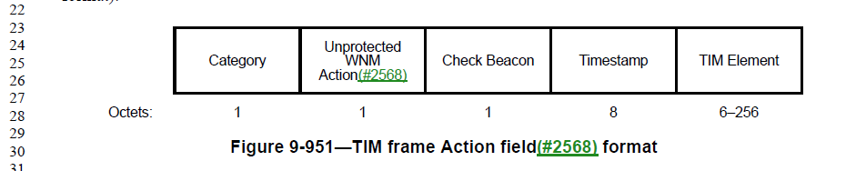

This is on the Timestamp field of the TIM action frame.

The Timestamp field is not optional, so the TIM frame will always include something in the field. Per ppg 2199-2200, if the result of the TIM Broadcast setup (Request/Response) is a status that says a “valid” timestamp will be present then the value is present in this field is a “valid” TSF – otherwise, per pg 1618, the field is reserved.

(At June 10 teleconference, the “The field is reserved otherwise” was pointed out.)

Ppg: 2199-2200:

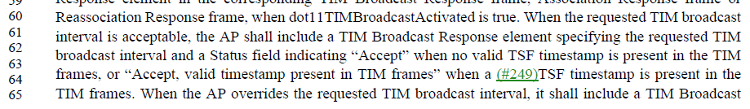
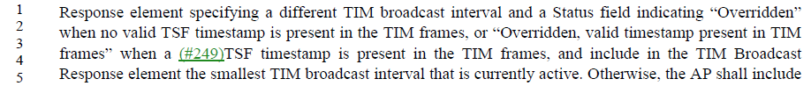

Proposed Resolution:

Delete “valid” at 1618.41, as requested.

Also, replace “no valid TSF timestamp is present” with “no timestamp is present” at both P2199.63 and P2200.2.

On June 24 teleconference, asked to add some more changes:
- Fix “valid TSF timestamp” (without the “no”)
- Update the descriptive strings that include “valid timestamp present”, also

Proposed Resolution:

Revised.

Delete “valid” at 1618.41, as requested.

Replace “no valid TSF timestamp is present” with “no timestamp is present” at both P2199.63 and P2200.2.

Replace “valid TSF timestamp” with “TSF timestamp” at P1623.41, P2193.15, P2193.19, P2193.31

Replace:
- “Accept, valid timestamp present in TIM frames” with “Accept, timestamp present in TIM frames”
- “Overridden, valid timestamp present in TIM frames” with “Overridden, timestamp present in TIM frames”
in Table 9-229, and at P1623.42, P1623.43, P2193.16, P2193.19, and P2193.28.

CID | Page | Clause | Comment | Proposed Change
4814 | 287.48 | 4.1 | The 802.11 Style Guide says clause 4 should be written in delcarative, not normative, language, and that it is intended to provide only a general description of the system. There are parts of clause 4 (4.10, for example), that get quite detailed (like specific frame exchange diagrams) and seem to be both beyond a "general description" and potentially are the only normative specification for these behaviors. There are also a few uses of "may" and many uses of "can" that should be checked/changed to clearly informative language. | At least 4.10, and potentially all of clause 4, needs to be scrubbed for details that are beyond "general description" and/or are the best/only normative specification in the Standard of any behaviors, and move such text to a later clause.
4780 | 288.1 | 4.10.2 | Most of the subclauses of 4.10 are way too detailed for clause 4. | Move 4.10.2 through 4.10.8, to appear after 12.2.5 and before 12.2.6.

Discussion:

CID 4780 has been discussed previously by the CRC (April 24), with the following notes:
Submission Required

Leave 4.10.2, 4.10.6, 4.10.7, 4.10.8, and reduce the content in the others (by moving to clause 12).

Otherwise: REJECTED. Similar to clause 4.9 which provides the reference model for the MAC and PHY, the referenced sub-clause describe how IEEE 802.1X authentication services are used with security and key management protocols in IEEE 802.11 to provide security. This clause describes the key components of the IEEE 802.11 security architecture and serves as a guide as to where requirements can be found in the remainder of the specification. These descriptions do not provide normative requirements so they should not be moved to clause 12.

The consideration at the time for moving 4.10.3, 4.10.4 and 4.10.5 is that these subclauses are all functional models of 802.1X security behaviour/operation for the infrastructure, IBSS and PBSS architectural models, respectively, and so could be helpful in clause 12.

New discussion:

Clause 4 is titled “General description”. Its subclause headings are similarly general/high-level in tone:

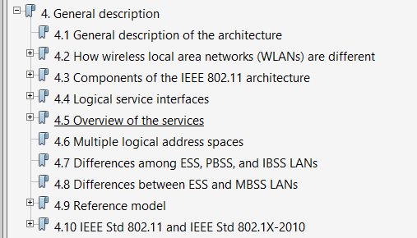

The 802.11 Style Guide says, in 3.2, says:

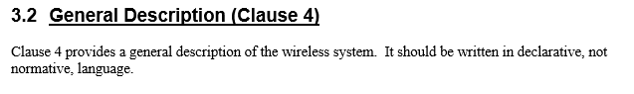

Thus, agree with the commenter that the language should be declarative, and the intent is to be largely descriptive and not detailed.

Per the Style Guide clause 2.8, the words “shall”, “should” and “may” are normative. There are no occurrences of shall or should in clause 4. These occurrences of “may” exist:

P266.48:
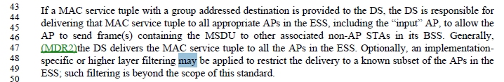

The above explicitly says the filtering in question is beyond the scope of this standard. The “may” should be a “might”.

P271.6:
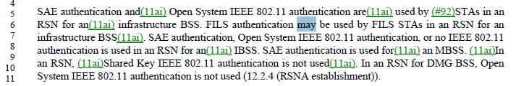

The above is discussing facilities within 802.11 itself. The “may” should be a “can”, as this behaviour is defined elsewhere in the standard.

P298.17:
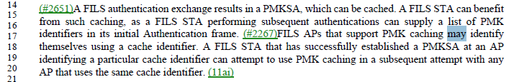

The above is again discussing behaviour defined elsewhere in the standard. The “may” should be a “can” (which is consistent with the other sentences in this paragraph).

The commenter also complains about the use of “can” in clause 4. The Style Guide is a bit confusing on this point. Also in clause 2.8, it lists “can” as a “non-normative” verb. It further goes on to talk about verbs that should appear in “informative text”. But it also describes clause 4 as “declarative”. So, we are left to interpret the difference/similarity between “non-normative”, “informative” and “declarative”.

A little guidance is provided by this paragraph, just a bit later in clause 2.8 of the Style Guide:

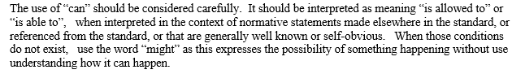

There appear to be about 140 occurrences of “can” in clause 4. A spot inspection indicates that most (if not all) of these are statements with normative support described elsewhere in the standard. Thus, the usage seems to be correct and acceptable, if we consider that clause 4’s “declarative” rule supports using “non-normative” verbs.

The commenters final point is about material in clause 4 that is “quite detailed”, especially in clause 4.10. Some examples that might be what was referenced include behaviour description such as:

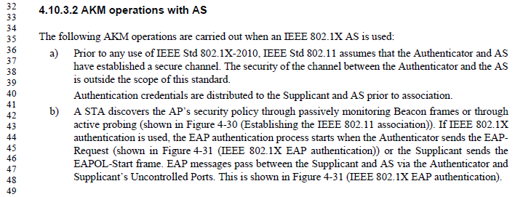

Flow diagrams, such as:
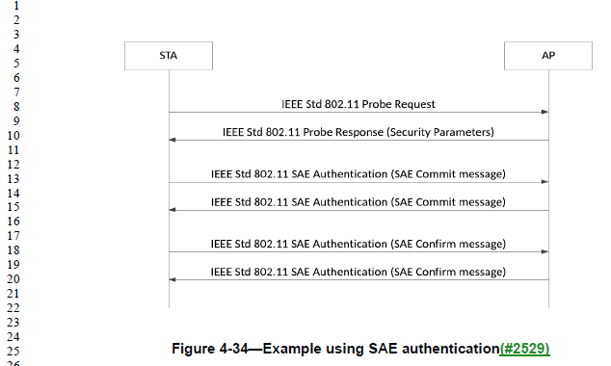
and
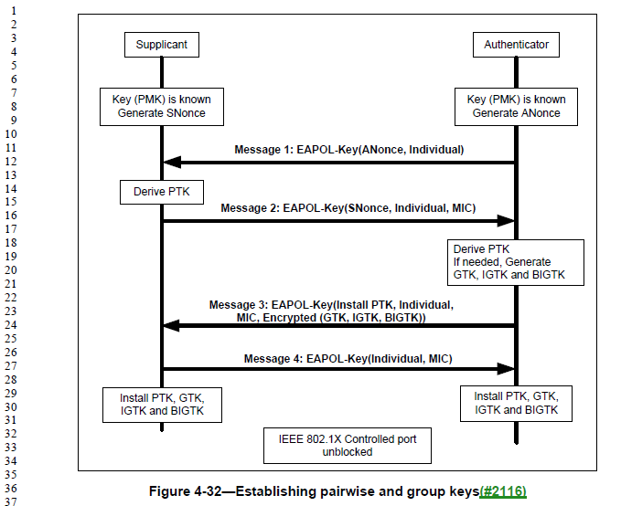

And step-by-step detailed behaviour flow such as:

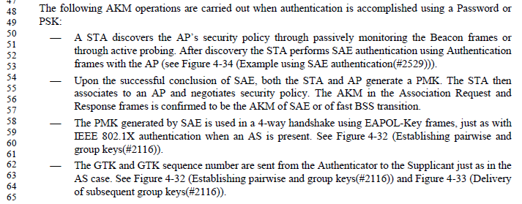

In some of these case, the behaviour being described is of the Authenticator and Supplicant. And, the Authenticator and Supplicant are arguably outside the scope of the standard, other than general statements about their expected use and behaviour, see Figure 4-24, which shows them as aspects contained within the SME, which is similarly outside the scope of the standard other than some general requirements on expectations:

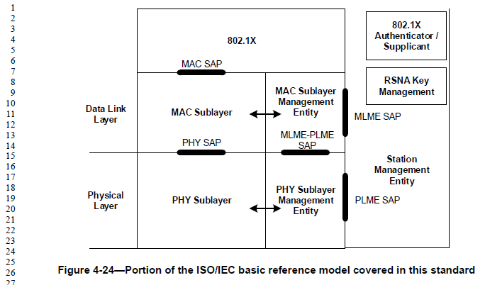

In other cases, the behaviour is of a STA [sic] or AP, but the behaviour is a high-level.

So, this is a grey area judgement call if this is going beyond general description, and/or if it is appropriate elsewhere in the standard if it is discussing components outside the scope of the standard.

Compare this text in clause 4 to text in clause 12. Two things can be noted. Clause 12 does also have behaviour that is required from the authenticator and supplicant. So, the argument about that material in clause 4 being there because it is (arguably) beyond the scope of the standard does not stand – clearly there are required aspects of the authenticator and supplicant that are within the scope of the standard. The other thing to notice is that clause 12 has flow diagrams very similarly “high level” to those in clause 4, for example:

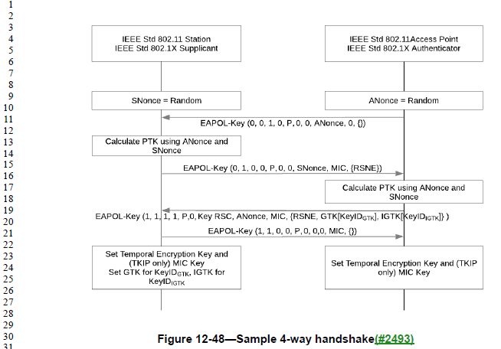

In summary, the level of detail and appropriateness of the material in clause 4 versus clause 12 is a very fine line, if there is any distinction at all.

Thus, we are left to decide what is most useful to the reader:
- Move some of the questionable material in clause 4 into a later clause, and in particular move much of subclause 4.10 into clause 12.
- Leave the 4.10 material where it is, and assume the reader needing high-level introduction to concepts will look there, while the reader needing more concrete behaviour will look in clause 12, and the line between the two is a bit fuzzy, but adequate as is.

How often are readers who frequently use this material finding themselves flipping back to clause 4, while discussing behaviour in clause 12, or vice-versa?

For now, let’s claim this isn’t a significant problem, and the commenter was not specific about what changes would address it without causing further disruption.

Proposed Resolution:

Revised.

At P266.48, replace “may” with “might”
At P271.6, replace “may” with “can”
At P298.17, replace “may” with “can”

Note to commenter: These three locations are the only occurrences of a normative verb in clause 4, so these corrections now complete clause 4 being scrubbed for normative language. Uses of “can” are not normative, per the 802.11 Style Guide, and the CRC deemed these appropriate in clause 4 for references to normative behaviour specified elsewhere in the standard. As for clause 4 being “quite detailed”, the CRC considered several examples of the more detailed text in clause 4, and found that while the distinction between “general description” and “detailed” is a grey line, there was consistency to what material is in, for example, subclause 4.10 versus clause 12, so no material was moved.

CID | Page | Clause | Comment | Proposed Change
4323 | 2154.47 | 11.1.3.8 | "The decimal value of the 11 LSBs of the AID assigned to an S1G STA shall be" -- the value is the value; the encoding/representation is irrelevant | Delete "decimal " in the cited text

Discussion:

Agree the “decimal” is unnecessary and potentially confusing. This appears to be the only occurrence of a usage like this in the Draft.

Proposed Resolution:

Accepted.

CID | Page | Clause | Comment | Proposed Change
4342 | 1563.10 | 9.6.7.36 | Should qualify the MCS in Table 9-386--FILS Minimum Rate | In Table 9-386--FILS Minimum Rate add "HT-" before "MCS" in the penultimate column, and "VHT-" before "MCS" in the last column (note this covers TVHT via the hand-wavy substitution rules elsewhere)

Discussion:

Context:

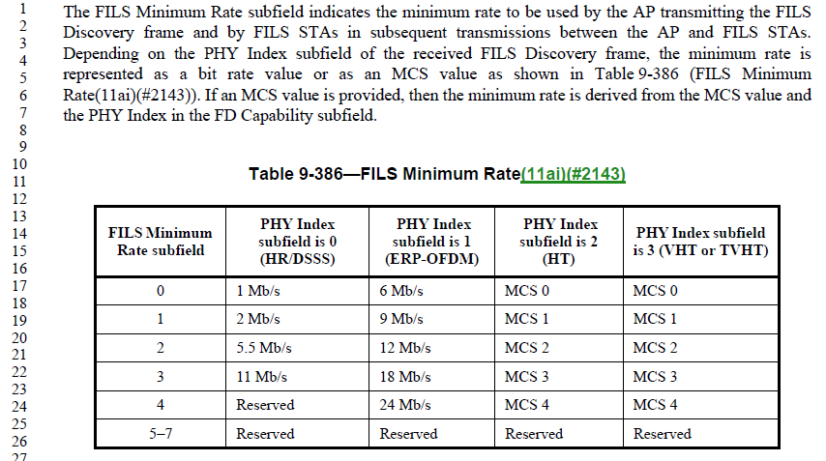

From a similar comment, CID 1400:

1400 | 2272.22 | 22 | 11.38.1 |  | "the STA shall indicate support for MCSs 8(n-1) to 8(n-1)+7" should be clearer as to what kind of MCS | On lines 22 and 23 at the referenced page change "MCS" to "HT-MCS"

Discussion:

Context:
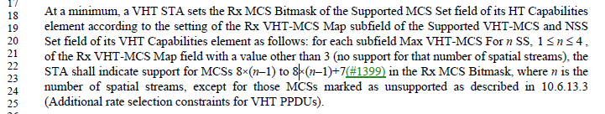

Arguably, it should be apparent that setting bits in the Rx MCS Bitmask contained in the HT Capabilites element, would be indicating HT MCS rates. However, this paragraph is already rather confusing with the number of cross-references between VHT and HT capabilities in the text, there is potential for confusion, so the proposed change seems to cause no harm and might be helpful.

The use of “HT-MCS” (with the hyphen) seems to be limited to “Basic HT-MCS Set” (the fieldname), however. The usage is “HT MCS” where the “HT” is an adjective.

Proposed Resolution:

Revised. On lines 22 and 23 at the referenced page change “MCSs” to “HT MCSs”.

There has been a general move to make uses of “MCS” clear as to their applicable scope, “HT-MCS”, “VHT-MCS”, etc. Only in situations where the applicability is meant to be general, do we leave it as “MCS”. While this almost certainly hasn’t been followed 100%, the proposed direction seems okay. Also, the uses of “MCS” in the paragraph before Table 9-386, which have general applicability, are okay, as is.

Also, CID 2446, in document 11-19/0838r1, corrected a number of instances of the phrase without a hyphen (such as “HT MCS”) to have the hyphen. So, the hyphenated version is correct.

Proposed Resolution:

Accepted.

CID | Page | Clause | Comment | Proposed Change
4376 | 0.00 | 9 | Some of the Frame Control field figures have the wrong bit numbering: the PV should be "B0 B1" not "B1 B2". Fix in Figure 9-5, 9-6 | As it says in the comment

Discussion:

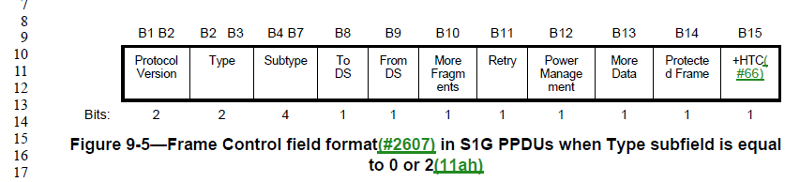

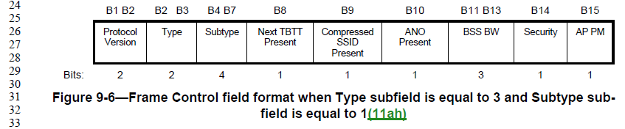

Agree with the comment, these should be lablled “B0 B1”.

Proposed Resolution:

Accepted.

CID | Page | Clause | Comment | Proposed Change
4373 | 1609.54 | 9.6.13.20 | "Each subelement starts with the ID and  Length fields. The Length field in the subelement is the length of the contents of the subelement." is duplication of the general rules for subelements | Delete the cited text

Discussion:

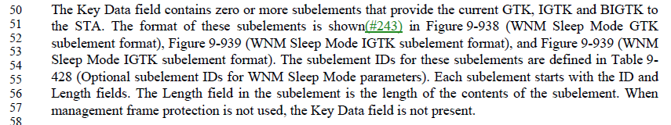

The cited text is describing how to format subelements within the Key Data field of WNM Sleep Mode Response frames.

Subclause 9.4.3 does define the general format for all Subelements, which does include the quoted information, already.

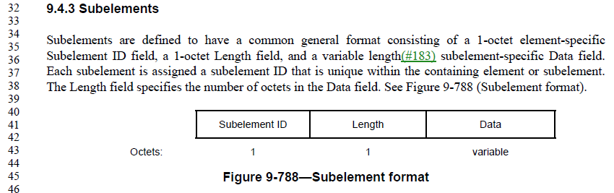

Proposed Resolution:

Accepted.

CID | Page | Clause | Comment | Proposed Change
4371 | 2376.17 | 11.22.6.4 | "initial Fine Timing Request frame" -- no such frame | Change to "initial Fine Timing Measurement Request frame"

Discussion:

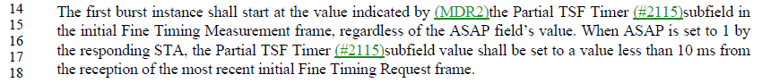

The commenter is correct. Per 11.22.6.3, the frame is called initial Fine Timing Measurement Request frame:

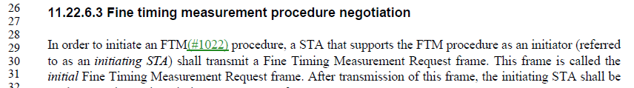

This is the only occurrence of “initial Fine Timing Request” in the draft.

Proposed Resolution:

Accepted.

CID | Page | Clause | Comment | Proposed Change
4410 | 2375.25 | 11.22.6.3 | " the Fine Timing Parameters field" -- no such field | " the Fine Timing Measurement Parameters field"

Discussion:

Similar, and related to the comments above, the commenter is correct, the field is called the Fine Timing Measurement Parameters field (within the Fine Timing Measurement Parameters element), per 9.4.2.167:

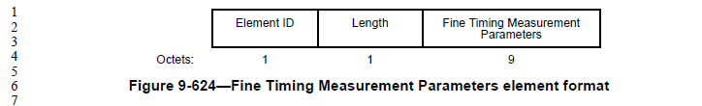

Proposed Resolution:

Accepted.

CID | Page | Clause | Comment | Proposed Change
4489 | 2465.00 | 11.28.2.2 | There are two references to a "Remaining BI field" (singular BI), but there is no such field | Change each to "Handover Remaining BI field"

Discussion:

This is actually a “duplicate” comment to CID 4488, which has already been discussed and agreed:

CID | Page | Clause | Comment | Proposed Change
4488 | 2465.00 | 11.28.2.2 | There are two references to a "Remaining BI field" (singular BI), but there is no such field | Change each to "Remaining BIs field"

Proposed Resolution (to CID 4488):

Revised. Change each “Remaining BI field” (singular) in the cited paragraph to “Handover Remaining BI field”.

Thus, the group ended up agreeing with the Proposed Change from CID 4489, without looking at it. It’s nice when a plan comes together! 😊

Proposed Resolution (for CID 4489):

Accepted.

CID | Page | Clause | Comment | Proposed Change
4768 | 680.44 | 6.3.97.2.2 | The ContactVerificationSignal parameter appears to be an entire CVS frame (as defined in 9.6.7.27), when the only information actually conveyed is the Map ID. The rest of the frame format is (should be) known only to the MAC, and not the user of the MLME SAP. | Change "ContactVerificationSignal" to "Map ID" in the parameter list and parameter table. In the parameter table's Description column, replace the text with, "The Map ID field is set to a number that is equal to the Map ID of the recently received WSM, which is being verified."This pattern of passing a frame, instead of information content, is found elsewhere, such as other primitives for the CVS/GDD function (including GDD Enablement Response), and the FT ("REMOTE-REQUEST"), Mesh peering management, Channel Availability Query, and Network Channel Control functions. A contribution will be provided for proposed changes to address these.

Discussion:

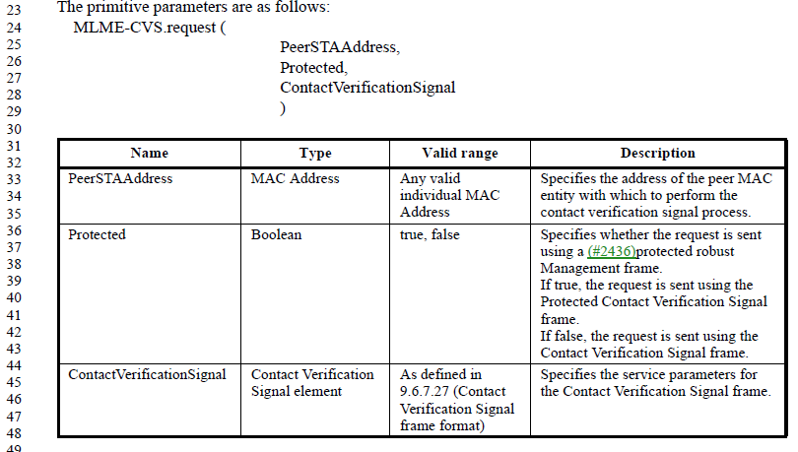

The Contact Verification Signal element is defined in 9.6.7.27, as an Action frame, with the format details shown below:

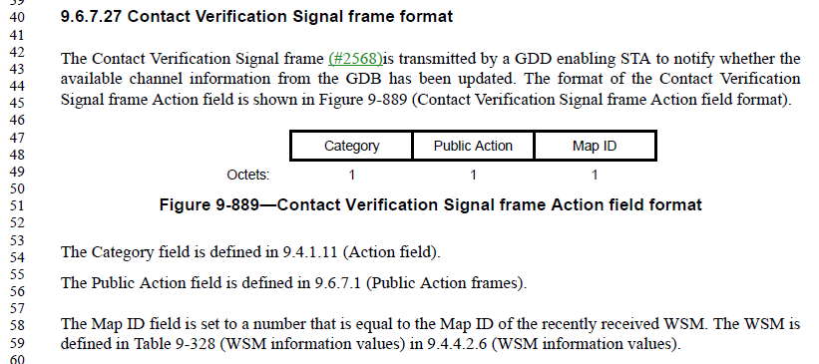

As can be seen, only the Map ID is useful contents for the SME to provide to the MLME with the MLME-CVS.request, since the rest of the fields are known from the frame format definition.

The Proposed Changes attempt to replace the “Contact Verification Signal” with “Map ID” as the parameter to the primitive. However, the Type column of “Contact Verification Signal element” was missed. Suggest that should be replaced with “Integer”. Further, this is talking about the parameters to a primitive, not fields in a frame, so the Description change should say “Map ID is set to …” instead of “The MAP ID field is set to …” Finally, the transmitter of the CVS is the device that established and transmitted the WSM, and the CSV is to confirm that the WSM is still valid. So, the proposed description has the endpoints backwards. Thus, suggest the following changes, for the cited location:

Change "ContactVerificationSignal" to "Map ID" in the parameter list and parameter table. Replace “Contact Verification Signal element” with “Integer”. In the Valid Range column, replace with “0 – 255”. In the parameter table's Description column, replace the text with, "Map ID is set to the Map ID field of the recently transmitted WSM, which is being verified."

The commenter requests to carry this style of change to other primitives.

The first and easiest, is the MLME-CVS.indication, which has exactly the same structure as the .request. Thus, similar changes can be made:
Change "ContactVerificationSignal" to "Map ID" in the parameter list and parameter table. Replace “Contact Verification Signal element” with “Integer”. In the Valid Range column, replace with “0 – 255”. In the parameter table's Description column, replace the text with, "Map ID field is the Map ID field of the received Contact Verification Signal frame, and identifies the WSM that is being verified."

The next suggestion is for other primitives for the GDD function (including GDD Enablement Response). The GDD primitives (for the MLME-GDDENABLEMENT function) for the .request and .indication don’t have any similar use of an entire element to carry individual information. However, the .response and .confirm primitives each have one parameter, “WSM”, which is described as being of Type “WSM element”, but the definition of the parameter references subclause 9.4.1.57, and that subclause is actually a description of the two items of interest that can be carried in the element:

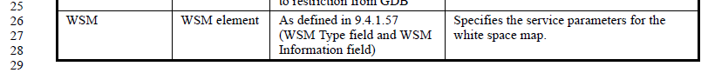

In this case, it is simplest to describe these two items of interest as the tuple of WSM Type and WSM Information, with very minimal changes required.

The next suggestion from the commenter is the FT (“REMOTE-REQUEST”) function. In this case, the request is for the AP to send an FT action frame over the DS to another AP. The action frame to be sent is, in effect, opaque data, and could be any FT action frame, per 9.6.8. So, the primitive’s parameter passing simply “a sequence of octets” which is defined as the contents of an FT action frame per 9.6.8, is reasonably accurate and appropriate. No change is suggested.

Mesh peering management primitives are the MLME-MESHPEERINGMANAGEMENT .request, .indication, .response and .confirm. Each of them is described as three different frame types: Mesh Peering Open, Mesh Peering Confirm and Mesh Peering Close. These frame types each contain a number of fields, different for each frame type. Unpacking this mess is probably not worth the effort, as even if there were one set of primitives for each frame type, the frames themselves are complex enough that listing the fields as individual parameters would add no value. No change is suggested.

The Channel Availability Query and Network Channel Control service primitives follow similar patterns. Both of these MLME functions serve to directly handle the transmission or reception of the associated frames, and in both cases the frames contain a relatively long list of fields. Rather than listing the fields in the primitive (and arguably duplicating the semantics from clauses 9 and 11 in the Description column here in clause 6), the original authors chose the “short cut” of just saying the fields as defined in the frame format are all passed as a set in a service primitive parameter. This isn’t horrible, and as mentioned previously, unpacking this is probably not worth the effort, as even if there were one set of primitives for each frame type, the frames themselves are complex enough that listing the fields as individual parameters would add no value. No change is suggested.

Proposed Resolution:

Revised.

At the cited location (P680.44 and P680.28): Change "ContactVerificationSignal" to "Map ID" in the parameter list and parameter table. Replace “Contact Verification Signal element” with “Integer”. In the Valid Range column, replace with “0 – 255”. In the parameter table's Description column, replace the text with, "Map ID is set to the Map ID field of the recently transmitted WSM, which is being verified."

At P681.17 and P681.34: Change "ContactVerificationSignal" to "Map ID" in the parameter list and parameter table. Replace “Contact Verification Signal element” with “Integer”. In the Valid Range column, replace with “0 – 255”. In the parameter table's Description column, replace the text with, "Map ID field is the Map ID field of the received Contact Verification Signal frame, and identifies the WSM that is being verified."

At P683.26 (MLME-GDDENABLEMENT.confirm) change “WSM element” to “Tuple of WSM Type field and WSM Information field”. Same thing at P685.23 (MLME-GDDENABLEMENT.response).

CID | Page | Clause | Comment | Proposed Change
4771 | 187.37 | 3.2 | After the first senence, this NOTE no longer seems necessary/useful in the Definitions, and further, seems to be mostly talking about MSDUs and A-MSDUs, not MMPDUs. | Confirm this material is stated in normative text, and delete it from here. (Or move it somewhere normative, if it is missing.)

Discussion:

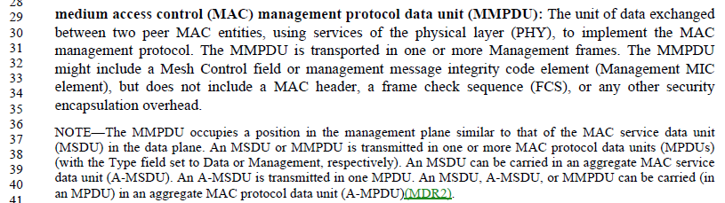

In the definition of MMPDU, it is useful to the reader to make the relationship between an MMPDU and an MSDU, as having similar roles in the architectural stack. Beyond that, the rest of these details are behavior constraints on the PDU structures, are stated elsewhere in normative text, and don’t add to the reader’s understanding of the MMPDU concept.

That an MSDU or MMPSU is transmitted in one or more MPDUs, and of the appropriate type, is clearly stated elsewhere.

That an MSDU can be carried in an A-MSDU is here:

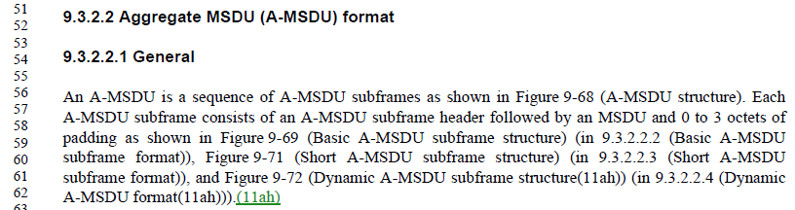

That an A-MSDU is transmitted in one MPDU is here, in that this text does not talk about fragmenting A-MSDUs:

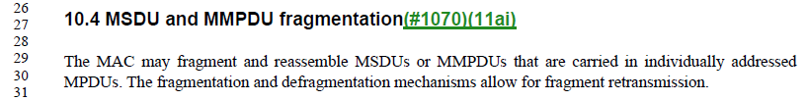

That an MSDU, A-MSDU, or A-MPDU can be carried in an A-MPDU follows from the rule that an A-MPDU consists of a sequence of A-MPDU subframes that contain an MPDU or a sequence of MPDUs (in the DMG case). So, anything that can be in an MPDU can be in an A-MPDU, and thus this derives from the above.

So, these are all stated in normative text elsewhere.

Proposed Resolution:

Rejected. The comment has not identified an error in the text. The contents of the NOTE are informative to the reader.

CID | Page | Clause | Comment | Proposed Change
4380 | 457.18 | 6.3.31.2.2 | "Set of Neighbor  List elements  each as defined  in the Neighbor  Report element  format" -- no such element (in the Neighbor Report element or otherwise) | Delete the referenced table row; also in the table in 6.3.31.3.2. Delete "The neighbor report contents are derived from  the NeighborListSet parameter of the MLME-NEIGHBORREPRESP.request primitive." in 11.10.10.1 and "The Reduced Neighbor Report element  contents may be derived from the NeighborListSet parameter of the MLME-NEIGHBORREPRESP.request  primitive." in 11.50 and "The Neighbor Report Response frame includes a list Neighbor Report elements one for each neighbor." in 11.10.10.3

Discussion:

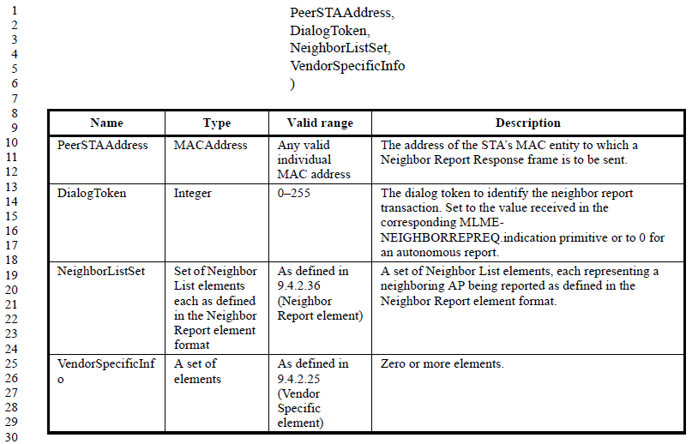

This comment is referring to the .request primitive for the Neighbor Report Response frame. This primitive generates the response to a Neighbor Report Request. Clearly, the Neighbor Report Response needs to carry the neighboring AP information. So, deleting this row is not appropriate.

Note that the same issue (reference to “Neighbor List elements”) also occurs on the next page in the .indication primitive.

However, the commenter is correct that there is no Neighbor List element. This appears to be a typo, and should reference the Neighbor Report element, as defined in 9.4.2.36.

Examining the other locations cited in the Proposed Changes we find:

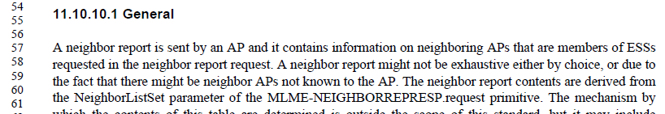
In this location, there is nothing wrong with the reference to the NeighborListSet parameter (once that parameter is fixed, per above). And the location in 11.50 is similar.

The only issue with the location in 11.10.10.3 is a missing “of” (P2315.49):
The phrase should be “list _of_ Neighbor Report elements”

However, there are three other locations that use the phrase “neighbor list”, and these could be clarified. These occur in the context of the Neighbor Report Request frame and its primitives:

At P1526.33 (Neighbor Report Request frame format):
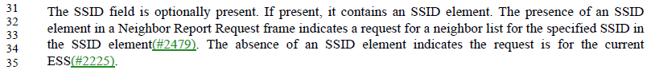

At P455.5 (Neighbor Report Request .request) and P455.63 (Neighbor Report Request .indication):

In the above locations, “neighbor list” would be more clear as “list of neighbor reports”.

Proposed Resolution:

Revised.

Change “Neighbor List elements” to “Neighbor Report elements” at P457.18 (2x) and at P458.17 (2x).

At P2315.49, insert “of” (to become “list _of_ Neighbor Report elements”).

At P1526.33, P455.5 and P455.63, change “neighbor list” to “list of neighbor reports”

CID | Page | Clause | Comment | Proposed Change
4479 | 2162.6 | 11.1.4.3.4 | "A STA that receives a Probe Request frame shall not respond if [...] c) The STA is a non-AP STA in an infrastructure BSS". Such a STA does not respond due to the rules in a) above, which mean that only an AP, IBSS STA, mesh STA, DMG STA or PCP responds | Delete list item c)

Discussion:

This comment is effectively a duplicate of CID 4480, which has already been approved and motioned (Motion #187) as Accepted. Details for CID 4480 are:

CID | Page | Clause | Comment | Proposed Change
4480 | 2162.6 | 11.1.4.3.4 | "A STA that receives a Probe Request frame shall not respond if [...] c) The STA is a non-AP STA in an infrastructure BSS". Such a STA does not respond due to the rules in a) above, which mean that only an AP, IBSS STA, mesh STA, DMG STA or PCP responds. Hm, or maybe the "DMG STA" case allows this? This needs to be clearer, then | Change "The STA is a non-AP STA in an infrastructure BSS" to "The STA is a non-AP STA in a DMG infrastructure BSS"

Given this conclusion for CID 4480, item c) in the list has now been made unique and still serves a purpose and should not be deleted.

Proposed Resolution:

Revised. Change "The STA is a non-AP STA in an infrastructure BSS" to "The STA is a non-AP STA in a DMG infrastructure BSS".

Note to commenter, this is per the resolution to CID 4480, which noted that the DMG case is not covered by a).

Note to Editor: This the same resolution as to CID 4480, which has already been implemented.

CID | Page | Clause | Comment | Proposed Change
4677 |  | 11 | Should specify that RA for Beacon frames (and e.g. FILS Discovery frames) is the broadcast address | As it says in the comment

Discussion:

This comment is effectively resolved by the resolution to CID 4432:

CID | Page | Clause | Comment | Proposed Change
4432 |  | 11 | "The Address 1 field of the TIM frame shall be set to the broadcast address." -- equivalent statements are needed for other Management frames that are always broadcast e.g. Beacon, FILS Discovery frames | As it says in the comment

CID 4432 resolved as: Revised:

In D3.1:

At the end of the first para of 11.46.2.1 FILS Discovery frame transmission add “The Address 1 field of the FILS Discovery frame shal)l be set to the broadcast address.”.

At the end of the second para (“In a non-DMG and non-S1G BSS, …”) of 11.1.3.1 General (in 11.1.3 Maintaining synchronization) add “The Address 1 field of the Beacon or Timing Advertisement frame shall be set to the broadcast address.”.

At the end of the third para (“In a DMG infrastructure BSS, …”) of 11.1.3.1 General (in 11.1.3 Maintaining synchronization) add “The Address 1 field of the Timing Advertisement frame shall be set to the broadcast address.”.

At the end of second para of 14.13.3.1 Beacon generation in MBSSs add “The Address 1 field of the Beacon frame shall be set to the broadcast address.”.

At the end of 11.8.8.1 General (in 11.8.8 Selecting and advertising a new channel) add a para “The Address 1 field of a Channel Switch Announcement frame shall be set to the broadcast address.”

At the end of 11.9.1 General (in 11.9 Extended channel switching (ECS)) add a para “The Address 1 field of an Extended Channel Switch Announcement frame shall be set to the broadcast address.”

At 2302.47 and 2302.49 change “multiple Beacons, Measurement Pilots, or Probe Response frames” to “multiple Beacon, Measurement Pilot, or Probe Response frames”.

At 2318.56, 2320.52/53(2x)/60/61/63, 2321.1/3/5/13/19/43 change “Measurement Pilots” to “Measurement Pilot frames”. At 327.16 change “measurement pilots” to “Measurement Pilot frames”.

Proposed Resolution:

Revised.

In D3.1:

At the end of the first para of 11.46.2.1 FILS Discovery frame transmission add “The Address 1 field of the FILS Discovery frame shal)l be set to the broadcast address.”.

At the end of the second para (“In a non-DMG and non-S1G BSS, …”) of 11.1.3.1 General (in 11.1.3 Maintaining synchronization) add “The Address 1 field of the Beacon or Timing Advertisement frame shall be set to the broadcast address.”.

At the end of the third para (“In a DMG infrastructure BSS, …”) of 11.1.3.1 General (in 11.1.3 Maintaining synchronization) add “The Address 1 field of the Timing Advertisement frame shall be set to the broadcast address.”.

At the end of second para of 14.13.3.1 Beacon generation in MBSSs add “The Address 1 field of the Beacon frame shall be set to the broadcast address.”.

At the end of 11.8.8.1 General (in 11.8.8 Selecting and advertising a new channel) add a para “The Address 1 field of a Channel Switch Announcement frame shall be set to the broadcast address.”

At the end of 11.9.1 General (in 11.9 Extended channel switching (ECS)) add a para “The Address 1 field of an Extended Channel Switch Announcement frame shall be set to the broadcast address.”

At 2302.47 and 2302.49 change “multiple Beacons, Measurement Pilots, or Probe Response frames” to “multiple Beacon, Measurement Pilot, or Probe Response frames”.

At 2318.56, 2320.52/53(2x)/60/61/63, 2321.1/3/5/13/19/43 change “Measurement Pilots” to “Measurement Pilot frames”. At 327.16 change “measurement pilots” to “Measurement Pilot frames”.

Note to commenter, this is per the resolution to CID 4432.

Note to Editor: This the same resolution as to CID 4432, which has already been implemented.

