IEEE P802.11
Wireless LANs
Initial SA ballot comments assigned to Hamilton
Date: 2020-05-27
Author(s):
Name | Affiliation | Address | Phone | email
Mark Hamilton | Ruckus/CommScope | 350 W Java Dr  Sunnyvale, CA 94089 | +1.303.818.8472 | mark.hamilton2152@gmail.com
Abstract

This submission contains comments on REVmd initial SA ballot, assigned to Mark Hamilton for preparation of proposed resolutions.

The first section contains comments with proposed resolutions ready for review or discussion by TGmd. The latter sections are comments not ready for discussion yet, or already completed.

R0 – initial version. CIDs ready for TGmd review or discussion: 4553, 4809, 4599, 4594, 4570, 4642, 4555, 4652, 4534, 4528, 4524, 4585, 4567, 4511, 4507, 4492, 4491, 4561, 4774.
R1 – Miscellaneous changes, marked in blue highlight, based on off-line review/discussion.
R2 – Agreed resolutions marked in green highlight: CIDs 4553, 4809, 4599, 4594, 4570, 4642, 4555, 4652, 4528, 4524, 4585, 4511, 4507, 4492, 4491, 4561.
R3 – Updated resolutions proposed with updates highlighted in blue for CIDs: 4534, 4567, 4774, 4392, 4653, 4325, 4445. CIDs with resolutions ready for review: 4808, 4462. Not ready yet: 4806, 4805.
R4 – Agreed resolutions marked in green highlight: CIDs: 4534, 4567, 4774, 4392, 4653, 4325, 4445, 4808, 4462.

For review by TG:

All page/line references are per REVmd D3.0.

CID | Page | Clause | Comment | Proposed Change
4534 | 1038.22 | 9.4.2.20.13 | Figure 9-211--Measurement Request field format for a Multicast Diagnostics request is confusing in showing a Multicast Triggered Reporting (optional) field because there is a separate Optional Subelements field and Table 9-117--Optional subelement IDs for STA Multicast Diagnostics request shows Multicast Triggered Reporting | In Table 9-117 delete the first two non-header rows and change 2-220 to 0-220

Discussion:

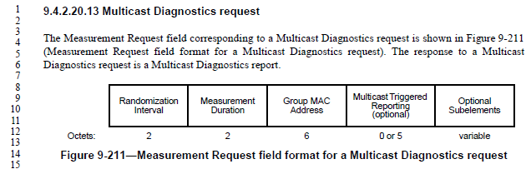

Indeed there are both the Multicast Triggered Reporting subfield and Optional Subelements in the Multicast Diagnostics request variant of the Measurement Request field.

The Multicast Triggered Reporting subfield is described, as:

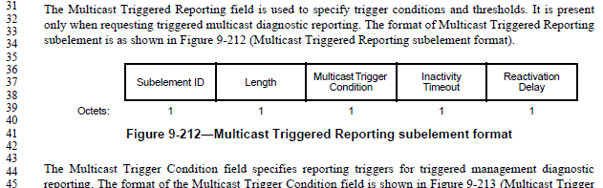

This text goes on for several paragraphs, describing these subfields.

However, nowhere in this text is the Sublement ID specified for the Multicast Triggered Reporting subelement. Thus, it seems the row in Table 9-117 is required for this specification:

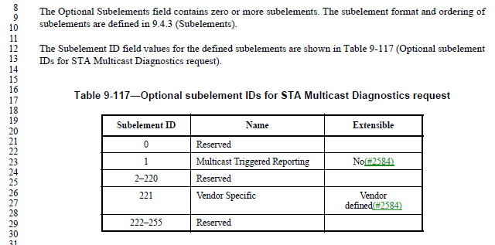

Since the Multicast Triggered Reporting subelement is optional, as is the Vendor Specific subelement, the question here perhaps should be why there is a specific call out for the Multicast Triggered Reporting sublement in the Figure 9-211 field layout, rather than having Multicast Triggered Reporting subelement just be one of the Optional Subelements, in the usual style.

Proposed Resolution:

Revised. Remove the field “Multicast Triggered Reporting (optional)” from Figure 9-211. Move the text from P1037.31 through P1038.10 to appear after the text at P1038.14 and Table 9-117 and before the text at P1038.32.

2020-02-19 Telecon:

Review P1037.31 – note that the removal of the field causes the text that is proposed to be moved no longer correct.
Optional fields need to have a subelement ID and then the subsequent optional fields can be identified. Having a strange tag for identifying the 4th field is strange.
More Work is needed to address the moving of the text.

Updated Proposed Resolution:

Revised. Remove the field “Multicast Triggered Reporting (optional)” from Figure 9-211. Move the text from P1037.31 through P1038.7 to appear after the text at P1038.14 and Table 9-117 and before the text at P1038.32, with the indicated changes:

The Multicast Triggered Reporting field subelement is used to specify trigger conditions and thresholds. It is present only when requesting triggered multicast diagnostic reporting. The format of Multicast Triggered Reporting subelement is as shown in Figure 9-212 (Multicast Triggered Reporting subelement format).

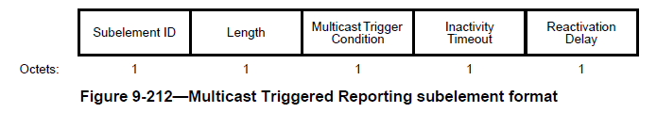

The Multicast Trigger Condition field specifies reporting triggers for triggered management diagnostic reporting. The format of the Multicast Trigger Condition field is shown in Figure 9-213 (Multicast Trigger Condition field format(#2607)).

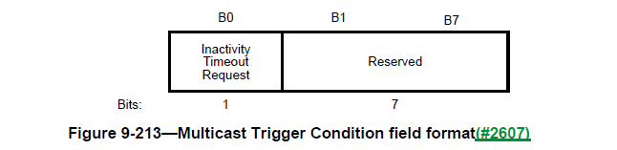

The Inactivity Timeout Request field is 1 to request that a multicast triggered report be generated when no group addressed frames with the monitored group address are received in a time equal to the value given in the Inactivity Timeout field. The Inactivity Timeout Request field is 0 when a multicast reception timeout is not requested.

The Inactivity Timeout field contains a time value in units of 100 TUs to be used as the threshold value for the inactivity timeout trigger condition.

The Reactivation Delay field contains a value in units of 100 TUs during which a measuring STA does not generate further multicast triggered reports after a trigger condition has been met.

CID | Page | Clause | Comment | Proposed Change
4567 | 2302.49 | 11.10.9.2 | "a Frame Report  Entry field where Transmitter Address (TA) matching the MAC address field value" -- is this TA in the MAC header? A field somewhere? I think it's a misnamed field from Figure 9-235--Frame Report Entry field format | Change to "a Frame Report  Entry field with a Transmit Address field matching the MAC address field value"

Discussion:

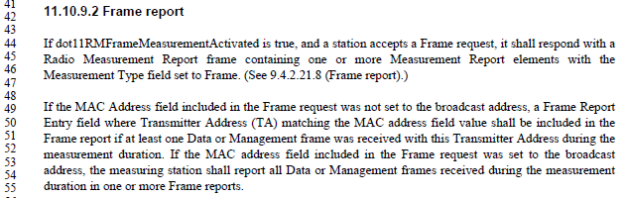

The Frame request frame has the following format and description:

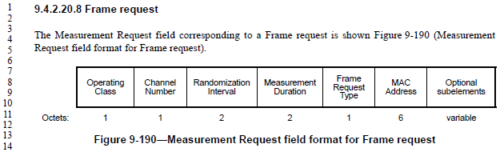

So, it is frames received with a TA that matches the Frame request’s MAC Address field, that are counted for the Frame report. So, agree with the commenter that this sentence is mixing up terms and concepts.

However, it would be better to state this clearly (with a re-write of the sentence), in a way that is similar to the subsequent sentence.

Proposed Resolution:
Revised.

Replace:
If the MAC Address field included in the Frame request was not set to the broadcast address, a Frame Report Entry field where Transmitter Address (TA) matching the MAC address field value shall be included in the Frame report if at least one Data or Management frame was received with this Transmitter Address during the measurement duration.

with:
If the MAC Address field included in the Frame request was not set to the broadcast address, the measuring station shall report, in one or more Frame reports, only those Data or Management frames received during the measurement duration with a TA field matching the MAC Address field of the Frame request, if at least one such frame was received.

Also, in 9.4.2.20.8, Replace:
If the MAC Address field is the broadcast address, then all Data or Management frames are counted toward the Frame report generated in response to this Frame request. For other MAC addresses, only frames matching this MAC address as the Transmitter Address are counted toward the Frame report generated in response to this Frame request.

with:
The MAC Address field indicates the TA field to match against Data and Management frames in order to count toward the Frame report generated in response to this Frame request.

CID | Page | Clause | Comment | Proposed Change
4808 | 1543.10 | 9.6.7.16 | RSNE, and FTE, are not "optionally present" if security is required. They _are_ present if security is required. | Delete "optionally" at P1543.10 and P1543.18.

Discussion:

From P1543:
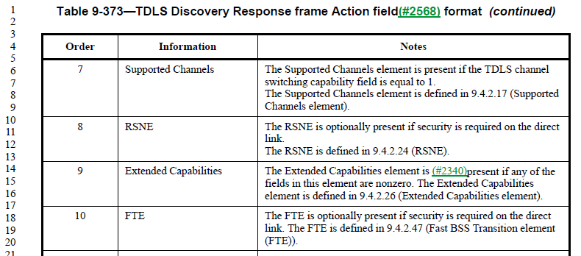

In TDLS Setup frames, the language is (for the RSNE, for example, FTE is similar): “The RSNE is present if security is required on the TDLS direct link and the Status Code is SUCCESS, and not present otherwise. The RSNE is defined in 9.4.2.24 (RSNE).”

Per 11.21.1 (General subclause of Tunneled direct-link setup): “Security is available on the TDLS direct link only when both TDLS peer STAs have an RSNA with the BSS.”

Per 12.7.8.4.2 (TPK handshake message 1): “If the TDLS initiator STA has security enabled on the link with the AP, it shall add an RSNE, FTE, and Timeout Interval element to its TDLS Setup Request frame.”

Per 12.7.8.4.3 (TPK handshake message 2): “If the TDLS responder STA validates the TPK handshake message 1 for this TDLS instance, the TDLS responder STA may respond with TPK handshake message 2. To do so, the TDLS responder STA shall add an RSNE, FTE, and Timeout Interval element to its TDLS Setup Response frame.”

Thus, it appears that the RSNE and FTE elements shall be present when security is enabled on the link to the AP (“with the BSS”) on both the initiator and responder.

In Table 9-373, we are dealing with TDLS Discovery. As the TDLS Discovery Request frame does not appear to provide security/RSN information for the potential TDLS initiator, at the time of responding to the discovery, the responder can only indicate whether it does have security enabled with the BSS, and security would be available on the TDLS link, if the initiator also has security enabled.

Thus, in the TDLS Discovery Response frame, the RSNE and FTE must be present if the transmitter has security enabled on the link with the AP.

Proposed Resolution:

Revised.

At P1543.10 and P1543.18, replace:
“is optionally present if security is required on the direct link.”

with:
“is present if the transmitting STA has security enabled on its link with the AP”.

CID | Page | Clause | Comment | Proposed Change
4653 | 885.35 | 9.3.3.11 | "conditionally present" is not clear | Change to "optionally present"

Discussion:

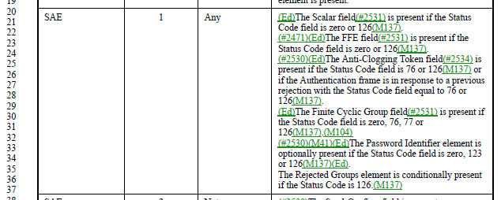

A very similar CID 4652 was previously reviewed and agreed to be “Accepted” to change “conditionally present” to just “present” (see elsewhere in this document). However, that analysis was that “conditionally present” is not the correct/usual text. No analysis was done on whether the field should be optional or not, at that time.

To answer the question on optionality, we look at P2574, in subclause 12.4.5.4, Processing of a peer’s SAE Commit message:

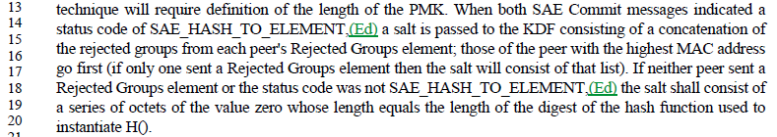

As status code 126 is SAE_HASH_TO_ELEMENT (per Table 9-52), the “conditionally present” referenced in Table 9-43 is on condition of that status code, as described in the above paragraph. The above paragraph makes it clear that either endpoint may send no Rejected Groups element, even when the status code is SAE_HASH_TO_ELEMENT.

Thus, it is correct/appropriate that “optionally present” is the correct phrase.

Proposed Resolution:

Accepted.

Also,

Revisit CID 4652, and change that resolution to:
Revised. Change to "optionally present"

CID | Page | Clause | Comment | Proposed Change
4325 |  |  | "AC parameters" is not a defined thing; should be "EDCA parameters" (5x) | As it says in the comment

Discussion:

In 11-20/272r6, Graham states that there are 5 instances of “AC parameters”, there are 22 instances of “EDCA parameters”.

Per 10.2.3.2 (HCF contention based channel access (EDCA)), the AP uses EDCA parameters per dot11QAPEDCATable in the MIB, while non-AP STAs use parameters as announced by the AP (or a default if no such announcement is made) and stored in dot11EDCATable.

Also per 10.2.3.2, “The QoS AP shall announce the EDCA parameters in selected Beacon frames and in all Probe Response and (Re)Association Response frames by the inclusion of the EDCA Parameter Set element using the information from the MIB entries in dot11ECDATable.”

So, the information being described in 9.4.2.28 (EDCA Parameter Set element) is the ECDA parameters announced by the AP.

Proposed Resolution:

Revised.

At the following locations, make changes as shown:

P1117L47 9.4.2.28
Change
“is incremented each time any of the AC parameters changes”
to
“is incremented each time any of the announced EDCA parameters change.”

P1717L60
Change
“When communicating within a BSS, the EDCA parameters used are from the EDCA Parameter Set element”
to
“For a non-AP STA communicating within a BSS, the EDCA parameters used are from the EDCA Parameter Set element”

P1718L58 10.2.3.2
Change
“following a change in AC parameters, which provides all STAs an opportunity to receive the updated EDCA parameters.”
To
following a change in announced EDCA parameters, which provides all STAs an opportunity to receive the updated EDCA parameters.

P1719L41 10.2.3.2
Change
“is incremented every time any of the AC parameters changes.”
To
“is incremented every time any of the announced EDCA parameters change.”

P4544L24 K.2.1.
“It is recommended that admission control not be required for the access categories AC_BE and AC_BK. The ACM subfield for these categories should be set to 0. The AC parameters chosen by the AP should account for unadmitted traffic in these ACs.”
To
“It is recommended that admission control not be required for the access categories AC_BE and AC_BK. The ACM subfield for these categories should be set to 0. The announced EDCA parameters and the EDCA parameters used by the AP should account for unadmitted traffic in these ACs.”

P4544L32 K.2.1.
Change:
“AC parameters chosen by the AP should further account for any unadmitted traffic in AC_VO and AC_VI that might be reserved for users of a particular SSPN.”
To
“The announced EDCA parameters and the EDCA parameters used by the AP should further account for any unadmitted traffic in AC_VO and AC_VI that might be reserved for users of a particular SSPN.”

CID | Page | Clause | Comment | Proposed Change
4445 | 1011.8 |  | "For nonmesh STAs, the Channel Switch Count field either is set to the number of TBTTs until the STA  sending the Channel Switch Announcement element switches to the new channel or is set to 0. (MDR2)A 1  indicates that the switch occurs immediately before the next TBTT. A 0 indicates that the switch occurs at  any time after the frame containing the element is transmitted." is self-contradictory. If it switches before the next TBTT, the number of TBTTs until the switch was 0 | Change to "For nonmesh STAs, the Channel Switch Count field is set to the number of TBTTs until the STA  sending the Channel Switch Announcement element switches to the new channel. (MDR2)1  indicates that the switch occurs immediately before the next TBTT. 0 indicates that the switch occurs at  any time after the frame containing the element is transmitted."  Proposed:  At P1011L8  Change  “For nonmesh STAs, the Channel Switch Count field either is set to the number of TBTTs until the STA sending the Channel Switch Announcement element switches to the new channel or is set to 0. A 1 indicates that the switch occurs immediately before the next TBTT. A 0 indicates that the switch occurs at any time after the frame containing the element is transmitted.”  To  "For nonmesh STAs, the Channel Switch Count field is set to the number of TBTTs until the STA sending the Channel Switch Announcement element switches to the new channel. A value of 1 indicates that the switch occurs immediately before the next TBTT and a value of 0 indicates that the switch occurs at any time after the frame containing the element is transmitted."

Discussion:

From discussion in February, and in 11-20/0272:

P1011L8
“For nonmesh STAs, the Channel Switch Count field either is set to the number of TBTTs until the STA sending the Channel Switch Announcement element switches to the new channel or is set to 0. (MDR2)A 1 indicates that the switch occurs immediately before the next TBTT. A 0 indicates that the switch occurs at any time after the frame containing the element is transmitted.”

Agree with commenter
Comment suggested change to:
"For nonmesh STAs, the Channel Switch Count field is set to the number of TBTTs until the STA sending the Channel Switch Announcement element switches to the new channel. (MDR2)1 indicates that the switch occurs immediately before the next TBTT. 0 indicates that the switch occurs at any time after the frame containing the element is transmitted."

Not sure about “1 indicates”, how about

REVISED
At P1011L8
Change
“For nonmesh STAs, the Channel Switch Count field either is set to the number of TBTTs until the STA sending the Channel Switch Announcement element switches to the new channel or is set to 0. (MDR2)A 1 indicates that the switch occurs immediately before the next TBTT. A 0 indicates that the switch occurs at any time after the frame containing the element is transmitted.”
To
"For nonmesh STAs, the Channel Switch Count field is set to the number of TBTTs until the STA sending the Channel Switch Announcement element switches to the new channel. (MDR2)A value of 1 indicates that the switch occurs immediately before the next TBTT and a value of 0 indicates that the switch occurs at any time after the frame containing the element is transmitted."

From 802.11 Editorial Style Guide (11-09/1034):
The use of “value of <field> field” is deprecated.

Note 802.11-2016 1.4 states: ‘If <x> represents a scalar field, scalar subfield, scalar parameter or scalar MIB attribute:
— if “<x> is” is used in a context that relates to the testing or setting the value of “<x>” this usage is to
be interpreted as though written “the value of <x> is”
— “<x> indicate(s)” is to be interpreted as though written “the value of <x> indicate(s)”
— “indicated by <x>” is to be interpreted as though written “indicated by the value of <x>”
— “<x> that indicate” isto be interpreted as though written “<x> whose value indicates” ’

There was also discussion on changing “immediately before” vs “at”
The argument of “at” the TBTT will start the change of channel, but you may have a race condition.
The switch has to occur before the beacon is created.

Suggest being clear that the change happens “at” the TBTT (and not before, which opens a small and unknown window when the AP is no longer on the old channel), and also clarifying that the Beacon is created assuming this new channel.

Proposed Resolution:

Revised.

At P1011L8
Change
“For nonmesh STAs, the Channel Switch Count field either is set to the number of TBTTs until the STA sending the Channel Switch Announcement element switches to the new channel or is set to 0. (MDR2)A 1 indicates that the switch occurs immediately before the next TBTT. A 0 indicates that the switch occurs at any time after the frame containing the element is transmitted.”
to
"For nonmesh STAs, the Channel Switch Count field is set to the number of TBTTs until the STA sending the Channel Switch Announcement element switches to the new channel. (MDR2)1 indicates that the switch occurs at the next TBTT (the ensuing Beacon frame is created assuming the new channel), and 0 indicates that the switch occurs at any time after the frame containing the element is transmitted."

CID | Page | Clause | Comment | Proposed Change
4462 |  |  | "of all MSDUs and A-MSDUs buffered at the STA". A STA does not buffer A-MSDUs. The things it receives via MA-UNITDATA.request are MSDUs, and those are the things it buffers prior to transmission Change the cited text to "of all MSDUs buffered at the STA" | Delete "or A-MSDUs" in 9.2.4.1.8 More Data subfield (4x), 9.2.4.5.6 Queue Size subfield, 9.2.4.5.8 AP PS Buffer State subfield

Discussion:

Examining Figure 5-1 - MAC data plane architecture(11ak)(#2273), we see that A-MSDU aggregation occurs higher in stack, thus before transmit buffering for Power Save.

This is consistent with the definition of bufferable unit:

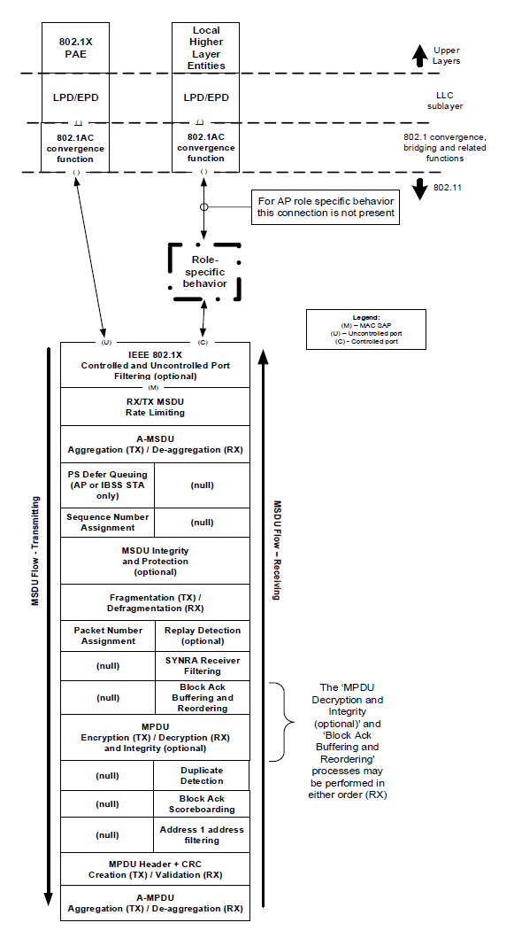

Proposed Resolution:

Rejected. As described in the definition of bufferable unit (BU), and Figure 5-1’s flow of action for transmitted frames, aggregation into A-MSDUs occurs before the power buffering stage, and thus A-MSDUs are buffered.

CID | Page | Clause | Comment | Proposed Change
4806 | 2235.37 | 11.3.5.3 | Sub-bullet (2) requires allocation of multiple, distinct AIDs for the STAs in the MMS element. How is this allocation communicated back to those STAs? | Add facility (Association Response frame contents, and MLME-ASSOCIATE.response parameter) to communicate these AIDs back to the peer.
4805 | 2235.34 | 11.3.5.3 | This text requires an MMS element be passed to the MLME-ASSOCIATION.response (sic), under some circumstances. The MLME-ASSOCIATE.response primitive has no such parameter. Add it. | Insert a row for an MMS paramter in the parameters table for the MLME-ASSOCIATE.response. Match the contents to the MMS row in the parameters Table in the MLME-ASSOCIATE.request, except change the Description to "Specifies the parameters within the Multiple MAC Sublayers element that are supported by the MAC entity, and were received from the MM-SME coordinated STA. The parameter is present if dot11MultipleMACActivated is  true and the corresponding MLME-ASSOCIATE.indication primitive included an MMS parameter, and is absent otherwise."

Discussion:

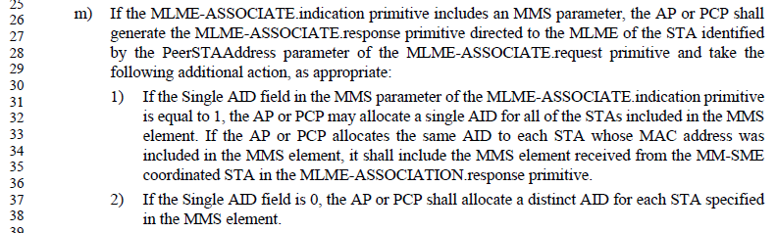

Similarly, for the MLME-REASSOCIATE:
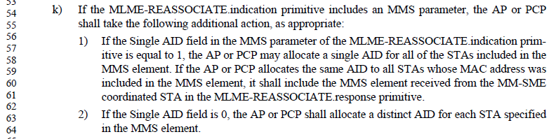

A check of the (Re)Association Request and (Re)Association Response frames (subclause 9.3.3) shows that they carry a Multiple MAC Sublayers element. However, the Multiple MAC Sublayers element does not carry AID(s) to be assigned to one or more requesting STA entities.

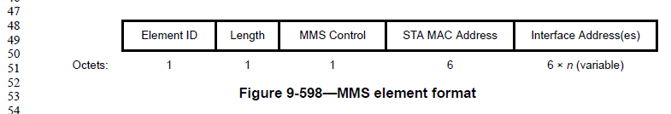

Table 9-94 says that the Multiple MAC Sublayers element is Extensible. However, there appears to be no indication of the number of Inferface Address(es) included in the element (that is, the value of ‘n’). However, the MMS element returned by the AP/PCP is the same one received from the request, in some scenarios, so in those cases the requesting MM-SME should know the value of “n”. In other cases, it is not clear how, or if, the Interface Address(es) field is formatter, or if the requesting MM-SME can parse an extension to the element.

So, despite the element claiming it is extensible, this is not obviously correct. It is probably safer to create a new element to carry the AID(s) in the response, rather than try to extend the MMS element.

Shifting consideration to the response primitives, it can be seen that the MLME-(RE)ASSOCIATE request, indication and confirm primitives have an MMS parameter. However, the MLME-(RE)ASSOCIATE.response primitive does not have such a parameter. This response primitive will need a parameter at least to pass the AID(s) (the new element mentioned above), but it seems to need the MMS element as well, to indicate whether the “Single AID” request was satisfied, or if the AP/PCP elected to allocate distinct AIDs for each STA in the request.

For purposes of carrying the AID assignments to the Interface Address(es), the AID Announcement element would appear to serve the purpose well:

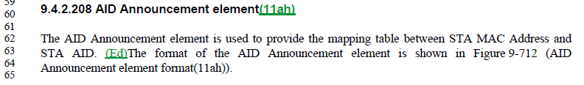
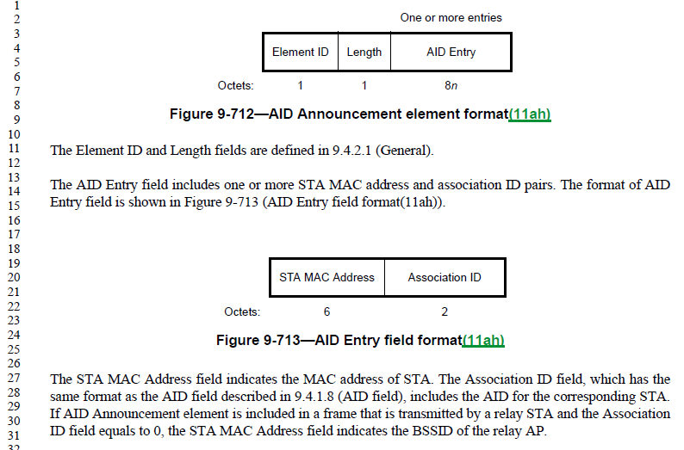

Proposed Resolution:

Revised.

In subclause 6.3.7.5.2 (Semantics of the [MLME-ASSOCIATE.response] service primitive) add a parameter in the parameter list: “MMS”, before the “FILSHLPContainer” parameter. Add a row in the parameter description table before the “FILSHLPContainer” row, with:
- Name=”MMS”,
- Type=”Multiple MAC Sublayers element”,
- Valid range=”As defined in 9.4.2.152”, and
- Description=”Specifies the parameters within the Multiple MAC Sublayers element that are supported by the MAC entity, and negotiated for the association. The parameter is present if dot11MultipleMACActivated is true and is absent otherwise.”

In subclauses:
- 6.3.7.5.2 (Semantics of the [MLME-ASSOCIATE.response] service primitive),
- 6.3.7.3.2 (Semantics of the [MLME-ASSOCIATE.confirm] service primitive),
- 6.3.8.5.2 (Semantics of the [MLME-REASSOCIATE.response] service primitive), and
- 6.3.8.3.2 (Semantics of the [MLME-REASSOCIATE.confirm] service primitive):
  - add a parameter in the parameter list: “AIDAnnouncement” immediately before the “VendorSpecificInfo” parameter.
  - add a row in the parameter description table, immediately before the VendorSpecificInfo row:
    - Name=“AIDAnnouncement”,
    - Type=”AID Announcement element”,
    - Valid range=”As defined in 9.4.2.208”,
    - Description=”Specifies the mapping from MAC Address(es) to assigned AID(s) for all of the STAs included in the MMS element. The parameter is present if dot11MultipleMACActivated is true, the corresponding MLME-[RE]ASSOCIATE.indication had an MMS parameter present, and distinct AIDs are assigned for each STA in the request per 11.3.5.3 [11.3.5.5 for REASSOCIATE]. The parameter is absent otherwise.”

In subclauses 9.3.3.6 (Association Response frame format) and 9.3.3.8 (Reassociation Response frame format), in the frame body Table, add a row before the Vendor Specific row:
- Order=<next value>
- Information=”AID Announcement”
- Notes=”The AID Announcement element is present if dot11MultipleMACActivated is true, the corresponding [Re]Association Request frame had a Multiple MAC Sublayers parameter present, and distinct AIDs are assigned for each STA in the request per 11.3.5.3 [11.3.5.5 for Reassociation]. The parameter is absent otherwise.”

In subclause 11.3.5.3, bullet (m), subbullet (2), add to the end, “, and shall include an AID Announcement element in the MLME-ASSOCIATION.response primitive indicating the AID assignments.”

In subclause 11.3.5.5, bullet (k), subbullet (2), add to the end, “, and shall include an AID Announcement element in the MLME-REASSOCIATION.response primitive indicating the AID assignments.”

In subclause 11.3.5.2, bullet (f), change “Single AID … is equal to 1” to xxxxxxxxxx

In subclause 11.3.5.2, insert a new bullet after bullet (f): “If an Association Response frame is received with a status code of SUCCESS at an MM-SME coordinated STA and the Single AID field within the MMS element is equal to 0, the MLME shall xxxxxxxxxx

In subclause 11.3.5.4, insert a new bullet after bullet (e): xxxxxxxxxx

Marked as “Insufficient detail”, until/unless a submission is provided:

CID | Page | Clause | Comment | Proposed Change

Not ready for review, yet:

CID | Page | Clause | Comment | Proposed Change
4806 | 2235.37 | 11.3.5.3 | Sub-bullet (2) requires allocation of multiple, distinct AIDs for the STAs in the MMS element. How is this allocation communicated back to those STAs? | Add facility (Association Response frame contents, and MLME-ASSOCIATE.response parameter) to communicate these AIDs back to the peer.
4805 | 2235.34 | 11.3.5.3 | This text requires an MMS element be passed to the MLME-ASSOCIATION.response (sic), under some circumstances. The MLME-ASSOCIATE.response primitive has no such parameter. Add it. | Insert a row for an MMS paramter in the parameters table for the MLME-ASSOCIATE.response. Match the contents to the MMS row in the parameters Table in the MLME-ASSOCIATE.request, except change the Description to "Specifies the parameters within the Multiple MAC Sublayers element that are supported by the MAC entity, and were received from the MM-SME coordinated STA. The parameter is present if dot11MultipleMACActivated is  true and the corresponding MLME-ASSOCIATE.indication primitive included an MMS parameter, and is absent otherwise."
4802 | 1056.02 | 9.4.2.21.7 | While considerably less likely, it is still possible for a beacon Measurement Report's Reported Frame Body to exceed the maximum element size, even for Reporting Detail type 1. Recommend moving this text about truncating elements and/or using fragmentation (when supported) to apply in all cases. | Break the paragraph into two, after the first sentence (at the full stop on line 2). Start the new paragraph with, "Some elements in the Reported Frame Body subelement, or the Reported Frame Body subelement itself, might be large."
4799 | 2153.65 | 11.1.3.8 | It's not clear what list of elements are implied by, "The AP or PCP may include all other elements in the nontransmitted BSSID profile." This list should be restricted to those allowed per 9.4.2.45. | Insert "allowed per 9.4.2.45" after "all other elements"
4797 | 2159.33 | 11.1.4.3.2 | Per the changes in 11-19/0551r17 (https://mentor.ieee.org/802.11/dcn/19/11-19-0551-17-000m-revmd-lb236-comments-assigned-to-hamilton.docx), as agreed on CID 2692 during working group ballot, bullet (e) is redundant, and should be deleted. | Delete bullet (e)
4641 | 2061.33 | 10.42.7 | "If the initiator receives the expected feedback" should be "If the beam tracking initiator receives the expected feedback"; ditto in that sentence "responder" -> "beam tracking responder" | As it says in the comment
4782 | 2164.58 | 11.1.4.3.4 | From the draft: "If a FILS STA receives one or more Probe Request frame(s), subject to the criteria above, and the STA has dot11FILSOmitReplicateProbeResponses equal to true, the responding STA shall select the response with the next Beacon frame or one or more Probe Response frames as a response to all Probe Request frames(11ai)." Huh? | Replace the sentence with: "If a FILS STA receives one or more Probe Request frame(s) and the STA has dot11FILSOmitReplicateProbeResponses equal to true, then the responding STA shall respond, subject to the criteria above, by letting the response be the next Beacon frame, a broadcast Probe Response frame, or one or more directed Probe Response frames."
4488 | 2465.00 | 11.28.2.2 | There are two references to a "Remaining BI field" (singular BI), but there is no such field | Change each to "Remaining BIs field"
4723 | 1165.59 | 9.4.2.47 | "The Wrapped Key field contains the encrypted GTK" is confusing -- is it wrapped or encrypted? | Change to "The Wrapped Key field contains the wrapped GTK"
4722 | 1166.25 | 9.4.2.47 | "The length of the resulting AES-Key-  wrapped IGTK in the Wrapped Key field is Key Length + 8 octets." -- this is true for the NIST key wrap algorithm (CID 2510 resolution) but might not be of other key wrap algorithms in the future, so risk of spec rot. Also, "AES-Key-wrapped" is not defined | Delete the cited sentence, and last sentence of referenced subclause (on BIGTK)
4709 | 0.00 | 10.6.7 | The CMMG rules being separated (in 10.6.8) causes the exclusion rules structure of 10.6.5.x to be confusing or broken. DMG started it with 10.6.7. | Delete 10.6.7 and 10.6.8
4708 | 0.00 | 10.6.7 | The CMMG rules being separated (in 10.6.8) causes the exclusion rules structure of 10.6.5.x to be confusing or broken. DMG started it with 10.6.7. | Merge 10.6.7 and 10.6.8 into 10.6.5. I think perhaps the other Mark has some ideas about this
4700 | 0.00 | 9.4.5 | Instead of ISO 14962 just refer to ASCII | In 9.4.5.4 and 9.4.5.21 change " is a 3-octet ISO 14962:1997 encoded string" to " is an ASCII string" and "ISO 14962:1997)" to "ASCII)"
4658 | 1464.28 | 9.4.2.246 | "concatenated list of " -- it can hardly be anything else. For other lists we don't explcitly say it's a concatenation | Delete "concatenated"
4795 | 2060.28 | 10.42.7 | No such thing as "TRN-R-PACKET" type. | Change "TRN-R-PACKET" to "TRN-R" throughout.
4234 | 793.14 | 9.2.4.2 | The Duration/ID field sent by (QoS) STAs in Extension frames is not specified | Change "In Data and Management frames sent by QoS STAs, the Duration/ID field contains a duration value  as defined for each frame type in 9.2.5 (Duration/ID field (QoS STA))." to "In Data, Management and Extension frames sent by QoS STAs, the Duration/ID field contains a duration value  as defined for each frame type in 9.2.5 (Duration/ID field (QoS STA)) and 9.3.4.3."
4318 | 2504.37 | 11.39.1 | "A STA shall not transmit an MPDU in a VHT PPDU to a STA that exceeds the maximum MPDU length  capability indicated in the VHT Capabilities element received from the recipient STA." -- it's not the STA that exceeds, it's the MPDU | Change to "An STA shall not transmit in a VHT PPDU an MPDU that exceeds the maximum MPDU length capability indicated in the VHT Capabilities element received from the recipient STA"; also for S1G instead of VHT in 10.12.5
4317 | 2504.37 | 11.39.1 | "A STA shall not transmit an MPDU in a VHT PPDU to a STA that exceeds the maximum MPDU length  capability indicated in the VHT Capabilities element received from the recipient STA." -- it's not the STA that exceeds, it's the MPDU | Delete "to a STA " in the cited text; also in 10.12.5
4309 | 844.18 | 9.3.1.19 | "in the Compressed Beamforming Feedback Matrix  subfield" -- no such subfield | Change to "in the compressed beamforming feedback matrix"
4295 | 797.37 | 9.2.4.5.1 | A TPU STA is by definition not in a mesh BSS | Delete "in a  nonmesh BSS" in the fifth from last to penultimate row of Table 9-10--QoS Control field
4285 | 1045.28 | 9.4.2.20.19 | "The (#151)Neighbor Report subelements specify a superset of nearby APs with which the  requested STA is requested to perform the FTM procedure" -- you can't do FTM with more than the nearby APs | Change "superset" to "subset" in the cited text
4253 | 1117.10 | 9.4.2.27 | "The default value of dot11ChannelUtilizationBea-  conIntervals is defined in Annex C." -- so is the default of many other MIB attributes, but we don't say so for any other ones | Delete the cited sentence
4490 | 994.47 | 9.4.2.5.1 | "The TIM element contains four fields: DTIM Count, DTIM Period, Bitmap Control, and Partial Virtual  Bitmap. See Figure 9-149 (TIM element format)." -- as the figure shows, it contains 6 fields, including Element ID and Length. Duplication considered harmful! | Change to "The TIM element is used to signal the timing and availability of data for associated STAs. The format of  this element is shown in Figure 9-149."
4240 | 855.52 | 9.3.3.1 | "Unused element ID codes are reserved." is unclear (how "unused"?) and unnecessary (T9-94 already lists all possible EIDs and EEIDs). Delete | Delete the cited text at the referenced location and in 9.8.5.1
4347 | 2159.33 | 11.1.4.3.2 | e) needs to be conditional on dot11SSIDListActivated is true, like d) | Change e) to start "When dot11SSIDListActivated is true and the SSID List parameter is present"
4221 | 1618.40 | 9.6.14.2 | There is no such thing as a "valid TSF" as opposed to an invalid one | Delete "valid " in the cited text
4216 | 2059.39 | 10.42.6.4.4 | "DMG Antenna Pattern Reciprocity" -- no such field | Delete "DMG " (2x in the para)
4201 | 1442.22 | 9.4.2.229.2 | A CMMG STA is not a DMG STA | Delete " DMG" in "Figure 9-754--CMMG Capabilities Info field format". In Table 9-313--Subfields of the CMMG Capabilities Info field format change "Number of RX  DMG Antennas" to "Number of Rx Antennas" (note Rx not RX) and change "DMG Antenna Reciprocity" to "Antenna Reciprocity" (as in the figure)
4193 | 1852.54 | 10.23.4.2.3 | "To describe the behavior at the STA, two MAC variables are defined. " duplicates the first para of the subclause | Delete the cited text
4154 | 1827.61 | 10.23.2.2 | The subbullets all refer to "that AC" but there is no reference for "that" | Add the words "corresponding to an AC" in the introductory phrase which immediately precedes item a), so that it reads, "The backoff procedure shall be invoked by an EDCAF corresopnding to an AC when"
4068 | 1503.49 | 9.5.4 | "STA needs transmit training". This is a protocol for interoperability, so I think it is better to say "STA requests transmit training". | Change "needs" to "requests".
4067 | 1503.42 | 9.5.4 | The ordering of these sentences is confusing to read: "To obtain the number of TRN-R subfields, the value of the L-RX subfield is multiplied by 4. Possible values range from 0 to 16." | Reword to "The L-RX field is an unsigned integer with range 0 to 16. Values outside this range are reserved. The number of requested TRN-R subfields is equal to the value of the L-RX subfield multiplied by 4."
4243 | 2467.63 | 11.29.2 | "The Information Response frame may include vendor-specific elements. " -- true of all Action frames unless explicitly disallowed | Delete the cited text
4377 | 805.22 | 9.2.4.6.2 | Figure 9-13--Link Adaptation Control subfield format should number the bits from 0, not from 1. Ditto Figure 9-12--HT Control Middle subfield of the HT variant HT Control field format, Figure 9-16--HT Control Middle subfield of the VHT variant HT Control field format, Figure 9-21--MFB subfield in the CMMG variant HT Control field format, Figure 9-687--Control field format, Figure 9-114--First example of Compressed Beamforming Report field encoding, Figure 9-115--Second example of Compressed Beamforming Report field encoding | Subtract 1 from each of the bit positions in the figure
4056 | 1121.31 | 9.4.2.29 | "Length (55)". The Length is 55 or 57. Also, there is no need to include "55" in the figure. | Delete "(55)" at 1121.31
4485 | 1242.42 | 9.4.2.83 | "The Low Rate TIM Rate field provides an indication of the rate that is used to transmit the low data rate TIM frame, in units of 0.5 Mb/s. A value of 0 indicates that the low rate TIM frame is not transmitted." -- 11.2.3.15 TIM Broadcast does not allow the low rate TIM frame not to be txed; only the high rate one is optional to transmit | Delete "A value of 0 indicates that the low rate TIM frame is not transmitted."
4454 | 1518.53 | 9.6.3.8 | "The QoS Action field is defined in 9.6.3.1 (General). representing ADDTS Reserve Response.  The (#2110)Higher Layer Stream ID element is defined in 9.4.2.124 (Higher Layer Stream ID element).  The Status Code field is defined in 9.4.1.9 (Status Code field)." is too vague. Needs to refer to specific contents. Similarly in other locations in 9.6.3 | At 1518.53, change to "The QoS Action field is defined in 9.6.3.1." and "The Higher Layer Stream ID field contains a Higher Layer Stream ID element (see 9.4.2.124)."
4447 | 1718.01 | 10.1 | The "Designation  (informative)" in Table 10-1 is not used anywhere, so just delete the column | As it says in the comment
4442 | 2272.13 | 11.6.2 | " If  the MAC and the transmitter of the (#1072)(#2409)sync packet are collocated within the same STA" -- huh? How can a MAC and a transmitter be distinct things that are collocated within a STA? | Change the cited text to "If the STA is the transmitter of the sync packet"
4422 | 1834.17 | 10.23.2.7 | "Frames from the primary AC shall be transmitted first." is not clear: does it mean at least one (or two?) shall be transmitted, or does it mean all available shall be transmitted (cf.previous bullet) | Change to "All frames from the primary AC shall be  transmitted first"
4418 | 1113.25 | 9.4.2.26 | The "Reject Unadmitted Frame" extended capability is weird: "When dot11RejectUnadmittedTraffic is true, the Reject Unadmitted Frame bit is  set to 1 to indicate that the STA rejects MA-UNITDATA.request primitives for  frames belonging to an unadmitted TS.  When dot11RejectUnadmittedTraffic is false, the Reject Unadmitted Frame bit is  set to 0 to indicate that the STA is not required to reject MA-UNITDATA.request  primitives for frames belonging to an unadmitted TS.". Why does the peer need to know the local policy on rejecting unadmitted traffic? Why does the peer not need to know for sure whether the peer will reject unadmitted traffic ("is not required to reject" ... but might). Also "the STA's MA-UNITDATA primitive rejects  frames" is weird -- it's not the primitive that rejects, it's the STA, and there is no MA-UNITDATA primitive, there are only MA-UNITDATA.something primitives | In Table 9-153--Extended Capabilities field change "the STA rejects MA-UNITDATA.request primitives for  frames belonging to an unadmitted TS" to "the STA does not transmit frames belonging to an unadmitted TS" and "the STA is not required to reject MA-UNITDATA.request  primitives for frames belonging to an unadmitted TS" to "the STA might transmit frames belonging to an unadmitted TS". In C.3 change "This attribute when true indicates the STA's MA-UNITDATA primitive rejects  frames" to "This attribute when true indicates the STA rejects MA-UNITDATA.requests"
4323 | 2154.47 | 11.1.3.8 | "The decimal value of the 11 LSBs of the AID assigned to an S1G STA shall be" -- the value is the value; the encoding/representation is irrelevant | Delete "decimal " in the cited text
4342 | 1563.10 | 9.6.7.36 | Should qualify the MCS in Table 9-386--FILS Minimum Rate | In Table 9-386--FILS Minimum Rate add "HT-" before "MCS" in the penultimate column, and "VHT-" before "MCS" in the last column (note this covers TVHT via the hand-wavy substitution rules elsewhere)
4376 | 0.00 | 9 | Some of the Frame Control field figures have the wrong bit numbering: the PV should be "B0 B1" not "B1 B2". Fix in Figure 9-5, 9-6 | As it says in the comment
4373 | 1609.54 | 9.6.13.20 | "Each subelement starts with the ID and  Length fields. The Length field in the subelement is the length of the contents of the subelement." is duplication of the general rules for subelements | Delete the cited text
4371 | 2376.17 | 11.22.6.4 | "initial Fine Timing Request frame" -- no such frame | Change to "initial Fine Timing Measurement Request frame"
4370 | 1353.29 | 9.4.2.167 | "Fine Timing Request" -- no such frame | Change to "initial Fine Timing Measurement Request frame"
4351 | 2159.33 | 11.1.4.3.2 | e) appears to duplicate d), though d) does not give the destination address | Delete e) and in d) after "send zero or more probe requests" add " to the broadcast destination address"
4349 | 2159.29 | 11.1.4.3.2 | d) says "These additional probe  requests (following step c)) should only carry SSIDs not indicated in the step c) probe request.". Why is this a should? There's no point sending probes for stuff that has already been probed | Delete "should" in the cited text
4489 | 2465.00 | 11.28.2.2 | There are two references to a "Remaining BI field" (singular BI), but there is no such field | Change each to "Handover Remaining BI field"
4410 | 2375.25 | 11.22.6.3 | " the Fine Timing Parameters field" -- no such field | " the Fine Timing Measurement Parameters field"
4814 | 287.48 | 4.1 | The 802.11 Style Guide says clause 4 should be written in delcarative, not normative, language, and that it is intended to provide only a general description of the system. There are parts of clause 4 (4.10, for example), that get quite detailed (like specific frame exchange diagrams) and seem to be both beyond a "general description" and potentially are the only normative specification for these behaviors. There are also a few uses of "may" and many uses of "can" that should be checked/changed to clearly informative language. | At least 4.10, and potentially all of clause 4, needs to be scrubbed for details that are beyond "general description" and/or are the best/only normative specification in the Standard of any behaviors, and move such text to a later clause.
4813 | 769.44 | 8.3.5.6.2 | 8.3.5.6.2 says "The required PHY parameters are listed in 8.3.4.3 (PHY SAP service primitives parameters)." But, 8.3.4.3 just says "A set of parameters" for PHY-TXSTART.confirm (and .request). | A submission will be provided.
4812 | 308.01 | 5.1.5.7 | There's no figure in clause 5 (like Figure 5-7) for a DMG Relay. | A submission will be provided.
4784 | 3857.08 | C.3 | Put the DESCRIPTION for 11ak MIB attributes in the standard layout. | A submission will be provided.
4768 | 680.44 | 6.3.97.2.2 | The ContactVerificationSignal parameter appears to be an entire CVS frame (as defined in 9.6.7.27), when the only information actually conveyed is the Map ID. The rest of the frame format is (should be) known only to the MAC, and not the user of the MLME SAP. | Change "ContactVerificationSignal" to "Map ID" in the parameter list and parameter table. In the parameter table's Description column, replace the text with, "The Map ID field is set to a number that is equal to the Map ID of the recently received WSM, which is being verified."This pattern of passing a frame, instead of information content, is found elsewhere, such as other primitives for the CVS/GDD function (including GDD Enablement Response), and the FT ("REMOTE-REQUEST"), Mesh peering management, Channel Availability Query, and Network Channel Control functions. A contribution will be provided for proposed changes to address these.
4820 |  |  | Text is inconsistent in treating elements at the end of a frame as a field:  (1) Some frame definitions indicate if a "field" X is present it contains "element" Y (e.g., see the "DMG Link Margin" field in 9.6.6.5 Link Measurement Report frame format)  (2) Classic frames (e.g., beacon, probe, association...) just list the frame body, often in a table format, and list the elements after fields, which is also consistent with the sentence at P847L24.  (3) Some other frams (e.g., 9.6.7.7 Extended Channel Switch Announcement frame format) list the elements directly in a figure representing teh frame, without a table, which is also consistent with (2)  I think (1) is the anomaly, and propose not to represent any IE appended to a frame as a field in that frame. This will simplify the text too, as there is no field to define (see example in proposed change). | Comment is general; by way of example, and using Link Measurement Report frame, either  -- Establish somewhere (e.g., P847L24) that everything is a field, and some fields include an element, (not in favor), or  - Preferably, indicate elements as just "elements" in all frame definitions, including those that are defined through a table (beacon, probe, association .., and they happen to follow this convention), and those without a table, e.g., Link Measurement Report.  The second path generally simplifies the text; in the Link Measurement Report frame example, if adopting the second (and preferred) path, the last two boxes in Figure 9-844 would be named as "DMG Link Margin element (optional)" and "DMG Link Adaptation Acknowledgement element (optional)", and the last two paragraphs in section 9.6.6.5 will greatly simplify (if not go away).
4780 | 288.1 | 4.10.2 | Most of the subclauses of 4.10 are way too detailed for clause 4. | Move 4.10.2 through 4.10.8, to appear after 12.2.5 and before 12.2.6.  Submission Required  Leave 4.10.2, 4.10.6, 4.10.7, 4.10.8, and reduce the content in the others (by moving to clause 12).  Otherwise: REJECTED. Similar to clause 4.9 which provides the reference model for the MAC and PHY, the referenced sub-clause describe how IEEE 802.1X authentication services are used with security and key management protocols in IEEE 802.11 to provide security. This clause describes the key components of the IEEE 802.11 security architecture and serves as a guide as to where requirements can be found in the remainder of the specification. These descriptions do not provide normative requirements so they should not be moved to clause 12.
4771 | 187.37 | 3.2 | After the first senence, this NOTE no longer seems necessary/useful in the Definitions, and further, seems to be mostly talking about MSDUs and A-MSDUs, not MMPDUs. | Confirm this material is stated in normative text, and delete it from here. (Or move it somewhere normative, if it is missing.)
4419 | 165.21 | 3.1 | (CID 2488 follow-up) The "mesh STA" definition suggests a STA that implements mesh but is currently operating in an IBSS or infrastructure BSS or PBSS is a "mesh STA". I suspect that's not how "mesh STA" is actually used; rather, it's actually used to mean "is starting/joining or has started/joined an MBSS". However, 4.3.21.4 says "Accordingly, a mesh STA is not a member of an IBSS or an infrastructure BSS.", which prima facie contradicts the definition | Change the definition of mesh STA to "A quality-of-service (QoS) STA that is starting or joining, or has started or joined, a mesh basic service set (MBSS)."  Ad hoc notes:  GEN: 2020-04-29 21:48:37Z - status set to: Submission Required - Mark Hamilton will bring proposed resoution or rejection words.  GEN: 2020-04-29 21:44:47Z - discussion: We chose to think of an instance of a STA as the current state, configuration, etc. of the implementation. If the STA "stops" and "restarts" with a differnt set of capabilities, configuration, etc., that is a new instance (by our convention). It is the instance that "implements" something - not the image on disk/ROM/etc.  Proposed rejection #2: The CID was discussed at length and no consensus was determined.  GEN: 2020-04-24 14:41:10Z - Proposed Rejection  Proposed Resolution: Reject; A Mesh STA is a Mesh STA even before it starts or join. A Mesh STA can  start discovery procedures. There is a general convention to describe a STA that implements or  activates. The wording of this definition is consistent with other STA definitions.  GEN: 2020-04-15 22:01:54Z - more discussion needed.  GEN: 2020-03-29 02:17:49Z - status set to: Review  Proposed resoution: Accept
4380 | 457.18 | 6.3.31.2.2 | "Set of Neighbor  List elements  each as defined  in the Neighbor  Report element  format" -- no such element (in the Neighbor Report element or otherwise) | Delete the referenced table row; also in the table in 6.3.31.3.2. Delete "The neighbor report contents are derived from  the NeighborListSet parameter of the MLME-NEIGHBORREPRESP.request primitive." in 11.10.10.1 and "The Reduced Neighbor Report element  contents may be derived from the NeighborListSet parameter of the MLME-NEIGHBORREPRESP.request  primitive." in 11.50 and "The Neighbor Report Response frame includes a list Neighbor Report elements one for each neighbor." in 11.10.10.3  MAC: 2020-03-19 01:34:08Z - status set to: Submission Required  See CID 4585 in this file.

Completed:

CID | Page | Clause | Comment | Proposed Change
4553 | 1748.00 | 10.3.2.12 | "the fragment BA procedure described in this subclause" -- there is no other fragment BA procedure than the one in this subclause | Delete " described in this subclause" (3x)

Discussion:

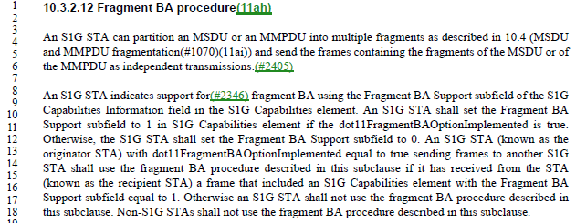

Arguably, it is helpful to be very clear that an S1G STA uses the procedure described in this subclause, and not the procedure described in 10.4, given the mention of partitioning MSDUs/MMPDUs per 10.4 in the prior paragraph.

“described in this subclause” could perhaps be parenthetical “(described in this subclause)” since saying “shall use the fragment BA procedure” is a complete specification. However, this is not the usual style in the Draft. The repetition of this information three times is excessive, however.

Proposed Resolution:

Revised.

At P1748.17, delete “described in this subclause”. Same thing at P1748.18.

At P1748.14, change “described in this subclause” to “, as described in this subclause,”. At line 13, replace “sending frames” with “sending an MSDU or MMPDU (whether fragmented or not)”

CID | Page | Clause | Comment | Proposed Change
4809 | 1589.40 | 9.6.12.3 | Change 6 occurrences of "in response to a received", to be simpler and match the majority language in the draft. | Delete "received" (and change "a" to "an" as appropriate) at P1589L40, P1590L53, P1592L56, P2180L1, P2482L30, and P2482L39.

Discussion:

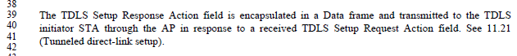

Agree with the comment, “in response to a TDLS Setup Request Action field” is simpler, and consistent with style elsewhere in the Draft.

The other locations are similar.

Proposed Resolution:

Accepted.

CID | Page | Clause | Comment | Proposed Change
4599 | 2487.52 | 11.32.5 | "A receiving TR-MLME may silently ignore the received On-channel Tunnel Request frame if  that frame is not targeting an NT-MLME in the same multi-band capable device with the TR-MLME." -- it has no choice but to ignore it. Also "with" should be "as" | Change to "A receiving TR-MLME shall silently ignore the received On-channel Tunnel Request frame if  that frame is not targeting an NT-MLME in the same multi-band capable device as the TR-MLME."

Discussion:

Agree with the commenter (on both points).

Also, “silently ignore” is duplicative; what other way can something be “ignored”?

Proposed Resolution:

Revised.

Replace
A receiving TR-MLME may silently ignore the received On-channel Tunnel Request frame if
that frame is not targeting an NT-MLME in the same multi-band capable device with the TR-MLME.
with
A receiving TR-MLME shall ignore the received On-channel Tunnel Request frame if
that frame is not targeting an NT-MLME in the same multi-band capable device as the TR-MLME.

CID | Page | Clause | Comment | Proposed Change
4594 | 1487.36 | 9.4.5.20 | "The Venue Number field identifies the position (1 = 1st, 2 = 2nd, and so on) of the corresponding Venue Name Tuple subfield in a Venue Name ANQP-element from the same STA, as defined in 9.4.5.4 (Venue Name ANQP-element). If that same STA does not advertise a Venue Name ANQP-element, or does not advertise any Venue Name Tuple subfields in the Venue Name ANQP-element, then the Venue Number field is set to 0." -- second sentence implies there can only be at most one Venue Name ANQP-element | Change "a" to "the" in the first sentence

Discussion:

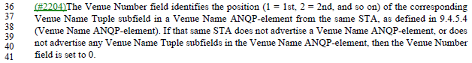

Unpacking the first sentence a bit:
- The STA might send a Venue Name ANQP-element, which contains zero or more venue names in Venue Name Tuples, as seen in 9.4.5.4:

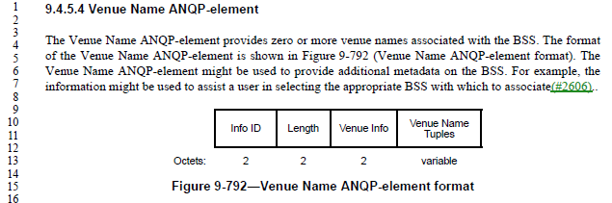

- There is only one Venue Name ANQP-element transmitted, as implied by 11.23.3.3.11 (note the use of “the” in this text):

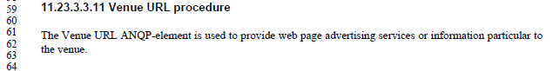
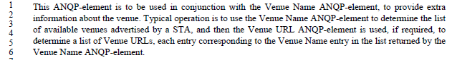

- The Venue Number field is used to carry an ‘index’ into the Venue Name Tuples, as described in the cited text. If there were more than one Venue Name ANQP-element from the same STA, this indexing would be ambiguous as to which Venue Name Tuples list was being referenced.

Thus, agree with the commenter, there is only one (at most) Venue Name ANQP-element from this STA, so the article should be “the” to reference this specific, single element.

Proposed Resolution:

Accepted.

CID | Page | Clause | Comment | Proposed Change
4570 | 1656.52 | 9.6.20.7 | "The MMPDU Frame Body subfield carries the content of the Frame Body field of an MMPDU that would  be constructed if the MMPDU for the corresponding management frame type were transmitted  (#2562)unencrypted over the air" -- well, the thing that is constructed is an MPDU, not an MMPDU, which (for an unencrypted case) goes straight into the Frame Body field | Change to "The MMPDU Frame Body subfield carries the content of the Frame Body field of an MPDU carrying the MMPDU that would  be constructed if the MMPDU for the corresponding management frame type were transmitted  (#2562)unencrypted over the air"

Discussion:

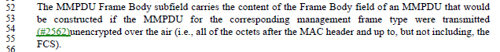

It is a management frame (which is by definition, a type of MPDU) that contains a Frame Body.

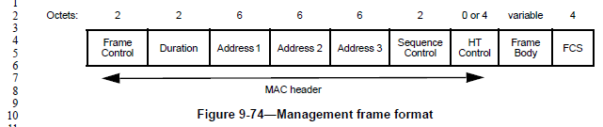
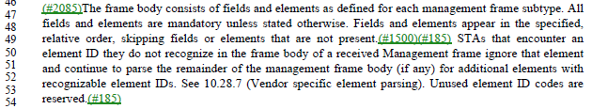

The management frame’s Frame Body is not described as carrying an MMPDU, but conceptually the “fields and elements … defined for each management frame subtype” comprise the “unit of data exchanged between two peer MAC entities … to implement the MAC management protocol”, which is the definition of MMPDU (see below). So, this is roughly equivalent.

So, agree with the commenter that the simplest way to describe this Frame Body is that it is the same Frame Body that would be in a management MPDU that conceptually is carrying the MMPDU.

Proposed Resolution:

Accepted.

CID | Page | Clause | Comment | Proposed Change
4642 | 0.00 | 10.42.7 | The MAC can't determine whether the dot11BeamTrackingTimeLimit came from the SME, the MAC or the default | Delete "from the SME" at 2061.54, "from SME" at 2062.5

Discussion:

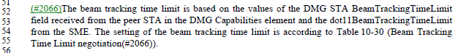

Agree with the commenter.

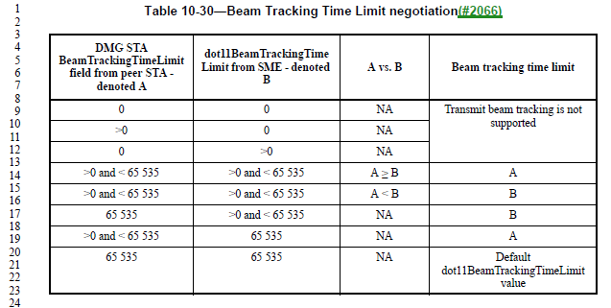

Agree with the commenter.

Proposed Resolution:

Accepted.

CID | Page | Clause | Comment | Proposed Change
4555 | 1721.54 | 10.2.6 | "increasing the probability of successful transmission (as defined in 10.2.2 (DCF))" -- 10.2.2 doesn't define successful transmission (this seems to be defined in 3.2 | Delete the parenthetical

Discussion:

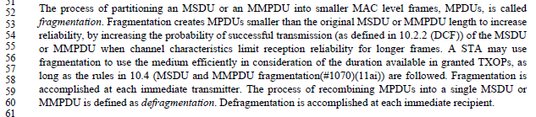

Agree with the commenter, this concept has been moved to the definitions (subclause 3.2):

Proposed Resolution:

Accepted.

CID | Page | Clause | Comment | Proposed Change
4652 | 885.35 | 9.3.3.11 | "conditionally present" is not clear | Change to "present"

Discussion:

The concept/phrase “conditionally present” does not appear anywhere else in a clause 9 table – there are a couple uses within the text.

Agree with the commenter.

Proposed Resolution:

Accepted.

CID | Page | Clause | Comment | Proposed Change
4528 | 1354.43 | 9.4.2.167 | "The Partial TSF Timer subfield value is derived as follows, so as to have units  of TUs: from the 64 TSF timer bits at the start of the first burst instance of an FTM session and remove the  most significant 38 bits and the least significant 10 bits." is garbled | Delete the first "and " in the cited text

Discussion:

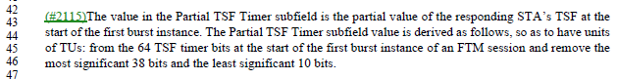

Agree with the commenter. However, inserting a comma might be helpful, as the introductory clause is somewhat long and complex.

Proposed Resolution:

Revised.

At P1354.45, replace the “and” with a comma.

CID | Page | Clause | Comment | Proposed Change
4524 | 2487.43 | 11.32.5 | The notion of a "request" or "response" tunnelled MMPDU is referred to but not defined | At the start of 11.32.5 add a para "A request tunnelled MMPDU is an MMPDU generated in the context of an MLME .request primitive. A response tunnelled MMPDU is an MMPDU generated in the context of an MLME .response primitive."

Discussion:

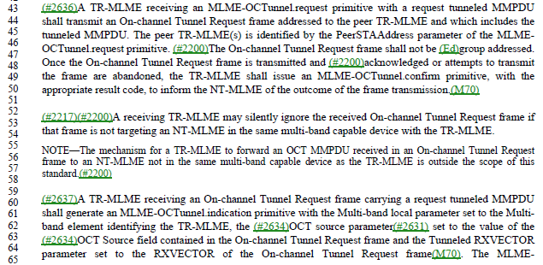

Similar text occurs at P2488.48 and P2488.57 for a “response tunnelled MMPDU”.

Figure 11-53 can help put these situations in context:

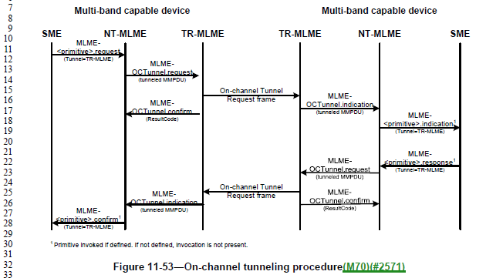

As can be seen in Figure 11-53, the text is attempting to identify the TR-MLME on the left (identified as getting a MLME-OCTunnel.request) and the TR-MLME on the right (identified as getting an On-channel Tunnel Request frame), as these are getting the “forward path” events in the Figure. The text goes on to also identify these two TR-MLMEs in the context of the “return path”, which has the same events. The difference between the forward path and the return path is only in the nature of the tunnelled MMPDU, being either a request MMPDU or a response MMPDU.

However, in agreement with the commenter, the terms "request tunnelled MMPDU " or "response tunnelled MMPDU” are never defined, as the method to convey this distinction.

The start of 11.32.5, where the commenter proposes to add text to define these terms, is the general introduction to the operation of OCT. It would not make sense to start with the introduction of these detailed terms before the introductory text is understood. So, “at the start” of 11.32.5 is probably not the right place. The procedure details start at P2487.16, and this is probably a better place for it.

A bit of introductory text for these terms would also help.

Proposed Resolution:

Revised.

At P2487.15, insert a new paragraph:
‘In the following procedure, a “request tunnelled MMPDU” is an MMPDU generated in the context of an MLME .request primitive. A “response tunnelled MMPDU” is an MMPDU generated in the context of an MLME .response primitive.’

CID | Page | Clause | Comment | Proposed Change
4585 | 1526.06 | 9.6.6.6 | Why is there a "Table 9-173--Optional subelement IDs for Neighbor report" but no table showing optional subelements for Neighbor request? | As it says in the comment

Discussion:

The Neighbor Report Request frame (note, not “Neighbor Request”) is described in 9.6.6.6:

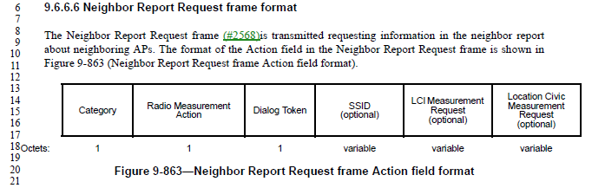

Contrast this with the Neighbor Report Response frame, described in 9.6.6.7:

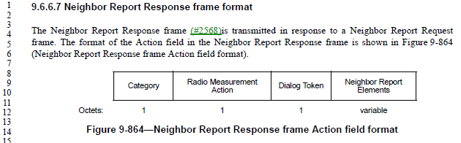

Unlike the Neighbor Report Response, the Neighbor Report Request does not carry “Neighbor Report Elements”.

Table 9-173 only applies to the concept “Neighbor Report Elements”. These elements are carried in various frames from the AP to the non-AP STA, including the Neighbor Report Response, but are not carried in a Neighbor Report Request or other frames from the non-AP STA to the AP.

So, in response to the commenter, two points:
- First, these element IDs apply to “Neighbor Reports” (per the title of Table 9-173), and in theory “Neighbor Reports” could include both the Request and Response frames. So, there is only one table of these values
- Second, in usage, however, the Neighbor Report elements in fact only appear in the information provided by the AP to the non-AP STA, and are not present in the request from the non-AP STA.

Proposed Resolution:

Revised. Change the title of Table 9-173 to have an upper-case “R”, (“Neighbor Report”).

Note to commenter: The elements listed in Table 9-173 appear wherever “Neighbor Report elements” are called out. Conceptually, this could be in both the Neighbor Report Response from the AP to the non-AP STA (and other informational frames from the AP) as well as in the Neighbor Report Request from the non-AP STA to the AP – which is what the commenter questioned. However, currently the Neighbor Report elements in fact only occur in frames from the AP to the non-AP STA, anyway.

CID | Page | Clause | Comment | Proposed Change
4511 | 0.00 | 10.3.8 | "frames with the TXVECTOR" should be "PPDUs with the TXVECTOR" | Change as indicated in 10.3.8 (2x), 19.3.2

Discussion:

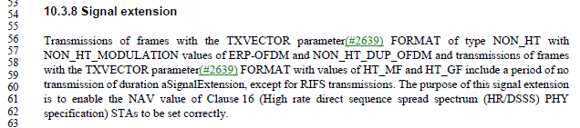

And in 19.3.2:

There are also 5 occurrences of “frame with the TXVECTOR”.

The vast majority of other uses of “with the TXVECTOR” are applied to PSDU(s) or PPDU(s).

Since the TXVECTOR is provided at the PHY SAP, along with a MPDU (== PSDU) to be transmitted, it seems that either MPDU or PSDU are most likely the best usage. There are zero occurrences of “MPDU(s) with the TXVECTOR”, however.

In the cases in 10.3.8, in the discussion of the Signal extension’s implication on clause 16 operation, it seems that PSDU is a logical object to reference. Same thing in 19.3.2.

Arguably, since these subclauses contain these details of PHY operation, they should be moved to the PHY service clause (clause 8). But, that is way beyond the scope of this comment. Also, the existing occurrences of “PPDU with the TXVECTOR” should be checked for whether these should be PSDU; but again, this is beyond the scope of this comment.

In the cases of “frame with the TXVECTOR” (singular “frame”), these occur in two places: rules for control response frame guard intervals, coding and format, and for S1G frame traveling pilots and preamble type. Since the control response frame examples are in the context of a particular frame (MPDU) type, it does not make sense to reference a PSDU – we don’t talk about a PSDU “type” of (for example) “control response”. Therefore, propose that these occurrences remain “frame with the TXVECTOR …”

The S1G frame traveling pilots and preamble type examples, however, are similar to the uses above that should be modified.

Proposed Resolution:

Revised.

At P1769.56 and P1769.57, replace "frames with the TXVECTOR" with "PSDUs with the TXVECTOR".

At P2988.14, replace "frames with the TXVECTOR" with "PSDUs with the TXVECTOR".

At P2126.39, replace “frame with the TXVECTOR” with “PSDU with the TXVECTOR”. Same thing at P2129.25.

Note to the commenter, there are also occurrences of “control response frame [singular] with the TXVECTOR”. Coincidentally, these occurrences all involve noting the MPDU frame type of the referenced frame, and so these are left using the term “frame”. Thus, there is inherent inconsistency in the Draft around this wording, depending on the context.

CID | Page | Clause | Comment | Proposed Change
4507 | 996.05 | 9.4.2.5.1 | "When the TIM is carried in an S1G PPDU, the traffic-indication virtual bitmap has the hierarchical structure shown in Figure 9-152 (Hierarchical structure of traffic-indication virtual bitmap carried in an S1G PPDU (11ah)), consists of 64NPNB bits and is organized into NP pages where each page consists of NB blocks, each block consists of eight subblocks, and each subblock consists of 8 bits (NP=4 and NB=32). Bit number N in the bitmap corresponds to bit number N[0:2] of the N[3:5]-th subblock of the N[6:5+n1]-th block of the N[6+n1:12]-th page, where n1 is log2NB and NB is power of 2. N[a:b] represents bits a to b inclusive of the bit number N." text duplicates figure | Change to "When the TIM is carried in an S1G PPDU, the traffic-indication virtual bitmap has the hierarchical structure shown in Figure 9-152 (Hierarchical structure of traffic-indication virtual bitmap carried in an S1G PPDU (11ah))."

Discussion:

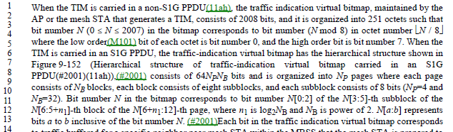

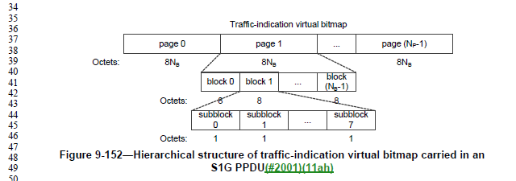

Agree with the commenter, the follow-on text seems to be representing Figure 9-152 in words.

Proposed Resolution:

Accepted.

CID | Page | Clause | Comment | Proposed Change
4492 | 994.53 | 9.4.2.5.1 | Figure 9-149--TIM element format suggests the Bitmap Control field might be absent but the Partial Virtual Bitmap field present, and there is nothing to say this is not allowed | After "If all bits in the virtual bitmap are 0 and all the bits of the Bitmap Control field  are 0, both the Partial Virtual Bitmap field and the Bitmap Control field are not present in the TIM element  and the Length field of the TIM element is set to 2." at 997.6 add "The Bitmap Control field is present if the Partial Virtual Bitmap field is present."

Discussion:

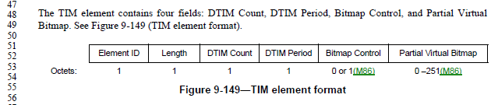

The paragraph on P997 does cover the cases where either/both of the fields are not present due to there being no non-zero bits. This does seem like the right place to note that if the Partial Virtual Bitmap is present, the Bitmap Control must be present.

However, the line reference in the Proposed Change is incorrect (P997.6 is not after the text quoted, P997.8 is).

Proposed Resolution:

Revised.

At P997.8, after “the Length field of the TIM element is set to 2." add "The Bitmap Control field is present if the Partial Virtual Bitmap field is present."

Note to the commenter, this is the requested change, with the location for the inserted text clarified.

CID | Page | Clause | Comment | Proposed Change
4491 | 1618.27 | 9.6.14.2 | Figure 9-951--TIM frame Action field(#2568) format shows the TIM Element field (which contains a TIM element) as being 6-256 octets, but Figure 9-149--TIM element format shows it might only contain 4 octets | Change "6-256" to "4-256"

Discussion:

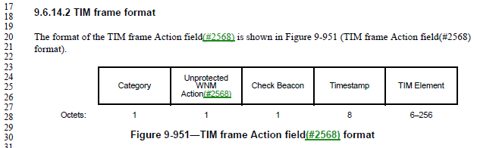

As specified in 9.4.2.5, a TIM element length could be 4-256 octets:

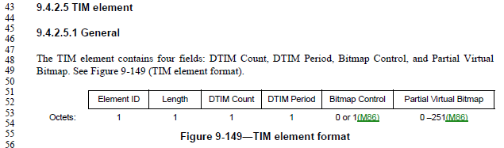

Proposed Resolution:

Accepted.

CID | Page | Clause | Comment | Proposed Change
4561 | 838.04 | 9.3.1.9 | "The Frame Control field is defined in 9.3.1 (Control frames). (MDR2)The subtype field is the value from  Table 9-1 (Valid type and subtype combinations) of 9.2.4.1.3 (Type and Subtype subfields) that corresponds  to Control Wrapper frame." -- we don't say this for any other frame | Delete the cited text

Discussion:

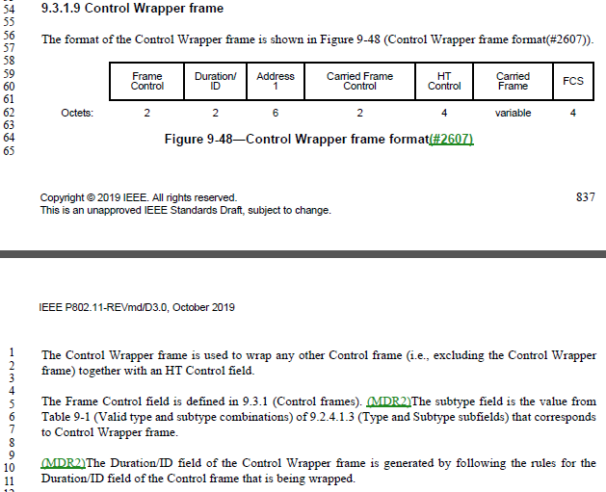

This Control Wrapper frame does appear to be the only frame definition that explicitly says this, and it is not necessary as the Frame Control field is clearly defined in the overall Control Frame format in 9.3.1.1.

Proposed Resolution:

Accepted.

CID | Page | Clause | Comment | Proposed Change
4774 | 2187.02 | 11.2.3.6 | There is no concept of StrictlyOrdered service class, anymore. | Delete "except those that have the StrictlyOrdered service class". Same thing at line 5.  Delete the paragraph at P299.29, discussing two service classes for non-QoS STAs.  At the start of subclause 5.1.1.4, insert a paragraph, "In Non-QoS STAs, the value of the service class parameter in invoked MAC Service Primitives (see 5.2) is ignored. The value of the service class parameter in generated MAC Service Primitives is set to ReorderableGroupAddressed."
4392 | 2187.02 | 11.2.3.6 | There is no strictly ordered service class anymore | In the referenced para delete ", except those that have the StrictlyOrdered service  class" (2x). In Figure 9-27 delete "/  Order"

Discussion:

There are exactly two occurrences of “StrictlyOrdered” (or “strictly ordered”) in the Draft, at the P2187 locations cited in the Proposed Changes.

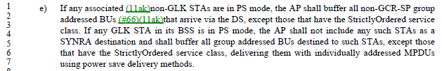

The cited locations on P299 (subclause 5.1.1.1) and in 5.1.1.4 are the only locations that discuss the concept “service class” for non-QoS STAs, without a restriction that only “ReorderableGroupAddressed” is allowed. So, these two locations are the only other places that need to be modified to complete the restriction to only “ReorderableGroupAddressed” service class for non-QoS STAs.

The paragraph at P299.29:
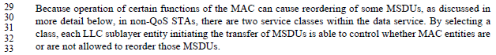
Note that this paragraph says, “as discussed in more detail below”, except it is not discussed below (that has been removed already).

Subclause 5.1.1.4 is where the service class parameter to the MAC SAP is discussed:
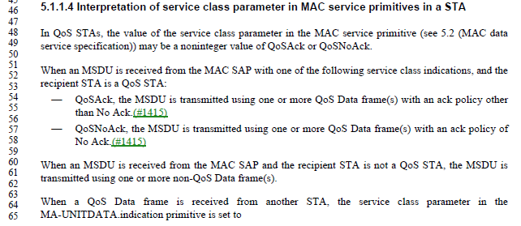
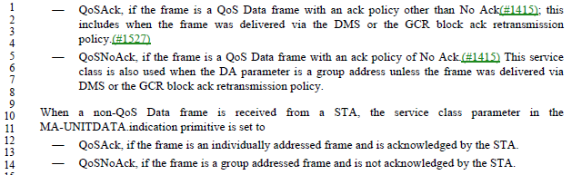

The last paragraph of this subclause deals with receiving a non-QoS Data frame. This could be in the context of a non-QoS STA receiving the frame, or a QoS STA receiving the frame. The current text seems correct for a QoS STA receiving the frame. But a non-QoS STA receiving the frame needs to yield a value of service class in the indication primitive that is understood by the non-QoS upper layers.

Thus, the Proposed Changes for CID 4774 appear correct. But, for completeness, it would be better to note in the last paragraph of 5.1.1.4 that the existing text applies if the non-QoS Data frame is received at a QoS STA. And, then, for clarity, the new text about a non-QoS STA receiving such a frame should be located here (at the end of the subclause, not the beginning).

Also, one straggling vestige of strictly ordered is the +HTC/Order bit in the Frame Control header of control frames in some cases, as shown in Figure 9-27. The use of this bit position as a “+HTC/Order” subfield, rather than just a “+HTC” subfield was removed previously, but the field in Figure 9-27 was missed.

Proposed Resolution:

Revised.

At 2187.02, delete "except those that have the StrictlyOrdered service class". Same thing at line 5.

Delete the paragraph at P299.29, discussing two service classes for non-QoS STAs.

In the (currently) last paragraph of 5.1.1.4, change “from a STA” to “at a QoS STA from any other STA”.

At the end of subclause 5.1.1.4, insert a paragraph, "In non-QoS STAs, the value of the service class parameter in invoked MAC service primitives (see 5.2) is ignored. The value of the service class parameter in generated MAC service primitives is set to ReorderableGroupAddressed."

In Figure 9-27, change the subfield “+HTC/Order” to be “+HTC”.

CID | Page | Clause | Comment | Proposed Change
4534 | 1038.22 | 9.4.2.20.13 | Figure 9-211--Measurement Request field format for a Multicast Diagnostics request is confusing in showing a Multicast Triggered Reporting (optional) field because there is a separate Optional Subelements field and Table 9-117--Optional subelement IDs for STA Multicast Diagnostics request shows Multicast Triggered Reporting | In Table 9-117 delete the first two non-header rows and change 2-220 to 0-220

Discussion:

Indeed there are both the Multicast Triggered Reporting subfield and Optional Subelements in the Multicast Diagnostics request variant of the Measurement Request field.

The Multicast Triggered Reporting subfield is described, as:

This text goes on for several paragraphs, describing these subfields.

However, nowhere in this text is the Sublement ID specified for the Multicast Triggered Reporting subelement. Thus, it seems the row in Table 9-117 is required for this specification:

Since the Multicast Triggered Reporting subelement is optional, as is the Vendor Specific subelement, the question here perhaps should be why there is a specific call out for the Multicast Triggered Reporting sublement in the Figure 9-211 field layout, rather than having Multicast Triggered Reporting subelement just be one of the Optional Subelements, in the usual style.

Proposed Resolution:

Revised. Remove the field “Multicast Triggered Reporting (optional)” from Figure 9-211. Move the text from P1037.31 through P1038.10 to appear after the text at P1038.14 and Table 9-117 and before the text at P1038.32.

2020-02-19 Telecon:

Review P1037.31 – note that the removal of the field causes the text that is proposed to be moved no longer correct.
Optional fields need to have a subelement ID and then the subsequent optional fields can be identified. Having a strange tag for identifying the 4th field is strange.
More Work is needed to address the moving of the text.

Updated Proposed Resolution:

Revised. Remove the field “Multicast Triggered Reporting (optional)” from Figure 9-211. Move the text from P1037.31 through P1038.7 to appear after the text at P1038.14 and Table 9-117 and before the text at P1038.32, with the indicated changes:

The Multicast Triggered Reporting field subelement is used to specify trigger conditions and thresholds. It is present only when requesting triggered multicast diagnostic reporting. The format of Multicast Triggered Reporting subelement is as shown in Figure 9-212 (Multicast Triggered Reporting subelement format).

The Multicast Trigger Condition field specifies reporting triggers for triggered management diagnostic reporting. The format of the Multicast Trigger Condition field is shown in Figure 9-213 (Multicast Trigger Condition field format(#2607)).

The Inactivity Timeout Request field is 1 to request that a multicast triggered report be generated when no group addressed frames with the monitored group address are received in a time equal to the value given in the Inactivity Timeout field. The Inactivity Timeout Request field is 0 when a multicast reception timeout is not requested.

The Inactivity Timeout field contains a time value in units of 100 TUs to be used as the threshold value for the inactivity timeout trigger condition.

The Reactivation Delay field contains a value in units of 100 TUs during which a measuring STA does not generate further multicast triggered reports after a trigger condition has been met.

CID | Page | Clause | Comment | Proposed Change
4567 | 2302.49 | 11.10.9.2 | "a Frame Report  Entry field where Transmitter Address (TA) matching the MAC address field value" -- is this TA in the MAC header? A field somewhere? I think it's a misnamed field from Figure 9-235--Frame Report Entry field format | Change to "a Frame Report  Entry field with a Transmit Address field matching the MAC address field value"

Discussion:

The Frame request frame has the following format and description:

So, it is frames received with a TA that matches the Frame request’s MAC Address field, that are counted for the Frame report. So, agree with the commenter that this sentence is mixing up terms and concepts.

However, it would be better to state this clearly (with a re-write of the sentence), in a way that is similar to the subsequent sentence.

Proposed Resolution:
Revised.

Replace:
If the MAC Address field included in the Frame request was not set to the broadcast address, a Frame Report Entry field where Transmitter Address (TA) matching the MAC address field value shall be included in the Frame report if at least one Data or Management frame was received with this Transmitter Address during the measurement duration.

with:
If the MAC Address field included in the Frame request was not set to the broadcast address, the measuring station shall report, in one or more Frame reports, only those Data or Management frames received during the measurement duration with a TA field matching the MAC Address field of the Frame request, if at least one such frame was received.

Also, in 9.4.2.20.8, Replace:
If the MAC Address field is the broadcast address, then all Data or Management frames are counted toward the Frame report generated in response to this Frame request. For other MAC addresses, only frames matching this MAC address as the Transmitter Address are counted toward the Frame report generated in response to this Frame request.

with:
The MAC Address field indicates the TA field to match against Data and Management frames in order to count toward the Frame report generated in response to this Frame request.

CID | Page | Clause | Comment | Proposed Change
4808 | 1543.10 | 9.6.7.16 | RSNE, and FTE, are not "optionally present" if security is required. They _are_ present if security is required. | Delete "optionally" at P1543.10 and P1543.18.

Discussion:

From P1543:

In TDLS Setup frames, the language is (for the RSNE, for example, FTE is similar): “The RSNE is present if security is required on the TDLS direct link and the Status Code is SUCCESS, and not present otherwise. The RSNE is defined in 9.4.2.24 (RSNE).”

Per 11.21.1 (General subclause of Tunneled direct-link setup): “Security is available on the TDLS direct link only when both TDLS peer STAs have an RSNA with the BSS.”

Per 12.7.8.4.2 (TPK handshake message 1): “If the TDLS initiator STA has security enabled on the link with the AP, it shall add an RSNE, FTE, and Timeout Interval element to its TDLS Setup Request frame.”

Per 12.7.8.4.3 (TPK handshake message 2): “If the TDLS responder STA validates the TPK handshake message 1 for this TDLS instance, the TDLS responder STA may respond with TPK handshake message 2. To do so, the TDLS responder STA shall add an RSNE, FTE, and Timeout Interval element to its TDLS Setup Response frame.”

Thus, it appears that the RSNE and FTE elements shall be present when security is enabled on the link to the AP (“with the BSS”) on both the initiator and responder.

In Table 9-373, we are dealing with TDLS Discovery. As the TDLS Discovery Request frame does not appear to provide security/RSN information for the potential TDLS initiator, at the time of responding to the discovery, the responder can only indicate whether it does have security enabled with the BSS, and security would be available on the TDLS link, if the initiator also has security enabled.

Thus, in the TDLS Discovery Response frame, the RSNE and FTE must be present if the transmitter has security enabled on the link with the AP.

Proposed Resolution:

Revised.

At P1543.10 and P1543.18, replace:
“is optionally present if security is required on the direct link.”

with:
“is present if the transmitting STA has security enabled on its link with the AP”.

CID | Page | Clause | Comment | Proposed Change
4653 | 885.35 | 9.3.3.11 | "conditionally present" is not clear | Change to "optionally present"

Discussion:

A very similar CID 4652 was previously reviewed and agreed to be “Accepted” to change “conditionally present” to just “present” (see elsewhere in this document). However, that analysis was that “conditionally present” is not the correct/usual text. No analysis was done on whether the field should be optional or not, at that time.

To answer the question on optionality, we look at P2574, in subclause 12.4.5.4, Processing of a peer’s SAE Commit message:

As status code 126 is SAE_HASH_TO_ELEMENT (per Table 9-52), the “conditionally present” referenced in Table 9-43 is on condition of that status code, as described in the above paragraph. The above paragraph makes it clear that either endpoint may send no Rejected Groups element, even when the status code is SAE_HASH_TO_ELEMENT.

Thus, it is correct/appropriate that “optionally present” is the correct phrase.

Proposed Resolution:

Accepted.

Also,

Revisit CID 4652, and change that resolution to:
Revised. Change to "optionally present"

CID | Page | Clause | Comment | Proposed Change
4325 |  |  | "AC parameters" is not a defined thing; should be "EDCA parameters" (5x) | As it says in the comment

Discussion:

In 11-20/272r6, Graham states that there are 5 instances of “AC parameters”, there are 22 instances of “EDCA parameters”.

Per 10.2.3.2 (HCF contention based channel access (EDCA)), the AP uses EDCA parameters per dot11QAPEDCATable in the MIB, while non-AP STAs use parameters as announced by the AP (or a default if no such announcement is made) and stored in dot11EDCATable.

Also per 10.2.3.2, “The QoS AP shall announce the EDCA parameters in selected Beacon frames and in all Probe Response and (Re)Association Response frames by the inclusion of the EDCA Parameter Set element using the information from the MIB entries in dot11ECDATable.”

So, the information being described in 9.4.2.28 (EDCA Parameter Set element) is the ECDA parameters announced by the AP.

Proposed Resolution:

Revised.

At the following locations, make changes as shown:

P1117L47 9.4.2.28
Change
“is incremented each time any of the AC parameters changes”
to
“is incremented each time any of the announced EDCA parameters change.”

P1717L60
Change
“When communicating within a BSS, the EDCA parameters used are from the EDCA Parameter Set element”
to
“For a non-AP STA communicating within a BSS, the EDCA parameters used are from the EDCA Parameter Set element”

P1718L58 10.2.3.2
Change
“following a change in AC parameters, which provides all STAs an opportunity to receive the updated EDCA parameters.”
To
following a change in announced EDCA parameters, which provides all STAs an opportunity to receive the updated EDCA parameters.

P1719L41 10.2.3.2
Change
“is incremented every time any of the AC parameters changes.”
To
“is incremented every time any of the announced EDCA parameters change.”

P4544L24 K.2.1.
“It is recommended that admission control not be required for the access categories AC_BE and AC_BK. The ACM subfield for these categories should be set to 0. The AC parameters chosen by the AP should account for unadmitted traffic in these ACs.”
To
“It is recommended that admission control not be required for the access categories AC_BE and AC_BK. The ACM subfield for these categories should be set to 0. The announced EDCA parameters and the EDCA parameters used by the AP should account for unadmitted traffic in these ACs.”

P4544L32 K.2.1.
Change:
“AC parameters chosen by the AP should further account for any unadmitted traffic in AC_VO and AC_VI that might be reserved for users of a particular SSPN.”
To
“The announced EDCA parameters and the EDCA parameters used by the AP should further account for any unadmitted traffic in AC_VO and AC_VI that might be reserved for users of a particular SSPN.”

CID | Page | Clause | Comment | Proposed Change
4445 | 1011.8 |  | "For nonmesh STAs, the Channel Switch Count field either is set to the number of TBTTs until the STA  sending the Channel Switch Announcement element switches to the new channel or is set to 0. (MDR2)A 1  indicates that the switch occurs immediately before the next TBTT. A 0 indicates that the switch occurs at  any time after the frame containing the element is transmitted." is self-contradictory. If it switches before the next TBTT, the number of TBTTs until the switch was 0 | Change to "For nonmesh STAs, the Channel Switch Count field is set to the number of TBTTs until the STA  sending the Channel Switch Announcement element switches to the new channel. (MDR2)1  indicates that the switch occurs immediately before the next TBTT. 0 indicates that the switch occurs at  any time after the frame containing the element is transmitted."  Proposed:  At P1011L8  Change  “For nonmesh STAs, the Channel Switch Count field either is set to the number of TBTTs until the STA sending the Channel Switch Announcement element switches to the new channel or is set to 0. A 1 indicates that the switch occurs immediately before the next TBTT. A 0 indicates that the switch occurs at any time after the frame containing the element is transmitted.”  To  "For nonmesh STAs, the Channel Switch Count field is set to the number of TBTTs until the STA sending the Channel Switch Announcement element switches to the new channel. A value of 1 indicates that the switch occurs immediately before the next TBTT and a value of 0 indicates that the switch occurs at any time after the frame containing the element is transmitted."

Discussion:

From discussion in February, and in 11-20/0272:

P1011L8
“For nonmesh STAs, the Channel Switch Count field either is set to the number of TBTTs until the STA sending the Channel Switch Announcement element switches to the new channel or is set to 0. (MDR2)A 1 indicates that the switch occurs immediately before the next TBTT. A 0 indicates that the switch occurs at any time after the frame containing the element is transmitted.”

Agree with commenter
Comment suggested change to:
"For nonmesh STAs, the Channel Switch Count field is set to the number of TBTTs until the STA sending the Channel Switch Announcement element switches to the new channel. (MDR2)1 indicates that the switch occurs immediately before the next TBTT. 0 indicates that the switch occurs at any time after the frame containing the element is transmitted."

Not sure about “1 indicates”, how about

REVISED
At P1011L8
Change
“For nonmesh STAs, the Channel Switch Count field either is set to the number of TBTTs until the STA sending the Channel Switch Announcement element switches to the new channel or is set to 0. (MDR2)A 1 indicates that the switch occurs immediately before the next TBTT. A 0 indicates that the switch occurs at any time after the frame containing the element is transmitted.”
To
"For nonmesh STAs, the Channel Switch Count field is set to the number of TBTTs until the STA sending the Channel Switch Announcement element switches to the new channel. (MDR2)A value of 1 indicates that the switch occurs immediately before the next TBTT and a value of 0 indicates that the switch occurs at any time after the frame containing the element is transmitted."

From 802.11 Editorial Style Guide (11-09/1034):
The use of “value of <field> field” is deprecated.

Note 802.11-2016 1.4 states: ‘If <x> represents a scalar field, scalar subfield, scalar parameter or scalar MIB attribute:
— if “<x> is” is used in a context that relates to the testing or setting the value of “<x>” this usage is to
be interpreted as though written “the value of <x> is”
— “<x> indicate(s)” is to be interpreted as though written “the value of <x> indicate(s)”
— “indicated by <x>” is to be interpreted as though written “indicated by the value of <x>”
— “<x> that indicate” isto be interpreted as though written “<x> whose value indicates” ’

There was also discussion on changing “immediately before” vs “at”
The argument of “at” the TBTT will start the change of channel, but you may have a race condition.
The switch has to occur before the beacon is created.

Suggest being clear that the change happens “at” the TBTT (and not before, which opens a small and unknown window when the AP is no longer on the old channel), and also clarifying that the Beacon is created assuming this new channel.

Proposed Resolution:

Revised.

At P1011L8
Change
“For nonmesh STAs, the Channel Switch Count field either is set to the number of TBTTs until the STA sending the Channel Switch Announcement element switches to the new channel or is set to 0. (MDR2)A 1 indicates that the switch occurs immediately before the next TBTT. A 0 indicates that the switch occurs at any time after the frame containing the element is transmitted.”
to
"For nonmesh STAs, the Channel Switch Count field is set to the number of TBTTs until the STA sending the Channel Switch Announcement element switches to the new channel. (MDR2)1 indicates that the switch occurs at the next TBTT (the ensuing Beacon frame is created assuming the new channel), and 0 indicates that the switch occurs at any time after the frame containing the element is transmitted."

CID | Page | Clause | Comment | Proposed Change
4462 |  |  | "of all MSDUs and A-MSDUs buffered at the STA". A STA does not buffer A-MSDUs. The things it receives via MA-UNITDATA.request are MSDUs, and those are the things it buffers prior to transmission Change the cited text to "of all MSDUs buffered at the STA" | Delete "or A-MSDUs" in 9.2.4.1.8 More Data subfield (4x), 9.2.4.5.6 Queue Size subfield, 9.2.4.5.8 AP PS Buffer State subfield

Discussion:

Examining Figure 5-1 - MAC data plane architecture(11ak)(#2273), we see that A-MSDU aggregation occurs higher in stack, thus before transmit buffering for Power Save.

This is consistent with the definition of bufferable unit:

Proposed Resolution:

Rejected. As described in the definition of bufferable unit (BU), and Figure 5-1’s flow of action for transmitted frames, aggregation into A-MSDUs occurs before the power buffering stage, and thus A-MSDUs are buffered.

