IEEE P802.11
Wireless LANs
Resolution for SA1 comment 4765 on 11md/D3.0
Date: 2020-02-14
Author:
Name | Affiliation | Address | Phone | Email
Peter Ecclesine | Cisco Systems | Cisco SJ-24-3, Milpitas, CA | +1.408.722.8489 | petere@ieee.org

This submission present proposed resolution for CID 4765. The proposed changes are based on REVmd/D3.0.

Revision history:

R0 – initial version

CID | Clause | Page | Line | Comment | Proposed Change
4765 | E.1 | 4379 | 44 | Global classes 115, 116, 118, 119, 125, 126 nonglobal operating classes reference should be to Table E.6 China, not Table E.5 Sub1GHz | Correct last nonglobal operating classes references to E.6.1, E.6.4, E.6.2, E.6.5, E.6.3 and E.6.6 respectively.

Discussion:
In Table E-4, the following circled entries represent the comment:
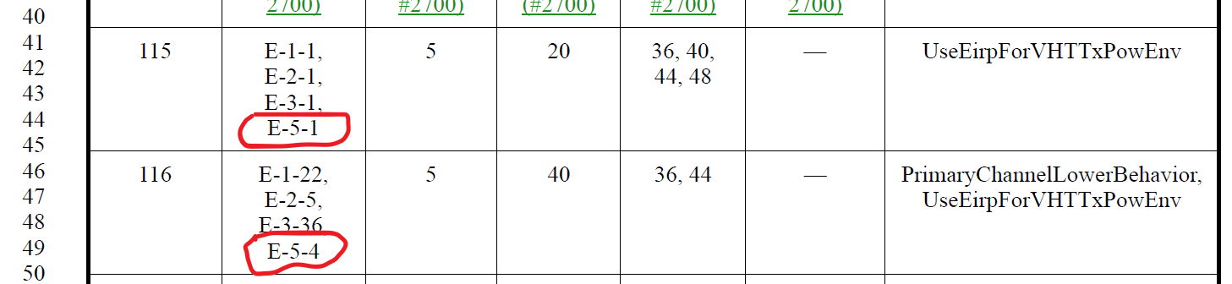
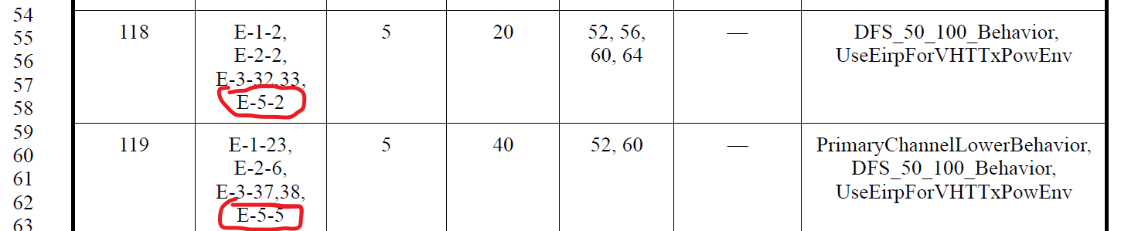
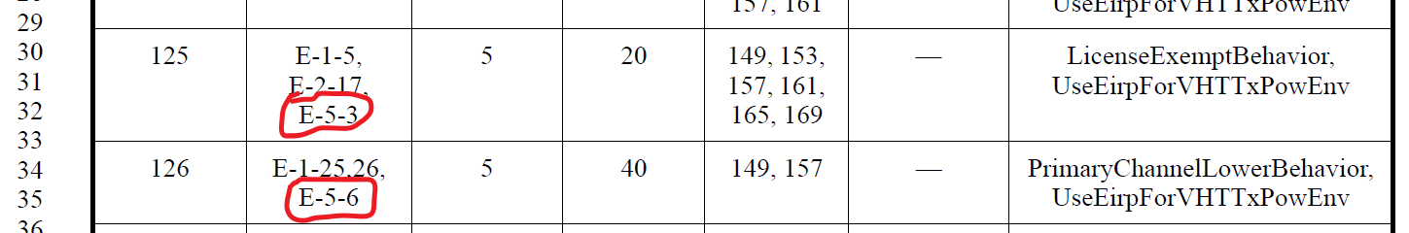
In each of the six circled entries, the last nonglobal table value should be E-6-x rather an E-5-x.
Proposed resolution:
Accepted
In Table E-4, in each of the six circled entries, replace “E-5-” with “E-6-”.

