IEEE P802.11
Wireless LANs
Initial SA Ballot Comment Resolution
Date: 2020-02-12
Author(s):
Name | Affiliation | Address | Phone | email
Claudio da Silva | Intel |  |  | claudio.da.silva@intel.com
Artyom Lomayev | Intel |  |  | artyom.lomayev@intel.com
Abstract
This submission proposes resolutions to comments submitted in the initial SA ballot. The text used as reference is D5.0.

CID | Clause | Page | Comment | Proposed change
6116 | 10.42.7 | 288.48 | Feedback of training performed with an EDMG BRP-RX/TX PPDU uses AWV Feedback IDs; thus, it must be carried within an EDMG Channel Measurement Feedback element. | Substitute "Channel Measurement Feedback element" with "EDMG Channel Measurement Feedback element".

Proposed resolution: Accepted

Modifications: Please modify the last paragraph of page 288 as follows:
If a beam tracking responder sends an EDMG BRP-RX/TX PPDU in response to an analog receive beam tracking request, the beam tracking initiator may aggregate in an A-MPDU a BRP frame that contains a an EDMG Channel Measurement Feedback element with the feedback (see 10.42.6.4.1). The feedback type shall be the same as the feedback type in the last BRP frame that was transmitted from the responder to the initiator with TX-TRN-REQ equal to 1. If the initiator has never received a BRP frame from the responder with TX-TRN-REQ equal to 1, the initiator shall respond with all subfields of the FBCK-TYPE field equal to 0 and set the BS-FBCK field to the AWV feedback ID corresponding to the TRN subfields received with the best quality.

CID | Clause | Page | Comment | Proposed change
6174 | 28.3.3.3.1 | 437.18 | It is not clear what " The EDMG-Header-A field is defined at the SC chip rate Fc." means. Does it mean "The EDMG-Header-A field is transmitted using SC modulation at chip rate Fc"? | Change "The EDMG-Header-A field is defined at the SC chip rate Fc." to "The EDMG-Header-A field is transmitted using SC modulation at chip rate Fc." or "The EDMG-Header-A field is modulated in SC at chip rate Fc"

Proposed resolution: Revised

Discussion:
- “DMG SC chip rate” and “EDMG SC chip rate” are defined in Table 28-47.
- “SC chip rate,” which appears 14 times in D5.0, is not defined.
- The goal of the sentence identified by the commenter is to define the transmission/chip rate of the EDMG-Header-A field, and not the modulation scheme used.
- To align the text in D5.0 with definitions found in Table 28-47, we propose to replace “SC chip rate” with “DMG SC chip rate” as listed below.
- Modifications below also include equivalent changes for the EDMG case.

Modifications: Please modify line 23 of page 431 as follows:
These fields are defined at the DMG SC chip rate F_{c} in 20.4.3.1.2, 20.3.6.2, 20.3.6.3, 20.4.3.2, and…

Please modify line 18 of page 437 as follows:
CEF and EDMG-Header-B fields. The EDMG-Header-A field is defined at the DMG SC chip rate Fc. The EDMG-

Please modify line 3 of page 479 as follows:
These fields are defined at the DMG SC chip rate Fc and transmitted in the EDMG control mode

Please modify line 12 of page 479 as follows:
The EDMG-Header-A and the Data fields are defined at the DMG SC chip rate Fc and transmitted in the EDMG control

Please modify line 15 of page 479 as follows:
The TRN field, if present, is transmitted at the EDMG SC chip rate F_{c EDMG} NCB×Fc as defined in 28.4.7.3.4

Please modify line 4 of page 481 as follows:
The non-EDMG control mode PPDU waveform shall be defined at the DMG SC chip rate Fc and include the

Please modify line 16 of page 484 as follows:
The preamble and Data field shall be defined at the DMG SC chip rate equal to F_{c} and include the following

Please modify line 16 of page 487 as follows:
The TRN field, (eq), shall be defined at the EDMG SC chip rate F_{c EDMG} equal to N_{CB}× F_{c} per

Please modify line 26 of page 488 as follows:
The EDMG control mode PPDU shall be defined at the DMG SC chip rate equal to Fc and include the following

Please modify line 12 of page 505 as follows:
= 1) shall be defined at the DMG SC chip rate Fc. The PPDU of this type does not include the EDMG-STF and

Please modify line 9 of page 506 as follows:
GHz channel shall be defined at the DMG SC chip rate Fc as shown in Figure 28-20.

Please modify line 12 of page 508 as follows:
GHz channel shall be defined at the DMG SC chip rate Fc as shown in Figure 28-20.

Please modify line 27 of page 524 as follows:
The non-EDMG PPDU waveform shall be defined at the DMG SC chip rate Fc and include the following modulated

Please modify line 28 of page 529 as follows:
The TRN field, (eq), shall be defined at the DMG SC chip rate Fc per iTXth transmit chain as defined in

Please modify line 17 of page 536 as follows:
SU PPDU is defined for the iTXth transmit chain at the Fc EDMG EDMG SC chip rate F_{c EDMG} and includes the following modulated

Please modify line 18 of page 538 as follows:
The TRN field,(eq), shall be defined at the EDMG SC chip rate equal to F_{c EDMG} per iTXth transmit chain

Please modify line 16 of page 540 as follows:
chain at the F_{c EDMG} EDMG SC chip rate F_{c EDMG} and includes the following modulated fields

Please modify line 2 of page 541 as follows:
The TRN field, (eq), shall be defined at the EDMG SC chip rate equal to F_{c EDMG} per iTXth transmit chain

Please modify lines 39-40 of page 606 as follows:
The basic SC TRN subfield waveform for the iTXth transmit chain in time domain shall be defined at the EDMG SC chip rate F_{c EDMG} NCB×Fc and chip time duration Tc/NCB as follows:

Please modify line 5 of page 607 as follows:
waveform for the iTXth transmit chain in time domain shall be defined at the DMG SC chip rate Fc and chip time

CID | Clause | Page | Comment | Proposed change
6175 | 28.3.3.3.1 | 437.21 | The sentence "Reserved bits shall be set to 0 by the transmitter and shall be ignored by the receiver." it is not clear which reserved bits belong to. | Change the sentence to indicate the field those bits are in.

Proposed resolution: Revised

Discussion: Sentence identified by the commenter is in the “General” sub-clause of the “EDMG portion of EDMG format preamble” clause, which covers the EDMG-Header-A, EDMG-STF, EDMG-CEF and EDMG-Header-B fields. Obviously, the sentence only applies to the EDMG-Header-A and EDMG-Header-B fields.

Modifications: Please delete line 21 of page 437
Reserved bits shall be set to 0 by the transmitter and shall be ignored by the receiver.

Please add the following sentence at the end of 28.3.3.3.2.1 (page 437)
Reserved bits in the EDMG-Header-A field shall be set to 0 by the transmitter and shall be ignored by the receiver.

Please add the following sentence at the end of 28.3.3.3.5.1 (page 449)
Reserved bits in the EDMG-Header-B field shall be set to 0 by the transmitter and shall be ignored by the receiver.

CID | Clause | Page | Comment | Proposed change
6176 | 28.3.3.3.2.2 | 438.7 | "In the first row of Table 28-11, the following statements should be conditioned under the EDMG TRN Length Field is non-zero: ""If this field set to 0, the BW field specifies that the TRN field of the PPDU is appended on a 2.16 GHz, 4.32 GHz, 6.48 GHz or 8.64 GHz channel. If this field set to 1, the BW field specifies that the TRN field is transmitted over a 2.16+2.16 GHz or 4.32+4.32 GHz channel.""" | Change "If this field set to 0 ..." to "If this field set to 0 and the EDMG TRN Length Field is non-zero ..." and change "If this field set to 0 ..." to "If this field set to 1 and the EDMG TRN Length Field is non-zero ...".

Proposed resolution: Rejected

Discussion: The text referred to by the commenter is:
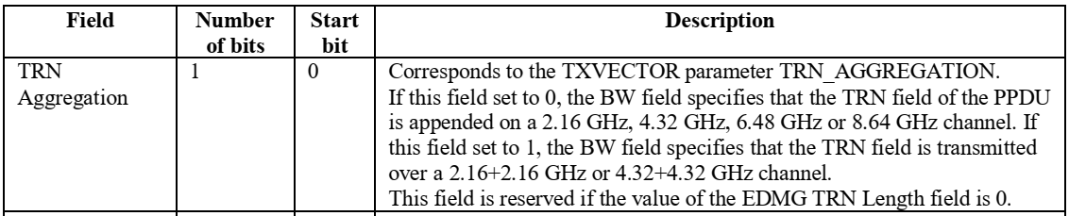

While the point/suggestion made by the commenter has merit, similar sentence constructions can be found in both P802.11ay/D5.0, such as

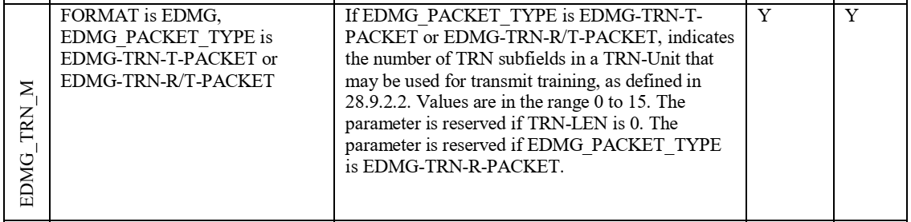,

and in 802.11-2016, including

and

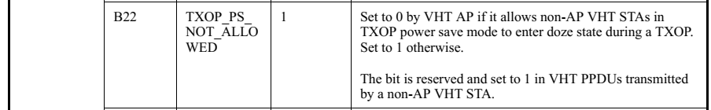.

For the sake of consistency, if the change proposed in CID 6176 is made, one could argue that we would carry it over to other places in the draft. Given that the structure used in the sentences under discussion can be found in 802.11-2016, my recommendation is to reject the CID.

CID | Clause | Page | Comment | Proposed change
6179 | 28.3.3.4.2 | 451.17 | This subclause applies to two channel aggregation cases: 2.16+2.16 GHz PPDU and 4.32+4.32 GHz PPDU, but there is no text mention the first case explicitly. Suggest make them explicitly. | "Change Line 21-22 to ""The lower half NTX/2 transmit chains (i.e., those with lower indices) are used for transmissions in the primary channel for a 2.16+2.16 GHz PPDU transmission, or primary and secondary channels for a 4.32+4.32 GHz PPDU transmission.  Change Line 23-24 to ""The upper half NTX/2 transmit chains (i.e., those with higher indices) are used for transmissions in the secondary channel for a 2.16+2.16 GHz PPDU transmission, or secondary1 and secondary2 channels for a 4.32+4.32 GHz PPDU transmission.  Similar changes can be applied to Line 28-31."

Proposed resolution: Revised

Modifications: Please modify lines 21 and 22 of page 451 as follows:
The lower half N_{TX}/2 transmit chains (i.e., those with lower indices) are used for transmissions in the primary channel for a 2.16+2.16 GHz PPDU transmission, or in the (primary and secondary channels for a 4.32+4.32 GHz PPDU transmission)

Please modify lines 23 and 24 of page 451 as follows:
The upper half N_{TX}/2 transmit chains (i.e., those with higher indices) are used for transmissions in the secondary channel for a 2.16+2.16 GHz PPDU transmission, or in the (secondary1 and secondary2 channels for a 4.32+4.32 GHz PPDU transmission)

Please modify lines 28 and 29 of page 451 as follows:
is the carrier center frequency of the primary channel for a 2.16+2.16 GHz PPDU transmission, or of the (primary and secondary channels for a 4.32+4.32 GHz PPDU transmission)

Please modify lines 30 and 31 of page 451 as follows:
is the carrier center frequency of the secondary channel for a 2.16+2.16 GHz PPDU transmission, or of the (secondary1 and secondary2 channels for a 4.32+4.32 GHz PPDU transmission)

CID | Clause | Page | Comment | Proposed change
6181 | 28.6.2.2 | 546.9 | The unit of "length" should be given for "short guard interval length", "normal guard interval length" and "long guard interval length". | See Comment

Proposed resolution: Rejected

Discussion: Short/normal/long guard interval length in Table 28-62 refer to the lengths of (Golay) sequences that define the three types of GIs. The length of a sequence is a well-known concept, and can be found in popular textbooks and websites; for example, “The number of elements (possibly infinite) is called the length of the sequence.” While a unit for the GI length (chips? symbols?) is not defined in both 802.11-2016 and P802.11ay/D5.0, it is important to note that their duration is defined for all cases further down in the table in nanoseconds. Since duration is a function of the sequence length, among other transmission parameters, we believe that this parameter makes it clear to the reader the meaning of length.

CID | Clause | Page | Comment | Proposed change
6195 | 10.42.5.1 | 321.33 | The sentence is garbled and has grammer errors. "Beam refinement protocol transmit sector sweep (BRP TXSS) is a procedure that makes use of BRP frames to perform transmit sector sweep and receive training and determine improved antenna configuration(s) for transmission and reception." | suggest to change the sentence to "Beam refinement protocol transmit sector sweep (BRP TXSS) is a procedure using BRP frames to perform transmit sector sweep and to determine improved antenna configuration(s) for transmission and reception."

Proposed resolution: Revised

Modifications: Please modify lines 33-35 of page 320 as follows:
Beam refinement protocol transmit sector sweep (BRP TXSS) is a procedure that makes use of BRP frames to perform transmit sector sweep and receive training and determine improved antenna configuration(s) for transmission and reception.

