IEEE P802.11  
Wireless LANs

|  |  |  |  |  |
| --- | --- | --- | --- | --- |
| Resolution for CIDs related to Multiple BSSID | | | | |
| Date: March 15, 2020 | | | | |
| Author(s): | | | | |
| Name | Affiliation | Address | Phone | email |
| Abhishek Patil | Qualcomm Inc. |  |  | appatil@qti.qualcomm.com |
| Alfred Asterjadhi | Qualcomm Inc. |  |  | aasterja@qti.qualcomm.com |
| George Cherian | Qualcomm Inc. |  |  | gcherian@qti.qualcomm.com |

Abstract

This submission proposes resolutions for following (11) CIDs received for TGax SA Ballot 1:

24545, 24055, 24108, 24469, 24115, 24109, 24110, 24111, 24039, 24112, 24113

Revisions:

* Rev 0: Initial version of the document.  
  Rev 1: Resolutions to CIDs 24545, 24109, 24110 are updated based on feedback (received during 3/16 telco and offline via emails)
* Rev 2:
  + Includes strawpoll results from 3/19/20 TGax telco
  + Minor update to the resolution for CID 24108 (changes highlighted)
* Rev 3:
  + Changes with respect to Rev 2 are highlighted in green
  + Added Annex AA to provide examples of Profile Periodicity and DTIM interval
  + Updates based on feedback from Mark R.
    - several editorial changes throughout the document
    - updated resolution for CID 24111 – changed from Accepted to Revised to include editorial changes to the proposed text by the commenter
    - provided instructions to the editor to fix several instances in the fix that say ‘associating with a (Tx or nonTx) BSSID’.
* Rev 4: Updated based on offline feedback from Po-Kai
  + Highlighted in pink
* Rev 5: Updated figure AA-4 to fix an error (BSSID-Index should be =15 not =12)

Interpretation of a Motion to Adopt

A motion to approve this submission means that the editing instructions and any changed or added material are actioned in the TGax Draft. This introduction is not part of the adopted material.

***Editing instructions formatted like this are intended to be copied into the TGax Draft (i.e. they are instructions to the 802.11 editor on how to merge the text with the baseline documents).***

***TGax Editor: Editing instructions preceded by “TGax Editor” are instructions to the TGax editor to modify existing material in the TGax draft. As a result of adopting the changes, the TGax editor will execute the instructions rather than copy them to the TGax Draft.***

|  |  |  |  |  |  |  |
| --- | --- | --- | --- | --- | --- | --- |
| **CID** | **Commenter** | **Pg/Ln** | **Section** | **Comment** | **Proposed Change** | **Resolution** |
| 24545 | Hamilton, Mark | 42.21 | 3.2 | Per REVmd D3.0, there is only one antenna connector in a STA. The defintion of antenna connector discusses how multiple antenna devices are modeled, as having a single antenna connector. Thus, this change to BSSID set is inconsistent with the antenna connector definition. | Change "antenna connectors" back to "antenna connector". Change "antenna connectors" to "antenna connector" in co-hosted BSSID set definition, and throughout the draft. | **Revised**  Agree with the comment. However some instances should be left plural. PHY folks have helped identify the instances that should be left unchanged (plural).  **TGax editor, please implement the change as suggested by the commenter except for the following location in 11ax D6.0:**  P91L10, P122L19, P126L33, P640L39 |
| 24055 | Inoue, Yasuhiko | 43.38 | 3.2 | The multiple basic service set identifier set is defined as "A collection of access points (APs), such that all APs use a common operating class, channel, and antenna connectors and advertise information for multiple BSSIDs using Beacon or Probe Response frames sent by the AP corresponding to the transmitted BSSID."    The co-hosted basic service set identifier (BSSID) set is defined as "A collection of access points (APs) such that all APs use a common operating class, channel, and antenna connectors and each AP advertises information for its BSSID using Beacon or Probe Response frames."    The difference between the multiple BSSIS and co-hosted BSSID is not clear enough. We do not need more than one term to mean the same thing. | Clarify the difference between the multiple BSSID and co-hosted BSSID, or delete either one definition and replace the deleted term with another one. | **Rejected**  The two definitions are complete and necessary to differentiate between the two features.  The key difference between the two sets how the information for each BSSID is advertised.  In a multiple BSSID, there is a single Beacon or Probe Response frame that carries information for all the BSSIDs in the set.  In contrast, in a co-hosted set, each AP corresponding to a BSSID sends a beacon or probe response. |
| 24469 | RISON, Mark | 291.32 | 11.1.3.8.1 | "NOTE--A BSSID is discoverable if the AP includes information of that BSSID in its Beacon and Probe Response frames (though not necessarily every frame)." -- this is the definition of BSSID discoverability, so it cannot just be informative | Delete the "NOTE--" | **Accepted**  **TGax editor, please delete the NOTE as suggested by the comment.** |
| 24115 | Patil, Abhishek | 459.50 | 26.17.2.3.2 | Clarify that the purpose of including RNR is that RNR + Multiple BSSID together provides information of all discoverable BSSIDs (similar comment for 11.1.3.8.3) | As in comment | **Revised**  The cited paragraphs in clause 11.1.3.8.3 and 26.17.2.3.2 are updated to clarify that RNR carries at least the nonTxBSSID profiles not advertised in the Multiple BSSID element carried in the Beacon or Probe Response frame. Further the content in 26.17.2.3. is moved to 11.1.3.8.3 so that all the multiple BSSID content is in the same clause.  **TGax editor, please make changes as shown in doc 11-20/0315r5 with the tag 24115** |
| 24109 | Patil, Abhishek | 293.62 | 11.1.3.8.3 | How is this scenario different from the one described in the next paragraph that covers the case when a STA's probe request includes the Known BSSID element. | Clarify that the Probe Request frame in this case has the BSSID field set to the nonTxBSSID and/or the SSID is matching the SSID of the nonTxBSSID. | **Revised**  Agree with the comment – the spec needs to provide clarification between the two scenarios. The text is updated to clarify that the STA transmitting the probe request frame is looking for a particular AP corresponding to a nonTxBSSID (by including the BSSID and/or a SSID for that BSSID).  **TGax editor, please make changes as shown in doc 11-20/0315r5 with the tag 24109** |
| 24110 | Patil, Abhishek | 294.01 | 11.1.3.8.3 | Clarify that the Probe Request frame is directed to the transmitted BSSID. | As in comment | **Revised**  Agree with the comment. The sentence is updated to clarify that the probe request is directed to transmitted BSSID.  **TGax editor, please make changes as shown in doc 11-20/0315r5 with the tag 24110** |
| 24111 | Patil, Abhishek | 294.04 | 11.1.3.8.3 | Simplify the sentence and clarify that it is possible that an AP may not be able to fit all the profiles not known to the requesting STA. | Update the sentence as: "An EMA AP, when transmitting a Probe Response frame in response to a Probe Request frame containing Known BSSID element shall, at a minimum, include the nontransmitted BSSID profiles not known to the requesting STA.  NOTE - It is possible that an AP is unable to fit all the profiles not known to the STA in the response frame." | **Revised**  Agree with the comment. The sentence is updated to clarify that the probe response frame is required to carry the profiles not known to the requesting STA unless the AP is unable fit them all in a single frame.  **TGax editor, please make changes as shown in doc 11-20/0315r5 with the tag 24111** |
| 24039 | Kneckt, Jarkko | 294.10 | 11.1.3.8.3 | The nontransmitted BSSID profiles handling in EMA AP is very unclearly written. The EMA AP shall include the non-transmitted BSSID profile in all DTIM beacons of the BSS. This is to ensure that STA gets updated BSS parameters when it obtains the group addressed data. The current mechanism that allows the profile to be added only to some DTIM beacons is more complicated and in practise the faster indication may not be possible to receive. The nontransmitted profile may be transmitted more often, if the AP desires to advertise the profile more often and optimize the discovery time of the profile. | Change the sentence from line 15 that EMA AP shall include the nontransmitted BSSID profile to all DTIM beacons and may include the profile to more frequently transmitted beacon frames as long as the non transmitted BSS information transmission periodicity is maintained. | **Revised**  Agree with the comment that the nonTxBSSID profile must be included in the DTIM beacon for that BSS so that STAs associated with that BSS can receive the profile (and any associated updates). This will help with the power-save on the STAs by not requiring them to wake-up for additional beacons. The sentence was updated to require that an EMA AP includes a nonTxBSSID’s profile in every DTIM beacon of a BSS. Further a note was added to specify that an AP must advertise any changes to the BSS configuration (including turning off of a BSS) during the BSS’s DTIM beacon. A new Annex clause is added to provide a few examples of how DTIM period and Profile Periodicity can be configured.  **TGax editor, please make changes as shown in doc 11-20/0315r5 with the tag 24039** |
| 24112 | Patil, Abhishek | 294.15 | 11.1.3.8.3 | A non-AP STA associated with a nontransmitted BSSID is expected to listen to the Beacon frame corresponding to it's profiles DTIM. Therefore, include the profile in its DTIM beacon regardless of whether there was any change. | As in comment | **Revised**  Agree with the comment that the nonTxBSSID profile must be included in the DTIM beacon for that BSS so that STAs associated with that BSS can receive the profile (and any associated updates). This will help with the power-save on the STAs by not requiring them to wake-up for additional beacons. The sentence was updated to require that an EMA AP includes a nonTxBSSID’s profile in every DTIM beacon of a BSS. Further a note was added to specify that an AP must advertise any changes to the BSS configuration (including turning off of a BSS) during the BSS’s DTIM beacon. A new Annex clause is added to provide a few examples of how DTIM period and Profile Periodicity can be configured.  **TGax editor, please make changes as shown in doc 11-20/0315r5 with the tag 24112** |
| 24113 | Patil, Abhishek | 294.20 | 11.1.3.8.3 | The note is incorrect as there is a single value of profile periodicity for the entire set. The DTIM period for each profile must be a multiple of the profile periodicity for the set. | As in comment | Revised  Agree with the comment that the note is incorrect. The DTIM interval must be an integer multiple of the profile periodicity. Further the recommendation in the note is made a mandatory requirement as it would provide consistent rule for all APs in a multiple BSSID set and provide a uniform expectation from a scanning non-AP STA. A new Annex clause is added to provide a few examples of how DTIM period and Profile Periodicity can be configured.  **TGax editor, please make changes as shown in doc 11-20/0315r5 with the tag 24113** |

* **Discovery of a nontransmitted BSSID profile**

*TGax editor, please make changes to this sub-clause as showing below*

An AP or PCP may choose to include only a partial list of nontransmitted BSSID profiles in the Beacon frame, S1G Beacon frame or DMG Beacon frame or to include different sets of nontransmitted BSSID profiles in different Beacon frames, S1G Beacon frames or DMG Beacon frames. An AP corresponding to the transmitted BSSID may choose to include only a partial list of nontransmitted BSSID profiles in an unsolicited broadcast Probe Response frame or a Probe Response frame sent in response to a Probe Request frame with Address 3 field set to wildcard BSSID and SSID set to wildcard. An AP advertising a complete list of nontransmitted BSSID profiles shall set the Complete List Of NonTxBSSID Profiles field of Extended Capabilities element to 1.

[24115]An EMA AP operating in the 2.4 GHz or 5 GHz band that transmits a Beacon or Probe Response frame carrying a partial list of nontransmitted BSSID profiles should include in the frame a Reduced Neighbor Report element carrying information for at least those nontransmitted BSSIDs that are not present in the Multiple BSSID element carried in that frame(#22115). Athat carryingfor at least those present in Multiple BSSID element Athat The EMA AP does this to aid the fast discovery of all nontransmitted BSSIDs in the multiple BSSID set that are discoverable.

received (see 26.17.2.4)

An EMA AP advertising a partial list of BSSID profiles, shall include the Multiple BSSID Configuration element (see 9.4.2.258 (Multiple BSSID Configuration element)) in its Beacon frame, S1G Beacon frame, or DMG Beacon frame and in any Probe Response frame it sends to indicate the configuration of the multiple BSSID set.

An AP shall set the BSSID Count field of the Multiple BSSID Configuration element to indicate the number of active BSSIDs in the multiple BSSID set, and shall set the Profile Periodicity field to indicate the number of beacons a scanning STA is required to receive in order to discover all the active nontransmitted BSSIDs in the set. An AP corresponding to the transmitted BSSID shall respond with a Probe Response frame carrying Multiple BSSID element(s) that includes, at a minimum, the profile for the nontransmitted BSSID(s) requested by the soliciting Probe Request frame.[24109]

NOTE – A nontransmitted BSSID profile is requested if, in the soliciting Probe Request frame, the SSID or BSSID matches the SSID or the BSSID respectively of the BSS corresponding to the nontransmitted BSSID.[24109]

[24110]An unassociated non-AP STA may transmit a Probe Request frame containing a Known BSSID element (see 9.4.2.259 (Known BSSID element)) addressed to an EMA AP corresponding to the transmitted BSSID to gather information of the nontransmitted BSSID(s) that it has not discovered. [24111]An EMA AP that transmits a Probe Response frame in response to a Probe Request frame containing a Known BSSID element shall, at a minimum, include the nontransmitted BSSID profile(s) not known to the requesting STA unless the AP is unable to fit all of them the response frame.

An EMA AP that includes a partial list of nontransmitted BSSID profiles in its Beacon frame, S1G Beacon frame, or DMG Beacon frame, shall advertise a particular nontransmitted BSSID profile in a repeating pattern such that the profile is present in at least one beacon in a sequence of beacons indicated by the Profile Periodicity field of the Multiple BSSID Configuration element unless the membership of the multiple BSSID set changes. [24039, 24112]An EMA AP shall include a nontransmitted BSSID profile in the DTIM beacon of that BSS so that STAs associated with that BSS can receive the profile (and any updates to the BSS configuration) without having to wake up for additional beacons. [24113]An EMA AP shall select the DTIM interval for a nontransmitted BSSID as a multiple of the value carried in the Profile Periodicity field of the Multiple BSSID Configuration element. Annex AA provides several example configurations.

[24113][24039, 24112]NOTE 1 – An AP corresponding to a nontransmitted BSSID advertises any changes to its BSS operational parameters during the beacon interval that follows the profile’s DTIM beacon. For example, an AP corresponding to the nontransmitted BSSID can send a broadcast Disassociation frame to disassociate all STAs associated with it.

NOTE 2—In order to aid fast discovery of nontransmitted BSSIDs via passive scanning, it is recommended that an AP select a small value for the Profile Periodicity field.

* AP behavior for fast passive scanning

*TGax editor, please move the following paragraphs in this sub-clause to clause 11.1.3.8.3 and add a new sentence in place of the paragraphs as showing below*

[24115]See 11.1.3.8 for procedures on advertisement of nontransmitted BSSIDs in a multiple BSSID set.

(#22115)

* Non-AP STA scanning behavior

*TGax editor, please add the following sentence at the end of this sub-clause as showing below*

[24115]See 11.1.3.8 for procedures on discovery of nontransmitted BSSIDs in a multiple BSSID set.

|  |  |  |  |  |  |  |
| --- | --- | --- | --- | --- | --- | --- |
| 24108 | Patil, Abhishek | 166.39 | 9.4.2.45 | A nonTxBSSID profile may be split across two Multiple BSSID IEs for a couple of reasons - the size of the profile is > 252 (255 - 1 octet each for Element ID, Length and MaxBSSID Indicator) or the element carries multiple profiles and subelement for a profile happens to be towards the end of the element and therefore needs to straddle across to the subsequent Multiple BSSID element. | In baseline spec, modify the following sentence: "The AP or DMG STA does not fragment a nontransmitted BSSID profile  subelement for a single BSSID across two Multiple BSSID elements unless the length of the nontransmitted BSSID profile subelement exceeds 255 octets." to "The AP or DMG STA does not fragment a nontransmitted BSSID profile subelement for a single BSSID across two Multiple BSSID elements unless the size of the nontransmitted BSSID profile subelement is greater than the number of octets remaining in the Multiple BSSID element after taking into account the mandatory fields and any preceding nontransmitted BSSID profile subelement(s) carried in the element (see 11.1.3.8.2).". | **Revised**  Agree with the comment. The text in 9.4.2.45 is updated to clarify that a profile is split across multiple Multiple BSSID element if it cannot fit in a single element (after taking into account the remaining octets in the element). Further the text and figure in clause 11.1.3.8.2 is updated to provide additional clarification.  **TGax editor, please make changes as showing in doc 11-20/0315r5 tagged as 24108** |

[24108]

* Multiple BSSID element

*TGax editor, please make changes to the following paragraph in this sub-clause as showing below*

When the Multiple BSSID element is transmitted in a Beacon, DMG Beacon, or Probe Response frame, the reference BSSID is the BSSID of the frame. The AP or DMG STA determines the number of Multiple BSSID elements. The AP or DMG STA does not fragment a nontransmitted BSSID profile ~~subelement~~ for a single BSSID across two Multiple BSSID elements unless the contents of the nontransmitted BSSID profile ~~subelement exceeds 255 octets~~ is greater than the number of octets remaining in the Multiple BSSID element after taking into account the mandatory fields (i.e., Element ID, Length, MaxBSSID Indicator) and any preceding Nontransmitted BSSID Profile subelement(s) carried in the element (see 11.1.3.8.2 (Nontransmitted BSSID profile)). When the Multiple BSSID element is transmitted as a subelement in a Neighbor Report element, the reference BSSID is the BSSID field in the Neighbor Report element.

* **Nontransmitted BSSID profile**

*TGax editor, please make changes to this sub-clause as showing below*

A nontransmitted BSSID profile represents information about a particular nontransmitted BSSID. It consists of a set of elements that are carried in a single Nontransmitted BSSID Profile subelement unless the subelement cannot fit in a single Multiple BSSID element, in which case the nontransmitted BSSID profile is fragmented and is carried in more than one Nontransmitted BSSID Profile subelement across more than one Multiple BSSID elements in the same frame. Each nontransmitted BSSID profile, at a minimum, shall include the elements that are mandatory for that BSS (i.e., Nontransmitted BSSID Capability element, SSID element, Multiple BSSID-Index element as described in 9.4.2.45 (Multiple BSSID element)). An example of Multiple BSSID element carrying one or more Nontransmitted BSSID Profile subelements is shown in Figure 11-3a (Example of a Multiple BSSID element carrying Nontransmitted BSSID Profile subelements). The figure also shows the order in which the elements are present within each Nontransmitted BSSID Profile subelement.

*Figure 11-3a remains unchanged and is not shown here*

An AP shall not carry a nontransmitted BSSID profile across multiple Multiple BSSID elements in a frame unless the nontransmitted BSSID profile cannot fit in one multiple BSSID element due to the size limit of the multiple BSSID element.

If there is a need to fragment a nontransmitted BSSID profile across more than one Multiple BSSID element in a frame, an AP shall not fragment an element in the profile across multiple Multiple BSSID elements, and it shall place the next element in that profile as the first element in the first Nontransmitted BSSID profile subelement of the immediately following Multiple BSSID element. An AP shall not fragment a nontransmitted BSSID profile across two frames. If a frame carries multiple Multiple BSSID elements, the MaxBSSID Indicator field in all the Multiple BSSID elements shall carry the same value.

An example of a nontransmitted BSSID profile fragmented across two Multiple BSSID elements in a frame is shown in Figure 11-3b (Example of a nontransmitted BSSID profile fragmented across multiple Multiple BSSID elements).

*TGax editor, please replace figure 11-3b with the figure shown in 11-20/0350r0 (copy shown below)*



* Example of a nontransmitted BSSID profile fragmented across multiple Multiple BSSID elements

NOTE—As described in 9.4.3 (Subelements), the Length field of the Nontransmitted BSSID Profile subelement indicates the number of octets only in the Data field of the subelement.

*TGax editor, please add new annex clause as shown below*

**Annex AA**

(Informative)

**Example of Multiple BSSID Configuration**

**AA.1 Introduction**

This annex provides a few examples showing the relationship between profile periodicity (indicated by the Profile Periodicity field in the Multiple BSSID Configuration element) and the DTIM interval (DTIM Period field in the Multiple BSSID-Index element) for a multiple BSSID set as described in Subclause 11.1.3.8.3 (Discovery of a nontransmitted BSSID profile). The examples are aimed to provide a guidance on how an AP can organize the advertisement of Nontransmitted BSSID profiles in its beacon frames when it can’t fit all the profiles in a single Beacon frame (i.e., partial list of profiles). By having the DTIM interval for a nontransmitted BSSID a multiple of the profile periodicity, the profile for that BSSID would always appear in its DTIM beacon. This helps save power on an associated non-AP STA as they are able to receive any updates to the profile when they wake-up to receive the DTIM beacon.

In the following examples, a BSSID with BSSID-index I, DTIM count of X and DTIM period of Y is represented as [I] X/Y. A profile appears in every pth Beacon frame; where p is the value carried in the Profile Periodicity field. Each set of profiles appearing in a beacon amongst the p Beacon frames is identified as set A to set P. In the following examples, a nontransmitted BSSID is considered as active if the AP corresponding to that BSSID has setup a BSS and the information of the BSSID is carried in a Beacon frame of the AP corresponding to the transmitted BSSID in the set. When an AP is advertising partial list of profiles, the information may not be carried in every Beacon frame (see 11.1.3.8.3). For simplicity, the examples show that the BSSIDs are activated in contiguous order of BSSID-index and appear in the same order in a Beacon frame. In practice, an AP can activate BSSIDs in any order and include a certain BSSID profile in a Beacon frame based on size.

**AA.2 Examples**

The first example illustrates the case where MaxBSSID Indicator (n) is set to 4 and there are 11 active nontransmitted BSSIDs in a multiple BSSID set. The AP is able to fit up to 3 nontransmitted BSSID profiles in each beacon and the Profile Periodicity field is set to 4. Figure AA-1 shows the configuration for DTIM count and DTIM period of each BSSID in this set. With the DTIM period being a multiple of profile periodicity, the AP is able to include a nontransmitted BSSID in its DTIM beacon.

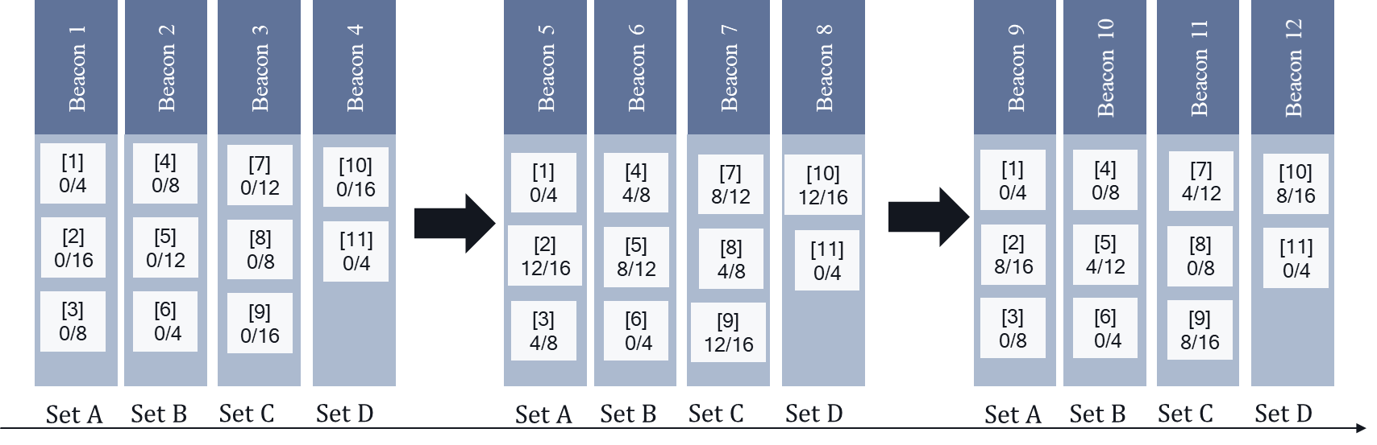

Figure AA-1: Example of partial list of profiles with profile periodicity of 4

The next example considers the case where MaxBSSID Indicator (n) is set to 4 and there are 15 active nontransmitted BSSID in a multiple BSSID set. In this example, the AP’s Beacon frame is able to fit up to 6 nontransmitted BSSID profiles and therefore the profile periodicity for the set has a value equal to 3. Figure AA-2 shows the configuration for DTIM count and DTIM period of each BSSID in this set. A BSSID profile would be included every third Beacon frame. In addition, since the DTIM interval is a multiple of profile periodicity, it would appear in the DTIM beacon of each profile.

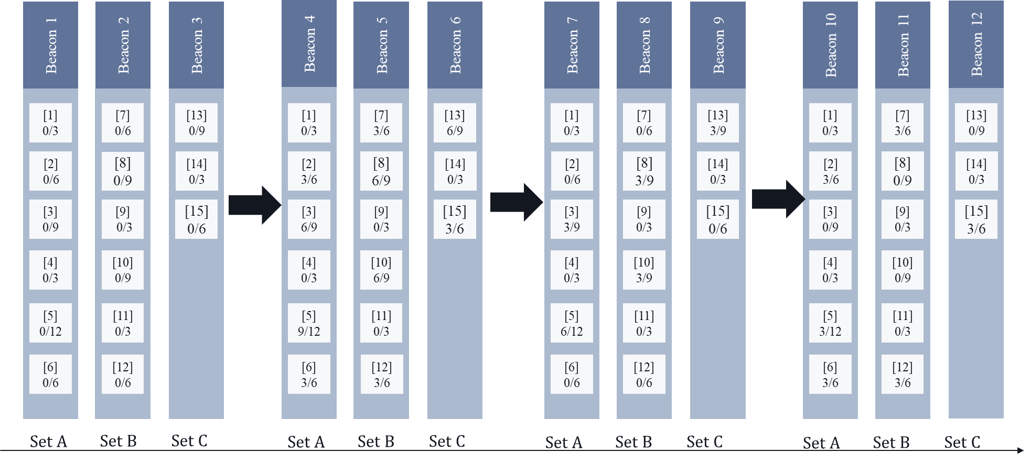

Figure AA-2: Example of partial list of profiles with profile periodicity of 3

The next example considers the case where a BSSID is deactivated. In this case, there are 15 nontransmitted BSSIDs that are active and one of the BSSID in set B (BSSID-Index=10 with DTIM period=9) is turned off at some point. Figure AA-3 illustrates this case. Once deactivated, this BSSID is no longer included in the Beacon frame. No other BSSIDs in set B or other sets are affected.

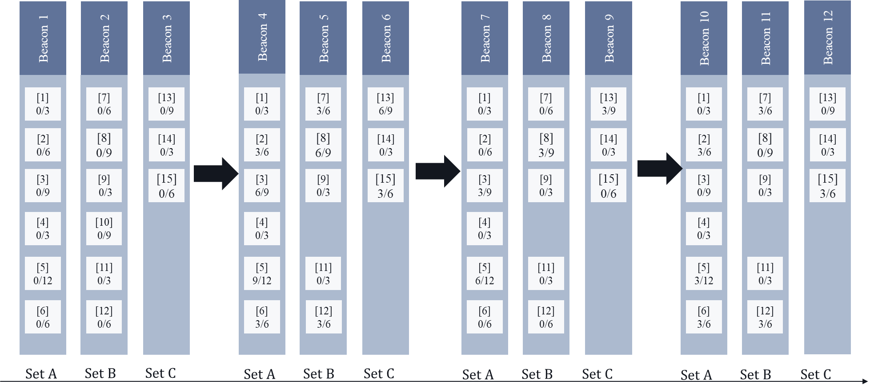

Figure AA-3: Example of a BSSID being deactivated

The next example considers the case where a BSSID that was not active earlier is activated. In this case, there are 14 nontransmitted BSSIDs that are active and a new BSSID (BSSID-Index=15 with DTIM period=6) is activated at some point. The AP is able to fit it as part of set C. Figure AA-4 illustrates this case. This BSSID is included in the next set of beacons and is advertised as part of set C. When the BSSID is included in a Beacon frame for the first time, it is started with DTIM count set to 0. With the DTIM Period being a multiple of profile periodicity, the AP can ensure that the profile appears in its DTIM beacon.

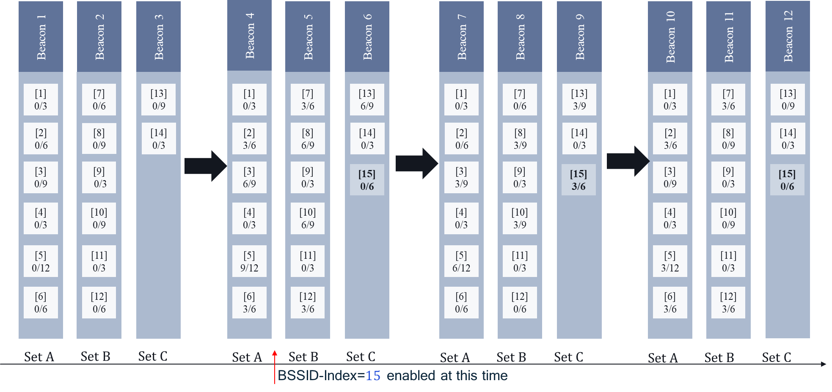

Figure AA-4: Example of a BSSID being activated

The next example considers the case where the DTIM period for a BSSID is updated. In this case, the DTIM period for a BSSID (BSSID-Index=12) is changed from 6 to 15. This change would be indicated during a DTIM beacon for that profile. This will ensure that STAs associated with that profile are able to receive the update. After the change, when the BSSID is included in a Beacon frame for the first time, it starts with DTIM count set to 0. With the new DTIM period (of 15) being a multiple of profile periodicity (of 3), the profile will appear in its DTIM beacon. Figure AA-5 shows the configuration for DTIM count and DTIM period of each BSSID in this set.

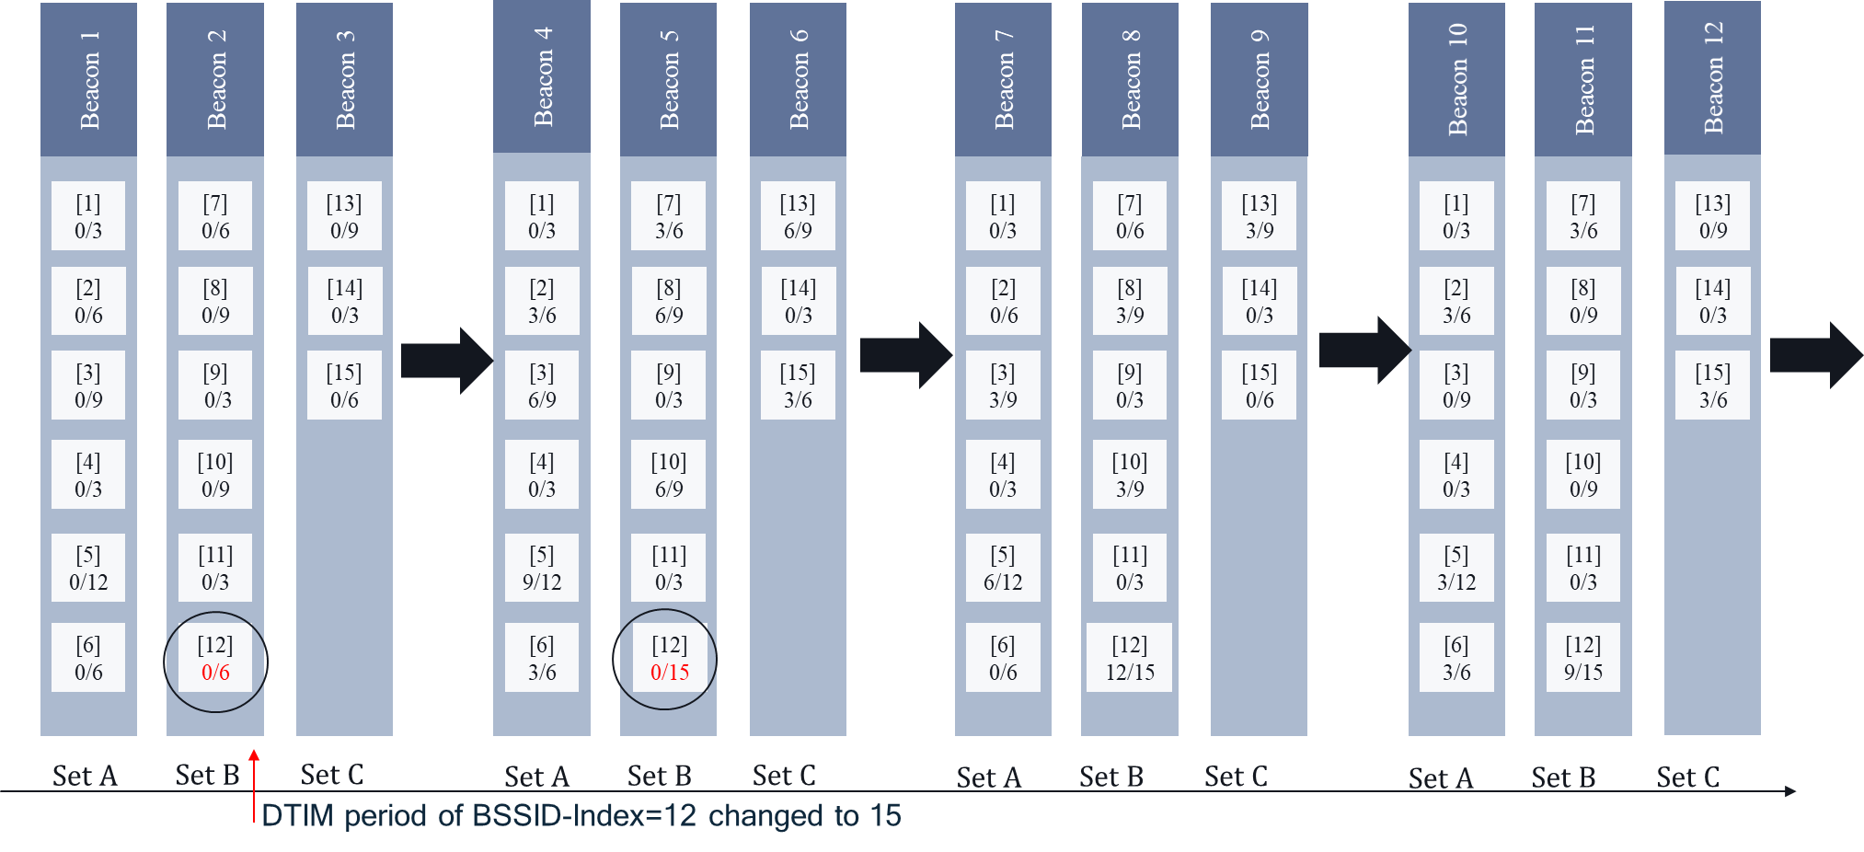

Figure AA-5: Example of DTIM period being changed for a particular BSSID

**Discussion:**

There are several instances in the spec which say a STA is associated with a (Tx or nonTx) BSSID. However, a STA associates with an AP. Therefore, these need to be fixed.

TGax editor, please replace all occurrence of ‘associated with a nontransmitted BSSID’ with ‘associated with an AP corresponding to a nontransmitted BSSID in 11ax D6.1 (13 occurrences): P322L13, P333L44, P341L35, P346L46, P349L29, P349L34, P358L38, P363L50, P371L19, P371L32, P384L12, P395L15, P443L55

TGax editor, please replace ‘associated to a nontransmitted BSSID’ with ‘associated with an AP corresponding to a nontransmitted BSSID on P387L32 in 11ax D6.1.

TGax editor, please replace ‘associated to a transmitted or nontransmitted BSSID’ with ‘associated with an AP corresponding to a transmitted or nontransmitted BSSID on P295L7 in D6.1

TGax editor, please replace all occurrence of ‘associated with the BSSID’ with ‘associated with an AP corresponding to the BSSID on P371L17 in 11ax D6.1

**SP ran during 3/19/20 telco**

**Do you agree to the resolutions provided in doc 11-20/315r1 for the following CIDs: 24545, 24055, 24108, 24469, 24115, 24109, 24110, 24111, 24039, 24112, 24113?**

**Y/N/A: 15/1/1**