IEEE P802.11
Wireless LANs
Suggested resolution to mesh comment

Date: 2020-02-04
Author(s):
Name | Company | Address | Phone | email
Kazuyuki Sakoda | Sony |  |  | Kazuyuki.Sakoda (at) sony (dot) com

Abstract

This submission brings discussion and/or suggested resolution to CID 4425.

The CIDs are in reference to Comment database on Draft IEEE 802.11md/D3.0.

Comment:

CID | PP.LL | Comment | Proposed Change
4425 | 2801.00 | It is not clear what a "standard size" is. Also there is duplication for ef | In the referenced subclause delete "standard " in "standard size" (2x), delete "for a (#1556)nominal frame containing a frame body of  size Bt" and change "It represents the estimated data rate" to "It is the estimated data rate"

Discussion:

D3.0 reads:
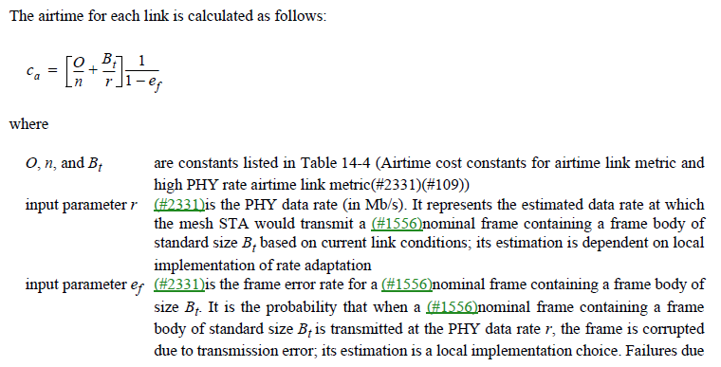

- It is true that “standard size” is not defined properly. Remove “standard” as suggested.
- r and e_{f} are reference values to guide how the airtime link metric should be calculated. Indeed, how to measure these values are implementation dependent. It is better to keep on using the term “nominal frame containing a frame body of size B_{t}”
- The description of the “input parameter r” and “input parameter e_{f}” can be improved.

Proposed resolution: Revise

Change the description on “input parameter r” and “input parameter e_{f}” as follows in 14.9.2 (Airtime link metric and high PHY rate airtime link metric):

input parameter r is the estimated PHY data rate (in Mb/s) at which the mesh STA would transmit a nominal frame containing a frame body of size B_{t} based on current link conditions; its estimation is dependent on local implementation of rate adaptation
input parameter e_{f} is the estimated frame error rate. It is the probability that when a nominal frame containing a frame body of size B_{t} is transmitted at the PHY data rate r, the frame is corrupted; its estimation is a local implementation choice. Failures due to exceeding Mesh TTL should not be included in this estimate as they are not correlated with link performance

Reference:

[1] Draft P802.11REVmd_D3.0.
[2] 11-19/2156r3 “REVmd Sponsor Ballot Comments”

