IEEE P802.11
Wireless LANs
Resolutions to S1G PHY
Date: 2020-02-14
Author(s):
Name | Affiliation | Address | Phone | email
Yujin Noh | Newracom |  |  | yujin.noh at newracom.com
Abstract
This submission shows
- Resolutions for comments from REVmd draft 3.0
- 5 CIDs: 4137, 4142, 4236, 4405 and 4452

Revisions:
- Rev 0: Initial version of the document.
- Rev 1: texts updated based on the teleconference call on Feb 14.

CID | P.L | Comment | Proposed Change | Resolution
4137 | 3370.6 | Why is bit 0 of the SIG-1 symbol of the short preamble reserved and set to 1 rather than 0? Is it reserved for future use or is it reserved for some other reason? If it will always be the value 1 then we can use it to further verify the short preamble signal field, which is protected by a weak CRC4. | Add a note saying why b0 of the S1G-1 symbol of the short preamble is reserved. | Rejected.  To be specific, the Reserved SIG Indication is used as one of criteria in PHY receive procedure whether the PHY shall issue the error condition PHY-RXEND.indication(FormatViolation) in different amendments (e.g. 11ac, 11ah and 11ax) when its reserved bit set to 0.  However, not to add the note -  a proposed note is not necessary because 1) weak CRC4 is not a technical approach 2) when CRC8 is supported in 11ac, reserved bits are set to 1.

Discussion
At P3434, highlighted texts can be refered

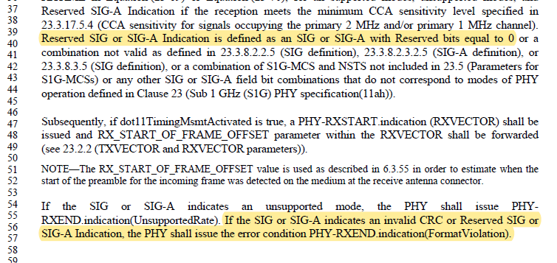

CID | P.L | Comment | Proposed Change | Resolution
4142 | 3406.7 | Equation 23-64, which specifies the 2 MHz duplicate data field, references (N-1) x 1 MHz subchannels. I assume it should be (N-1) x 2 MHz subchannels. The error appears to be in the equation. The definition of the variables below the equation references 2 MHz subchannels. There also seems to be a stray % sign in the equation which might supposed to be a bar. Some other equations may be similarly affected. | Review and correct equation 23-64 if necessary | Revised.  N_{1MHz} in Equation (23-64) needs to be replaced with N_{2MHz}. N_{2MHz} is the number of 2 MHz subchannels that are contained within the whole bandwidth of the current PPDU.  Typo %s are shown in several equations. It should be ~ such as $\tilde{D}.$  The equations to be updated are below.  Equation (23-55), (23-56), (23-57), (23-59), (23-62) and (23-64).  As for Equatoin (23-59), there are two %s.  TGm Editor: make changes according the direction above.

Discussion

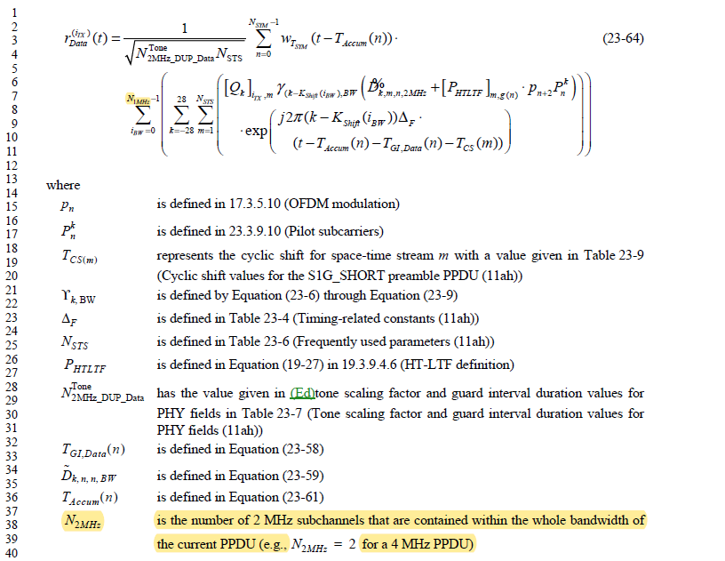

CID | P.L | Comment | Proposed Change | Resolution
4236 | 3528.41 | "If the channel bandwidth is 1080 MHz, the modulated SIG symbols are transmitted using duplication style as described in 25.3.10 (Duplication transmission on a 1080 MHz channel)." -- itself duplicates 25.6.5.3 | Delete the cited text | Accepted.

Discussion

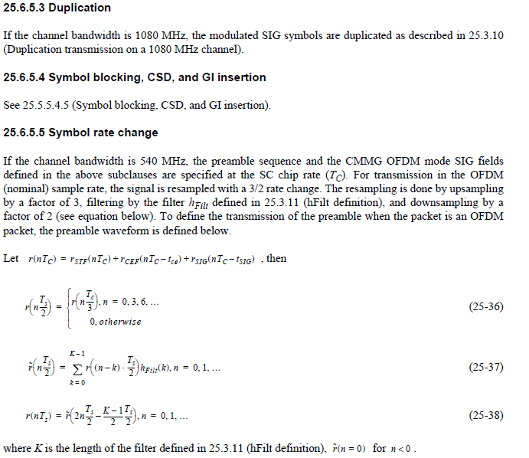

If the channel bandwidth is 1080 MHz, the modulated SIG symbols are transmitted using duplication style
as described in 25.3.10 (Duplication transmission on a 1080 MHz channel).

------------- End Text Changes ------------------

CID | P.L | Comment | Proposed Change | Resolution
4405 | 3371.1 | Table 23-11--Fields in the SIG field of short preamble numbers each bit within a symbol starting from 0, but Table 23-18--Fields in the SIG field of S1G_1M PPDU numbers the bits from 0 in the first symbol and doesn't reset to 0 for each symbol | Since 9.9.1 counts without resetting, add 13 to each of the bit numbers shown in the second column of Table 23-11--Fields in the SIG field of short preamble for the SIG-2 row | Rejected.  HT-SIG field, VHT-SIG field, HE-SIG field consist of two SIG symbols with resetting. (e.g. starting B0 in the 2nd SIG symbol).  SIG field in S1G_1M PPDU is only one exception because one symbol contains only 6 bits (not 24 or 26 bits). Since Length field is 9 bits, it would be better to keep counting without resetting.  The exception for SIG_1M PPDU is described at the beginning of clause 23.3.8.3.5 (SIG definition)

Discussion

Table 23-11 shows Fields in the SIG field of sholrt preamble below
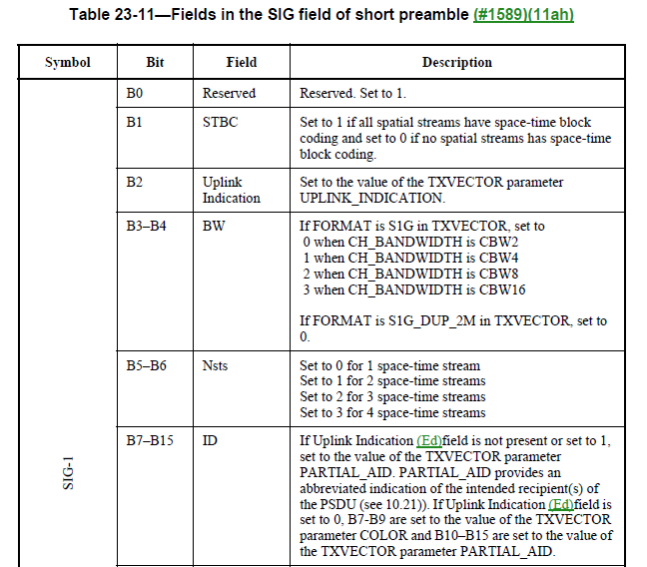
…
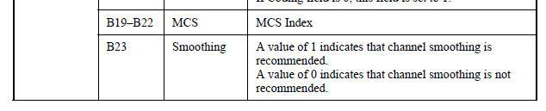
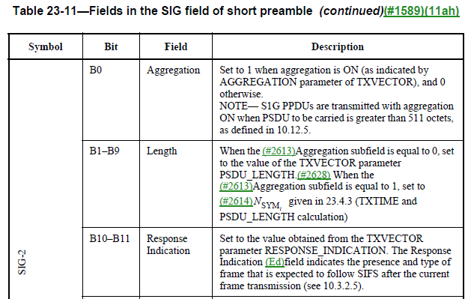
…

Table 23-18 shows Fields in the SIG field of S1G_1M PPDU below
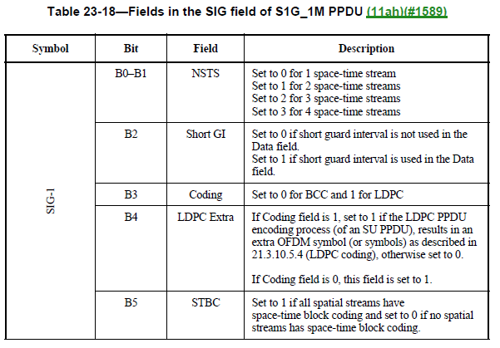
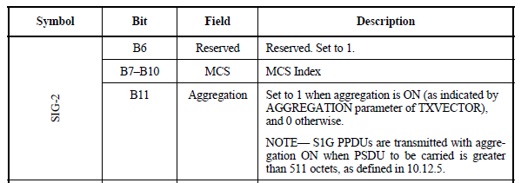
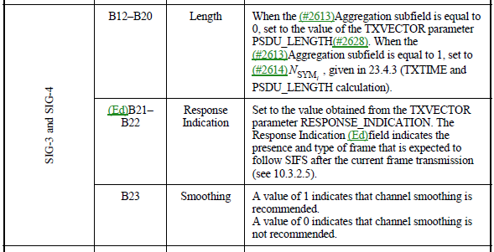
…

CID | P.L | Comment | Proposed Change | Resolution
4452 |  | Should not refer to TXVECTOR in SIG descriptions, since what matters is what is signalled, not how the signalling was achieved | In Table 21-12--Fields in the VHT-SIG-A field delete "Set to the value of the TXVECTOR parameter GROUP_ID.", "Set to the value of the TXVECTOR  parameter PARTIAL_AID" (also delete in 22.3.8.3.3 TVHT-SIG-A definition). In Table 23-11--Fields in the SIG field of short preamble and Table 23-13--Fields in the SIG-A field of S1G_LONG preamble SU PPDU and Table 23-18--Fields in the SIG field of S1G_1M PPDU and Table 25-7--Fields in the CMMG SIG field change "Set to the value of the TXVECTOR parameter  UPLINK_INDICATION." to "Set to 1 for uplink and to 0 otherwise." and delete "set to the value of the TXVECTOR parameter  PARTIAL_AID" and change "B7-B9 are set to the value of the TXVECTOR  parameter COLOR and B10-B15 are set to the value of  the TXVECTOR parameter PARTIAL_AID." to "B7-B9 are the BSS color and B10-B15 are the partial AID." and " the value of the TXVECTOR parameter  PSDU_LENGTH" to " the PSDU length" | Revised.  TGm Editor: make changes according to this document 11-20-0244-00-00m Resolutions to S1G PHY

To TGm Editor: P3190L10 update the description in the Table 21-12 below.
------------- Begin Text Changes ---------------

Two parts of  VHT-SIG-A | Bit | Field | Description
VHT-SIG-A1
 | B4-B9 | Group ID | Set to the value of the TXVECTOR parameter GROUP_ID.  A value of 0 or 63 indicates a VHT SU PPDU; otherwise,  indicates a VHT MU PPDU.i  (See TXVECTOR parameter GROUP_ID.)
 | B10-B21 | NSTS/Partial  AID | …  B13-B21  Partial AID: Set to the value of the TXVECTOR parameter PARTIAL_AID. Partial AID provides an abbreviated indication of the intended recipient(s) of the PSDU.  (See TXVECTOR parameter PARTIAL_AID and 10.19 (Group ID and partial AID in VHT and CMMG(11aj) PPDUs)).

------------- End Text Changes ------------------

To TGm Editor: P3370L02 update the description in the Table 23-11 below.
------------- Begin Text Changes ---------------

Two parts of  VHT-SIG-A | Bit | Field | Description
SIG-1
 | B2 | Uplink  Indication | Set to 1 if the PPDU is addressed to an AP. Set to 0 otherwise.  Set to (See TXVECTOR parameter UPLINK_INDICATION.)
 | B7–B15 | ID | If Uplink Indication (Ed)field is not present or set to 1,  set to the value of the TXVECTOR parameter PARTIAL_AID. PARTIAL_AID B7-B15 are the partial AID to provides an abbreviated indication of the intended recipient(s) of the PSDU (see 10.21)). If Uplink Indication field is set to 0, B7-B9 are an identifier of the BSS set to the value of the TXVECTOR parameter COLOR and B10–B15 are the Partial AID set to the value of the TXVECTOR parameter PARTIAL_AID.  (See TXVECTOR parameter COLOR and TXVECTOR parameter PARTIAL_AID.)
SIG-2
 | B1–B9 | Length | When the Aggregation subfield is equal to 0, set to the number of octets in the PSDUvalue of the TXVECTOR parameter PSDU_LENGTH. When the Aggregation subfield is equal to 1, set to N_{SYM}, given in 23.4.3 (TXTIME and PSDU_LENGTH calculation)  (See TXVECTOR parameter PSDU_LENGTH.)

------------- End Text Changes ------------------

To TGm Editor: P3377L02 update the description in the Table 23-13 below.
------------- Begin Text Changes ---------------

Symbol | Bit | Field | Description
SIG-A1
 | B2 | Uplink  Indication | Set to 1 if the PPDU is addressed to an AP. Set to 0 otherwise.  Set to (See TXVECTOR parameter UPLINK_INDICATION.)
 | B7–B15 | ID | If Uplink Indication field is not present or set to 1,  set to the value of the TXVECTOR parameter PARTIAL_AID. PARTIAL_AID B7-B15 are the partial AID to provides an abbreviated indication of the intended recipient(s) of the PSDU (see 10.21)). If Uplink Indication field is set to 0, B7-B9 are an identifier of the BSS set to the value of the TXVECTOR parameter COLOR and B10–B15 are the Partial AID set to the value of the TXVECTOR parameter PARTIAL_AID.  (See TXVECTOR parameter COLOR and TXVECTOR parameter PARTIAL_AID.)
SIG-A2
 | B1–B9 | Length | When the Aggregation subfield is equal to 0, set to the number of octets in the PSDUvalue of the TXVECTOR parameter PSDU_LENGTH. When the Aggregation subfield is equal to 1, set to N_{SYM}, given in 23.4.3 (TXTIME and PSDU_LENGTH calculation)  (See TXVECTOR parameter PSDU_LENGTH.)

------------- End Text Changes ------------------

To TGm Editor: P3391L02 update the description in the Table 23-18 below.
------------- Begin Text Changes ---------------

Symbol | Bit | Field | Description
SIG-3 and SIG-4
 | B12–B20 | Length | When the Aggregation subfield is equal to 0, set to the number of octets in the PSDUvalue of the TXVECTOR parameter PSDU_LENGTH. When the Aggregation subfield is equal to 1, set to N_{SYM}, given in 23.4.3 (TXTIME and PSDU_LENGTH calculation)  (See TXVECTOR parameter PSDU_LENGTH.)

------------- End Text Changes ------------------

To TGm Editor: P3504L06 update the description in the Table 25-7 below.
------------- Begin Text Changes ---------------

Bit | Field | Number of bits | Description
B8 | Uplink  Indication | 1 | Set to 1 if the PPDU is addressed to an AP. Set to 0 otherwise.  Set to (See TXVECTOR parameter UPLINK_INDICATION.)
B9–B17 | PAID | 9 | If Uplink Indication (Ed)field is not present or set to 1,  set to the value of the TXVECTOR parameter PARTIAL_AID. PARTIAL_AID B9-B17 are the partial AID to provides an abbreviated indication of the intended recipient(s) of the PSDU (see 10.19 (Group ID and partial AID in VHT and CMMG(11aj) PPDUs)). If Uplink Indication field is set to 0, B9-B11 are an identifier of the BSS set to the value of the TXVECTOR parameter COLOR and B12–B17 are the Partial AID set to the value of the TXVECTOR parameter PARTIAL_AID.  (See TXVECTOR parameter COLOR and TXVECTOR parameter PARTIAL_AID.)

------------- End Text Changes ------------------

