IEEE P802.11
Wireless LANs
Assorted CRs on REVmd draft 3.0
Date: January 16, 2020
Author(s):
Name | Affiliation | Address | Phone | email
Menzo Wentink | Qualcomm | Utrecht, The Netherlands | +31-65-183-6231 | mwentink  @qti.qualcomm.com

Abstract
This document contains assorted comment resolutions for REVmd draft 3.0, addressing the following CIDs:

- 4001, 4002, 4004, 4041, 4042, 4043, 4044, 4051, 4137,
- 4143, 4144, 4148, 4149, 4150, 4151, 4152, 4153, 4168,
- 4264, 4270, 4271, 4289, 4291, 4294, 4315, 4326, 4436,
- 4437, 4438, 4439, 4495, 4573, 4574, 4582, 4584, 4649,
- 4699, 4703, 4717, 4718, 4719, 4720, 4725, 4729, 4730,
- 4743, 4750, 4754, 4756, 4761, 4762, 4763, 4764, 4811

The baseline for this document is Draft P802.11REVmd D3.0.

CID Identifiers | Comment | Proposed Change | Proposed Resolution
CID 4001  11.1.3.2  2148.2148  Myles, Andrew | There has been discussion in the Coexistence SC as to whether the IEEE 802.11 WG should support the proposal in ETSI BRAN to further constrain the use of "short LBT" (like a PIFS) for short control signalling.  When this proposal was made, it was believed that this would mainly affect the transmission of DRS (like a Beacon) by NR-U. Simulations seemed to show that use of "short LBT" for DRS by NR-U would have an unreasonable adverse affect on 802.11 systems.  However, there was resistance to supporting the proposal from some 802.11 stakeholders, for reasons that the stakeholders did not want to discuss. It turns out that at least two 802.11 chip vendors often use PIFS without any backoff for the transmisison of Beasons. At least one 802.11 chip vendor mostly/always does not.  The problem is that the 802.11 standard does not appear to support the transmission of Beacons at PIFS by these vendors. Instead, the 802.11 standard specifies (11.1.3.2) that Beacons are sent "using the the medium access rules specified in Clause 10", ie DCF or EDCA (HCCA does not seem to apply given the APs in question are not acting as HCs, and even HCs can old send a Beacon at PIFS when starting a CFP). Other clauses in 802.11 suggest that Beacons should be sent using EDCA at AC-VO. Noting that an AP can use an AIFS of 1, this means that Beacons can be sent at PIFS at least sometimes, but this is only because the random backoff is sometimes 0. | My personal view is that vendors should not be sending Beacons (or any other frame) at PIFS without a backoff, because doing so is known to cause harm to the overall system. However, I will defer to the majority view on this question at this time. That said, if it is desired that Beacons can be sent at PIFS without any backoff then it should be explicitly allowed by the 802.11 standard, so that all implementers are aware of the possibility.  There are multiple locations in the 802.11 standard where this could be specified. I will leave it to the experts in 802.11 TGmd to determine the most appropriate location for this change, and therefore it most appropriate form. If desired by the BRC, I am willing to provide explicit text.. | Discission required  - Mark Rison points out that an AP is an HC and therefore can send beacons at PIFS  - Sean Coffey adds that vendors can implement proprietary improvements, which may be difficult to stop  - Sean Coffey asks whether there have been any negative effects reported in the 15 years that this has been in the standard  - Dorothy summarizes that the standard may be ambiguous on this point  - Dorothy requests that related text is summarized and revisited in a subsequent session, Andrew volunteers

CID 4002  9.4.2.3  992.60  Hiertz, Guido | Clarify that the total number of entries in the Supported Rates Element must not exceed eight. We are seeing implementations in the field that put nine entries into this element (bit rates 6 Mb/s ... 54 Mb/s plus a membership selector), and the first sentence of this clause may be read in a way that this is legitimate. | Replace  "The Supported Rates and BSS Membership Selectors element specifies up to eight rates in the OperationalRateSet parameter, as described in the MLME-JOIN.request and MLME-START.request primitives, and zero or more BSS membership selectors. The Information field is encoded as 1 to 8 octets, where each octet describes a single supported rate or BSS membership selector (see Figure 9-147 (Supported Rates and BSS Membership Selectors element format))."  with  "The Supported Rates and BSS Membership Selectors element specifies up to eight BSS membership selectors or rates in the OperationalRateSet parameter, as described in the MLME-JOIN.request and MLME-START.request primitives. The total number of Supported Rates and BSS Membership Selectors does not exceed eight. The Information field is encoded as 1 to 8 octets, where each octet describes a single supported rate or BSS membership selector (see Figure 9-147 (Supported Rates and BSS Membership Selectors element format))." | Revised - 992.60 replace with the following:  The Supported Rates and BSS Membership Selectors element specifies any combination of up to eight BSS membership selectors and rates in the OperationalRateSet parameter, as described in the MLME-JOIN.request and MLME-START.request primitives.  The Information field is encoded as 1 to 8 octets, where each octet describes a single supported rate or BSS membership selector (see Figure 9-147 (Supported Rates and BSS Membership Selectors element format)).

CID 4004  9.4.2.28  1120.5  Hiertz, Guido | Submission 11-19/693 reveals that many 802.11 implementations apply TXOP Limits that exceed the limits defined in table 9-155. Furthermore, version 2.1.1 of Harmonized Standard (HS) EN 301 893 defines TXOP Limits that are larger than the once described in table 9-155. In the standard, align the TXOP Limits with the HS. | For PHYs in clause 17, 18, 19, and 21 define the TXOP Limits as follows: AC_BK = 6.0 ms, AC_BE = 6.0 ms, AC_VI = 4.0 ms, AC_VO = 2.0 ms | Table 9-155 specifies default EDCA parameters that will be included in the beacon and used by the STAs in the BSS. These values are not mandatory and also do not cover the EDCA parameters for the AP.  In addition to 6 ms, ETSI allows 8 and 10 ms for AC_BE.  Discussion required.  Rejected -- the group discussed the comment and is concerned with making the change. There was no technical evidence provided to support the change. Specific values may vary based on the specific regulatory domain. Document 11-13/14r1 provides the rationale for the current numbers, with the technical justification.

CID 4041  .  Adachi, Tomoko | ATIM is not useful at all and gives only harm to IBSS operation. | Delete ATIM operation throughout the draft. | ATIM is the frame transmitted intermittently by STAs in an IBSS, for purpose of IBSS power save. Most of the related text is in 11.2.4 (Power management in an IBSS).  But ATIM is also used in DMG, described in 11.2.7.4 (ATIM frame usage for power management of non-AP STAs), which is part of 11.2.7 Power management in a PBSS and DMG infrastructure BSS.  Given that the comment only cites IBSS operation, it is assumed that it is not related to ATIM operation in DMG.  It is not specified what harm there is to IBSS operation.  Given that deleting ATIM for IBSS may impact ATIM for DMG, this deletion may not be trivial.  Rejected -- the comment does not identify a technical issue in sufficient detail.

CID 4042  9.3.1.9  .  Adachi, Tomoko | It's likely that the Control Wrapper frame is not used after all. | Delete the Control Wrapper frame throughout the draft. | The Control Wrapper frame is used to wrap a Control frame  together with an HT Control field.  In total, there are 24 occurrences of Control Wrapper in the spec, mainly in  9.3.1.9 (Control Wrapper frame)  10.9 (Control Wrapper operation)  A deletion seems to be relatively straightforward.  Rejected -- The comment does not identify a technical issue in sufficient detail. There is not sufficient evidence that Control Wrapper is indeed not used. (Stock reject will be used.)

CID 4043  10.3.7  1768.31  Adachi, Tomoko | The behaviour according to dot11DynamicEIFSActivated is true will be obsolete other than when the MPDU contained therein is 14 or 32 octets.  HE PPDU has TXOP_DURATION and if it has a valid value, then it will not cause EIFS. When the TXOP_DURATION is set to UNSPECIFIED, then eq. (10-7) will be applied anyway. So, Table 10-8 will never be updated from 802.11ax. And BlockAck frame length will no further be limited to 32 octets from 802.11ax, as HE STAs use Multi-STA BlockAck and Compressed BlockAck with variable length. | Revert to the original EIFS description by deleting dot11DynamicEIFSActivated MIB variable and its related descriptions.  Or, delete Table 10-8, eq. (10-8) and descriptions according to when dot11DynamicEIFSActivated is set to true except the paragraph starting with  "When dot11DynamicEIFSActivated is true and the PPDU that causes the EIFS contains a single MPDU with a length equal to 14 or 32 octets, ...".  Add  "When dot11DynamicEIFSActivated is true, if the PPDU that causes the EIFS does not contain a single MPDU with a length equal to 14 or 32 octets, then EIFS is determined as shown in Equation (10-7)."  at the end of that paragraph. | Dynamic EIFS allows to reduce the EIFS time based on a presumed duration of the response frame to the frame causing the EIFS, and to start no EIFS after what looks like a response frame. Not reducing the EIFS time has been shown to cause potential capture effects.  New PHYs may make dynamic EIFS less effective in certain situations, but there may still be benefits. The change proposed by the commenter may not work because the presence or absence of a response or the length of a presumed response cannot (easily) be determined from the PHY header.  Proposed resolution: reject.

CID 4044  10.3.2.3.2  1728.  Adachi, Tomoko | RIFS is not used by VHT, S1G, and HE STAs. There's no chance to use it also in further amendements. | Delete RIFS throughout the draft. | Rejected - RIFS is supported in products and should not be removed for this reason. RIFS is marked as obsolete for non-DMG STAs.

CID 4051  9.4.2.20.11  1034.50  Qi, Emily | dot11LongRetryLimit is depreciated, see 4152.5. The use of dot11LongRetryLimit should be removed. | Remove  "or dot11LongRetryLimit"  at 1034.50, 1034.57, 1076.41, 1076.46, 4000.38, 4000.53.  At 1759.37, remove  "when SLRC reaches dot11LongRetryLimit,".  At 1763.65, remove  "or until the LRC for the MPDU with the Type subfield equal to Data or Management is equal to dot11LongRetryLimit." | Proposed resolution -- Revised  Remove  "or dot11LongRetryLimit"  at 1034.50, 1034.57, 4000.38, 4000.53.  Remove  "or dot11LongRetryLimit (as appropriate)"  at 1076.41, 1076.46  At 1759.37, remove  "when SLRC reaches dot11LongRetryLimit,".  At 1763.65, remove  "or until the LRC for the MPDU with the Type subfield equal to Data or Management is equal to dot11LongRetryLimit."  At 4163.8, 4166.46, 4181.45 change  "either the dot11ShortRetryLimit or dot11LongRetryLimit" to "the dot11ShortRetryLimit".

CID 4137  23.3.8.2.2.5  3370.6  Goodall, David | Why is bit 0 of the SIG-1 symbol of the short preamble reserved and set to 1 rather than 0? Is it reserved for future use or is it reserved for some other reason? If it will always be the value 1 then we can use it to further verify the short preamble signal field, which is protected by a weak CRC4. | Add a note saying why b0 of the S1G-1 symbol of the short preamble is reserved. | Response from Eugene Baik (Qualcomm):  "There was a desire to keep the bitmaps and generation steps of the long and short preamble SIG/SIG-A fields in Sub-1GHz similar whenever possible, which is why the CRC is 4-bits across the preamble types and why B0 of the short preamble SIG is reserved.  The commenter is correct in pointing out that a 4-bit CRC is pretty weak, but it was kept at 4-bits for the short preamble SIG because the long preamble SIG-A payload couldn’t accommodate a longer CRC. There was a desire to keep the CRC generation between the long and short preamble SIGs (for 2MHz and above BWs) the same (i.e. didn’t want separate generation hardware).  Bit 0 of the long preamble SIG-A is used for indicating whether the PPDU is MU or SU. The short preamble SIG doesn’t need that field because it’s always SU, but in an effort to keep the bitmap ordering between short and long preamble SIGs similar (to potentially simplify the parsing out of the fields of the SIG/SIG-A payload at the receiver), the decision was to make B0 of the short SIG payload unused and hence reserved. I don’t remember why ‘1’ was chosen instead of ‘0’, but I think in general for reserved fields a value is specified."  Therefore, it appears like bit 0 can indeed be used in addition to the CRC4 to check whether the SIG is correct.  Proposed resolution:  Revised -- agree with the comment.  At 3372.63 add  "NOTE -- The Extra Check Bit subfield (B0) of the SIG field of S1G format PPDUs sent with a short preamble is always 1 and can be used in addition to the CRC field to verify that the SIG field is correct."  At 3369.14 change  "Reserved" to "Extra Check Bit"  At 3370.6 change the Field entry to "Extra Check Bit" and the Description entry to "Set to 1."

CID 4143  9.2.4.2  793.45  Goodall, David | Table 9-9 states that AID 0 is used for broadcast transmission in S1G PPDU. How is it used? Should that be PV1 frames rather than S1G PPDUs, in which case it would be used in the A1 field. | Please clarify use of AID 0 for broadcast transmission by S1G STAs, e.g. it's used as an address in a particular field. Change S1G PPDUs to PV1 frames if that is correct. | Submission required. Menzo working on it.

CID 4144  3.1  170.48  Aboulmagd, Osama | The IEEE 802.11e amendment added Traffic Category (TC), User Priority (UP), Traffic Stream (TS) and TSID. Among these four new additions Traffic Category seems to be redundant and can easily map to UP. TC seems to be an intermediate parameter that serves no purpose. It is also true that the term traffic category is not available in 802.1D which is the reference for the UP bits. In fact 802.1D makes use of the term "Traffic Classes" which is easier to understand that the vague Traffic Category term. | Delete Traffic Category from the draft and replace it with UP everywhere. | An MSDU can either have a relative priority referred to as Traffic Category (TC), or belong to a Traffic Stream (TS). The TC or TS is then mapped to a User Priority (UP), which is subsequently mapped to Access Category (AC), which is associated with an EDCAF.  TC and TS are also used for block ack signaling.  Therefore it appears that the extra level between UP and TC is required, essentially because there are also TSs on which an MSDU can be transmitted.  Proposed resolution: reject.  Osama is working on this.

9.4.1.13 Block Ack Parameter Set field

The TID subfield contains the TC or TS for which the BlockAck frame is being requested.

9.2.4.5.2 TID subfield

The TID subfield identifies the TC or TS to which the corresponding MSDU (or fragment thereof) or A-MSDU in the Frame Body field belongs. The TID subfield also identifies the TC or TS of traffic for which a TXOP is being requested, through the setting of TXOP duration requested or queue size. The encoding of the TID subfield depends on the access policy (see 9.4.2.29 (TSPEC element)) and is shown in Table 9-12 (TID subfield). Additional information on the interpretation of the contents of this field appears in 5.1.1.3 (Interpretation of priority parameter in MAC service primitives).

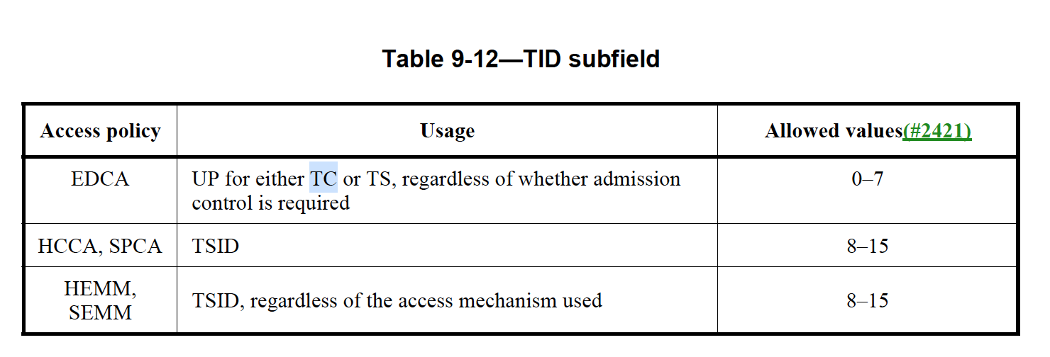

CID 4148  9.4.2.26  1114.31  Aboulmagd, Osama | What is Alternate EDCA? Is it another EDCA for medium access? Why it hasn't been defined as EDCA in Clause 3? The fact is there is only one EDCA and the term "Alternate EDCA" is probably a bad name for a bad design. | I believe the term "Alternate EDCA" should be deleted and replaced with something else, if necessary. | The term alternate EDCA refers to an alternate EDCA queue rather than the primary EDCA queue. It seems to be mostly used in reference to a queue in the spec. The only exception is where it talks about the Alternative EDCA capability.  Splitting between a primary queue and an alternate queue is possible because there are 8 UPs and only 4 ACs, so a mapping needs to take place where multiple UPs are mapped to a single AC, which makes it possible to have multiple separate queues on top of the AC.  Proposed resolution: reject.

CID 4149  10.2.3.2  1718.1  Aboulmagd, Osama | This comment is related to my previous comment. According to table 10-1 and the levels of priorities indicated in the table. Voice (alternate) is higher priority than Voice (prime) and Video (alternate) is lower priority than Video (prime). Since the words prime and alternate are not representative of any property in the queue architecture I suggest use "Higher Priority) and "Lower Priority" or other representative words. | As in comment

CID 4150  10.23.2.1  1827.1  Aboulmagd, Osama | Figure 10-25 does not add anything different from Figure 10-24 and needs to be deleted. Figure 10-25 still shows the four EDCAFs as in Figure 10-24. The only difference is in the addition of alternate queues (really different priority queues) which is insignificant difference and doesn't need to be depicted explicitly. How the queues and priorities are managed are implementation issues and Figure 10-24 is sufficient to show the main concepts. | Delete Figure 10-25 and any related description. | Rejected -- The figures are for reference implementations, and they are correct. Therefore it is fine to keep them in the spec. Having alternative queues is the whole point of Alternate EDCA, therefore Figure 10-25 is significant.

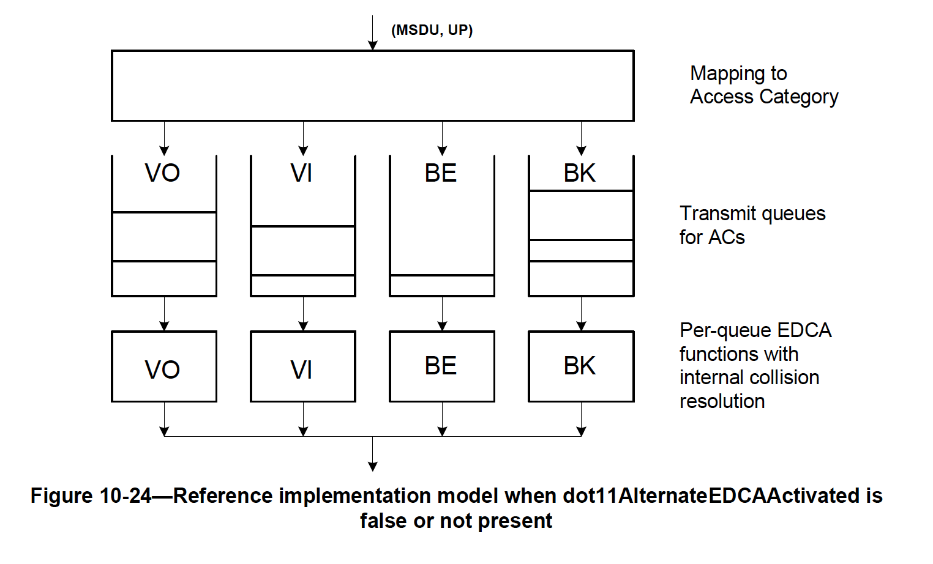

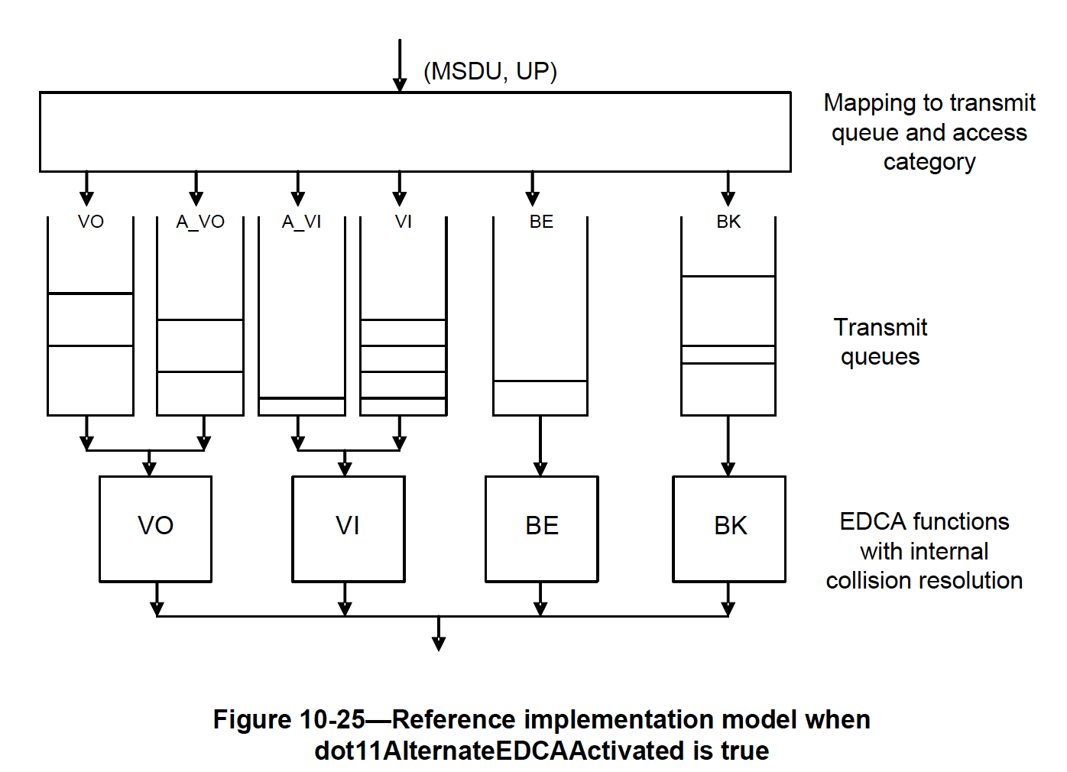

CID 4151  4394.1  Aboulmagd, Osama | Annex G is becoming obsolete and is very difficult to follow. The attribute table is totally arbitrary and doesn't follow any rules. It was written in the past by a single person and now is starting to diverge since many amendments are trying to modify the Annex. Additionally the sequences can better be followed in the corresponding Clauses which is easier to follow and perhaps more accurate. | Delete Annex G | Ok in principle to delete Annex G, but there are references to Annex G which need to be addressed also.  Proposed resolution: reject.

CID 4152  .  Aboulmagd, Osama | The draft is 4647 pages and is expected to get bigger. The group needs to think seriously what amendments are widely deployed and what amendments haven't seen deployment success, e.g. 802.11s, 802.11aa, 802.11z, 802.11ak just to mention a few. Those amendments may move to a different volume to make the main standard manageable. Few years ago there was an attempt to harmonize 802.11e with WMM and perhaps delete HCCA. I don't think the situation has changed since 2007 and maybe it makes sense now to look at HCCA and its acceptance. | Start with deleting HCCA and free valuable code points in the TID Subfield for use by other more important amendments.  Discuss and possible delete other amendments that have limited or no success in deployments. | 802.11s and 802.11z are used extensively in the field, for example in Google home networks (11s) and Chromcast (TDLS). 11ak was just published.  HCCA is used in video deployments.  Proposed resolution: reject.

CID 4153  9.3.1.8.1  833.23  Fischer, Matthew | It would be nice to have the ability to inform the transmitter of an AMPDU that missing acknowledgements for some MPDUs are not due to a poor MCS choice, but instead, to local interference that occurred during the AMPDU reception. An indication of such occurence should be signaled in the BA. | Add a mechanism in the BA frame to allow a recipient transmitting the BA to indicate to the originator that missing acknolwedgements within the BA frame are due to local interference or buffer constraints and not a poor MCS choice. | This proposal was discussed extensively in a prior phase of REVmd, and ultimately rejected.  Amongst the arguments for rejecting the comment was the proposed alternative of using an Action frame for the purpose of signaling a temporary limited connection (TLC), because  - an Action frame can convey additional information about the nature of the interference  - an Action frame can convey additional information about possible measures to take, like enable RTS/CTS, lower the MCS, shorten the transmissions, leave room in between, etc.  - an Action frame can inform whether a CTS will not be sent in case of interference  - there will be no BA when no data has been received, but a BA would have to be sent to provide any signaling  - A BA provides no specific feedback about whether any measures taken by the transmitter are successful, or too much, etc  Therefore, an action frame was considered to be a more versatile way of conveying interference mitigation.  Proposed resolution: reject.

CID 4168  10.3.4.4  1763.63  RISON, Mark | "Retries for failed transmission attempts shall continue until the SRC for the MPDU with the Type subfield equal to Data or Management is equal to dot11ShortRetryLimit or until the LRC for the MPDU with the Type subfield equal to Data or Management is equal to dot11LongRetryLimit. When either of these limits is reached, retry attempts shall cease, and the MPDU with the Type subfield Data (and any MSDU of which it is a part) or Management shall be discarded."  is missing the lifetime limit (cf. 10.23.2.12.1 for EDCA) | Change the cited text to  "Retries for failed transmission attempts shall continue until the SRC for the MPDU with the Type subfield equal to Data or Management is equal to dot11ShortRetryLimit or until the LRC for the MPDU with the Type subfield equal to Data or Management is equal to dot11LongRetryLimit, or until the transmit MSDU timer for the MSDU or any undelivered fragments of that MSDU exceeds dot11MaxTransmitMSDULifetime (see 10.4 MSDU and MMPDU fragmentation). When any of these limits is reached, retry attempts shall cease, and the MPDU with the Type subfield Data (and any MSDU of which it is a part) or Management shall be discarded." | Accepted.

CID 4264  10.3.1  1724.15  RISON, Mark | Having stuff in DCF clauses that applies to EDCA (especially stuff that cannot apply to DCF, e.g. stuff related to HT/VHT) is very confusing | Move EDCA-only stuff to EDCA clauses. Move stuff that is common to both DCF and EDCA to a common clause | It might make sense to delete DCF and move EDCA related parts to EDCA.  But this might be a significant effort.  Proposed resolution: reject.

CID 4270  .  RISON, Mark | Can TDLS be used between two STAs that are in different BSSes of an ESS (since tunnelled)? If not, what happens if a TDLS STA reassociates to a different AP? | As it says in the comment | The cited cases are addressed in TDLS as follows:  11.21 (Tunneled direct-link setup)  11.21.1 (General)  "To set up and maintain a direct link, both TDLS peer STAs shall be associated with the same infrastructure BSS."  11.21.5 (TDLS direct-link teardown)  "A TDLS Teardown frame with Reason Code LEAVING_NETWORK_DEAUTH shall be transmitted to all TDLS peer STAs (via the AP or via the direct path) prior to transmitting a Disassociation frame or a Deauthentication frame to the AP."  Proposed resolution: reject.

CID 4271  .  RISON, Mark | An AP needs 2 MIB tables for EDCA: one for itself and one for what it will signal to non-AP STAs. The former is dot11QAPEDCATable but the latter is not dot11EDCATable because this is defined as being set from an incoming EDCA Parameter Set element | Update dot11EDCATable so that at an AP it is used to define the EDCA parameters that are signalled to associated STAs | Submission required.

CID 4289  10.23.2.7  1834.11  RISON, Mark | "Frames from a higher priority AC may be included when at least one frame from the primary AC has been transmitted and all frames from the primary AC have been transmitted. [...] Frames from the primary AC shall be transmitted first."  -- is this desirable? Shouldn't higher-priority frames go out first (while meeting the restrictions on EDCA TXOP sharing)? As long as all the primary AC traffic is put in the first PPDU (otherwise it might not go out at all, if the first PPDU is not received), this doesn't impair fairness w.r.t. other STAs | Change the cited text to  "Frames from a higher priority AC may be included when at least one frame from the primary AC is transmitted in the first PPDU of the TXOP and all frames from the primary AC are transmitted in the first PPDU of the TXOP. [...]"  (delete the "Frames from the primary AC shall be transmitted first.") | Revised - agree with the comment.  1834.11 change to  "Frames from a higher priority AC may be included when at least one frame from the primary AC will be transmitted and all frames from the primary AC will have been transmitted."  1834.18 delete  "Frames from the primary AC shall be transmitted first."

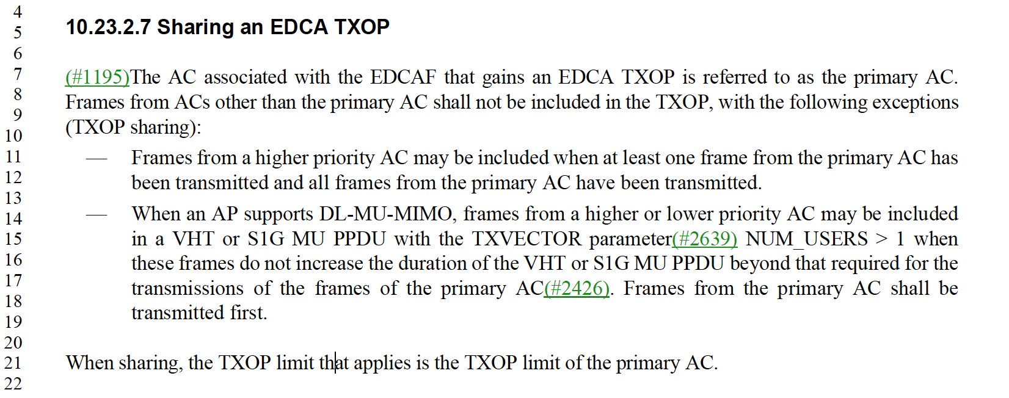

CID 4291  .  RISON, Mark | CID 2262 got rid of the PCF, but there are still lots of "+CF-Poll", "QoS CF-Poll", "CF-Ack", etc., which are only used under the PCF. There is also still a CF pollable definition and dot11QosCFPolls* MIB variables. These all need to go | As it says in the comment | Rejected - these items are related to HCCA, which was not deleted.

CID 4294  9.2.4.5.1  797.20  RISON, Mark | "QoS Data and QoS Data +CF-Ack frames sent by non-AP STAs that are not a TPU buffer STA or a TPU sleep STA in a nonmesh BSS" doesn't work or isn't clear, since a mesh STA is "not a TPU buffer STA or a TPU sleep STA in a nonmesh BSS" | Change to  "QoS Data and QoS Data +CF-Ack frames sent by nonmesh non-AP STAs that are not a TPU buffer STA or a TPU sleep STA". Change the next cell down to "QoS Null frames sent by nonmesh non-AP STAs that are not a TPU buffer STA or a TPU sleep STA" | Rejected - the limitation is to non-AP STAs in a nonmesh BSS, excluding TPU STAs.

CID 4315  .  RISON, Mark | PCF was deleted, but some some vestigial PCF-related references remain:  STAs in a non-DMG IBSS shall use information that is not in the CF Parameter Set element  f) Modification of the CF Parameter Set element  A mesh STA in a mesh BSS shall use information that is not in the CF Parameter Set element  The attribute describes the number of DTIM intervals between the start of CFPs.  The attribute describes the maximum duration of the CFP that may be generated by the PCF.  In a non-AP STA, it is written by the MAC when it receives an updated CF Parameter Set in a Beacon frame. [2x]  This attribute indicates the maximum amount of time that a point coordinator (PC) may control the usage of the wireless medium (WM) | As it says in the comment | Revised - agree with the comment. Make changes as shown in <this document>.

11.1.3.7 Beacon reception

2153.14 modify as shown.

STAs in a non-DMG IBSS shall use information in any received Beacon frame for which the IBSS subfield of the Capability field is 1, the content of the SSID element is equal to the SSID of the IBSS, and the TSF value is later than the receiving STA’s TSF timer. Use of this information is specified in 11.1.5 (Adjusting STA timers).

11.2.3.15 TIM Broadcast

2201.12 delete

f) Modification of the CF Parameter Set element

and renumber the remaining items accordingly.

14.13.3.2 Beacon reception for mesh STA

2851.30 modify as shown.

A mesh STA in a mesh BSS shall use the Timestamp field, the Beacon Interval field, the Beacon Timing element, the MCCAOP Advertisement Overview element, or the MCCAOP Advertisement element in received Beacon frames only if the mesh STA maintains a mesh peering with the transmitter of the Beacon frame.

"The attribute describes the number of DTIM intervals between the start of CFPs." -- this sentence is found in dot11CFPPeriod, which is marked as deprecated. No edit required.

" The attribute describes the maximum duration of the CFP that may be generated by the PCF." -- this sentence is found in dot11CFPMaxDuration, which is marked as deprecated. No edit required.

" In a non-AP STA, it is written by the MAC when it receives an updated CF Parameter Set in a Beacon frame. [2x]" -- these are found in dot11CFPPeriod and dot11CFPMaxDuration, both of which are marked as deprecated. No edit required.

" This attribute indicates the maximum amount of time that a point coordinator (PC) may control the usage of the wireless medium (WM)." -- I could not find this item.

CID 4326  12.6.18  2640.41  RISON, Mark | "NOTE 2---Because the IEEE 802.11 Null frame does not derive from an MA-NITDATA.request primitive, it is not protected."  -- the real reason is that there is nothing to protect. Some TDLS frames, for example, are not derived from MA-UNITDATA.requests, but are protected nonetheless. It's not clear what the point of this NOTE is anyway | Delete the cited text at the referenced location, and delete the " 1" immediately above | Accepted.

CID 4436  .  RISON, Mark | If we are keeping non-HT immediate block ack, we need to also cover HT-immediate block ack | Change 917.1 from  "The Block Ack Policy subfield is set to 1 for immediate block ack"  to  "The Block Ack Policy subfield is set to 1 for immediate or HT-immediate block ack".  At 1874.57 change  "There are two types of block ack mechanisms: immediate and (#2289)HT-delayed. Immediate block"  to  "There are three types of block ack mechanisms: immediate, HT-immediate and (#2289)HT-delayed. Immediate and HT-immediate block".  At 2266.55 change  "immediate"  to  "HT-immediate".  At 4404.22 change  "HT-delayed or immediate block ack policy"  to  "HT-delayed, HT-immediate or immediate block ack policy" | The changes look good to me, but are we indeed keeping non-HT immediate Block Ack?  Non-HT block ack is currently marked as obsolete.  Proposed resolution: reject.

CID 4437  11.5.2.2  2266.52  RISON, Mark | "examining its (#2289)Block Ack and Immediate Block Ack capability bits"  -- neither of these bits exists! | Change  "If the peer STA is a non-DMG STA, check whether the intended peer STA is capable of participating in the block ack mechanism by discovering and examining its (#2289)Block Ack and Immediate Block Ack capability bits. (11ah)If the peer STA is an S1G STA and the recipient is capable of participating in an immediate block ack(#1512) session"  to  "(11ah)If the peer STA is an S1G STA " | Accepted.

CID 4438  .  RISON, Mark | There are no implementations of HT-delayed BA. HT-delayed BA is not useful, as it impairs throughput. Note: hypothetical use of HT-delayed BA by amendments to 802.11-202x is not relevant to REVmd | Delete the HT-delayed BA feature | Discussion required.  HT-delayed BA was previsouly not deleted based on possible applicability in uni-directional links.  Proposed resolution: reject.

CID 4439  .  RISON, Mark | There are no implementations of HT-delayed BA. HT-delayed BA is not useful, as it impairs throughput. Note: hypothetical use of HT-delayed BA by amendments to 802.11-202x is not relevant to REVmd | Delete 10.25.7 HT-delayed block ack extensions | Discussion required.  HT-delayed BA was previsouly not deleted based on possible applicability in uni-directional links.  Proposed resolution: reject.

CID 4495  11.4.6  2783.63  RISON, Mark | The retryCounter is set to 0 or incremented, but not used for anything else (e.g. never compared against a limit) | At 2783.63 delete  "set the retryCounter to 0, and".  At 2784.46 delete  "and the retryCounter shall be incremented".  At 2785.63 delete  ", increment the retryCounter," | Accepted.

CID 4573  10.23.2.2  1828.22  RISON, Mark | In our discussion of CID 2359, why did we decide that if you backoff for reason e) you should double CW? Indeed, why backoff at all, if you've been using multiple protection? You've reserved the medium to TXNAV, so you might as well just try again after SIFS, if you want, no?  Using more than this, or at least more than PIFS, is just wasteful | Add a para  "If the transmission by the TXOP holder of an MPDU in a non-initial PPDU of a TXOP fails, as defined in this subclause, a STA may retransmit after SIFS and without invoking the backoff procedure if it used multiple protection and the retransmission does not cause TXNAV to be exceeded."  after e) | Item e allows a random backoff when no response is received to a non-initial transmissions in a TXOP (i.e. when an initial response was already received).  The note following item e addresses the two options that are available in this case (PIFS or backoff):  "NOTE—If the transmission by the TXOP holder of an MPDU in a non-initial PPDU of a TXOP failed, the STA can perform either a PIFS recovery, as described in 10.23.2.8 (Multiple frame transmission in an EDCA TXOP), perform a backoff as described in item e) above, or wait for the TXNAV timer to expire and invoke the backoff procedure per item b) above. How it chooses between these two is implementation dependent."  It seems fine to allow more than just a PIFS for recovery in this case. And when the interval is longer than PIFS, a random backoff appears the most obvious choice, in case there are areas where the protection did not come through.  But the case seems shallow.  Proposed resolution: reject.

CID 4574  10.23.2.2  1828.11  RISON, Mark | "The transmission of the MPDU in the final PPDU transmitted by the TXOP holder during the TXOP for that AC has completed" -- has a number of issues:  - what does "has completed" mean (just "has been put on the air, don't care about response if needs one"?)  - what is the "AC was a primary AC" about? Presumably this is the MPDU at the start of the sentence?  - so you start backoff immediately, even if you then transmit a secondary AC MPDU in the TXOP? Or you don't do backoff at all if the last MPDU you transmitted in the TXOP was a secondary AC MPDU?  - what does "the MPDU in the final PPDU" mean if there is more than one MPDU in the final PPDU?  - what if there isn't a TXNAV (i.e. multiple protection is not being used)?  - so if the TXNAV timer has not expired you need to wait until it does and then do backoff? (More plausible than "you don't do backoff at all if the TXNAV hadn't expired at the same time as the "completion" of the last transmission!) | As it says in the comment

CID 4582  .  RISON, Mark | The definition of dot11EDCATableMSDULifetime (and QAP version) needs to allow for A-MSDUs and MMPDUs, since those are/can be sent under a particular AC. Also similarly change 1763.63 in 10.3.4.4 and dot11MaxTransmitMSDU Lifetime in C.3 | As it says in the comment

CID 4584  3.2  199.52  RISON, Mark | Is there any such thing as "successful transmission" of RTS frames? The current definition does not allow for this (because it talks of acknowledgment/Ack frames) | Make the changes suggested after "Otherwise the following changes would be needed:" under CID 2418 in 19/0856

CID 4649  10.3  .  RISON, Mark | There is lots of duplication between 10.3.3 Random backoff time and 10.3.4.3 Backoff procedure for DCF | Merge the two subclauses | It might be worth considering removing DCF and moving relevant parts to EDCA. But this will be a substantial effort.  Discussion required.  Proposed resolution: reject.

CID 4699  .  RISON, Mark | "remaining TXOP duration" is not well-defined. Maybe it's just TXNAV? | As it says in the comment | Rejected - "remaining TXOP duration" is used in several locations, and the meaning seems clear. It is the time remaining in the TXOP.

CID 4703  .  RISON, Mark | There are some places that are poorly worded and suggest the EDCA Parameter Set element is not always provided at association in a QoS BSS | As it says in the comment | Rejected - the comment fails to identify a technical issue in sufficient detail.

CID 4717  10.23.2.7  1834.4  RISON, Mark | A figure is needed to illustrate higher-AC TXOP sharing with non-A-MPDUs, since there is considerable subtlety here | Copy Figure 10-27, keep the top unchanged except for making AC_BE the primary and only having one frame in it, and then show below a sequence where the following are under a "TXOP" arrow: the striped BE frame, an Ack frame, the spotty VO frame, an Ack frame, the lowest VI frame and an Ack frame. At the end of the referenced subclause add "An illustration of TXOP sharing with frames from a higher-priority AC is shown in Figure 10-xx." | Rejected - the comment fails to identify a technical issue in sufficient detail.

CID 4718  10.23.2.7  1834.4  RISON, Mark | A figure is needed to illustrate higher-AC TXOP sharing with A-MPDUs, since there is considerable subtlety here | Copy Figure 10-17, keep the top unchanged except for making AC_BE the primary, and then show below a PPDU containing the two AC_BE frames to STA-2 and then the AC_VO frame to STA-2, followed by BA, BAR and BA. At the end of the referenced subclause add "An illustration of TXOP sharing with A-MPDUs is shown in Figure 10-yy." | Rejected - the comment fails to identify a technical issue in sufficient detail.

CID 4719  .  RISON, Mark | CID 1505 followup. This got rid of QLRC and QSRC, because they were not clearly specified and not actually implemented, but did not touch LRC and SLRC and SRC and SSRC, which suffer from the same problem. Note: DCF is not deprecated | Delete "LRC" and "SLRC" and "SRC" and "SSRC" throughout | DCF was not cleaned up with respect to the retry counters because it is probably of little relevance in light of EDCA.  Maybe this should be taken up in a larger effort to remove DCF and move relevant parts to EDCA.  Discussion required.

CID 4720  .  RISON, Mark | CID 1505 follow-up. There are still references to short/long retry count(er) in 10.3.3:  "The SSRC shall be incremented when any short retry count (SRC)"  "The SLRC shall be incremented when any long retry count (LRC)"  and in 11.8.3  "The short retry counter and long retry counter for the MSDU or A-MSDU are not affected."  Also  "A STA shall maintain a SRC and an LRC for each MSDU or MMPDU awaiting transmission." "The SRC for an MPDU [...]. This SRC and the SSRC shall be reset when [...]. The LRC for an MPDU [...]. This LRC and the SLRC shall be reset when"  "Retries for failed transmission attempts shall continue until the SRC for the MPDU [...] or until the LRC for the MPDU [...]"  in 10.3.4.4.  Note: DCF is not deprecated | Delete all references to short/long retry count(er)s throughout | DCF was not cleaned up with respect to the retry counters because it is probably of little relevance in light of EDCA.  Maybe this should be taken up in a larger effort to remove DCF and move relevant parts to EDCA.  Discussion required.

CID 4725  10.3.4.4  .  RISON, Mark | We don't have unlucky packets, just unlucky connections. The next packet to a given peer is just as likely to fail as the previous given the same Tx vector. It makes sense to have a Tx lifetime per AC as delivering a late real-time packet is a worthless whereas best effort frames should be retried until the link times out, but for a given AC there's no point hitting a retry limit and then just moving on to the next packet to that AC+destination. [xxnj] | In 10.3.4.4 change  "Error recovery shall be attempted by retrying transmissions for frame exchange sequences that the initiating STA infers have failed. Retries shall continue, for each failing frame exchange sequence, until the transmission is successful, or until the relevant retry limit is reached, whichever occurs first."  to  "Error recovery shall be attempted by retrying transmissions for frame exchange sequences that the initiating STA infers have failed. Retries shall continue, for each failing frame exchange sequence, until the transmission is successful, or until the relevant lifetime is reached, whichever occurs first.".  In 10.24.2.12.1 delete from  "Retries for failed transmission attempts shall continue until one or more of the following conditions occurs:"  to  "When any of these limits is reached, retry attempts shall cease, and the MSDU, A-MSDU, or MMPDU shall be discarded."  inclusive | Rejected - the comment fails to identify a technical issue in sufficient detail. The proposed 10.3.4.4 change makes no change it seems.

CID 4729  12  .  RISON, Mark | WEP and TKIP should be removed from the standard | Delete 12.3.2 and 12.5.2 | Rejected -- WEP and TKIP are still in products and therefore should not be deleted from the spec at this point.

CID 4730  12  .  RISON, Mark | WEP and TKIP should be removed from the standard | As it says in the comment | Rejected -- WEP and TKIP are still in products and therefore should not be deleted from the spec at this point.

CID 4743  .  RISON, Mark | There are references to "physical carrier sense", "virtual carrier sense" and "physical CS" and "virtual CS" but the terms are never defined.  Use "CS" rather than "carrier sense" except when defined etc.  The terms PHYCS and PHYED are defined but barely used.  There is a zoo of inconsistent terminology for "carrier sense", whch makes it hard to understand exactly what is meant where and how the various PHYs compare: CS, CCA, CS/CCA, energy detect, ED, PHYED, CCA-ED, CCA Mode 1-5.  "CCA-ED" just confuses everyone, because everyone thinks it means CCA using ED, when in fact it means some wacko mode of operation in wacky regulatory domains/bands.  There are also issues of editorial and technical consistency between the PHYs. | As it says in the comment

CID 4750  .  RISON, Mark | Discussions related to CID 7592 and 7593 in mc have revealed that the description of legacy PS and U-APSD is hopelessly muddled in terms of things like how PS-Polls operate for U-APSD and duplication of statements and consistency of description | Refactor the wording | Submission required.  Proposed resolution: reject.

CID 4754  10.6  .  RISON, Mark | The multirate rules are an impenetrable mess. It's impossible to determine whether they are complete, let alone whether they are correct | Rewrite as a flowchart or table, so that it can be seen that the rules are complete and correct | Submission required.  Proposed resolution: reject.

CID 4756  .  RISON, Mark | There seem to be at least three flavours of awake window: mesh, TDLS and DMG (and there has been a suggestion in TGmd that there are also IBSS awake windows, though the term does not appear). The first seems to be so denoted, but the others not | Add "TDLS" or "DMG" before "awake window" where "mesh" is not present there | 11.2.3.12 TDLS peer power save mode  Clause 11.2.3.12 defines a TDLS Peer PSM Awake Window and further refers to it as Awake Window within the clause.  "The timing of the periodic schedule of the TDLS Peer PSM Awake Windows is based on the Offset field, the Interval field ...."  This seems fine.  The DMG awake window is likely also confined to DMG clauses, so there is little chance for confusion there either.  Proposed resolution: reject.

CID 4761  10.19  1816.41  Sun, Li-Hsiang | the formula dec(BSSID[39:47]) is  1) inconsistent with the definition on p152: "dec(A[b:c]) is the cast from binary to decimal operator, where c is the least significant bit in binary value [b:c]". Bit 47 should be MSB not LSB  2) inconsistent with NOTE1 on p1817, where bit 47 is indeed calculated as MSB | Either fix all the dec() on p1816 and p1817, or revise the definition on p152 and NOTE1 on p1817

CID 4762  9.4.2.157.3  1340.44  Sun, Li-Hsiang | Suggest to add reference to Table 11-25 so the meaning of this table and the field 'Supported Channel Width Set' is clear  Not clear why row ('Supported Channel Width Set','Ext NSS BW Support')=(0,1), (1,0) are needed  For example, for 160MHz BSS, row (0,1) and (0,2) are equivalent, and should just be signaled as (0,2) | Add reference to Table 11-25  delete rows (0,1), (1,0) or mark them as deprecated  Delete the text '1' and 'CCFS1' in row (1,2) column 6 and 8

CID 4763  10.42.2.3.3  2034.36  Sun, Li-Hsiang | including any LBIFS if required', but on L23, it says each SSW is separated by SBIFS | remove ''including any LBIFS if required'

CID 4764  9.4.2.56  1185.40  Sun, Li-Hsiang | Suggest to add reference to Table 11-25 | as in comment

CID 4811  9.4.2.36  1151.5  Hamilton, Mark | The signaling of the channel center frequency segments in the Wide Bandwidth Channel Switch subelement of a Neighbor Report doesn't align with that of the VHT Operation element. The "original" and now deprecated signaling is still there. | Update Table 9-175 to reflect the "new" signaling. A possible approach is to include the HT Operation element Channel Width, the VHT Operation element Channel Width, CCFS0, CCFS1, CCFS2 and refer to Tables 9-274 and 11-25.

