IEEE P802.11
Wireless LANs
Draft Text for 9.6.33 eBCS Service Advertisement Frame
Date: 2020-01-xx
Author(s):
Name | Affiliation | Address | Phone | email
Antonio de la Oliva | InterDigital Inc. | Madrid, Spain |  | aoliva@it.uc3m.es
Xiaofei Wang | InterDigital Inc. | USA |  | Xiaofei.wang@interdigital.com
Robert Gazda | InterDigital | USA
Abstract
This document describes a draft text proposal for eBCS Service Advertisement frame.

9. Frame formats

9.6 Action frame format details

9.6.7 Public Action details

9.6.7.1 Public Action frames

Add new entry (and adjust the reserved value) to Table 9-362 as shown below.

Public Action field value | Description
<ANA> | eBCS Service Advertisement
<ANA+1> - 255 | Reserved

Add the following new subclause under 9.6.7

9.6.7.<ANA> eBCS Service Advertisement frame format

The format of the Action field of the eBCS Service Advertisement frame is shown in Figure 9-<ANA> (eBCS Service Advertisement frame Action field format).

 | Category | Public Action | Sequence Number | Fragmentation  Control | eBCS Advertisement Interval | Contents Information Number | Contents Information 1 | … | Contents Information N
Octets: | 1 | 1 | 8 | 1 | 1 | 1 | variable |  | variable
Figure 9-<ANA> eBCS Info frame Action field format

The Category field is defined in 9.4.1.11 (Action field).
The Public Action field is defined in 9.6.7.1 (Public Action frames).
The Sequence Number field is a 64bit unsigned integer.
The Fragmentation Control field is shown in Figure 9-<ANA> (eBCS Service Advertisement frame Fragmentation Control field format)

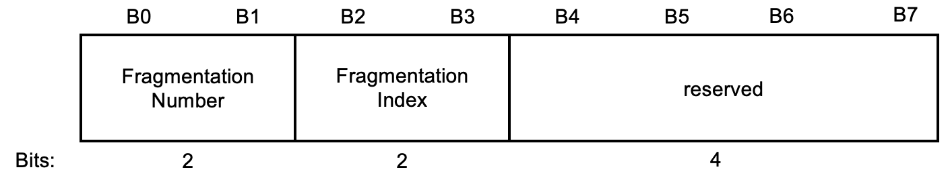

Figure 9-<ANA> eBCS Service Advertisement frame Fragmentation Control field format

The Fragmentation Number subfield in the Flags field is a 2bit unsigned integer that is the total number of the fragmentation.
The Fragmentation Index subfield is the Flags field is a 2bit unsigned integer that is the fragmentation index of the eBCS Service Advertisement frame.
Fragmentation procedure is described in 11.<ANA> (eBCS Service Advertisement frame generation).

The eBCS Advertisement Interval field is an 8bit undsigned integer that is the interval of the eBCS Service Advertisement frame transmission interval in units of 100ms.

The Contents Information Number field is an 8bit unsigned integer that indicates the number of the Contents Information fields.
The Contents Information field is shown in 9-<ANA> (eBCS Service Advertisement frame Contents Information field format).

 | Content Control | Higher Layer  Destination Address | Title Length | Title | Data Length | Data
Octets: | 1 | variable | 0-1 | 0-variable | 0-2 | 0-variable

Figure 9-<ANA> eBCS Service Advertisement frame Contents Information field format

The Content Control subfield in the Contents Information field is shown in Figure 9-<ANA> (Content Control subfield in the Contents Information field format)

 | Title Included | Data Included | Service requires association | Higher Layer Protocol | Reserved
Bits: | 1 | 1 | 1 | 3 | 2
Figure 9-<ANA> Content Control subfield in the Contents Information field format

The Title Included subfield in the Flags subfield is set to 1 if the Title Length subfield and the Title subfield are present, otherwise set to 0.
The Data Included subfield in the Flags subfield is set to 1 if the Data Length subfield and the Data subfield are present, otherwise set to 0.
The Service requires association subfield is set to 1 if the service described in this Content information field requires of association, otherwise set to 0.

The Higher Layer Protocol subfield in the Flags subfield is a 3bit unsigned integer that shown in Table 9-<ANA> (Higher Layer Protocol subfield). UDP/hostname may be used for Uplink eBCS only. Others are used for both Uplink and Downlink eBCS.

Table 9-<ANA> Higher Layer Protocol subfield

Value | Higher Layer Protocol
0 | UDP/IPv4
1 | UDP/IPv6
2 | UDP/hostname (Uplink only)
3 | MPEG Transport stream identifier
4 | MAC Address
5-7 | Reserved

The Title Length subfield in the Contents Information field is 8bit unsigned integer that is the length of the following Title field in units of octes.
The Title subfield in the Contents Information field is the human readable title of the contents coded by UTF-8.

The Higher Layer Destination Address subfield in the Contents Information field is the higher layer destination address and port encoded as following.
If the higher layer protocol is UDP/IPv4, the format of the Higher Layer Destination Address subfield format is shown in the Figure 9-<ANA> (Higher Layer Destination Address subfield format for UDP/IPv4). The Destinatin UDP Port subfield is encoded in little endian.

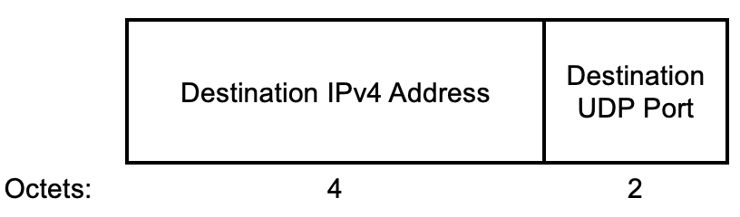

Figure 9-<ANA> Higher Layer Destination Address subfield format for UDP/IPv4

If the higher layer protocol is UDP/IPv6, the format of the Higher Layer Destination Address subfield format is shown in the Figure 9-<ANA> (Higher Layer Destination Address subfield format for UDP/IPv6). The Destinatin UDP Port subfield is encoded in little endian.

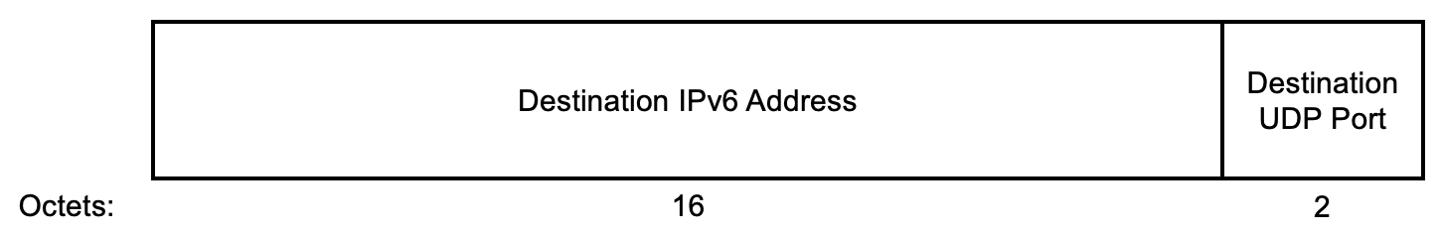

Figure 9-<ANA> Higher Layer Destination Address subfield format for UDP/IPv6

If the higher layer protocol is UDP/hostname, the format of the Higher Layer Destination Address subfield format is shown in the Figure 9-<ANA> (Higher Layer Destination Address subfield format for UDP/hostname). The Hostname Length subfield indicates the length of the Hostname subfield. The Hostname subfield is the hostname in UTF-8. The Destinatin UDP Port subfield is encoded in little endian.

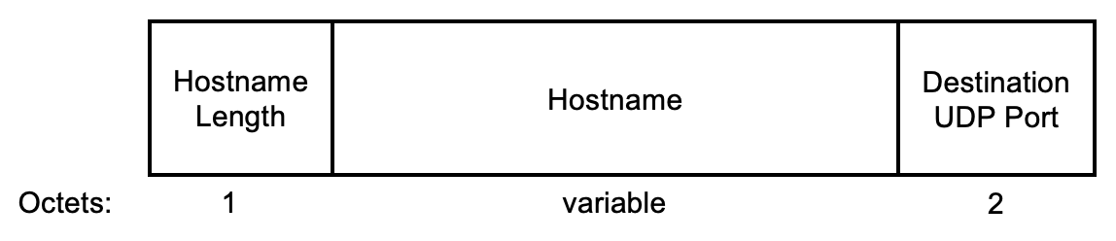

Figure 9-<ANA> Higher Layer Destination Address subfield format for UDP/hostname

If the higher layer protocol is MPEG Transport stream, the format of the Higher Layer Destination Address subfield format is shown in the Figure 9-<ANA> (Higher Layer Destination Address subfield format for MPEG Transport stream). The MPEG Transport stream Length subfield indicates the length of the MPEG Transport stream subfield. The MPEG Transport stream subfield is the MPEG Transport stream identifier in UTF-8.

 | MPEG Transport stream length | MPEG Transport stream
Octets | 1 | Variable
Figure 9-<ANA> Higher Layer Destination Address subfield format for MPEG Transport stream

If the higher layer protocol is MAC Address, the format of the Higher Layer Destination Address subfield format is shown in the Figure 9-<ANA> (Higher Layer Destination Address subfield format for MAC Address).

 | MAC Address
Octets | 6
Figure 9-<ANA> Higher Layer Destination Address subfield format for MAC Address

The Title Length subfield and the Title subfield are present if the Title Included flag in the Content Control subfield is set to 1.
The Title Length subfield in the Contents Information field is 8bit unsigned integer that is the length of the following Title field in units of octes.
The Title subfield in the Contents Information field is the human readable title of the contents coded in UTF-8.

The Data Length subfield is the length of the Data subfield.
The Data subfield is shown in the Figure 9-<ANA> (Data subfield format).

 | Data Control | Service URL Length | Service URL | Vendor specific
Octets | 1 | 0-1 | 0-Variable | 0- variable
Figure 9-<ANA> Data subfield format

The Data Control subfield is shown in Figure-<ANA> (Data Control subfield format).

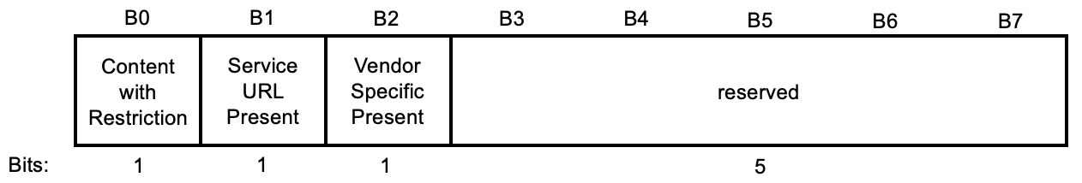
Figure 9-<ANA> Data Control subfield format

The Content with restriction bit indicates if the content requires of some kind of offline registration to be accessed. The registration process is out of the scope of this document.
The Service URL Present bit indicates that the Service URL Length subfield and Service URL subfield are present in the Data subfield.
The Vendor Specific Present bit indicates that the Vendor Specific subfield is present in the Data subfield.

In the case the Data Control indicate the Service URL subfield is present, the Service URL Length subfield is a 1-octet field whose value is set to 1 plus the number of octets in the Service URL field.
The Service URL field is a variable length field that indicates the URL at which information relevant to the corresponding eBCS service might be retrieved. The Service URL field is formatted in accordance with IETF RFC 3986.
The Vendor specific subfield is to be defined by application specific requirements.

