IEEE P802.11
Wireless LANs
IEEE 802.11bd Task Group Meeting Minutes –
January 2020
Date: 2020-01-17
Author(s):
Name | Affiliation | Address | Phone | email
James Lepp | BlackBerry | 1001 Farrar Road, Ottawa, Canada |  | jlepp@blackberry.com
Hongyuan Zhang | NXP
Joseph Levy | Interdigital
Abstract

This document includes minutes of all IEEE 802.11bd meetings at the IEEE 802.11 interim meeting in Irvine California, USA January 13-17, 2020.

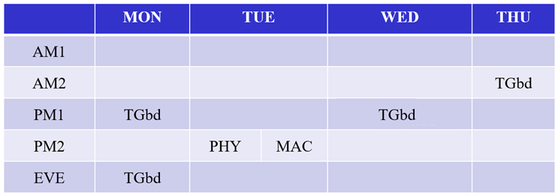

Thanks to Joseph Levy and Bo Sun for recording the minutes during Ad-Hoc sessions.
Versions:
- R0: Uploaded Feb 5, 2020
- R1:

TGbd Task Group PM1 – Tuesday, January 13, 2019

Opening
  - Call to order 1:30pm in Irvine, California. 30 participants in the room.
  - Displaying agenda 802.11-19/2126r2
  - Chair introduced the task group leadership and welcomed the members to Irvine.
  - Chair reminded members of the meeting protocol including recording their attendance and announcing their name and affiliation when speaking at the mic.
  - Chair presented policy slides and called for potentially essential patents.
  - No response from the members.
  - Chair showed the links to IEEE patent policy information and other guidelines.
  - Chair informed members that if they do not agree with the policy, they should not participate.

Agenda
  - Chair presented the agenda as shown in 802.11-19/2126r2 slide 10.
  - Chair asked if there is any other new business to add to the agenda. There is none.
  - Discussion about categorization and order of technical submissions. Chair updated table on slide 13.
  - Comment that the spec text submissions are missing from the agenda slides
  - Chair response that they can be found in the Technical Editors Report. (802.11-19/2045)
  - Agenda for this session has been adopted without objection

Minutes
  - Motion: Approve the TGbd minutes for Nov-2019 meeting and TGbd TCs before Jan-2020 meeting as below: https://mentor.ieee.org/802.11/dcn/19/11-19-2014-00-00bd-tgbd-nov-2019-meeting-minutes.docx and https://mentor.ieee.org/802.11/dcn/19/11-19-2116-01-00bd-tgbd-dec-2019-teleconference-minutes.docx
  - Moved: James Lepp
  - Seconded: Rui Cao
  - Result: Motion passed unanimously

Approval of Task Group Documents
  - Motion: Approve the updated SFD document as in 11-19/0497r5:
  - https://mentor.ieee.org/802.11/dcn/19/11-19-0497-05-00bd-802-11bd-specification-framework-document.docx
  - Moved: Bahar Sadeghi
  - Seconded: James Lepp
  - Result: Motion passes unanimously

Liaison Updates

  - Chair mentions the only liaison update to report is that the Tuesday PM2 session is a joint session with IEEE 1609 members.

Editors Report (IEEE 802.11-19/2045r1)

  - FRD/SFD Motion Booklet: 802.11-19/0514r12
  - FRD: 802.11-19/0495r3 (r3 approved in Nov meeting)
  - SFD: 802.11-19/0497r5
  - Draft 0.1 is in the members area. http://www.ieee802.org/11/private/Draft_Standards/11bd/index.html
  - New at this meeting and still pending draft text submissions are listed on slide 4.
  - Editor asks contributors to provide any contributed drawings in Visio file format.
  - Floor open for comments
  - Comment that IEEE 802.11 Editors style guide was updated to revision 15 in November. (802.11-09/1034)
  - No other comments.

FCC 5.9GHz NPRM Discussion (IEEE 802.11-19/2157r1)

  - Presentation by Vice Chair Joseph Levy
  - Discussion
    - Comment that on slide 1 or 2 you need to call out NPRM “ET Docket 19-138” by number
    - Comment that they are calling this now 1 single band, and it used to be 1 single band, but now there are 2 services in the single band. When defining the out of band, this needs to be de-ambiguated, as it is fundamental to the definitions.
    - Discussion about timeline between NPRM comment period, and then to the rulemaking.
    - Comment that the FCC has an impact on the work of 11bd, but there are other regulators for other parts of the world.
  - Presenting the draft NPRM response document 802.11-20/0104r0
  - Discussion led by Vice Chair Joseph Levy who is editing this document
    - This is something that would be good for 802.11bd to consider and provide to 802.18 as soon as possible.
    - Further discussion on process regarding 802.11bd TG, 802.11 WG and 802.18 RR TAG.
  - This topic will be revisited at the evening session.

Technical Submission (IEEE 802.11-20/0001r1)

  - Presentation by Yossi Shaul
  - Discussion
    - Comment: Asking for clarification about the mention that there won’t be any more 10MHz channels. The FCC doesn’t channelize so this doesn’t matter.
    - Question: What would be the advantage of defining a different 20MHz mode that doesn’t account for 10MHz channels.
    - Question: is there a possibility for puncturing? For example, using OFDMA to puncture 2MHz pieces of it. Intention to protect the boundary of the band. This would provide better coexistence with the neighboring band.
    - Comment that the proposal to send 20MHz preamble is better to coexist with 20MHz incumbents, and 2x10MHz preamble better coexists with 10MHz incumbents. But today there is no UNII4 incumbent, so we are assuming something. Might want to think about it more.
    - Comment that one of the issues from the Coexistence Tiger Team from a few years ago is that prioritization of the frames requires deep packet inspection – as it’s the only way to determine a “Wi-Fi” 802.11 frame from a “DSRC” 802.11 frame.
    - Discussion on Strawpoll 1:
      - Comment: that we already have a 20MHz PPDU design
      - Comment: only talking about the preamble
      - Comment: this is proposing a new PPDU type.
      - Question about why not just use 11ac. Response that the 11bd is designed for high doppler environments.
      - Comment: can look at 11ax 20MHz PPDU.
      - Comment on timing, of the 11bd spec drafting, and the FCC NPRM outcome.
      - Response: lets continue work on this now and not delay.
    - Straw Poll 1: Do you agree that 802.11bd shall add 10MHz channel operation mode, without co-existence with legacy 10MHz
    - Y6/N0/A15plus
    - Discussion on Strawpoll 2:
      - Comment: Is this just UNII-4? I don’t think FCC is proposing any sharing scheme other than all unlicensed users share equally. This would be a within 802.11 scheme.
      - Comment: that this might be bigger than 802.11bd and need buy in from 802.11.
      - Comment: Change WiFi to 802.11
      - Comment: add UNII-4
      - Comment: add “above 5850MHz”
    - Straw Poll 2: Do you agree that 802.11bd shall define and validate 802.11 sharing scheme?
    - Y:5/N:1/A:many
    - Strawpoll 3: Do you agree that 802.11bd shall define wider channels (40/80MHz) for effective WiFi sharing?
    - Y0/N2/A15

Closing

  - Chair recessed at 3:26pm

TGbd Task Group PM3 – Monday, November 13, 2019

Opening
  - Call to order at 7:30pm in Irvine California. Approx. 40 participants in the room.
  - Agenda displayed is 802.11-19/2126r1.

Agenda
  - Chair presented the agenda 802.11-19/2126r1
  - Discussion on the agenda
  - Some material copied from the November meeting agenda was updated in the slides on screen with feedback from the group.
  - During this session 1:30 will be for technical presentations, last half hour will be for the NPRM submission draft.
  - Agenda is accepted by unanimous consent.

Technical Presentation (IEEE 802.11-19/1845r0)
  - Presented by Insun Jang
  - Discussion:
    - Comment that a STA may run more than one service, thus an individual STA may need to transmit 10MHz PPDUs and 20MHz PPDUs (at different times consecutively). Concerned about the presentation setting out a 10MHz STA and 20MHz STA.
    - Comment that this isn’t a good model. STA should be able to transmit or receive both 10MHz and 20MHz PPDUs.
  - Strawpoll 3: The Strawpoll was deferred.

Technical Presentation (IEEE 802.11-19/1968r1)
  - Presented by Liwen Chu
  - Discussion:
    - Comment that there are two options, but option 1 is already in the SFD
    - Question about why to send the two 10MHz ACKs instead of just a single 10MHz ACK
    - This is to enable the legacy 10MHz STAs to see the ACK. And adjust its timers.
    - Strawpolls were deferred until similar presentations.

Technical Presentation (IEEE 802.11-19/1973r0)
  - Presented by Hanseul Hong
  - Discussion:
    - Comment that this option 1 on slide 7 is another new mode in addition to the agreed mode.
    - Comment this is just an additional rule for switching between 10MHz and 20MHz.

Technical Presentation (IEEE 802.11-20/0046r2)
  - Presented by Rui Cai
  - Discussion
    - Discussion about false alarm rate of the GI mechanism
    - Discussion about effect of non-802.11 (non-OFDM) interference
    - Discussion about how to specify the secondary channel detection in the standard: specify ED/GI/PD or just a performance threshold and let the designer choose how to build the hardware.
    - Discussion about the Strawpoll, but no Strawpoll was run.

NPRM Submission Discussion (802.11-20/0104r1)
  - Presentation by Vice Chair Joseph Levy
  - Two members sent Joe additional comments
  - Section regarding NPRM paragraph 44. Its about references to ASTM E.2213-03 vs IEEE 802.11p.
  - Discussion about referencing a particular version of the standard
  - Discussion about what reference is too specific that it prevents future innovation.
  - Discussion about reasons FCC needs to point to a specific published version rather than giving, by reference, ability of an SDO
  - In the second section promoting 802.11 in the full 75mhz, a comment to be more direct with the ask that the full 30MHz ITS band be available for 802.11 based technologies
  - Comment on wording for 802.11p and backwards compatible technologies

Closing
  - Chair recessed 9:31pm

PHY ad-hoc PM2 – Tuesday, November 13, 2019

Opening
  - Call to order 16:05pm in Irvine
  - Displaying agenda 11-20/0153r0
  - Chair: Qinghua Li
  - Active Secretary: Bo Sun

Technical Presentation (802.11-19/1864r1)
  - Presented by Yujin Noh (Newracom)

  - SP1 as in 11-19/1864r1
Result: O1:1/O2:6
  - SP3 as in 11-19/1864r1
Result: Y13/N0/A4
  - SP4 as in 11-19/1864r1
Result: Y13/N0/A3

Technical Presentation (802.11-19/1863r1)
  - Presented by Yujin Noh (Newracom)
  - SP1 as in 11-19/1863r1
Result: Y13/N0/A2
  - SP2 as in 11-19/1863r1
Result: O1:10/O2:1
  - SP3 as in 11-19/1863r2
The SP3 content in 11-19/1863r1 was modified and captured in 11-19/1863r2.
Result: Y14/N0/A4
  - SP4 as in 11-19/1863r2
The SP4 content in 11-19/1863r1 was modified and captured in 11-19/1863r2.
Result: Y11/N0/A3
  - SP5 as in 11-19/1863r2
Result: Y12/N0/A2
  - SP6 as in 11-19/1863r2
Result: Y10/N0/A3
  - SP7 as in 11-19/1863r2
Result: Y12/N0/A2

Technical Presentation (802.11-19/2011r0)
  - Presented by Feng Jiang (Intel)
  - No SP.
  - The author confirmed will provide further analysis and proposal on ranging in 11bd in future.

Technical Presentation (802.11-19/1929r1)
  - Presentation by Stephan Sand (DLR)
  - No SP.

Technical Presentation (802.11-20/0045r1)
  - Presented by Rui Cao (NXP)
  - SP1 as in 11-20/0045r1
Result: Y15/N0/A3
  - SP2 as in 11-20/0045r1
Result: Y15/N0/A4
  - SP3 as in 11-20/0045r2
  - The SP3 content in 11-20/0045r1 was modified and captured in 11-20/0045r2
Result: Y15/N0/A0
  - SP4 as in 11-20/0045r2
  - The SP4 content in 11-20/0045r1 was modified and captured in 11-20/0045r2
Result: Y15/N0/A0

Technical Presentation (802.11-20/0044r1)
  - Presented by Rui Cao (NXP)
  - SP1 as in 11-20/0044r1
Result: Y17/N0/A1
  - SP2 as in 11-20/0044r1
Result: Y17/N0/A1
  - SP2 as in 11-20/0044r1
Result: Y18/N0/A0

MAC ad-hoc PM2 – Tuesday, November 13, 2019

Opening
  - The Co-Chair, James Lepp, convened the meeting at 16:05 PST. Approx. 23 participants in the room. Co-Chair Joseph Levy acting as secretary for the session.
  - Agenda displayed is 802. 11-20/0155r0.
  - The Chair welcomed the members and introduced the Ad Hoc leadership.
  - The Chair reviewed the administrative slides (slides 3 and 5-9) and called for potentially essential patents.
  - No response to the call for patents.

Agenda
  - Chair presented the agenda 802. 11-20/0155r0 copied below for reference:
    - Discussion on the agenda
    - Call for order and appoint secretary
    - IEEE-SA policies and IPR policies
    - Agenda Agreement
    - Discussion on IEEE 802.11bd↔IEEE 1609 interfaces
    - Presenting of technical submissions for the week
    - Any other business
    - Adjourn
  - Proposal to add FCC NPRM to the agenda
  - Proposal to remove the discussion of the IEEE 802.11bd IEEE 1609 interfaces to a telecon where the author of the proposal can participate.
  - Updated agenda:
    - Discussion on the agenda
    - Call for order and appoint secretary
    - IEEE-SA policies and IPR policies
    - Agenda Agreement
    - Presenting of technical submissions for the week
    - 802.11-19/2115r1
    - Discussion of the FCC NPRM 19-138 response
    - Any other business
    - Adjourn
  - The Chair called for additional contributions – none were forthcoming
  - Agenda is accepted by unanimous consent.

Technical Presentation (802.11-19/2115r1)
  - Presented by Yossi Shaul (Autotalks)
  - Discussion
    - Discussion about how upper layer knows which addresses to request ACK from
    - Discussion about broadcast ACK vs blind retransmission and the effect on reliability, and overhead costs.
  - Straw Poll: Do you agree to add the following text into Section 3 of SFD?
“11bd shall allow Broadcast and Multicast reception feedback based on BlockAck. Upper layer initiates the request and selects the recipients.” 3/3/many.

Discussion of the FCC NPRM 19-138 response
  - Vice chair (Joe Levy) continued to lead discussion of the committee drafting the NPRM response
  - Suggestion to add a sentence about the ITU-R study results on the 5.9GHz ITS band. A member offers to provide text.
  - Comment about the FCC 2003 R&O statements: explanation for why to put a specific standard in the FCC rules. “To ensure interoperability and robust safety/public safety”.
  - Suggestion on why the group should comment in favor of the FCC regulation being technology neutral. Technology needs to adapt and evolve for future application.
  - Comment to modify the first sentence to add “..MHz for Wi-Fi and DSRC applications”
  - Discussion about the section on spectrum needs. One side wants to see the word 75MHz and the other wants to see the word 30MHz. Maybe we need to talk about spectrum needs without using either number.
  - If we want a strong statement that all 30MHz should be assigned for 802.11-based protocols, a member has more text to add to support that statement.
  - Regarding the proposed out of band emissions (OOBE) limits – A member offered to provide some text.
  - Discussion on this topic will continue later in the week.

Closing
  - The chair adjourned at 6pm.

802.11bd Task Group PM1 – Wednesday, November 13, 2019

Opening
  - Call to order 1:30pm in Irvine. 30 individuals are in the room.
  - Displaying agenda 802-11/2126r3
  - Chair made call for potentially essential patent claims
  - No response
  - Chair showed the agenda for the session
  - Discussion about the agenda
  - Comment about new contribution 181 regarding NPRM.
  - This is added to the agenda
  - First will do Strawpolls on 20MHz channel access, followed by adaptive repetition.
  - One presentation on the list does not need to be strawpolled and was removed from the list.
  - No further discussion
  - No objection to adopting this agenda for the session.

Technical Presentation (802.11-19/1973r1)
  - Presentation by Hanseul Hong
  - Strawpolls
  - Straw Poll 1 iscussion:
    - Comment: the AIFS period is triggered when sensing the channel transitions from busy to idle.
    - Comment that you don’t need to mandate the sensing method of the secondary channel. PD in the primary is ok, don’t need to specify for secondary.
    - Comment that there will be a Strawpoll in another presentation on the TBD method in the secondary channel
    - Question about whether the “channel sensing period” terminology is already in the base spec.
    - Comment that the intention is the backoff procedure is same as if it was a 10MHz transmission.
    - Further discussion and wording updates.
  - Straw Poll 1 Do you agree to add the followings to SFD:
  - -20 MHz channel consists of two contiguous 10 MHz channel:
  - -In one 10 MHz channel (denoted as OCB primary channel), the channel sensing with PD and ED with NAV setting method shall be applied.
  - -When the OCB primary channel is sensed as channel busy, the backoff procedure shall be same as the backoff procedure of 10 MHz transmission.
  - Y11/N0/A12
  - Strawpoll 2 Discussion
    - Comment: suggest to change to 802.11p signal.
    - Comment: while you state you are trying to harmonize with the baseline, this proposal seems to be changing the behavior quite a bit.
    - Comment that the baseline already has different sensing period for primary and secondary.
    - Discussion about difference in performance between decoding the preamble successfully and knowing the duration and other interferes.
    - Chair cut discussion to 3 more minutes for this Strawpoll
    - Further discussion and changes
  - Strawpoll 2 Do you agree to add the followings to SFD:
  - -When OCB secondary channel is sensed busy and the duration of channel busy is not known, EIFS sensing period shall be used.
  - -When OCB secondary channel is sensed busy and the duration of channel busy can be known, AIFS sensing period shall be used.
  - Note: STA is not required to have a capability to detect the duration of channel busy on the OCB secondary channel.
  - Y4/N1/A17
  - Strawpoll 3 Which options do you support regarding the 10 MHz fallback operation?
  - Option 1: The decision of using 10 MHz fallback mechanism is indicated by upper layer
  - Option 2: The 10 MHz fallback operation during 20 MHz channel access is not allowed in any circumstance
  - Discussion about the two options relative to the baseline behavior of wider channel fallback to narrower channel.
  - Opt 1: 7 / Opt 2: 1 / Abstain 10
  - Strawpoll 4 Discussion
    - Discussion: commenter in favor of option 1, but doesn’t see the need dictate which information the upper layer makes the decision
    - Comment that it should be a STA policy to do fallback or not, not something indicated on a frame by frame basis.
    - Comment that this is the same as Strawpoll 3. Response that that was a decision on way forward, but Strawpoll 4 is the SFD text proposal.
  - Strawpoll 4: Do you agree to add the followings to SFD:
  - The decision of using 10 MHz fallback mechanism as specified in the baseline spec is indicated by upper layer.
  - Y 16/N 0/A 5

Technical Presentation (802.11-20/0046r3)

  - Presentation by Rui Cao
  - Strawpoll 1: Do you agree to add the following text into Section 3 of SFD?
  - “For 20 MHz operation, the CCA sensitivity on the secondary 10 MHz channel shall be -85 dBm for NGV and legacy 802.11p PPDUs, and shall be -65 dBm for any other signal.”
  - Y 18/N 0/A 6
  - Comment after the Strawpoll that this should be “minimum sensitivity” when we formalize the text.

FCC NPRM discussion (802.11-20/0181r0)
  - Presentation by Vice Chair Joseph Levy who is chaperoning the FCC NPRM response drafting process for the task group
  - .

  - Presenter described the process for IEEE 802.11 to approve a document. One is to have a motion at the Friday plenary, the other is to have an electronic working group ballot after our meeting this week. Should that pass the document can be given to the 802 EC for a 10 day ballot.
  - Presenter mentions that 6 versions have been posted, 2 were posted by other individuals who failed to set their own name in the field when uploading. Reminded members that they should set the name when submitting a new revision.
  - Strawpolls are being presented by Ioannis Sarris.
  - Comment from a member that he is not ready to answer all of the questions in this deck (which has been online close to 4 hours).
  - Comment from leadership that this is to help get some general direction before drafting new sections of the paper.
  - Strawpoll 1: Do you believe that TGbd should post comments to the 5.9 GHz NPRM proposal by FCC?
  - Y25/N0/A2
  - Strawpoll 2 Discussion:
    - Question about using Chicago rules. Agreed to allow members to vote for more than one.
    - Discussion about option 3 and the meaning of technology agnostic
    - A member commented on the benefits of option A over option C.
    - Comment that this Strawpoll is specific to the NPRM, but not a comment on the 5.9GHz globally and in general.
    - Comment on the lack of a safety proven coexistence method that would enable option C.
    - Comment that the band today is licensed for ITS uses and shares with other licensed uses.
    - Comment that this should be specific about which part of the NPRM we are addressing.
    - Comment on the difficulty of “coexistence” based on experience in two years of the 802.11 Coexistence Standing Committee.
  - Strawpoll 2: Which of the following statements regarding the choice of V2X technology at 5.9 GHz do you endorse?
  - A: Only DSRC* should be allowed
  - B: DSRC* & C-V2X should be allowed on different channels
  - C: Only C-V2X should be allowed
  - D: Allocation should be technology agnostic as long as coexistence is ensured
  - E: None / Other / Abstain
  - * includes interoperable / backwards-compatible technologies
  - A:19 B:2 C:2 D:0 E:5 (members were allowed to vote for more than one option)
  - Strawpoll 3 Discussion:
  - Comment that this is highly controversial and if 30 is chosen it will be vetoed, and if 75 is chosen it will be vetoed. Suggestion to add an option to explicitly not comment on this.
  - Comment to add an at least 40MHz option since both C-V2X and 802.11bd are using 20MHz channels.
  - Comment that we need to justify that we want more than 30MHz.
  - Comment about submitting wording that supports 802.11p and 802.11bd DSRC services operating in the 45MHz unlicensed block. This may be something good for 802 to submit to make it more clear. And this could be a neutral stance on the 45 MHz.
  - Strawpoll 3
  - Which of the following spectrum allocation for V2X do you endorse?
  - A: 75 MHz (licensed only)
  - B: 75 MHz (licensed and unlicensed)
  - C: 40 MHz (two 20MHz channels licensed)
  - D: 30 MHz (licensed)
  - E: 10 MHz (licensed)
  - F: No opinion for 802.11bd
  - G: Other / Abstain
  - * includes interoperable / backwards-compatible technologies
  - A:14 B:12 C:3 D:10 E:0 F:3 G:0 (members were allowed to vote for more than one option)
  - Straw Poll 4 Discussion:
    - Comment that we should comment on this. There is an inconsistency in the NPRM that needs to be corrected – and this is both for ITS and Wi-Fi. There may be problems at the channel edges and there will be compromises needed.
    - We need to have a comment on paragraph 54 and 55, and it needs to be justified qualitatively.
    - Comment there are 2 other incumbents in the 5.9GHz band. DSRC, military radar and satellite. Getting an RSU site license from the FCC requires coordinating with those other licensed users. There were studies several years ago on where the other licensed users and which part of the 75MHz they use. Member is looking for that citation and will provide it to 802.18.
    - Comment on the existing interference from UNII-3 into channel 172. There was much discussion in the UNII-5 NPRM on the out of band interference. Comment on mobile hotspot interference when brought into a vehicle.
    - Comment that if we go for the 75MHz this doesn’t need to be done. If we go for the 10 or 30 MHz this is needed.
  - Strawpoll 4: Do you agree that TGbd should post comments on OOB performance/requirements?
  - Y24/N0/A1
  - Strawpoll 5 Discussion:
  - Comment: does this mean a common format for basic safety messages?
  - Discussion about system level interoperability
  - We are at time (4:30pm) No objection to taking 2 more minutes for Strawpoll
  - Strawpoll 5: Do you agree that TGbd should post comments on the need for a common PHY/MAC basic safety messages for V2X?
  - Y19/N0/A4

Closing
  - The Chair recessed at 3:32pm

802.11bd Task Group AM2 – Thursday, November 14, 2019

Opening
  - Call to order 10:30am in Irvine. 30 participants are in the room.
  - Displaying agenda 802.11-19/2126r4
  - Chair introduces task group leadership
  - Chair displayed meeting policies
  - Chair made call for potentially essential patents
  - No response to the call for patents
  - No objection to adopting this agenda for the session.
  - The task group editor announced the state of the motions presentation (19/0514r13) and called for members to send her a note immediately in case one is missing as this is on the agenda in about an hour.

NPRM Discussion (IEEE 802.11-19/0104r7)

  - Presentation by Vice Chair Joseph Levy
  - Discussion:
    - Comments from Vice Chair compiling this document: This revision 7 includes all contributions received via email.
    - This document is not nearly complete and ready to be submitted
    - This document needs references and other updates.
    - Work can continue on task group teleconferences. Strawpolls can be conducted on teleconference, but not motions.
    - Discussion about procedure to agree the document.
    - 802.11 should make a decision at Friday plenary on the procedure. Subsequent work can continue on teleconferences.
    - Also need to contribute outcome of the Strawpolls from yesterday into the document
    - Comment from the 802.18 chair on the status of discussion in AM1 this morning. Suggestion to move forward in the area there is agreement on.
    - Continuing the Strawpolls presentation (IEEE 802.11-20/0181r0)
    - Strawpoll 6:
    - Do you agree that TGbd should post comments on the need for interoperability and backwards compatibility between different generations of V2X technologies?
    - No Discussion
    - Y26/N0/A3
    - Strawpoll 7 Discussion:
      - Comments about wording regarding new technology including or excluding 802.11bd.
      - Comment about C-V2X deployment in China
      - Comment of support for first sentence, but suggestion the rest of the paragraph is conjecture.
      - Taking straw poll as is.
    - Strawpoll 7: Do you agree with the following statement? (Y/N/A):
    - The reasons which caused a slower adoption of DSRC in the US than originally anticipated were not related to the technical merits of this technology. The same difficulties will also be faced by any other V2X technology which may be specified by FCC. Therefore, it is expected that specifying a new technology will lead to a significant delay to the adoption of V2X at 5.9 GHz.
    - Y23/N3/A4
    - Vice Chair (Joe) is putting together a proposed timeline for the 802.11 plenary
    - 802.18 chair mentions the EC early close ballot. Sometimes it has worked, sometimes it does not.

TG Motion on developing FCC NPRM response

  - Presentation by Chair
  - Motion is displayed on screen from 802.11-19/2126r4 agenda deck.
  - Discussion:
  - Discussion. Procedurally this is a recommendation to the WG from the TG.
  - Discussion about whether this should be a motion or a Strawpoll. As a task group this is still just a suggestion to the WG. Suggestions to clarify wording.
  - Discussion about whether this is instead of or in parallel to with 802.18.
  - A comment for using the established 802.18 process to draft and approve the FCC response, not 802.11 as the EC approval may be smoother.
  - Comment that this motion is to provide 802.11 with ability to approve the document. Doesn’t preclude 802.11 WG sending to 802.18 as opposed to sending it directly. Comment that wording isn’t clear on that.
  - Comment that this is a TG motion, and what it does is propose something to the WG plenary.
    - Motion for developing comments on FCC NPRM on 5.9 GHz band
    - Approve TGbd to develop comment document responding to FCC NPRM on 5.9GHz band. Joseph Levy leads developing of comments with 11-20/0104 as the comment document. And run a WG to approve the completed comment document and for the WG Chair to decide to send to FCC after EC review or forward to 802.18 for LMSC process.

    - Moved: Joseph Levy
    - Second: Stuart Kerry
    - Result: Motion passes (23Y/1N/3A)

Technical Presentation (802.11-19/1969r1)

  - Presentation by Rui Cao
  - Strawpoll 1 Discussion:
    - Comment that we have no concept of “TXOP holder” but agree with the intent. Suggestion to change it to transmitter who makes the choice.
    - Discussion about the decision point for channel access vs channel sensing requirements.
    - Comment on the term “two NGV STAs”. Is this for unicast or broadcast.
    - Presenter suggests this might be for unicast stations only
    - Other commenters don’t want this tied to unicast and ensure the feature works for broadcast transmissions
    - Comment that this isn’t testable as STA can decide to transmit 10 MHz or 20 MHz at any time
    - Comment that this isn’t sufficient to sense on the secondary then transmit 10MHz on the secondary channel. 10 MHz transmission is only allowed on the primary.
    - Comment that the decision to send 10 MHz or 20 MHz might be by upper layer
  - Strawpoll 1:
  - Do you agree to add the following text to 11bd SFD:
  - For a transmission from a NGV STA that support 20MHz BW the transmitter can decide whether primary 10MHz or 20MHz PPDU is used after gaining channel access of 20MHz.
  - Strawpoll deferred
  - Strawpoll 2 Discussion:
    - Comment that this first sentence was already in a prior agreed Strawpoll and used different terminology
    - Discussion about upper layer or spec deciding which 10mhz channel is primary
  - Strawpoll 2
  - Do you agree to add the following text to 11bd SFD:
  - Within a 20MHz channel, one 10MHz channel is OCB primary 10MHz channel, another 10MHz channel is OCB secondary 10MHz channel. The OCB primary 10mHz channel is decided by upper layer.
  - Y16/N0/A7

Technical Motions (802.11-19/0514r13)

  - Presentation by Editor Bahar Sadeghi and Chair Bo Sun
  - Motion 71 (DCN:11-19/1973r2)
  - Move to include the following text to section 3.2 of the 11bd SFD
  - “20 MHz channel consists of two contiguous 10 MHz channels:
  - -In one 10 MHz channel (denoted as OCB primary channel), the channel sensing with PD and ED with NAV setting method shall be applied.
  - When the OCB primary channel is sensed as channel busy, the backoff procedure on the OCB primary channel shall be same as the backoff procedure of 10 MHz transmission.”
  - Moved: Hanseul Hong
  - Second: Ronny Kim
  - Discussion about definition of the “NAV setting” action in the sentence. NAV setting comes from the duration field in the MAC header in the PD operation on the primary channel.
  - Comment that the backoff procedure is what happens when the channel is idle, what happens when the channel is busy is to reset the backoff procedure.
  - Comment that this is the action of pausing the counter. First line is the NAV setting.
  - Discussing details of the busy sensing and the effect on countdown timer. Initial sensing busy and continued sensing busy have different effects on the procedure.
  - Motion Passes Y12/N0/A10
  - Motion #72 (DCN: 11-19/1973r2)
  - Move to include the following text to section 3.2 of the 11bd SFD
  - “When OCB secondary channel is sensed busy and the duration of channel busy is not known, EIFS sensing period shall be used.
  - When OCB secondary channel is sensed busy and the duration of channel busy is known, AIFS sensing period shall be used.
  - Note: STA is not required to decode the duration of channel busy on the OCB secondary channel.”
  - Mover: Hanseul Hong
  - Second: Ronny Kim
  - Discussion:
    - Comment that AIFS is only set when the channel transitions from busy to idle, not when the channel is busy.
    - Discussion about the EIFS procedure vs the AIFS procedure.
    - Motion to table the motion #72
    - Moved: Ronny Kim
    - Second: Hanseul Hong
    - No objection to tabling the motion. The motion is tabled
  - Motion #73 (DCN: 11-20/0074r4)
  - Move to include the following text to section 3.2 of the 11bd SFD
  - “The decision of whether the STA is allowed to use 10 MHz fallback mechanism, as specified in the baseline 802.11 specification, is indicated by the upper layer.”
  - Moved: Hanseul Hong
  - Second: Ronny Kim
  - No discussion
  - Result: Motion passes unanimously
  - Motion #74 (DCN: 11-20/0046r4)
  - Move to include the following text to section 3 of the 11bd SFD
  - “For 20 MHz operation, the minimum CCA sensitivity on the secondary 10 MHz channel shall be -85 dBm for NGV and legacy 802.11p PPDUs, and shall be -65 dBm for any other signal.”
  - Moved: Rui Cao
  - Second: Dongguk Lim
  - No discussion
  - Result: Motion passes unanimously
  - Motion #75 (DCN: 11-20/0045r3)
  - Move to include the following text to section 3 of the 11bd SFD
  - “LDPC is the only coding scheme for the data portion of 11bd PPDU.”
  - Moved: Rui Cao
  - Second: Dongguk Lim
  - Discussion:
    - A member speaks against the motion as it restricts the ability to specify optimal codings for fast moving environments. Suggest LDPC with midambles isn’t always better than BCC.
    - Another member suggests this has been extensively discussed, but in broadcast modes there is no mechanism to determine the optimal mode. States this is a good compromise between complexity and performance
    - A comment that keeping the convolutional code does not add complexity since it is there already. Suggesting that this is a move against backwards compatibility.
    - Comment that this was analyzed in the presentation and it still supports backwards compatibility by virtue of supporting the 802.11p PPDU formats and rates.
  - Result: Motion Passes (Y7/N2/A11)
  - Motion #76 (DCN 11-20/0045r3)
  - Move to include the following text to section 3 of the 11bd SFD
  - “Only three Midamble periodicity are defined in 11bd. The fourth option is Reserved.”
  - Moved: Rui Cao
  - Second: Dongguk Lim
  - No discussion
  - Result: Motion passed unanimously
  - Motion #77 (DCN 11-20/0045r3)
  - Move to include the following text to section 3 of the 11bd SFD
  - “L-STF and L-LTF power boost and repeated NGV-LTF only apply to 11bd transmission using 10MHz bandwidth, one spatial stream and BPSK modulation.”
  - Moved: Rui Cao
  - Second: Dongguk Lim
  - No discussion
  - Result: Motion passed unanimously
  - Motion #78 (DCN 11-20/0045r3)
  - Move to include the following text to section 3 of the 11bd SFD
  - “NGV-LTF-1x only applies to 11bd transmissions with one spatial stream.”
  - Moved: Rui Cao
  - Second: Dongguk Lim
  - No discussion
  - Result: Motion passed unanimously
  - Motion #79 (DCN 11-20/0044r2)
  - Move to include the following text to section 3 of the 11bd SFD
  - “NGV SIG includes 2 PHY version bits and 2 Reserved bits.”
  - Moved: Rui Cao
  - Second: Dongguk Lim
  - No discussion
  - Result: Motion passed unanimously
  - Motion #80 (DCN 11-20/0044r2)
  - Move to include the following text to section 3 of the 11bd SFD
  - “The 24-bit NGV SIG content table is defined as below.”
  - 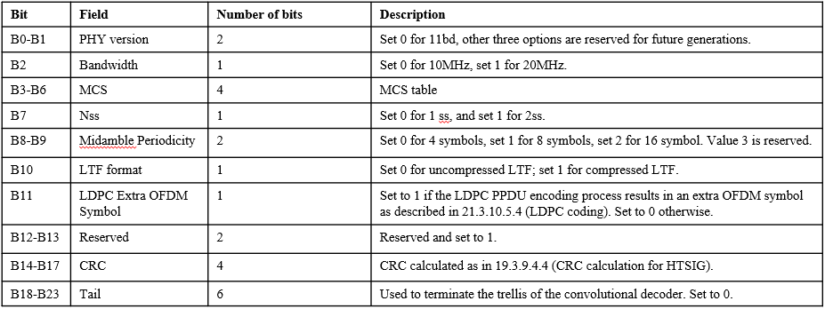
  - Moved Rui Cao
  - Second Dongguk Lim
  - Discussion: Clarification about the need for bit 11
  - Result: Motion passes unanimously
  - Motion #81 (DCN: 11-20/0044r2)
  - Move to include the following text to section 3 of the 11bd SFD
  - “11bd defines the following MCS table.”
  - 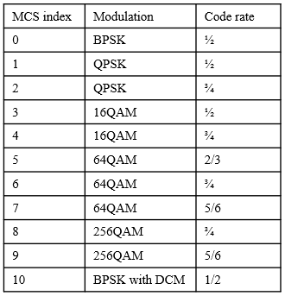
  - Moved: Rui Cao
  - Second: Dongguk Lim
  - No discussion
  - Result: Motion passes unanimously
  - Motion #82 (DCN:11-19/1863r2)
  - Discussion about the definition of N_{MA} was defined in the presentation, but missing from the table on the screen. The definition of N_{MA} is in the baseline so members agree to run the SFD motion with a note that the bottom row isn’t part of the motion. It is difficult to edit the image on the screen.
  - Move to include the following text to section 3 of the 11bd SFD
  - 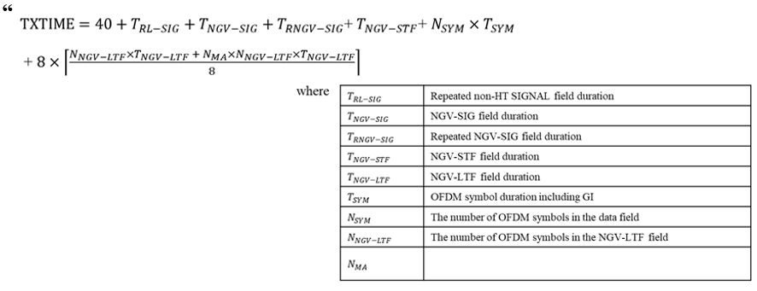
  - Note “remove the N_{MA} row”
  - Moved: Yujin Noh
  - Second: Dongguk Lim
  - No Discussion
  - Result: Motion passes unanimously
  - Motion #83 (DCN 11-19/1863r2)
  - Move to include the following text to section 3 of the 11bd SFD
  - 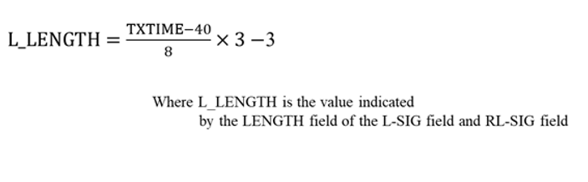
  - Moved: Yujin Noh
  - Second: Dongguk Lim
  - No Discussion
  - Result: Motion passes unanimously
  - Motion #84 (DCN:11-19/1863r2)
  - Move to include the following text to section 3 of the 11bd SFD
  - 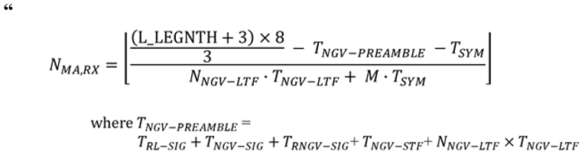
  - Moved: Yujin Noh
  - Second: Dongguk Lim
  - No discussion
  - Result: Motion passes unanimously.
  - Motion #85 (DCN:11-19/1863r2)
  - Move to include the following text to section 3 of the 11bd SFD
  - 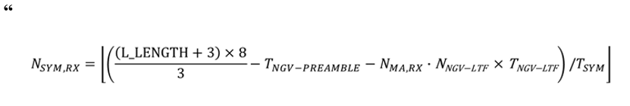
  - Moved: Yujin Noh
  - Second: Dongguk Lim
  - No discussion
  - Result: Motion passes unanimously
  - Motion #86 (DCN:11-19/1863r2)
  - Move to include the following text to section 3 of the 11bd SFD
  - 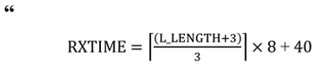
  - Moved: Yujin Noh
  - Second: Dongguk Lim
  - No discussion
  - Result: Motion passes unanimously
  - Motion #87 (DCN:11-19/1864r1)
  - Comment that some editorial work is needed on the fonts/characters used in the text but the editor can clean it up.
  - Move to include the following text to section 3 of the 11bd SFD
  - 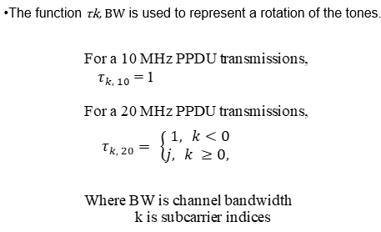
  - Moved: Yujin Noh
  - Second: Dongguk Lim
  - No Discussion
  - Result: Motion passes unanimously
  - Motion to remove motion #72 from the table
  - Moved: Ronny Kim
  - Second: Bahar Sadeghi
  - No discussion
  - Result: Motion passes without objection
  - Motion to amend motion #72 as shown on the screen
  - Motion now on the screen is:
  - Move to include the following text to section 3.2 of the 11bd SFD
  - “When OCB secondary channel is sensed busy and the duration of channel busy is not known, after the channel state transitions from busy to idle, EIFS interval shall be used to detect if the channel remains idle before resuming the backoff procedure.
  - When OCB secondary channel is sensed busy and the duration of channel busy is known, after the channel state transitions from busy to idle, AIFS interval shall be used to detect if the channel remains idle before resuming the backoff procedure.
  - Note: STA is not required to decode the duration of channel busy on the OCB secondary channel.”
  - Moved: Ronny Kim
  - Second: Hanseul Hong
  - No discussion
  - Result: Motion to amend passes unanimously
  - Amended motion#72 is now on the floor
  - No discussion
  - Result: Motion passes unanimously
  - Motion #88 (DCN:11-19/1969r2)
  - Move to include the following text to section 3 of the 11bd SFD
  - Within a 20MHz channel, one 10MHz channel is OCB primary 10MHz channel, another 10MHz channel is OCB secondary 10MHz channel.
  - The OCB primary 10MHz channel is decided by upper layer.
  - Moved: Rui Cao
  - Second: Dongguk Lim
  - No discussion
  - Result: Motion passes unanimously

Specification text motion (802.11-19/2126r4)
  - Motion for creating spec draft
  - Instruct the TGbd tech editor to create 802.11bd draft 0.2 based on draft 0.1 and the latest revisions of the following member contributions on mentor:
  - DCNs 19/1848, 19/1982, 19/1894, 20/0096, 20/0097, 20/0079, 20/0113, 20/0051, 20/0050
  - And place in the members area for review
  - Moved: Bahar Sadeghi
  - Second: Rui Cao
  - No discussion
  - Result: Motion accepted unanimously

Timeline (802.11-19/2126r4)

  - Presentation by Chair
  - Discussion:
    - Might be a delay after March, but it depends on progress during March meeting. For now, keeping the timeline unchanged.

Teleconference Plan
  - Feb 4, 18, Mar 3, 31
  - Time 9-11am ET
  - Platform Webex
  - No objection to this teleconference plan

Closing Report (802.11-20/0202r0)

  - Presentation by Chair
  - Chair reviewed his closing report slides
  - No discussion

Closing
  - Chair adjourned the meeting at 12:27pm.

Next Meetings
Face to face:
Hilton Atlanta, Georgia, USA, March 16, 2019
http://802world.org/plenary/
Teleconferences:
Feb 4, 18, Mar 3, 31
Time 9-11am ET
Platform Webex
Meeting Documents:
https://mentor.ieee.org/802.11/documents
Task Group Email reflector:
http://www.ieee802.org/11/email/stds-802-11-tgbd/index.html
Website:
http://www.ieee802.org/11/Reports/tgbd_update.htm

