IEEE P802.11
Wireless LANs
Draft technical report on interworking between 3GPP 5G network & WLAN
Date: 2021-01-04
Author(s):
Name | Affiliation | Address | Phone | email
Hyun Seo OH | ETRI | Gajeongro 218 Yusunggu  Daejeon, Korea | +82.42.860.5659 | hsoh5@etri.re.kr
Hanbyeog CHO | ETRI | Gajeongro 218 Yusunggu  Daejeon, Korea | +82.42.860.5531 | hbcho@ etri.re.kr
Yoohwa Kang | ETRI | Gajeongro 218 Yusunggu  Daejeon, Korea | +82.42.860.6364 | yhkang@etri.re.kr
Chang Han OH | allRadio Co. Ltd | 280, Seobusaet-gil, Geumcheon-gu, Seoul, Korea | +82.2.801.1310 | choh@allradio.co.kr
Shinho CHO | allRadio Co. Ltd | 280, Seobusaet-gil, Geumcheon-gu, Seoul, Korea | +82.10.3351.8424 | shcho@allradio.co.kr
Raeman KIM | allRadio Co. Ltd | 280, Seobusaet-gil, Geumcheon-gu, Seoul, Korea | +82.10.5512.9390 | rmkim01@allradio.co.kr
Si Young HEO | KT | KT R&D Center, 151, Taebong-ro, Seocho-gu, Seoul, Korea | +82.10.266.4569 | siyoung.heo@kt.com
Yangseok Jeong | KT | KT R&D Center, 151, Taebong-ro, Seocho-gu, Seoul, Korea | +82.10.9530.0856 | Yangseok.jeong@  kt.com
Hyeong Ho LEE | Nevision Telecom Inc., Korea Univ. | 412, 199, Techno2-ro, Yuseong-Gu, Daejeon, 34025, Korea | +82.42.931.4130 | hhlee@netvisiontel.com
Youngjae KIM | TTA | 47, Bundang-ro, Bundang-gu, Seongnam-city, Gyeonggi-do, 13591, Korea | +82.10.5110,2895 | yjkim@tta.or.kr
Choon Sik Yim | RCN | 199, Techno2-ro, Yuseong-Gu, Daejeon | +82.10.9531.3610 | Yim253@hnamail.net
Yixue Lei | Tencent | Tencent Building, Kejizhongyi Avenue, Hi-tech Park, Nanshan District, Shenzhen | +86-755-86013388 | yixuelei@tencent.com
Xin Zuo | Tencent | Tencent Building, Kejizhongyi Avenue, Hi-tech Park, Nanshan District, Shenzhen | +86-755-86013388 | xinzuo@tencent.com
Harry Hwang | Tencent | Tencent Building, Kejizhongyi Avenue, Hi-tech Park, Nanshan District, Shenzhen | +86-755-86013388 | harryhwang@tencent.com
Glen Hu | Tencent | Tencent Building, Kejizhongyi Avenue, Hi-tech Park, Nanshan District, Shenzhen | +86-755-86013388 | glennhu@tencent.com

Edits provided by: Joseph LEVY, AANI SC Chair [InterDigital, Inc.], Stephen McCANN [Huawei Technologies Co., Ltd.], Graham SMITH [SR Technologies]
Abstract
This contribution is a draft technical report on Wireless Local Area Network (WLAN) interworking to 3rd Generation Partnership Project (3GPP) 5th Generation (5G) network. It describes the interworking reference model and interworking types supported by 3GPP 5G network and WLAN, and defines the necessary functionalities and specific procedures that enable WLAN access networks to interwork with 3GPP 5G network. This technical report on interworking between 3GPP 5G network and WLAN will provide a reference and guideline for stakeholders with interest in standardization and system development.

Revision History

Rev.0 January 2020, Draft technical report on interworking between 3GPP 5G network and WLAN is presented by Hyun Seo Oh.

Rev.1 April 2020, Draft technical report on interworking between 3GPP 5G network and WLAN is updated by Hyun Seo Oh.

Rev.2 June 3, 2020, Harry Hwang added comments on 3.1 WLAN interworking type and N1 signaling forwarding.

Rev.3 June 23, 2020, Joseph Levy added editorial comments and updated to clarify the technical report.
3 types of TSN bridges are described.

Rev. 4 July 14, 2020, comments were made on the technical report by Binita Gupta and Necati Canpolat.
Revision on the tightly coupled and loosely coupled interworking and the terminal types (UE and STA) was made.

Rev. 5 July 28, 2020, rev. 4 of the document was reviewed on the AANI SC teleconference, all changes were discussed. This document accepts the changes and provides some minor editorial changes (spelling/grammar) to align the draft with the 802.11 editorial style (US English – based on the latest edition of Merriam-Webster’s New Collegiate Dictionary), note additional edits may be necessary. The document was also converted to PDF format, with line numbers, to support comment collection.

Rev.6. October 20, 2020, rev. 5 of the document was changed according to the comment resolution process from August 21 to October 12 AANI meeting. The update was based on comment resolution excel sheet: DCN 11-20-1262-05 “CC32-AANI-Report-Comments” by chair Joseph Levy.

Rev. 7. November 1, 2020, rev. 6 of the document is updated to clarify the terminal types: UE and STA. Figure 1 is added and figure 3 and 4 are modified. The figures are renumbered with editorial update by Harry Hwang.

Rev. 8. January 4, 2021, rev. 7 of the document was editorially updated by AANI SC chair Joseph Levy, Stephen McCann, Graham Smith, and reviewed by co-authors. The updated documents are Rev. 8 (marked version) and Rev. 9.0 (clean version).

Table of Contents

1. Definition, acronyms and abbreviations…………………………………………………….. 5
1.1 Definitions 5
1.2 Acronyms and abbreviations 6
2. Introduction……………………………………………………………………………………………... 8
2.1 Objective 8
2.2 Scope 8
3. 5GS-WLAN interworking reference model………………………………………………….. 9
3.1 WLAN interworking types 9
3.2 WLAN interworking functional model in 5G system 10
4. 5GS-WLAN interworking function and procedures…………………………………… 12
4.1 WLAN radio channel sharing method 12
4.2 Registration and authentication message procedures 12
4.2.1 Registration and authentication function 12
4.2.2 Message procedures 13
4.3 IP tunneling function and its message procedures 14
4.3.1 IP tunneling function 14
4.3.2 Message procedures 14
5. 5GS QoS management………………………………………………………………………………… 15
5.1 5GS QoS model 15
5.2 ATSSS function support 16
6. Gap analysis and recommendations………………………………………………………….. 17
6.1 Gap Analysis 17
6.2 Technical recommendations 19
6.3 TSN topics 20
7. Conclusions……………………………………………………………………………………………... 22
8. References………………………………………………………………………………………………. 23

List of Figures

Figure 1. Overview of interworking reference model 8
Figure 2. Tightly coupled interworking reference model between 5G core network and WLAN 9
Figure 3. Loosely coupled interworking reference model between 5G core network and WLAN 9
Figure 4. Untrusted WLAN interworking reference model with 5G core network 10
Figure 5. Trusted WLAN interworking reference model with 5G core network 11
Figure 6. Control plane between STA and N3IWF (3GPP TS 23.501) 12
Figure 7. R3 interface 13
Figure 8. NWu interface 13
Figure 9. N1 interface 14
Figure 10. Data plane between STA and N3IWF (3GPP TS 23.501) 14
Figure 11. QoS flows and mapping to AN resources in user plane (3GPP TS 23.501) 16
Figure 12. Architecture reference model for ATSSS support (3GPP TS 23.501) 16
Figure 13. QoS mapping and scheduling example of WLAN 19
Figure 14. TSN bridge using 5G AN and CN 20
Figure 15. TSN bridge using WLAN and 5G CN interworking 20
Figure 16. TSN bridge using WLAN only 21

List of Tables

Table 1. QoS characteristics (3GPP TS 23.501) 15
Table 2. Service categories to interwork with 3GPP core network 18
Table 3. Gap analysis of GBR service between 3GPP 5G network and WLAN 18

Definition, acronyms and abbreviations

Definitions

ANC Access network control function of Wireless Local Area Network (WLAN) access network, which refers to IEEE 802 network reference model [18].

NWt Reference point between the User Equipment (UE) and Trusted Non-3rd Generation Partnership Project (non-3GPP) Gateway Function (TNGF) in 5th Generation (5G) system [8].

NWu Reference point between the User Equipment (UE) and Untrusted Non-3rd Generation Partnership Project (non-3GPP) Inter Working Function (N3IWF) in 5th Generation (5G) system [8].

N1 Reference point between the User Equipment (UE) and the Access and Mobility Management Function (AMF) in 5th Generation (5G) system [8].

N2 Reference point between the Access Network (AN) and the Access and Mobility Management
Function (AMF) in 5th Generation (5G) system [8].

N3 Reference point between the Access Network (AN) and the User Plane Function (UPF) in 5th
Generation (5G) system [8].

N4 Reference point between the Session Management Function (SMF) and the User Plane Function (UPF) in 5th Generation (5G) core network [8].

N11 Reference point between the Access and Mobility Management Function (AMF) and the
Session Management Function (SMF) in 5th Generation (5G) core network [8].

R1 Reference point for Physical Layer (PHY)/Media Access Control (MAC) layer function between terminal and access network [18].

R3 Reference point for Physical Layer (PHY)/Media Access Control (MAC) layer function between access network and access router [18].

R8 Reference point for control and management signaling between terminal and the access network [18].

R9 Reference point for control and management interface between access network and access router [18].

Y2 Reference point for Physical Layer (PHY)/Media Access Control (MAC) layer function between the untrusted non-3rd Generation Partnership Project (non-3GPP) access network and the Non-3GPP Inter Working Function (N3IWF) which refers to 3rd Generation Partnership Project (3GPP) 23.501 [8].

Ta Reference point between the trusted non-3rd Generation Partnership Project (non-3GPP) access network and the Trusted Non-3GPP Gateway Function (TNGF), which is used to support an Authentication Authorization Accounting (AAA) interface which refers to 3rd Generation Partnership Project (3GPP) 23.501 [8].

Acronyms and abbreviations

3GPP 3rd Generation Partnership Project

5G 5th Generation

5G-AN 5th Generation Access Network

5GS 5th Generation System

AAA Authentication Authorization Accounting

AIFS Arbitrary Inter-Frame Spacing

AN Access Network

ANC Access Network Control

AMF Access and Mobility Management Function

ATSSS Access Traffic Steering Switching and Splitting

CN Core Network

DRB Data Radio Bearers

DS Distribution System

EAP-5G Extended Authentication Protocol-5th Generation

EDCA Enhanced Distributed Channel Access

ESS Extended Service Set

GBR Guaranteed Bit Rate

GRE Generic Routing Encapsulation

HCCA Hybrid Controlled Channel Access

IKEv2 Initial Key Exchange Protocol Version 2

IP Internet Protocol

IPsec Internet Protocol Security

MAC Media Access Control

MSDU MAC Service Data Unit

NAS Non-Access Stratum

N3IWF Non-3GPP Inter Working Function

PCF Policy Control Function

PDU Packet Data Unit

PER Packet Error Rate

PHY Physical Layer

RAN Radio Access Network

RAT Radio Access Technology

QoS Quality of Service

SMF Session Management Function

STA Station

TEC Terminal Control

TEI Terminal Interface

TNGF Trusted Non-3GPP Gateway Function

TSPEC Traffic Specification

TSN Time Sensitive Network

UE User Equipment

UPF User Plane Function

V2X Vehicle to Anything

WM Wireless Module

WLAN Wireless Local Area Network

Introduction

This technical report provides an overview of the IEEE 802.11 Working Group’s understanding of Wireless Local Area Network (WLAN), based on IEEE Std 802.11, interworking with the 3rd Generation Partnership Project (3GPP) 5th Generation (5G) core network.

The functional interworking reference model is described in Clause 3. Two WLAN interworking types are discussed: a tightly coupled case and a loosely coupled case.

Clause 4 describes the interworking function and specific procedures regarding radio channel sharing, registration, authentication, and IP tunneling. Clause 5 describes the 5th Generation System (5GS) model and Access Traffic Steering Switching and Splitting (ATSSS) function support. Clause 6 describes technical gap analysis, technical recommendations, and Time Sensitive Network (TSN) topics. Conclusions are summarized in Clause 7.

Objective

This technical report on WLAN interworking with the 3GPP 5G core network provides a reference and guideline for stakeholders with interest in standardization and system development of WLAN based on IEEE Std. 802.11.

Scope

The high-level interworking reference model consists of a terminal, an access network, the 3GPP 5G core network and a data network as shown in Figure 1.

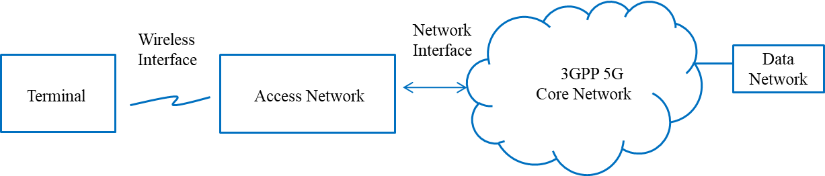

Figure 1. Overview of interworking reference model

This report considers two types of interworking reference models (tightly and loosely coupled), two types of network access (trusted and untrusted) and two types of terminals (a Station (STA) and a combined User Equipment (UE) and STA). The two interworking reference models define how coupled the 3GPP network is to the WLAN access network. The architectural models, necessary functionalities and specific procedures that allow WLAN access networks to interwork with 3GPP 5G core network are discussed for the trusted as well as untrusted case, as defined in TS 23.501, comprising integrated or stand-alone implementations of WLAN and 3GPP 5G access networks and terminals.

5GS-WLAN interworking reference model

WLAN interworking types

We consider two types of WLAN interworking: tightly coupled and loosely coupled.

The tightly coupled interworking type, as shown in Figure 2, assumes that functional entities in the terminal and the access network are tightly coupled and connect to 3GPP core network via a single network interface. This requires co-located 3GPP access and WLAN access that operate in a coordinated manner to provide wireless services via the 3GPP 5G core network. This interworking model allows for the optimization of overall system performance by integrating the access of the two access networks, enabling improved overall network access to services.

The loosely coupled interworking type, as shown in Figure 3, assumes that functional entities in the terminal and the access network operate independently and may be either co-located within a device or separated. In this interworking model, two types of terminals are considered: a STA terminal and a combined UE and STA terminal. STA terminal can only support WLAN access to interwork with 5G core network. The combined UE and STA terminal can support both 3GPP access and WLAN access to interwork with 5G core network.. The loosely coupled interworking can provide the same service functions that a tightly coupled interworking type can provide, but since the two access networks will not be coordinated there may be some loss of the ability to optimize overall network performance.

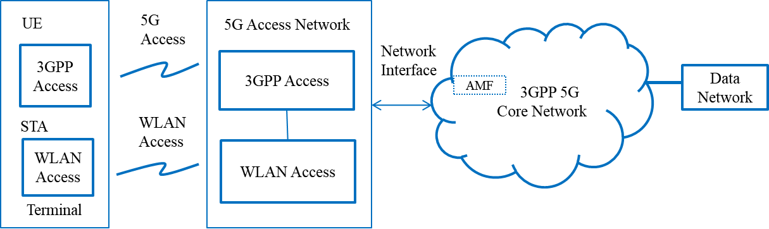

Figure 2. Tightly coupled interworking reference model between 5G core network and WLAN

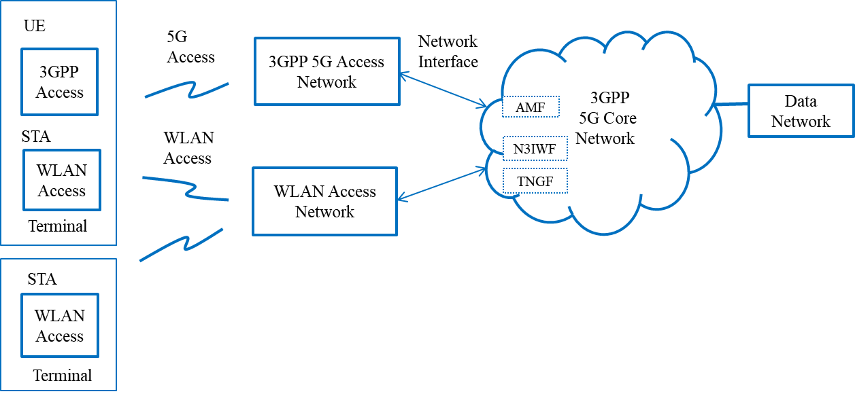

Figure 3. Loosely coupled interworking reference model between 5G core network and WLAN

3GPP cellular system has specified both RAN level (layer 2) interworking and CN level (layer 3 and above) interworking [2-4]. The RAN level interworking assumes the tightly coupled interworking model and the CN level interworking may support the loosely coupled interworking models. The 3GPP 5G system allows for WLAN access network connection as a non-3GPP Radio Access Technologies (RAT) and can be directly connected to the 5G Core Network (CN) via the Non-3GPP Inter Working Function (N3IWF) or the Trusted Non-3GPP Gateway Function (TNGF), depending on whether the WLAN is trusted or untrusted [8].

WLAN interworking functional model in 5G system

3GPP describes the 5G system-WLAN interworking function model as consisting of a UE/STA terminal, a 3GPP/WLAN access network and the 3GPP core network as shown in Figures 4 and 5.

WLAN divides the WLAN STA functions into a terminal interface (TEI) entity and a terminal control (TEC) entity. WLAN access network functions are divided into WLAN access data path and access network control (ANC) according to the WLAN network reference model of IEEE 802.1CF-2019 [18]. 3GPP 5G network functions are divided into a UE, a 3GPP access network, and the 5G core network, and their signaling interfaces are described according to the 3GPP specification [8-9].

For untrusted WLAN to 3GPP core network interworking, as shown in Figure 4, 3GPP NWu interface signaling shall be processed in the WLAN domain and N1 signaling is transparently forwarded in the WLAN domain. The N1 interface provides the signaling procedures between the UE or TEC and 3GPP 5GS core network to support Access and Mobility Management Function (AMF). The NWu interface provides the signaling procedures between the STA (TEC) and N3IWF of 3GPP core network to support a secured IP channel.

In the WLAN domain, R1 and R3 interfaces support the data flow via the Physical Layer (PHY) and Media Access Control (MAC) layers of STA and WLAN access network. In addition to the R1 and R3 interfaces, control and management interfaces R8 and R9 are defined in IEEE Std. 802.1CF, which provide Quality of Service (QoS) mapping and MAC scheduling. In Figure 4, the red colored R1/R3 and R8/R9 interfaces are in the domain of WLAN, and they are provided in the STA and the WLAN access network. The R3 interface is mapped to the Y2 interface for untrusted WLAN interworking in 3GPP domain.

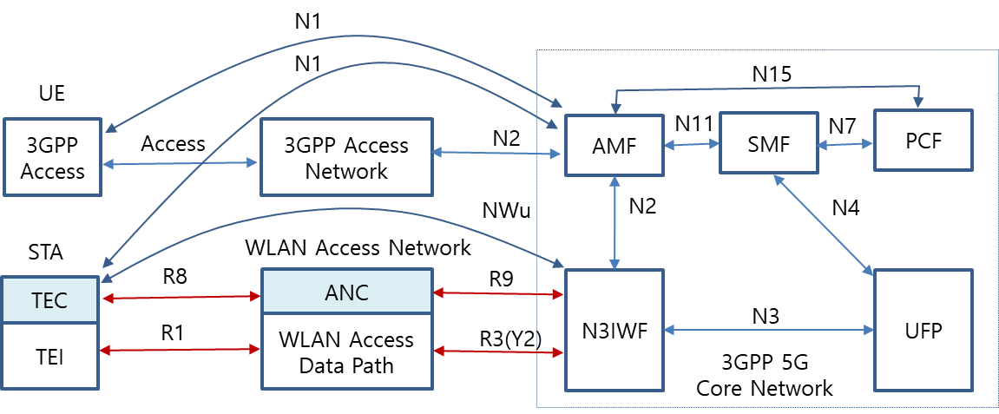

Figure 4. Untrusted WLAN interworking reference model with 5G core network

In trusted WLAN to 3GPP core network interworking, as shown in Figure 5, the NWt interface provides the signaling procedures between the STA (TEC) and TNGF of 3GPP core network to support a secured IP channel and the R3 interface is mapped to Ta interface in the 3GPP domain.

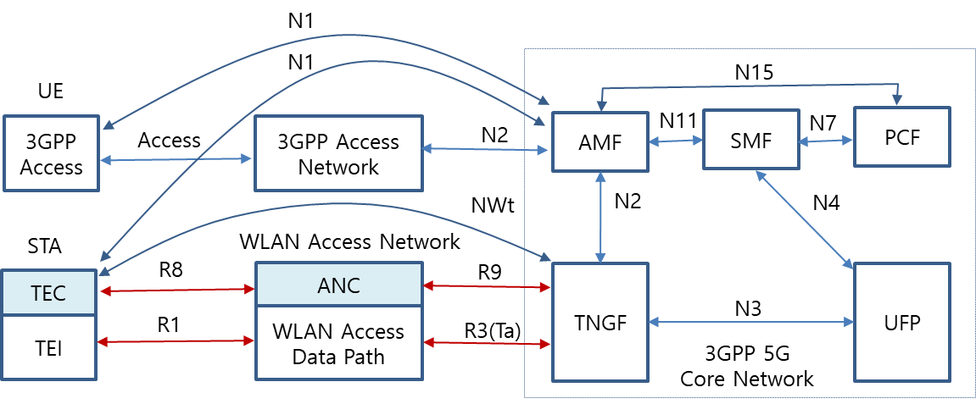

Figure 5. Trusted WLAN interworking reference model with 5G core network

5GS-WLAN interworking function and procedures

The radio channel access and communication procedures must be specified to enable WLAN interworking with 5G core network.
A radio channel sharing method is described in 4.1. Initial registration and authentication procedures between STA and AMF of 5G core network are described in 4.2. Examples of IP secure transport and data exchange procedures between the STA of the terminal device and User Plane Function (UPF) of 5G core network are described in 4.3.

WLAN radio channel sharing method

The STA TEI monitors WLAN access network usage to determine if the WLAN radio channel is busy or idle. If the radio channel is idle, the STA may attempt to send control or data traffic through the WLAN radio channel. If the radio channel is busy, the STA will not send control or data traffic through the WLAN radio channel, and it will wait until the radio channel is idle.

Registration and authentication message procedures

The STA shall initially support registration and authentication to establish a connection between the STA (TEC) and N3IWF. NWu for registration and authorization involves IP protocol, IKEv2 and EAP-5G protocol, and secured signaling tunnel over N1 (a.k.a. signaling radio bearer) is required to exchange Non-Access Stratum (NAS) signals.

Registration and authentication function

Association and authentication services provided by the IEEE 802.11 Distribution System (DS) allow the N3IWF to perform the required registration and authentication of individual IEEE 802.11 STAs within an Extended Service Set (ESS). Figure 6 shows the control plane interface between STA and N3IWF, which includes the following protocols.

- IP communication protocol
- IKEv2 authorization protocol
- EAP-5G protocol

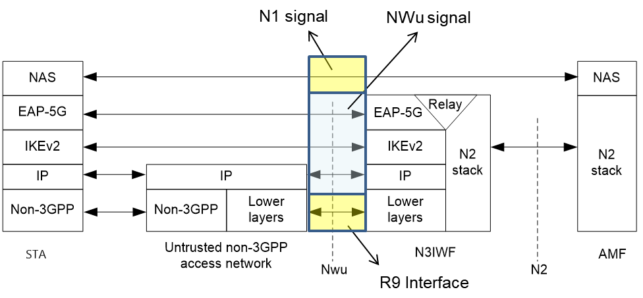
Figure 6. Control plane between STA and N3IWF (3GPP TS 23.501)

Message procedures

- R3 interface

The R3 interface is Ethernet protocol between WLAN access network and N3IWF (see Figure 7). An IEEE 802.11 DS within WLAN access network connects an ANC incorporated in an Access Point Portal or Mesh Gate to a N3IWF.

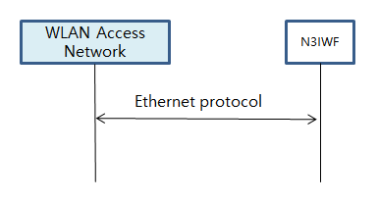

Figure 7. R3 interface

- NWu interface

The NWu interface is an IP based communication protocol between a STA in the WLAN access network and N3IWF of 3GPP 5G core network, used to establish a secured data channel. The IKEv2 authorization protocol and EAP-5G protocol for N2 interface are applied as shown in Figure 8.

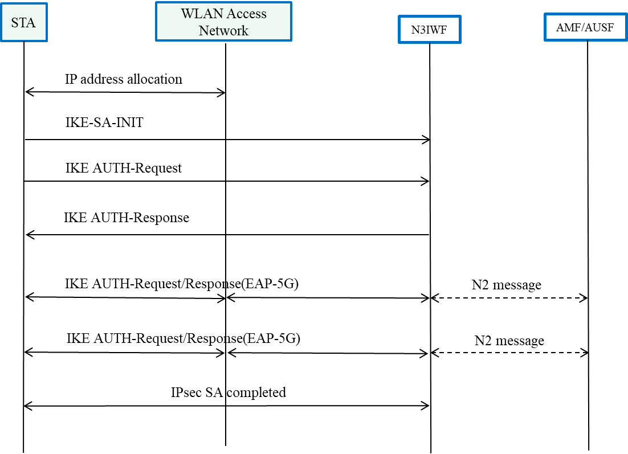

Figure 8. NWu interface

- N1 interface

The N1 interface uses a secured IP communication protocol between STA of WLAN access network and AMF of 3GPP 5G core network to provide NAS signaling, as shown in Figure 9.

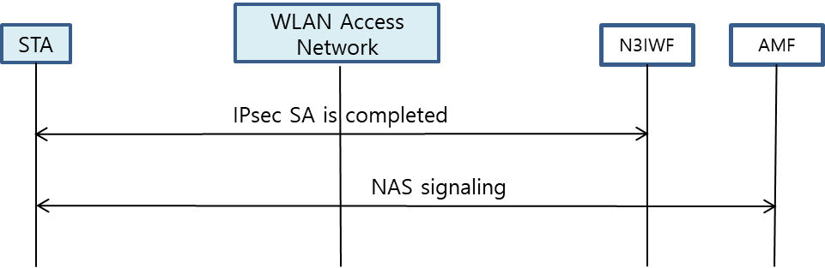

Figure 9. N1 interface

IP tunneling function and its message procedures

A STA shall support secured IP transport between terminal unit and UPF, and traffic data is exchanged over the established IP channel.

IP tunneling function

The STA and N3IWF shall have the following specific functional requirements to interwork with 3GPP 5G core network (see Figure 10).

- IP communication protocol
- IPsec communication protocol
- GRE communication protocol

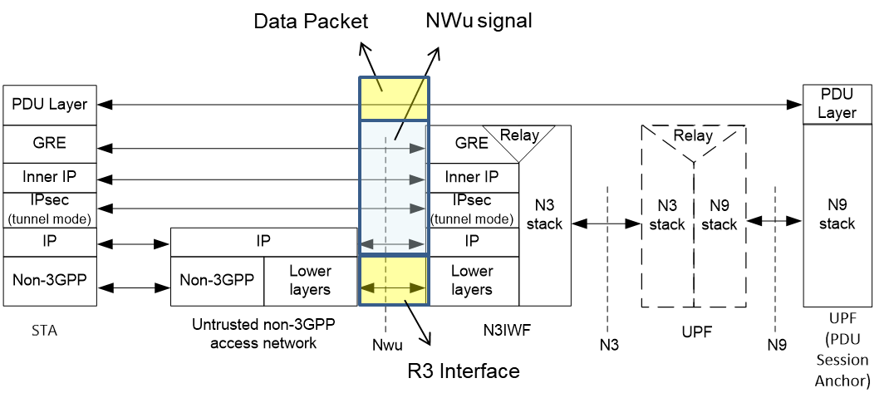

Figure 10. Data plane between STA and N3IWF (3GPP TS 23.501)

Message procedures

The STA and N3IWF shall provide IPsec tunneling and PDU session establishment to interwork with 3GPP 5G core network:

- IPsec tunneling procedures shall be processed via the WLAN access network.
- PDU session establishment shall be processed via the WLAN access network.

5GS QoS management

5GS QoS model

The 3GPP Quality of Service (QoS) flow is access agnostic. When the traffic is distributed between the 5G access network and the WLAN access network, the same QoS should be supported. Issues arise if the WLAN access network cannot support the QoS treatment required by the 5G access network. QoS flows for Guaranteed Bit Rate (GBR) traffic and Non-GBR traffic are specified in 3GPP TS 23.501 and QoS flows are defined as follows:

- GBR QoS flow: A QoS flow using the GBR resource type or the Delay-critical GBR resource type and requiring a guaranteed flow bit rate.

- Non-GBR QoS flow: A QoS flow using the Non-GBR resource type and not requiring a guaranteed flow bit rate.

Table 1 shows the characteristics of GBR and delay critical GBR QoS flows from 3GPP. Therefore, it is necessary that GBR flows are supported by the WLAN in both directions, e.g., non-AP STA to AP and AP to non-AP STA.

Table 1. QoS characteristics (3GPP TS 23.501)
Resource Type | Default Priority Level | Packet Delay Budget | Packet Error  Rate | Default Maximum Data Burst Volume | Default  Averaging Window | Example Services
GBR | 20 | 100 ms | 10⁻² | N/A | 2000 ms | Conversational Voice
 | 40 | 150 ms | 10⁻³ | N/A | 2000 ms | Conversational Video (Live Streaming)
 | 30 | 50 ms | 10⁻³ | N/A | 2000 ms | Real Time Gaming, V2X messages  Electricity distribution – medium voltage, Process automation - monitoring
 | 50 | 300 ms | 10⁻⁶ | N/A | 2000 ms | Non-Conversational Video (Buffered Streaming)
 | 7 | 75 ms | 10⁻² | N/A | 2000 ms | Mission Critical user plane Push To Talk voice (e.g., MCPTT)
 | 20 | 100 ms | 10⁻² | N/A | 2000 ms | Non-Mission-Critical user plane Push To Talk voice
 | 15 | 100 ms | 10⁻³ | N/A | 2000 ms | Mission Critical Video user plane
 | 56 | 150 ms | 10⁻⁶ | N/A | 2000 ms | "Live" Uplink Streaming (e.g., TS 26.238 [y])
 | 56 | 300 ms | 10⁻⁴ | N/A | 2000 ms | "Live" Uplink Streaming (e.g., TS 26.238 [y])
 | 56 | 300 ms | 10⁻⁸ | N/A | 2000 ms | "Live" Uplink Streaming (e.g., TS 26.238 [y])
 | 56 | 500 ms | 10⁻⁸ | N/A | 2000 ms | "Live" Uplink Streaming (e.g., TS 26.238 [y])
 | 56 | 500 ms | 10⁻⁴ | N/A | 2000 ms | "Live" Uplink Streaming (e.g., TS 26.238 [y])
Delay Critical GBR | 19 | 10 ms | 10-4 | 255 bytes | 2000 ms | Discrete Automation (see TS 22.261 [x])
 | 22 | 10 ms | 10-4 | 1354 bytes | 2000 ms | Discrete Automation (see TS 22.261 [x])
 | 24 | 30 ms | 10-5 | 1354 bytes | 2000 ms | Intelligent transport systems (see TS 22.261 [x])
 | 21 | 5 ms | 10-5 | 255 bytes | 2000 ms | Electricity Distribution- high voltage (see TS 22.261 [x])

The Session Management Function (SMF) assigns QoS profile to AN in WLAN domain with QoS Flow Identification (QFI), which defines the QoS parameters for a QoS flow in the PDU session. The QoS flow is then mapped to AN resources for the assigned QFI (see Figure 11).

Figure 11. QoS flows and mapping to AN resources in user plane (3GPP TS 23.501)

ATSSS function support

Traffic data shall be transmitted over the WLAN access channel and/or 3GPP access channel by using the ATSSS function. In this subclause, in the loosely coupled interworking model, the terminal UE type is assumed to support the ATSSS function.

- 3GPP supports ATSSS between 3GPP and non-3GPP access networks.
- ATSSS can enable traffic selection, switching and splitting between the 5th Generation Access Network (5G-AN) and WLAN, shown in Figure 12 as 3GPP access and non-3GPP Access, respectively.

Figure 12. Architecture reference model for ATSSS support (3GPP TS 23.501)

Figure 12 shows the reference architecture for supporting ATSSS which handles either Guaranteed Bit Rate flow (GBR) QoS flow or Non-GBR QoS flow traffic.

Gap analysis and recommendations

Gap analysis

In the technical gap analysis the terminal STA is assumed to be compatible with the new functionalities and communication protocols necessary to interwork with 5G core network. These new functionalities and communication protocols are assumed to be implemented in the STA and WLAN access network devices.

The higher layer control and protocols (i.e., IKEv2, EAP-5G, IPsec and GRE) provided by the 3GPP 5G core network to support interworking, are defined and specified by the Internet Engineering Task Force (IETF) and modified for interworking by 3GPP. These protocols can be implemented in the STA TEC and WLAN ANC.

NAS signaling to AMF and packet session control to SMF are specified in 3GPP specifications and can be implemented in STA TEC and WLAN ANC. WLAN QoS management was first introduced in IEEE Amendment 802.11e and is specified in IEEE Std 802.11-2016, and can be adapted to support fine granularity of QoS levels.

The 3GPP specification provides GBR, Non-GBR and delay critical GBR QoS requirements. The delay critical GBR is specified to require low latency (less than 30msec) and low packet error rate (PER) (less than 10⁻⁴). 3GPP also specifies QoS management to support packet delay, PER, default maximum data burst volume and default average window for several service types.

3GPP resource types and QoS related parameters are provided to the WLAN using R8 and R9 interfaces. WLAN supports QoS function and related message procedures, which provide QoS mapping, scheduling algorithm and MAC interface that support the QoS requirements. STA TEC and WLAN ANC must provide the necessary functionality to support these requirements.

The EDCA of IEEE Std 802.11-2016 covers four classes of QoS management: background, best effort, audio and video. EDCA QoS is managed according to service class, contention window and Arbitrary Inter-Frame Spacing (AIFS) value. This capability allows WLAN to use EDCA as currently specified to support some GBR as well as non-GBR services. EDCA is contention based and therefore may not be capable of meeting some GBR requirements in a WLAN without low latency access to the Wireless Media (WM). Low latency access is dependent on the load on the WM due to RF interference, the network traffic load and how other users are using the WM. Hybrid Controlled Channel Access (HCCA) relies upon Traffic Specifications (TSPECs) to allocate controlled access and does have the potential to provide low latency and GBR, but will set a limit based on the available WM access latency. 3GPP system specifies QoS profiles and characteristics in the following areas:

- Service priority level
- Packet latency
- Packet error rate
- Guaranteed data rate
- Averaging window

To support 3GPP QoS requirement the STA TEC and WLAN ANC should process QoS management according to the QoS profile provided by 3GPP 5G core network. Table 2 shows service categories and related WLAN specification to interwork with 3GPP core network, and Table 3 shows gap analysis of GBR service between 3GPP 5G network and WLAN.

Table 2. Service categories to interwork with 3GPP core network

Service Categories | Related WLAN function | Related WLAN Specification
Non-GBR | 4 service classes; Background, Best effort, audio and video | IEEE 802.11e
GBR | To be defined in fine granularity of service classes and QoS management | Shall specify QoS mapping and scheduling. And IEEE 802.1 TSN is for deterministic Ethernet network.

Table 3. Gap analysis of GBR service between 3GPP 5G network and WLAN

Resource Type | Services Examples | Packet Delay Budget | PER | Default Maximum Data Burst Volume | Gap Analysis of WLAN specification
GBR | Conversational Voice | 100 ms | 10⁻² | N/A | . 802.11ax MAC cannot support 3GPP GBR service requirements of deterministic packet latency, PER and data rate because EDCA is CSMA based MAC and supports only 4 service types of best effort, background, voice and video by controlling TXOP, AIFSN & contention window size.  . Enhanced MAC (802.11be) should consider QoS mapping, packet scheduling and related management procedures to support GBR. PHY and MAC should be improved to control packet latency and reliability.  . QoS flow identification and service priority shall be mapped to have fine granularity of service types and QoS parameters.
 | Conversational Video | 150 ms | 10⁻³ | N/A
 | Real Time Gaming, V2X messages | 50 ms | 10⁻³ | N/A
 | Non-Conversational Video | 300 ms | 10⁻⁶ | N/A
 | MCPTT | 75 ms | 10⁻² | N/A
 | Non-MCPTT | 100 ms | 10⁻² | N/A
 | MC-Video | 100 ms | 10⁻³ | N/A
 | "Live" Uplink Streaming | 150 ms | 10⁻⁶ | N/A
 | "Live" Uplink Streaming | 300 ms | 10⁻⁴ | N/A
 | "Live" Uplink Streaming | 300 ms | 10⁻⁸ | N/A
 | "Live" Uplink Streaming | 500 ms | 10⁻⁸ | N/A
 | "Live" Uplink Streaming | 500 ms | 10⁻⁴ | N/A
Delay Critical GBR | Discrete Automation | 10 ms | 10-4 | 255 bytes | . 802.11ax MAC cannot guarantee 3GPP delay critical GBR service requirements of latency, PER and guaranteed data rate.  . Enhanced MAC (802.11be) should consider QoS mapping, packet scheduling and related management procedures to support GBR. PHY and MAC should be improved to control packet latency and reliability.  . 802.11bd NGV should consider ITS service requirement.
 | Discrete Automation | 10 ms | 10-4 | 1354 bytes
 | Intelligent transport systems | 30 ms | 10-5 | 1354 bytes
 | Electricity Distribution- high voltage | 5 ms | 10-5 | 255 bytes

3GPP QoS flow in SMF describes QoS identification and its priority according to resource types, and the QoS information is transferred to AP and STA. QoS mapping from 3GPP QoS to WLAN QoS is necessary. WLAN must support fine granularity for QoS and priority because 5G QoS ID has 6 bits and specifies QoS parameters involving GBR, latency and PER. The packet scheduling function in STA and AP should configure the MAC operation to support the required QoS. AP QoS profile and STA Data Radio Bearers (DRB), provided by the 5G Core, contains service QoS identification and parameters to define data rate, packet latency and PER values. The packet scheduler configures data rate, packet latency, PER and packet size for an MSDU packet to support these requirements (see Figure 13).

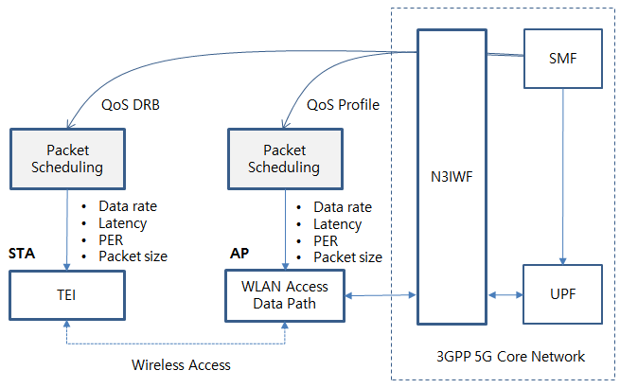
Figure 13. QoS mapping and scheduling example of WLAN
QoS mapping to the WLAN domain relies on the R9 and N1 interfaces to send QoS profile and QoS DRB information, respectively. Alternatively, QoS DRB may be delivered from the AP to the STA over R8 interface if QoS DRB through NAS signaling is not available.

It is well known that TSPEC based transmission time scheduling can guarantee low packet latency and that Hybrid ARQ supports PER improvement [19-20]. To support GBR, data rate and bandwidth control are required.

Technical recommendations

WLAN supports high data rates that are necessary to meet the performance goals of the 5G network in the low mobility scenarios, and WLAN needs to support interworking capability to 3GPP 5G network for ATSSS function. Therefore, the 802.11 Working Group should consider adding some new functional entities and signaling procedures to enhance the support of interworking with the 3GPP 5G network. Enhancements to the following 802.11 services and facilities should be considered:

- Active scanning facility
- Association
- Authentication
- QoS facility

The key areas to be considered are:

- Radio scanning and association process is specified in WLAN 802.11. However, additional radio scanning for ATSSS function should be supported.

- IKEv2, EAP-5G and IPsec protocol for registration and authentication support should be added in the implementation of STA TEC and the WLAN ANC.

- NAS signaling to connect AMF should be added in the implementation of STA TEC and the WLAN ANC.

- Packet session initiation/modification/termination to connect SMF should be added in implementation of the STA TEC and WLAN ANC.

- Packet data QoS management of WLAN shall specify QoS identification, profile and DRB to guarantee packet delay and PER for the required service types.
  - QoS mapping to WLAN is necessary to support more granularity of QoS ID and parameters.
  - Packet scheduling in the STA and AP should meet data rate, latency and PER.
  - Timing scheduling and the introduction of a Hybrid ARQ scheme may be necessary to support GBR.
  - 802.11ax, as implemented, cannot fully support all 3GPP service QoS requirements. Improvements being developed in 802.11be EHT and 802.11bd (NGV) should consider MAC enhancements to support these service requirements.

Consideration of the WLAN interworking model and terminal types to support 3GPP 5G interworking can provide insight to real world requirements and should be considered for 802.11 interworking system design and implementations. For example, the terminal STA type should support both data and control functions to interworking with 5G core network. The terminal UE will support all the control functions for interwork with 5G core network and WLAN access function of UE can be used to support high speed data requirements.

TSN topics

3GPP 5G System can be integrated with the external TSN as a TSN bridge. The TSN bridge includes TSN translator functionality for interoperation between TSN System and 5G System both for user plane and control plane. The 5G system TSN translator functionality consists of device-side TSN translator (DS-TT) and network-side TSN translator (NW-TT). 5G system specific procedures in a 5G core network and RAN, wireless communication links, etc. remain hidden from the TSN network [8]

As for TSN applications, such as smart factory and automation field, TSN bridges can be configured in three different types. The first type is to use 5G system as a TSN bridge (see Figure 14). 3GPP domain needs to consider the timing synchronization and TSN translator (TT) function in UE and 5G CN. The second type is to use WLAN and 5G CN interworking as a TSN bridge (see Figure 15). The third type is to use WLAN only as a TSN bridge (see Figure 16).

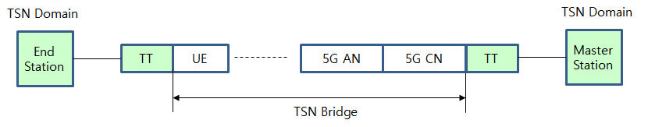
Figure 14. TSN bridge using 5G AN and CN

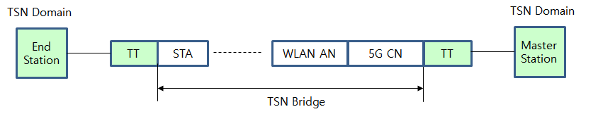

Figure 15. TSN bridge using WLAN and 5G CN interworking

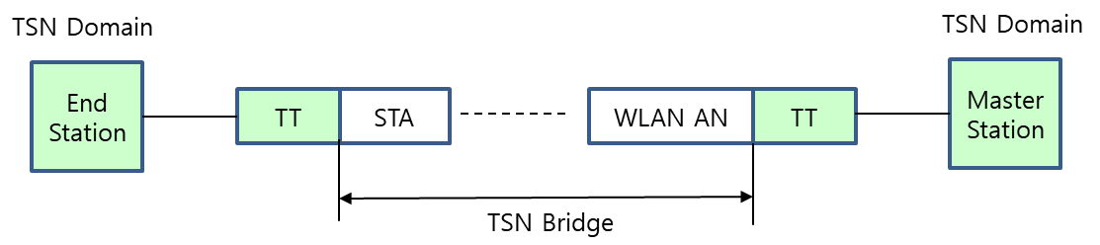

Figure 16. TSN bridge using WLAN only

Conclusions

The IEEE 802.11 Standard can support interworking with the 3GPP 5G network and is able to support high data rates to meet the performance goals of 5G network vision in the low mobility scenario. The new functional entities and signaling procedures have been identified:

- Radio scanning and association
- Registration and authentication
- NAS signaling messages
- Packet session initiation/modification/termination
- Packet data QoS management

Through gap analysis, the STA TEC and WLAN ANC can use or adapt IEEE WLAN radio scanning and association process, IETF specification such as IKEv2, EAP-5G and IPsec for implementation. the STA TEC and WLAN ANC can implement NAS signaling, ATSSS and QoS management functions, and should follow the guidance of the 3GPP specifications.

In the loosely coupled interworking model, the new functional entities and signaling procedures can be assigned to UE or STA to interwork with 5G core network. A terminal consisting of UE and STA can support all of the described control and signaling functions. A terminal consisting only of STA should be augmented so that it can support all the control and signaling functions required by the interworking with 5G network.

As for QoS management, IEEE 802.11 should specify enhancements to its QoS mapping and MAC scheduling that include QoS identification and profiles to guarantee QoS in terms of deterministic packet delay, low PER and data rate. The new WLAN interfaces R8 and R9 have been defined to deliver QoS profiles between 5G CN (N3IWF, TNGF) and a WLAN STA to be supported.

Regarding TSN applications, WLAN domain should consider introducing or enhancing capabilities to achieve timing synchronization required to operate in the TSN domain, and how to implement TSN translation in WLAN STAs interworking with the 3GPP 5G CN.

References

- 3GPP TS 22.261 V15.5.0 (2018-06) “Service requirements for the 5G system (Stage 1)”
- 3GPP TS 22.278 “Service requirements for the Evolved Packet System (EPS)”
- 3GPP TS 23.401 “EPS Architecture and Procedures”
- 3GPP TS 23.402 "Architecture enhancements for non-3GPP accesses”
- 3GPP TR 23.716 “Study on the Wireless and Wireline Convergence for the 5G System Architecture”
- 3GPP TR 23.793 “Study on Access Traffic Steering, Switching and Splitting support in the 5G system architecture”
- 3GPP TR 23.799 “Study on Architecture for Next Generation System”
- 3GPP TS 23.501 “System Architecture for the 5G System (Stage 2)”
- 3GPP TS 23.502 “Procedures for the 5G System (Stage 2)”
- 3GPP TS 24.302 “Access to the 3GPP Evolved Packet Core (EPC) via non-3GPP access networks (Stage 3)”
- 3GPP TS 24.501 “Non-Access-Stratum (NAS) protocol for 5G System (5GS) (Stage 3)”
- 3GPP TS 24.502 “Access to the 3GPP 5G Core Network (5GCN) via Non-3GPP Access Networks (N3AN) (Stage 3)”
- 3GPP TS 33.501 “Security Architecture and Procedure for the 5G System”
- 3GPP TR 33.899 “Study on the Security Aspects of the Next Generation System”
- 3GPP TS 37.324 “Service Data Adaptation Protocol (SDAP) Specification”
- 3GPP TS 38.300 “NR and NG-RAN Overall Description”
- RAN convergence paper, WBA and NGMN alliance, September 2019.
- IEEE 802.1CF-2019; IEEE Recommended Practice for Network Reference Model and Functional Description of IEEE 802® Access Network, 2019.
- Lim, L. W., et al. "A QoS scheduler for IEEE 802.11 e WLANs." First IEEE Consumer Communications and Networking Conference, 2004. CCNC 2004. IEEE, 2004.
- Lott, Christopher, Olgica Milenkovic and Emina Soljanin. "Hybrid ARQ: Theory, state of the art and future directions." 2007 IEEE Information Theory Workshop on Information Theory for Wireless Networks. IEEE, 2007.

