IEEE P802.11
Wireless LANs
Draft technical report on interworking between 3GPP 5G network & WLAN
Date: 2020-11-01
Author(s):
Name | Affiliation | Address | Phone | email
Hyun Seo OH | ETRI | Gajeongro 218 Yusunggu  Daejeon, Korea | +82.42.860.5659 | hsoh5@etri.re.kr
Hanbyeog CHO | ETRI | Gajeongro 218 Yusunggu  Daejeon, Korea | +82.42.860.5531 | hbcho@ etri.re.kr
Yoohwa Kang | ETRI | Gajeongro 218 Yusunggu  Daejeon, Korea | +82.42.860.6364 | yhkang@etri.re.kr
Chang Han OH | allRadio Co. Ltd | 280, Seobusaet-gil, Geumcheon-gu, Seoul, Korea | +82.2.801.1310 | choh@allradio.co.kr
Shinho CHO | allRadio Co. Ltd | 280, Seobusaet-gil, Geumcheon-gu, Seoul, Korea | +82.10.3351.8424 | shcho@allradio.co.kr
Raeman KIM | allRadio Co. Ltd | 280, Seobusaet-gil, Geumcheon-gu, Seoul, Korea | +82.10.5512.9390 | rmkim01@allradio.co.kr
Si Young HEO | KT | KT R&D Center, 151, Taebong-ro, Seocho-gu, Seoul, Korea | +82.10.266.4569 | siyoung.heo@kt.com
Yangseok Jeong | KT | KT R&D Center, 151, Taebong-ro, Seocho-gu, Seoul, Korea | +82.10.9530.0856 | Yangseok.jeong@  kt.com
Hyeong Ho LEE | Nevision Telecom Inc., Korea Univ. | 412, 199, Techno2-ro, Yuseong-Gu, Daejeon, 34025, Korea | +82.42.931.4130 | hhlee@netvisiontel.com
Youngjae KIM | TTA | 47, Bundang-ro, Bundang-gu, Seongnam-city, Gyeonggi-do, 13591, Korea | +82.10.5110,2895 | yjkim@tta.or.kr
Choon Sik Yim | RCN | 199, Techno2-ro, Yuseong-Gu, Daejeon | +82.10.9531.3610 | Yim253@hnamail.net
Yixue Lei | Tencent | Tencent Building, Kejizhongyi Avenue, Hi-tech Park, Nanshan District, Shenzhen | +86-755-86013388 | yixuelei@tencent.com
Xin Zuo | Tencent | Tencent Building, Kejizhongyi Avenue, Hi-tech Park, Nanshan District, Shenzhen | +86-755-86013388 | xinzuo@tencent.com
Harry Hwang | Tencent | Tencent Building, Kejizhongyi Avenue, Hi-tech Park, Nanshan District, Shenzhen | +86-755-86013388 | harryhwang@tencent.com
Glen Hu | Tencent | Tencent Building, Kejizhongyi Avenue, Hi-tech Park, Nanshan District, Shenzhen | +86-755-86013388 | glennhu@tencent.com

Abstract
This contribution is a draft technical report on WLAN interworking to 3GPP 5G network. It describes the interworking reference model and interworking types supported by 3GPP 5G network and WLAN, and defines the necessary functionalities and specific procedures that enable WLAN access networks to interwork with 3GPP 5G network. This technical report on interworking between 3GPP 5G network and WLAN will provide a reference and guideline for stakeholders with interest in standardization and system development.

Revision History

Rev.0 January 2020, Draft technical report on interworking between 3GPP 5G network and WLAN is presented by Hyun Seo Oh.

Rev.1 April 2020, Draft technical report on interworking between 3GPP 5G network and WLAN is updated by Hyun Seo Oh.

Rev.2 June 3, 2020, Harry Hwang added comments on 3.1 WLAN interworking type and N1 signalling forwarding.

Rev.3 June 23, 2020, Joseph Levy added editorial comments and updated to clarify the technical report.
3 types of TSN bridges are described.

Rev. 4 July 14, 2020, comments were made on the technical report by Binita Gupta and Necati Canpolat.
Revision on the tightly coupled and loosely coupled interworking and the terminal types (UE and STA) was made.

Rev. 5 July 28, 2020, rev. 4 of the document was reviewed on the AANI SC teleconference, all changes were discussed. This document accepts the changes and provides some minor editorial changes (spelling/grammar) to align the draft with the 802.11 editorial style (US English – based on the latest edition of Merriam-Webster’s New Collegiate Dictionary), note additional edits may be necessary. The document was also converted to PDF format, with line numbers, to support comment collection.

Rev.6. October 20, 2020, rev. 5 of the document was changed according to the comment resolution process from August 21 to October 12 AANI meeting. The update was based on comment resolution excel sheet: DCN 11-20-1262-05 “CC32-AANI-Report-Comments” by chair Joseph Levy.

Rev. 7. November 1, 2020, rev. 6 of the document is updated to clarify the terminal types: UE and STA. Figure 1 is added and figure 3 and 4 are modified. And the figures are renumbered with editorial update by Harry Hwang.

The Table of Contents

- Definition, acronyms and abbreviations
  - Definitions
  - Acronyms and abbreviations

- Introduction
  - Objective
  - Scope

- 5GS-WLAN interworking reference model
  - WLAN Interworking types
  - WLAN interworking functional model in 5G system

- 5GS-WLAN Interworking function and procedures
  - WLAN radio channel sharing method
  - Registration and authentication and its message procedures
  - IP Tunneling function and its message procedures

- 5GS QoS management
  - 5GS QoS model
  - ATSSS function support

- Gap analysis and Recommendations
  - Gap Analysis
  - Technical Recommendations
  - TSN topics

- Conclusions

References

- Definition, acronyms and abbreviations

  - Definitions

ANC Access network control function of WLAN access network, which refers to IEEE 802 network reference model [18].

NWt Reference point between the UE and TNGF in 5G system [8].

NWu Reference point between the UE and N3IWF in 5G system [8].

N1 Reference point between the UE and the AMF in 5G system [8].

N2 Reference point between the (R)AN and the AMF in 5G system [8].

N3 Reference point between the (R)AN and the UPF in 5G system [8].

N4 Reference point between the SMF and the UPF in 5G core network [8]

N7 Reference point between the SMF and the PCF in 5G core network [8].

N11 Reference point between the AMF and the SMF in 5G core network [8].

N15 Reference point between the PCF and the SMF in 5G core network [8].

R1 Reference point for PHY/MAC layer function between terminal and access network [18].

R3 Reference point for PHY/MAC layer function between access network and access router [18].

R8 Reference point for control and management signaling between terminal and the access network [18].

R9 Reference point for control and management interface between access network and access router [18].

Y2 Reference point for PHY/MAC layer function between the untrusted non-3GPP access network and the N3IWF which refers to 3GPP 23.501 [8].

Ta Reference point between the trusted non-3GPP access network and the TNGF, which is used to support an AAA interface which refers to 3GPP 23.501 [8].

  - Acronyms and abbreviations

3GPP 3rd Generation Partnership Project

5G 5th Generation

5G-AN 5th Generation Access Network

AIFS Arbitrary Inter-Frame Spacing

AN Access Network

ANC Access Network Control

AMF Access and Mobility Management Function

ATSSS Access Traffic Steering Switching and Splitting

CN Core Network

HCCA Hybrid Controlled Channel Access

EAP-5G Extended Authentication Protocol-5th Generation

EDCA Enhanced Distributed Channel Access

GBR Guaranteed Bit Rate

GRE Generic Routing Encapsulation

IKEv2 Initial Key Exchange Protocol Version 2

IP Internet Protocol

IPsec Internet Protocol Security

MAC Media Access Control

NAS Non-Access Stratum

N3IWF Non-3GPP Inter Working Function

PCF Policy Control Function

PDU Packet Data Unit

PER Packet Error Rate

PHY Physical Layer

RAN Radio Access Network

RAT Radio Access Technology

QoS Quality of Service

SMF Session Management Function

STA Station

TEC Terminal Control

TEI Terminal Interface

TNGF Trusted Non-3GPP Gateway Function

TSN Time Sensitive Network

UE User Equipment

UPF User Plane Function

V2X Vehicle to Anything

WLAN Wireless Local Area Network

- Introduction

This clause introduces objective and scope of the technical report on WLAN interworking to 3GPP 5G core network. WLAN interworking types can be divided into a tightly coupled or loosely coupled model, and functional reference model to interwork with 3GPP 5G network is described in Clause 3.

Clause 4 describes the interworking function and specific procedures regarding radio channel sharing, registration and authentication, IP tunneling. Clause 5 describes 5GS model and ATSSS function support, and Clause 6 describes technical gap analysis, technical recommendations and TSN topics. Finally, conclusions are summarized in Clause 7.

  - Objective

This technical report on interworking between 3GPP 5G network and WLAN provides a reference and guideline for stakeholders with interest in standardization and system development of WLAN (IEEE Std. 802.11).

  - Scope

This report considers two types of interworking reference model: a tightly coupled model and loosely coupled model that connects different types of terminal individually. The architectural models, necessary functionalities and specific procedures that allow WLAN access networks to interwork with 3GPP 5G core network services are discussed for both the trusted as well as untrusted case as defined in TS 23.501 comprising integrated or stand-alone implementations of WLAN and 3GPP 5G access networks and terminals.

The high level interworking reference model consists of terminal, access networks, 3GPP 5G core network and a data network as shown in Figure 1.
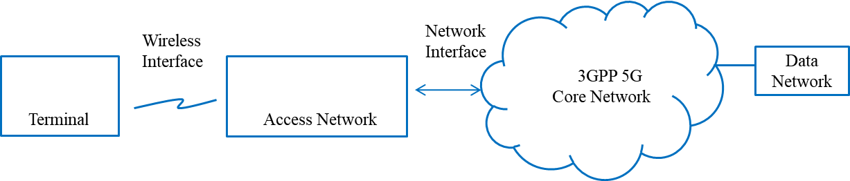
Figure 1. Overview of interworking reference model

In Figure 2, it further entails the functions within each entity. There are two terminal types: 1) a UE and a STA, 2) a STA. 3GPP access network and 5G core network are defined in 3GPP specification [8, 16] and WLAN access network considered is defined in the IEEE 802 network reference model of IEEE 802.1CF-2019 [18].

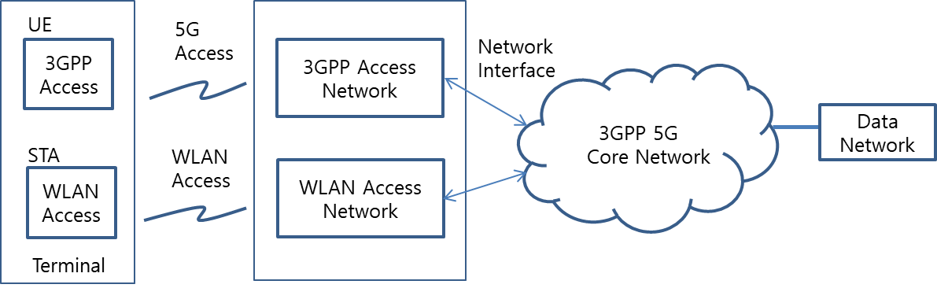

Figure 2. Overview of WLAN interworking with 3GPP 5G core network

- 5GS-WLAN interworking reference model

  - WLAN interworking types

We introduce two types of WLAN interworking: tightly coupled interworking and loosely coupled interworking. The tightly coupled interworking type assumes that functional entities of the terminal and the two access networks are combined together and connect to 3GPP core network thus allowing a co-located 3GPP access network and a WLAN access. Allowing a co-located 3GPP access network and WLAN access network to operate in a coordinated manner provides wireless services via the 3GPP 5G core network. This interworking model allows for the optimization of overall system performance by integrating the access of the two access networks from an architecture design perspective, enabling improved overall network access to services.

The loosely coupled interworking type assumes that 3GPP and WLAN access networks operate independently and may be either co-located or be separate. In this interworking model, there are two types of terminals: UE or STA. The terminal UE type can support both 3GPP access and WLAN access to interwork with 5G core network and STA type can support WLAN access only to interwork with 5G core network. This type of interworking can provide the same service functions as a tightly coupled interworking type, though the optimization of access to the two access networks will not be coordinated.

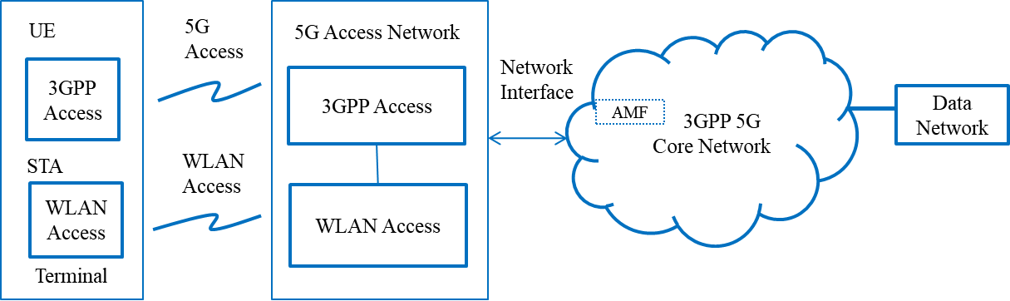

Figure 3. Tightly coupled interworking reference model between 5G core network and WLAN

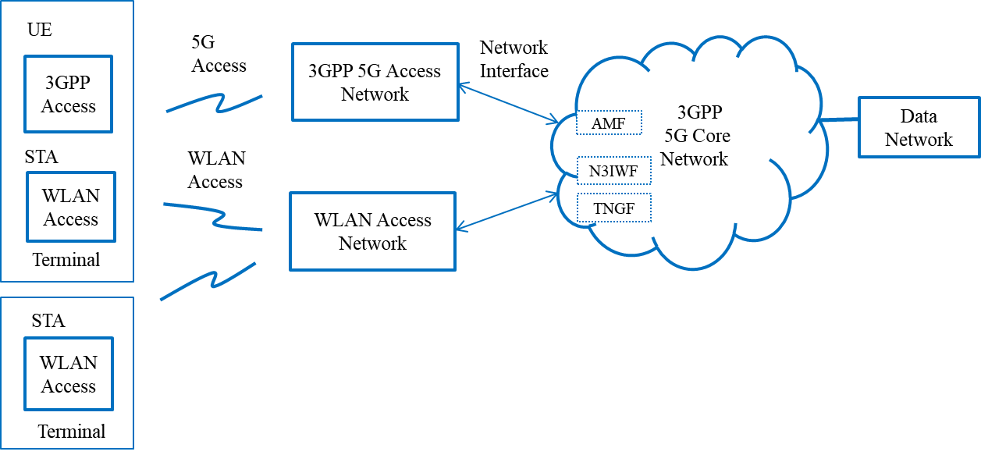
Figure 4. Loosely coupled interworking reference model between 5G core network and WLAN

3GPP cellular system has specified both RAN level (layer 2) interworking and CN level (layer 3 and above) interworking [2-4]. The RAN level interworking belongs to the tightly coupled interworking model and the CN level interworking belongs to the loosely coupled interworking model. However, 3GPP 5G system has allowed WLAN access as a non-3GPP Radio Access Technologies (RAT) that can be directly connected to 5G Core Network (CN) via the N3IWF (Non-3GPP Interworking Function) or the TNGF (Trusted Non-3GPP Gateway Function) depending on whether the WLAN is trusted or untrusted [8]. Therefore, the CN level interworking model in the 5G system is different from the LTE system.

  - WLAN interworking functional model in 5G system

In the 5G system, WLAN interworking function model consists of UE/STA terminal, 3GPP/WLAN access network and 3GPP core network as shown in Figure 5 and 6.

WLAN STA functions are divided into terminal interface (TEI) and terminal control (TEC). WLAN access network functions are divided into WLAN access data path and access network control (ANC) according to the WLAN network reference model of IEEE 802.1CF-2019 [18]. 3GPP functions are divided into UE and 3GPP access network, 5G core network and their signaling interfaces are described according to 3GPP specification [8-9].

For untrusted WLAN to 3GPP core network interworking, 3GPP NWu interface signaling shall be processed in WLAN domain and N1 signaling is transparently forwarded in WLAN domain. The N1 interface provides the signaling procedures between the UE and 3GPP 5GS core network to support Authentication and Mobility Function (AMF). The NWu interface provides the signaling procedures between the STA and N3IWF of 3GPP core network to support a secured IP channel.

In the WLAN domain, R1 and R3 interfaces support the data flow via the PHY and MAC layers of STA and WLAN access network. In addition to the R1 and R3 interfaces, we propose R8 and R9 interfaces which are control and management interfaces to provide QoS mapping and MAC scheduling. In Figure 4, the red colored R1/R3 and R8/R9 interfaces are in the domain of WLAN, and they are provided in the STA and the WLAN access network. R3 interface is mapped to Y2 interface for untrusted WLAN interworking in 3GPP domain.

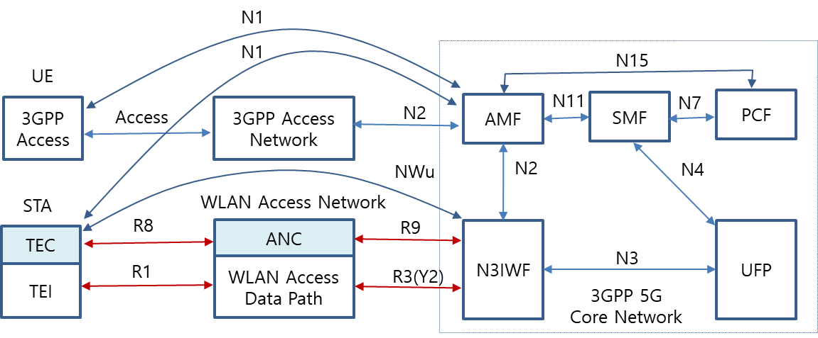

Figure 5. Untrusted WLAN interworking reference model with 5G core network

In trusted WLAN to 3GPP core network interworking, the NWt interface provides the signaling procedures between the STA and TNGF of 3GPP core network to support a secured IP channel. R3 interface is mapped to Ta interface for trusted WLAN interworking in 3GPP domain.

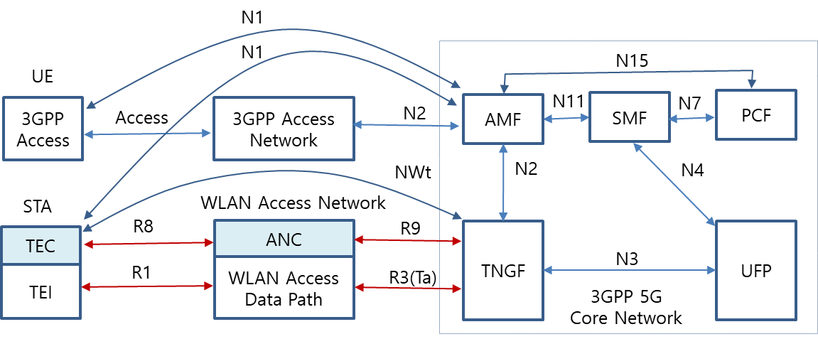

Figure 6. Trusted WLAN interworking reference model with 5G core network

- 5GS-WLAN Interworking function and procedures

The radio channel access and communication procedures have to be specified to enable WLAN interworking with 5G core network
A radio channel sharing method is described in 4.1. Initial registration and authentication procedures between STA and AMF of 5G core network are described in 4.2. Example IP secure transport and data exchange procedures between the STA of the terminal device and UPF of 5G core network are described in 4.3.

  - WLAN radio channel sharing method

The STA TEI monitors WLAN access network usage (monitoring if the radio channel is busy or idle). If the radio channel is idle, the STA may attempt to send control or traffic data through the WLAN radio channel. If the radio channel is busy, the STA will not send control of traffic data through the WLAN radio channel, it will wait until the radio channel is idle.

  - Registration and authentication and its message procedures

The STA shall initially support registration and authentication to establish a connection between the STA and N3IWF. NWu for registration and authorization involves IP protocol, IKEv2 and EAP-5G protocol, and secured signaling tunnel over N1 (a.k.a. signaling radio bearer) is required to exchange NAS signals.

    - Registration and authentication function

Association and authentication services provided by the IEEE 802.11 DS allow the N3IWF to perform the required registration and authentication of individual IEEE 802.11 STAs within an ESS.

- IP communication protocol
- IKEv2 authorization protocol
- EAP-5G protocol

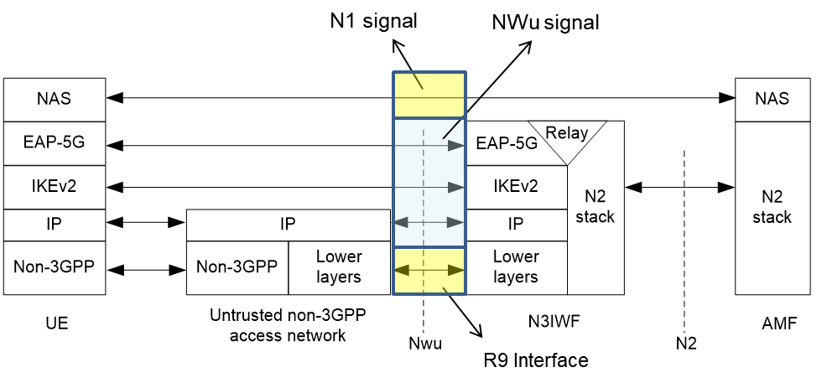
Figure 7. Control plane between STA and N3IWF (3GPP TS 23.501)

    - Message procedures

- R3 interface

R3 interface is an IEEE 802.11 Distribution System that connects an ANC incorporated in an Access Point Portal or Mesh Gate to a N3IWF, and provides the following services in addition to those provided by the IEEE 802.11 DS.

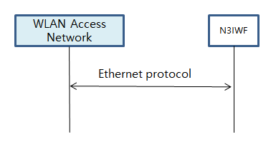

Figure 8. R3 interface

- NWu interface

The NWu interface is IP based communication protocol between STA of WLAN access network and N3IWF of 3GPP 5G core network in order to establish secured data channel. IKEv2 authorization protocol and EAP-5G protocol is applied

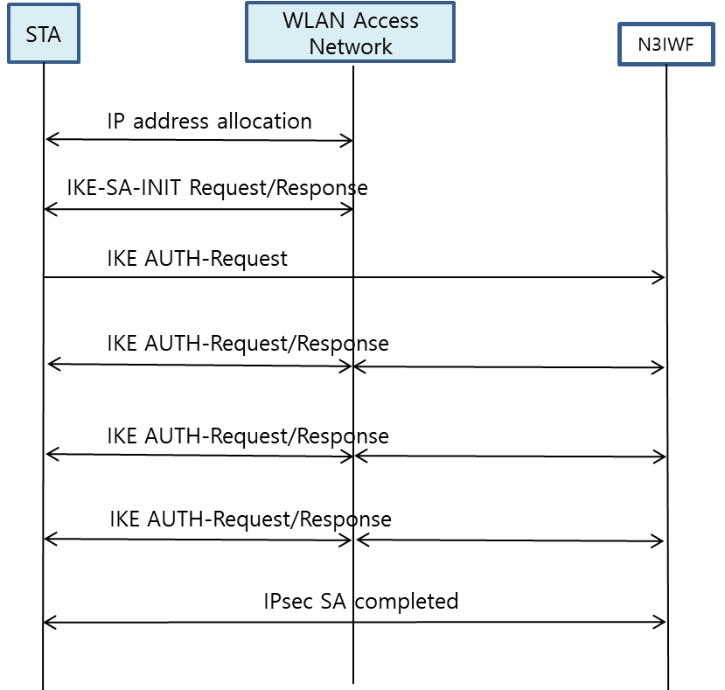

Figure 9. NWu interface

- N1 interface

The N1 interface is secured IP communication protocol between STA of WLAN access network and AMF of 3GPP 5G core network to provide NAS signaling

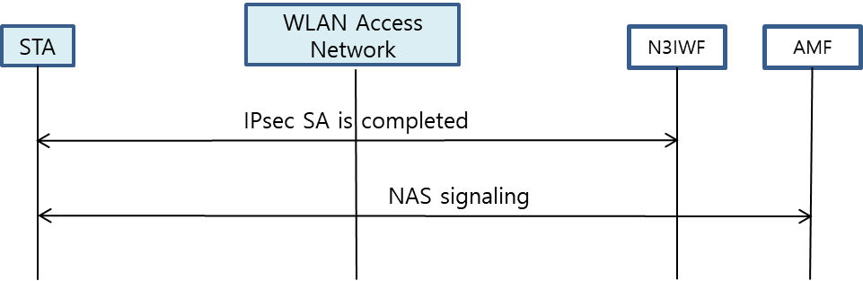

Figure 10. N1 interface

  - IP Tunneling function and its message procedures

STA shall initially support secured IP transport between terminal unit and UPF, and traffic data is exchanged over the established IP channel.

    - IP Tunneling Function

The STA and N3IWF shall have following specific functional requirements to interwork with 3GPP 5G core network.

- IP communication protocol
- IPsec communication protocol
- GRE communication protocol

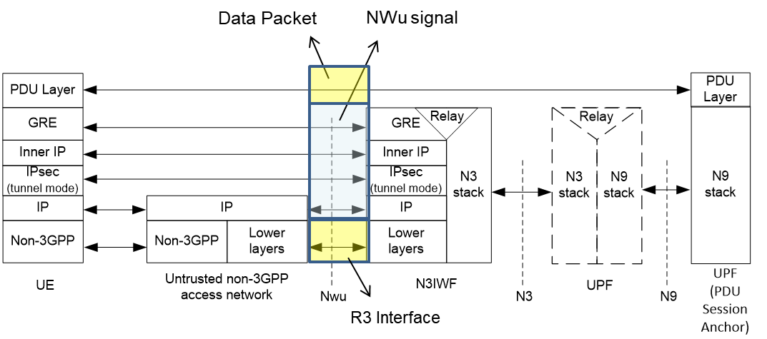

Figure 11. Data plane between STA and N3IWF (3GPP TS 23.501)

    - Message procedures

- IPsec tunneling procedures shall be processed via the WLAN access network.
- PDU session establishment shall be processed via the WLAN access network.

- 5GS QoS management

5.1 5GS QoS model

The 3GPP QoS flow is access agnostic, when the traffic is distributed between 5G access network and WLAN access network, the same QoS should be supported as long as the WLAN access network can support the same QoS treatment as the 5G access network. QoS flows on GBR traffic and Non-GBR traffic are specified in 3GPP TS 23.501and QoS flows are defined as follows:

- GBR QoS flow: A QoS flow using the GBR resource type or the Delay-critical GBR resource type and requiring guaranteed flow bit rate.

- Non-GBR QoS flow: A QoS flow using the Non-GBR resource type and not requiring guaranteed flow bit rate.

Table 1 shows the characteristics of GBR and delay critical GBR QoS flows from 3GPP. Therefore, it is necessary that GBR flows are supported by the WLAN in both directions, e.g. non-AP STA to AP and AP to non-AP STA.
Table 1. QoS characteristics (3GPP TS 23.501)
Resource Type | Default Priority Level | Packet Delay Budget | Packet Error  Rate | Default Maximum Data Burst Volume | Default  Averaging Window | Example Services
GBR | 20 | 100 ms | 10⁻² | N/A | 2000 ms | Conversational Voice
 | 40 | 150 ms | 10⁻³ | N/A | 2000 ms | Conversational Video (Live Streaming)
 | 30 | 50 ms | 10⁻³ | N/A | 2000 ms | Real Time Gaming, V2X messages  Electricity distribution – medium voltage, Process automation - monitoring
 | 50 | 300 ms | 10⁻⁶ | N/A | 2000 ms | Non-Conversational Video (Buffered Streaming)
 | 7 | 75 ms | 10⁻² | N/A | 2000 ms | Mission Critical user plane Push To Talk voice (e.g., MCPTT)
 | 20 | 100 ms | 10⁻² | N/A | 2000 ms | Non-Mission-Critical user plane Push To Talk voice
 | 15 | 100 ms | 10⁻³ | N/A | 2000 ms | Mission Critical Video user plane
 | 56 | 150 ms | 10⁻⁶ | N/A | 2000 ms | "Live" Uplink Streaming (e.g. TS 26.238 [y])
 | 56 | 300 ms | 10⁻⁴ | N/A | 2000 ms | "Live" Uplink Streaming (e.g. TS 26.238 [y])
 | 56 | 300 ms | 10⁻⁸ | N/A | 2000 ms | "Live" Uplink Streaming (e.g. TS 26.238 [y])
 | 56 | 500 ms | 10⁻⁸ | N/A | 2000 ms | "Live" Uplink Streaming (e.g. TS 26.238 [y])
 | 56 | 500 ms | 10⁻⁴ | N/A | 2000 ms | "Live" Uplink Streaming (e.g. TS 26.238 [y])
Delay Critical GBR | 19 | 10 ms | 10-4 | 255 bytes | 2000 ms | Discrete Automation (see TS 22.261 [x])
 | 22 | 10 ms | 10-4 | 1354 bytes | 2000 ms | Discrete Automation (see TS 22.261 [x])
 | 24 | 30 ms | 10-5 | 1354 bytes | 2000 ms | Intelligent transport systems (see TS 22.261 [x])
 | 21 | 5 ms | 10-5 | 255 bytes | 2000 ms | Electricity Distribution- high voltage (see TS 22.261 [x])

The SMF assigns QoS profile to AN in WLAN domain with QoS Flow Identification (QFI), which defines the QoS parameters for a QoS flow in the PDU session. And the QoS flow is then mapped to AN resources for the assigned QFI.

Figure 12. QoS flows and mapping to AN resources in user plane (3GPP TS 23.501)
  - ATSSS function support

Traffic data shall be transmitted over the WLAN access channel and/or 3GPP access channel by using ATSSS function. In this subclause, the terminal UE type is assumed to support ATSSS function in the loosely coupled interworking model.

- 3GPP supports ATSSS between 3GPP and non-3GPP access networks
- ATSSS can enable traffic selection, switching and splitting between 5G-AN and WLAN

Figure 13. Architecture reference model for ATSSS support (3GPP TS 23.501)

Figure 12 shows the reference architecture for supporting ATSSS which handles either Guaranteed Bit Rate flow (GBR) QoS flow or Non-GBR QoS flow traffic.

6. Gap analysis and Recommendations

6.1 Gap Analysis

In the technical gap analysis, the terminal STA type is assumed to figure out new functionalities and communication protocol to interwork with 5G core network in WLAN domain. The new functionalities and communication protocols can be assigned and implemented in STA and WLAN access network.

In the view of higher layer control and protocol to interwork with 3GPP 5G core network, IKEv2, EAP-5G, IPsec and GRE protocol are referred to IETF specification and modified for interworking. And these protocols can be implemented in the STA TEC and WLAN ANC.

NAS signaling to AMF and packet session control to SMF are referred to 3GPP specification and can be implemented in STA TEC and WLAN ANC. And WLAN QoS management is referred to IEEE 802.11e and should be adapted to support fine granularity of QoS levels.

3GPP specification provides GBR, Non-GBR and delay critical GBR. Delay critical GBR needs lower latency (less than 30msec) and lower packet error rate (PER) (less than 10⁻⁴). And 3GPP have more characterized QoS management so as to support packet delay, PER, default maximum data burst volume and default average window for the service types.

3GPP resource types and QoS related parameters shall be shared with WLAN using R8 and R9 interfaces. WLAN will support QoS function and related message procedures. QoS management functions need to cover QoS mapping, scheduling algorithm and MAC interface. STA TEC and WLAN ANC will deal with them.

In QoS management, the current IEEE 802.11-2016 EDCA covers four classes: background, best effort, audio and video. And EDCA QoS is managed according to service class, contention window and AIFS value. Thus, WLAN using EDCA currently can support some kinds of GBR as well as non-GBR services, but it is contention based. HCCA relies upon TSPECs to allocate controlled access and does have the potential to provide low latency and GBR, but has a low level of implementation. 3GPP system specifies QoS profile and characteristics in the following area.

- Service priority level
- Packet latency
- Packet error rate
- Guaranteed data rate
- Averaging window

The STA TEC and WLAN ANC should process QoS management according to QoS profile provided by 3GPP 5G core network.

Table 4. Service categories to interwork with 3GPP core network

Service Categories | Related WLAN function | Related WLAN Specification
Non-GBR | 4 service classes; Background, Best effort, audio and video | IEEE 802.11e
GBR | To be defined in fine granularity of service classes and QoS management | Shall specify QoS mapping and scheduling. And IEEE 802.1 TSN is for deterministic Ethernet network.

Table 5. Gap analysis of GBR service between 3GPP 5G network and WLAN

Resource Type | Services Examples | Packet Delay Budget | PER | Default Maximum Data Burst Volume | Gap Analysis of WLAN specification
GBR | Conversational Voice | 100 ms | 10⁻² | N/A | . 802.11ax MAC cannot support 3GPP GBR service requirements of deterministic packet latency, PER and data rate because EDCA is CSMA based MAC and supports only 4 service types of best effort, back ground, voice and video by controlling TXOP, AIFSN & contention window size.  . Enhanced MAC (802.11be) should consider QoS mapping, packet scheduling and related management procedures to support GBR. And PHY and MAC should be improved to control packet latency and reliability.  . QoS flow identification and service priority shall be mapped to have fine granularity of service types and QoS parameters.
 | Conversational Video | 150 ms | 10⁻³ | N/A
 | Real Time Gaming, V2X messages | 50 ms | 10⁻³ | N/A
 | Non-Conversational Video | 300 ms | 10⁻⁶ | N/A
 | MCPTT | 75 ms | 10⁻² | N/A
 | Non-MCPTT | 100 ms | 10⁻² | N/A
 | MC-Video | 100 ms | 10⁻³ | N/A
 | "Live" Uplink Streaming | 150 ms | 10⁻⁶ | N/A
 | "Live" Uplink Streaming | 300 ms | 10⁻⁴ | N/A
 | "Live" Uplink Streaming | 300 ms | 10⁻⁸ | N/A
 | "Live" Uplink Streaming | 500 ms | 10⁻⁸ | N/A
 | "Live" Uplink Streaming | 500 ms | 10⁻⁴ | N/A
Delay Critical GBR | Discrete Automation | 10 ms | 10-4 | 255 bytes | . 802.11ax MAC cannot guarantee 3GPP delay critical GBR service requirements of latency, PER and guaranteed data rate.  . Enhanced MAC (802.11be) should consider QoS mapping, packet scheduling and related management procedures to support GBR. And PHY and MAC should be improved to control packet latency and reliability.  . 802.11bd NGV should consider ITS service requirement.
 | Discrete Automation | 10 ms | 10-4 | 1354 bytes
 | Intelligent transport systems | 30 ms | 10-5 | 1354 bytes
 | Electricity Distribution- high voltage | 5 ms | 10-5 | 255 bytes

3GPP QoS flow in SMF defines QoS identification and its priority according to resource types and QoS information is transferred to AP and STA. At first, QoS mapping from 3GPP QoS to WLAN QoS is necessary. WLAN shall support fine granularity of QoS and priority because 5G QoS ID has 6 bits and specifies QoS parameters involving GBR (Guaranteed Bit Rate), latency and PER. Secondly, packet scheduling in STA and AP shall control MAC operation to meet required QoS. AP QoS profile and STA DRB (Data Radio Bearers) contains service QoS identification and its parameters to define data rate, packet latency and PER value. Packet scheduler configures data rate, packet latency, PER and packet size for MSDU packet. And QoS mapping to WLAN domain needs to specify R9 and N1 interface to send QoS profile and QoS DRB information, respectively. Alternatively, QoS DRB may be delivered from the AP to the STA over R8 interface if QoS DRB through NAS signaling is not available.

It is reported that transmission time scheduling can guarantee low packet latency and that Hybrid ARQ supports PER improvement. To support GBR, data rate and bandwidth control is required.

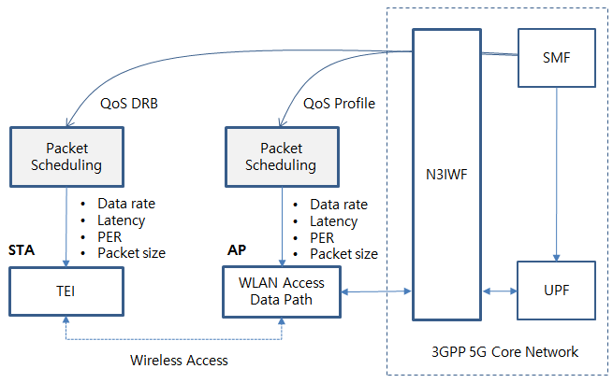
Figure 14. QoS mapping and scheduling example of WLAN

6.2 Technical Recommendations

WLAN supports high data rate to meet the performance of 5G network vision in the low mobility scenario and it is integrated as one of access networks for 3GPP 5G network. Therefore, 802.11 should consider adding new functional entities and signaling procedures to support interworking with the 3GPP 5G network. The following 802.11 services and facilities should be enhanced:

- Active scanning facility
- Association
- Authentication
- QoS facility

The key considerations on WLAN to interwork 5G core network as follows;

- Radio scanning and association process is well specified in WLAN 802.11 and is capable of supporting WLAN interworking with the 5G core network.

- IKEv2, EAP-5G and IPsec protocol for registration and authentication support should be added in the STA TEC and the WLAN ANC.

- NAS signaling to connect AMF should be added in the STA TEC and the WLAN ANC.

- Packet session initiation/modification/termination to connect SMF should be added in the STA TEC and WLAN ANC.

- Packet data QoS management of WLAN shall specify QoS identification, profile and DRB to guarantee packet delay and PER for the required service types.
  - QoS mapping to WLAN is necessary to support more granularity of QoS ID and parameters
  - Packet scheduling in the STA and AP should meet data rate, latency and PER
  - Timing scheduling and the introduction of a Hybrid ARQ scheme are very important
  - 802.11ax, as implemented, cannot support 3GPP service QoS, and improved version (11be EHT, 11bd NGV) should consider MAC enhancement to support the service requirements.

The WLAN interworking model and terminal types will give an impact on interworking system design and implementation. For example, the terminal STA type should support both data and control functions to interwork with 5G core network. The terminal UE will support all the control functions to interwork with 5G core network and WLAN access function of UE can be used for radio data forwarding.

  - TSN topics

3GPP 5G System can be integrated with the external TSN as a TSN bridge. The TSN bridge includes TSN Translator functionality for interoperation between TSN System and 5G System both for user plane and control plane. 5G system TSN translator functionality consists of Device-side TSN translator (DS-TT) and Network-side TSN translator (NW-TT). 5G system specific procedures in a 5G core network and RAN, wireless communication links, etc. remain hidden from the TSN network [8]

As for TSN applications such as smart factory and automation field, TSN bridges can be configured in three different types. The first type is to use 5G system as a TSN bridge in Figure 15. 3GPP domain needs to consider the timing synchronization and TSN translator (TT) function in UE and 5G CN. The second type is to use WLAN and 5G CN interworking as a TSN bridge in Figure 16. The third type is to use WLAN only as a TSN bridge in Figure 17.

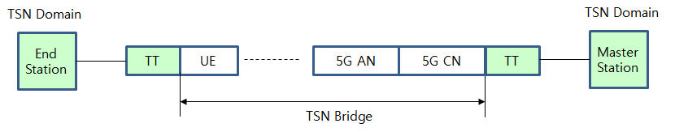
Figure 15. TSN Bridge using 5G AN and CN
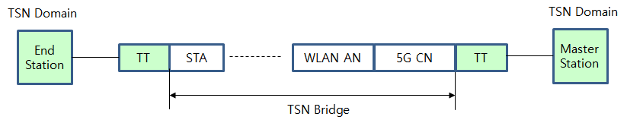

Figure 16. TSN Bridge using WLAN and 5G CN interworking

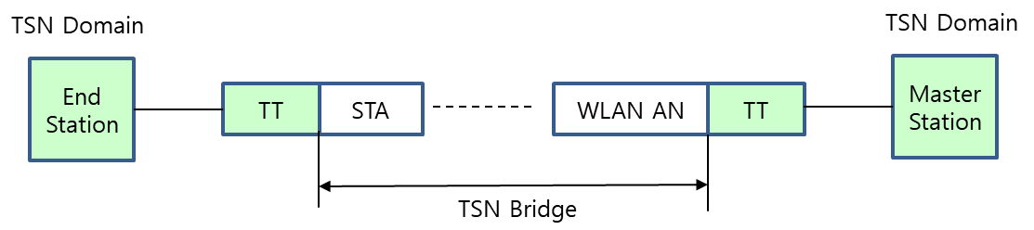

Figure 17. TSN Bridge using WLAN only

- Conclusions

The IEEE 802.11 can support interworking with the 3GPP 5G network and is able to support high data rate to meet the performance of 5G network vision in the low mobility scenario. The new functional entities and signaling procedures have been identified:

- Radio scanning and association
- Registration and authentication
- NAS signaling messages
- Packet session initiation/modification/termination
- Packet data QoS management

Through gap analysis, IEEE WLAN radio scanning and association process, IETF specification such as IKEv2, EAP-5G and IPsec can be used or adapted and implemented in the STA TEC and WLAN ANC. NAS signaling, ATSSS and QoS management can be implemented in the STA TEC and WLAN ANC, and should follow the guidance of the 3GPP specifications.

In the loosely coupled interworking model, the new functional entities and signaling procedures can be assigned to UE or STA to interwork with 5G core network. The terminal UE can support the above control and signaling functions. However, the terminal STA type should support all the control and signaling functions to interwork 5G network.

As for QoS management, WLAN should specify QoS mapping and MAC scheduling including QoS identification and profile to guarantee QoS in terms of deterministic packet delay, low PER and data rate. The new interfaces R8 and R9 are defined to deliver QoS profile between 5G CN (N3IWF, TNGF) and WLAN STA.

For TSN applications, WLAN domain needs to consider the timing synchronization with TSN domain and TSN translation in WLAN STA and 5G CN.

References

- 3GPP TS 22.261 V15.5.0 (2018-06) “Service requirements for the 5G system (Stage 1)”
- 3GPP TS 22.278 “Service requirements for the Evolved Packet System (EPS)”
- 3GPP TS 23.401 “EPS Architecture and Procedures”
- 3GPP TS 23.402 "Architecture enhancements for non-3GPP accesses”
- 3GPP TR 23.716 “Study on the Wireless and Wireline Convergence for the 5G System Architecture”
- 3GPP TR 23.793 “Study on Access Traffic Steering, Switching and Splitting support in the 5G system architecture”
- 3GPP TR 23.799 “Study on Architecture for Next Generation System”
- 3GPP TS 23.501 “System Architecture for the 5G System (Stage 2)”
- 3GPP TS 23.502 “Procedures for the 5G System (Stage 2)”
- 3GPP TS 24.302 “Access to the 3GPP Evolved Packet Core (EPC) via non-3GPP access networks (Stage 3)”
- 3GPP TS 24.501 “Non-Access-Stratum (NAS) protocol for 5G System (5GS) (Stage 3)”
- 3GPP TS 24.502 “Access to the 3GPP 5G Core Network (5GCN) via Non-3GPP Access Networks (N3AN) (Stage 3)”
- 3GPP TS 33.501 “Security Architecture and Procedure for the 5G System”
- 3GPP TR 33.899 “Study on the Security Aspects of the Next Generation System”
- 3GPP TS 37.324 “Service Data Adaptation Protocol (SDAP) Specification”
- 3GPP TS 38.300 “NR and NG-RAN Overall Description”
- RAN convergence paper, WBA and NGMN alliance, September 2019.
- IEEE 802.1CF-2019; IEEE Recommended Practice for Network Reference Model and Functional Description of IEEE 802® Access Network, 2019.

