IEEE P802.11
Wireless LANs
Draft technical report on interworking between 3GPP 5G network & WLAN
Date: 2020-03-16
Author(s):
Name | Affiliation | Address | Phone | email
Hyun Seo OH | ETRI | Gajeongro 218 Yusunggu  Daejeon, Korea | +82.42.860.5659 | hsoh5@etri.re.kr
Hanbyeog CHO | ETRI | Gajeongro 218 Yusunggu  Daejeon, Korea | +82.42.860.5531 | hbcho@ etri.re.kr
Yoohwa Kang | ETRI | Gajeongro 218 Yusunggu  Daejeon, Korea | +82.42.860.6364 | yhkang@etri.re.kr
Chang Han OH | allRadio Co. Ltd | 280, Seobusaet-gil, Geumcheon-gu, Seoul, Korea | +82.2.801.1310 | choh@allradio.co.kr
Shinho CHO | allRadio Co. Ltd | 280, Seobusaet-gil, Geumcheon-gu, Seoul, Korea | +82.10.3351.8424 | shcho@allradio.co.kr
Raeman KIM | allRadio Co. Ltd | 280, Seobusaet-gil, Geumcheon-gu, Seoul, Korea | +82.10.5512.9390 | rmkim01@allradio.co.kr
Si Young HEO | KT | KT R&D Center, 151, Taebong-ro, Seocho-gu, Seoul, Korea | +82.10.266.4569 | siyoung.heo@kt.com
Yangseok Jeong | KT | KT R&D Center, 151, Taebong-ro, Seocho-gu, Seoul, Korea | +82.10.9530.0856 | Yangseok.jeong@  kt.com
Hyeong Ho LEE | Nevision Telecom Inc., Korea Univ. | 412, 199, Techno2-ro, Yuseong-Gu, Daejeon, 34025, Korea | +82.42.931.4130 | hhlee@netvisiontel.com
Youngjae KIM | TTA | 47, Bundang-ro, Bundang-gu, Seongnam-city, Gyeonggi-do, 13591, Korea | +82.10.5110,2895 | yjkim@tta.or.kr
Choon Sik Yim | RCN | 199, Techno2-ro, Yuseong-Gu, Daejeon | +82.10.9531.3610 | Yim25@hnamail.net
Abstract
This contribution is a draft technical report on WLAN interworking to 3GPP 5G network. It describes the interworking reference model and interworking types supported by 3GPP 5G network and WLAN, and defines the necessary functionalities and specific procedures that enable WLAN access networks to interwork with 3GPP 5G network. This technical report on interworking between 3GPP 5G network and WLAN will provide a reference and guideline for stakeholders with interest in standardization and system development.

- Definition, acronyms and abbreviations

  - Definitions

ANC Access network control function of WLAN access network, which refers to IEEE 802 network reference model [15].

NWu Reference point between the UE and N3IWF for establishing secure tunnel(s) between the UE and N3IWF so that control-plane and user-plane exchanged between the UE and the 5G Core Network is transferred securely over untrusted non-3GPP access, which refers to 3GPP TS 23.502 [8]. This is in the domain of WLAN access network.

STA WLAN STA consists of TEC (terminal control) and TEI (terminal data path interface), which refers to IEEE 802 network reference model [15].

N1 Reference point between the UE and the AMF in 5G core network [7].

N2 Reference point between the (R)AN and the AMF in 5G core network [7].

N3 Reference point between the (R)AN and the UPF in 5G core network [7].

N4 Reference point between the SMF and the UPF in 5G core network [7].

N7 Reference point between the SMF and the PCF in 5G core network [7].

N11 Reference point between the AMF and the SMF in 5G core network [7].

N15 Reference point between the PCF and the AMF in the case of non-roaming scenario, PCF in the visited network and AMF in the case of roaming scenario in 5G core network [7].

Y1 Reference point for PHY/MAC layer function between STA and the untrusted non-3GPP access network (e.g. WLAN). This depends on the non-3GPP access technology. This is in the domain of WLAN access network.

Y2 Reference point for PHY/MAC layer function between the untrusted non-3GPP access network (e.g. WLAN) and the N3IWF for the transport of NWu traffic which refers 3GPP TS 23.502. This is in the domain of WLAN access network.

Y3 Reference point for control and management interface between STA and the untrusted non-3GPP access network (e.g. WLAN). This depends on the non-3GPP access technology. This is in the domain of WLAN access network.

Y4 Reference point for control and management interface between the untrusted non-3GPP access network (e.g. WLAN) and the N3IWF for the transport of NWu traffic which refers 3GPP TS 23.502. This is in the domain of WLAN access network.

  - Acronyms and abbreviations

3GPP 3rd Generation Partnership Project

5G 5th Generation

5G-AN 5th Generation Access Network

AIFS Arbitrary Inter-Frame Spacing

ANC Access Network Control

AMF Access and Mobility Management Function

ATSSS Access Traffic Steering Switching and Splitting

HCCA Hybrid Controlled Channel Access

EAP-5G Extended Autenication Protocol-5th Genration

EDCA Enhanced Distributed Channel Access

GBR Guaranteed Bit Rate

GRE Generic Routing Encapsulation

IKEv2 Initial Key Exchange Protocol Version 2

IP Internet Protocol

IPsec Internet Protocol Security

MAC Media Access Control

NAS Non Access Stratum

N3IWF Non-3GPP Inter Working Function

PCF Policy Control Function

PDU Packet Data Unit

PER Packet Error Rate

PHY Physical Layer

QoS Quality of Service

SMF Session Management Function

STA Station

TEC Terminal Control

TEI Terminal Interface

UE User Equipment

UPF User Plane Function

V2X Vehicle to Antyhing

WLAN Wireless Local Area Network

- Introduction

This clause introduces basic objectives and scope of the technical report on WLAN interworking to 3GPP 5G core network. WLAN interworking types may have tightly coupled or loosely coupled, and functional reference model to interwork with 3GPP 5G network are described in Clause 3.

And the interworking function and specific procedures regarding radio channel sharing, registration and authentication, IP tunneling, ATSSS and QoS function are described in Clause 4. Through technical study, gap analysis and technical recommendations are commented in Clause 5. And finally conclusions are summarized in Clause 6.

  - Objectives

This technical report on interworking between 3GPP 5G network and WLAN will provide a reference and guideline for stakeholders with interest in standardization and system development.

  - Scope

This report covers an interworking reference model, necessary functionalities and specific procedures that allow WLAN access network to interwork with 3GPP 5G network. We consider two types of interworking reference model, which are tightly coupled type and loosely coupled type.

The interworking reference model consists of terminal part, access networks, 3GPP 5G core network and sever as shown in Figure 1. Two access networks are connected to server via 3GPP 5G core network. 3GPP access network and 5G core network refer to 3GPP specification and WLAN access network refers to IEEE 802 network reference model of IEEE 802.1CF-2019 [15].

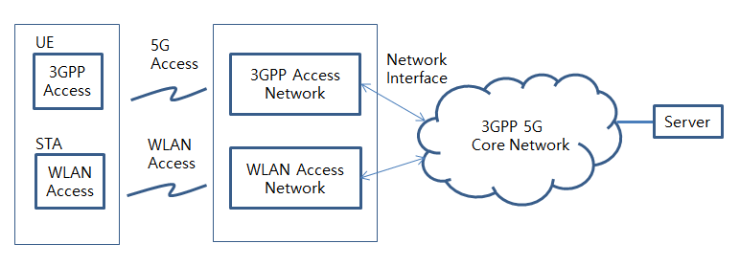

Figure 1. Overview of WLAN interworking with 3GPP core network

- WLAN interworking reference model

  - WLAN interworking types

There are two types of interworking model; tightly coupled or loosely coupled.

Tightly coupled interworking type assumes that fuctional entities of terminal and two access networks are combined together and two access networks are connected to 3GPP core network because 3GPP access network and WLAN access network can be located at the same position and operated together. It will optimize overall system performance by doing system integration from architecture design to system implementation.

Loosely coupled interworking type assumes that 3GPP and WLAN access network are separately located and ony terminal function can be combined. This type will provide same service functions as thigtly coupled type.

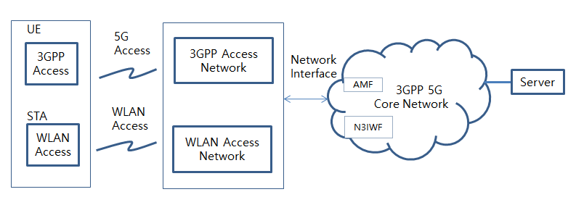
Figure 2. Tightly coupled interworking reference model between 5G core network and WLAN

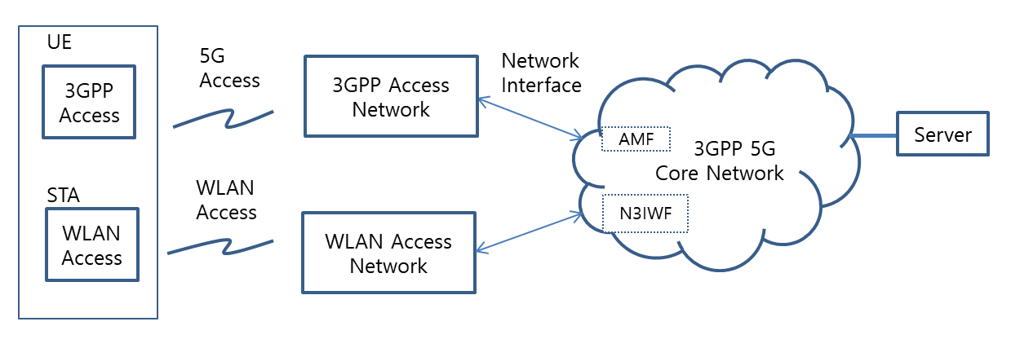

Figure 3. Loosely coupled interworking reference model between 5G core network and WLAN

  - WLAN interworking functional model

WLAN interworking function model consists of UE/STA terminal, 3GPP/WLAN access network and 3GPP core network as shown in Figure 4.

WLAN STA functions are divided into terminal interface(TEI) and terminal control(TEC). And WLAN access network functions are divided into WLAN access data path and access network control(ANC) according to WLAN network reference model IEEE 802.1CF-2019. And 3GPP fuctions are divided into UE and 3GPP access network, 5G core network and their signalling interfaces are described according to 3GPP specification.

For WLAN interworking to 3GPP core network, 3GPP N1 signalling and NWu interfaces shall be processed in WLAN domain. N1 is signalling procedures between UE and 3GPP core network to support Authentication and Mobility Function (AMF). NWu is signalling procedures between UE and N3IWF of 3GPP core network to support secured IP channel.

In WLAN domain, Y1 and Y2 interfaces are PHY and MAC layer function of STA and WLAN access network. And Y3 and Y4 interfaces are control and management interface to provide ATSSS and QoS management. These red coloured Y1, Y2, Y3 and Y4 interfaces are in the domain of WLAN and may be provided in STA and WLAN access network. The other reference interfaces are referred to 3GPP core network.

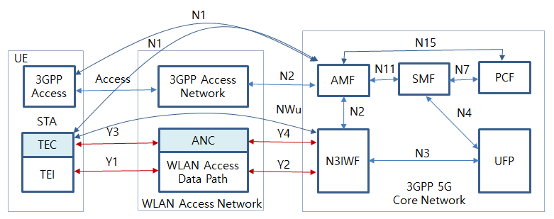

Figure 4. WLAN interworking reference model with 5G core network

- Interworking function and procedures

The radio channel access and communication procedures have to be specified to provide WLAN interworking with 5G core network. Even though there are tightly coupled or loosely coupled interworking types, the common procedures can be applied for them.

Radio channel sharing method is described in 4.1. And initial registration and authentication procedures between STA of UE and AMF of 5G core network are described in 4.2, IP secure transport and data exchange between STA of UE and UPF of 5G core network are described as an example in 4.3.

ATSSS function and QoS management on WLAN will be expected to have some interface or modification on MAC layer of STA and wireless access network. These functions will be described in 4.4 and 4.5.

  - Radio channel sharing method

TEI of STA monitors the usage of WLAN access network if the radio channel is busy or idle. If the radio channel is idle, STA tries to send control or traffic data.

  - Registration and authentication and its message procedures

STA shall initially support registration and authentication to be connected between UE and N3IWF. NWu for registration and authorization involves IP protocol, IKEv2 and EAP-5G protocol. And N1 signalling is needed to exchange NAS signal.

    - Registration and authentication function

TEC of UE and ANC of WLAN access network shall have specific functional requirements to interwork with 3GPP 5G core network

- IP communication protocol
- IKEv2 authorization protocol
- EAP-5G protocol
- NAS signalling

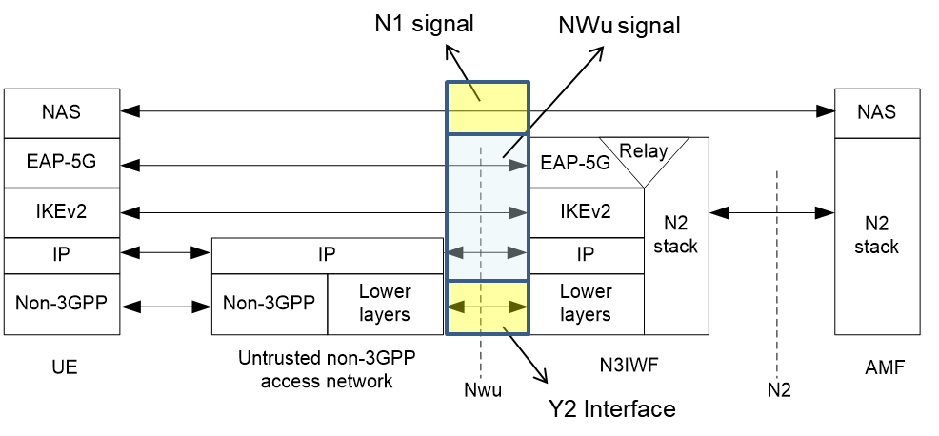
Figure 5. Control Plane between UE and N3IWF (3GPP TS 23.501)

    - Message procedures

- Y2 interface

Y2 interface is PHY/MAC data communication protocol between ANC of WLAN access network and N3IWF of 3GPP 5G core network. Y2 follows IEEE 802.3 standard.

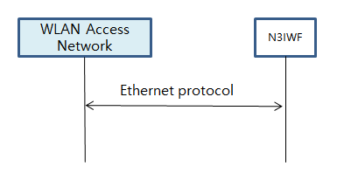

Figure 6. Y2 interface

- NWu interface

NWu interface is IP based communication protocol between STA of WLAN access network and N3IWF of 3GPP 5G core network to establish secured data channel. IKEv2 authorization protocol and EAP-5G protocol is applied

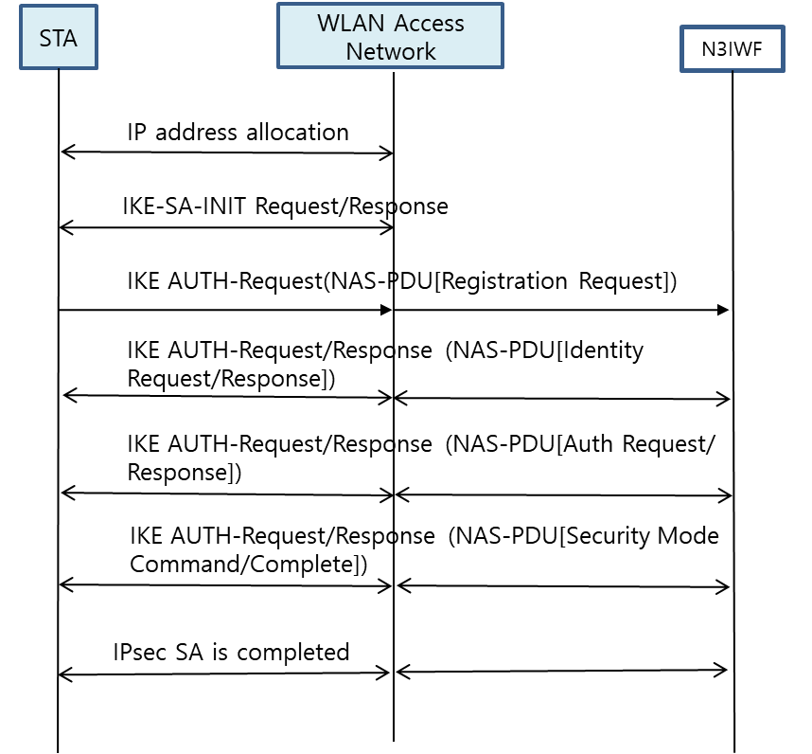

Figure 7. NWu interface

- N1 interface

N1 interface is secured IP communication protocol between UE of WLAN access network and AMF of 3GPP 5G core network to provide NAS signalling

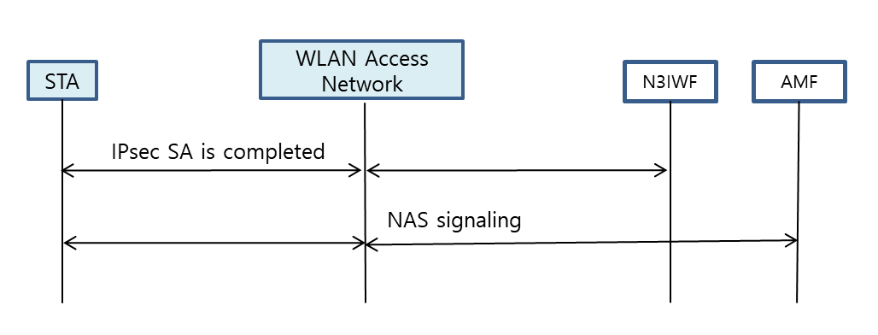

Figure 8. N1 interface

  - IP Tunnelling function and its message procedures

STA shall initially support secured IP transport between UE and UPF, and traffic data is exchanged over the established IP channel.

    - IP Tunnelling Function

SC of UE and ANC of WLAN access network shall have specific functional requirements to interwork with 3GPP 5G core network.

- IP communication protocol
- IPsec communication protocol
- GRE communication protocol

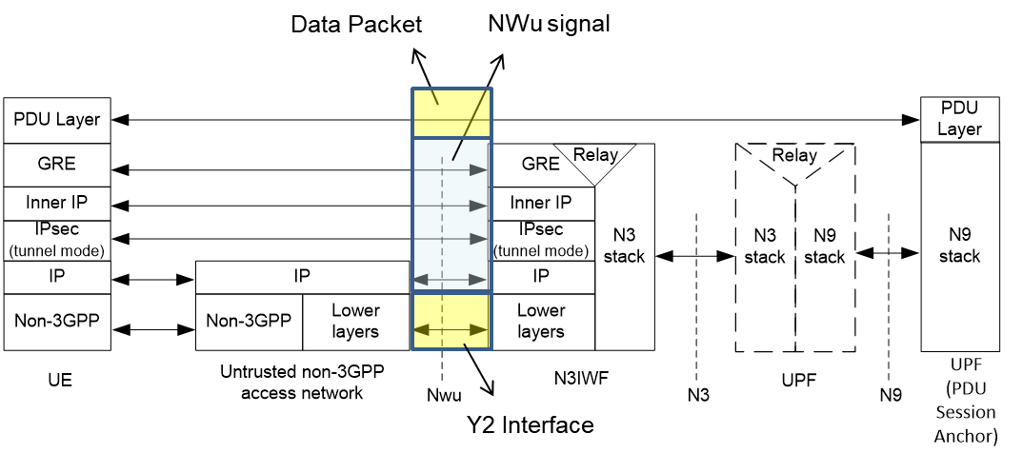

Figure 9. Data Plane between UE and N3IWF (3GPP TS 23.501)

    - Message procedures

- IPsec tunnelling procedures shall be processed via WLAN access network
- PDU session establishmenr shall be processed via WLAN access network.

  - ATSSS function support

Traffic data shall be transmitted over WLAN access channel and/or 3GPP access channel by using ATSSS function.

- 3GPP supports ATSSS between 3GPP and non-3GPP access networks
- ATSSS can enable traffic selection, switching and splitting between 5G-AN and WLAN

Figure 10. Architecture reference model for ATSSS support (3GPP TS 23.501)

The 3GPP QoS flow is access agnostic, so the same QoS is supported when the traffic is distributed over 5G access network and WLAN access network. The QoS flow may be either gurauranteed flow bit rate (GBR) or Non-GBR, so 3GPP can support GBR traffic as well as Non-GBR traffic defined in 3GPP TS 23.501 as follows:

- GBR QoS Flow: A QoS Flow using the GBR resource type or the Delay-critical GBR resource type and requiring guaranteed flow bit rate.

- Non-GBR QoS Flow: A QoS Flow using the Non-GBR resource type and not requiring guaranteed flow bit rate.

Table 1 shows the characteristics of GBR and delay-critical GBR QoS flows from 3GPP. Therefore, it is required to consider how to support GBR flows in WLAN.

Table 1. QoS characteristics (3GPP TS 23.501)
Resource Type | Default Priority Level | Packet Delay Budget | Packet Error  Rate | Default Maximum Data Burst Volume | Default  Averaging Window | Example Services
GBR | 20 | 100 ms | 10⁻² | N/A | 2000 ms | Conversational Voice
 | 40 | 150 ms | 10⁻³ | N/A | 2000 ms | Conversational Video (Live Streaming)
 | 30 | 50 ms | 10⁻³ | N/A | 2000 ms | Real Time Gaming, V2X messages  Electricity distribution – medium voltage, Process automation - monitoring
 | 50 | 300 ms | 10⁻⁶ | N/A | 2000 ms | Non-Conversational Video (Buffered Streaming)
 | 7 | 75 ms | 10⁻² | N/A | 2000 ms | Mission Critical user plane Push To Talk voice (e.g., MCPTT)
 | 20 | 100 ms | 10⁻² | N/A | 2000 ms | Non-Mission-Critical user plane Push To Talk voice
 | 15 | 100 ms | 10⁻³ | N/A | 2000 ms | Mission Critical Video user plane
 | 56 | 150 ms | 10⁻⁶ | N/A | 2000 ms | "Live" Uplink Streaming (e.g. TS 26.238 [y])
 | 56 | 300 ms | 10⁻⁴ | N/A | 2000 ms | "Live" Uplink Streaming (e.g. TS 26.238 [y])
 | 56 | 300 ms | 10⁻⁸ | N/A | 2000 ms | "Live" Uplink Streaming (e.g. TS 26.238 [y])
 | 56 | 500 ms | 10⁻⁸ | N/A | 2000 ms | "Live" Uplink Streaming (e.g. TS 26.238 [y])
 | 56 | 500 ms | 10⁻⁴ | N/A | 2000 ms | "Live" Uplink Streaming (e.g. TS 26.238 [y])
Delay Critical GBR | 19 | 10 ms | 10-4 | 255 bytes | 2000 ms | Discrete Automation (see TS 22.261 [x])
 | 22 | 10 ms | 10-4 | 1354 bytes | 2000 ms | Discrete Automation (see TS 22.261 [x])
 | 24 | 30 ms | 10-5 | 1354 bytes | 2000 ms | Intelligent transport systems (see TS 22.261 [x])
 | 21 | 5 ms | 10-5 | 255 bytes | 2000 ms | Electricity Distribution- high voltage (see TS 22.261 [x])

  - QoS function and its message procedures

3GPP resource types and QoS related parameters shall be shared with WLAN using Y3 and Y4 interfaces and WLAN will support QoS function and related message procedures. QoS management functions need to cover QoS mapping, scheduling algorithm and MAC interface and TEC of STA and ANC of WLAN access network will deal with them.

PHY and MAC specification are important factor to meet the required QoS value. The current technologies to provide QoS management is EDCA and HCCA, which are distributed based access scheme. IEEE 802.11e provides 4 kinds of access categories, which are best effort, video probe, video and voice. According to access categories, contention widow size and arbitration inter-frame space (AIFS) is variable to meet the erquired qualtity of service.

3GPP specification provides GBR, Non-GBR and delay critical GBR. Delay critical GBR needs lower latency (less than 30msec) and higher packet error rate (PER) (less than 10⁻⁴). And 3GPP have more characterised QoS management to support packet delay, PER, default maximum data burst volume and default average window for the service types.

It is reviewed that EDCA and HCCA of WLAN technology will meet QoS for Non-GBR service type and will be limited to meet low latency and high reliablity for GBR and delay critical GBR types.

- Gap analysis and Recommendations

  - Gap Analysis

WLAN interworking to 3GPP core network can have merits in terms of access and mobility, QoS managed ATSSS of packet data service. However, it has to add new functional entities and signalling procedures on WLAN. In this section, we analyze the gap of WLAN specification to interwork with 3GPP core network.

New functional entities to interwork with 3GPP core network are radio sharing function, registration and authentication, NAS message, IP tunnelling, Packet session control and QoS mamaged ATSSS.

Radio sharing function with Y1 interfaces can be implemented by WLAN channel scaning and association procedure. Registration and authentication should have IP communication protocol, IKEv2 and EAP-5G communication protocol using Y3 and Y4 interfaces. NAS messages with Y3 and Y4 interfaces should have IPsec and GRE communication protocol referred from 3GPP specification.

IP tunnelling and packet session control with Y3 and Y4 interfaces should refer to IPsec and GRE protocol specified by 3GPP core network. ATSSS function with Y1 and Y2 interfaces is packet data transmission specified by WLAN 802.11 specification. QoS management with Y3 and Y4 interfaces shoud define QoS identification and profiling.

Table2 New functional entities and communication protocols to interwork with 3GPP core network

New functional entities | Communication protocols | WLAN interfaces
Radio sharing function | Channel scanning and association | Y1
Registration & authentication | IP protocol, IKEv2 and EAP-5G protocol | Y3 and Y4
NAS message | NAS signalling | Y3 and Y4
IP tunneling | IPsec and GRE protocol | Y3 and Y4
Packet session control | Session control protocol | Y3 and Y4
ATSSS | Packet data transmission | Y1 and Y2
QoS management | QoS identification and profile | Y3 and Y4

In the view of higher layer control and protocol to interwork with 3GPP 5G core network, IKEv2, EAP-5G, IPsec and GRE protocol are referred to IETF specification and modified for interworking. And these protocols can be implemented in TEC and ANC of WLAN access network.

NAS signalling to AMF and packet session control to SMF are refered to 3GPP specification and can be implemented in TEC and ANC of WAN access network. And WLAN QoS management is referred to IEEE 802.11e and shoud be adapted to support fine granularity of QoS levels.

Table3 New signalling to interwork with 3GPP core network

Communication protocols | Related WLAN function | Related WLAN Specification
IKEv2 | TEC, ANC | IETF Internet Key Exchange Protocol
EAP-5G | TEC, ANC | IETF EAP protocol
IPsec | TEC, ANC | IETF IPsec protocol
NAS | TEC, ANC | 3GPP Protocol
GRE | TEC, ANC | IETF ESP protocol
Session control | TEC, ANC | 3GPP protocol
QoS identification and profile | TEC, ANC | IEEE 802.11e

In QoS management, the current IEEE 802.11-2016 covers four classes; back ground, best effort, audio and video. And QoS is managed according to service class, contention window and AIFS value. Thus, WLAN currently can support only non-GBR service and has to consider QoS identification and profile to support GBR service. 3GPP system specifies QoS profile and characteristics in QoS level as follows;
- Service priority level
- Packet latency
- Packet error rate
- Gauranteed data rate
- Averaging window

And TEC of STA and ANC of WAN access network should process QoS management according to QoS profile provided by 3GPP 5G core network.

Table4 Serice categories to intework with 3GPP core network

Service Categories | Related WLAN fucntion | Related WLAN Specification
Non-GBR | 4 service classes; Back ground, Best effort, audio and video | IEEE 802.11e
GBR | To be defined in fine granularity of service classes and QoS managemen | Shall specify QoS mapping and scheduling. And IEEE 802.1 TSN is for deterministic Ethernet netwotk.

Table5 Gap analysis of GBR service between 3GPP 5G network and WLAN.

Resource Type | Services Examples | Packet Delay Budget | PER | Default Maximum Data Burst Volume | Gap Analysis of WLAN specification
GBR | Conversational Voice | 100 ms | 10⁻² | N/A | . 802.11ax MAC can not support 3GPP GBR service requirements of determinisitc packet latency, PER and data rate because EDCA is CSMA based MAC and supports only 4 service types of best effort, back ground, voice and video by controlling TXOP, AIFSN & contention window size.  . Enhanced MAC (802.11be) should consider QoS mapping, packet scheduling and related management procedures to support GBR. And PHY and MAC should be improved to control packet latency and reliability.  . QoS flow identification and service priority shall be mapped to have fine granularity of service types and QoS parameters.
 | Conversational Video | 150 ms | 10⁻³ | N/A
 | Real Time Gaming, V2X messages | 50 ms | 10⁻³ | N/A
 | Non-Conversational Video | 300 ms | 10⁻⁶ | N/A
 | MCPTT | 75 ms | 10⁻² | N/A
 | Non-MCPTT | 100 ms | 10⁻² | N/A
 | MC-Video | 100 ms | 10⁻³ | N/A
 | "Live" Uplink Streaming | 150 ms | 10⁻⁶ | N/A
 | "Live" Uplink Streaming | 300 ms | 10⁻⁴ | N/A
 | "Live" Uplink Streaming | 300 ms | 10⁻⁸ | N/A
 | "Live" Uplink Streaming | 500 ms | 10⁻⁸ | N/A
 | "Live" Uplink Streaming | 500 ms | 10⁻⁴ | N/A
Delay Critical GBR | Discrete Automation | 10 ms | 10-4 | 255 bytes | . 802.11ax MAC can not guarantee 3GPP delay critical GBR service requirements of latency, PER and gauranteed data rate.  . Enhanced MAC (802.11be) should consider QoS mapping, packet scheduling and related management procedures to support GBR. And PHY and MAC should be improved to control packet latency and reliability.  . 802.11bd NGV should consider ITS service requirement.
 | Discrete Automation | 10 ms | 10-4 | 1354 bytes
 | Intelligent transport systems | 30 ms | 10-5 | 1354 bytes
 | Electricity Distribution- high voltage | 5 ms | 10-5 | 255 bytes

3GPP QoS flow in SMF defines QoS identification and its priority according to resource types and QoS information is transferred to AP and STA.

At first, QoS mapping from 3GPP QoS to WLAN QoS is necessary. WLAN shall support fine granularity of QoS and priority because 5G QoS ID has 6bits and specifies QoS parameters involving GBR (Guaranteed Bit Rate), latency and PER. Secondly, packet scheduling in STA and AP shall control MAC operation to meet required QoS. AP QoS profile and STA DRB (Data Radio Bearers) contains service QoS identification and its parameters to define data rate, packet latency and PER value. Packet scheduler configures data rate, packet latency, PER and packet size for MSDU packet.

It is reported that transmission time scheduling guaranteed low packet latency and Hybrid ARQ supports PER improvement. And data rate and bandwith control shall support GBR.

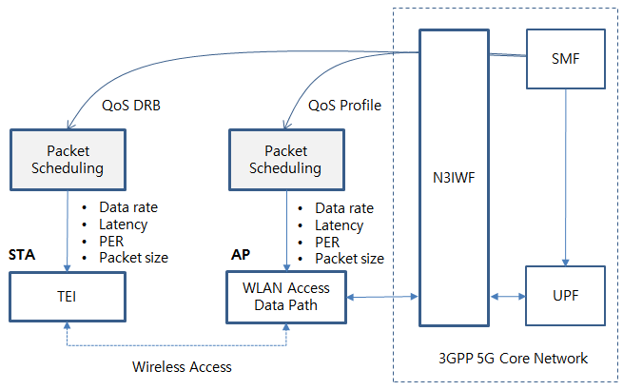
Figure 11QoS mapping and scheduling example of WLAN.

  - Technical Recommendations

WLAN can support high data rate to meet the performance of 5G network vision in the low mobility scenario and it is merged into an access network of 3GPP 5G network. Therefore it needs to conider new functional entities and signalling procedures. The new functional entities are as follows;
- Radio scanning and association
- Registartion and authentication
- NAS signallling messages
- Packet session intiation/modification/termination
- Packet data QoS management

The key considerations on WLAN to interwork 5G core network as follows;

- Radio scanning and association process is well specified in WLAN 802.11 and will be performed if WLAN interworking is necessary.

- IKEv2, EAP-5G and IPsec protocol for registartion and authentication shall be added in function of TEC and ANC of WLAN.

- NAS signalling to connect AMF shall be added in function of TEC and ANC of WLAN.

- Packet session intiation/modification/termination to connect SMF shall be added in function of TEC and ANC of WLAN.

- Packet data QoS management of WLAN shall specify QoS identification, profile and DRB to gurauntee packet delay and PER for the required service types.
  - QoS mapping to WLAN is necessary to support more granularity of QoS ID and parameters
  - Packet scheduling in STA and AP should meet data rate, latency and PER.
  - Timing scheduling and Hybrid ARQ scheme are very important
  - 802.11ax can not support 3GPP service QoS, and improved version (11be EHT, 11bd NGV) should consider MAC enhancement to support service requirements.

- Conclusions
WLAN is merged into an access network of 3GPP 5G network and is able to support high data rate to meet the performance of 5G network vision in the low mobility scenario. The new functional entities and signalling procedures are analyzed as follows;
- Radio scanning and association
- Registartion and authentication
- NAS signallling messages
- Packet session intiation/modification/termination
- Packet data QoS management

Through gap analysis, IEEE WLAN radio scanning and assoiciation process, IETF specification such as IKEv2, EAP-5Ga and IPsec can be used and partly modified. And they will be implemented in TEC and ANC of WLAN. NAS signalling, ATSSS and QoS management shall be implemented in TEC and ANC of WLAN according to 3GPP specification.

As for QoS management, WLAN shall specify QoS mapping and MAC scheduling including QoS identification and profile to gurauntee QoS in terms of deterministic packet delay, low PER and data rate.

- References

- 3GPP TS 22.261 V15.5.0 (2018-06) “Service requirements for the 5G system (Stage 1)”
- 3GPP TS 22.278 “Service requirements for the Evolved Packet System (EPS)”
- 3GPP TS 23.402 "Architecture enhancements for non-3GPP accesses”
- 3GPP TR 23.716 “Study on the Wireless and Wireline Convergence for the 5G System Architecture”
- 3GPP TR 23.793 “Study on Access Traffic Steering, Switching and Splitting support in the 5G system architecture”
- 3GPP TR 23.799 “Study on Architecture for Next Generation System”
- 3GPP TS 23.501 “System Architecture for the 5G System (Stage 2)”
- 3GPP TS 23.502 “Procedures for the 5G System (Stage 2)”
- 3GPP TS 24.302 “Access to the 3GPP Evolved Packet Core (EPC) via non-3GPP access networks (Stage 3)”
- 3GPP TS 24.501 “Non-Access-Stratum (NAS) protocol for 5G System (5GS) (Stage 3)”
- 3GPP TS 24.502 “Access to the 3GPP 5G Core Network (5GCN) via Non-3GPP Access Networks (N3AN) (Stage 3)”
- 3GPP TS 33.501 “Security Architecture and Procedure for the 5G System”
- 3GPP TR 33.899 “Study on the Security Aspects of the Next Generation System”
- 3GPP TS 37.324 “Service Data Adaptation Protocol (SDAP) Specification”
- 3GPP TS 38.300 “NR and NG-RAN Overall Description”
- RAN convergence paper, WBA and NGMN alliance, September, 2019.
- IEEE 802.1CF-2019; IEEE Recommended Practice for Network Reference Model and Functional Description of IEEE 802® Access Network, 2019.

