IEEE P802.11
Wireless LANs
802.11 SENS SG Proposed PAR
Date: 2020-08-03
Author(s):
Name | Affiliation | Address | Phone | email
Claudio da Silva | Intel |  |  | claudio.da.silva@intel.com
Abstract
This submission includes the IEEE 802.11 WLAN Sensing (SENS) Study Group proposed PAR.

Note: The P802.11bf PAR approved by SENS SG and 802.11 WG (19/2103r11) in the July 2020 plenary (20/0325r3) is included below as an embedded file and in text format as found in myProject.

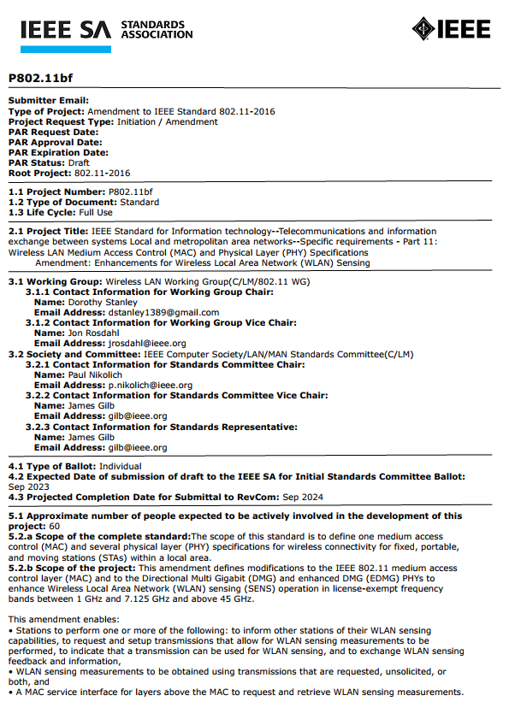

P802.11bf

Submitter Email:
Type of Project: Amendment to IEEE Standard 802.11-2016
Project Request Type: Initiation / Amendment
PAR Request Date:
PAR Approval Date:
PAR Expiration Date:
PAR Status: Draft
Root Project: 802.11-2016

1.1 Project Number: P802.11bf
1.2 Type of Document: Standard
1.3 Life Cycle: Full Use

2.1 Project Title: IEEE Standard for Information technology--Telecommunications and information exchange between systems Local and metropolitan area networks--Specific requirements - Part 11: Wireless LAN Medium Access Control (MAC) and Physical Layer (PHY) Specifications
Amendment: Enhancements for Wireless Local Area Network (WLAN) Sensing

3.1 Working Group: Wireless LAN Working Group(C/LM/802.11 WG)
3.1.1 Contact Information for Working Group Chair:
Name: Dorothy Stanley
Email Address: dstanley1389@gmail.com
3.1.2 Contact Information for Working Group Vice Chair:
Name: Jon Rosdahl
Email Address: jrosdahl@ieee.org
3.2 Society and Committee: IEEE Computer Society/LAN/MAN Standards Committee(C/LM)
3.2.1 Contact Information for Standards Committee Chair:
Name: Paul Nikolich
Email Address: p.nikolich@ieee.org
3.2.2 Contact Information for Standards Committee Vice Chair:
Name: James Gilb
Email Address: gilb@ieee.org
3.2.3 Contact Information for Standards Representative:
Name: James Gilb
Email Address: gilb@ieee.org

4.1 Type of Ballot: Individual
4.2 Expected Date of submission of draft to the IEEE SA for Initial Standards Committee Ballot: Sep 2023
4.3 Projected Completion Date for Submittal to RevCom: Sep 2024

5.1 Approximate number of people expected to be actively involved in the development of this
project: 60
5.2.a Scope of the complete standard: The scope of this standard is to define one medium access control (MAC) and several physical layer (PHY) specifications for wireless connectivity for fixed, portable, and moving stations (STAs) within a local area.
5.2.b Scope of the project: This amendment defines modifications to the IEEE 802.11 medium access control layer (MAC) and to the Directional Multi Gigabit (DMG) and enhanced DMG (EDMG) PHYs to enhance Wireless Local Area Network (WLAN) sensing (SENS) operation in license-exempt frequency bands between 1 GHz and 7.125 GHz and above 45 GHz.

This amendment enables:
• Stations to perform one or more of the following: to inform other stations of their WLAN sensing capabilities, to request and setup transmissions that allow for WLAN sensing measurements to be performed, to indicate that a transmission can be used for WLAN sensing, and to exchange WLAN sensing feedback and information,
• WLAN sensing measurements to be obtained using transmissions that are requested, unsolicited, or both, and
• A MAC service interface for layers above the MAC to request and retrieve WLAN sensing measurements.

This amendment defines modifications to the PHY service interface of the High Throughput (HT), Very High Throughput (VHT), High Efficiency (HE) and Extremely High Throughput (EHT) PHYs.

This amendment provides backward compatibility and coexistence with legacy IEEE 802.11 devices operating in the same band.

5.3 Is the completion of this standard contingent upon the completion of another standard? Yes
Explanation: As defined in 5.2.b, to enhance WLAN sensing, this amendment augments PHY and MAC capabilities defined in the IEEE P802.11ax, IEEE P802.11ay, IEEE P802.11az and IEEE P802.11be amendments and the IEEE P802.11 revision standard.
5.4 Purpose: The purpose of this standard is to provide wireless connectivity for fixed, portable, and moving stations within a local area. This standard also offers regulatory bodies a means of standardizing access to one or more frequency bands for the purpose of local area communication.
5.5 Need for the Project: Measurement capabilities defined in the IEEE P802.11 revision standard and in the amendments identified in 5.3, specified as part of features such as beamforming and fine-timing measurement, do not suitably support WLAN sensing. An amendment with the scope defined in 5.2.b is necessary to enhance reliability and efficiency of WLAN sensing and to allow for interoperability of WLAN sensing functionalities.
5.6 Stakeholders for the Standard: Manufacturers and users of semiconductors, personal computers, enterprise networking devices, consumer electronic devices, home networking equipment, mobile devices, wireless sensing equipment (including for behavior recognition, vehicular, smart homes, and security applications), and test and measurement equipment providers.

6.1 Intellectual Property
6.1.1 Is the Standards Committee aware of any copyright permissions needed for this project? No
6.1.2 Is the Standards Committee aware of possible registration activity related to this project? No

7.1 Are there other standards or projects with a similar scope? No
7.2 Is it the intent to develop this document jointly with another organization? No

8.1 Additional Explanatory Notes : 5.2.b: WLAN sensing is the use of PHY and MAC features of IEEE 802.11 stations to obtain channel measurements that characterize the environment in which the stations operate. Measurements obtained with WLAN sensing are used to enable applications such as presence detection and gesture classification, among others. The specification of such applications is beyond the scope of the project.

5.2.b: Backward compatibility with legacy 802.11 devices implies that devices implementing this amendment shall maintain data communication compatibility.

5.2.b: The capabilities introduced in this amendment will be evaluated in a set of deployment scenarios, including residential, enterprise, indoor, and outdoor, which are applicable to the main expected applications.

5.3:
• IEEE P802.11 - IEEE Standard for Information technology—Telecommunications and information exchange between systems Local and metropolitan area networks—Specific requirements - Part 11: Wireless LAN Medium Access Control (MAC) and Physical Layer (PHY) Specifications
• IEEE P802.11ax - Part 11: Wireless LAN Medium Access Control (MAC) and Physical Layer (PHY) Specifications - Amendment: Enhancements for High Efficiency WLAN
• IEEE P802.11ay - Part 11: Wireless LAN Medium Access Control (MAC) and Physical Layer (PHY) Specifications - Amendment: Enhanced throughput for operation in license-exempt bands above 45 GHz
• IEEE P802.11az - Part 11: Wireless LAN Medium Access Control (MAC) and Physical Layer (PHY) Specifications - Amendment: Enhancements for positioning
• IEEE P802.11be - Part 11: Wireless LAN Medium Access Control (MAC) and Physical Layer (PHY) Specifications - Amendment: Enhancements for Extremely High Throughput

