IEEE P802.11  
Wireless LANs

|  |  |  |  |  |
| --- | --- | --- | --- | --- |
| Punctured 802.11ax SEM Analysis | | | | |
| Date: 2019-11-12 | | | | |
| Author(s): | | | | |
| Name | Affiliation | Address | Phone | email |
| Dorin Viorel | CableLabs |  |  | d.viorel@cablelabs.com |
| Lili Hervieu | CableLabs |  |  | l.hervieu@cablelabs.com |
|  |  |  |  |  |

Abstract

IEEE 802.11ax introduces the preamble punctured feature. This submission analyzes the impact of the preamble puncturing emission mask upon legacy (802.11ac) signals and makes corresponding recommendations.

Contents

1 Introduction 3

2 Objectives, Assumptions and Methodology 3

2.1 Objectives 3

2.2 Assumptions 3

2.3 Methodology 4

3 Simulations Results 4

3.1 Case 1 (Victim: Ch 2 and 3, Aggressors: Ch 1 and 4) 4

3.1.1 Candidate SEMs 5

3.1.2 SINR Degradation 5

3.2 Case 2 (One punctured victim channel, 3 aggressors) 6

3.2.1 Case 2.1 (Victim: Ch 3, Aggressors: Ch 1, 2 and 4) 6

3.2.2 Case 2.2 (Victim: Ch2, Aggressors: Ch 3 and 4) 7

3.3 Case 3 (3 punctured victims Ch 2, 3, 4 or 5, aggressor Ch 1) 8

3.4 SINR degradation 9

4 Conclusions 11

5 References 13

6 AppendixAppendix 14

6.1 Case 1. 802.11ac reference SEM 14

6.2 Methodology 14

6.3 Victim OFDM Waveform 15

6.4 Case 1. SINR degradation (SNR=10 and 20dB) 16

# Introduction

NR-U considers using non-contiguous channel allocations for wide band channels (e.g., BW=80 MHz). This represents a departure from the contiguous channel allocations employed by LTE LAA and 802.11ac (only contiguous 20/40/80/160 MHz allocations being supported).

RAN4 studies the related NR-U Spectrum Emission Mask (SEM), considering to re-use elements of the IEEE802.11ax punctured SEM, as specified by ([3] section #27.3.18).

This paper analyses the potential impact of the NR-U SEM or IEEE802.11ax SEM upon legacy (802.11ac) SEM and makes corresponding recommendations.

# Objectives, Assumptions and Methodology

The simulations target the potential impact of SEM aggressors (802.11ax or NR-U) upon victim legacy (802.11ac) devices.

## Objectives

The following test cases are discussed (see Table 1), referenced to an 80 wide-band case:



Table 1. Summary of the punctured channel(s) test cases under discussion.

It should be noted that:

* IEEE802.11ax do not support more than 2 puncture use cases within a 80 MHz wide band. However, Cases 2, 3-1, 3-, 3-3 are analyzed in order to address the requirements presented in [1].
* Case 3-4 address a valid IEEE802.11ax use case. Other possible sub-cases (victim located in Channels 6, 7 or 8) are not discussed since the differences, compared with Case 3-4 are minimal

## Assumptions

In all cases, the victim is a single 802.11ac 20 MHz channel with the exception of Case 1, which may use 1 or 2 20 MHz victim channels, the only difference being the victim’s throughput.

1. **Inputs**

* SNR: victim 802.11n/ac signal to noise ratio
  + 3 values were exercised covering cell edge (SNR=10dB, RSSI=-86dBm[1]), mid cell (SNR=20dB, RSSI=-76dBm[2]) and cell center (SNR=30dB, RSSI=-66dBm[3])
  + For the 3D simulations a wide range of SNR values from 0 to 50 with 1-dB increment was used
* Δ*PRX*= *PRX*(victim)-*PRX*(Aggressor), which represent relative location (distance or path loss) between victim transmitter to victim receiver, and between aggressor transmitter and victim receiver
  + Δ*PRX* from -30 to 20 dB with 1-dB increment
* Equal Power Spectral Density (PSD) assumed for the aggressor and the victim. Victim power spectrum density (PSD), details are presented in section 6.3
* SIR: victim signal to interference (SIR) ratio
  + Calculated per frequency points (640001 points over 80 MHz BW, 125 Hz RBW)
  + Apply interferer (e.g., 802.11ax) SEMs, victim received PSD and Δ*PRX*

1. **Outputs**

* Signal to interference plus noise ratio (SINR): $SINR=\frac{S}{I+N}=\frac{1}{\frac{1}{SNR}+\frac{1}{SIR}}$,
  + SINR degradation is calculated per active subcarrier.
  + SINR is further averaged (linear units) over the occupied victim channel(s) bandwidth
  + The absolute and relative SINR degradation for the SNR cases mentioned above for *PRX* range under consideration (from -30 to 20 dB with 1-dB increment unless otherwise specified).

## Methodology

The methodology is presented in 6.2.

# Simulations Results

The test cases indicated in section 2.1 are analyzed.

## Case 1 (Victim: Ch 2 and 3, Aggressors: Ch 1 and 4)

The independent and compounded SEMs are analyzed, as follows:

* Two aggressors (Ch 1 and 4) using 802.11ac independent and combined SEMs.
* Two aggressors (Ch 1 and 4) using NR-U independent and combined SEMs.

### Candidate SEMs

Ch 1 and 4 related independent and compounded SEMs are presented in Appendix section 6.4.

It could be observed that two compounded 802.11ac SEMs with 2 punctured middle channels generate a lower vertex around -37dBm.

The following SEM candidates were identified, as presented in Figure 1:

* 802.11ac compounded SEM (reference)
* NR-U (single carrier) compounded SEM
* Triangular -25 dBr vertex SEM (named CL25)
* Triangular -28 dBr vertex SEM (named CL28)
* Triangular --31 dBr vertex SEM (named CL31)
* IEEE punctured 802.11ax SEM

Figure 1. Aggresor SEM for the 2 punctured (Ch 2 and 3) wide band case.

The 802.11ac reference SEMs, used as an input are presented in section 6.1. It should be noted that the NR-U SEMs look identical.

### SINR Degradation

Three sub-cases are analyzed:

1. SNR=10 dB (equivalent to RSSI ~ -86dBm), presented in section 6.4
2. SNR=20dB (equivalent to RSSI ~ -76dBm), presented in section 6.4.
3. SNR=30dB (equivalent to RSSI ~ -66dBm), presented in Figure 2.

|  |  |
| --- | --- |
|  |  |

Figure 2. Absolute and relative SINR degradation (SNR=30dB) of the 1 puncture 802.11ac 2×20MHz carriers (Ch 2 and 3) when subject to aggresors positioned on Ch 1 and 4.

**Observation 1: The relative SINR degradation of the 802.11ac victim is presented below (Case 1)**



Table 2 SINR degradation for Case 1

## Case 2 (One punctured victim channel, 3 aggressors)

Two subcases are discussed: Case 2.1 (victim: Ch2, aggressors: Ch 1, 3 and 4) and Case 2.2 (victim: Ch3, aggressors: Ch 1, 2 and 4).

### Case 2.1 (Victim: Ch 3, Aggressors: Ch 1, 2 and 4)

Ch1 and 2 use a 40 MHz SEM while Ch4 uses a 20 MHz SEM.

**Proposal 2**

|  |  |  |  |  |  |  |  |  |
| --- | --- | --- | --- | --- | --- | --- | --- | --- |
| **Relative Frequency** | **-0.5N** | **-0.5N+1 MHz** | **-.05N+10 MHz** | **-0.5 N+20 MHz** | **0.5 N-20 MHz** | **-.0.5N-10MHz** | **-0.5N-1 MHz** | **0.5N** |
| **Relative Power [dBr]** | **0** | **-20** | **-25** | **-28** | **-28** | **-25** | **-20** | **0** |

Table 3 Proposed Co-existence Level 28 SEM (N is bandwidth of punctured channels, e.g., 20, 40 or 60 MHz)

|  |  |
| --- | --- |
|  |  |

Figure 3. Case 2.1 Candidate SEMs and Victim.

The 802.11ac SEM (green dash-dotted line) and NR-U SEM (pink dashed line) are combined from a 40-MHz channel and a 20-MHz channel. These two SEMs are asymmetrical, where the min value is -22.4 dBr at 10.74 MHz.

### Case 2.2 (Victim: Ch2, Aggressors: Ch 3 and 4)

Ch1 and 3 use a 20 MHz SEM (reference 802.11ac) while the aggressor uses a 20 MHz SEM (Ch1) and a 40 MHz SEM (Ch 3 and 4) for the NR-U and 802.11ax cases).

|  |  |
| --- | --- |
|  |  |

Figure 4. Case 2.2 Candidate SEMs and Victim.

The 802.11ac SEM (green dash-dotted line) is the result of two compounded 20 MHZ SEMs, driving to asymmetrical SEM, with the min at -20.1dBr (@-10 MHz).

The NR-U SEM (dotted red line) is the result of one 20 MHz SEM (Ch1) and a 40 MHz SEM (Ch 3-4), driving to an asymmetrical SEM, where the min value is -17.6 dBr at -10.74 MHz.

This use case does not flag any coexistence impact (802.11ax/NR-U upon the legacy 802.1ac devices)

## Case 3 (3 punctured victims Ch 2, 3, 4 or 5, aggressor Ch 1)

The related sub-cases under analysis are summarized in Figure 5. This case discusses the implications for a 80 Mhz wide-band (aggressors on Ch 2, 3 or 4) and for 160 wide band (aggressor on channel 5).

|  |  |
| --- | --- |
|  |  |
|  |  |

Figure 5. Case 4. Three puncture 802.11ax SEM: victim and aggressors.

The candidate SEMs are presented below.

Figure 6. Case 4. Candidate SEMs (80 MHz wide band).

## SINR degradation

A summary of the SINR degradation for the 4 sub-cases (SNR=30dB) is presented below (from top to bottom: aggresors on Ch 5, 3, 2).

|  |  |
| --- | --- |
|  |  |
|  |  |
|  |  |

Figure 7. SINR degradation (SNR=30dB) for the 3 puncture case. From top to bottom: victim Ch5 (160 MHz wide-band), Ch 3 and Ch2 (80 MHz wide-band).

**The SEM CL31 provides the lowest SINR degradation of the SEM candidates.**

**Proposal 2 (N=80 MHz)**

|  |  |  |  |  |  |  |  |
| --- | --- | --- | --- | --- | --- | --- | --- |
| **Relative Frequency** | **-0.5N** | **-0.5N+1 MHz** | **-.05N+10MHz** | **0** | **-.0.5N-10MHz** | **-0.5N-1 MHz** | **0.5N** |
| **Relative Power [dBr]** | **0** | **-20** | **-25** | **-31** | **-25** | **-20** | **0** |

Table 4. Proposed SEM for the 3 punctures case.

# Conclusions

The analysis covers the impact of 802.11ax and NR-U aggressors upon 802.11ac victims, based on an equal power Spectral Density criterion applied to both the victims and aggressors. It should be noted that by applying this criterion, the aggressors’ impact is reduced but also the aggresors coverage (vs. the victim 802.11ac coverage).

In this paper, we analyzed the SINR degradation of 802.11ac and NR-U victims when 802.11ax carriers are used as aggresors for different the wide 80 MHz band when punctured cases.



Table 5. Summary of the SINR degradation (SNR=30dB) for Cases 1, 2, 3.

The following observations and proposals were made.

**Proposal 1**

|  |  |  |  |  |  |  |  |
| --- | --- | --- | --- | --- | --- | --- | --- |
| **Frequency [MHz]** | **-N** | **-0.5N+1 MHz** | **-0.25N** | **0** | **0.25N** | **0.N-1 MHz** | **N** |
| **Power [dBr]** | **0** | **-20** | **-25** | **-28** | **-25** | **-20** | **0** |

**Proposal 2 (N=80 MHz)**

|  |  |  |  |  |  |  |  |
| --- | --- | --- | --- | --- | --- | --- | --- |
| **Relative Frequency** | **-0.5N** | **-0.5N+1 MHz** | **-.05N+10MHz** | **0** | **-.0.5N-10MHz** | **-0.5N-1 MHz** | **0.5N** |
| **Relative Power [dBr]** | **0** | **-20** | **-25** | **-31** | **-25** | **-20** | **0** |

# References

[1] IEEE Draft P802.11ax D5.0, October 2019.

[2] R4-1911850, “Further discussions on Emissions Mask Considerations for NR-U DL single wideband carrier operation modes”, Charter Communications, CableLabs, RAN4 #92.

[3] R4-1913059, “Draft WF on punctured channels”, Charter Communications, RAN4 #92.

# AppendixAppendix

## Case 1. 802.11ac reference SEM

|  |  |
| --- | --- |
|  |  |

Figure 8. Independent and compounded SEM 802.11ac reference SEMs for Case 1 and NR-U SEM (Case 1)

## Methodology

1. Divide the non-contiguous channel allocations into multiple cases (as defined in 2.1)
2. Build OFDM waveforms for each victim case
3. Build non-coherent aggressor waveforms based of non-coherent energy (white noise) shaped by the desired aggressor SEM
4. Reference case: the aggressor is another 802.11ac waveform
   1. Set the victim’s SNR for 3 cases: 10 dB (outer cell), 20 dB (mid cell) and 30 cell center)
   2. Vary the aggressor Rel Rx Power level in 0.5 dB steps
   3. Assign a set of mixed modulations (5/6 QAM256, 5/6QAM64, 3/4QAM16, 3/4QPSK) applied to the victim’s subcarriers.
   4. Map/Calculate SINR per subcarrier.
   5. Calculate the PHY throughput (reference) per SC and the aggregated (total) RxRefTput.
5. Replace the aggressor 802.11ac waveform with another aggressor waveform (see next slide) under test (1st phase: 802.11ax)
   1. Repeat step #4 for different aggressor SEMs.
6. Compare results from steps 4 and 5 and make the SEM recommendation.
   1. Compare the SINR and Tput (#5 vs. #4).

## Victim OFDM Waveform

The victim 802.11ac OFDM waveform was based on the following:

* OFDM waveform: 2 adjacent 20-MHz channels (the SINR impact for the puncture channels) is the same of using Ch 2 or 3 or both Ch 2 and. The tput impact is scaled
* For each 20-MHz channel:
* 125 Hz frequency resolution
* 312.5 kHz subcarrier spacing
* 52 active subcarriers: [-28:-22 -20:-8 -6:-1 1:6 8:20 22:28]
* 11 guard tones [-32:-29 29:31]
* 1 DC component: [0]
* 4 pilot tones (do not convey data): [-21 -7 7 21]
* Random binary bits make the PSD fluctuate; the simulated PSD use is averaged over 1000 times

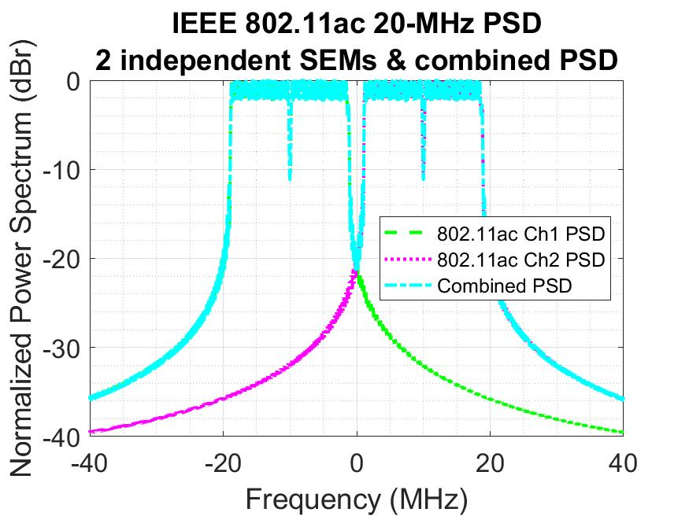

Figure 9. 802.11ac victim OFDM waveform used in the simulation

## Case 1. SINR degradation (SNR=10 and 20dB)

|  |  |
| --- | --- |
|  |  |
|  |  |

Figure 10. Case 1. Absolute and Relative SINR degradation for SNR=20dB and 10dB.

1. Noise Floor: -101 dBm/20MHz, Noise Figure: 5 dB
2. Noise Floor: -101 dBm/20MHz, Noise Figure: 5 dB
3. Noise Floor: -101 dBm/20MHz, Noise Figure: 5 dB