IEEE P802.11
Wireless LANs
Proposed resolution for CIDs Related to Quiet Time Period
Date: 2019-11-12
Author(s):
Name | Affiliation | Address | Phone | email
Kaiying Lu | Mediatek Inc. | 2840 Junction Ave. San Jose, CA | (408) 3872160 | Kaiying.lu@mediatek.com

Abstract
This submission proposes resolutions for comments related to TGax D5.0 subclause 26.17.3.1 with the following CIDs:
22536

Revisions:
Rev 0: Initial version of the document.
Rev 1: modify the comment resolution in the table and the corresponding text.

Interpretation of a Motion to Adopt

A motion to approve this submission means that the editing instructions and any changed or added material are actioned in the TGax Draft. This introduction is not part of the adopted material.

Editing instructions formatted like this are intended to be copied into the TGax Draft (i.e. they are instructions to the 802.11 editor on how to merge the text with the baseline documents).

TGax Editor: Editing instructions preceded by “TGax Editor” are instructions to the TGax editor to modify existing material in the TGax draft. As a result of adopting the changes, the TGax editor will execute the instructions rather than copy them to the TGax Draft.

CID | commenter | Section | Pg / Ln | Comment | Proposed Change | Resolution
22536 | Yongho Seok | 26.17.3.1 | 456/32 | Why is BSSID [39:44] used? If it is just arbitrary chosen, please use single byte of the BSSID, e.g., BSSID[42:47] or BSSID[40-45].  Also, bin[x, k] is the operator that casts decimal value x into k bits binary vector. It is necessary to map bit vector to field value. | As in the comment. | Revised  For the first part of comments, BSSID [39:44] is just arbitrarily chosen and it is of no issues.  Agree with the commenter in principle for the second part of comments.  To be consistent with the baseline, change BSSID [39:44] to dec (BSSID [39:44]) and change transmitted BSSID [39:44] to dec (transmitted BSSID [39:44]).  TGax editor, please make changes as shown in 11-19/2053r1 CID 22536

Discussion:
In REVmd, CID 1300 is listed here:
1300 | There are several sections of the spec that refer to portions of the MAC address (or BSSID) as MSB/LSB. This is confusing as MAC address/BSSID is a sequence of 48-bits. At times, the spec says I/G bit is the MSB in the address. This conflicts with the description in 802-2014 (clause 8 Fig 10) where it says I/G is bit 0 of the first octet. Please updates sections: 9.4.1.25 (P857L34), 9.4.2.21.10 (P996L29), 9.4.2.104 (P1183L1), 11.45.5.3 (P2305L20), 14.13.2.4.5 (P2612L1) and MIB references. | Please update the cited spec text to remove any references to MSB (or LSB) and instead use bit positions (e.g., MAC_ADDR[0:47]) to describe (or operate on) the corresponding bits in the MAC address. | REVISED (MAC: 2018-09-11 00:27:28Z): Incorporate the changes in 11-18/1350r3. These changes remove references to MSB and LSB in MAC Addresses, in the direction suggested by the commenter.
It has been globally updated by replacing bit vector BSSID[a:b] with dec() as follows:
From REVmd D1.0,
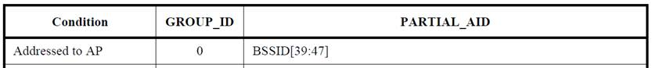
To REVmd D3.0,
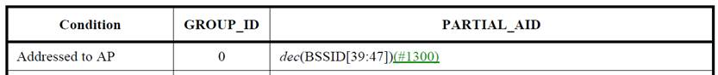

TGax editor: please add the following primitives in 26.17.3.1 (D5.0 page456/ line32) as follows:

26.17.3 BSS color

26.17.3.1 General (#22536)

BSS color identifies a BSS and assists a STA receiving a PPDU that carries BSS color in identifying the BSS from which the PPDU originates so that the STA can use the channel access rules in 26.10 (Spatial reuse operation), reduce power consumption as described in 26.14.1 (Intra-PPDU power save for non-AP HE STAs) or update its NAV as described in 26.2.4 (Updating two NAVs).

All APs that are members of a multiple BSSID set or co-hosted BSSID set shall use the same BSS color.

A non-AP HE STA associated with an HE AP that is transmitting an HE PPDU in a direct path to a TDLS peer STA shall set the BSS Color subfield of the HE Operation element it transmits to the peer STA to the value indicated in the BSS Color subfield of the HE Operation element received from the HE AP. An HE STA associated with a non-HE AP that is the initiating STA of the TDLS link shall use the same active BSS color for all its TDLS links by setting the BSS Color subfield of the HE Operation element it transmits to the TDLS peer HE STA to the value of dec(BSSID [39:44]) of the non-HE AP or dec(transmitted BSSID [39:44]) of the non-HE AP if the AP indicates the support of multiple BSSID in its Extended Capabilities element.

