IEEE P802.11
Wireless LANs
Resolution to HESIGB and Related Comments

Date: 2019-11-13
3Brian Hart | Cisco Systems | 170 W Tasman Dr, San Jose CA 94087 | brianh@cisco.com

Abstract
This submission proposes a resolution for PHY-related CIDs 22441, 22041, 22038, 22016, 22391
22296, 22443, 22040 (8 CIDs)

R2: For CID 22441, added 16-31, 96-112 (for empty central ru26)

Interpretation of a Motion to Adopt

A motion to approve this submission means that the editing instructions and any changed or added material are actioned in the TGax Draft. This introduction is not part of the adopted material.

Editing instructions formatted like this are intended to be copied into the TGax Draft (i.e. they are instructions to the 802.11 editor on how to merge the text with the baseline documents).

TGax Editor: Editing instructions preceded by “TGax Editor” are instructions to the TGax editor to modify existing material in the TGax draft. As a result of adopting the changes, the TGax editor will execute the instructions rather than copy them to the TGax Draft.

CID | Page | Clause | Comment | Proposed Change | Proposed Resolution
22441 | 566.45 | 27.3.10.8.3 | Specification text is 'certain values' without listing them. This is unclear. | List values explicitly. | Revised. In general agreement with commenter. See resolution under CID 22441 in 19/1871 <motioned-revision>

Discussion
For context here is the Draft 5 text:

In an HE MU PPDU, an RU that is not allocated to a user can be indicated as follows:
— The Center 26-tone RU subfield in the HE-SIG-B Common field is set to 0 (see Table 27-24 (Com-
mon field))
— The RU Allocation subfield in the HE-SIG-B Common field is set to certain values (see Table 27-26
(RU Allocation subfield))
— The STA-ID subfield in the HE-SIG-B User field is set to 2046 (see 26.11.1 (STA_ID) and
27.3.10.8.4 (User Specific field)).

The cross reference to Table 27-24 includes the “certain values” but does not identify which “certain values” were intended. As shown below, relevent RU Allocation subfields of Table 27.26 are 16-31 and 96-112 (empty ru26[#5]), 113 (empty ru242) and 114 (empty ru484).

115 appears to be relevant but IMHO is not: a) when not using 80 MHz, either this is a 0-bandwidth PPDU (!) or 80 MHz is not used out of 160 MHz, and this must be the secondary 80 MHz in order that the content channels be correctly delivered, so then this is just describing an 80 MHz PPDU. It is not advisable to advertise an 160 MHz PPDU when an 80 MHz PPDU is being transmitted.

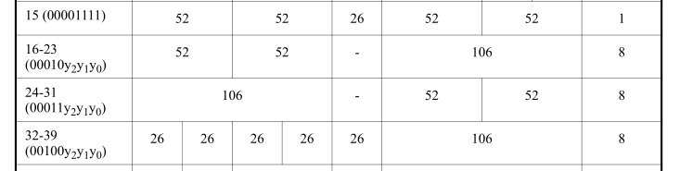
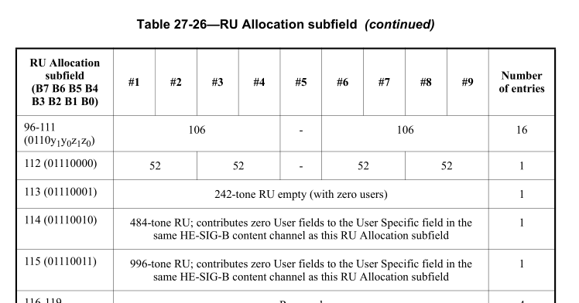

Under CID 22441, TGax Editor please change:
In an HE MU PPDU, an RU that is not allocated to a user can be indicated as follows:
…
— The RU Allocation subfield in the HE-SIG-B Common field is set to 16 to 31 inclusive or 96 to 113 inclusive (see Table 27-26 (RU Allocation subfield))
— Both RU Allocation subfields at the same position in each HE-SIG-B Common field of the two HE-SIG-B content channels are set to 114 (see Table 27-26 (RU Allocation subfield))

CID | Page | Clause | Comment | Proposed Change | Proposed Resolution
22041 | 571.11 | 27.3.10.8.3 | Language refers to STAs yet, because of the broadcast RU 1 user has many STAs. The right term is user. | Change "STA/s" to "user/s", 9 times in this table footer. Also P572L33, P574L41, P574L42, P575L27, P575L29, , P575L30, , P575L25, P576L56, P576L33, P577L25, P577L26. P573L48 and P573L49 probably should stay the same (with a cross-reference to the MAC clause 26.5.1.2 that does not the Broadcast RU to be decoded whenever the STA has its own User field). P577L20 may need a modest rewrite or xref to account for the Broadcast RU too. | Revised. In general agreement with commenter. See resolution under CID 22441 in 19/1871 <motioned-revision>

Discussion

Agree with commenter that user rather than STA is the correct term.

As well, at P573L48 and P573L49, “addressed to a single STA” is poor language since the STA-ID is used in HESIGB, not a STA’s address. “As well, “multiple RUs” is the wrong phrase since this doesn’t preclude multiple users in the same RU from being addressed to the same STA.

Meanwhile, it is true that the MAC clause 26.5.1.2 (see below) has important confirmatory language, and a cross-reference is advised.

P577L20 does not need a rewrite because the Broadcast RU cannot be steered (sounding is too hard to gather).

26.5.1.2 RU addressing in an HE MU PPDU
…
The AP shall not include in the TXVECTOR more than one parameter STA_ID with the same value unless the value is 2046 (indicating an unallocated RU).
…
A non-AP STA that receives an HE MU PPDU where the RXVECTOR includes a parameter STA_ID that
matches the 11 LSBs of the non-AP STA's AID may disregard any broadcast RU in the HE MU PPDU. A
non-AP STA that receives an HE MU PPDU where the RXVECTOR includes a parameter STA_ID that is
equal to the BSSID Index of the BSSID of the AP with which the STA is associated (see 9.4.2.73 (Multiple
BSSID-Index element)) may disregard a broadcast RU (parameter STA_ID equal to 2047).
An MPDU of an HE MU PPDU sent in a broadcast RU shall not include information intended for a STA that
is identified as the recipient of another RU in the same HE MU PPDU.

P577L20

Under CID 22041, TGax Editor please change "STA/s" to "user/s", 9 times in this table footer. Also make the same change at P572L33, P574L41, P574L42, P575L27, P575L29, , P575L30, , P575L25, P576L56, P576L33, P577L25, P577L26.

Under CID 22041, TGax Editor please change P577L48-49 and P573L20-24 as follows:
Since a single STA is not required to decode the data for more than one user (see 26.5.1.2 (RU addressing in an HE MU PPDU)) therefore, the sig-
naling that enables a STA to decode its data is carried in only one User field.

CID | Page | Clause | Comment | Proposed Change | Proposed Resolution
22038 | 571.56 | 27.3.10.8.3 | Dynamic Split and Equitable Split are important concepts that merit their own clause 3 definitions. Also P571L56 is missing a "Dynamic" | Add definitions for Dynamic Split and Equitable Split in Clause 3. Use the appropriate one of these capitized terms at P506L36, P506L41, P567L1, P571L55, P573L34, P573L39, P577L3, P577L11, P769L62, P772L4, P772L10, P772L16 | Revised. In general agreement with commenter. See resolution under CID 22441 in 19/1871 <motioned-revision>
Discussion
This seems to be a helpful direction. Some language needs to be modestly wordsmithed to turn the verbal forms “dynamically split” and “equitably split” into their nouns. The group prefers a clause 7 definition instead of a clause 3 definition.

Meanwhile P506L41 needs expansion especially because it does not describe or reference the dynamic split.

Under CID 22041, TGax Editor please change as follows:

Sidebar, not for inclusion in the draft: the TGax editor has indicated a dislike of “dynamic split” since practically everything in 802.11 is dynamic. “Load-based split” might be a better term than “dynamic split”.

27.3.10.8.1 General

Dynamic split is defined as the split of User fields across HE-SIG-B content channels according to the Common field in each HE-SIG-B content channel and used when the HE-SIG-B Compression field in the HE-SIG-A field equals 0.

Equitable split is defined as the split of User fields across HE-SIG-B content channels used when the HE-SIG-B Compression field in the HE-SIG-A field equals 1.

27.3.2.5 Resource indication and User identification in an HE MU PPDU

If there is more than one User field (see Table 27-29 (User field format for a MU-MIMO allocation)) for an RU in the HE-SIG-B content channel, then the number of allocated spatial streams for each user in the RU is indicated by the Spatial Configuration field of the User field in HE-SIG-B. Note that for an RU with 484 or more subcarriers and having two or more intended users, the User fields corresponding to the RU may be split between two HE-SIG-B content channels. In this case, the total number of users and the total number of spatial streams in the RU are the sum of the number of users and number of spatial streams per user, respectively, indicated in both HE-SIG-B content channels. For PPDU bandwidths greater than 20 MHz, the split is an equitable split in the case of full bandwidth DL MU-MIMO (see 27.3.10.8.4 (User Specific field)), or a dynamic split in the case when the HE-SIG-B Compression field in the HE-SIG-A field equals 0 (see 27.3.10.8.3 (Common field)).

27.3.10.8.3 Common field

NOTE 1—The exact dynamic split of User fields between the two content channels, N user (r, 1) and N user (r, 2), is not specified and might be used to reduce any disparity in the number of User fields between content channels.

For an MU-MIMO allocation of RU size greater than 242 subcarriers, the dynamic split of User fields between HE-SIG-B content channel 1 and HE-SIG-B content channel 2 is decided by the AP (on a per case basis) and signaled by the AP using the RU Allocation subfields in each HE-SIG-B content channel. See Annex Z for examples.

27.3.10.8.4 User Specific field

If the HE-SIG-B Compression field in the HE-SIG-A field of an HE MU PPDU is 0, then for an MU-MIMO allocation of RU size greater than 242 subcarriers, the AP performs a dynamic split of the User fields between HE-SIG-B content channel 1 and HE-SIG-B content channel 2 as described in 27.3.10.8.3 (Common field).

If the HE-SIG-B Compression field in the HE-SIG-A field of an HE MU PPDU is 1, for bandwidths larger than 20 MHz, the AP performs an equitable split of the User fields between two HE-SIG-B content channels, i.e., User field k of a K user MU-MIMO PPDU is carried in HE-SIG-B content channel c, where c is defined in Equation (27-20).

…

If the HE-SIG-B Compression field in the HE-SIG-A field is 0 and MU-MIMO is used in RUs of size greater than 242 subcarriers, the AP performs a dynamic split of the User fields corresponding to the same MU-MIMO allocations as described in 27.3.10.8.3 (Common field) into two HE-SIG-B content channels and the number of users (N_{user}) is computed as the sum of the number of User fields indicated for the RU by the 8-bit RU Allocation subfield in each HE-SIG-B content channel.

If the HE-SIG-B Compression field in the HE-SIG-A field is 1, then the number of users (N_{user}) is signaled by the Number Of HE-SIG-B Symbols Or MU-MIMO Users field in the HE-SIG-A field and the AP performs an equitable split of User fields following Equation (27-20).

Z.2 Example 1

The AP performs a dynamic split of the User fields for the two MU-MIMO STAs on 484-tone RU 1 with 2 User fields assigned to HE-SIG-B content channel 1 and none to HE-SIG-B content channel 2, to balance their load. The User field for STAs 1441, 1442, 1443 and 1444 are in HE-SIG-B content channel 1 while User field for STAs 1445, 1446, 1447 and 1448 are in HE-SIG-B content channel 2. The content of the entire HE-SIG-B for this example is shown in Table Z-2.

CID | Page | Clause | Comment | Proposed Change | Proposed Resolution
22016 | 571.62 | 27.3.10.8.3 | This paragraph duplicates the content already present in Table 27-24--Common field. | Remove spurious paragraph. | Accepted.

Discussion

Offending paragraph and table read:

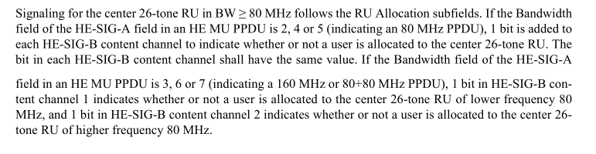
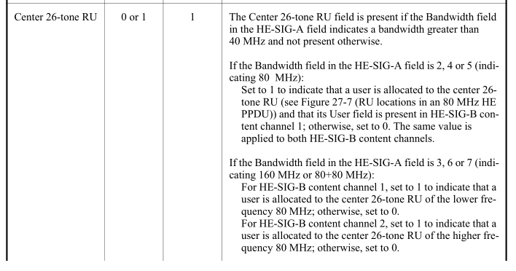
The paragraph does duplicate the table, but is actually less useful: e.g. a) “is added” is confusing since according to the table the field is already present in this case (“is included” would be better) and b) “indicate[s] whether or not a user is allocated to the center 26-tone RU” does not provide any information about the value of the field: is “1” associated with allocation or non-allocation?

Thus agreed with the commenter: delete the duplicative text.

CID | Page | Clause | Comment | Proposed Change | Proposed Resolution
22391 | 575.52 | 27.3.10.8.4 | "Set to 1 if a beamforming steering matrix is applied tothe waveform in an SU transmission." -- err, but this is HE-SIG-B, which by definition is an MU transmission | Delete "in an SU transmission" from the cited text in Table 27-18--HE-SIG-A field of an HE SU PPDU and HE ER SU PPDU and Table 27-28--User field format for a non-MU-MIMO allocation. | Revised. See resolution under CID 22441 in 19/1871 <motioned-revision>

Discussion
Agree with the commenter that “SU transmission” looks like a copy/paste error. Meanwhile, the TXVECTOR defines

“BEAMFORMED … FORMAT is HE_MU or HE_TB … For an RU assigned to no more than 1 user, set to 1 if a beamforming steering matrix is applied and set to 0 otherwise. For each user in an RU assigned to more than 1 user, always set to 0.”

This definition is consistent with the value of this field which is to indicate when an RU is beamformed and so an RX must take great caution before applying any frequency-domain smoothing to the CSI, including for DL-OFDMA as suggested by the TXVECTOR definition. However, the remedy is to broaden the definition of the field.

Under CID 22391, TGax Editor please change as follows:

Table 27-28—User field format for a non-MU-MIMO allocation

14 | Beamformed | 1 | Set to 1 if a beamforming steering matrix is applied to the portion of the waveform contributed by the RU that contains this user’s allocation and the RU contains no more than one user.  Set to 0 otherwise.

CID | Page | Clause | Comment | Proposed Change | Proposed Resolution
22296 | 576.00 | 27.3.10.8.4 | "NOTE--If the STA-ID subfield is 2046, then the other subfields can be set to arbitrary values." -- this should be normative | In Table 27-28--User field format for a non-MU-MIMO allocation and Table 27-29--User field format for a MU-MIMO allocation delete the NOTE row and then at the end of the rightmost cell of all the rows apart from the heading and STA-ID and Reserved rows add "Reserved if the STA-ID subfield is 2046." | Revised. See resolution under CID 22441 in 19/1871 <motioned-revision>

Discussion
Whether a transmitted field is arbitrary or not is normative, and a NOTE is inappropriate. The commenter’s suggested remedy is unambiguous, complete and appropriate, except that “arbitrary value” is preserved to avoid a technical change.

Under CID 22296, TGax Editor please change as follows: In Table 27-28--User field format for a non-MU-MIMO allocation and Table 27-29--User field format for a MU-MIMO allocation delete the NOTE row and then at the end of the rightmost cell of all the rows apart from the heading and STA-ID and Reserved rows add "Set to an arbitrary value if the STA-ID subfield is 2046."

CID | Page | Clause | Comment | Proposed Change | Proposed Resolution
22443 | 578.27 | 27.3.10.8.4 | The equation "u = n-1" is ambivalent, since 'n' is also a variable with a different meaning in referenced equations (symbol number). | Change 'n' to a unique variable name. | Revised. In general agreement with commenter. See resolution under CID 22441 in 19/1871 <motioned-revision>

Discussion

The commenter correctly points out that n is also a variable with a different meaning in referenced equations (symbol number).. Since the choice of n is arbitrary (see Table below, where there is no variable n), another choice can reduce ambiguity.

Among initial-lowercase English letters, the referenced equations use iSeg, iTX, j, k, m, r, t, u. The letter s seems to be aligned with the meaning and is free, so this is chosen to replace n. Also, the equation xref is bad, needs to be fixed.

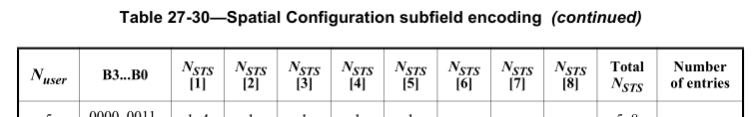

Under CID 22443, TGax Editor please change as follows:

The user ordering identified by the column headers N STS [s], s = 1, 2, 3, … in Table 27-30 (Spatial Configuration subfield encoding) shall be the same as the user index u, u = 0, 1, 2, … in Equation (27-38), Equation (27-59) and Equation (27-108), i.e., u = s – 1.

CID | Page | Clause | Comment | Proposed Change | Proposed Resolution
22040 | 578.38 | 27.3.10.8.5 | This language refers to band not content channel. Moreover, the CRC is already defined as part of the Common and User Block fields. | Change band to CC and omit redundant CRC language: i.e. at P578L38-40, change the para to "In each HE-SIG-B content channel, the bits of the Common field shall be BCC encoded at rate R = 1/2." Also change P578L42-43 to "The bits of the User Specific field, for each HE-SIG-B content channel, shall be BCC encded at rate R = 1/2. If ..." | Revised. In general agreement with commenter. See resolution under CID 22441 in 19/1871 <motioned-revision>

Discussion
Agree with the commenter that the reference to appending the CRC and tails bit to the Common field is misleading since these fields are already present in the Common field. Also the CRC calulation details are spurious (see the table which provides the same content already). Ditto for the User Specific fields.
However, when deleting “each 20 MHz band” it is better to replace that with “each HE-SIG-B content channel”, and use an indefinite article given there could be two CCs.
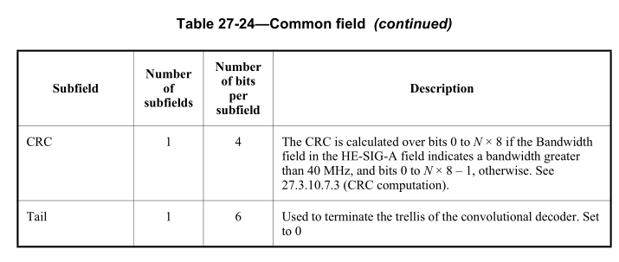
Under CID 22040, TGax Editor please change as follows:

27.3.10.8.5 Encoding and modulation
The bits in the Common field of each HE-SIG-B content channel shall be BCC encoded at rate R = 1/2.

In the User Specific field, each User Block field of each HE-SIG-B content channel shall be BCC encoded at rate R = 1/2. If the number of User fields in an HE-SIG-B content channel is odd, CRC and tail bits are added after the last User field, which is not grouped.

