IEEE P802.11  
Wireless LANs

|  |  |  |  |  |
| --- | --- | --- | --- | --- |
| Initial technical draft report on interworking between 3GPP 5G network & WLAN | | | | |
| Date: 2019-11-12 | | | | |
| Author(s): | | | | |
| Name | Affiliation | Address | Phone | email |
| Hyun Seo OH | ETRI | Gajeongro 218 Yusunggu  Daejeon, Korea | +82.42.860.5659 | hsoh5@etri.re.kr |
| Hanbyeog CHO | ETRI | Gajeongro 218 Yusunggu  Daejeon, Korea | +82.42.860.5531 | hbcho@ etri.re.kr |
| Yoohwa Kang | ETRI | Gajeongro 218 Yusunggu  Daejeon, Korea | +82.42.860.6364 | yhkang@etri.re.kr |
| Chang Han OH | allRadio Co. Ltd | 280, Seobusaet-gil, Geumcheon-gu, Seoul, Korea | +82.2.801.1310 | choh@allradio.co.kr |
| Shinho CHO | allRadio Co. Ltd | 280, Seobusaet-gil, Geumcheon-gu, Seoul, Korea | +82.10.3351.8424 | shcho@allradio.co.kr |
| Raeman KIM | allRadio Co. Ltd | 280, Seobusaet-gil, Geumcheon-gu, Seoul, Korea | +82.10.5512.9390 | rmkim01@allradio.co.kr |
| Si Young HEO | KT | KT R&D Center, 151, Taebong-ro, Seocho-gu, Seoul, Korea | +82.10.266.4569 | siyoung.heo@kt.com |
| Yangseok Jeong | KT | KT R&D Center, 151, Taebong-ro, Seocho-gu, Seoul, Korea | +82.10.9530.0856 | Yangseok.jeong@  kt.com |
| Hyeong Ho LEE | Nevision Telecom Inc., Korea Univ. | 412, 199, Techno2-ro, Yuseong-Gu, Daejeon, 34025, Korea | +82.42.931.4130 | hhlee@netvisiontel.com |
| Youngjae KIM | TTA | 47, Bundang-ro, Bundang-gu, Seongnam-city, Gyeonggi-do, 13591, Korea | +82.10.5110,2895 | yjkim@tta.or.kr |
| Choon Sik Lim | RCN | 199, Techno2-ro, Yuseong-Gu, Daejeon | +82.10.9531.3610 | Yim25@hnamail.net |

Abstract

This contribution is initial draft of the technical report on WLAN interworking to 3GPP 5G network. It describes the interworking reference model and interworking types supported by 3GPP 5G network and WLAN, and defines the necessary functionalities and specific procedures that enable WLAN access networks to interwork with 3GPP 5G network. This technical report on interworking between 3GPP 5G network and WLAN will provide a reference and guideline for stakeholders with interest in standardization and system development.

1. **Definition, acronyms and abbreviations**
   1. **Definitions**

**ANC**  Access network control function of WLAN access network, which refers to WLAN reference model

**NWu** Reference point between the UE and N3IWF for establishing secure tunnel(s) between the UE and N3IWF so that control-plane and user-plane exchanged between the UE and the 5G Core Network is transferred securely over untrusted non-3GPP access, which refers to 3GPP TS 23.502. This is in the domain of WLAN access network.

**STA** WLAN STA consists of TEC (terminal control) and TEI (terminal data path interface), which refers to WLAN reference model

**N1** Reference point between the UE and the AMF in 5G core network

**N2**  Reference point between the (R)AN and the AMF in 5G core network

**N3** Reference point between the (R)AN and the UPF in 5G core network

**N4** Reference point between the AMF and the UPF in 5G core network

**N7** Reference point between the SMF and the PCF in 5G core network

**N11** Reference point between the AMF and the SMF in 5G core network

**N15** Reference point between the PCF and the AMF in the case of non-roaming scenario, PCF in the visited network and AMF in the case of roaming scenario.in 5G core network

**Y1**  Reference point between STA and the untrusted non-3GPP access network (e.g. WLAN). This depends on the non-3GPP access technology. This is in the domain of WLAN access network.

**Y2**  Reference point between the untrusted non-3GPP access network (e.g. WLAN) and the N3IWF for the transport of NWu traffic which refers 3GPP TS 23.502. This is in the domain of WLAN access network.

**Y3**  Reference point between STA and untrusted non-3GPP access network (e.g. WLAN) for 5G network signalling which refers 3GPP TS 23.502. This is in the domain of WLAN access network.

* 1. **Acronyms and abbreviations**

**ANC**  Access Network Control

**AMF**  Access and Mobility Management Function

**ATSSS** Access Traffic Steering Switching and Splitting

**EDCA** Enhanced Distributed Channel Access

**GRE** Generic Routing Encapsulation

**NAS** Non Access Stratum

**N3IWF** Non-3GPP Inter Working Function

**PCF** Policy Control Function

**QoS** Quality of Service

**SMF** Session Management Function

**STA** Station

**TEC** Terminal Control

**TEI** Terminal Interface

**UE**  User Equipment

**UPF**  User Plane Function

1. **Introduction**

This chapter introduces basic objectives and scope of the technical report on WLAN interworking to 3GPP 5G core network. WLAN interworking types may have tightly coupled or loosely coupled, and functional reference model to interwork with 3GPP 5G network are described in chapter 3. And the interworking function and specific procedures regarding registration and signalling of 5G core network are described in chapter 4. Through technical study, required functional entities and related message protocols in WLAN are defined and technical recommendations are commented in chapter 5. And finally conclusions are summarized in chapter 6.

* 1. **Objectives**

This technical report on interworking between 3GPP 5G network and WLAN will provide a reference and guideline for stakeholders with interest in standardization and system development.

* 1. **Scope**

This report covers an interworking reference model, necessary functionalities and specific procedures that allow WLAN access network to interwork with 3GPP 5G network. We consider two types of interworking reference model, which are tightly coupled and loosely coupled type.

The interworking reference model consists of UE, 3GPP and WLAN access network, 3GPP 5G core network and sever. UE have functions of 3GPP access and WLAN station, which consists of TEC and TEI.

And WLAN access network may have ANC and WLAN access data path according to WLAN network reference model IEEE 802.ICF/D3.1

N1 signalling, NWu and Y2 interfaces are defined in 3GPP specification, but functionalities and procedures are not defined in WLAN entities to allow for interworking with 3GPP 5G network. This interfaces have to be implemented in STA and WLAN access network according to 3GPP specification. Also some management or modifications on TEC of STA and ANC of WLAN access network will be needed. MAC function or interface for 5G core network will be analysed for ATSSS and QoS management.

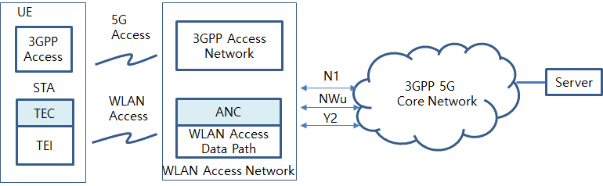

Figure 1 Overview of WLAN interworking with 3GPP core network

1. **WLAN interworking reference model**
   1. **WLAN interworking types**

The interworking reference model consists of UE, 3GPP and WLAN access network, 3GPP 5G core network and sever). At first, tightly coupled interworking model is shown as figure 2. It has combined functional entities in UE and access network at the same location, and only 3GPP core network is connected with the defined interfaces N1, NWu and Y2. Secondly, loosely coupled interworking model is shown as figure 3. It has separate functional entity in access network at the different location. 3GPP core network is connected to WLAN access network with the defined interfaces N1, NWu and Y2.

N1 signalling and NWu interfaces are defined in 3GPP specification, but functionalities and procedures are not defined in WLAN entities to allow for interworking with 3GPP 5G network. N1 is signalling procedures between STA of UE and AMF of 3GPP core network to support Authentication and Mobility Function (AMF) for WLAN access network. NWu is signalling procedures between STA of UE and UPF of 3GPP core network to support secured IP tunnelling for WLAN access network. Y2 interface is wireline communication protocol between WLAN access network and N3IWF of 3GPP core network for transport of traffic data and control data.

This report will describe N1, NWu and Y2 interface and new functional entities, which are TEC in a station and ANC in WLAN access network. The communication and signalling procedures will be described for the functional entities of a station, WLAN access network, 3GPP 5G access network and 3GPP 5G core network.

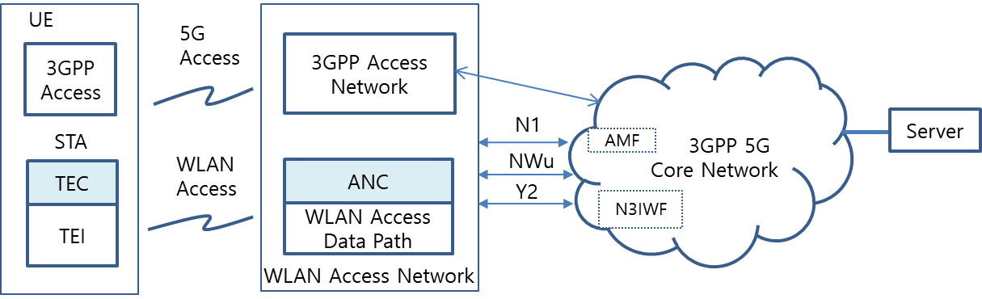

Figure 2 Tightly coupled interworking reference model between 5G core network and WLAN

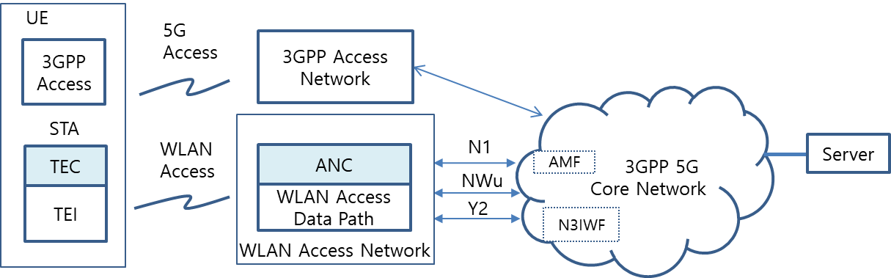

Figure 3 Loosely coupled interworking reference model between 5G core network and WLAN

* 1. **WLAN interworking functional model**

WLAN interworking function model consists of UE, WLAN access network and 5G core network as shown in Figure 4. TEI of UE provides wireless data path between STA and WLAN access network by using Y1 interface. And TEC of UE provides wireless networking and signalling among STA, WLAN access network and 3GPP core network by using Y3 interface and N1 signalling.

WLAN access data path of WLAN access network provides data exchange between between WLAN access network and 3GPP core network by using Y2 interface. And ANC of WLAN access network provides communication protocol between WLAN access network and 3GPP core network by using NWu interface.

These red coloured Y1, Y2, Y3 and NWu interfaces are in the domain of WLAN and may be provided in STA and WLAN access network. The other reference interfaces are referred to 3GPP core network.

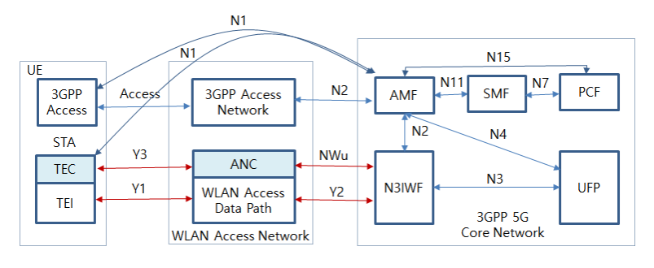

Figure 4 WLAN interworking reference model with 5G core network

1. **Interworking function and procedures**

The radio channel access and communication procedures have to be specified to provide WLAN interworking with 5G core network. Even though there are tightly coupled or loosely coupled interworking types, the common procedures can be applied for them.

Radio channel sharing method is described in section 4.1. And initial registration and authentication procedures between STA of UE and AMF of 5G core network are described in section 4.2, IP secure transport and data exchange between STA of UE and UPF of 5G core network are described as an example in section 4.3.

ATSSS function and QoS management on WLAN will be expected to have some interface or modification on MAC layer of STA and wireless access network. These functions will be described in section 4.4 and 4.5.

* 1. **Radio channel sharing method**

TEI of STA monitors the usage of WLAN access network if the radio channel is busy or idle. If the radio channel is idle, UE tries to send control or traffic data.

* 1. **Registration and authentication and its message procedures**

STA shall initially support registration and authentication to be connected between UE and N3IWF. NWu for registration and authorization involves IP protocol, IKEv2 and EAP-5G protocol. And N1 signalling is needed to exchange NAS signal.

* + 1. **Registration and authentication function**

TEC of UE and ANC of WLAN access network shall have specific functional requirements to interwork with 3GPP 5G core network

* IP communication protocol
* IKEv2 authorization protocol
* EAP-5G protocol
* NAS signalling

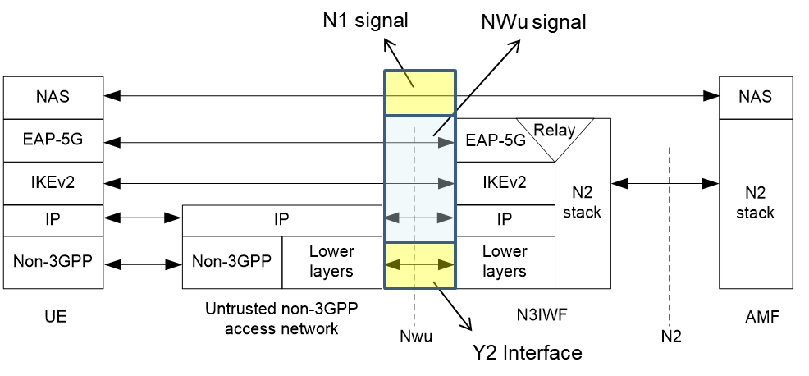

Figure 5 Control Plane between UE and N3IWF (3GPP TS 23.501)

* + 1. **Message procedures**
* **Y2 interface**

Y2 interface is PHY/MAC communication protocol between ANC of WLAN access network and N3IWF of 3GPP 5G core network. Y2 follows IEEE 802.3 standard. Ethernet RJ45 connector and CSMA/CD protocol following IEEE 802.3 standard is commonly applied.

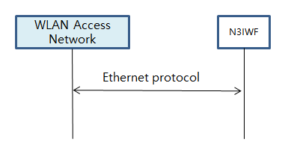

Figure 6 Y2 interface

* **NWu interface**

NWu interface is IP based communication protocol between SC of WLAN access network and N3IWF of 3GPP 5G core network to establish secured data channel. IKEv2 authorization protocol and EAP-5G protocol is applied

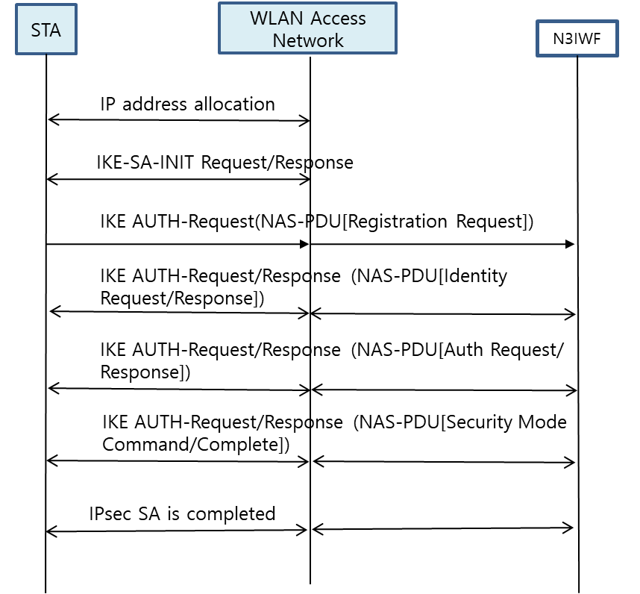

Figure 7 NWu interface

* **N1 interface**

N1 interface is secured IP communication protocol between UE of WLAN access network and AMF of 3GPP 5G core network to provide NAS signalling

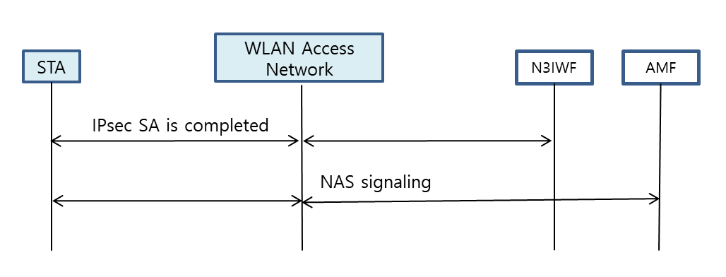

Figure 8 N1 interface

* 1. **IP Tunnelling function and its message procedures**

STA shall initially support secured IP transport between UE and UPF, and traffic data is exchanged over the established IP channel.

* + 1. **IP Tunnelling Function**

SC of UE and ANC of WLAN access network shall have specific functional requirements to interwork with 3GPP 5G core network.

* IP communication protocol
* IPsec communication protocol
* GRE communication protocol

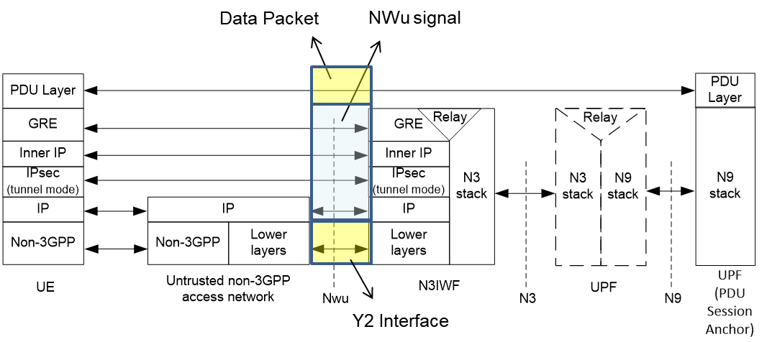

Figure 9 Data Plane between UE and N3IWF (3GPP TS 23.501)

**4.3.2 Message procedures**

(To be described)

* 1. **ATSSS function and its message procedures**

Traffic data shall be transmitted over WLAN access channel and/or 3GPP access channel by using ATSSS function.

* 3GPP supports ATSSS between 3GPP and non-3GPP access networks
* ATSSS can enable traffic selection, switching and splitting between 5G and WLAN



Figure 10 ATSSS between UE and UPF (3GPP TS 23.501)

(To be described)

* 1. **QoS function and its message procedures**

WLAN has EDCA to assign QoS values in WLAN MAC layer and network slicing shall provide QoS management in 3GPP core network domain. To provide adaptive QoS management in terms of data rate, message latency. It shall provide QoS mapping between MAC layer and Network slicing in 5G core network.

(To be described)

1. **Gap analysis and Recommendations**

(To be described)

1. **Conclusions**

(To be described)

1. **References**
2. 3GPP TS 22.261 V15.5.0 (2018-06) “Service requirements for the 5G system (Stage 1)”
3. 3GPP TS 22.278 “Service requirements for the Evolved Packet System (EPS)”
4. 3GPP TS 23.402 "Architecture enhancements for non-3GPP accesses”
5. 3GPP TR 23.716 “Study on the Wireless and Wireline Convergence for the 5G System Architecture”
6. 3GPP TR 23.793 “Study on Access Traffic Steering, Switching and Splitting support in the 5G system architecture”
7. 3GPP TR 23.799“Study on Architecture for Next Generation System”
8. 3GPP TS 23.501“System Architecture for the 5G System (Stage 2)”
9. 3GPP TS 23.502“Procedures for the 5G System (Stage 2)”
10. 3GPP TS 24.302 “Access to the 3GPP Evolved Packet Core (EPC) via non-3GPP access networks (Stage 3)”
11. 3GPP TS 24.501 “Non-Access-Stratum (NAS) protocol for 5G System (5GS) (Stage 3)”
12. 3GPP TS 24.502 “Access to the 3GPP 5G Core Network (5GCN) via Non-3GPP Access Networks (N3AN) (Stage 3)”
13. 3GPP TS 33.501 “Security Architecture and Procedure for the 5G System”
14. 3GPP TR 33.899 “Study on the Security Aspects of the Next Generation System”
15. RAN convergence paper, WBA and NGMN alliance, September, 2019.
16. IEEE P802.1CF/D3.1; IEEE Draft Recommended Practice for Network Reference Model and Functional Description of IEEE 802® Access Network, 2018.