IEEE P802.11bb
Wireless LANs
Proposed LC PHY text for TGbb D0.1
Date: 2019-11-12
Author(s):
Name | Company | Address | Phone | email
Chong Han | pureLiFi |  |  | Chong.han@purelifi.com
Nikola Serafimovski | pureLiFi |  |  | nikola.serafimovski@purelifi.com
Stephan Berner | pureLiFi |  |  | stephan.berner@purelifi.com
Mostafa Afgani | pureLiFi |  |  | mostafa.afgani@purelifi.com
Abstract

This document contains the initial text input for the proposed mandatory LC PHY for the TGbb draft D0.1.

Contents
1.1 LC PHY 3
1.1.1 General information 3
1.1.2 LC Common Mode PHY 3
1.1.2.1 MU transmission 3
1.1.2.2 OFDMA 3
1.1.2.3 Forward Error Correction 4
1.1.2.4 OFDM Modulator 6
1.1.2.5 PPDU format 8
1.1.2.6 PPDU transmission 11
1.1.3 LC Legacy PHY 12
1.1.3.1 Forward Error Correction 12
1.1.3.2 OFDM Modulator 12
1.1.3.3 PPDU format 12
1.1.3.4 PPDU transmission 12
1.1.4 LC Optimized PHY 12

  - LC PHY
    - General information
    - LC Common Mode PHY
The SISO 20 MHz channel bandwidth LC PHY is used as a mandatory common mode for all LC STAs.
      - MU transmission
(27.3.1.1 MU transmission in IEEE P802.11ax D5.1)
The MU transmissions include DL MU transmissions and UL MU transmissions.
DL MU transmission allows an AP to simultaneously transmit information to more than one non-AP STA. For a DL MU transmission, the AP uses the HE MU PPDU format and employs either DL OFDMA, DL MU-MIMO, or a mixture of both. UL MU transmission allows an AP to simultaneously receive information from more than one non-AP STA. UL MU transmissions are preceded by a triggering frame from the AP. The non-AP STAs transmit using the HE TB PPDU format and employ either UL OFDMA, UL MUMIMO, or a mixture of both.
The HE PHY supports OFDMA transmissions, both in the DL and the UL where different users can occupy different RUs in a PPDU (see 27.3.9 (Mathematical description of signals)). The transmission within an RU in a PPDU may be a single stream to one user, spatially multiplexed to one user (SU-MIMO), or spatially multiplexed to multiple users (MU-MIMO).
The HE PHY supports DL MU-MIMO and UL MU-MIMO, for both the full bandwidth case as well as for the partial bandwidth case where MU-MIMO is used only on certain RUs in the PPDU. The combination of SU transmissions and MU-MIMO transmissions on different RUs in one PPDU is also supported.
      - OFDMA
(27.3.1.2 OFDMA in IEEE P802.11ax D5.1)
OFDMA is an OFDM-based multiple access scheme where different subsets of subcarriers are allocated to different users, allowing simultaneous data transmission to or from one or more users. In OFDMA, users are allocated different subsets of subcarriers that can change from one PPDU to the next. The difference between OFDM and OFDMA is illustrated in Figure 1 (Illustration of OFDM and OFDMA concepts).
Similar to OFDM, OFDMA employs multiple subcarriers, but the subcarriers are divided into several groups where each group is referred to as an RU. With OFDMA, different transmit powers may be applied to differ-ent RUs.
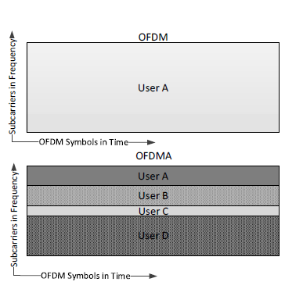
- —Illustration of OFDM and OFDMA concept

      - Forward Error Correction
(27.3.6.10 Construction of the Data field in an HE SU PPDU, HE ER SU PPDU, and HE TB PPDU in IEEE P802.11ax D5.1)
        - Construction of the Data field in an HE SU PPDU, HE ER SU PPDU, and HE TB PPDU
          - Using BCC
The construction of the Data field in an HE SU PPDU, HE ER SU PPDU, and HE TB PPDU with BCC encoding proceeds as follows:
a) Construct the SERVICE field as described in 27.3.11.3 (SERVICE field) and append the PSDU to the SERVICE field.
b) Pre-FEC padding: Append the pre-FEC pad bits and tail bits as described in 27.3.11 (Data field).
c) Scrambler: Scramble the pre-FEC padded data.
d) BCC encoder: BCC encode as described in 27.3.11.5.1 (BCC coding and puncturing).
e) Post-FEC padding: Append the post-FEC pad bits and PE field as described in 27.3.11 (Data field).
f) Stream parser: Rearrange the output of BCC encoder into blocks as described in 27.3.11.6 (Stream parser).
g) BCC interleaver: Interleave as described in 27.3.11.8 (BCC interleavers).
h) Constellation mapper: Map to BPSK, BPSK DCM, QPSK, QPSK DCM, 16-QAM, 16-QAM DCM, 64-QAM, or 256-QAM constellation points as described in 27.3.11.9 (Constellation mapping).
i) STBC: Apply STBC as described in 27.3.11.11 (Space-time block coding).
j) Pilot insertion: Insert pilots following the steps described in 27.3.11.13 (Pilot subcarriers).
k) CSD: Apply CSD for each space-time stream and frequency segment as described in 27.3.10.2.2 (Cyclic shift for HE modulated fields).
l) Spatial mapping: Apply the Q matrix as described in 27.3.11.14 (OFDM modulation).
m) IDFT: In an 80+80 MHz transmission, map each frequency subblock to a separate IDFT. Compute the inverse discrete Fourier transform.
n) Insert GI and apply windowing: Prepend a GI determined by the TXVECTOR parameter GI_TYPE and apply windowing as described in 27.3.9 (Mathematical description of signals).
o) Analog and RF: Upconvert the resulting complex baseband waveform with each transmit chain to an RF signal according to the center frequency of the desired channel and transmit. Refer to 27.3.9 (Mathematical description of signals) and 27.3.10 (HE preamble) for details.
        - Construction of the Data field in an HE MU PPDU
(27.3.6.11 Construction of the Data field in an HE MU PPDU in IEEE P802.11ax D5.1)
          - General
In an HE MU transmission, the PPDU encoding process is performed independently in an RU on a per user basis up to the input of the spatial mapping block, except that CSD is performed with knowledge of the space-time streams starting index for that user. All user data in an RU is combined and mapped to the transmit chains in the spatial mapping block.
          - Using BCC
A Data field with BCC encoding is constructed using steps (a) to (l) in 27.3.6.10.1 (Using BCC), then applying CSD for an HE MU PPDU as described in 27.3.10.2.2 (Cyclic shift for HE modulated fields).
          - Using LDPC
A Data field with LDPC encoding is constructed using steps (a) to (l) in 27.3.6.10.2 (Using LDPC), then applying CSD for an HE MU PPDU as described in 27.3.10.2.2 (Cyclic shift for HE modulated fields).
          - Combining to form an HE MU PPDU
The per user data is combined as follows:
a) Spatial mapping: The Q matrix is applied as described in 27.3.11.14 (OFDM modulation). The combining of all user data of an RU is done in this block.
b) IDFT: Compute the inverse discrete Fourier transform.
c) Insert GI and apply windowing: Prepend a GI determined by the TXVECTOR parameter GI_TYPE and apply windowing as described in 27.3.9 (Mathematical description of signals).
d) Analog and RF: Upconvert the resulting complex baseband waveform with each transmit chain to an RF signal according to the center frequency of the desired channel and transmit. Refer to 27.3.9 (Mathematical description of signals) and 27.3.10 (HE preamble) for details.
      - OFDM Modulator
The real time-domain OFDM signal, generated at the PHY layer, is used to modulate the light emitting device (a light emitting diode (LED) or a laser diode (LD)), which serves as the transmitter front-end. The modulation is conducted only within the active operational range of the device. In this range, the electrical signal and the light output signal can only be positive at all times. The conventional approach for modulating the LED active range with an OFDM signal shall be to set a positive operating point, around which the bipolar OFDM signal can be realized. Figure 2 illustrates this principle. The positive bias can be introduced as part of the analog front-end (in the case of AC-coupled LED drivers) or as part of the information signal (in case of DC-coupled drivers). This approach is known as DC-biased optical OFDM (DCO-OFDM).
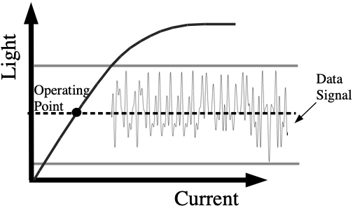
- —DC-biased optical OFDM (DCO-OFDM)
The time domain waveform of Data field of LC PPDUs without a bias can be found in 27.3.11.14 (OFDM modulation).
(27.3.11.14 OFDM modulation in IEEE P802.11ax D5.1)
If midambles are not present, the time domain waveform of the Data field of an HE PPDU that is not an HE TB PPDU for transmit chain i_{TX}, $1≤i_{TX}≤N_{TX}$, and frequency segment i_{Seg} shall be as defined in Equation (27-108).
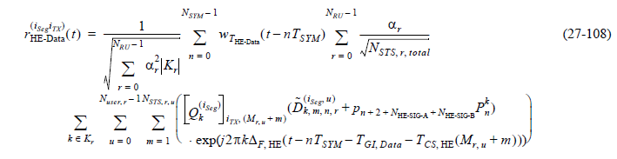
where
T_{SYM} is defined in Table 27-12 (Timing-related constants)
pn is defined in 17.3.5.10 (OFDM modulation)
$p_{n}^{k}$ is defined in 27.3.11.13 (Pilot subcarriers)
$T_{CS,HE}(M_{r,u}+m)$ represents the cyclic shift for space-time stream Mr,u + m as defined in 27.3.10.2.2 (Cyclic shift for HE modulated fields)
$T_{GI,DATA}$ is the guard interval duration as defined in Table 27-12 (Timing-related constants)
${\tilde{D}}_{k,m,n,r}^{(i_{Seg},u)}$ is the transmitted constellation for user u in the r-th RU at subcarrier k, space-time stream m, and Data field OFDM symbol n and is defined by Equation (27-109).
${\tilde{D}}_{k,m,n,r}^{(i_{Seg},u)}=\left\{\begin{aligned}0, k∈K_{Pilot} \\ {\tilde{d}}_{M_{r}\left(k\right),m,n,r,u}^{(i_{Seg})}, otherwise\end{aligned}\right.$ (27-109)
where
KPilot is the set of subcarrier indices of pilot subcarriers, as defined in 27.3.2.4 (Pilot subcarriers)
Mr(k) is defined in Equation (27-110)
$$M_{r}\left(k\right)=k-K_{r,min}-\left|\left\{k^{'}:K_{r,min}≤k'≤k\}∩K_{Pilot}\right.\right|$$
where
Kr,min is the minimum value of the set Kr
$\left|Φ\right|$ is the cardinality of a set Ф
NOTE—Mr(k) translates a subcarrier index ($k∈K_{r}$) into the index of data symbols in a transmission over RU r (0 ≤ Mr(k) ≤ NSD). The subcarrier index k for the data subcarrier is first offset by the minimum value of subcarrier index Kr,min (for the lower edge subcarrier) in this RU, and then subtracted by the number of pilot subcarriers falling in between the data subcarrier and the edge subcarrier.
      - PPDU format
(27.3.4 HE PPDU formats in IEEE P802.11ax D5.1)
Four HE PPDU formats are defined: HE SU PPDU, HE MU PPDU, HE ER SU PPDU and HE TB PPDU. The HE sounding NDP is a variant of the HE SU PPDU and defined in 27.3.16 (HE sounding NDP). The HE TB feedback NDP is a variant of the HE TB PPDU and defined in 27.3.17 (HE TB feedback NDP).
NOTE—The HE ER SU PPDU is not a variant of the HE SU PPDU. Requirements related to HE SU PPDUs and HE ER SU PPDUs are specified separately. The format of the HE SU PPDU is defined as in Figure 27-8 (HE SU PPDU format). This PPDU format is used for SU transmission and, in this format, the HE-SIG-A field is not repeated.
The format of the HE SU PPDU is defined as in Figure 3 (HE SU PPDU format). This PPDU format is used for SU transmission and, in this format, the HE-SIG-A field is not repeated.
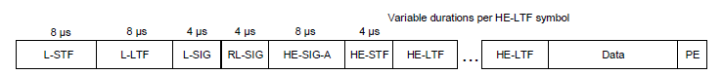
- —HE SU PPDU format
The format of the HE MU PPDU is defined as in Figure 4(HE MU PPDU format). This format is used for transmission to one or more users if the PPDU is not a response of a Trigger frame. In the HE MU PPDU, the HE-SIG-A field is not repeated. The HE-SIG-B field is present in this format.
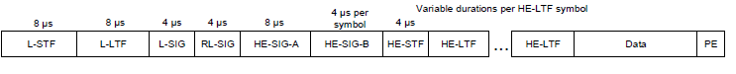
- —HE MU PPDU format
The format of the HE ER SU PPDU is defined as in Figure 5 (HE ER SU PPDU format). This format is used for SU transmission and, in this format, the HE-SIG-A field is twice as long as the HE-SIG-A field in other HE PPDU formats.
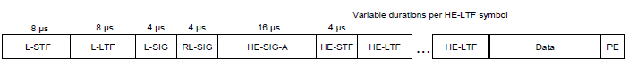
- —HE ER PPDU format

The format of the HE TB PPDU is defined as in Figure 6 (HE TB PPDU format). This format is used for a transmission that is a response to a triggering frame from an AP.
The format of the HE TB PPDU is the same as the HE SU PPDU except that the duration of the HE-STF field in the HE TB PPDU is twice the duration o f the HE-STF field in the HE SU PPDU.
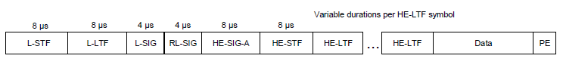
- —HE TB PPDU format
The fields of the HE PPDU formats are summarized in Table 27-11 (HE PPDU fields).

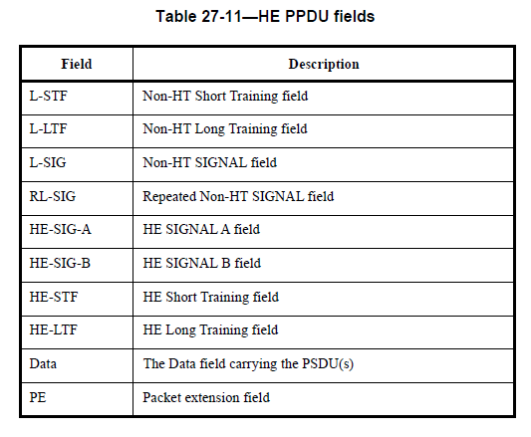
The RL-SIG, HE-SIG-A, HE-STF, HE-LTF, and PE fields are present in all HE PPDU formats. The HE-SIG-B field is present only in the HE MU PPDU. The PE field is defined in 27.3.12 (Packet extension).
The L-STF, L-LTF, L-SIG, RL-SIG, HE-SIG-A, and HE-SIG-B fields are referred to as pre-HE modulated fields, while the HE-STF, HE-LTF and Data fields are referred to as the HE modulated fields.
In the HE TB PPDU, the pre-HE modulated fields, which include L-STF, L-LTF, L-SIG, RL-SIG and HE-SIG-A fields, are sent only on the 20 MHz channels where the STA’s HE modulated fields are located.
A PPDU transmitted with the TXVECTOR parameter NO_SIG_EXTN set to false is followed by a period of duration aSignalExtension without transmission. See 10.3.8 (Signal extension).
A signal extension shall be present in a transmitted PPDU if the TXVECTOR parameter NO_SIG_EXTN is false and one of the following conditions apply:
— The TXVECVTOR parameter FORMAT is HE, HT_MF or HT_GF
— The TXVECTOR parameter FORMAT is NON_HT and the TXVECTOR parameter NON_HT_MODULATION is ERP-OFDM or NON_HT_DUP_OFDM
A signal extension shall be assumed to be present (for the purpose of timing of PHY-RXEND.indication and PHY-CCA.indication primitives, as described below and in 27.3.21 (HE receive procedure)) in a received PPDU if one of the following conditions apply:
— The RXVECTOR parameter FORMAT is HE, HT_MF or HT_GF
— The RXVECTOR parameter FORMAT is NON_HT and the RXVECTOR parameter NON_HT_MODULATION is ERP-OFDM or NON_HT_DUP_OFDM
A PPDU containing a signal extension is called a signal extended PPDU. When transmitting a signal extended PPDU, the PHY-TXEND.indication primitive shall be emitted a period of aSignalExtension after the end of the actual ending time of the PPDU. When receiving a signal extended PPDU, the PHYRXEND.indication primitive shall be emitted a period of aSignalExtension after the end of the actual ending time of the PPDU.
(27.3.16 HE sounding NDP in IEEE P802.11ax D5.1.)
The HE sounding NDP is a variant of the HE SU PPDU. The format of an HE sounding NDP is defined in Figure 7 (HE sounding NDP format).
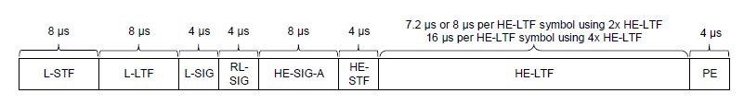
- —HE sounding NDP format
NOTE—The number of HE-LTF symbols in the HE sounding NDP is indicated in the NSTS And Midamble Periodicity field in the HE-SIG-A field.
The HE sounding NDP has the following properties:
— Uses the HE SU PPDU format but without the Data field
— Has a PE field that is 4 μs in duration
The HE sounding NDP overlapping the 242-tone RUs corresponding to bits with a value of 1 in the bitmap of the TXVECTOR parameter INACTIVE_SUBCHANNELS or overlapping a punctured center 26-tone RU of an HE sounding NDP are punctured. The center 26-tone RU of the HE sounding NDP is punctured if either one of the adjacent 242-tone RUs is punctured.
It is mandatory to support the 2x HE-LTF with 0.8 μs GI and 2x HE-LTF with 1.6 μs GI. It is optional to support the 4x HE-LTF with 3.2 μs GI. The other combinations of HE-LTF type and GI duration are disallowed. If the Beamformed field in HE-SIG-A of an HE sounding NDP is 1, then the receiver of the HE sounding NDP should not perform channel smoothing when generating the compressed beamforming feedback report.
(27.3.17 HE TB feedback NDP in IEEE P802.11ax D5.1.)
The HE TB feedback NDP is used to carry the NDP feedback report information as introduced in 26.5.7 (NDP feedback report procedure). The PPDU structure of an HE TB feedback NDP is shown in Figure 8 (HE TB feedback NDP format).
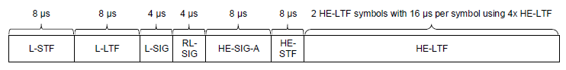
- —HE TB feedback NDP format
The HE TB feedback NDP has the following properties:
— Uses the HE TB PPDU format but without the Data field and PE field
— Has two 4x HE-LTF symbols
— 4x HE-LTF with 3.2 μs GI is the only HE-LTF type and GI duration combination for the HE-LTF
— The generation of HE-LTF symbols for the HE TB feedback NDP is defined in 27.3.10.10 (HE-LTF)
— The HE-STF and the pre-HE modulated fields are transmitted only on the 20 MHz channel where the STA is assigned
      - PPDU transmission
(27.3.18.1 Transmit spectral mask in IEEE P802.11ax D5.1)
The bandwidth of the spectral mask applied to an HE SU PPDU, an HE TB PPDU and an HE MU PPDU with the Bandwidth field of the HE-SIG-A field equal to 0, 1, 2 or 3 shall be determined by the bandwidth indicated in the Bandwidth field of the HE-SIG-A field. The bandwidth of the spectral mask applied to an HE ER SU PPDU is 20 MHz. The bandwidth of the spectral mask applied to an HE MU PPDU with the Bandwidth field of the HE-SIG-A field equal to 4 or 5 is 80 MHz. The bandwidth of the spectral mask applied to an HE MU PPDU with the Bandwidth field of the HE-SIG-A field equal to 6 or 7 is 160 MHz. All HE PPDU formats shall be compliant with the transmit spectral mask described in this section.
The 20 MHz mask PPDU of LC format is TBD.
    - LC Legacy PHY
MU transmission and OFDMA are supported as in the Clause 27.3.1.1 (MU transmission) and Clause 27.3.1.2 (OFDMA).
      - Forward Error Correction
The construction of the Data field in an LC SU PPDU, LC ER SU PPDU, and LC TB PPDU with LDPC encoding proceeds as Clause 27.3.6.10.1 (Using BCC).
The construction of the Data field in an LC SU PPDU, LC ER SU PPDU, and LC TB PPDU with LDPC encoding proceeds as Clause 27.3.6.10.2 (Using LDPC).
The construction of the Data field in an LC MU PPDU with LDPC encoding proceeds as Clause 27.3.6.11.2 (Using BCC).
The construction of the Data field in an LC MU PPDU with LDPC encoding proceeds as Clause 27.3.6.11.3 (Using LDPC).
      - OFDM Modulator
The time domain waveform of Data field of LC PPDUs without a bias can be found in 27.3.11.14 (OFDM modulation) in IEEE P802.11ax D5.1.
      - PPDU format
See sub-clause 27.3.4 HE PPDU formats, 27.3.16 HE sounding NDP and 27.3.17 HE TB feedback NDP in IEEE P802.11ax D5.1.
      - PPDU transmission
See sub-clause 27.3.18.1 Transmit spectral mask in IEEE P802.11ax D5.1.
    - LC Optimized PHY

