IEEE P802.11bb
Wireless LANs
Mandatory LC PHY text for TGbb D0.1
Date: 2019-11-08
Author(s):
Name | Company | Address | Phone | email
Chong Han | pureLiFi |  |  | Chong.han@purelifi.com
Nikola Serafimovski | pureLiFi |  |  | nikola.serafimovski@purelifi.com
Stephan Berner | pureLiFi |  |  | stephan.berner@purelifi.com
Mostafa Afgani | pureLiFi |  |  | mostafa.afgani@purelifi.com
Abstract

This document contains the initial text input for mandatory LC PHY for the TGbb draft D0.1.

Contents
1. Overview 1
1.1 Scope 1
1.2 Purpose 1
1.3 Word usage 1
2. Normative references 2
3. Definitions, acronyms, and abbreviations 2
3.1 Definitions 2
4. Light Communication (LC) MAC specification 2
5. Light Communication (LC) PHY specification 2
5.1 LC PHY Introduction 3
5.1.1 Introduction to LC PHY 3
5.1.2 LC PHY functions 3
5.1.3 PPDU formats 4
5.2 LC PHY Service interface 4
5.2.1 Introduction 4
5.2.2 TXVECTOR and RXVECTOR parameters 4
5.2.3 TRIGVECTOR parameters 5
5.2.4 PHYCONFIG_VECTOR parameters 5
5.3 LC PHY 5
5.3.1 General information 5
5.3.2 LC Common Mode PHY 5
5.3.3 LC Legacy PHY 7
5.3.4 LC Optimized PHY 8
5.4 LC PLME 8
5.4.1 PMLE_SAP sublayer management primitives 8
5.4.2 PHY MIB 8
5.4.3 TXTIME and PSDU_LENGTH calculation 8
5.4.4 LC PHY characteristics 8
5.5 LC PHY Parameters 9
5.5.1 MCS for LC Common Mode PHY 9
5.5.2 MCS for LC Legacy PHY 9
5.5.3 BATs for LC Optimized PHY 9
Annex A (informative) Bibliography 10

- Overview
  - Scope
  - Purpose
  - Word usage
<This subclause is mandatory and shall be the last subclause of Clause 1>
The word shall indicates mandatory requirements strictly to be followed in order to conform to the standard and from which no deviation is permitted (shall equals is required to).,
The word should indicates that among several possibilities one is recommended as particularly suitable, without mentioning or excluding others; or that a certain course of action is preferred but not necessarily required (should equals is recommended that).
The word may is used to indicate a course of action permissible within the limits of the standard (may equals is permitted to).
The word can is used for statements of possibility and capability, whether material, physical, or causal (can equals is able to).
- Normative references
The following referenced documents are indispensable for the application of this document (i.e., they must be understood and used, so each referenced document is cited in text and its relationship to this document is explained). For dated references, only the edition cited applies. For undated references, the latest edition of the referenced document (including any amendments or corrigenda) applies.

- Definitions, acronyms, and abbreviations
  - Definitions
For the purposes of this document, the following terms and definitions apply. The IEEE Standards Dictionary Online should be consulted for terms not defined in this clause.
single input, single output (SISO): A physical layer (PHY) configuration in which both transmitter and receiver use a single antenna.
- Light Communication (LC) MAC specification
The use of Fast Session Transfer was agreed as a MAC feature for 11bb (doc. 11-19/1612r1)
EDCA-only MAC or HE-MAC
- Light Communication (LC) PHY specification
  - LC PHY Introduction
    - Introduction to LC PHY
Clause 5 (Light Communication (LC) PHY specification) specifies the PHY entity for an orthogonal frequency division multiplexing (OFDM) system that enables operation of wireless light communications.
The LC PHY data subcarriers are modulated using BPSK, BPSK DCM, QPSK, QPSK DCM, 16-QAM, 16- QAM DCM, 64-QAM and 256-QAM. Forward error correction (FEC) coding (convolutional or LDPC coding) is used with coding rates of 1/2, 2/3, 3/4 and 5/6. (More modulation modes are TBD.)
The LC PHY provides support for 20 MHz as mandatory channel bandwidth; and 40 MHz, 80 MHz and 160 MHz contiguous channel widths, 80+80 MHz non-contiguous channel width and 320 MHz non-contiguous channel width as optional features.
    - LC PHY functions
      - Wavelength
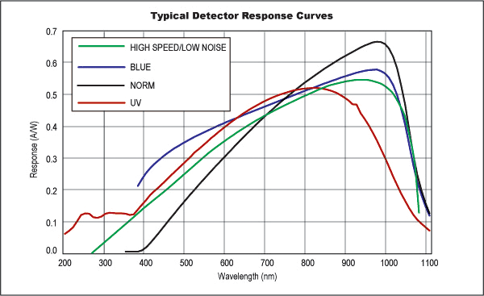
- —Typical Si photo-detector wavelength sensitivity
Figure 1 shows typical responsivity curves with wavelength of silicon based photodetectors. It has been known that the photo sensitivity value of Si photo-detector is higher on longer wavelength than on shorter wavelength in the visible band as shown in Figure 1. The green curve with high speed and low noise is the one most applicable to a LiFi system and shows very little change in responsivity with wavelength between 850nm and 1000nm.
    - PPDU formats
The structure of the PPDU transmitted by an LC STA is determined by the TXVECTOR parameters as defined in Table 27-1—TXVECTOR and RXVECTOR parameters in IEEE P802.11axD4.1.
The FORMAT parameter determines the overall structure of the PPDU and can take on one of the following values:
— HE SU PPDU format (HE_SU) carries a single PSDU. With this format the HE-SIG-A field is not repeated.
— HE ER SU PPDU format (HE_ER_SU) carries a single PSDU. It is similar to the HE SU PPDU format, except that the HE-SIG-A field is repeated.
— HE MU PPDU format (HE_MU) carries one or more PSDUs to one or more users.
— HE TB PPDU format (HE_TB) carries a single PSDU and is sent in response to a PPDU that carries a Trigger frame or a frame that contains a TRS Control subfield. The preamble format prior to the HE-STF field is identical to the HE SU PPDU.
— LC SU PPDU format (LC_SU) carries a single PSDU. With this format the LC-SIG-A field is not repeated.
— LC ER SU PPDU format (LC_ER_SU) carries a single PSDU. It is similar to the LC SU PPDU format, except that the LC-SIG-A field is repeated.
— LC MU PPDU format (LC_MU) carries one or more PSDUs to one or more users.
— LC TB PPDU format (LC_TB) carries a single PSDU and is sent in response to a PPDU that carries a Trigger frame or a frame that contains a TRS Control subfield. The preamble format prior to the LC-STF field is identical to the LC SU PPDU.
  - LC PHY Service interface
    - Introduction
The PHY provides an interface to the MAC through an extension of the generic PHY service interface. The interface includes TXVECTOR, RXVECTOR, and PHYCONFIG_VECTOR.
Using the TXVECTOR, the MAC supplies the PHY with per-PPDU transmit parameters. Using the RXVECTOR, the PHY informs the MAC of the received PPDU parameters. Using the PHYCONFIG_VECTOR, the MAC configures the PHY for operation, independent of frame transmission or reception.
    - TXVECTOR and RXVECTOR parameters
The parameters are defined as in Table 27-1—TXVECTOR and RXVECTOR parameters in IEEE P802.11axD4.1.
NOTE—when LC SU PPDU, LC MU PPDU, LC ER SU PPDU or LC TB PPDU formats are referred, see Conditions for HE_SU, HE_MU, HE_ER_SU or HE_TB respectively.
NOTE—the table is to be elaborated if optional channel bandwidths are proposed for TGbb.
    - TRIGVECTOR parameters
The TRIGVECTOR is carried in a PHY-TRIGGER.request primitive and provides the PHY of the AP with the parameters needed to receive LC TB PPDU over each assigned RU. The parameters in Table 27-2 (TRIGVECTOR parameters) are defined as part of the TRIGVECTOR parameter list in the PHY-TRIGGER.request primitive.
NOTE—when LC TB PPDU is referred, see the parameters settings for HE TB PPDU.
NOTE—the table is to be elaborated if optional channel bandwidths are proposed for TGbb.
    - PHYCONFIG_VECTOR parameters
20 MHz channel bandwidth is mandatory. Other channel bandwidths are TBD. The sub-clause is to be elaborated after confirmation of channel bandwidths.
  - LC PHY
    - General information
The SISO 20 MHz bandwidth LC PHY is used as a mandatory common mode for all LC STAs. Other HE PHY features or an LC-optimized PHY based on the ITU-T Rec. G.9991 are optional modes for all LC STAs.
The LC PHY adopts the 800nm–1000nm wavelength spectrum as the mandatory common mode wavelength for all LC STAs.
    - LC Common Mode PHY
The SISO 20 MHz channel bandwidth LC PHY is used as a mandatory common mode for all LC STAs. MU transmission and OFDMA are supported as in the Clause 27.3.1.1 (MU transmission) and Clause 27.3.1.2 (OFDMA).
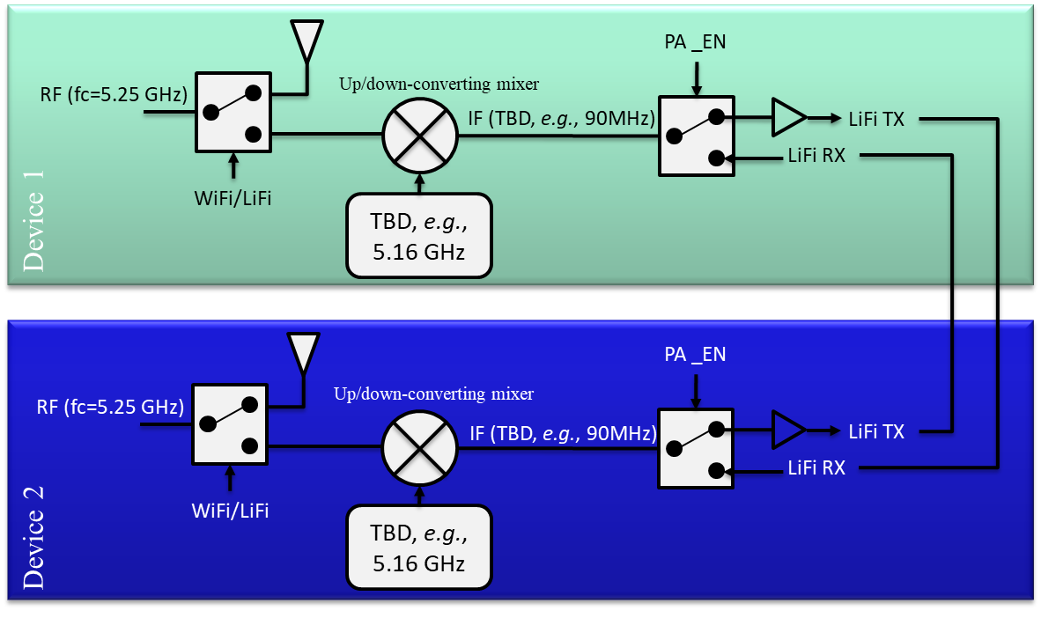
- —Circuit diagram for converting existing RF solutions to operate for LC
Figure 2 gives an example to convert existing RF solutions to operate for LC. The diagram shows the implementation enabling IEEE 802.11ax baseband chips to be used for LC. The chips can be simply switched for different services, such as WiFi and LiFi, which keeps the LC to be compatible with existing WiFi access technologies.
      - Forward Error Correction
The construction of the Data field in an LC SU PPDU, LC ER SU PPDU, and LC TB PPDU with LDPC encoding proceeds as Clause 27.3.6.10.1 (Using BCC).
The construction of the Data field in an LC SU PPDU, LC ER SU PPDU, and LC TB PPDU with LDPC encoding proceeds as Clause 27.3.6.10.2 (Using LDPC).
The construction of the Data field in an LC MU PPDU with LDPC encoding proceeds as Clause 27.3.6.11.2 (Using BCC).
The construction of the Data field in an LC MU PPDU with LDPC encoding proceeds as Clause 27.3.6.11.3 (Using LDPC).
      - OFDM Modulator
The real time-domain OFDM signal, generated at the PHY layer, is used to modulate the light emitting device (a light emitting diode (LED) or a laser diode (LD)), which serves as the transmitter front-end. The modulation is conducted only within the active operational range of the device. In this range, the electrical signal and the light output signal can only be positive at all times. The conventional approach for modulating the LED active range with an OFDM signal shall be to set a positive operating point, around which the bipolar OFDM signal can be realized. Figure 3 illustrates this principle. The positive bias can be introduced as part of the analog front-end (in the case of AC-coupled LED drivers) or as part of the information signal (in case of DC-coupled drivers). This approach is known as DC-biased optical OFDM (DCO-OFDM).
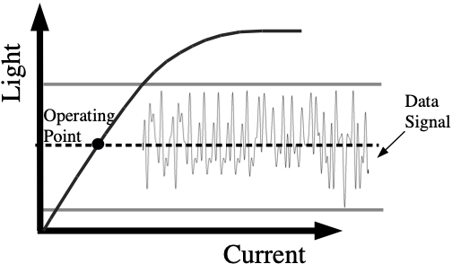
- —DC-biased optical OFDM (DCO-OFDM)
The time domain waveform of Data field of LC PPDUs without a bias can be found in 27.3.11.14 (OFDM modulation). LC SU PPDU, LC MU PPDU and LC ER SU PPDU follow the rules for HE PPDU that is not an HE TB PPDU; LC TB PPDU follows the rules for HE TB PPDU.
      - PPDU format
Four LC PPDU formats are defined: LC SU PPDU, LC MU PPDU, LC ER SU PPDU and LC TB PPDU.
The LC NDP PPDU is a variant of the LC SU PPDU and the LC TB NDP feedback PPDU is a variant of the LC TB PPDU.
NOTE—the PPDU formats for LC shall follow the definitions for HE PPDU formats, i.e., LC SU PPDU, LC MU PPDU, LC ER SU PPDU and LC TB PPDU follow the sub-clause 27.3.4 HE PPDU formats; while LC NDP PPDU follows the sub-clause 27.3.16 HE sounding NDP and LC TB NDP feedback PPDU follows the sub-clause 27.3.17 HE TB feedback NDP.
      - PPDU transmission
The bandwidth of the spectral mask applied to an LC SU PPDU, an LC TB PPDU and an LC MU PPDU with the Bandwidth field of the LC-SIG-A field equal to 0, 1, 2 or 3 shall be determined by the bandwidth indicated in the Bandwidth field of the LC-SIG-A field. The bandwidth of the spectral mask applied to an LC ER SU PPDU is 20 MHz. The bandwidth of the spectral mask applied to an LC MU PPDU with the Bandwidth field of the LC-SIG-A field equal to 4 or 5 is 80 MHz. The bandwidth of the spectral mask applied to an LC MU PPDU with the Bandwidth field of the LC-SIG-A field equal to 6 or 7 is 160 MHz. All LC PPDU formats shall be compliant with the transmit spectral mask described in this section.
The 20 MHz mask PPDU of LC format is TBD.
    - LC Legacy PHY
optional use other 11ax features
      - Forward Error Correction
      - OFDM Modulator
      - PPDU format
      - PPDU transmission

    - LC Optimized PHY
      - Forward Error Correction
      - Adaptive Bit-loading
      - OFDM Modulator
      - PPDU format
      - PPDU transmission

  - LC PLME
    - PMLE_SAP sublayer management primitives
    - PHY MIB
    - TXTIME and PSDU_LENGTH calculation
    - LC PHY characteristics

  - LC PHY Parameters
    - MCS for LC Common Mode PHY
MCS for LC common mode PHY is available in the sub-clause 27.5 Parameters for HE-MCSs. Modulation 10 and 11 may not applicable for LC common mode PHY (TBD).
    - MCS for LC Legacy PHY
    - BATs for LC Optimized PHY

(informative)
Bibliography
Bibliographical references are resources that provide additional or helpful material but do not need to be understood or used to implement this standard. Reference to these resources is made for informational use only

The use of the word must is deprecated and shall not be used when stating mandatory requirements, must is used only to describe unavoidable situations.
The use of will is deprecated and shall not be used when stating mandatory requirements, will is only used in statements of fact.
IEEE Standards Dictionary Online is available at: http://dictionary.ieee.org.

