IEEE P802.11
Wireless LANs
Resolutions for some comments on 11ax/D4.0 (LB238)
Date: 2019-09-18
Author(s):
Name | Affiliation | Address | Phone | email
Mark RISON | Samsung Cambridge Solution Centre | SJH, CB4 0DS, U.K. | +44 1223 434600 | at samsung (a global commercial entity) I'm the letter emme then dot rison
Abstract
This submission proposes resolutions for CIDs on 11ax/D4.0. Green indicates material agreed to in the group, yellow material to be discussed, red material rejected by the group and cyan material not to be overlooked. The “Final” view should be selected in Word.

Identifiers | Comment | Proposed change
CID 20618  Mark RISON  9.4.1.65  128.55 | This subclause is missing some of the material in the subclause on the VHT CBR field, e.g. the "where Na is the number of angles used for the compressed beamforming feedback matrix subfield" (i.e. Na is not actually defined anywhere) and "No padding is present between angles in the VHT Compressed Beamforming Report information, even if they correspond to different subcarriers. If the size of the VHT Compressed Beamforming Report information is not an integer multiple of 8 bits, up to seven zeros are appended to the end of the field to make its size an integer multiple of 8 bits." (i.e. the padding is not defined - there are some SU cases where 4 zero bits need to be appended) | Insert the cited text (changing VHT to HE) in the locations that parallel their locations in the subclause on the HE CBR field

Discussion:

19/1590r3 deals with the padding issue.

In the baseline, Na is always defined:

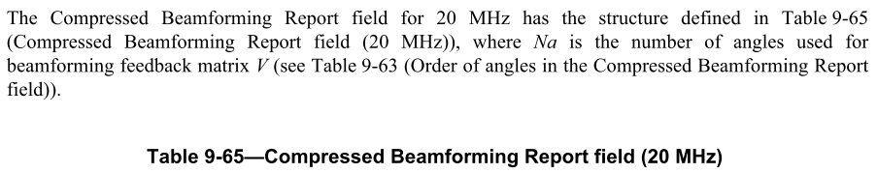

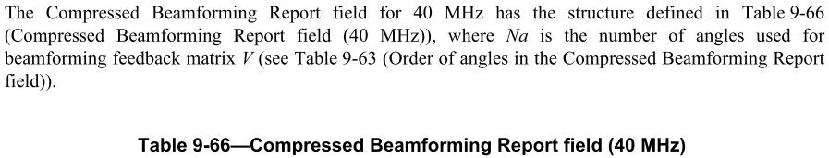

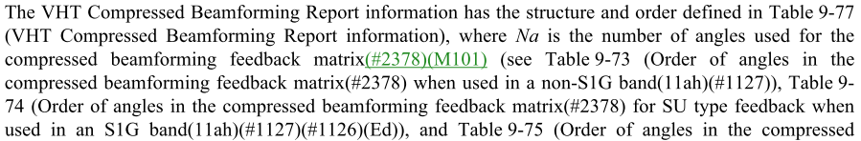
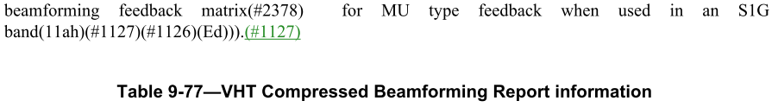

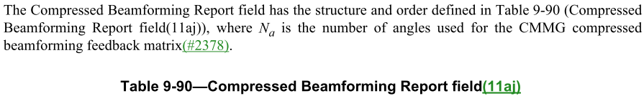

Proposed resolution:

REVISED

Make the changes shown in 19/1590r3, which deal with the padding issue.

In 9.4.1.65 HE Compressed Beamforming Report field change:

The HE Compressed Beamforming Report information has the structure and order defined in Table 9-93b
(HE Compressed Beamforming Report information).

to:

The HE Compressed Beamforming Report information has the structure and order defined in Table 9-93b
(HE Compressed Beamforming Report information), where Na is the number of angles used for the compressed beamforming feedback matrix (see Table 9-73 (Order of angles in the compressed beamforming feedback matrix when used in a non-S1G band)).

Identifiers | Comment | Proposed change
CID 20991  Mark RISON | "MCS" should be "HE-MCS" wherever it refers to an HE-MCS | As it says in the comment

Discussion:

To avoid confusion, the flavour of MCS should always be specified.

Proposed changes:

REVISED

In D4.3:

Change MCS (not preceded by a hyphen) to HE-MCS in:

9.2.4.6a.1 TRS Control (3x inc. Figure 9-22a—Control Information subfield for TRS Control)
Table 9-24b—HLA Control subfields (2x)
9.3.1.22 Trigger frame format (4x inc. Figure 9-64d—User Info field)
9.4.2.157.3 Supported VHT-MCS and NSS Set field (2x)
9.4.2.242.4 Supported HE-MCS And NSS Set field excluding Table 9-321c—Subfields of the Supported HE-MCS And NSS Set field (7x)
Table 9-385—FILS Minimum Rate last column (5x)
26.5.2.3.3 TXVECTOR parameters for HE TB PPDU response to Trigger frame in "the UL MCS subfield"
26.5.2.3.4 TXVECTOR parameters for HE TB PPDU response to TRS Control subfield in "the UL MCS subfields"
26.5.2.4 A-MPDU contents in an HE TB PPDU (6x)
26.10.3.4 UL Spatial Reuse subfield(#20874) of Trigger frame
26.15 PPDU format, BW, MCS, NSS, and DCM selection rules (9x inc. 2x caption and 2x "CandidateMCSSet" but exc. cross-ref parentheses)
26.17.1 Basic HE BSS operation in "those MCSs"
Table 27-1—TXVECTOR and RXVECTOR parameters in "Indicates the MCS that the receiver recommends"
Table 27-2—TRIGVECTOR parameters (5x inc. 2x MCS_LIST)
27.3.2.6 Resource allocation for an HE TB PPDU
27.3.7 HE modulation and coding schemes (HE-MCSs) in "<MCS" (5x)
Table 27-18—HE-SIG-A field of an HE SU PPDU and HE ER SU PPDU (5x; also put space before "n" in "MCSn" (2x))
Table 27-20—HE-SIG-A field of an HE MU PPDU (15x)
Table 27-28—User field format for a non-MU-MIMO allocation (4x; also put space before "n" in "MCSn" (1x))
Table 27-29—User field format for a MU-MIMO allocation (2x; also put space before "n" in "MCSn" (1x))
27.3.10.8.5 Encoding and modulation(#21226) (3x)
27.3.11.5 Coding (2x)
27.3.14.2 Power pre-correction (2x)
27.3.14.3 Pre-correction accuracy requirements (2x)
Table 27-49—Allowed relative constellation error versus constellation size and coding rate (3x)
27.3.18.4.4 Transmitter modulation accuracy (EVM) test
Figure 27-54—PHY transmit procedure for an HE SU PPDU
Figure 27-55—PHY transmit procedure for an HE ER SU PPDU
Figure 27-56—PHY transmit procedure for an HE MU PPDU (2x)
Figure 27-58—PHY transmit state machine for an HE PPDU without midambles(#21439)
Figure 27-59—PHY receive procedure for an HE SU PPDU(#20504)(#20536)
Figure 27-60—PHY receive procedure for an HE ER SU PPDU(#20504)(#20536)
Figure 27-61—PHY receive procedure for an HE MU PPDU(#20504)(#20536) (2x)

In 27.3.11.15 Dual carrier modulation change "HE-SIG-B-MCSs" to "HE-SIG-B HE-MCSs"

Identifiers | Comment | Proposed change
CID 20979  Mark RISON  9.2.4.7.1  86 | I think that when there's no VHT Capabilities field then actually the HT size rules kick in (cf. A-MSDU size/NOTE 3 and MPDU size/NOTE 5) | As it says in the comment

Discussion:

If there's no VHT Capabilities element (i.e. when the HE STA is not in the 5 GHz band) the limits can't come from that. They must come from the HT Capabilities element (in the 2G4 band) or the HE 6 GHz Band Capabilities element.

Proposed resolution:

REVISED

In Table 9-25—Maximum data unit sizes (in octets) and durations (in microseconds), change the MPDU size cell for HE PPDU from:

3895 or 7991 or
11 454 (see
also Table 9-
273 (Subfields
of the VHT
Capabilities
Information
field))

to

2.4 GHz band: see NOTE 5

Otherwise: 3895 or 7991 or
11 454 (see
also Table 9-
273 (Subfields
of the VHT
Capabilities
Information
field) and 9.4.2.256 (HE 6 GHz Band Capabilities element))

Change the A-MSDU size cell for HE PPDU from:

See NOTE 3

to

2.4 GHz band: 3839 or 7935
(see also
Table 9-185
(Subfields of
the HT Capa-
bility Informa-
tion field))

Otherwise: see NOTE 3

Identifiers | Comment | Proposed change
CID 20637  Mark RISON | The ESS Report might be useful in a non-HE BSS too (and indeed 11.22.7.5 has no HE restrictions) | Remove the restrictions on use only with HE

Discussion:

The comment is clear.

Proposed resolution:

REVISED

In the table in 6.3.3.3.2 delete "dot11HEOptionImplemented is true and ".

In the table in 6.3.7.3.2, 6.3.7.5.2, 6.3.8.3.2, 6.3.8.5.2 delete " if dot11HEOptionImplemented is true; otherwise not present".

In Tables 9-34, 9-37, 9-39, 9-41 delete " if dot11HEOptionImplemented is true; otherwise it is not present".

Identifiers | Comment | Proposed change
CID 20758  Mark RISON | Re CID 16172: the things noted in the resolution need to be specified | At the end of the referenced subclaus add "A TDLS STA shall not transmit a triggering PPDU and shall not transmit an HE MU PPDU to more than one STA."

Discussion:

The proposed change is already covered by requirements for a non-AP STA (a TDLS STA is a non-AP STA). At 326.61 it states "A non-AP STA shall not send a Trigger frame or a frame with a TRS Control subfield." However, on further review, it appears there is no explicit statement restricting a non-AP STA's transmission of an HE MU PPDU to a single user. The requirement is only implicitly in statements in 27.1 on what a non-AP STA "may" support.

Proposed resolution:

REVISED

Note to the commenter: at 326.61 it states "A non-AP STA shall not send a Trigger frame or a frame with a TRS Control subfield.", so nothing additional is needed regarding triggering PPDUs.

Add the following statement at the end of 26.11.1 (STA_ID_LIST): "A non-AP STA shall not transmit an HE MU PPDU where the TXVECTOR parameter STA_ID_LIST includes more than one entry in the range 0 to 2007."

Identifiers | Comment | Proposed change
CID 20624  Mark RISON | “When the MUEDCATimer[AC] of a non-AP HE STA reaches zero, then the STA may update CWmin[AC],  CWmax[AC] and AIFSN[AC] either to the values that are contained in the most recently received EDCA  Parameter Set element sent by the AP with which the STA is associated, or to the default EDCA parameter  values (see Table 9-137 (Default EDCA Parameter Set element parameter values if dot11OCBActivated is  false)) if an EDCA Parameter Set element has not been received.” -- this can't happen because an MU EDCA Params is always associated with an EDCA Params (and EDCA Params is sent in assoc rsp anyway) | Change to “When the MUEDCATimer[AC] of a non-AP HE STA reaches zero, the STA shall update CWmin[AC],  CWmax[AC] and AIFSN[AC] to the values that are contained in the most recently received EDCA  Parameter Set element sent by the AP with which the STA is associated.”

Discussion:

19/1204r1 asserts that:

baseline has contradicting statements. It is sometimes said that the EDCA parameter set element shall be always present in association frames, while it is said in other places that if it is not present, the default EDCA parameters apply.

However, it is clear that the intent of the baseline is that the EDCA Parameter Set element is included in association responses. There are a couple of locations that are ambiguous because they are trying to cover the situation prior to association (or for mesh or OCB), but the fact that the EDCA parameters are always known after association is otherwise clear.

Furthermore, note that the analogue of this in the Wi-Fi Alliance WMM specification (see https://www.wi-fi.org/file/wmm-specification-v12 ) says:

An association response frame shall contain a WMM Parameter Element [the equivalent of an EDCA Parameter Set element] in addition to the information specified elements in [IEEE Std 802.11] if the corresponding association request contained a WMM Information element [indicating that the non-AP STA is a QoS STA]

Proposed changes:

Change 10.2.3.2 HCF contention based channel access (EDCA) as follows:

When communicating within a non-mesh QoS BSS, the EDCA parameters used are from the EDCA Parameter Set element or (for a non-AP STA prior to association in an infrastructure BSS, a mesh STA, or a STA that operates OCB) from the default values for the parameters when no EDCA Parameter Set element is received from the AP of the BSS with which the STA is associated or when the STA is a mesh STA.

Change 10.2.3.2 HCF contention based channel access (EDCA) as follows:

TheA QoS AP shall announce the EDCA parameters in selected Beacon frames and in all Probe Response and (Re)Association Response frames by the inclusion of the EDCA Parameter Set element using the information from the MIB entries in dot11ECDAEDCATable. If no such element ishas been received (e.g. prior to association in an infrastructure BSS), a non-AP QoS STA shall use the default values for the parameters.

Proposed resolution:

REVISED

Make the proposed changes and also the changes shown under “Proposed changes” for CID 20624 in <this document>, which make it clear that the AP always supplies the EDCA parameters in the (re)association response.

Identifiers | Comment | Proposed change
CID 21203  Pooya Monajemi  26.6.4.1  354.53 | I believe based on the paragraph before & after the Note, that the recommendation is incorrect. Provided the TID Aggregation Limit is not exceeded, it is preferable to include lower priority traffic then sending Zero Delimiters to pad the PSDU. The recommendation should be to allow lower priority, only when no others are available. | Replace the Note text with "While it is recommended that the non-AP STA aggregate QoS Data from an AC that has lower priority than the preferred AC, only when QoS Data from other AC have been exhausted, the STA is still permitted to aggregate QoS Data from an AC that has lower priority than the preferred AC when QoS Data from other AC are still available".

Discussion:

There has been extensive discussion in TGmd of the extent to which multiple ACs’ traffic could be transmitted within a given TXOP. The conclusion (see 18/1368 and 18/1260) was that the correct balance of optimal spectrum utilisation and optimal QoS prioritisation was that:

• Allowing a lower AC to transmit into an AC with higher priority degrades the differentiated service offered to the higher AC

though:

• However, once a lower AC has gained access, allowing the same STA higher AC to leverage that same TXOP makes sense

i.e. you can aggregate higher-priority traffic only, after transmitting everything available on the primary AC.

This balance exists for non-TB transmission in 11ax/D4.0/26.6.3.1:

A multi-TID A-MPDU shall not be transmitted in an HE SU PPDU, HE ER SU PPDU or HE MU PPDU, unless the TXOP limit is greater than 0 for the AC that is used to gain access to the medium. The AC used to gain access to the medium is the primary AC (see 10.22.2.8 (TXOP limits)). If the TXOP limit is greater than 0, then the STA may aggregate QoS Data frames from one or more TIDs in the A-MPDU under the following conditions:

— The A-MPDU shall be carried in either an HE SU PPDU or an HE ER SU PPDU transmitted by the non-AP STA or the AP within the obtained TXOP or an HE MU PPDU transmitted by a non-AP STA within the obtained TXOP

— The A-MPDU shall contain one or more MPDUs with any of the TIDs that correspond to the primary AC

— If no more MPDUs can be aggregated in the A-MPDU from any of the TIDs that correspond to the primary AC then the A-MPDU may additionally contain one or more MPDUs with TIDs that do not correspond to the primary AC if the TIDs correspond to any AC that has a higher priority with respect to the primary AC and the addition of these MPDUs does not cause the STA to exceed the current TXOP duration

However in 11ax/D4.0 for TB transmission any ACs are allowed, with just a recommendation to transmit from the preferred AC or higher. The rule should be closer to the above, with encouragement to use the preferred AC first, then any higher-priority ACs, then anything else.

Proposed changes:

In 26.6.3.1 change:

If the AP specifies a value defined in Table 9-154 (ACI-to-AC encoding)(#20006) in the Preferred AC subfield in the Trigger Dependent User Info field of a Basic Trigger frame, then an HE STA that transmits a multi-TID A-MPDU to the AP should aggregate QoS Data frames from any one of the TIDs from the same AC or higher priority AC as indicated in the Preferred AC subfield of the Trigger Dependent User Info field that is addressed to the STA in the Trigger frame, up to the limit indicated in the TID Aggregation Limit subfield in Trigger Dependent User Info field of the Trigger frame.

NOTE—While it is recommended that the STA transmit QoS Data from the AC that is same or higher than the preferred AC, the STA might still(#20227) to aggregate QoS Data from an AC that has lower priority than the preferred AC.

The STA may aggregate MPDUs from TIDs in other ACs within the remaining time to the HE TB PPDU duration value indicated in the UL Length subfield in the Common Info field of the received Trigger frame, up to the limit indicated in the TID Aggregation Limit subfield in Trigger Dependent User Info field of the Trigger frame.

NOTE—If the AP indicates AC_BK in the Preferred AC subfield in the Trigger Dependent User Info field of a Basic Trigger frame, then an HE STA that transmits a multi-TID A-MPDU to the AP might aggregate MPDUs from any AC/TID or combination of TIDs, up to the limit indicated in the TID Aggregation Limit subfield in Trigger Dependent User Info field of the Trigger frame.

An HE STA that intends to send QoS Data frames from a single TID should select a TID from the same or higher priority AC indicated in the Preferred AC subfield in the Trigger Dependent User Info field of a Basic Trigger frame. If the HE STA has no buffered MPDU for TIDs belonging to the same or higher priority AC indicated in the Preferred AC subfield in the Trigger Dependent User Info field of a Basic Trigger frame, then the HE STA may include MPDUs for a TID belonging to any other AC in that A-MPDU carried in the HE TB PPDU.

to:

An HE STA that transmits a multi-TID A-MPDU in an HE TB PPDU should aggregate MPDUs in the following order:
- first, any and all MPDUs that correspond to the Preferred AC subfield of the Trigger Dependent User Info field addressed to the STA in the Trigger frame
- then, any and all MPDUs that correspond to any AC that has a higher priority
- then, any MPDUs that correspond to any AC that has a lower priority
subject to:
- the limit indicated in the TID Aggregation Limit subfield in the Trigger Dependent User Info field addressed to the STA in the Trigger frame
- the duration indicated in the UL Length subfield in the Common Info field of the Trigger frame
NOTE—These rules permit a STA to not aggregate any MPDUs from the preferred AC or a higher priority AC.

In 26.4.1 change:

An HE STA that transmits a Multi-TID BlockAckReq frame in a PPDU that is not an HE TB PPDU shall set the TID subfields in the AID TID Info fields in the Per TID Info subfields of the BAR Information field of the Multi-TID BlockAckReq frame to TIDs that correspond to ACs that have the same or higher priority as the primary AC. An HE STA that transmits a Multi-TID BlockAckReq frame in an HE TB PPDU may set the TID subfields in the AID TID Info fields in the Per TID Info subfields of the BAR Information field of the Multi-TID BlockAckReq frame to a TID that corresponds to any AC.

to:

An HE STA that transmits a Multi-TID BlockAckReq frame in a PPDU that is not an HE TB PPDU shall set the TID Value subfields in the Per TID Info subfields of the BAR Information field of the Multi-TID BlockAckReq frame to TIDs that correspond to ACs that have the same or higher priority as the primary AC. An HE STA that transmits a Multi-TID BlockAckReq frame in an HE TB PPDU should set the TID Value subfields in the Per TID Info subfields of the BAR Information field of the Multi-TID BlockAckReq frame to TIDs that correspond to ACs that have the same or higher priority as the preferred AC.

Proposed resolution:

REVISED

Make the changes shown under “Proposed changes” for CID 21203 in <this document>, which align the rules for multi-AC transmission in an HE TB PPDU with those for multi-AC transmission in other HE PPDUs and with multi-TID transmission in the baseline.

Identifiers | Comment | Proposed change
CID 20671  Mark RISON  10.24.4.2.3  261.3 | "Frame exchange sequences for Management frames and the HE TB PPDU are excluded from the used_time update." is unclear (what is a frame exchange sequence for "the HE TB PPDU"?) and also gives an unfair advantage to HE STAs over non-HE STAs (note that non-HE STAs using RD don't get any exemption from updating used_time) | Revert the insertion of "and the HE TB PPDU" in the cited text at the referenced location

Discussion:

It is true that the sentence is unclear. However, TXOPs involving HE TB PPDUs should be excluded from used_time because it is not clear how the non-AP STAs should account for them and the AP can account for them when it allocates the admitted_time to the non-AP STA; any other unfairness is addressed by other mechanisms (e.g. the MU EDCA parameter set). It is true that the specification is silent on how used_time should be updated for RD, but this item is beyond the scope of the task group and is best addressed by TGmd.

Proposed resolution:

REVISED

In the referenced location, change the cited text to:

Frame exchange sequences for Management frames and frame exchange sequences that include HE TB PPDU transmission are excluded from the used_time update.

Note to the commenter: the issue of how used_time should be updated for an RD grant by the AP is already present in the baseline and so should be dealt with by TGm.

Identifiers | Comment | Proposed change
CID
Mark RISON

Discussion:

Proposed changes:

Proposed resolution:

REVISED

Make the changes shown under “Proposed changes” for CID in <this document>, which

References:

802.11ax/D4.0 except where otherwise specified

