IEEE P802.11
Wireless LANs
LB238 CID 20785, 20934
Date: 2019-09-10
Author(s):
Name | Affiliation | Address | Phone | email
Youhan Kim | Qualcomm |  |  | youhank@qti.qualcomm.com

Abstract
This submission proposes UPDATED resolutions for the following comments from the letter ballot on P802.11ax D4.0:

20785, 20934

NOTE – Set the Track Changes Viewing Option in the MS Word to “All Markup” to clearly see the proposed text edits.

Revision History:

R0: Initial version.
R1: Proposed text update for CID 20934 updated per discussion during IEEE meeting.

CID 20785

CID | Page.Line | Clause | Comment | Proposed Change | Previous  Resolution
20785 | 562.16 | 27.3.10.10 | Re CID 16344: it does hurt to repeat the same requirement in multiple places as this leads to spec rot. It's even worse if the duplication is only partial, because the reader is left wondering whether there's some distinction between the material that was duplicated and that which was not, or if there is a mistake and if so which is correct | Delete ""It is optional  to support the 1x HE-LTF in an HE SU PPDU and HE ER SU PPDU. It is mandatory to support 1x HE-LTF  for full bandwidth UL MU-MIMO, for a STA declaring support for UL MU-MIMO. The 1x HE-LTF is dis-  allowed in an HE MU PPDU and in an HE TB PPDU with more than one RU." | ACCEPTED (EDITOR: 2019-05-14 20:43:51Z) - Note to Editor: Proposed text updates for CIDs 20785 and 20783 in 11-19/0831r1 has the consolidated text changes which includes the exact changes proposed by the commenter.

Discussion

D4.0 P562
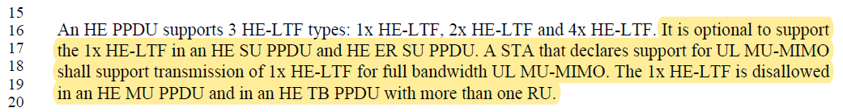
…
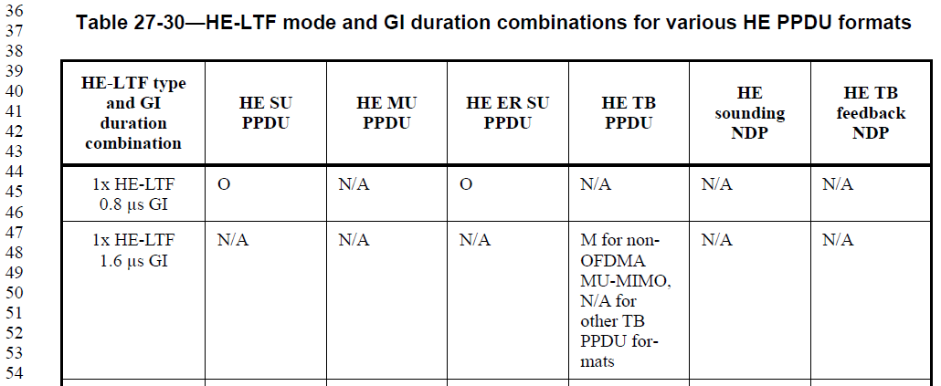

The commenter had requested the above yellow highlight sentence to be deleted, and the comment was accepted, and the sentence has been deleted in D4.3.

In CID 20783, however, Table 27-30 was also updated, which removed from Table 27-30 (Table 27-31 in D4.3) information that 1x HE-LTF 1.6us GI is applicable only for non-OFDMA MU-MIMO in HE TB PPDU.

D4.3 P590-591:
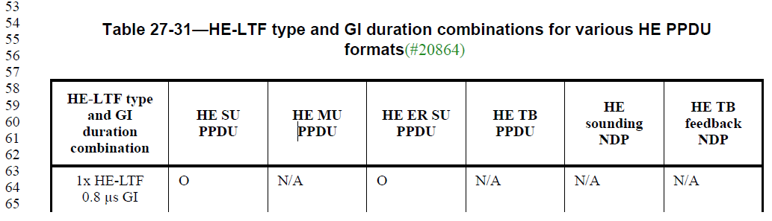
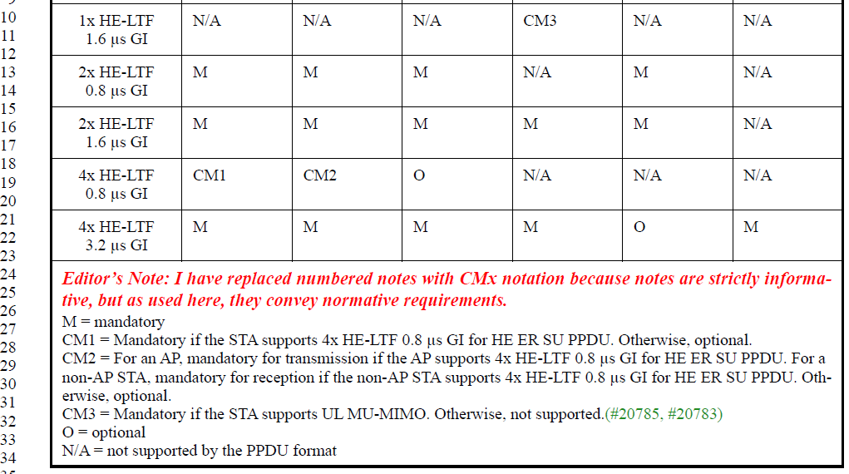

Proposal is to add back that information to Table 27-31.

Proposed Resolution: CID 20785
Revised
The cited sentence has already been removed in D4.3 as per this comment. However, Table 27-31 (D4.3) was also updated, during which we lost the information that 1x HE-LTF 1.6us GI is applicable only for non-OFDMA MU-MIMO in HE TB PPDU. Proposed text update for CID 20785 in 11-19/1531 adds back that information.

Instruction to Editor: Implement the text updates for CID 20785 in 11-19/1531r0.

Proposed Text Updates: CID 20785

27.3.10.10 HE-LTF
TGax Editor: Update Table 27-31 at D4.3 P591L32 as shown below.
- HE-LTF type and GI duration combinations for various HE PPDU formats
HE-LTF type and GI duration combination | HE SU PPDU | HE MU PPDU | HE ER SU PPDU | HE TB PPDU | HE sounding NDP | HE TB feedback NDP
1x HE-LTF  0.8 µs GI | O | N/A | O | N/A | N/A | N/A
1x HE-LTF  1.6 µs GI | N/A | N/A | N/A | CM3 | N/A | N/A
2x HE-LTF  0.8 µs GI | M | M | M | N/A | M | N/A
2x HE-LTF  1.6 µs GI | M | M | M | M | M | N/A
4x HE-LTF  0.8 µs GI | CM1 | CM2 | O | N/A | N/A | N/A
4x HE-LTF  3.2 µs GI | M | M | M | M | O | M
- I have replaced numbered notes with CMx notation because notes are strictly informative, but as used here, they convey normative requirements.
M = mandatory
CM1 = Mandatory if the STA supports 4x HE-LTF 0.8 µs GI for HE ER SU PPDU. Otherwise, optional.
CM2 = For an AP, mandatory for transmission if the AP supports 4x HE-LTF 0.8 µs GI for HE ER SU PPDU. For a non-AP STA, mandatory for reception if the non-AP STA supports 4x HE-LTF 0.8 µs GI for HE ER SU PPDU. Otherwise, optional.
CM3 = Mandatory for full bandwidth UL MU-MIMO if the STA supports UL MU-MIMO. Otherwise, not supported. N/A for partial bandwidth UL MU-MIMO or UL OFDMA.
O = optional
N/A = not supported by the PPDU format

CID 20934

CID | Page.Line | Clause | Comment | Proposed Change | Previous  Resolution
20934 |  |  | Re CID 16138: the field name is therefore very poor. Also not clear what "payload in" refers to. Also an RU in a 20M PPDU is necessarily in the primary 20 MHz channel. Also not clear why this is restricted to from non-AP STA (is this to allow HE TDLS STAs to restrict each other?). Also "single" not clear | Change "Rx Partial BW SU Using HE MU PPDU From Non-AP STA" to "Rx Partial BW SU In 20 MHz HE MU PPDU" in Figure 9-772c and Table 9-321b and at 419.2. In Table 9-321b change "Indicates support for the reception of payload in a  20 MHz HE MU PPDU with a single 106-tone RU in  the primary 20 MHz channel." to "Indicates support for the reception of a  20 MHz HE MU PPDU with just a 106-tone RU.". At 419.1 change "An STA shall not transmit a 20 MHz HE MU PPDU with just a 106-tone RU to a peer STA  unless it has received from the peer STA" | ACCEPTED (EDITOR: 2019-07-19 18:36:00Z)

Background

D4.0 P176: (HE PHY Capabilities Information field)
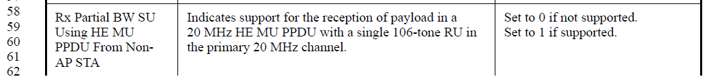

D4.3 P188: (HE PHY Capabilities Information field)
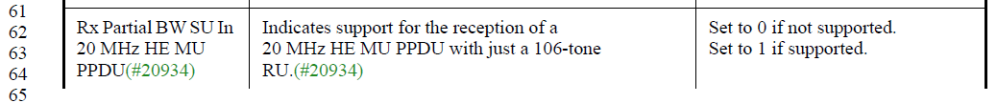

D4.0 P419: (26.15.2 PPDU format selection)

D4.3 P438: (26.15.2 PPDU format selection)

Strawpoll taken during 9/16/2019 TGax PHY ad hoc session (PM2):
Strawpoll:
Should receiving a 20 MHz HE MU PPDU with just a 106-tone RU be mandatory or optional in TDLS?

Mandatory: 3
Optional: 10
Abstain: 5

Proposed Resolution: CID 20934
Revised
D4.3 P338L33 (D4.0 P323L49) requires HE MU PPDU transmissions from an AP to have “at least N x 4 x 26 subcarriers are modulated by the allocated RUs within the entire PPDU, where N is the number of 20 MHz subchannels that are not preamble punctured in the PPDU.” A 20 MHz HE MU PPDU using just a 106-tone RU satisfies this requirement. As non-AP STAs are required support receiving all RU sizes in an HE MU PPDU (DL OFDMA) anyway, there is no reason to disallow a 20 MHz HE MU PPDU using just a 106-tone RU from an AP to a non-AP STA – otherwise, it imposes additional restriction on AP transmitter scheduler.

When a non-AP STA is transmitting a 20 MHz HE MU PPDU, however, using just a 106-tone RU is not very beneficial. Unlike HE TB PPDU (UL OFDMA), there is no range benefit, for example, since receivers need to process the 20 MHz preamble of the HE MU PPDU. Hence, 20 MHz HE MU PPDU using just a 106-tone RU from a non-AP STA to an AP was optional in D4.0, and the “Rx Partial BW SU In 20 MHz HE MU PPDU From Non-AP STA” was the corresponding capabilities bit.

By previously accepting CID 20934, however, reception of a 20 MHz HE MU PPDU using just a 106-tone RU from AP to a non-AP STA has also been made optional.

Note that the question from the commenter was on the TDLS case. This case is similar to the case of non-AP STA transmitting to AP STA, hence it makes sense to keep it optional.

Proposed text update for CID 20751 in 11-19/1531 keeps the 20 MHz HE MU PPDU using just a 106-tone RU optional when transmitted by a non-AP STA (including TDLS), but keeps it mandatory when transmitted by an AP.

Instruction to Editor: Implement the text updates for CID 20934 in 11-19/1531r1.

Proposed Text Updates: CID 20934

9.4.2.242.3 HE PHY Capabilities Information field
TGax Editor: Update Table 9-321b at D4.3 P188L62 as shown below.

Rx Partial BW SU In 20 MHz HE MU PPDU | For an AP, TDLS STA or IBSS STA, indicates support for the reception of a 20 MHz HE MU PPDU with just a 106-tone RU.  NOTE—It is mandatory for a non-AP HE STA to receive a 20 MHz HE MU PPDU with just a 106-tone RU. | For an AP, TDLS STA or IBSS STA:  Set to 0 if not supported.  Set to 1 if supported.  Reserved for a non-AP STA

26.15.2 PPDU format selection
TGax Editor: Update D4.3 P438L15 as shown below.
A non-AP STA, TDLS STA or IBSS STA shall not transmit a 20 MHz HE MU PPDU with just a 106-tone RU to a peer STA unless it has received from the peer STA an HE Capabilities element with the Rx Partial BW SU In 20 MHz HE MU PPDU subfield in the HE PHY Capabilities Information field equal to 1.

[End of File]

