IEEE P802.11
Wireless LANs
LB238 CID 20742, 20751
Date: 2019-09-10
Author(s):
Name | Affiliation | Address | Phone | email
Youhan Kim | Qualcomm |  |  | youhank@qti.qualcomm.com

Abstract
This submission proposes resolutions for the following comments from the letter ballot on P802.11ax D4.0:

20742, 20751

NOTE – Set the Track Changes Viewing Option in the MS Word to “All Markup” to clearly see the proposed text edits.

Revision History:

R0: Initial version.

CID 20742

CID | Page.Line | Clause | Comment | Proposed Change
20742 |  |  | Re CID 16117: examples are 410.53 "Each 8 bits of the RU_ALLOCATION are set to 01110001", 410.55, 458.54 "For each 8 bits, only the following values are allowed:  01110001  11000000", 548.8 "8-bit RU Allocation subfield used to signal that 996-tones RU shall be set to 01110011.", 607.24 "For each non-HT duplicate PPDU transmission that is a preamble punctured PPDU, each punctured 20 MHz  subchannel is indicated as punctured by including the value of 01110001", 607.28 "including the value of 11000000 in the 8 bits of the TXVECTOR parameter RU_ALLOCATION" | As it says in the comment

Background

From LB33 (11-19/1123r14):
CID | Page.Line | Clause | Comment | Proposed Change | Resolution
16117 |  |  | Field values should not be expressed as binary numbers unless it is clear which bit of the binary number is the msb and which is the lsb | Either express such field values as decimal or put them in a table where each bit has its own explicitly numbered column (see baseline) | Rejected.  The comment doesn't identify the paragraph or the location where the issue occurs. The commenter is invite to submit a more precise comment identifying the locations where suchh an issue occurs.

Proposed Resolution: CID 20742
Revised
Table 27-26 (RU Allocation subfield) clearly indicates which bit is MSB and which is LSB. Having said that, it is often easier/clearer to use decimal numbers. For example, sniffers represent the HE-SIG-B RU Allocation content in decimal numbers. Hence, when the sniffer indicates an RU allocation of, say, 112, then one has to first convert it to binary representation (01110000) before one can look up the definition in Table 27-26. Hence, it would be helpful for Table 27-26 to have both the decimal representation and the binary representation. We should keep the binary representation as well because some of the RU allocation values use the notation “y_0 y_1 y_2” which is best understood in binary notation.
Proposed text update for CID 20742 in 11-19/1530 is mostly inline with what the commenter has implied.

Instruction to Editor: Implement the text updates for CID 20742 in 11-19/1530r0.

Proposed Text Updates: CID 20742

26.11.7 INACTIVE_SUBCHANNELS and RU_ALLOCATION
TGax Editor: Update D4.3 P429L11 as shown below.
Each 8 bits of the RU_ALLOCATION are set to 113 (01110001 in binary representation) for the 242-tone RU that is most closely aligned in frequency with the 20 MHz subchannel that is indicated as disallowed by the value 1 in the INACTIVE_SUBCHANNELS parameter. Each 8 bits of the RU_ALLOCATION are set to 192 (11000000 in binary representation) for the 242-tone RU that is most closely aligned in frequency with the 20 MHz subchannel that is indicated as not disallowed by the value 0 in the INACTIVE_SUBCHANNELS parameter.

27.2.2 TXVECTOR and RXVECTOR parameters
TGax Editor: Update Table 27-1 at D4.3 P482L54 as shown below.

RU_ALLOCATION | FORMAT is HE_MU and SIG_B_COMPRESSION_MODE is 0 | For the TXVECTOR, indicates the RU Allocation subfield of Common field in the HE-SIG-B of the transmitted PPDU.  8 bits for a 20 MHz PPDU;  16 bits for a 40 MHz PPDU;  32 bits for an 80 MHz PPDU  64 bits for a 160 MHz or 80+80 MHz PPDU.  See 27.3.10.8.3 for details.  For the RXVECTOR, 8 bits are used to indicate the RU allocated in the whole bandwidth.  See 9.3.1.22 for details. | Y | Y
 | FORMAT is HE_TB | 8 bits are used to indicate the RU allocated in the whole bandwidth per user.  See 9.3.1.22 for details. | Y | N
 | FORMAT is HE_SU, APEP_LENGTH is 0, and CH_BANDWIDTH is not CBW20 or CBW40 | For the TXVECTOR, indicates the active RUs.  32 bits for 80 MHz PPDU  64 bits for 160 MHz and 80+80 MHz PPDU  For each 8 bits, only the following values are allowed:  113 (01110001 in binary representation)  192 (11000000 in binary representation)  See 27.3.10.8.3 for details. | Y | N
 | FORMAT is NON_HT, NON_HT_MODULATION is NON_HT_DUP_OFDM, and CH_BANDWIDTH is not CBW20 or CBW40
 | Otherwise | Not present | N | N

27.3.10.8 HE-SIG-B
27.3.10.8.2 HE-SIG-B content channels
TGax Editor: Update D4.3 P571L29 as shown below.
For a 996-tone RU, for each HE-SIG-B content channel, the first 8-bit RU Allocation subfield referring to the RU may use values 208~215 (11010y₂y₁y₀ in binary representation) as in Table 27-26 with y₂y₁y₀ indicating the number of User fields signaled in the corresponding content channel, while the second 8-bit RU Allocation subfield referring to the RU shall be set to 115 (01110011 in binary representation).

TGax Editor: Update Table 27-26 at D4.3 P573L15 as shown below.
Table 27-26 - RU Allocation subfield
RU Allocation subfield  (B7 B6 B5 B4 B3 B2 B1 B0) | #1 | #2 | #3 | #4 | #5 | #6 | #7 | #8 | #9 | Number of entries
0 (00000000) | 26 | 26 | 26 | 26 | 26 | 26 | 26 | 26 | 26 | 1
1 (00000001) | 26 | 26 | 26 | 26 | 26 | 26 | 26 | 52 |  | 1
2 (00000010) | 26 | 26 | 26 | 26 | 26 | 52 |  | 26 | 26 | 1
3 (00000011) | 26 | 26 | 26 | 26 | 26 | 52 |  | 52 |  | 1
4 (00000100) | 26 | 26 | 52 |  | 26 | 26 | 26 | 26 | 26 | 1
5 (00000101) | 26 | 26 | 52 |  | 26 | 26 | 26 | 52 |  | 1
6 (00000110) | 26 | 26 | 52 |  | 26 | 52 |  | 26 | 26 | 1
7 (00000111) | 26 | 26 | 52 |  | 26 | 52 |  | 52 |  | 1
8 (00001000) | 52 |  | 26 | 26 | 26 | 26 | 26 | 26 | 26 | 1
9 (00001001) | 52 |  | 26 | 26 | 26 | 26 | 26 | 52 |  | 1
10 (00001010) | 52 |  | 26 | 26 | 26 | 52 |  | 26 | 26 | 1
11 (00001011) | 52 |  | 26 | 26 | 26 | 52 |  | 52 |  | 1
12 (00001100) | 52 |  | 52 |  | 26 | 26 | 26 | 26 | 26 | 1
13 (00001101) | 52 |  | 52 |  | 26 | 26 | 26 | 52 |  | 1
14 (00001110) | 52 |  | 52 |  | 26 | 52 |  | 26 | 26 | 1
15 (00001111) | 52 |  | 52 |  | 26 | 52 |  | 52 |  | 1
16~23 (00010y₂y₁y₀) | 52 |  | 52 |  | - | 106 |  |  |  | 8
24~31 (00011y₂y₁y₀) | 106 |  |  |  | - | 52 |  | 52 |  | 8
32~39 (00100y₂y₁y₀) | 26 | 26 | 26 | 26 | 26 | 106 |  |  |  | 8
40~47 (00101y₂y₁y₀) | 26 | 26 | 52 |  | 26 | 106 |  |  |  | 8
48~55 (00110y₂y₁y₀) | 52 |  | 26 | 26 | 26 | 106 |  |  |  | 8
56~63 (00111y₂y₁y₀) | 52 |  | 52 |  | 26 | 106 |  |  |  | 8
64~71 (01000y₂y₁y₀) | 106 |  |  |  | 26 | 26 | 26 | 26 | 26 | 8
72~79 (01001y₂y₁y₀) | 106 |  |  |  | 26 | 26 | 26 | 52 |  | 8
80~87 (01010y₂y₁y₀) | 106 |  |  |  | 26 | 52 |  | 26 | 26 | 8
88~95 (01011y₂y₁y₀) | 106 |  |  |  | 26 | 52 |  | 52 |  | 8
96~111 (0110y₁y₀z₁z₀) | 106 |  |  |  | - | 106 |  |  |  | 16
112 (01110000) | 52 |  | 52 |  | - | 52 |  | 52 |  | 1
113 (01110001) | 242-tone RU empty (with zero users)(#21036) |  |  |  |  |  |  |  |  | 1
114 (01110010) | 484-tone RU; contributes zero User fields to the User Specific field in the same HE-SIG-B content channel as this RU Allocation subfield(#21237) |  |  |  |  |  |  |  |  | 1
115 (01110011) | 996-tone RU; contributes zero User fields to the User Specific field in the same HE-SIG-B content channel as this RU Allocation subfield(#21237) |  |  |  |  |  |  |  |  | 1
116~119 (011101x₁x₀) | Reserved |  |  |  |  |  |  |  |  | 4
120~127 (01111y₂y₁y₀) | Reserved |  |  |  |  |  |  |  |  | 8
128~191 (10y₂y₁y₀z₂z₁z₀) | 106 |  |  |  | 26 | 106 |  |  |  | 64
192~199 (11000y₂y₁y₀) | 242 |  |  |  |  |  |  |  |  | 8
200~207 (11001y₂y₁y₀) | 484 |  |  |  |  |  |  |  |  | 8
208~215 (11010y₂y₁y₀) | 996 |  |  |  |  |  |  |  |  | 8
216~223 (11011y₂y₁y₀) | Reserved |  |  |  |  |  |  |  |  | 8
224~255 (111x₄x₃x₂x₁x₀) | Reserved |  |  |  |  |  |  |  |  | 32
If signaling RUs of size greater than 242 subcarriers, y₂y₁y₀ = 000–111 indicates the number of User fields in the HE-SIG-B content channel that contains the corresponding 8-bit RU Allocation subfield. Otherwise, y₂y₁y₀ = 000–111 indicates the number of STAs multiplexed in the 106-tone RU, 242-tone RU or the lower frequency 106-tone RU if there are two 106-tone RUs and one 26-tone RU is assigned between two 106-tone RUs. The binary vector y₂y₁y₀ indicates Nuser(r,c)=2² × y₂ + 2¹ × y₁ + y₀ + 1 STAs multiplexed in the RU.
z₂z₁z₀ = 000–111 indicates the number of STAs multiplexed in the higher frequency 106-tone RU if there are two 106-tone RUs and one 26-tone RU is assigned between two 106-tone RUs. The binary vector z₂z₁z₀ indicates Nuser(r,c)=2² × z₂ + 2¹ × z₁ + z₀ + 1 STAs multiplexed in the RU.
Similarly, y₁y₀ = 00–11 indicates the number of STAs multiplexed in the lower frequency 106-tone RU. The binary vector y₁y₀ indicates Nuser(r,c)=2¹ × y₁ + y₀ + 1 STAs multiplexed in the RU.
Similarly, z₁z₀ = 00-11 indicates the number of STAs multiplexed in the higher frequency 106-tone RU. The binary vector z₁z₀ indicates Nuser(r,c)=2¹ × z₁ + z₀ + 1 STAs multiplexed in the RU.
#1 to #9 (from left to the right) is ordered in increasing order of the absolute frequency.
x₁x₀ = 00-11, x₄x₃x₂x₁x₀ = 00000–11111.
‘-’ means no STA in that RU, i.e., Nuser(r,c)=0.
For RU r that is a 106-tone or larger RU, Nuser(r,c) is indicated by the letters (such as y₂y₁y₀ or z₂z₁z₀) in the RU allocation subfield above if the letters are present in the RU allocation subfield; otherwise Nuser(r, c) is 0.
For RU r that is a 26-tone or 52-tone RU, Nuser(r, c) is 1.

27.3.13 Non-HT duplicate transmission
TGax Editor: Update D4.3 P636L60 as shown below.
For each non-HT duplicate PPDU transmission that is a preamble punctured PPDU, each punctured 20 MHz subchannel is indicated as punctured by including the value of 113 (01110001 in binary representation) in the 8 bits of the TXVECTOR parameter RU_ALLOCATION corresponding to the 242-tone RU that is most closely aligned with the punctured 20 MHz subchannel. Each 20 MHz subchannel that is not punctured is indicated as such by including the value of 192 (11000000 in binary representation) in the 8 bits of the TXVECTOR parameter RU_ALLOCATION corresponding to the 242-tone RU that is most closely aligned with that 20 MHz subchannel.

CID 20751

CID | Page.Line | Clause | Comment | Proposed Change
20751 |  |  | Re CID 16146: the problem was clearly identified (duplication), and it does cause harm to repeat the same requirement in multiple places as this leads to spec rot | Make the change indicated in CID 16146

Background

From LB33 (11-19/1123r14):
CID | Page.Line | Clause | Comment | Proposed Change | Resolution
16146 |  |  | That an AP with >= 4SS needs to support DL MU-MIMO is stated too many times | Delete in at least one of 4.13.4a, T9-262aa, 27.6.2, 28.1.1, 28.3.3.9.2 | Rejected.  The comment doesn't identify problem with the draft. It does not cause any harm to repeat the term in several place.

There is no Table 9-262aa in D4.0.

There is no section 27.6.2 in D4.0.
There is nothing in section 26.6.2 in D4.0 related to DL MU-MIMO.

D4.3 P47
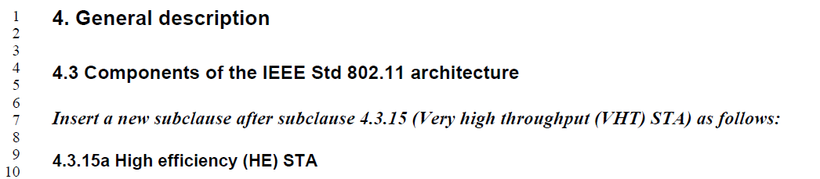
…
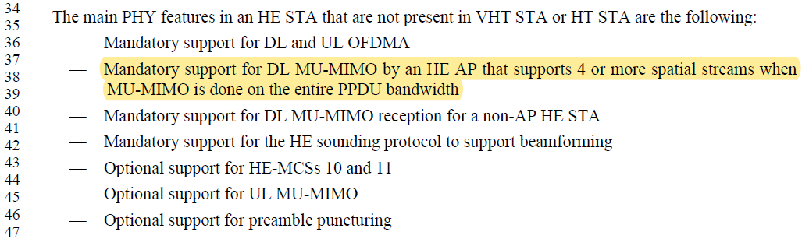

D4.3 P467:
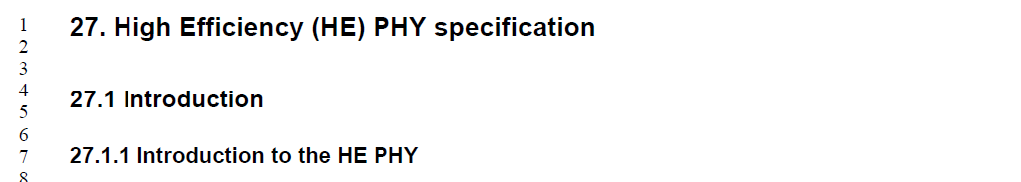
…

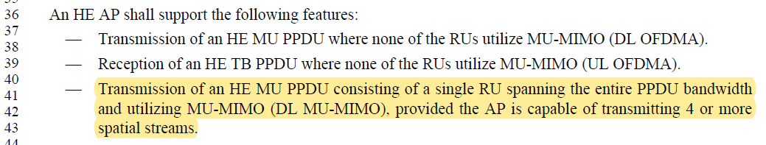

D4.3 P511:
…

Proposed Resolution: CID 20751
Rejected
The commenter has listed 5 places indicating the conditional mandatory status of DL MU-MIMO transmission.

Of these, 2 places do not exist.
There is no T9-262aa or Table 9-262aa in D4.0.
There is no section 27.6.2 in D4.0. There is nothing in section 26.6.2 in D4.0 related to DL MU-MIMO.

Of the remaining three places, one is in Clause 4 (General description), and is not a normative language. Hence, there are only two places (D4.3 P467L41, P511L46) which clarify the conditional mandatory status of DL MU-MIMO transmission, which is reasonable and helpful to readers.

[End of File]

