IEEE P802.11
Wireless LANs
Objective and scope of technical report on interworking between 3GPP 5G network & WLAN
Date: 2019-09-15
Author(s):
Name | Affiliation | Address | Phone | email
Hyun Seo Oh | ETRI | Gajeongro 218 Yusunggu  Daejeon, Korea | +82-42-860-5659 | hsoh5@etri.re.kr
Hanbyeog CHO | ETRI | Gajeongro 218 Yusunggu  Daejeon, Korea | +82.42.860.5531 | hbcho@ etri.re.kr
Chang Han OH | allRadio Co. Ltd | 280, Seobusaet-gil, Geumcheon-gu, Seoul, Korea | +82.2.801.1310 | choh@allradio.co.kr
Si Young HEO | KT | KT R&D Center, 151, Taebong-ro, Seocho-gu, Seoul, Korea | +82.10.266.4569 | siyoung.heo@kt.com
Hyeong Ho LEE | Nevision Telecom Inc., Korea Univ. | 412, 199, Techno2-ro, Yuseong-Gu, Daejeon, 34025, Korea | +82.42.931.4130 | hhlee@netvisiontel.com
Abstract
This contribution presents an objective and scope of technical report on WLAN interworking to 3GPP 5G network. Also we present an example of interworking reference model and propose the detailed table of contents of the report. The technical report can be used for a reference and guideline for stakeholders with interest in standardization and system development.

- Objectives

This technical report on interworking between 3GPP 5G network and WLAN will provide a reference and guideline for stakeholders with interest in standardization and system development. This report will provide the interworking reference model and describes interworking types supported by 3GPP 5G network and WLAN. And this defines the necessary functionalities and specific procedures that enable WLAN access networks to interwork with 3GPP 5G network.

- Scope

This report covers an interworking reference model, necessary functionalities and specific procedures that allow WLAN access network to interwork with 3GPP 5G network. We consider two types of interworking reference model, which are tightly coupled and loosely coupled type. The reference model consists of WLAN stations (STAs), WLAN access network (consisting of WLAN access point (APs) and a Distribution System (DS)), 3GPP 5G access network and 3GPP 5G core network. N1 signalling and NWu interfaces are defined in 3GPP specification, but functionalities and procedures are not defined in WLAN entities to allow for interworking with 3GPP 5G network. This report will describe Y2 interface and new funtional entities, which are Staion Controller (SC) in a station and Access Network Controller (ANC) in WLAN access network. The signalling and control procedures will be described for the functional entities of a station, WLAN acess network, 3GPP 5G access network and 3GPP 5G core network.

- Contents of the technical report

- Introduction (Overview)
- Terms and acronyms
- WLAN interworking reference model

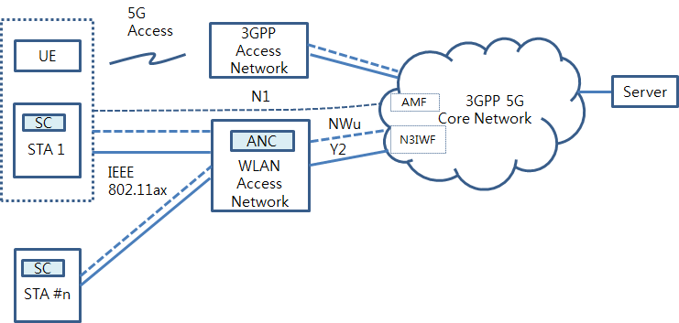

[Figure] example of interworking reference model between 5G core network and WLAN

- Tightly coupled interworking type

Interworking for a UE containing both 3GPP 5G and WLAN radios is tighly coupled because WLAN access network and 3GPP access network are co-located and interworking may be done efficiently. Fucntion and procedures for tightly coupled interworking are as follows.

- Radio channel sharing method
- Registration and authentication function and its message procedures
- Signalling function and its message procedures
- ATSSS function and its message procedures
- QoS function and its message procedures

- Loosely coupled interworking type

Interworking for a UE containing both 3GPP 5G and WLAN radios is loosely coupled because WLAN access network and 3GPP access network are separately located. Fucntion and procedures for loosely coupled interworking are as follows.

- Radio channel sharing method
- Registration and authentication function and its message procedures; EAP 5G signalling
- Signalling function and its message procedures; IP data tunnelling
- ATSSS function and its message procedures
- QoS function and its message procedures

- Conclusion

- References

- 3GPP TS 22.261 V15.5.0 (2018-06) “Service requirements for the 5G system (Stage 1)”
- 3GPP TS 22.278 “Service requirements for the Evolved Packet System (EPS)”
- 3GPP TS 23.402 "Architecture enhancements for non-3GPP accesses”
- 3GPP TR 23.716 “Study on the Wireless and Wireline Convergence for the 5G System Architecture”
- 3GPP TR 23.793 “Study on Access Traffic Steering, Switching and Splitting support in the 5G system architecture”
- 3GPP TR 23.799 “Study on Architecture for Next Generation System”
- 3GPP TS 23.501 “System Architecture for the 5G System (Stage 2)”
- 3GPP TS 23.502 “Procedures for the 5G System (Stage 2)”
- 3GPP TS 24.302 “Access to the 3GPP Evolved Packet Core (EPC) via non-3GPP access networks (Stage 3)”
- 3GPP TS 24.501 “Non-Access-Stratum (NAS) protocol for 5G System (5GS) (Stage 3)”
- 3GPP TS 24.502 “Access to the 3GPP 5G Core Network (5GCN) via Non-3GPP Access Networks (N3AN) (Stage 3)”
- 3GPP TS 33.501 “Security Architecture and Procedure for the 5G System”
- 3GPP TR 33.899 “Study on the Security Aspects of the Next Generation System”
- RAN convergence paper, WBA and NGMN alliance, September, 2019.

