IEEE P802.11
Wireless LANs
LB236 CID 2343
Date: 2019-09-09
Author(s):
Name | Affiliation | Address | Phone | email
Youhan Kim | Qualcomm |  |  | youhank@qti.qualcomm.com

Abstract
This submission proposes resolutions for the following comments from the letter ballot on P802.11-REVmd D2.0:

2343

NOTE – Set the Track Changes Viewing Option in the MS Word to “All Markup” to clearly see the proposed text edits.

Revision History:

R0: Initial version.

CID 2343

CID | Clause | Page.Line | Comment | Proposed Change
2343 | 9.4.1.49 | 944.60 | "DC subcarriers (0, +/-1) are skipped in each frequency segment." -- it is not clear that the segments of 80+80 actually have DC subcarriers at all | Change the cited text at the referenced location to "the subcarriers (0, +/-1) that would correspond to a DC subcarrier for 80 MHz channel width are skipped in each frequency segment."

Background

D2.0 P944
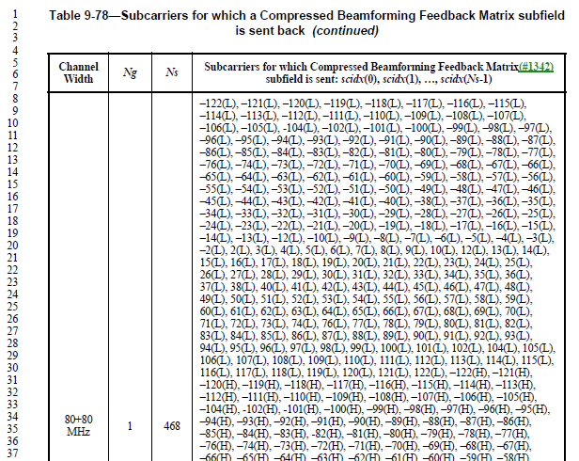

…

D2.4 P3171
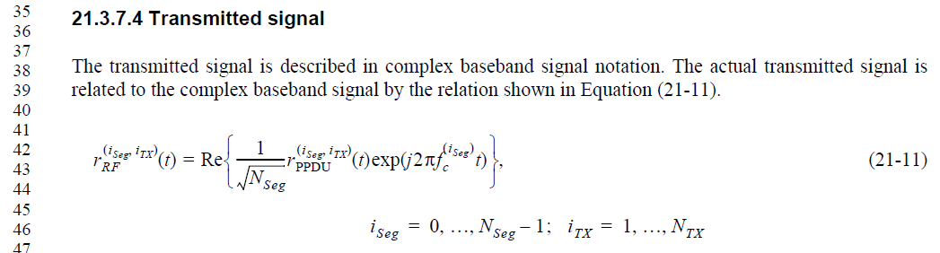

Proposed Resolution: CID 2343
Rejected.
In Clause 21, 80+80 MHz is described as two 80 MHz segments each having separate RF carriers. For example, Equation (21-11) in D2.4 is the transmitted signal, where each segment has a distinct carrier frequency of f_{c}^{(i_seg)}. Hence, each 80 MHz segment of 80+80 has DC subcarriers.

[End of File]

