IEEE P802.11  
Wireless LANs

|  |  |  |  |  |
| --- | --- | --- | --- | --- |
| Resolution for CID 2273 | | | | |
| Date: 2019-08-06 | | | | |
| Author: | | | | |
| Name | Affiliation | Address | Phone | Email |
| Edward Au | Huawei Technologies | 303 Terry Fox Drive, Suite 400, Ottawa, Ontario K2K 3J1 |  | [edward.ks.au@huawei.com](mailto:edward.ks.au@huawei.com) |

##### This submission present proposed resolution for CID 2273. The proposed changes are based on REVmd/D2.3.

##### Revision history:

##### R0 – initial version

|  |  |  |  |  |  |
| --- | --- | --- | --- | --- | --- |
| CID | Clause | Page | Line | Comme | Proposed Change |
| 2273 | 5.1.5.1 | 302 | 0 | Fix top part of Figure 5-2 and Figure 5-7 (from 11ak) to match changes in Figure 5-1. | To Figure 5-2, add 802.1AC entities and corresponding layer, and the "Legend box". In Figure 5-7, replace "LLC/SNAP" with "LPD/EDP" and add 802.1AC entities and corresponding layer, "Role-specific behavior" box and associated arrow label, and "Legend box". |

***Discussion:***

The following shows the top part of Figure 5-1 in D2.3:



The following shows the top part of Figure 5-2 in D2.3:



The following shows the top part of Figure 5-7 in D2.3:



The commenter is right that the formats of Figure 5-2 and Figure 5-7 are not consistent with that of Figure 5-1. To be specific, the “802.1 convergence, bridging and related functions” layer is missing in both figures.

For Figure 5-2:

As per the discussion with Mark Hamilton, agree to

[1] add 802.1AC convergence function entities

[2] add the corresponding layer “802.1 convergence, bridging and related functions

[3] add “Legend” in the “Legend box” to make it more clear that this is the purpose of the box per the discussion in the July 11th call.

For Figure 5-7:

As per the discussion with Mark Hamilton, agree to

[1] replace “LLC/SNAP” with “LPD/EDP”

[2] add the corresponding layer “802.1 convergence, bridging and related functions

[3] add “Legend” in the “Legend box” to make it more clear that this is the purpose of the box per the discussion in the July 11th call

[4] modify the text in the “Role-specific box” as “Non-STA AP behavior” in Figure 5-7, to reflect that in this case (an S1G relay) we know the specific role is a non-AP STA.

***Proposed resolution:***

Revised

For Figure 5-2, add 802.1AC convergence function entities and the corresponding layer “802.1 convergence, bridging and related functions”, and add “Legend” in the “Legend box” as shown in page 6.

For Figure 5-7, replace “LLC/SNAP” with “LPD/EDP”, add 802.1AC convergence function entities and the corresponding layer “802.1 convergence, bridging and related functions”, add “Non-STA AP behavior” box, and add “Legend” in the “Legend box” as shown in page 7.

Note to Editors: The source files of Figure 5-2 and Figure 5-7 are attached here.



Revised Figure 5-2:

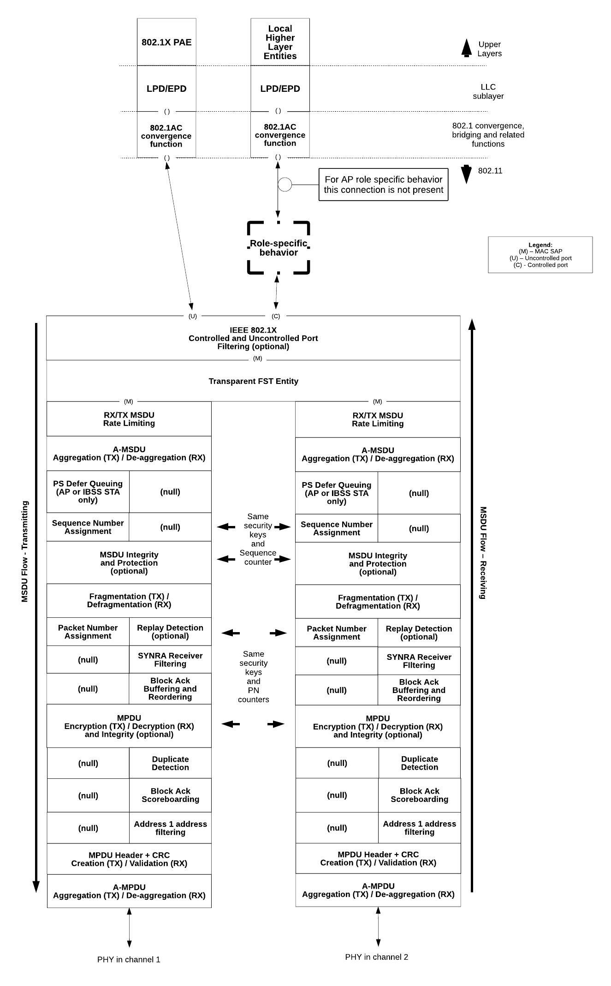

Revised Figure 5-7:

