IEEE P802.11
Wireless LANs
Resolutions to CIDs 2559 and 2560

Date: 2019-07-30
Brian Hart | Cisco Systems | 170 W Tasman Dr, San Jose CA 94087 | brianh@cisco.com

Abstract
This submission proposes a resolution for CIDs 2559 and 2560 (2 CIDs)

Interpretation of a Motion to Adopt

A motion to approve this submission means that the editing instructions and any changed or added material are actioned in the 11md Draft. This introduction is not part of the adopted material.

Editing instructions formatted like this are intended to be copied into the Draft (i.e. they are instructions to the 802.11 editor on how to merge the text with the baseline documents).

CID | Section# | Page# | L# | Comment | Proposed Change | Resolution
2559 | 8.3.5.14.2 | 770 | 9 | Should not return the RXVECTOR in the RXEND. Should just return the bits needed for radio measurement, since the rest has already been returned in the RXSTART, and returning it again is confusing. Also RSNI is missing | In the referenced subclause, change ",  RXVECTOR" to ", RCPI, RSNI" and change the last para to "The RCPI and RSNI are included only when dot11RadioMeasurementActivated is true.". In Tables 15-2, 16-5, 17-2 delete the RCPI row and the NOTE. In Tables 18-3, 19-1, 20-1, 21-1, 22-1, 23-1, 24-1, 25-1 delete the RCPI row | Rejected.  As described in doc 19/xxxx<motionedRev>, RSNI is computed in the MLME using IPI reports made by the PHY, filtered by the MLME’s knowledge of virtual carrier sense. Therefore RSNI does not come from the PHY.  RXVECTOR is used to convey RCPI in the RXEND primitive since it is (usually) measured in the Data field. Although it is true that this instance of RXVECTOR contains parameters already sent in RXSTART, it is trivial to discard known duplicates and the choice of RXVECTOR has the advantage of interface consistency.
2560 |  |  |  | Need to return RCPI and RSNI for radio measurement | In Figures 21-36, 23-33, 23-34, 23-35 change "Measure RCPI" to "Measure RCPI and RSNI". In Figure 20-18 change "Measure channel" to "Measure RCPI and RSNI". In Figure 25-38 change "Message RCPI" to "Measure RCPI and RSNI" and change the other two "Message"s to "Measure"s. In Figures 19-25, 19-26, 20-18 add an arrow up from the end of the "Data" box saying "Measure RCPI and RSNI" | Revised.  See changes under CID 2560 in  doc 19/xxxx<motionedRev>

Background for RSNI
The 802.11k design is as follows:
- RCPI is measured during a PPDU and reported in RXVECTOR
- IPI (Idle Power Indicator) is measured “when the PHY is neither transmitting nor receiving …” (8.3.5.10.2 Semantics of the service primitive, etc) and reported by IPI-REPORT in the PHY-CCA.indication and PHY-CCARESET.indication primitives (Table 8-3)
- From 11.10.9.4 Noise Histogram report, IPI may be used to calculate ANPI, and then, with RCPI, may be used by the MLME to calculate RSNI (via the equation in 9.4.2.40 RSNI element):
“A STA shall include in the Noise Histogram report an average noise power indicator (ANPI) value representing the average noise plus interference power on the measured channel at the antenna connector during the measurement duration. The STA may use Noise Histogram IPI density values to calculate ANPI.
The IPI densities in the Noise Histogram report may be used to calculate an average noise power for the channel during the measurement duration. This calculated average IPI power value may be reported as the value for ANPI. Any equivalent method to measure ANPI may also be used. …
ANPI may be calculated over any period and for any received frame. ANPI may be calculated in any period and at any time by filtering all PHY IPI values in a MAC filter to exclude IPI values received when NAV is nonzero. These filtered IPI values represent idle channel noise and may be stored in a first-in-first-out (FIFO) buffer to facilitate ANPI calculation over a fixed number of IPI samples. ANPI may be so calculated upon receipt of any frame and may be used with RCPI to calculate RSNI for any received frame. Any equivalent method to measure ANPI may also be used to calculate RSNI for any received frame.”

802.11k implemented the final averaging and filtering in the MLME because only the MAC/MLME knows virtual carrier sense.
Furthermore, recall that the PHY’s RX procedure and the RXVECTOR it returns is associated with receiving an actual PPDU. Noise is measured outside the transmission or reception of a PPDU, so it is not especially logical to report a noise measurement with a PHY primitive associated with a received PPDU. For instance if there were no PPDU receptions for an extended period, then there would be no noise measurements for an extended period. Furthermore, such a measurement cannot become an ANPI measurement nor a RSNI measurement unless the MAC/MLME is also pushing virtual carrier information down to the PHY beforehand (for which no primitive exists).

Background for RCPI in RXVECTOR
RCPI is measured during the “frame” in Clauses 15 and 16 and for the Data field in Clauses 17-25 except 20 and 25 of a PPDU (in the OFDM clauses).
However, for the mmWave PHYs (Clause 20 and 25), RCPI is measured during the preamble. This affects the proper placement of the arrows in the RX procedure figures.
As a corollary, RCPI in the RXVECTOR in the RXSTART.indication in Clauses 15-19 and 21-24 can only be populated with 255 (“Measurement not available”), hence the presence of RXVECTOR in RXEND. However, RCPI can be populated with a meaningful value in the RXSTART.indication in Clauses 20 and 24.

Discussion on CID 2560
With that background, reviewing the comment in detail:

In Figures 21-36, 23-33, 23-34, 23-35 change "Measure RCPI" to "Measure RCPI and RSNI".
Since RSNI is calculated by the MLME (from IPI measurements from the PHY), proposed change is rejected.

In Figure 20-18 change "Measure channel" to "Measure RCPI and RSNI".
Since TRN field is for measuring the channel during the TRN not RCPI, proposed change is rejected (but see below).

In Figure 25-38 change “Message RCPI” to “Measure RCPI and RSNI”
Since RSNI is calculated by the MLME (from IPI measurements from the PHY), proposed RSNI change is rejected. But the arrow is associated with the Data field which is too late, which needs fixing.

… and change the other two “Message”s to “Measure”s.
Agree that all three “Messages” should be changed to “Measures”

In Figures 19-25, 19-26, … add an arrow up from the end of the "Data" box saying "Measure RCPI and RSNI"
Agree that we need the arrow for RCPI (but not for RSNI)

In Figures … 20-18 add an arrow up from the end of the "Data" box saying "Measure RCPI and RSNI"
Agree that we need the arrow for RCPI (but not RSNI), but at the end of the preamble.

Discussion on CID 2559
The commenter is correct that the parameters in the RXVECTOR sent in the RXEND.indication, except for RCPI, are duplicative. There is no error here, and discarding duplicated parameters is a trivial exercise in any implementation. However, agreed there would be less confusion if RXVECTOR were replaced by RCPI for the relevant PHY clauses (which is agreeable to the commenter).
Sidebar
Meanwhile I see some confusion between PPDUs and frames/MPDUs and some copy/past eerrors (use of RCPI when RSNI meant). I do some light clean-up below.
Also “ANPI may be calculated over any period and for any received frame. ANPI may be calculated in any period and at any time by filtering all PHY IPI values in a MAC filter to exclude IPI values received when NAV is nonzero.” Has some duplication (over any period / in any period) and some erroneous language (“ANPI may be calculated for any received frame” yet ANPI is calculate outside frames). Therefore do some more clean up below.
Also include the RX pricedures for discussion purposes.
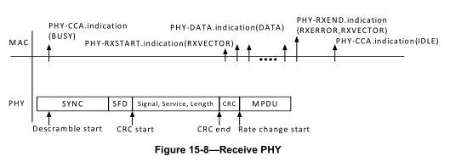

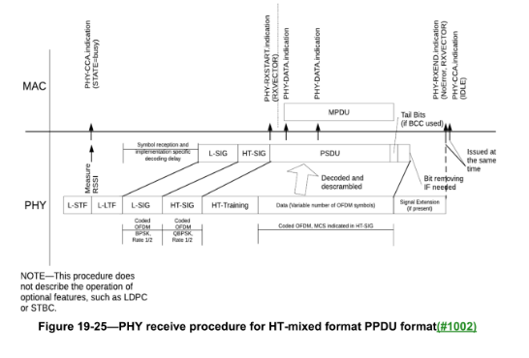
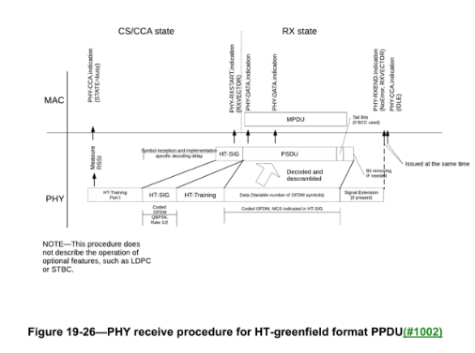
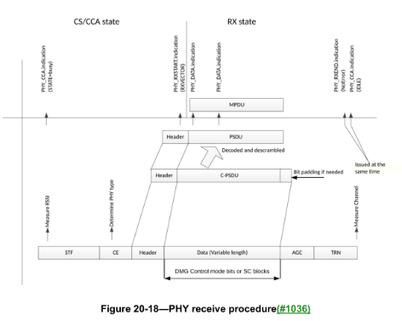
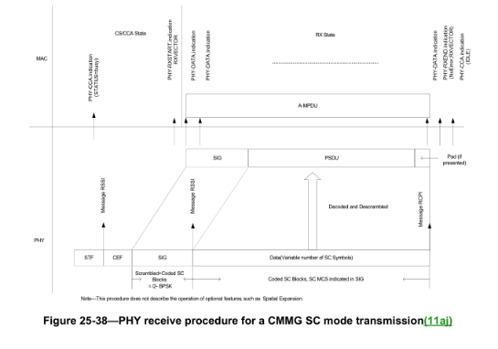

TG editor, wrt D2.1, change, under CID 2560, according to the following instructions
In Figure 15-8, change “PHY-RXEND.indication(RXERROR,RXVECTOR)” to “PHY-RXEND.indication(RXERROR,RCPI)”
In Figures 19-25, 19-26 add an arrow up from the end of the "Data" box saying "Measure RCPI"
In Figure 20-18 add an arrow up from the end of the preamble (the end of the “Header” box) saying "Measure RCPI"
In Figure 25-38 change change the three "Message"s to "Measure"s. Delete the “Measure RCPI” at the end of the Data field and change the “Measure RSSI” at the end of the preamble (the end of the “SIG” box) to “Measure RSSI and RCPI”.
TG editor: wrt D2.1, change, under CID 2560, as shown by Word Track changes:
Table 8-3—PHY SAP service primitive parameters
Parameter | Associated primitive | Value
RXVECTOR | PHY-RXSTART.indication | A set of parameters
RCPI | PHY-RXEND.indication | Clauses 15-19 and 21-23: 0-255; clauses 20, 24 and 25 (i.e. DMG, CDMG and CMMG): not present

8.3.5.14 PHY-RXEND.indication
8.3.5.14.2 Semantics of the service primitive
The primitive provides the following parameters:
PHY-RXEND.indication(
RXERROR,
RCPI
)
The RXERROR parameter can convey NoError or one or more values indicating an error condition. A number of error conditions may occur after the PHY’s receive state machine has detected what appears to be a valid preamble and SFD. The following describes the parameter returned for each of those error conditions.
— NoError. This value is used to indicate that no error occurred during the receive process in the PHY.
— FormatViolation. This value is used to indicate that the format of the received PPDU was in error.
— CarrierLost. This value is used to indicate that during the reception of the incoming PSDU, the carrier was lost and no further processing of the PSDU can be accomplished.
— UnsupportedRate. This value is used to indicate that during the reception of the incoming PPDU, a nonsupported date rate was detected.
— Filtered. This value is used to indicate that during the reception of the PPDU, the PPDU was filtered out due to a condition set in the PHYCONFIG_VECTOR.
NOTE—The filtered condition might occur in a VHT STA due to GROUP_ID or PARTIAL_AID filtering in the PHY.
RCPI is a parameter included in the PHY-RXEND.indication that the PHY provides the local MAC entity. If present, RCPI is a measure of the received RF power averaged over all of the receive chains in the data portion of a received frame. RCPI is an included parameter only when dot11RadioMeasurementActivated is true and the PHY is other than a DMG, CDMG or CMMG PHY. The required parameters are listed in 8.3.4.4 (Vector descriptions).
NOTE – When dot11RadioMeasurementActivated is true, for DMG, CDMG or CMMG PHYs, RCPI is included in the RXVECTOR parameter of the RXSTART.indication primitive instead.

8.3.5.10.2 Semantics of the service primitive
The primitive provides the following parameter:
PHY-CCARESET.request(
IPI-STATE
)
The IPI-STATE parameter is present if dot11RadioMeasurementActivated is true. The IPI-STATE parameter can be one of two values: IPI-ON or IPI-OFF. The parameter value is IPI-ON when the MAC sublayer is requesting the PHY entity to report IPI values when the PHY is neither receiving nor transmitting a PPDU. IPI-ON turns on IPI reporting in the PHY entity. IPI-OFF turns off IPI reporting in the PHY entity.

11.10.9.4 Noise Histogram report
ANPI may be calculated in any period and at any time by filtering all PHY IPI values in a MAC filter to exclude IPI values received when NAV is nonzero. These filtered IPI values represent idle channel noise and may be stored in a first-in-first-out (FIFO) buffer to facilitate ANPI calculation over a fixed number of IPI samples. ANPI may be so calculated upon receipt of any frame and may be used with RCPI to calculate RSNI for any received frame. Any equivalent method to measure ANPI may also be used to calculate RSNI for any received frame. (#2560)

15.2.3.6 RXEND.indication parameter RCPI
The allowed values for the RCPI parameter are in the range 0 to 255, as defined in 9.4.2.37 (RCPI element). This parameter is a measure by the PHY of the received channel power. The performance requirements for the measurement of RCPI are defined in 15.4.6.6 (Received Channel Power Indicator Measurement).

15.2.3.1
Table 15-2—RXVECTOR parameters
Parameter | Value
LENGTH | 0 to 2 12 – 1
RSSI | 0–255
SIGNAL | 1, 2 Mb/s
SERVICE | 1, 2 Mb/s
SQ | 0–255
RX_ANTENNA | (#195)0–255
RX_START_OF_FRAME_OFFSET | 0 to 2 32 – 1. An estimate of the offset (in 10 ns units) from the point in time at which the start of the preamble corresponding to the incoming frame arrived at the receive antenna connector to the point in time at which this primitive is issued to the MAC.

15.3.7 Receive PHY
The RXVECTOR associated with this primitive includes the SIGNAL field, the SERVICE field, the MPDU length in octets (calculated from the LENGTH field in microseconds), the antenna used for receive (RX_ANTENNA), RSSI, and SQ.
TG editor: Insert new penultimate paragraph in this section
If dot11RadioMeasurementActivated is true and RXERROR equals NoError or UnsupportedRate, the PHY-RXEND.indication primitive also includes RCPI as a parameter.
16.2.6 Receive PHY
Upon receiving the transmitted energy, according to the selected CCA mode a PHY-CCA.indication(BUSY) primitive shall be issued for ED and/or code lock prior to correct reception of the PHY header. The PHY measures the SQ, and RSSI parameters and these are reported to the MAC in the RXVECTOR.
If the PHY header reception is successful (and the SIGNAL field is completely recognizable and supported), a PHY-RXSTART.indication(RXVECTOR) primitive shall be issued. The RXVECTOR associated with this primitive includes:
a) The SIGNAL field
b) The SERVICE field
c) The PSDU length in octets (calculated from the LENGTH field in microseconds and the
DATARATE in Mb/s, in accordance with the formula in 16.2.3.6 (Long PHY LENGTH field))
d) RXPREAMBLE_TYPE (which is an enumerated type taking on values SHORTPREAMBLE or
LONGPREAMBLE)
e) RX_ANTENNA(#196), RSSI, and SQ
TG editor: Insert new penultimate paragraph in this section
If dot11RadioMeasurementActivated is true and RXERROR equals NoError or UnsupportedRate, the PHY-RXEND.indication primitive also includes RCPI as a parameter.
Table 16-5—Parameter vectors
Parameter | Associated vector | Value

Table 17-2—RXVECTOR parameters
Parameter | Associated primitive | Value
RCPI (see NOTE) | PHY-RXEND.indication | 0–255

17.2.3.6 RXEND.indication parameter RCPI
The allowed values for the RCPI parameter are in the range 0 to 255, as defined in 17.3.10.7 (Received Channel Power Indicator Measurement). This parameter is a measure by the PHY of the received channel power. RCPI indications of 8 bits are supported. RCPI shall be measured over the entire received frame or by other equivalent means that meet the specified accuracy.

18.2 PHY-specific service parameter list
The architecture of the IEEE 802.11 MAC is intended to be PHY independent. Some PHY implementations require PHY-dependent MAC state machines running in the MAC sublayer in order to meet certain PHY requirements. The PHY-dependent MAC state machine resides in a sublayer defined as the MLME. In certain PHY implementations, the MLME may need to interact with the PLME as part of the normal PHY SAP primitives. These interactions are defined by the PLME parameter list currently defined in the PHY service primitives as TXVECTOR, TXSTATUS, and RXVECTOR. The list of these parameters and the values they may represent are defined in the specific PHY specifications for each PHY. This subclause addresses the TXVECTOR, TXSTATUS, and RXVECTOR for the ERP. The service parameters for TXVECTOR, TXSTATUS, and RXVECTOR shall follow 17.2.2 (TXVECTOR parameters), 17.2.4 (TXSTATUS parameters), and 17.2.3 (RXVECTOR parameters), respectively.
Table 18-3—RXVECTOR parameters
Parameter | Value

Table 19-1—TXVECTOR and RXVECTOR parameters
Parameter | Condition | Value | TXVECTOR | RXVECTOR

Table 21-1—TXVECTOR and RXVECTOR parameters
Parameter | Condition | Value | TXVECTOR | RXVECTOR

Table 21-3—Mapping of VHT PHY parameters for NON_HT operation able 21-3—Mapping of VHT PHY parameters for NON_HT operation
VHT PHY Parameter | 5 GHz operation defined by Clause 17 (Orthogonal frequency division multiplexing (OFDM) PHY specification) | Parameter List

Table 22-1—TXVECTOR and RXVECTOR parameters
Parameter | Condition | Value | TXVECTOR | RXVECTOR

Table 23-1—TXVECTOR and RXVECTOR parameters
Parameter | Condition | Value | TXVECTOR | RXVECTOR

B.4.15 Radio management extensions
RM13.4 | RCPI Measurement for Extended Rate PHY at 2.4 GHz | 8.3.5.14 RXEND.indication

Annex C
dot11WirelessMGTEventTransitionSourceRCPI OBJECT-TYPE
SYNTAX Unsigned32 (0..255)
MAX-ACCESS read-only
STATUS current
DESCRIPTION
"This attribute indicates the received channel power of the most recently measured PPDU containing a frame from the Source BSSID before the STA reassociates to the Target BSSID. The Source RCPI is a logarithmic function of the received signal power, as defined in 9.4.2.37 (RCPI element)."
::= { dot11WirelessMGTEventEntry 13 }

dot11WirelessMGTEventTransitionTargetRCPI OBJECT-TYPE
SYNTAX Unsigned32 (0..255)
MAX-ACCESS read-only
STATUS current
DESCRIPTION
"This attribute indicates the received channel power of the first measured PPDU containing a frame from the Target BSSID just after STA reassociates to the Target BSSID. If association with target BSSID failed, the Target RCPI field indicates the received channel power of the most recently measured PPDU containing a frame from the Target BSSID. The Target RCPI is a logarithmic function of the received signal power, as defined 9.4.2.37 (RCPI element)."
::= { dot11WirelessMGTEventEntry 15 }
dot11WirelessMGTEventTransitionTargetRSNI OBJECT-TYPE
SYNTAX Unsigned32 (0..255)
MAX-ACCESS read-only
STATUS current
DESCRIPTION
"This attribute indicates the received signal-to-noise indication of the first measured frame just after STA reassociates to the Target BSSID. If association with target BSSID failed, the Target RSNI field indicates the received signal-to-noise indication of the most recently measured frame from the Target BSSID. The Target RSNI is a logarithmic function of the signal-to-noise ratio, as defined in 9.4.2.40 (RSNI element)."
::= { dot11WirelessMGTEventEntry 16 }
dot11BeaconRprtRCPI OBJECT-TYPE
(#252)SYNTAX Unsigned32 (0..255)
UNITS "dBm"
MAX-ACCESS read-only
STATUS current
DESCRIPTION
"This is a status variable. It is written by the SME when a measurement report is completed. This attribute indicates the received channel power of the PPDU containing a beacon or Probe Response frame as defined 9.4.2.37 (RCPI element). RCPIval = Floor((RCPIpower in dBm + 110)*2), for RCPI in the range -110 dBm to 0 dBm. RCPIval = 220 for RCPI > 0 dBm. RCPIval = 255 when RCPI is not available."
::= { dot11BeaconReportEntry 11 }

dot11FrameRprtAvgRCPI OBJECT-TYPE
(#252)SYNTAX Unsigned32 (0..255)
UNITS "dBm"
MAX-ACCESS read-only
STATUS current
DESCRIPTION
"This is a status variable. It is written by the SME when a measurement report is completed. This attribute indicates the average value for the received channel power of all of the PPDUs containing the frames received and counted in this frame report entry as defined 9.4.2.37 (RCPI element). RCPIval = Floor((RCPIpower in dBm + 110)*2), for RCPI in the range -110 dBm to 0 dBm. RCPIval = 220 for RCPI > 0 dBm. RCPIval = 255 when RCPI is not available."
::= { dot11FrameReportEntry 11 }
dot11FrameRprtLastRCPI OBJECT-TYPE
(#252)SYNTAX Unsigned32 (0..255)
UNITS "dBm"
MAX-ACCESS read-only
STATUS current
DESCRIPTION
"This is a status variable. It is written by the SME when a measurement report is completed. This attribute indicates the received channel power of the most recently measured PPDU containing the frame in this frame report entry as defined 9.4.2.37 (RCPI element). RCPIval = Floor((RCPIpower in dBm + 110)*2), for RCPI in the range -110 dBm to 0 dBm. RCPIval = 220 for RCPI > 0 dBm. RCPIval = 255 when RCPI is not available."
::= { dot11FrameReportEntry 13 }
dot11WNMEventTransitRprtSourceRCPI OBJECT-TYPE
(#252)SYNTAX Unsigned32 (0..255)
MAX-ACCESS read-only
STATUS current
DESCRIPTION
"This is a status variable. It is written by the SME when a management report is completed. This attribute indicates the received channel power of the most recently measured PPDU containing a frame from the Source BSSID before the STA reassociates to the Target BSSID. The Source RCPI is a logarithmic function of the received signal power, as defined 9.4.2.37 (RCPI element)."
::= { dot11WNMEventTransitReportEntry 13 }
dot11WNMEventTransitRprtTargetRCPI OBJECT-TYPE
(#252)SYNTAX Unsigned32 (0..255)
MAX-ACCESS read-only
STATUS current
DESCRIPTION
"This is a status variable. It is written by the SME when a management report is completed. This attribute indicates the received channel power of the first measured PPDU containing a frame from the Target BSSID just after STA reassociates to the Target BSSID. If association with target BSSID failed, the Target RCPI field indicates the received channel power of the most recently measured PPDU containing a frame from the Target BSSID. The Target RCPI is a logarithmic function of the received signal power, as defined 9.4.2.37 (RCPI element)."
::= { dot11WNMEventTransitReportEntry 15 }
dot11WNMEventTransitRprtTargetRSNI OBJECT-TYPE
(#252)SYNTAX Unsigned32 (0..255)
MAX-ACCESS read-only
STATUS current
DESCRIPTION
"This is a status variable. It is written by the SME when a management report is completed. This attribute indicates the received signal-to-noise indication of the first measured frame just after STA reassociates to the Target BSSID. If association with target BSSID failed, the Target RSNI field indicates the received signal-to-noise indication of the most recently measured frame from the Target BSSID. The Target RSNI is a logarithmic function of the signal-to-noise ratio, as defined in 9.4.2.40 (RSNI element)."
::= { dot11WNMEventTransitReportEntry 16 }

