IEEE P802.11
Wireless LANs
Suggested comment resolution for CID 2651 on REMmd D2.0
Date: 2019-07-15
Author(s):
Name | Affiliation | Address | Phone | email
Marc Emmelmann | Self | Berlin, Germany |  | emmelmann@ieee.org
Hitoshi Morioka | SRC Sorftware | Fukuoka, Japan |  | hmorioka@src-soft.com
Hiroshi Mano | KDTI | Tokyo, Japan |  | mano@koden-ti.com
Dan Harkins | HPE

Abstract

This submission presents a suggested comment resolution for CID(s) 2651 on REVmd D2.0

Table of Contents
Abstract 1
Comment 3
Discussion 3
Proposed Resolution 4

Comment

CID | LB | Draft | Page | Line | Clause | Comment | Proposed Change
2651 | 236 | 2 |  |  | 4.10.7 | FILS is for fast *initial* link setup. Therefore SA caching does not apply. This was rejected in CID 1534 on the basis that "the result of a FILS setup yields a PMKSA which can be used with caching", but the referenced text is about using caching in the FILS setup ("A FILS STA performing FILS authentication can supply a list of PMK identifiers in its initial  Authentication frame."), not about using FILS to yield a PMKSA for future caching | Delete the last para of the referenced subclause

Discussion

Context of the comment (D2.0 P294)
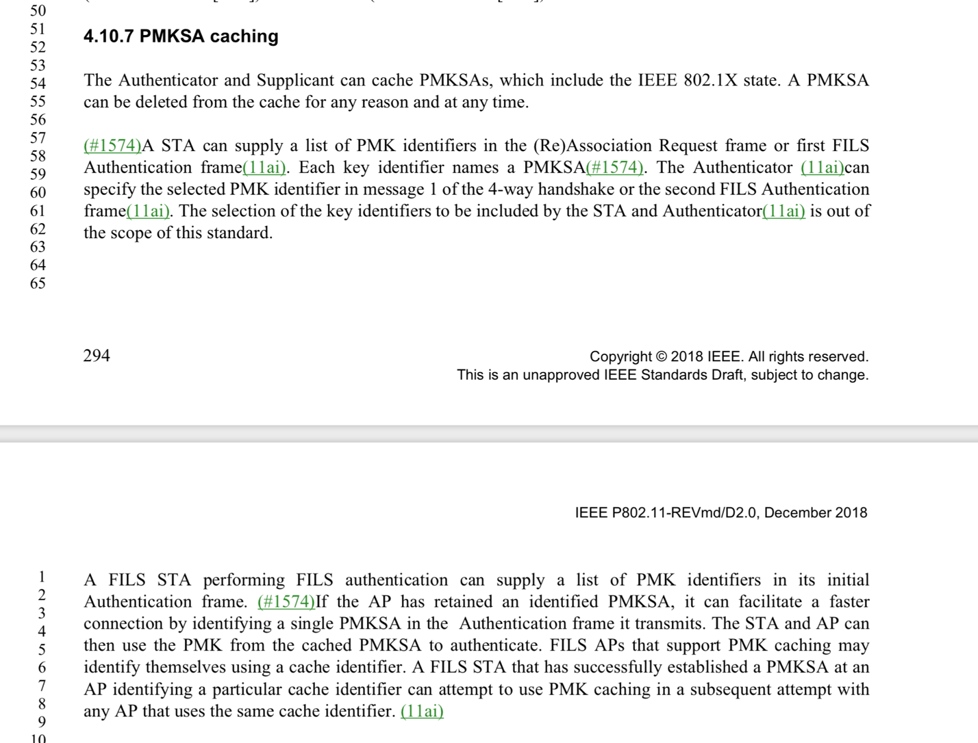

The result of a FILS setup yields a PMKSA which can be used with caching. Hence text indicating this potential use of FILS is suitable in the referenced clause.

The last paragraph as referenced in the comment is not to be deleted.

To accommodate the comment, the initial sentence of the cited paragraph is extended to indicate that STAs may benefit from caching despite the fact that the acronym per PAR contains the word “initial”.

Proposed Resolution

Revised.

Start the first sentence in the paragraph as follows:

The result of a FILS setup yields a PMKSA, which can be used with caching. A FILS STA can benefit from such caching, as a FILS STA performing FILS authentication can supply …….

