IEEE P802.11
Wireless LANs
Suggested comment resolution for CID 2247 and 2525 on REMmd D2.0
Date: 2019-07-15
Author(s):
Name | Affiliation | Address | Phone | email
Marc Emmelmann | Self | Berlin, Germany |  | emmelmann@ieee.org
Hitoshi Morioka | SRC Sorftware | Fukuoka, Japan |  | hmorioka@src-soft.com
Hiroshi Mano | KDTI | Tokyo, Japan |  | mano@koden-ti.com

Abstract

This submission presents a suggested comment resolution for CID(s) 2247 and 2525 on REVmd D2.0

Table of Contents
Abstract 1
Comment 3
Discussion 3
Proposed Resolution 5

Comment

CID | LB | Draft | Page | Line | Clause | Comment | Proposed Change
2247 | 236 | 2 | 180.00 | 29 | 3.2 | CID 338 removed most of the remaining "FILSC" concept, but it remains in clause 9 terminology and definition. Get rid of FILSC completely (definition, acronym, and clause 9 names). | Delete "fast initial link setup category (FILSC)" definition in subclause 3.2. Delete FILSC acronym in subclause 3.4. In 9.4.2.186, replace "FILS Type" field name with "DILS fields present" (4 occurences, including the figure caption), and also in 11.46.5.3 (1 occurrence).
2525 | 236 | 2 |  |  | 9.4.2.186 | "fast initial link setup category (FILSC): A value that indicates the priority category of the station (STA) for fast initial link setup" is confusing. FILSC is just DILS by another name, and should be called that | In 3.2: delete the FILSC definition and add a DILS definition "differentiated initial link setup (DILS): A mechanism for restricting fast initial link setup (FILS) to certain categories of stations."  In 3.4: delete the FILSC expansion and add DILS with expansion "differentiated initial link setup"  In 9.4.2.186 (multiple), 11.46.5.3: change "FILSC Type" to "DILS Type"  In 9.4.2.186: change "The Differentiated FILS Time field contains an unsigned integer that specifies the time duration for the validity of the MAC Address Filter field or the FILS User Priority field" to "The Differentiated FILS Time field contains an unsigned integer that specifies the time duration for the DILS restrictions (see 11.46.5.3)"  Finally, in 9.4.2.186 (multiple), 11.45.5 (multiple): change "Differentiated FILS Time" to "DILS Duration"

Discussion

Both comments relate to the (usage of) fast link setup category (FILSC), which has been removed as part of the previous comment resolution process. Both comments address related issues in the definition subclause and in cls 9.4.2:

Context of the comment (D2.0 P180)

Context of the comment (D2.0 P207)

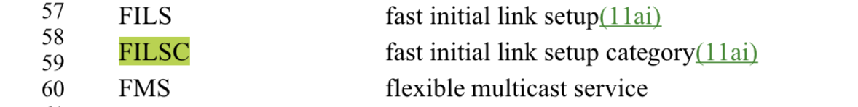

Context of the comment (D2.0 P1355ff)
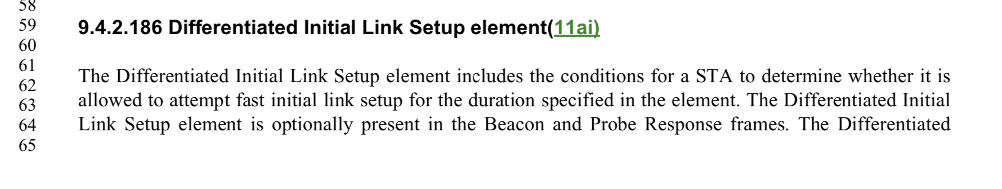
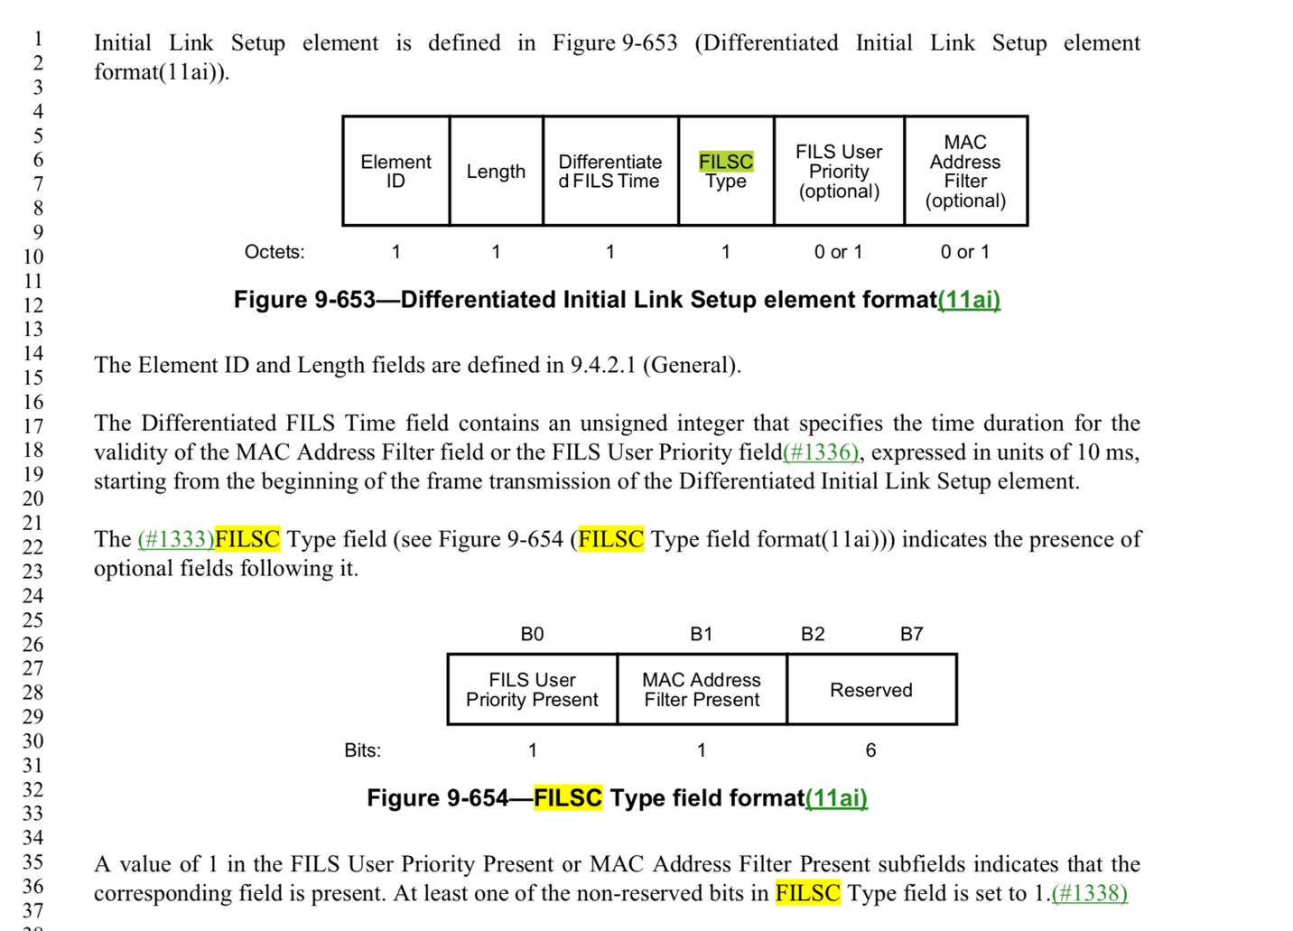

Context of the comment (D2.0 P2500)

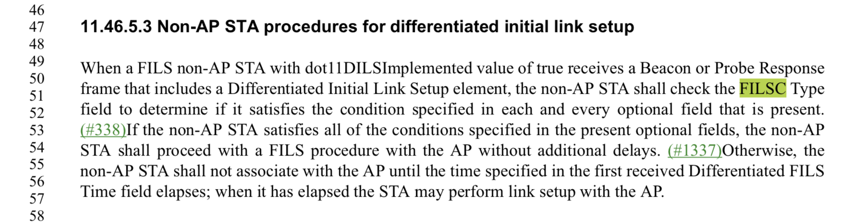

Conclusion: Both comments identifies changes that should be addressed due to the previous deprication of FIlSC.

The capitalization of the proposed resolution per comments needs though to be changes as “FILSC Type” is a field and the replacement should be named “DILS Field Present”.

Note that this results in potential wordings such as (for example): The DILS Field Present field ….”

In addition, a definition for DILS should be added as it is missing.

The suggested rewording of “The Differentiated FILS Time field contains.. “ should be accepted as it crossreferences the relevant section stating the validity, instead of restating it in the sentence”.

Proposed Resolution

REVISED

Delete "fast initial link setup category (FILSC)" definition in subclause 3.2.

In 3.2: add a DILS definition "differentiated initial link setup (DILS): A mechanism for restricting fast initial link setup (FILS) to certain categories of stations."

Delete FILSC acronym in subclause 3.4.

In 3.4 add the DILS acronym: “DILS -- differentiated initial link setup”

In 9.4.2.186, replace "FILS Type" field name with "DILS Fields Present" (4 occurences, including the figure caption), and also in 11.46.5.3 (1 occurrence).

In 9.4.2.186: change "The Differentiated FILS Time field contains an unsigned integer that specifies the time duration for the validity of the MAC Address Filter field or the FILS User Priority field" to "The Differentiated FILS Time field contains an unsigned integer that specifies the time duration for the DILS restrictions (see 11.46.5.3)"

