IEEE P802.11
Wireless LANs
Suggested comment resolution for CID 2247 on REMmd D2.0
Date: 2019-07-13
Author(s):
Name | Affiliation | Address | Phone | email
Marc Emmelmann | Self | Berlin, Germany |  | emmelmann@ieee.org
Hitoshi Morioka | SRC Sorftware | Fukuoka, Japan |  | hmorioka@src-soft.com
Hiroshi Mano | KDTI | Tokyo, Japan |  | mano@koden-ti.com

Abstract

This submission presents a suggested comment resolution for CID(s) 2247 on REVmd D2.0

Note – please do NOT consider this document. It has been merged in 11-19/1278 to address several related comments.

Table of Contents
Abstract 1
Comment 3
Discussion 3
Proposed Resolution 4

Comment

CID | LB | Draft | Page | Line | Clause | Comment | Proposed Change
2247 | 236 | 2 | 180.00 | 29 | 3.2 | CID 338 removed most of the remaining "FILSC" concept, but it remains in clause 9 terminology and definition. Get rid of FILSC completely (definition, acronym, and clause 9 names). | Delete "fast initial link setup category (FILSC)" definition in subclause 3.2. Delete FILSC acronym in subclause 3.4. In 9.4.2.186, replace "FILS Type" field name with "DILS fields present" (4 occurences, including the figure caption), and also in 11.46.5.3 (1 occurrence).

Discussion

Context of the comment (D2.0 P180)

Context of the comment (D2.0 P207)

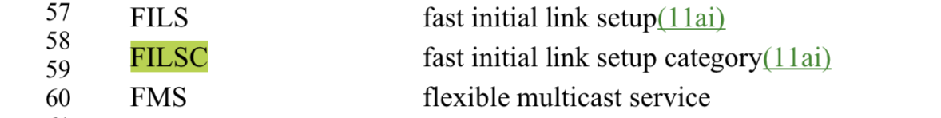

Context of the comment (D2.0 P1355ff)
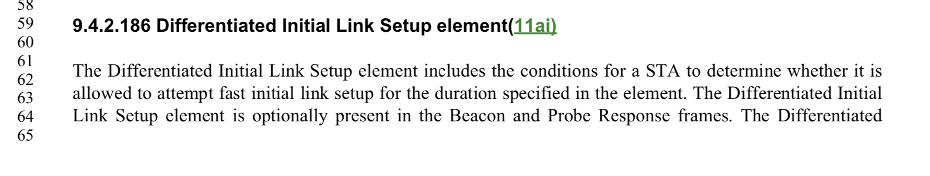
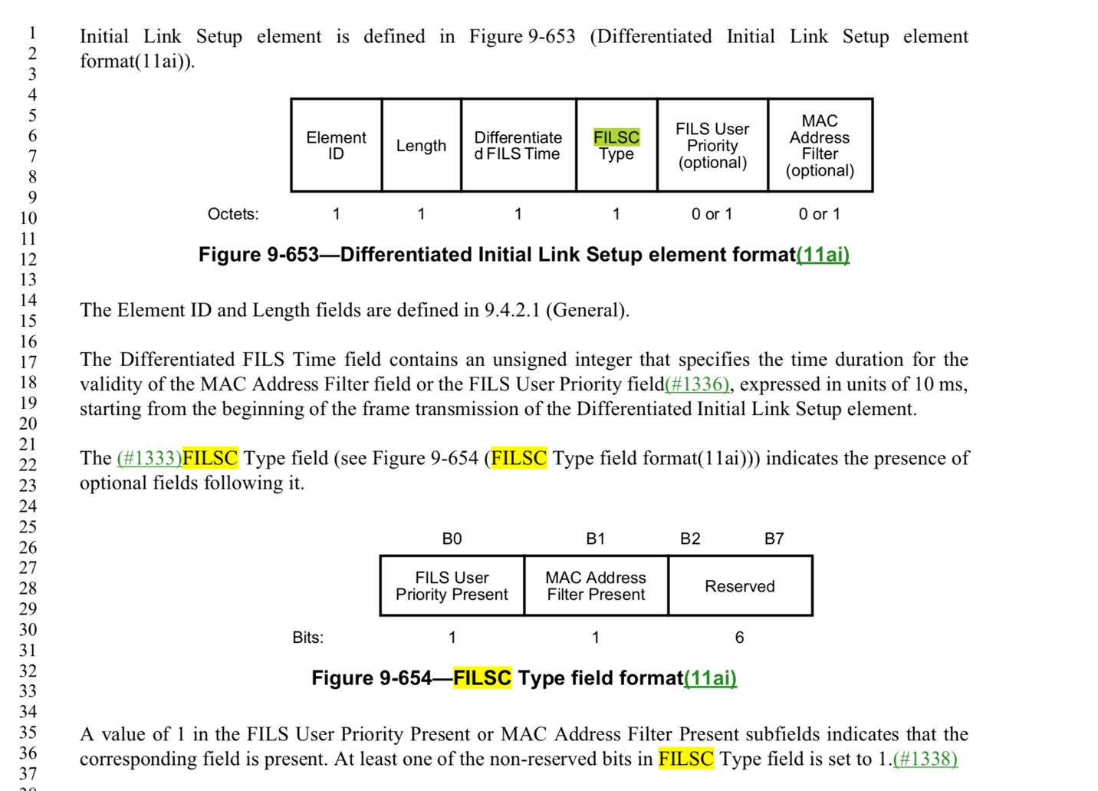

Context of the comment (D2.0 P2500)

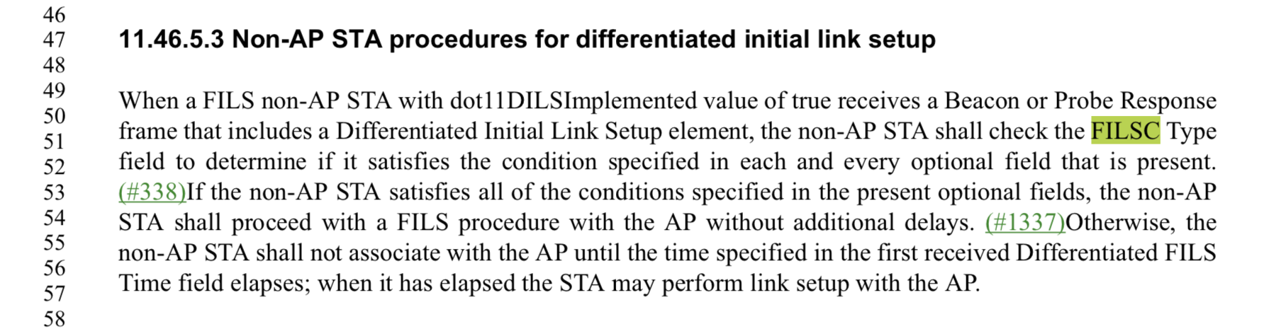

The comment identifies changes that should be addressed due to the previous deprication of FIlSC.

The capitalization of the proposed resolution per comments needs though to be changes as “FILSC Type” is a field and the replacement should be named “DILS Field Present”.

Note that this results in potential wordings such as (for example): The DILS Field Present field ….”

Proposed Resolution

REVISED

Delete "fast initial link setup category (FILSC)" definition in subclause 3.2.

Delete FILSC acronym in subclause 3.4.

In 9.4.2.186, replace "FILS Type" field name with "DILS Fields Present" (4 occurences, including the figure caption), and also in 11.46.5.3 (1 occurrence).

