IEEE P802.11
Wireless LANs
Suggested comment resolution for CID 2233 on REMmd D2.0
Date: 2019-07-13
Author(s):
Name | Affiliation | Address | Phone | email
Marc Emmelmann | Self | Berlin, Germany |  | emmelmann@ieee.org
Hitoshi Morioka | SRC Sorftware | Fukuoka, Japan |  | hmorioka@src-soft.com
Hiroshi Mano | KDTI | Tokyo, Japan |  | mano@koden-ti.com
George Calcev | Huaweii

Abstract

This submission presents a suggested comment resolution for CID(s) 2233 on REVmd D2.0

Table of Contents
Abstract 1
Comment 3
Discussion 3
Proposed Resolution 4

Comment

CID | LB | Draft | Page | Line | Clause | Comment | Proposed Change
2233 | 236 | 2 | 2139.00 | 21 | 11.1.4.3.10 | "The AP may maintain the AP-CSN values in the AP-CSN List for a duration whose value is out of the scope of this standard." This is so vague that it says nothing ("may" "for a duration [that] is out of scope"). | Clarify what the interoperability requirements really are, if there are any at all.

Discussion

Context of the comment (D2.0 P2139)

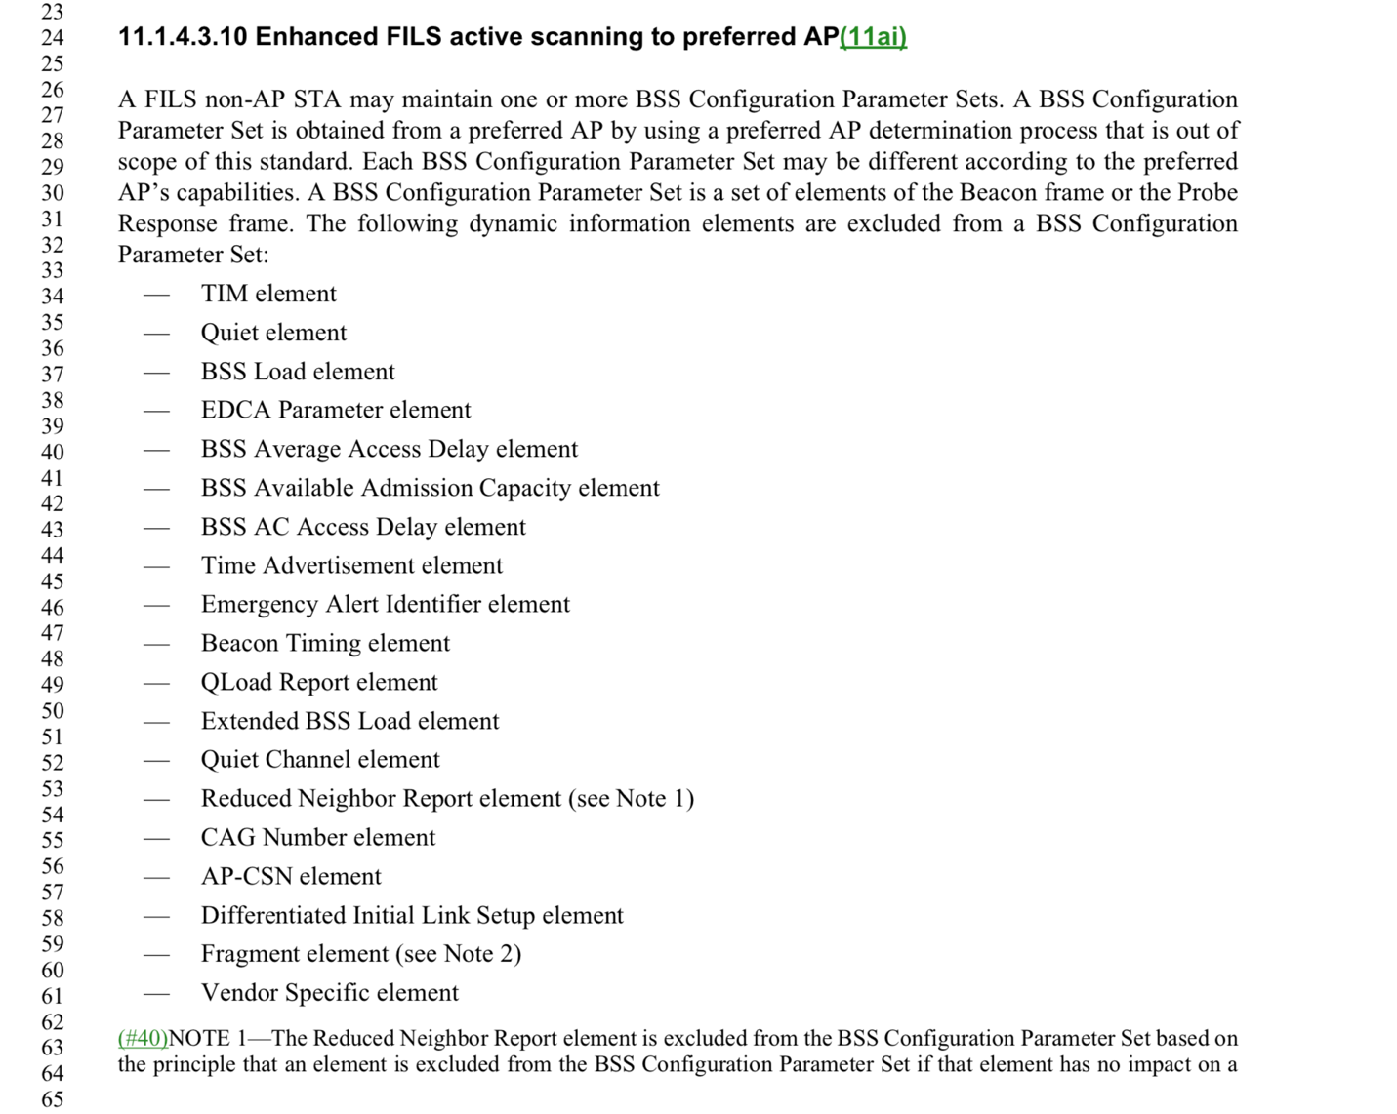
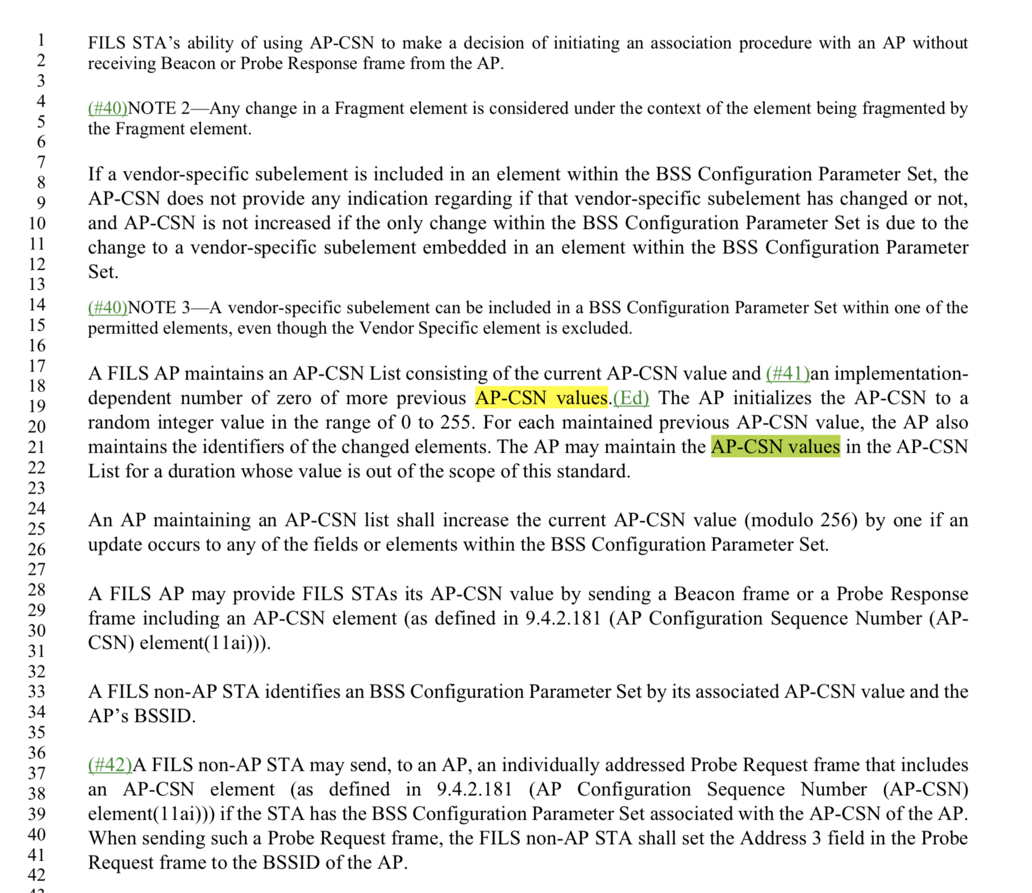

The AP maintains at least one AP-CSN value and in addition previous AP-CSN values. The referred sentence simply states, that it is up to the AP to decice on how long to keep these additional (past) values.

Since the duration may be zero, keeping past values is not required for interoperability.

Proposed Resolution

Revised.

Convert the quoted sentence into a “note” after the paragraph, i.e. to:

“Note -- The AP may maintain the AP-CSN values in the AP-CSN List for a duration whose value is out of the scope of this standard.”

