IEEE P802.11
Wireless LANs
Suggested comment resolution for CID 2579 on REMmd D2.0
Date: 2019-07-13
Author(s):
Name | Affiliation | Address | Phone | email
Marc Emmelmann | Self | Berlin, Germany |  | emmelmann@ieee.org
Hitoshi Morioka | SRC Sorftware | Fukuoka, Japan |  | hmorioka@src-soft.com
Hiroshi Mano | KDTI | Tokyo, Japan |  | mano@koden-ti.com

Abstract

This submission presents a suggested comment resolution for CID(s) 2579 on REVmd D2.0

Table of Contents
Abstract 1
Comment 3
Discussion 3
Proposed Resolution 4

Comment

CID | LB | Draft | Page | Line | Clause | Comment | Proposed Change
2579 | 236 | 2 | 2133.00 | 7 | 11.1.4.3.4 | "A FILS STA may choose not to respond to Probe Request frames from a FILS STA  addressed to broadcast address if the responding STA receives an acknowledged probe response addressed  to the requesting STA containing the SSID of the responding STA." -- it's not clear which is the "responding STA" here since this is about a FILS STA choosing not to respond! | Change to "A first FILS STA may choose not to respond to Probe Request frames from a second FILS STA  addressed to the broadcast address if the first STA receives an acknowledged probe response addressed  to the second STA containing the SSID of the first STA."

Discussion

Context of the comment (D2.0 P2133)

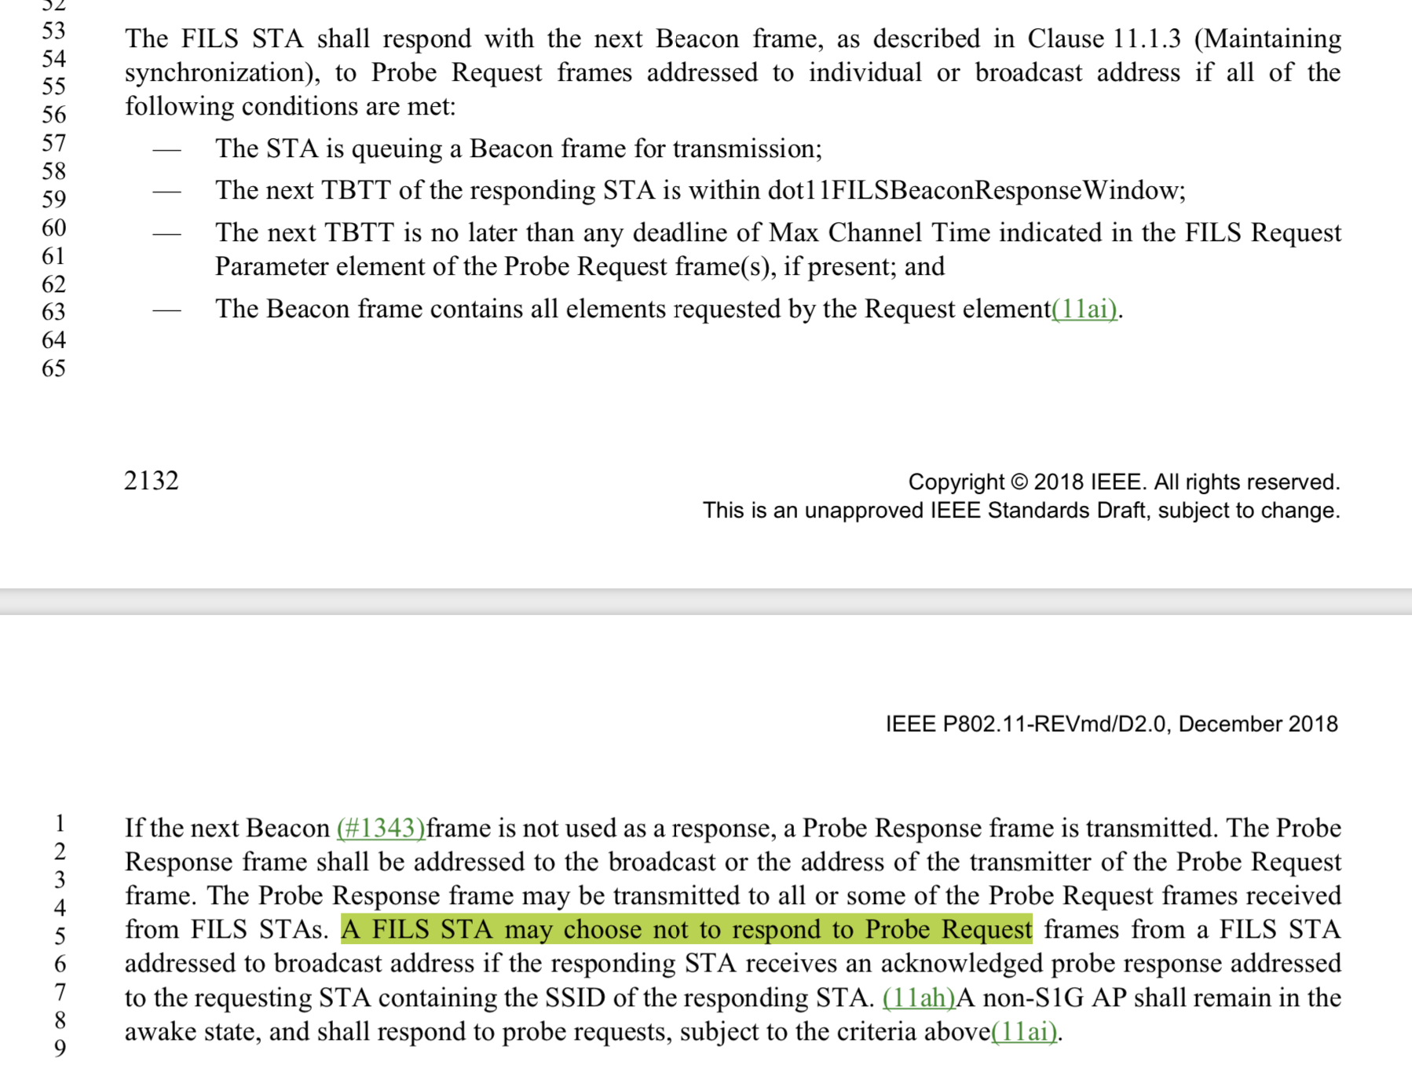

The comment identifies a potentially confusing wording and provides a suggested rewording.

Proposed Resolution

ACCEPT

