IEEE P802.11
Wireless LANs
Suggested comment resolution for CID 2547 on REMmd D2.0
Date: 2019-07-13
Author(s):
Name | Affiliation | Address | Phone | email
Marc Emmelmann | Self | Berlin, Germany |  | emmelmann@ieee.org
Hitoshi Morioka | SRC Sorftware | Fukuoka, Japan |  | hmorioka@src-soft.com
Hiroshi Mano | KDTI | Tokyo, Japan |  | mano@koden-ti.com

Abstract

This submission presents a suggested comment resolution for CID(s) 2547 on REVmd D2.0

Table of Contents
Abstract 1
Comment 3
Discussion 3
Proposed Resolution 4

Comment

CID | LB | Draft | Page | Line | Clause | Comment | Proposed Change
2547 | 236 | 2 | 1354.07 |  | 9.4.2.184.3 | The gateway address should be provided if the device address is. CID 1542 rejected this because "This is conceptually not required. A STA, e.g. in a purely local network environment, may be assigned an IP address without requiring a gateway address." If this is really the claim, it needs to be made explicitly | In Table 9-293 at the end of the rightmost cell for rows B2 and B4 add "See NOTE." and at the bottom of the table add a table "NOTE---A STA in a purely local network environment may be assigned an IP address without requiring a gateway address."

Discussion

Context of the comment (D2.0 P1353ff)

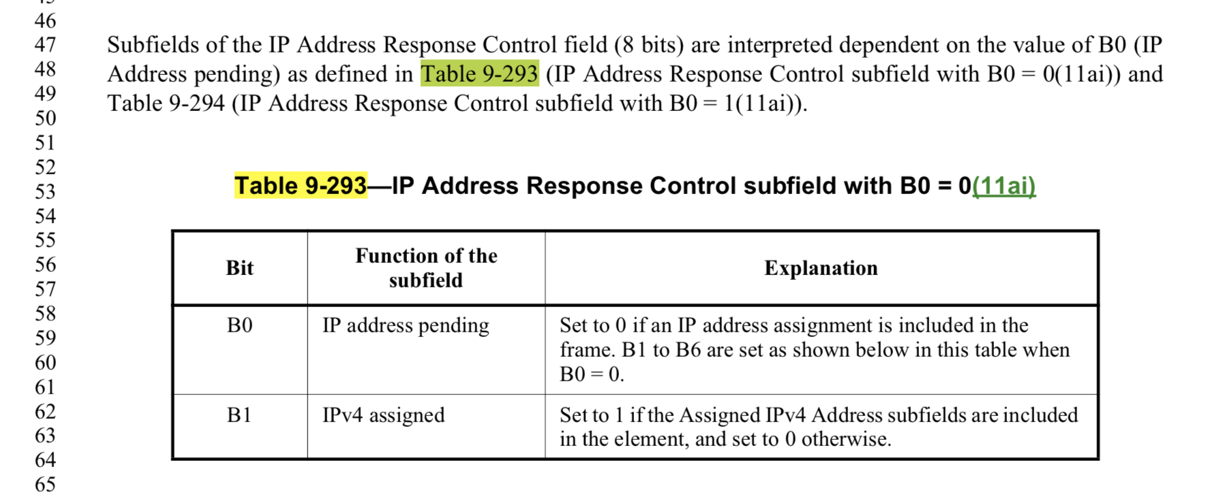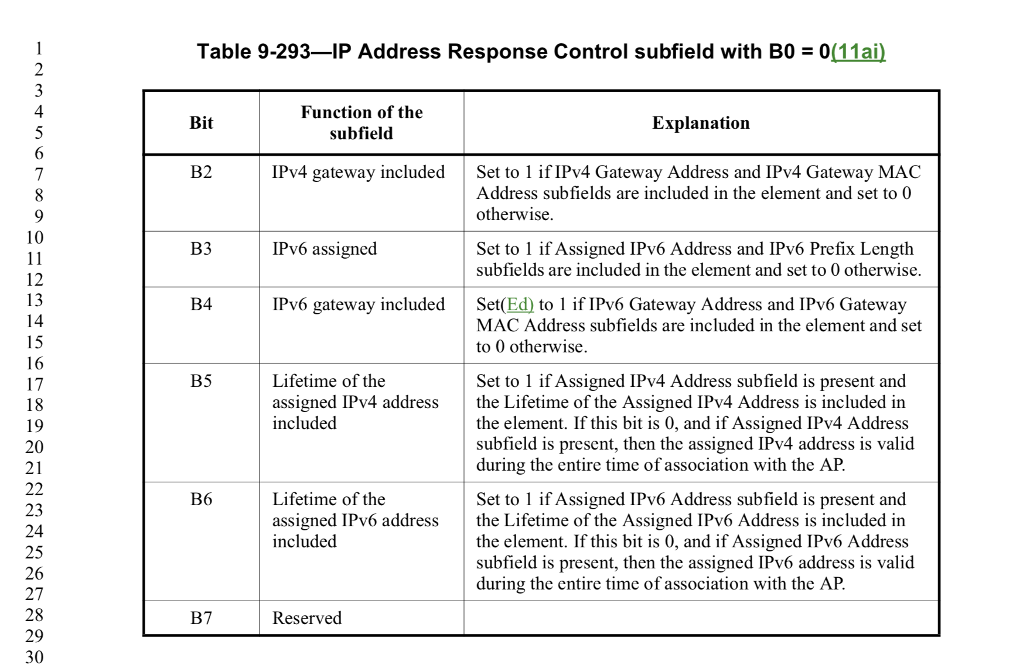

The commnt does not address a technical deficiency. At the same time it suggest to add an explanatory note to the table which adds useful information on how to set the values for local networks without a gateway.

Proposed Resolution

Revised:

In Table 9-293 at the end of the rightmost cell for rows B2 and B4 add "See NOTE." and at the bottom of the table add a table "NOTE---A STA in a purely local network environment might be assigned an IP address without requiring a gateway address."

