IEEE P802.11
Wireless LANs
Suggested comment resolution for CID 2524 on REMmd D2.0
Date: 2019-08-02
Author(s):
Name | Affiliation | Address | Phone | email
Marc Emmelmann | Self | Berlin, Germany |  | emmelmann@ieee.org
Hitoshi Morioka | SRC Sorftware | Fukuoka, Japan |  | hmorioka@src-soft.com
Hiroshi Mano | KDTI | Tokyo, Japan |  | mano@koden-ti.com

Abstract

This submission presents a suggested comment resolution for CID(s) 2524 on REVmd D2.0

Table of Contents
Abstract 1
Comment 3
Discussion 3
Proposed Resolution 4

Comment

CID | LB | Draft | Page | Line | Clause | Comment | Proposed Change
2524 | 236 | 2 | 692.00 | 54 | 6.3.103.4.4 | "The SME is notified of the receipt of this FILSContainer request." -- what's a "FILSContainer request" | Change to "The SME is notified of the IP Address setup request."

Discussion

Context of the comment (D2.0 P692)
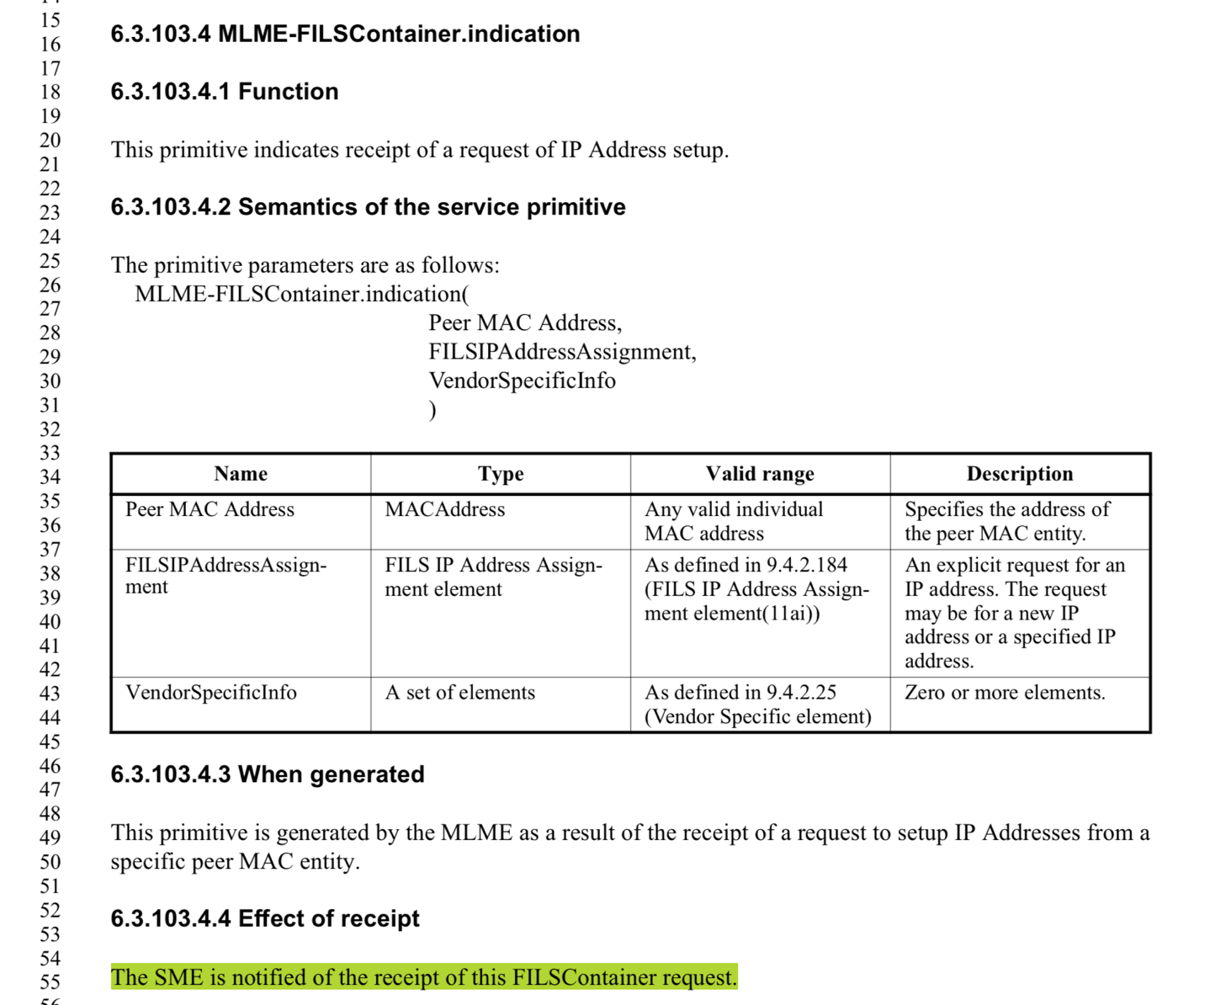

The comment correctly identifies a technical deficiency. The SME should not be notified about the receipt of the FILSContainer, but of the IP addresses requested to set-up, as contained in the FILSContainer.

Proposed Resolution

Revised

Change to "The SME is notified of the received IP Address setup request."

