IEEE P802.11
Wireless LANs
Suggested comment resolution for CID 2423 on REMmd D2.0
Date: YYYY-MM-DD
Author(s):
Name | Affiliation | Address | Phone | email
Marc Emmelmann | Self | Berlin, Germany |  | emmelmann@ieee.org
Hitoshi Morioka | SRC Sorftware | Fukuoka, Japan |  | hmorioka@src-soft.com
Hiroshi Mano | KDTI | Tokyo, Japan |  | mano@koden-ti.com

Abstract

This submission presents a suggested comment resolution for CID(s) 2423 on REVmd D2.0

Table of Contents
Abstract 1
Comment 3
Discussion 3
Proposed Resolution 4

Comment

CID | LB | Draft | Page | Line | Clause | Comment | Proposed Change
2423 | 236 | 2 | 1537.00 | 17 | 9.6.7.36 | "The FILS Discovery frame may include one or more Vendor Specific elements. The Vendor Specific  element is defined in 9.4.2.25 (Vendor Specific element)." -- this is already part of the generic Action frame rules | Delete the cited text at the referenced location

Discussion

Context of the comment (D2.0 P1530ff)
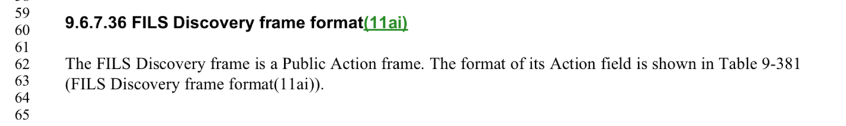
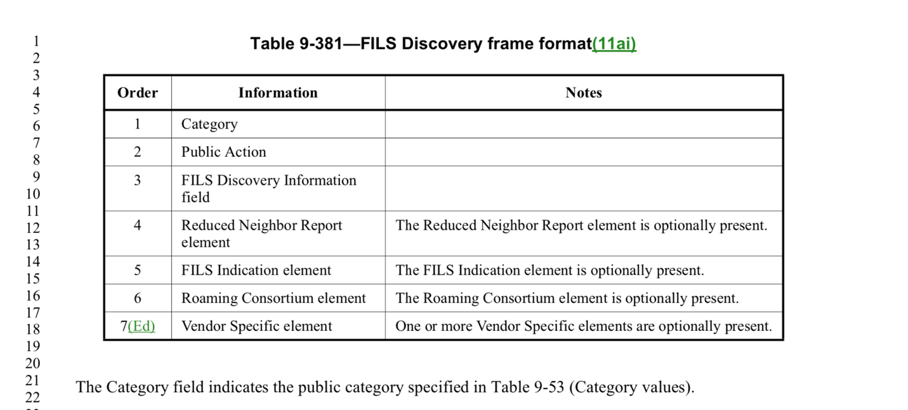

The following pages describe each field of the frame.
The Cls. Concludes with:

The general structure of the clause is that for each field, a short description is given. Even though the comment is valid in stating that this statement is redundant information / already part of the generic Action frame rules, keeping the cited text (a) maintains the logical structure of the clause and (b) helps the reader to identify the cls. Wher the field is further detailed.

The addressed issue does not address a technical defect but rather a style issue. It is felt beneficial – especially in view of having a draft of several thousand pages – to have this additional cross reference in place.

Proposed Resolution

REJECT

The general structure of the clause is that for each field, a short description is given. Even though the comment is valid in stating that this statement is redundant information / already part of the generic Action frame rules, keeping the cited text (a) maintains the logical structure of the clause and (b) helps the reader to identify the cls. Wher the field is further detailed.

The addressed issue does not address a technical defect but rather a style issue. It is felt beneficial – especially in view of having a draft of several thousand pages – to have this additional cross reference in place.

