IEEE P802.11
Wireless LANs
Suggested comment resolution for CID 2407 on REMmd D2.0
Date: 2019-08-02
Author(s):
Name | Affiliation | Address | Phone | email
Marc Emmelmann | Self | Berlin, Germany |  | emmelmann@ieee.org
Hitoshi Morioka | SRC Sorftware | Fukuoka, Japan |  | hmorioka@src-soft.com
Hiroshi Mano | KDTI | Tokyo, Japan |  | mano@koden-ti.com

Abstract

This submission presents a suggested comment resolution for CID(s) 2407 on REVmd D2.0

Table of Contents
Abstract 1
Comment 3
Discussion 3
Proposed Resolution 4

Comment

CID | LB | Draft | Page | Line | Clause | Comment | Proposed Change
2407 | 236 | 2 |  |  |  | There are references to "high priority link setup", but it is not clear that this differs from FILS | Change each instance of "high priority link setup" to "FILS"

Discussion

“high priority link setup” has 4 matches in D2.0

Context of the comment (D2.0 P2500):
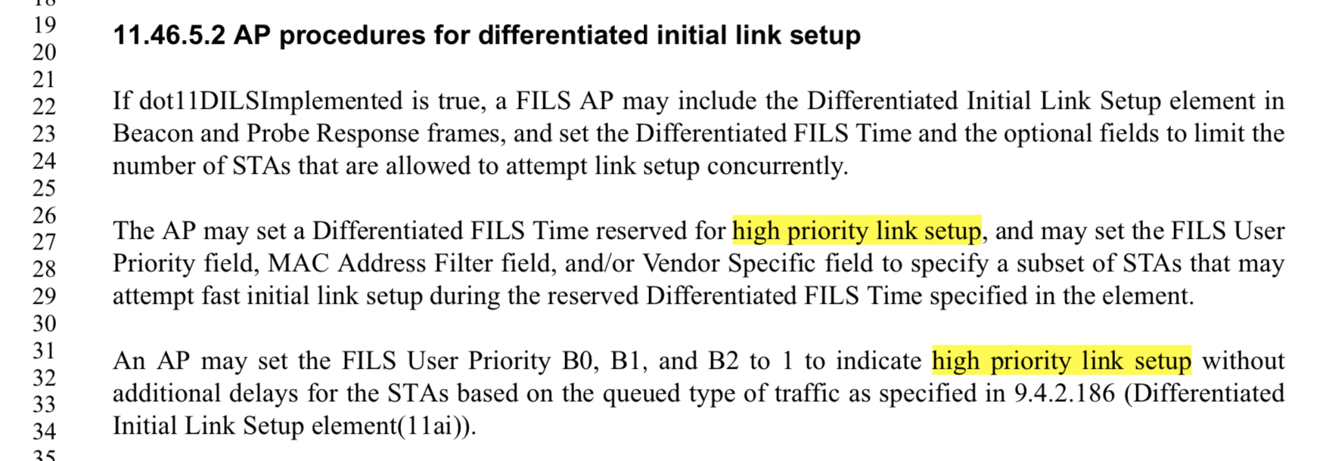

The first occurence relates to DILS used to allow STAs to get link setup at a higher priority. This idea needs to be expressed here; hence the text should not be changed according to the comment. The text may be reworded to be more precise.

The second occorence may be changed to FILS as from its context, it is clear that the DILS concept is invoked.

Context of the comment (D2.0 P1356):
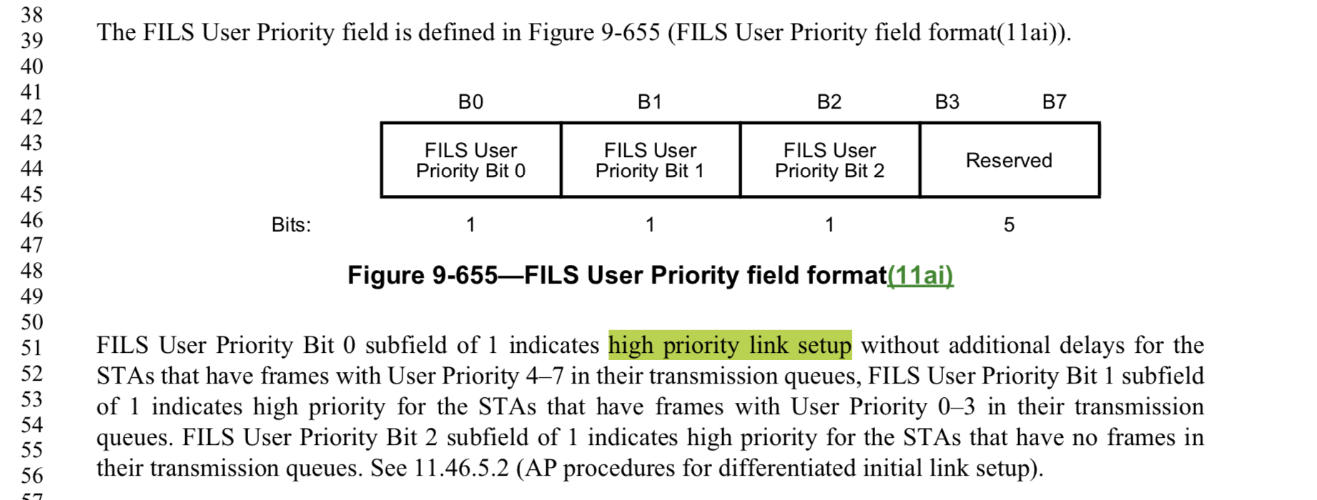

The occorence may be changed to FILS as from its context, it is clear that the DILS concept is invoked.

Context of the comment (D2.0 P2500):
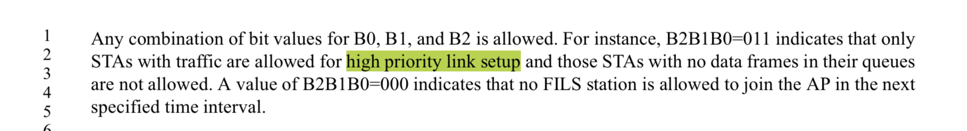

The occurrence cannot simply be changed to FILS, as this would not indicate that within FILS, certain STAs are given priority to. Suggestion: use “prioritised FILS”.

Note for discussion: maybe use “are given priority within FILS”; change then the proposed resolution if preferred

Proposed Resolution

REVISED

In Cls. 11.46.5.2 (P2500L27 of D2.0) change:

“high priority link setup”

To

“FILS at a high priority”

In Cls. 11.46.5.2 (P2500L31 of D2.0)
And in Cls. 9.4.2.186 (P2500L51 of D2.0) change:

“high priority link setup”

To

“FILS”

In Cls. 11.46.5.3 (P2500L3) change:

“high priority link setup”

To

“FILS at a high priority”

