IEEE P802.11  
Wireless LANs

|  |  |  |  |  |
| --- | --- | --- | --- | --- |
| Comment resolution on PICs for LB238 | | | | |
| Date: 2019-09-16 | | | | |
| Author: | | | | |
| Name | Affiliation | Address | Phone | Email |
| Edward Au | Huawei Technologies | 303 Terry Fox Drive, Suite 400, Ottawa, Ontario K2K 3J1 |  | edward.ks.au@gmail.com |

This submission present a resolution for CIDs 20100, 21538, and 20114. The proposed changes are based on P802.11ax D4.2.

##### Revision history:

##### R0 – initial version

R1 – Updated the status of the CIDs per the discussion on August 8.

R2 – Updated the proposed resolution on CIDs 21538 and 20114.

R3 – Updated the proposed resolution on CID 21538 based on the discussion on Monday AM2 in the September 2019 interim.

|  |  |  |  |  |  |  |
| --- | --- | --- | --- | --- | --- | --- |
| CID | Clause | Page | Line | Comment | Proposed Change | Resolution |
| 20100 | Annex B | 668 | 13 | PICS parameter CFHE160 missing for 160 MHz BW operation. CFHE80 is for 80 MHz and 80+80 non-contiguous BW and not 160 MHz. CFHE160 operation is for HE PHY operation in the 5 and 6 GHz bands. | Add PICS for 160 MHz BW CFHE160. Text: "HE operation with capability of 160 MHz" "for Clause 27 | REJECTED  CFHE80 is for HE operation with capability of 80 MHz or wider channel width, which includes 160 MHz. |

Discussion:

CFHE80 is for HE operation with capability of 80 MHz or wider channel width, which includes 160 MHz.

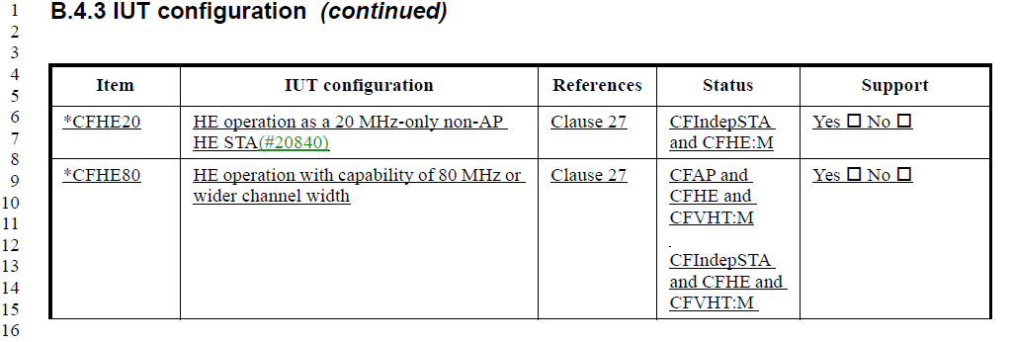

The commenter’s comment on the PICS for HE PHY 160 MHz operation in the 5 and 6 GHz bands is indicated by HEP3.4.



|  |  |  |  |  |  |  |
| --- | --- | --- | --- | --- | --- | --- |
| CID | Clause | Page | Line | Comment | Proposed Change | Resolution |
| 21538 | B.4.27.1 | 690 | 30 | Please update the PICS about the 6 GHz band scanning (26.17.2.3 (Scanning in the 6 GHz band) and 26.17.2.4 (Out of band discovery of a 6 GHz BSS)). | As in comment. | Revised  Agree in principle. Please refer to the changes as shown in 19/1243r3. |
| 20114 | B | 687 | 1 | The tables of Annex B seem to have been updated but the changes from D3.0 to D4.0 are not shown in the redline version of the document. As such it is difficult to determine which changes are to be commented on. Please ensure that Annex B is up to date. | As in comment. | Rejected.  The commenter does not provide specific technical resolution. |

Discussion:

The commenter is right that there is no PICS about the 6 GHz band scanning.

Proposed resolution on CID 21538:

Add the following entry at the end of B.4.3 at 703.65.

|  |  |  |  |  |
| --- | --- | --- | --- | --- |
| Item | Protocol capability | References | Status | Support |
| CFcolocAP | An AP operating in the 6 GHz band that is co-located with an AP operating in the 2.4 GHz band or 5  GHz band. | 26.17.2 | (CFHE2G4 or CFHE5G) AND CFHE6G: M | Yes □ No □ N/A □ |

Add the following two entries at the end of B.4.27.1 at 709.52.

|  |  |  |  |  |
| --- | --- | --- | --- | --- |
| Item | Protocol capability | References | Status | Support |
| HEM12 | HE BSS operation in 6 GHz |  |  |  |
| HEM12.1 | Scanning in the 6 GHz band | 26.17.2.3 | CFHE6G: O | Yes □ No □ N/A □ |
| HEM12.2 | Out of band discovery | 26.17.2.4 | CFcolocAP: M | Yes □ No □ N/A □ |