IEEE P802.11  
Wireless LANs

|  |  |  |  |  |
| --- | --- | --- | --- | --- |
| Comment resolution on MIBs for LB238 | | | | |
| Date: 2019-07-14 | | | | |
| Author: | | | | |
| Name | Affiliation | Address | Phone | Email |
| Edward Au | Huawei Technologies | 303 Terry Fox Drive, Suite 400, Ottawa, Ontario K2K 3J1 |  | edward.ks.au@gmail.com |

This submission present a resolution for CIDs 20100, 21538, and 20114. The proposed changes are based on P802.11ax D4.2.

##### Revision history:

##### R0 – initial version

|  |  |  |  |  |  |  |
| --- | --- | --- | --- | --- | --- | --- |
| CID | Clause | Page | Line | Comment | Proposed Change | Resolution |
| 20100 | Annex B | 668 | 13 | PICS parameter CFHE160 missing for 160 MHz BW operation. CFHE80 is for 80 MHz and 80+80 non-contiguous BW and not 160 MHz. CFHE160 operation is for HE PHY operation in the 5 and 6 GHz bands. | Add PICS for 160 MHz BW CFHE160. Text: "HE operation with capability of 160 MHz" "for Clause 27 | REJECTED  CFHE80 is for HE operation with capability of 80 MHz or wider channel width, which includes 160 MHz. |

Discussion:

CFHE80 is for HE operation with capability of 80 MHz or wider channel width, which includes 160 MHz.

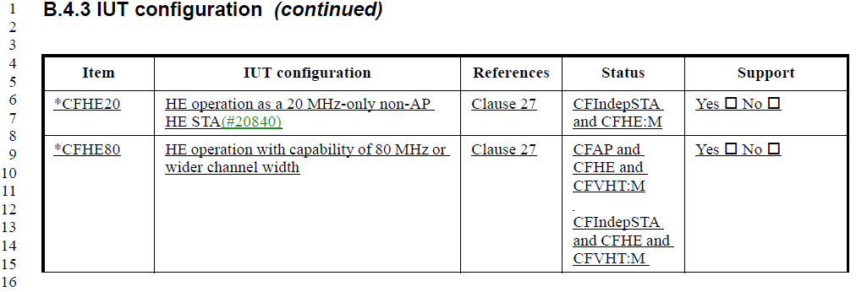

The commenter’s comment on the PICS for HE PHY 160 MHz operation in the 5 and 6 GHz bands is indicated by HEP3.4.



|  |  |  |  |  |  |  |
| --- | --- | --- | --- | --- | --- | --- |
| CID | Clause | Page | Line | Comment | Proposed Change | Resolution |
| 21538 | B.4.27.1 | 690 | 30 | Please update the PICS about the 6 GHz band scanning (26.17.2.3 (Scanning in the 6 GHz band) and 26.17.2.4 (Out of band discovery of a 6 GHz BSS)). | As in comment. | Revised  Agree in principle. Please refer to the changes as shown in 19/1243r0. |
| 20114 | B | 687 | 1 | The tables of Annex B seem to have been updated but the changes from D3.0 to D4.0 are not shown in the redline version of the document. As such it is difficult to determine which changes are to be commented on. Please ensure that Annex B is up to date. | As in comment. | Revised  Agree in principle especially the PICs on 6 GHz scanning is missing.    Please refer to the changes as shown in 19/1243r0. |

Discussion:

The commenter is right that there is no PICS about the 6 GHz band scanning.

Proposed resolution on CIDs 21538 and 20114:

Add the following two entries at the end of B.4.27.1 at 709.52.

|  |  |  |  |  |
| --- | --- | --- | --- | --- |
| Item | Protocol capability | References | Status | Support |
| HEM12 | HE BSS operation in 6 GHz |  |  |  |
| HEM12.1 | Scanning | 26.17.2.3 | CFHE6G: M | Yes □ No □ N/A □ |
| HEM12.2 | Out of band discovery | 26.17.2.4 | CFHE6G: M | Yes □ No □ N/A □ |