IEEE P802.11
Wireless LANs
D4.0 Comment Resolution – Part 4
Date: 2019-7/16
Author(s):
Name | Affiliation | Address | Phone | email
Youhan Kim | Qualcomm |  |  | youhank@qti.qualcomm.com

Abstract
This submission proposes resolutions for the following comments from the letter ballot on P802.11ax D4.0:

20631, 20632, 20203, 20883

NOTE – Set the Track Changes Viewing Option in the MS Word to “All Markup” to clearly see the proposed text edits.

Revision History:

R0: Initial version.

CID 20631, 20632

CID | Page.Line | Clause | Comment | Proposed Change
20631 | 183.11 | 9.4.2.242.4 | The changes in 18/2085 to say "If the operating channel width of the  STA is greater than 80 MHz, indicates  the maximum value of the RXVECTOR  parameter MCS of a PPDU that can be  received by the STA for a PPDU with  bandwidth less than or equal to 80 MHz  for each number of spatial streams.  If the operating channel width of this  STA is less than or equal to 80 MHz,  indicates the maximum value of the  RXVECTOR parameter MCS for a  PPDU that can be received by the STA  for each number of spatial streams." are not clear. The discussion of those changes suggested the intent was to be about the RU size not the PPDU width | Revert the changes made in 18/2085 to Table 9-321c---Subfields of the Supported HE-MCS And NSS Set field
20632 | 183.11 | 9.4.2.242.4 | The changes in 18/2085 to say "If the operating channel width of the  STA is greater than 80 MHz, indicates  the maximum value of the RXVECTOR  parameter MCS of a PPDU that can be  received by the STA for a PPDU with  bandwidth less than or equal to 80 MHz  for each number of spatial streams.  If the operating channel width of this  STA is less than or equal to 80 MHz,  indicates the maximum value of the  RXVECTOR parameter MCS for a  PPDU that can be received by the STA  for each number of spatial streams." are not clear. The discussion of those changes suggested the intent was to be about the RU size not the PPDU width | Change "for a PPDU with bandwidth less than or equal to 80 MHz" to "for a RU with 996 tones or fewer" in the cited text at the referenced location, and also in the cell immediately below

Context

D4.0 Redline Compared to D3.0, P235:
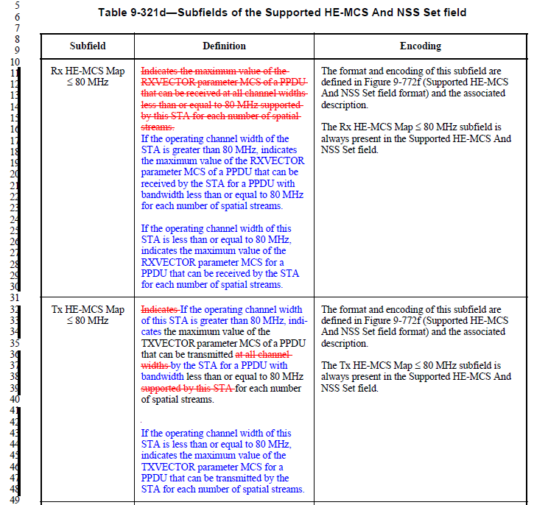
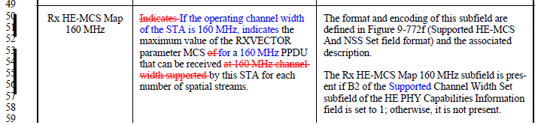
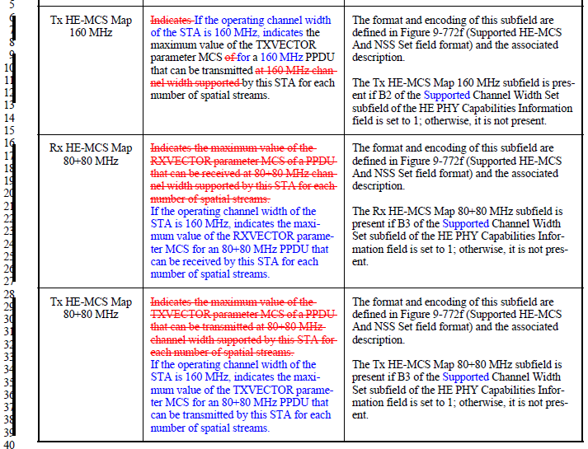

Proposed Resolution: CID 20631, 20632
Rejected
Tx/Rx HE-MCS Map allows three different capabilities for PPDU bandwidths ≤ 80 MHz, 160 MHz and 80+80 MHz to allow receiver reconfiguration based on PPDU bandwidth indicated in HE-SIG-A. Hence, Table 9-321d in D4.0 is correct.

CID 20203

CID | Type of Comment | Page.Line | Clause | Comment | Proposed Change
20203 | E | 185.51 | 9.4.2.242.5 | The way of handling variable length lists in IEEE 802.11-2016/REVmd changed to the pattern shown at 1605.26 - 1605.56 or 1606.38-1606.60 (REVmd D2.0). Figure 9-772g follows the old pattern with repeating fields shown in the frame format. | Change the format of figure 9-772g to the format that is similar to 1605.26 - 1605.56 or 1606.38-1606.60 (REVmd D2.0).

Proposed Resolution: CID 20203
Rejected
REVmd has re-opened discussion on this topic. Suggest to wait until that has been settled at REVmd.

CID 20883

CID | Type of Comment | Page.Line | Clause | Comment | Proposed Change
20883 | E |  |  | Re CID 16005: the comment was not fully addressed | Change throughout to use NPE as meaning nominal packet extension (not PPE), change PPET to NPET, change T_PE,nominal to T_PE,minimum

Proposed Resolution: CID 20883
Rejected
Suppose, for example, that a STA2 indicated 8 usec of packet padding required for a given <NSS,QAM> in the HE Capabilities. When a STA1 is sending a PPDU to STA2 using that <NSS,QAM> and pre-FEC padding factor of 4, for example, then the allowed packet extension duration for that PPDU is 8, 12 or 16 usec. Hence, in this sense, 8 usec (T_PE,nominal) is a ‘minimum’. However, for the same case where STA2 indicated 8 usec of packet padding required for a given <NSS,QAM>, the minimum packet extension being required by the STA2 for pre-FEC padding factor of 1, 2, 3 and 4 is 0, 0, 4 and 8 usec, respectively. Hence, in this sense, 8 usec (T_PE,nominal) is a ‘maximum’. Hence, the term “nominal” was used in the variable “T_PE,nominal” to avoid using the terms “minimum/maximum”.

Regarding PPET, PPET is used to compute the nominal packet padding. The nominal packet extension can be computed only at the time of transmitting a PPDU, when the pre-FEC packet padding is known. Hence, it is not appropriate to chage PPET to NPET.

[End of File]

