IEEE P802.11
Wireless LANs
D4.0 Comment Resolution – Part 4
Date: 2019-7/16
Author(s):
Name | Affiliation | Address | Phone | email
Youhan Kim | Qualcomm |  |  | youhank@qti.qualcomm.com

Abstract
This submission proposes resolutions for the following comments from the letter ballot on P802.11ax D4.0:

20631, 20632, 20203, 20883

NOTE – Set the Track Changes Viewing Option in the MS Word to “All Markup” to clearly see the proposed text edits.

Revision History:

R0: Initial version.

CID 20631, 20632

CID | Page.Line | Clause | Comment | Proposed Change
20631 | 183.11 | 9.4.2.242.4 | The changes in 18/2085 to say "If the operating channel width of the  STA is greater than 80 MHz, indicates  the maximum value of the RXVECTOR  parameter MCS of a PPDU that can be  received by the STA for a PPDU with  bandwidth less than or equal to 80 MHz  for each number of spatial streams.  If the operating channel width of this  STA is less than or equal to 80 MHz,  indicates the maximum value of the  RXVECTOR parameter MCS for a  PPDU that can be received by the STA  for each number of spatial streams." are not clear. The discussion of those changes suggested the intent was to be about the RU size not the PPDU width | Revert the changes made in 18/2085 to Table 9-321c---Subfields of the Supported HE-MCS And NSS Set field
20632 | 183.11 | 9.4.2.242.4 | The changes in 18/2085 to say "If the operating channel width of the  STA is greater than 80 MHz, indicates  the maximum value of the RXVECTOR  parameter MCS of a PPDU that can be  received by the STA for a PPDU with  bandwidth less than or equal to 80 MHz  for each number of spatial streams.  If the operating channel width of this  STA is less than or equal to 80 MHz,  indicates the maximum value of the  RXVECTOR parameter MCS for a  PPDU that can be received by the STA  for each number of spatial streams." are not clear. The discussion of those changes suggested the intent was to be about the RU size not the PPDU width | Change "for a PPDU with bandwidth less than or equal to 80 MHz" to "for a RU with 996 tones or fewer" in the cited text at the referenced location, and also in the cell immediately below

Context

D4.0 Redline Compared to D3.0, P235:
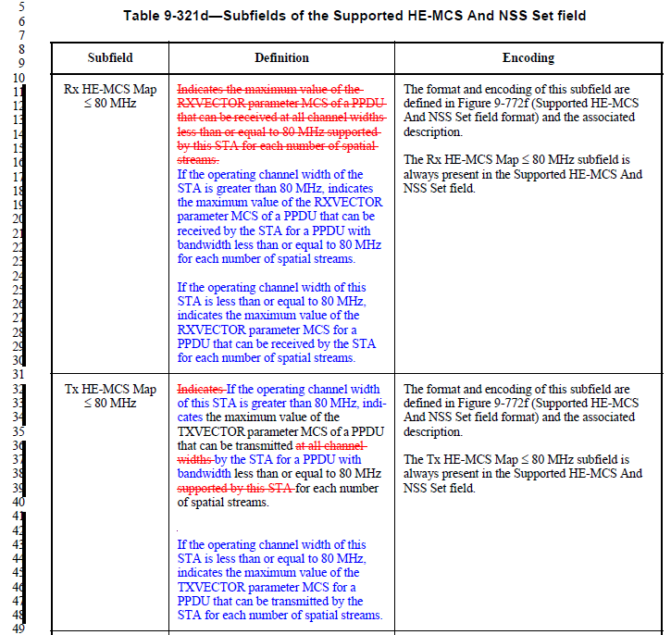
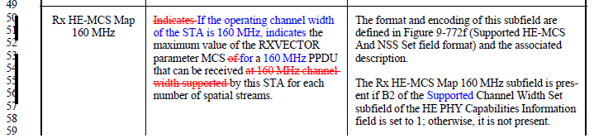
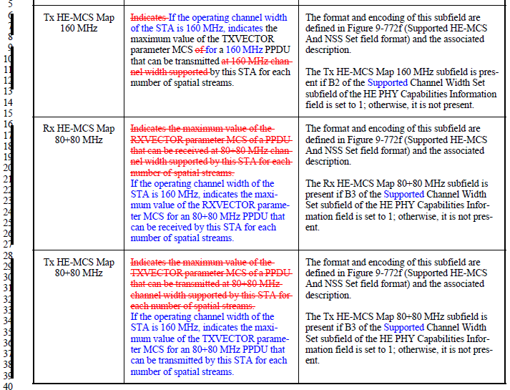

Proposed Resolution: CID 20631, 20632
Rejected
Tx/Rx HE-MCS Map allows three different capabilities for PPDU bandwidths ≤ 80 MHz, 160 MHz and 80+80 MHz to allow receiver reconfiguration based on PPDU bandwidth indicated in HE-SIG-A. Hence, Table 9-321d in D4.0 is correct.

CID 20203

CID | Type of Comment | Page.Line | Clause | Comment | Proposed Change
20203 | E | 185.51 | 9.4.2.242.5 | The way of handling variable length lists in IEEE 802.11-2016/REVmd changed to the pattern shown at 1605.26 - 1605.56 or 1606.38-1606.60 (REVmd D2.0). Figure 9-772g follows the old pattern with repeating fields shown in the frame format. | Change the format of figure 9-772g to the format that is similar to 1605.26 - 1605.56 or 1606.38-1606.60 (REVmd D2.0).

Context

REVmd D2.0 P1605:
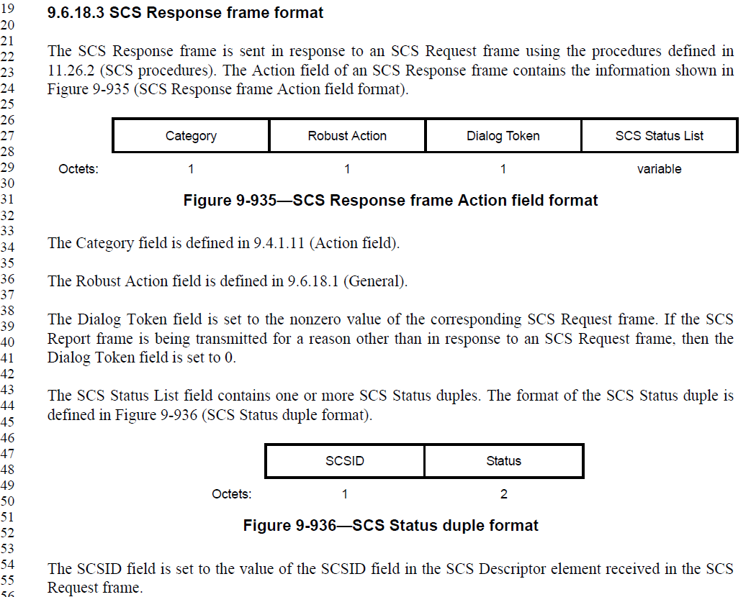

Note that the proposed text update came from Robert Stacey, and this reviewer agrees with the changes proposed by him to address this comment.

Proposed Resolution: CID 20203
Revised
Proposed text updates for CID 20203 in 11-19/1226 updates the relevant text to be compliant with the style used in REVmd.

Instruction to Editor: Implement the text updates for CIDs 20203 in 11-19/1226r0.

Proposed Text Updates: CID 20203

9.4.2.242.5 PPE Thresholds field
TGax editor: change as follows:
The PPE Thresholds field determines the nominal packet padding value (see 26.12 (HE PPDU post FEC padding and packet extension)) for an HE PPDU of a particular RU size and number of space-time streams. The format of the PPE Thresholds field is defined in Figure 9-772f (PPE Thresholds field format).
 | B0 B2 | B3 B6
 | NSTS | RU Index Bitmask | PPE Thresholds List | PPE Pad
Bits: | 3 | 4 | variable | 0 to 7
- PPE Thresholds field format

The NSTS subfield indicates the number of space-time streams for which PPE threshold values are provided and is set to the number of space-time streams minus 1
The RU Index Bitmask subfield contains a bitmask that indicates whether or not PPE threshold values are present for each of four effective RU sizes. The bitmask is indexed by the RU size index defined in Table 9-321e (RU allocation index). For example, if B0 of the RU Index Bitmask subfield (B3 of the PPE Thresholds field) is set to 1, then PPE threshold values are present in the PPE Thresholds List subfield for a 242-tone RU. If B0 of the RU Index Bitmask subfield is set to 0, then PPE threshold values are not present in the PPE Thresholds List subfield for a 242-tone RU.
The PPE Thresholds List subfield contains NSTS + 1 PPE Threshold Info fields, where NSTS is the value in the NSTS subfield, for each RU size for which the corresponding bit in the RU Index Bitmask subfield is nonzero. The PPE Threshold Info subfields in the PPE Threshold List subfield are ordered by increasing RU size and, within each RU size, by increasing number of space-time streams. For example, the PPE Threshold Info field for a 242-tone RU with 1 space-time stream appears first, followed by the PPE Threshold Info field for a 242-tone RU with 2 space-time streams, etc. The PPE Threhsold Info field for the largest RU size with largest number of space-time streams appears last.
The PPE Thresholds Info field contains the PPE threshold values for a particular RU size with a particular number of space-time steams and the format is defined in Figure 9-772g (PPE Thresholds Info field format).
- PPE Thresholds Info field format
 | B0 B2 | B3 B5
 | PPET16 | PPET8
Bits: | 3 | 3
- PPE Thresholds Info field format

The PPET8 and PPET16 subfields of the PPE Threholds Info subfield each contain a constellation index defined in Table 9-321d (Constellation index) that is used to compute the nominal packet padding value.
- Constellation index
Constellation index | Corresponding Transmission Constellation
0 | BPSK
1 | QPSK
2 | 16-QAM
3 | 64-QAM
4 | 256-QAM
5 | 1024-QAM
6 | Reserved
7 | None

TGax editor: move the Table 9-321e anchor to the reference above.

RU size index
RU size index | RU size without DCM | RU size with DCM
0 | 242-tone RU | 106-tone RU
1 | 484-tone RU | 242-tone RU
2 | 996-tone RU | 484-tone RU
3 | 2×996-tone RU | 996-tone RU and 2x996-tone RU

The PPE Pad field contains all 0s. The number of bits in the PPE Pad field is the least number of bits required to round the length of the PPE Thresholds Info field to an integer number of octets.

- HE PPDU post FEC padding and packet extension
An HE STA with dot11PPEThresholdsRequired set to false may include the PPE Thresholds field in HE Capabilities elements that it transmits.
An HE STA with dot11PPEThresholdsRequired set to true shall include the PPE Thresholds field in HE Capabilities elements that it transmits.

A STA that does not include the PPE Threshold field in the HE Capabilities element indicates its required nominal packet padding for all constellations, NSS and RU sizes using the Nominal Packet Padding field in the HE PHY Capabilities Information field in the HE Capabilities element.
A STA that includes the PPE Thresholds field in the HE Capabilities element, indicates its required nominal packet padding for constellations, NSS and RU sizes that it supports in the PPE Threshold field.
A STA that transmits an HE SU PPDU, HE ER SU PPDU or HE MU PPDU addressed to a recipient STA shall set the TXVECTOR parameter NOMINAL_PACKET_PADDING to the recipient STA’s required nominal packet padding for the constellation, NSS and RU size used for that recipient STA.
A STA that includes the PPE Thresholds field in the HE Capabilities elements that it transmits indicates a nominal packet padding per constellation, NSS and RU size in the PPE Thresholds field. A STA that indicates nominal packet padding using the PPE Thresholds field shall indicate a nominal packet padding value for all contealltions, NSS and RU sizes it supports.

After receiving the PPE Thresholds field from a second STA, the first STA uses the combination of the PPET8 NSTSn RUb subfield and PPET16 NSTSn RUb subfield values to determine the nominal packet padding for HE PPDUs that are transmitted to the second STA using NSTS = n and an RU allocation corresponding to RU Allocation Index b, for each value of NSTS and RU specified by the field. The nominal packet padding is used in computing the PE field duration (see 27.3.12 (Packet extension)).
NOTE—If the pre-FEC padding factor is 4, then the value of nominal T_{PE} is equal to the nominal packet padding (see Table 27-44 (Nominal TPE values)).
For all values of n and b for which PPET8 and PPET16 are not present, the nominal packet padding is 0 for HE PPDUs that are transmitted to the STA using NSTS = n and an RU allocation corresponding to RU allocation index b. The nominal packet padding as a function of the PPE thresholds, the number of spatial streams and the RU allocation index is described in Table 26-12 (PPE thresholds per PPET8 and PPET16).
- Nominal packet padding value for a given constellation index and PPE Thresholds Info field
Result of comparison of the constellation index to the PPET8 subfield | Result of comparison of the constellation index to the PPET16 subfield | Nominal packet padding value
Constellation index greater than or equal to PPET8 subfield | Constellation index less than PPET16 subfield or PPET16 subfield indicates None | 8 µs
Constellation index greater than PPET8 subfield or PPET8 subfield indicates None | Constellation index greater than or equal to PPET16 subfield | 16 µs
All other combinations not otherwise listed in this table |  | 0

In Table 26-12 (PPE thresholds per PPET8 and PPET16), "RU Allocation index = (b + DCM)" means the following. With the exception of a 2×996-tone RU, if DCM is applied in a given RU, the nominal packet padding value is based on the next larger RU size (RU index + 1). For example, if DCM is applied to a 242-tone RU then the nominal packet padding value for a 484-tone RU is used. If DCM is applied to 106-tone RU then the nominal packet padding value for a 242-tone RU is used. If DCM is applied to a 2×996-tone RU then the nominal packet padding value for a 2×996-tone RU is used.
The nominal packet padding value for a 242-tone or larger RU or for a 106-tone RU with DCM is determined as follows. The RU size index is determined from Table 9-321e based on the RU size and whether or not DCM is applied. The number of space-time streams is the value of the TXVECTOR parameter NSTS for that user. The RU size index and the number of space-time streams identify the PPE Threshold Info field in the PPE Threshold List subfield in HE PHY Capabilities Information field in the HE Capabilities element received from the STA that is used. The constellation index is determined from Table 9-321d for the constellation used in the RU. The nominal packet padding value for that user is then determined from Table 26-12 using the constellation index and the identified PPE Threshold Info field.
The nominal packet padding value shall be zero for all RU less than 242 unless the RU size is 106 and DCM is enabled.
A STA transmitting an HE PPDU provides the nominal packet padding in the TXVECTOR parameter NOMINAL_PACKET_PADDING for the minimal PE calculation (see 27.3.12 (Packet extension)).
A STA transmitting an HE PPDU that carries a broadcast MPDU shall set the value of the TXVECTOR parameter NOMINAL_PACKET_PADDING to 16 µs. A STA transmitting an HE PPDU that carries a group addressed, but not broadcast, MPDU shall not set the value of the TXVECTOR parameter NOMINAL_PACKET_PADDING to a value which is less than that required for any of the recipients in the multicast group.(#21209)
A STA transmitting an HE PPDU to a receiving STA shall include post-FEC padding determined by the pre-FEC padding factor (see 27.3.11 (Data field)) and after including the post-FEC padding, the transmitting STA shall include a packet extension with a duration indicated by the TXVECTOR parameter NOMINAL_PACKET_PADDING (see 27.3.12 (Packet extension)).

CID 20883

CID | Type of Comment | Page.Line | Clause | Comment | Proposed Change
20883 | E |  |  | Re CID 16005: the comment was not fully addressed | Change throughout to use NPE as meaning nominal packet extension (not PPE), change PPET to NPET, change T_PE,nominal to T_PE,minimum

Proposed Resolution: CID 20883
Rejected
Suppose, for example, that a STA2 indicated 8 usec of packet padding required for a given <NSS,QAM> in the HE Capabilities. When a STA1 is sending a PPDU to STA2 using that <NSS,QAM> and pre-FEC padding factor of 4, for example, then the allowed packet extension duration for that PPDU is 8, 12 or 16 usec. Hence, in this sense, 8 usec (T_PE,nominal) is a ‘minimum’. However, for the same case where STA2 indicated 8 usec of packet padding required for a given <NSS,QAM>, the minimum packet extension being required by the STA2 for pre-FEC padding factor of 1, 2, 3 and 4 is 0, 0, 4 and 8 usec, respectively. Hence, in this sense, 8 usec (T_PE,nominal) is a ‘maximum’. Hence, the term “nominal” was used in the variable “T_PE,nominal” to avoid using the terms “minimum/maximum”.

Regarding PPET, PPET is used to compute the nominal packet padding. The nominal packet extension can be computed only at the time of transmitting a PPDU, when the pre-FEC packet padding is known. Hence, it is not appropriate to chage PPET to NPET.

[End of File]

