IEEE P802.11  
Wireless LANs

|  |  |  |  |  |
| --- | --- | --- | --- | --- |
| D4.0 CR for 6GHz channelization | | | | |
| Date: 2019-07-01 | | | | |
| Author(s): | | | | |
| Name | Affiliation | Address | Phone | email |
| Ruchen Duan | Samsung | 3655 N 1st St., San Jose, CA 95134 |  | r.duan@samsung.com |
| Wook Bong Lee | Samsung |  |  |  |
| Alexander Thoukydides | Samsung |  |  |  |
| Srinivas Kandala | Samsung |  |  |  |
| Alfred Asterjadhi | Qualcomm Inc. |  |  | aasterja@qti.qualcomm.com |
| Sigurd Schelstraete | Quantenna |  |  | sschelstraete@quantenna.com |

Abstract

This submission proposes resolutions for the following comments on 6GHz channelization of TGax D4.0:

* 20452, 20453, 20518, 20519

Revisions:

* Rev 0: Initial version of the document. Use D4.0 as baseline spec text.
* Rev 1: Modify the discussion. Add document number and revision version
* Rev 2: Add comments, 20518, 20519
* Rev 3: Some editorial change

Interpretation of a Motion to Adopt

A motion to approve this submission means that the editing instructions and any changed or added material are actioned in the TGax Draft. This introduction is not part of the adopted material.

***Editing instructions formatted like this are intended to be copied into the TGax Draft (i.e. they are instructions to the 802.11 editor on how to merge the text with the baseline documents).***

***TGax Editor: Editing instructions preceded by “TGax Editor” are instructions to the TGax editor to modify existing material in the TGax draft. As a result of adopting the changes, the TGax editor will execute the instructions rather than copy them to the TGax Draft.***

|  |  |  |  |  |  |
| --- | --- | --- | --- | --- | --- |
| **CID** | **Clause Number** | **Page** | **Comment** | **Proposed Change** | **Resolution** |
| 20452 | 26.17.2.3.3 | 432 | Add parens, for clarity of operator precedence | Change the equation to: channel starting frequency + (5 ├ù 16 ├ù (n - 1)) | Revised –  Agree in principle with the comment. Proposed resolution accounts for the suggested change.  TGax editor to make the changes shown in 11-19/1017r3 under all headings that include CID 20452. |
| 20453 | 26.17.2.3.3 | 432 | Eq 27-134 clearly indicates the channel starting frequency of 5.940 GHz, and the equation results in channel #1 being the lowest frequency, and centered on 5.945 Ghz. However, the equation on P432.7 (for the PSCs) doesn't explicilty list the channcel starting frequency, so we assume it is 5.940 GHz per Annex E, and thus the lowest PSC is 5.940 GHz. | Replace the PSC equation with: (channel starting frequency + 5) + (80 ├ù (n - 1)) | Revised –  The comment and proposed change are not consistent with each other. The proposed resolution addresses the comment, which mentions that the equation here does not clearly state the channel starting frequency. To fix this the resolution clarifies that the channel starting frequency is defined in 27.3.22.2.  In addition to that, there are problem in current PSC equation. Hence, modification is necessary. See discussion in 11-19/1017r1.  TGax editor to make the changes shown in 11-19/1017r3 under all headings that include CID 20453. |
| 20518 | 26.17.2.3.3 | 432 | "The set of 20 MHz channels in the 6 GHz band, with channel center frequency, ch_a = channel starting frequency + 5 x 16 x (n - 1), where n = 1, ..., 15, are referred to as preferred scanning channels (PSCs)." -- normally channel 0 refers to the channel at the channel starting frequency | Change "(n - 1)" to "n" and change "1, ..., 15" to "0, ..., 14" | Revised –  Modified equation based on similar way defined in section 27.3.22.2.  TGax editor to make the changes shown in 11-19/1017r3 under all headings that include CID 20518. |
| 20519 | 26.17.2.3.3 | 432 | "The set of 20 MHz channels in the 6 GHz band, with channel center frequency, ch_a = channel starting frequency + 5 x 16 x (n - 1), where n = 1, ..., 15, are referred to as preferred scanning channels (PSCs)." -- normally channel 0 refers to the channel at the channel starting frequency. See 27.3.22.2 | Change the cited text at the referenced location to "The set of 20 MHz channels in the 6 GHz band with channel numbers 12 + 16 <mult> n, where n = 0, ..., 14, are referred to as preferred scanning channels (PSCs)." | Revised –  Modified equation based on similar way defined in section 27.3.22.2.  TGax editor to make the changes shown in 11-19/1017r3 under all headings that include CID 20519. |

**Discussion:**

There are two issues in current 6 GHz band channelization.

1. Center frequency equation discrepancy

2. Preferred scanning channel (primary channel for 6 GHz-only AP) in the first 20MHz in the 80MHz band which may have some issue under ETSI regulation

First, center frequency equation discrepancy.

*Equation (27-134),*

*Channel center frequency = Channel starting frequency + 5 × nch (MHz) (27-134)*

*Where nch = 1, ..., 253 Channel starting frequency is 5.940 GHz*

*In annex E,*

*20MHz channel center frequency can be 1, 5, 9, 13, … with channel starting frequency 5.940GHz.*

*In section 26.17.2.3.3,*

*The set of 20 MHz channels in the 6 GHz band, with channel center frequency, ch_a = channel starting frequency + 5 × 16 × (n - 1), where n = 1, ..., 15, are referred to as preferred scanning channels (PSCs).*

Thus, the equation in section 26.17.2.3.3 should be

*ch_a = channel starting frequency + 5 × (16 × (n - 1) +1), where n = 1, ..., 15,*

However, this brings third issue.

There is a recommendation:

*A 6 GHz-only AP should set up the BSS with a primary 20 MHz channel that coincides with a preferred scanning channel (PSC).*

If we follow

*ch_a = channel starting frequency + 5 × (16 × (n - 1) +1), where n = 1, ..., 15*,

then the **recommended** primary channel of 6 GHz-only AP is in the lowest 20MHz for 80MHz BSS.

For a device operating in 80MHz BSS, it typically does not change center frequency when it needs to transmit 20MHz PPDUs. In this case, there will be LO leakage outside of 20MHz PPDUs.

In the IEEE 802.11ax specification, LO leakage is exempt from spectral mask and EVM requirements for any PPDU type including TB PPDU.

*NOTE 3—For rules regarding TX center frequency leakage levels, see 27.3.18.4.2 (Transmit center frequency leakage). The spectral mask requirements in this subclause do not apply to the RF LO.*

*For 80 MHz capable devices that transmits 20 MHz or 40 MHz PPDU, the potential LO leakage subcarriers exist outside the PPDU bandwidth and should not affect the transmitter modulation accuracy test.*

*The unequalized observed symbol of potential LO leakage subcarrier locations shall be treated as zero during unoccupied subcarriers transmit modulation accuracy test.*

However, according to the ETSI regulation [ 1] chapter 4.2.4.2, for the 5GHz, a device shall meet the spectrum mask shown in Figure 1.

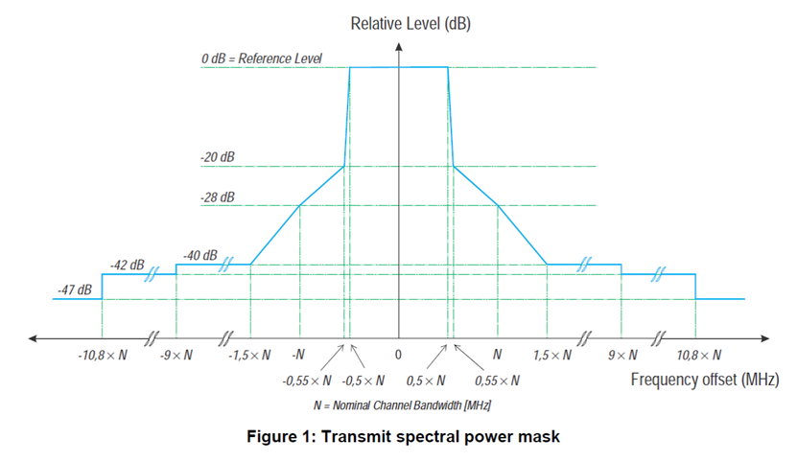

Figure 1 Transmit spectral power mask

*“The mean Power Density (measured with a 1 MHz measurement bandwidth) of the transmitter unwanted emissions within the 5 GHz RLAN bands shall not exceed the limits of the mask provided in figure 1 or an absolute level of -30 dBm/MHz, whichever is greater. The limits in figure 1 are relative to the maximum Power Density of the RLAN device when measured with a reference bandwidth of 1 MHz.”*

In the case transmitting any 20MHz PPDU, the transmit power shall meet the 20MHz spectrum mask. This means, transmitting 20MHz PPDU located on the edge 20MHz in 80MHz BSS, the LO leakage requirement is -40dB lower than inband transmitting power level or -30dBm, which ever is greater. In some implementation, meeting this requirement may be quite tough.

Since having PSC in one of the 20 MHz adjacent to the center of the 80 MHz band does not cause any problem, we propose to change PSC as follows.

*ch_a = channel starting frequency + (5 × (16 × (n - 1) +5)), where n = 1, ..., 15*,

**Proposed Changes:**

***TGax Editor: Modify text in 26.17.2.3.3 (Non-AP STA scanning behaviour):***

The set of 20 MHz channels in the 6 GHz band, with channel center frequency, *ch_a* = Channel starting frequency – 55 + 80 × *n* (MHz) are referred to as preferred scanning channels (PSCs). Channel starting frequencyis defined in 27.3.22.2, and *n = 1, ..., 15*. *(#20452, 20453, 20518, 20519)*

**End of proposed changes.**

**References**

**[ 1]** **5 GHz RLAN Harmonised Standard covering the essential equirementsof article 3.2 of Directive 2014/53/EU**