IEEE P802.11  
Wireless LANs

|  |  |  |  |  |
| --- | --- | --- | --- | --- |
| Liaison from Wi-Fi Alliance re: assigned reserved values | | | | |
| Date: 2019-05-31 | | | | |
| Author(s): | | | | |
| Name | Affiliation | Address | Phone | email |
| Dorothy Stanley | Hewlett Packard Enterprise | 3333 Scott Blvd. Santa Clara, CA 95054 | +1 630 363 1389 | [dstanley@ieee.org](mailto:dstanley@ieee.org) |
|  |  |  |  |  |

Abstract

This document contains a liaison statement received from Wi-Fi Alliance providing a status update on the WFA actions described in a prior liaison, see <https://mentor.ieee.org/802.11/dcn/19/11-19-0277-00-0000-2019-02-liaison-response-from-wi-fi-alliance-re-reserved-value-usage.docx> .

The received liaison is embedded below and reproduced on the following pages.





10900-B Stonelake Boulevard, Suite 126 **∙** Austin, Texas 78759 U.S.A. Phone: +1-512-498-9434 (WIFI) **∙** Fax: +1-512-498-9435

www.wi-fi.org

# Liaison follow up from Wi-Fi Alliance re: IEEE 802.11 Standard Reserved values

**FROM:** Edgar Figueroa, CEO, Wi-Fi Alliance, efigueroa@wi-fi.org

**TO:** Dorothy Stanley, IEEE 802.11 Working Group Chair, dstanley@ieee.org

**CC:** Konstantinos Karachalios, IEEE-SA Standards Board, Secretary, IEEE-SA Board of Governors, sasecretary@ieee.org

Paul Nikolich, IEEE 802 chair, p.nikolich@ieee.org

Jon Rosdahl, Vice-chair, IEEE 802.11 WLAN Working Group, jrosdahl@ieee.org

Robert Stacey, Vice-Chair, IEEE 802.11 WLAN Working Group, robert.stacey@intel.com

Steve Shearer, , Wi-Fi Alliance, sshearer@wi-fi.org

Mark Hung, Technology and Engineering Vice President, Wi-Fi Alliance, mhung@wi-fi.org Tina Hanzlik, Communications Director, Wi-Fi Alliance, thanzlik@wi-fi.org

**SUBJECT:** Usage of IEEE 802.11 Reserved fields and values in Wi-Fi Alliance specifications

**DATE:** May 31, 2019

Dear Dorothy,

We are writing to provide a status update in reference to our previous liaison on this topic, where we specified certain actions that we would take to improve the integrity of the Wi-Fi Alliance process in this regard.

We have taken the following actions

1. Taken inventory of our specifications and have discovered a potential discrepancy in the way that two elements are defined in the Hotspot 2.0 and the MBO specifications. It appears that the same elements are used in both specifications, but they seem to have slightly different meaning. We expect to provide a more details on how to address this by the end of August.
2. Updated our procedures to include training on this topic for our Technical Task Groups at the start of our program development, and added additional checks in our document finalization phase, to ensure these proposed allocations do not go unnoticed in the future.

Page 1 | 2



10900-B Stonelake Boulevard, Suite 126 **∙** Austin, Texas 78759 U.S.A. Phone: +1-512-498-9434 (WIFI) **∙** Fax: +1-512-498-9435 www.wi-fi.org

Thank you again for informing us about this and helping us maintain good document alignment between our two organizations. We will follow up with you again in writing before the end of August 2019. Please note that future updates on this topic may come directly from Steve or Mark who are copied here.

Finally, thank you for your patience through this process.

Edgar Figueroa

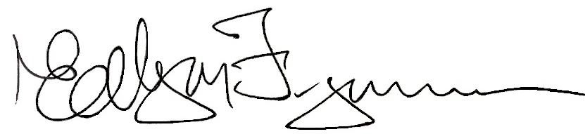

Regards,

President and CEO

Page 2 | 2

**References:**

<https://mentor.ieee.org/802.11/dcn/19/11-19-0185-01-000m-proposed-ls-to-wfa-on-reserved-usage.docx>

<https://mentor.ieee.org/802.11/dcn/19/11-19-0277-00-0000-2019-02-liaison-response-from-wi-fi-alliance-re-reserved-value-usage.docx>

<https://mentor.ieee.org/802.11/dcn/19/11-19-0287-00-0000-proposed-ls-response-to-wfa-fils-discovery-allocation.docx> and <http://grouper.ieee.org/groups/802/11/Liaisons/2019-03-19-Liaison%20statement%20response%20from%20IEEE%20802.11%20to%20WFA.pdf>